WEEK: … Date of planning: …
PERIOD: … Date of teaching: …

UNIT 7: ENVIRONMENTAL PROTECTION

Lesson 6: Skills 2

I. OBJECTIVES
By the end of this lesson, Ss will be able to:
1. Knowledge
- Listen about water pollution
- Write a notice
2. Competences
- Develop communication skills and creativity
- Be collaborative and supportive in pair work and teamwork
- Actively join in class activities
3. Personal qualities
- Love reading and talking about activities to protect the environment
II. MATERIALS
- Grade 8 textbook, Unit 7, skills 2
- Computer connected to the Internet
- Projector / TV
- hoclieu.vn
III. PROCEDURES
1. WARM-UP (7 mins)
a. Objectives:
- To create an active atmosphere in the class before the lesson;
- To lead into the new lesson.
b. Content:
- Ss work in groups. Every student gives at least one activity that causes water pollution.
- Encourage Ss to give as many causes of water pollution as possible. Whether their sentences are true or not is not very important as long as they speak English.
c. Expected outcomes:
- Students know the topic of the unit and be ready for the conversation.
d. Organisation

TEACHER’S AND STUDENTS’ ACTIVITIES | CONTENTS
Task 1: Work in groups. Make a list of some activities that cause water pollution  - Teacher shows the pictures (PPT slides) to the whole class.  - Teacher ask students to work in groups and name the activities in the picture that causes water pollution  - Students work in groups for 3 minutes then go to the board and write their answers  - Teacher elicits answers from students.  - Encourage Ss to give as many causes of water pollution as possible.  - Teacher corrects for students (if needed) | 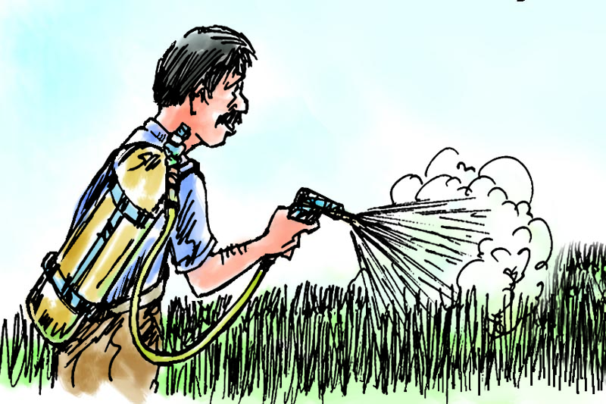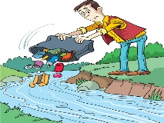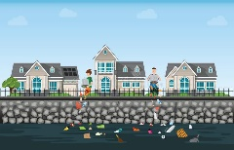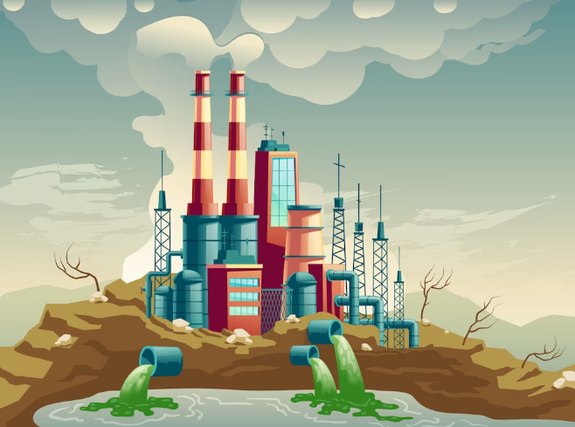  Suggested answer:  - throwing rubbish into rivers and lakes  - pouring domestic wastes  - pouring industrial wastes  - using chemicals and pesticides in soil  - spilling fuel
2. ACTIVITY 1: PRESENTATION (15 mins)
a. Objectives:
- To help Ss practise listening for specific information.
- To help Ss practise listening for general and specific information.
b. Content:
- Task 2,3 in Student book
c. Expected outcomes:
- Students understand how to listen and get the general and specific information.
d. Organisation
TEACHER’S AND STUDENTS’  ACTIVITIES | CONTENTS
Task 2. Listen to the conversation and choose the correct word to complete each sentence
* Pre – listening  - Teacher explains the meaning of the new word:  - Ask Ss to run through the sentences and predict the correct word to complete each sentence  * While listening  - Tell Ss that they are going to listen to a conversation about water pollution.  - Play the recording. Tell Ss to listen carefully and pay attention to key words that help them understand the ideas of the recording.  - Ss choose the correct answers. Check their answers and predictions  1. Polluted water is unsafe for drinking / cooking and for other uses.  2. Sometimes toxic substances flow into rivers from factories / hospitals.  3. Water pollution has a dangerous / harmful effect on our life.  4. We couldn’t / shouldn’t throw litter into rivers and lakes  - Ask ss to read the completed sentences | New word:  - toxic substances (np) chất độc hại  Suggested answers:  1. drinking  2. factories  3. harmful  4. shouldn’t
Task 3. Listen again and give short answers to the following questions. Use no more than THREE words.
- Have Ss read the questions carefully, underline the key words and predict the answers  - Play the recording once or twice. Ask Ss to listen carefully and answer the questions using no more than three words.  - Play the recording once more for Ss to check their answers. Correct their mistakes.  1. What is the listening text about?  2. How many sources of water pollution are there?  3. What are two common sources of drinking water?  4. What type of effect does water pollution have on our life?  5. What products can we use to reduce water pollution?  - Teacher corrects for students as a whole class. | Answer key:  1. Water pollution.  2. Two.  3. Rivers and lakes.  4. A harmful effect.  5. Green
3. ACTIVITY 2: PRACTICE (10 mins)
a. Objectives:
- To familiarise Ss with the form and purpose of a notice that they are going to write;
- To help Ss write a notice
b. Content:
- Task 4: Work in pairs. Read the notice and match the headings with the numbers.
c. Expected outcomes:
- Students’ notices
d. Organisation
TEACHER’S AND STUDENTS’ ACTIVITIES | CONTENTS
Task 4: Work in pairs. Read the notice and match the headings (a – e) below with the numbers (1 – 5)  - First, T explains to Ss that a notice can be an announcement, a warning, or an invitation  - Have Ss work in pairs.  - Tell them to read all the details in the notice, think about them and match the headings (a – e) with the numbers (1 – 5). Remind them of the order of these details in a notice.  - Check the answers as a class | Suggested outcome:  1. a  2. c  3. b  4. e  5. d
4. ACTIVITY 3: PRODUCTION (8 mins)
a. Objectives:
- To familiarise Ss with the form and purpose of a notice that they are going to write;
- To help Ss write a notice
b. Content:
- Task 5: Write a notice for the Go Green Club leader to invite students to attend a lecture on water pollution. Use the following details.
c. Expected outcomes:
- Students’ notices
d. Organisation
TEACHER’S AND STUDENTS’ ACTIVITIES | CONTENTS
Task 5: Write a notice for the Go Green Club  leader to invite students to attend a lecture on water pollution. Use the following details.  - Tell Ss to study the details given.  - Ask Ss to give the information about:  + Name  + Body  + Date of writing the notice  + Contact details  + Author’s name and signature  - Set a time limit for Ss to write the notice. Tell them to refer to the sample notice in 4. Monitor Ss’ work and give assistance when necessary.  - Collect some Ss’ papers and mark them, and later comment to the class.  - If there is not enough time for Ss to do their task in class, have them do it as homework.  - Teacher gives corrections and feedbacks. | Suggested outcome:  Students’ first draft  Suggested answers:  + Name: Go Green Club  + Body: Go Green Club is organising a lecture about the Water Pollution. Students from all the classes will be invitied to participate. Interested students should contact the club by 17 February, 2023.  + Date of writing the notice: 12 January, 2023  + Contact details: If you have any questions, please contact us at 012-3476-789 or email gogreen@fmail.com.  + Author’s name and signature: Club Leader  Nguyen Hong Mai
5. CONSOLIDATION (5 mins)
a. Wrap-up
- Ask one or two Ss to tell the class what they have learnt.
- Ask Ss to say aloud some words and phrases they remember from the lesson.
- Ask Ss to say aloud some activities that cause water pollution.
b. Homework
- Name some activities that cause water pollution.
- Name some activities that can reduce water pollution.
- Do exercises ……… in the workbook.
- Prepare Lesson 7: Looking back and Project.
===================================

