READING
PART 1
Look at the picture. Read the words. Which words go with the picture? Fill in the correct circles on your answer sheet.
1.

(A) The boy is drawing a picture. | (B) The boy is taking a photo. | (C) The boy is talking on the phone
The answer is “B”. Fill in “B” on your answer sheet.
2.
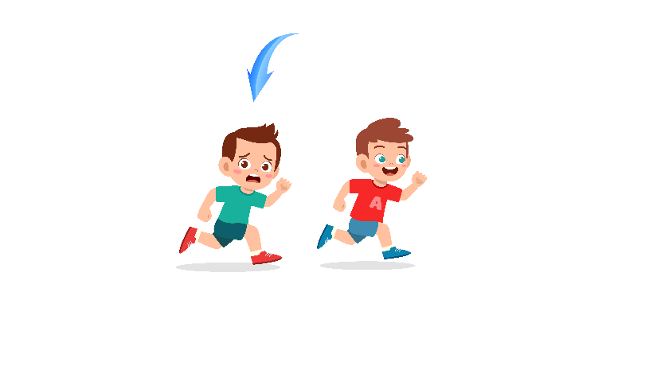
What does the arrow show?
The boy with the arrow is ahead of the other boy.
(A) Ahead | (B) Beside | (C) Under
The answer is “A”. Fill in “A” on your answer sheet.

3.


(A) Doll | (B) Toy train | (C) Robot
4.

(A) Ship | (B) Bike | (C) Taxi
5.
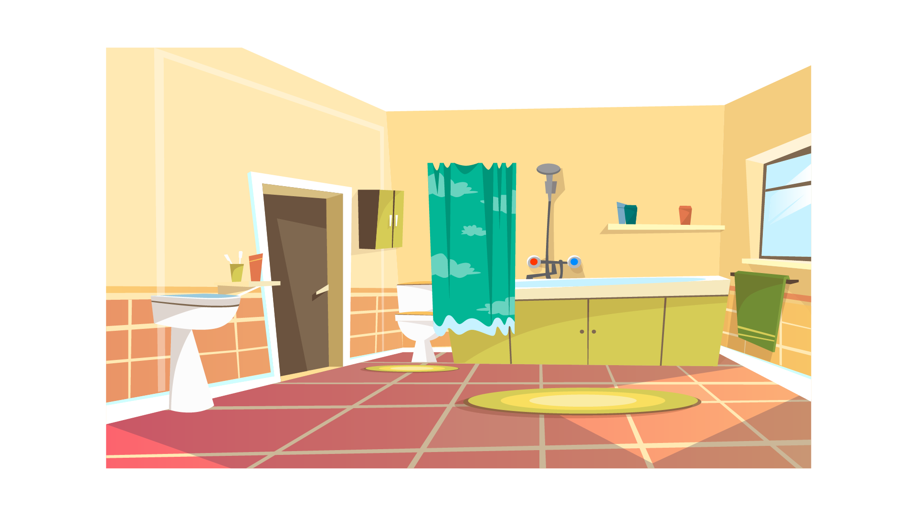
(A) Bathroom | (B) Garden | (C) Kitchen
6.

(A) Strawberry | (B) Banana | (C) Orange
7.
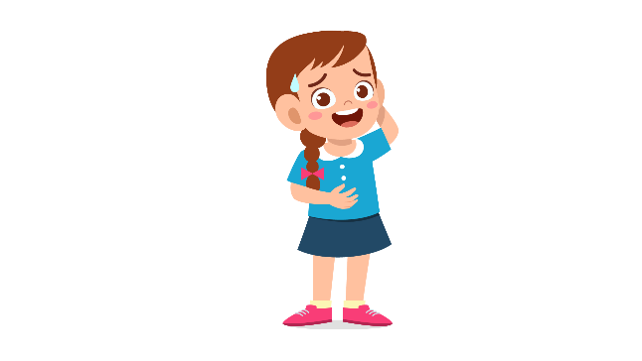
(A) Sad | (B) Happy | (C) Shy
8.
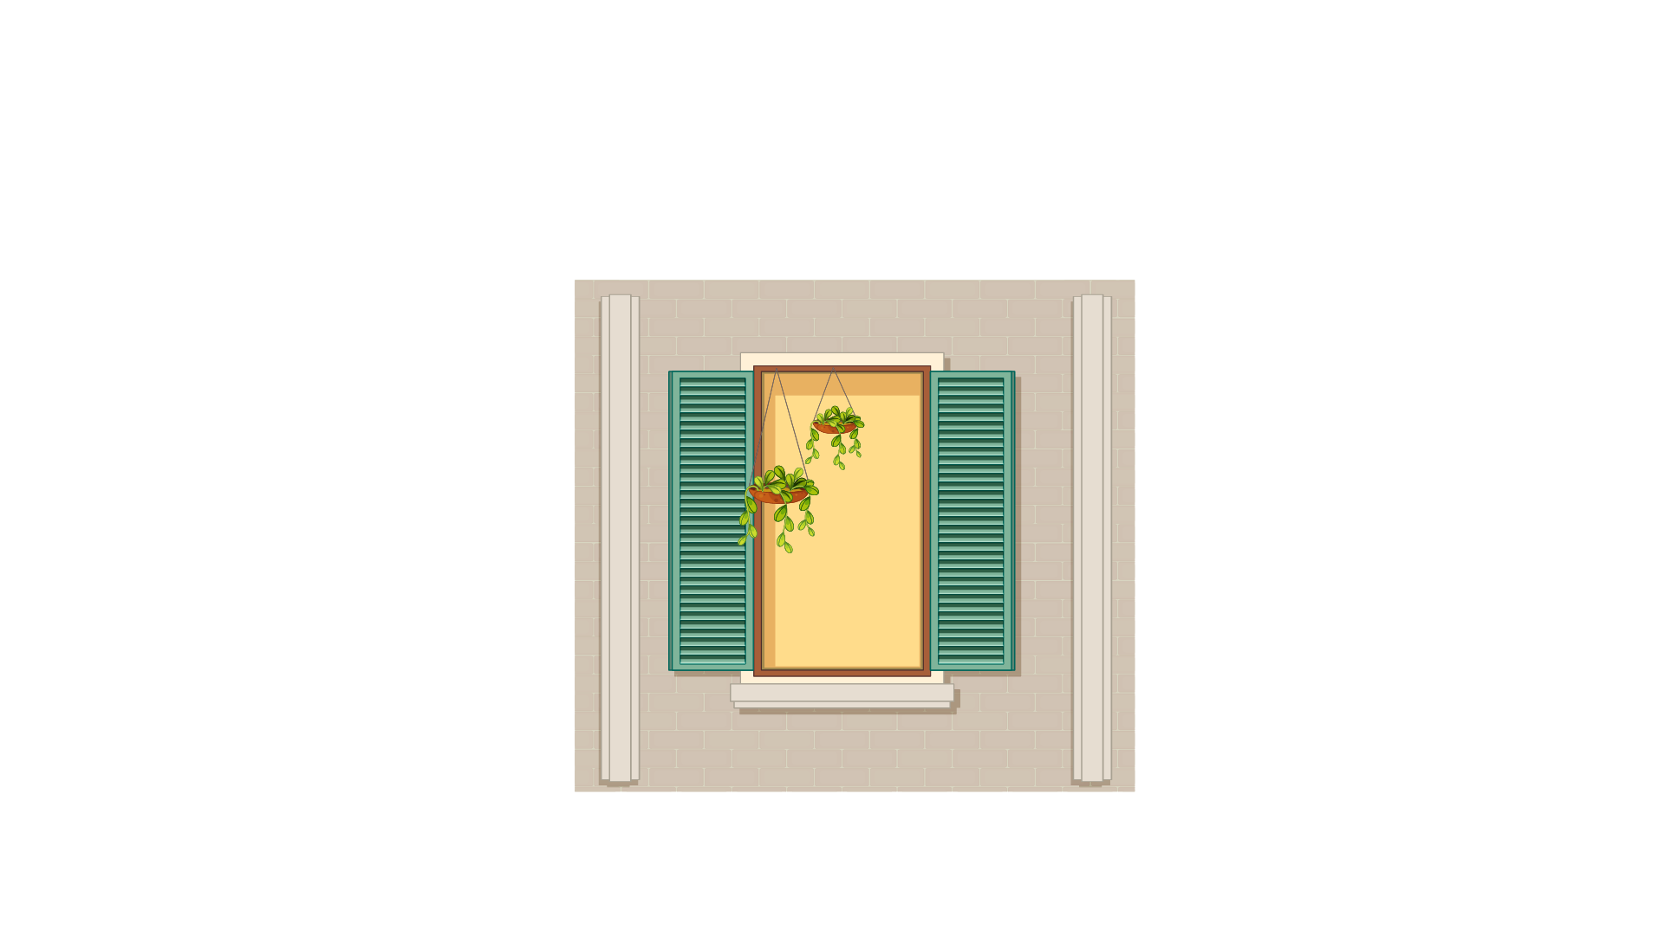
(A) Door | (B) Window | (C) Painting
9.

(A) Inside | (B) Outside | (C) Above
10.


(A) They are cutting apples. | (B) They are picking apples. | (C) They are eating apple pies.
11.


(A) The boy is drinking. | (B) The boy is studying. | (C) The boy is sleeping.
12.

(A) The girls are jumping rope. | (B) The girls are baking. | (C) The girls are sitting.
13.

(A) The car is going up the hill.  14. | (B) The car is at the foot of the hill.   | (C) The car is going down the hill.
(A) The boy is raising his hand. | (B) The boy is sitting quietly. | (C) The boy is taking notes.
15.
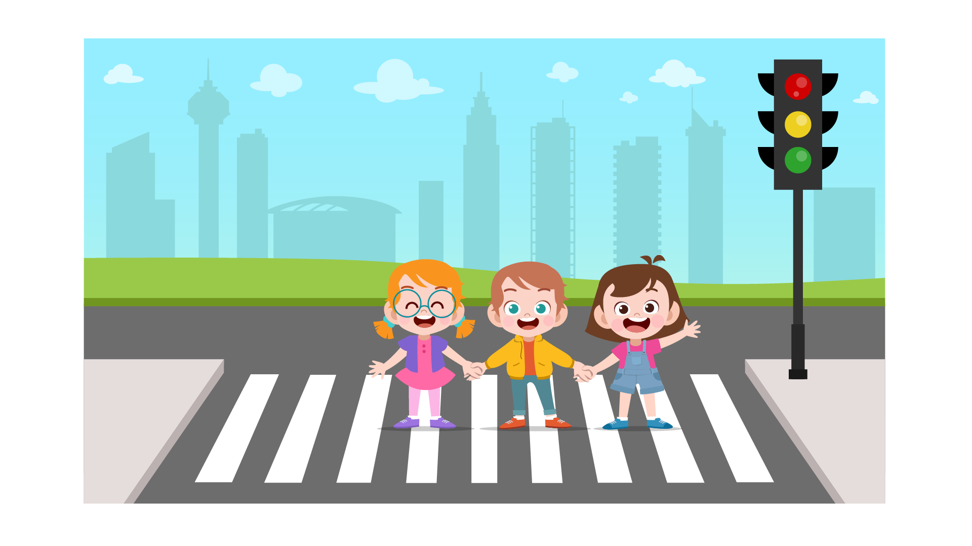
(A) They are crossing the roads. | (B) They are stopping at the bus stop. | (C) They are running at full speed.
16.
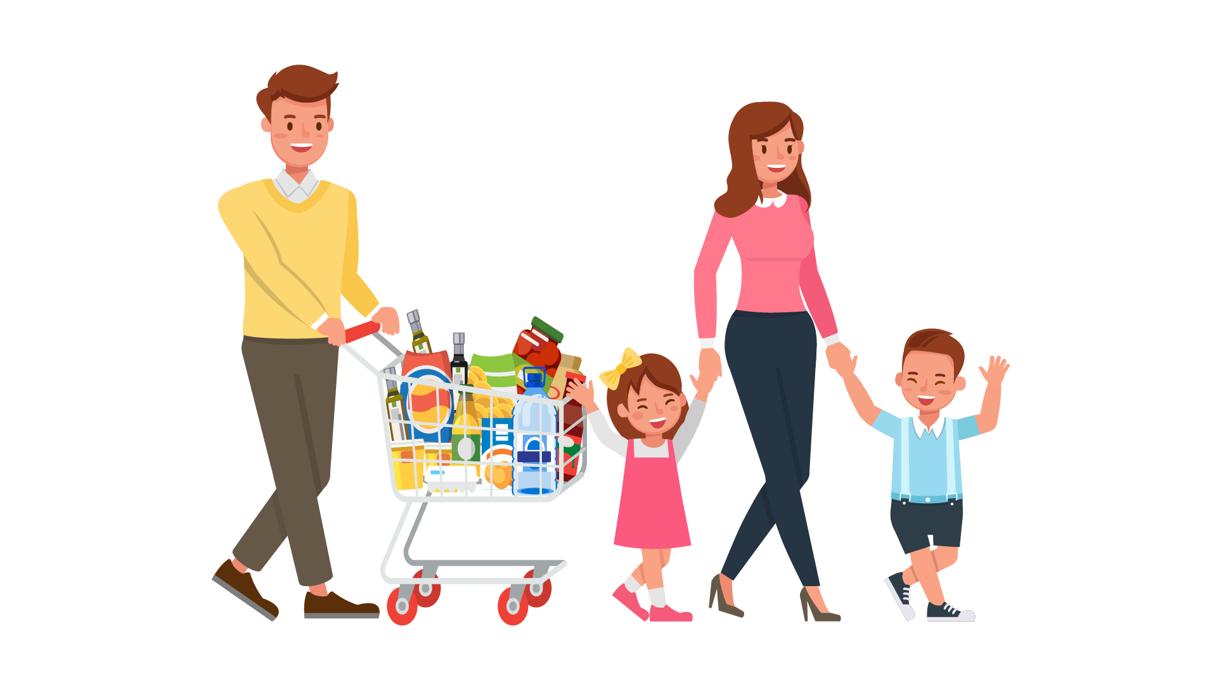
(A) The family ate cookies. | (B) The family bought fruit. | (C) The family went shopping.
17.
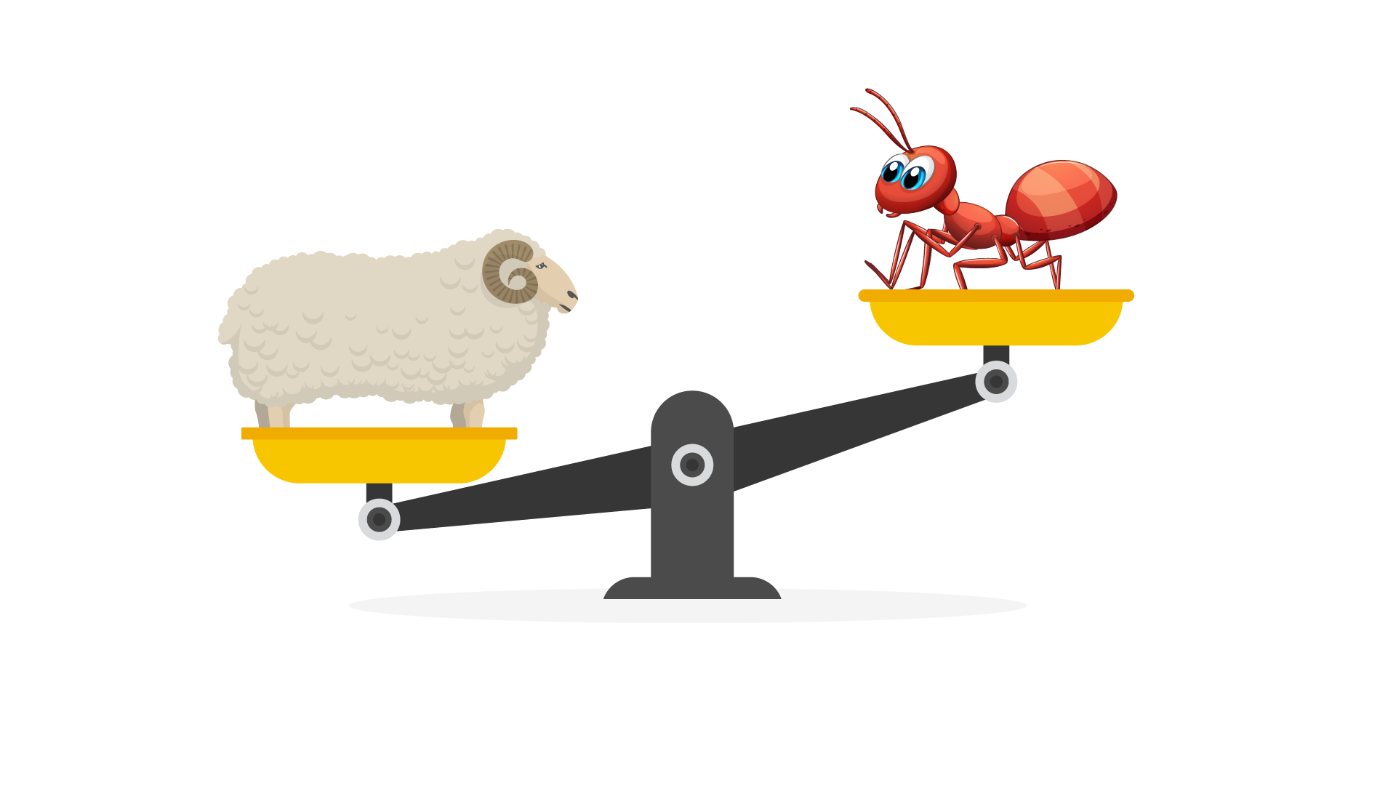
(A) The sheep is lighter than the ant. | (B) The sheep is heavier than the ant. | (C) The ant is heavier than the sheep.

PART 2
Read and find the answer.
Fill in the correct circles on your answer sheet.
Let’s do an example.
- Students go to class here. Teachers work here. It has many desks. What is it?
  - (A) A house
  - (B) A school
  - (C) A bank
The correct answer is a school. Fill in "B" on your answer sheet.

- It is very quiet. It is the place where people read books. It has many books.
Where is it?
(A) A farm
(B) A factory
(C) A library

- This is a school object. You use it to write notes. You use it without ink.
What is it?
(A) A pencil
(B) A pen
(C) A ruler

- This takes people from one place to another. You need tickets for it. It travels on the sea.
(A) A ship
(B) A plane
(C) A bus

- Your tooth hurts. You can’t eat. You can’t talk. You have _________.
(A) a fever
(B) toothache
(C) red eyes

- You do this when you want to understand the words. You want to understand what people write.
You _________ .
(A) listen
(B) read
(C) watch

- You go outside and it is bright. It is hot. It is _________.
(A) windy
(B) sunny
(C) snowy

- You have nothing to do. You are not happy. You are __________.
(A) surprised
(B) happy
(C) bored

PART 3
Read the schedule. Answer questions 26 to 29.
Fill in the correct circles on your answer sheet.
Dane, Elena, Freud and Tom go to a festival. There is a schedule on the gate.

Schedule for the Festival
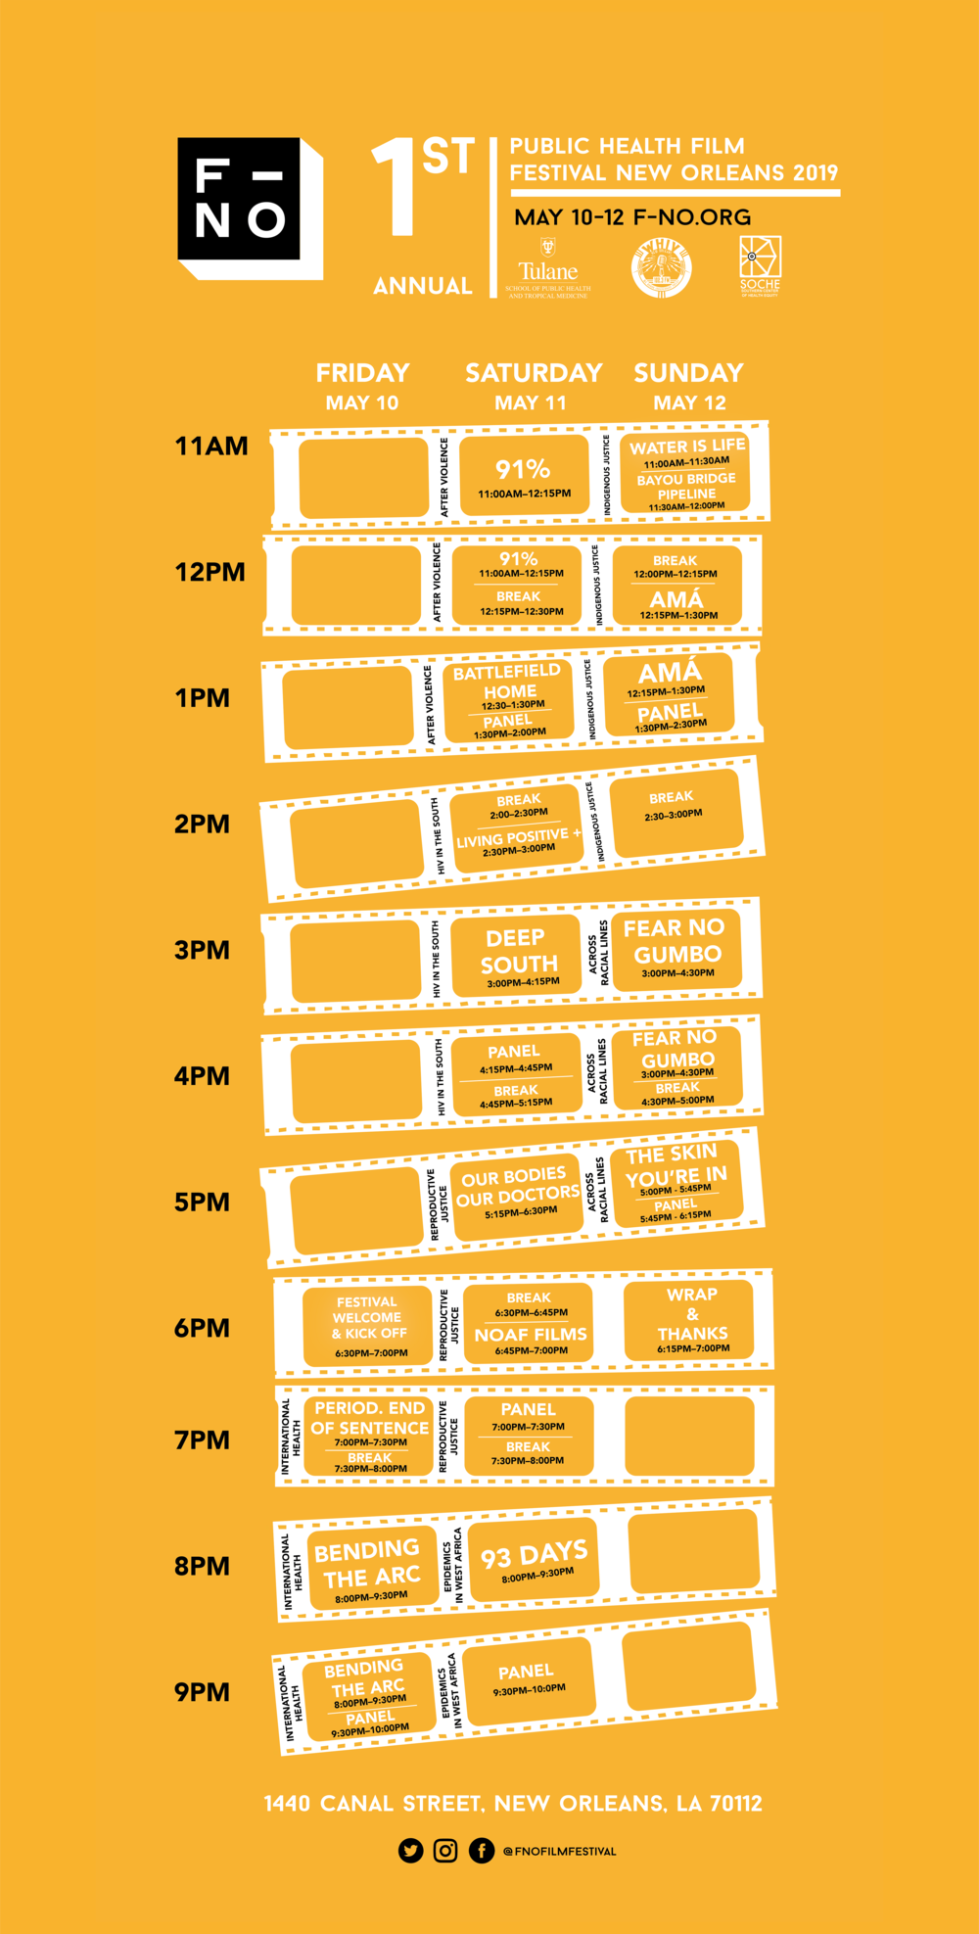
26. Dane wants to see the flowers showcase. It starts at ____________.
(A) 8 a.m
(B) 9 a.m
(C) 10 a.m

27. Elena likes dancing a lot. She can watch ____________.
(A) Costume competition
(B) Flowers Showcase
(C) Local Dance performances

28. Freud enjoys playing exciting things. He should go to ____________.
(A) Games & Mini lottery
(B) Lunch break
(C) Food around the world

29*. The lunch break lasts for ____________.
(A) one hour
(B) one and a half hour
(C) two hours
Read the housework board. Answer questions 30 to 33.
 | Monday | Tuesday | Wednesday
John | Wash the dishes | Empty the trash bin | Cook meals
Claire | Empty the trash bin | Cook meals | Wash the dishes
Jims | Cook meals | Wash the dishes | Empty the trash bin
30. Who washes the dishes on Mondays?
(A) John
(B) Claire
(C) Jims

31. How often does Claire cook meals?
(A) Every Monday
(B) Every Tuesday
(C) Every Wednesday

32.What does Jims do on Wednesday?
(A) Wash the dishes
(B) Empty the trash bin
(C) Cook meals
33.Which housework is NOT on the board?
(A) Empty the trash bin
(B) Cook meals
(C) Clean the living room
Read the letter. Answer questions 34 to 35.

Dear Mrs. Oakland,

This is Tom. I am writing this to ask about your health. I heard that you were sick and tired lately. I hope that you will get better soon. We all miss your Art lessons. No teacher is as funny and kind as you.

Lately, our class is preparing a school project about the environment. We try our best to make the project interesting, so we build a model of a flying car. We are waiting for your return soon. Looking forward to your reply.

Sincerely,
Tom

34. Why does Tom write to Mrs Oakland?
(A) To ask about her health
(B) To talk about his class
(C) To tell her about the new teacher
35. What does Tom hope for Mrs Oakland?
(A) She will prepare a project.
(B) She will try her best.
(C) She will get better.

Read the email. Answer questions 36 to 37.
To: Anna
From: Jane
Subject: My new pond

Dear Anna. This is Jane. This email is to tell you about my family’s new pond. My father built a small pond in the garden. It’s beautiful with colorful fish and underwater decoration. We can watch the fish from the shore. It looks really beautiful under the sunlight. I will show you when you visit my house.

Your best friend,
Jane
36. Why does Jane write to Anna?
(A) To tell her about the new pond
(B) To invite her to stay over
(C) To ask her to go swimming together

37. What is probably true about Anna?
(A) She is Jane’s cousin.
(B) She is Jane’s sister.
(C) She is Jane’s best friend.

Read the information about the class rules. Answer questions 38 to 39.

5A - CLASS RULES
1. Turn off all the lights and fans when you don’t use them.
2. No littering in the classroom.
3. Put your shoes outside before going in the classroom.
4. Keep your belongings in your own place.
5. No chatting during the lessons.

38. What do students do to their shoes?
(A) Put their shoes outside the classroom
(B) Put their shoes in their place
(C) Put their shoes inside the classroom
39. What is in the class rules?
(A) Leaving the lights and fans on
(B) Chatting a lot in class
(C) No littering in class

You finished the reading test.
LISTENING
PART 1
Listen to the words. Look at the pictures.
Fill in the correct circles on your answer sheet.
1.
 | 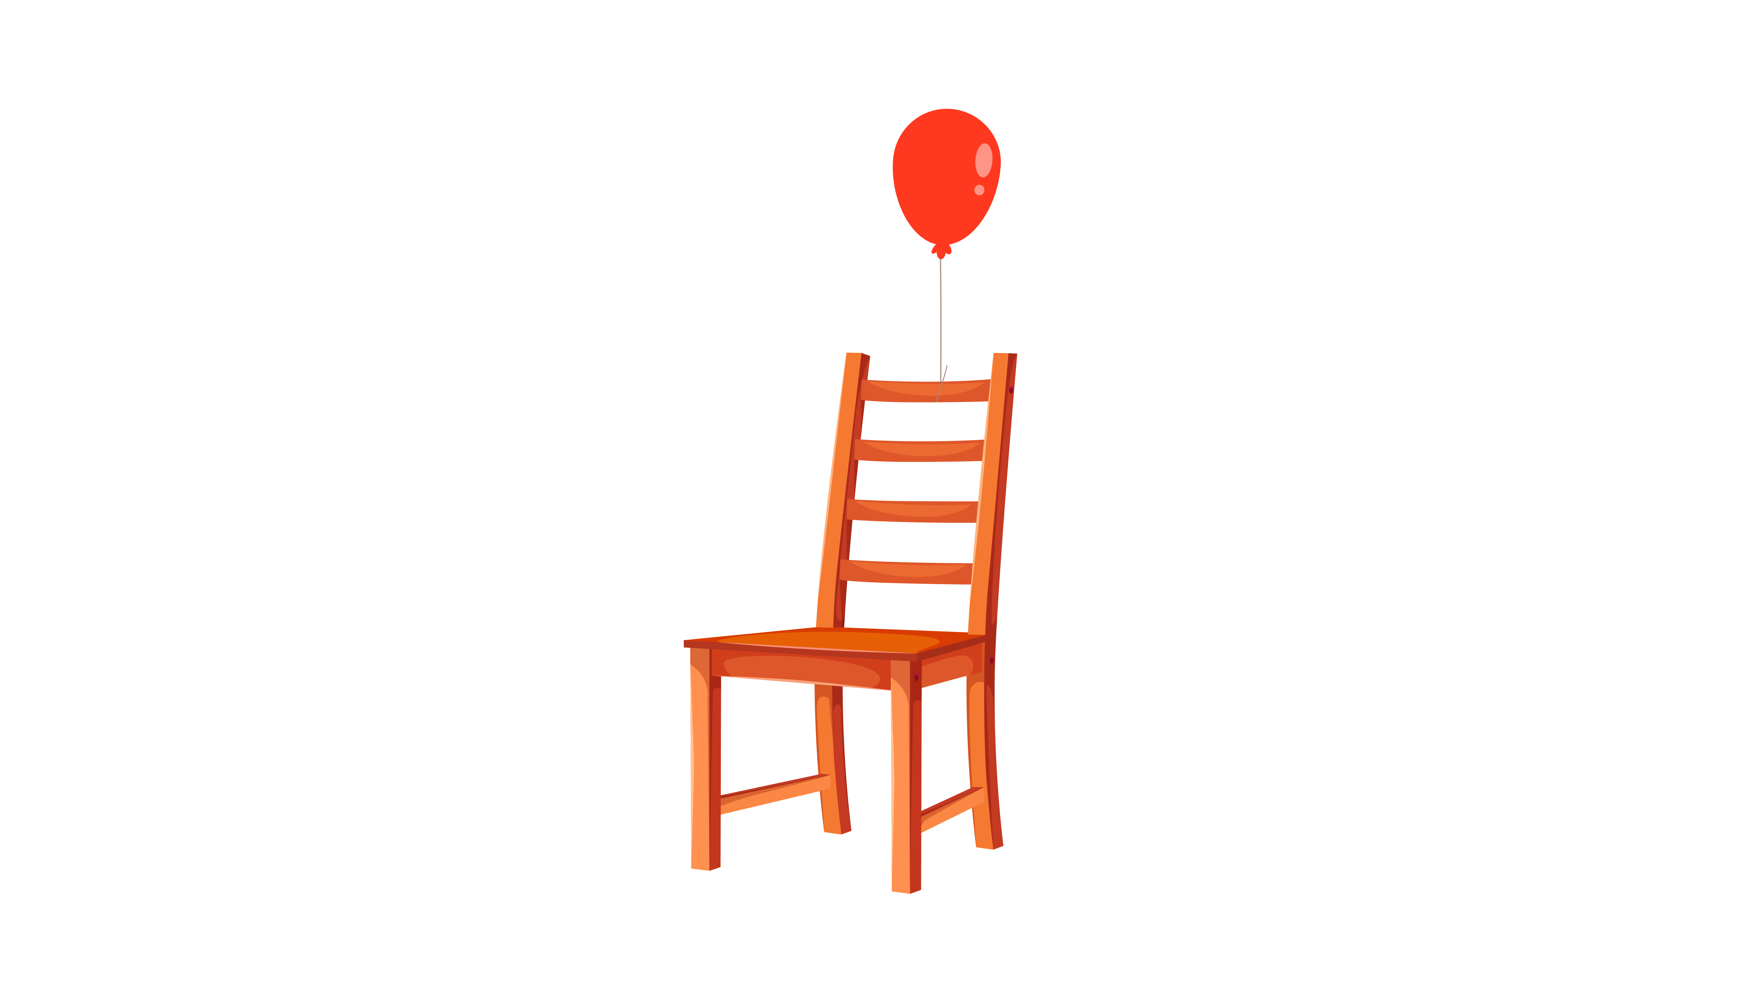 | 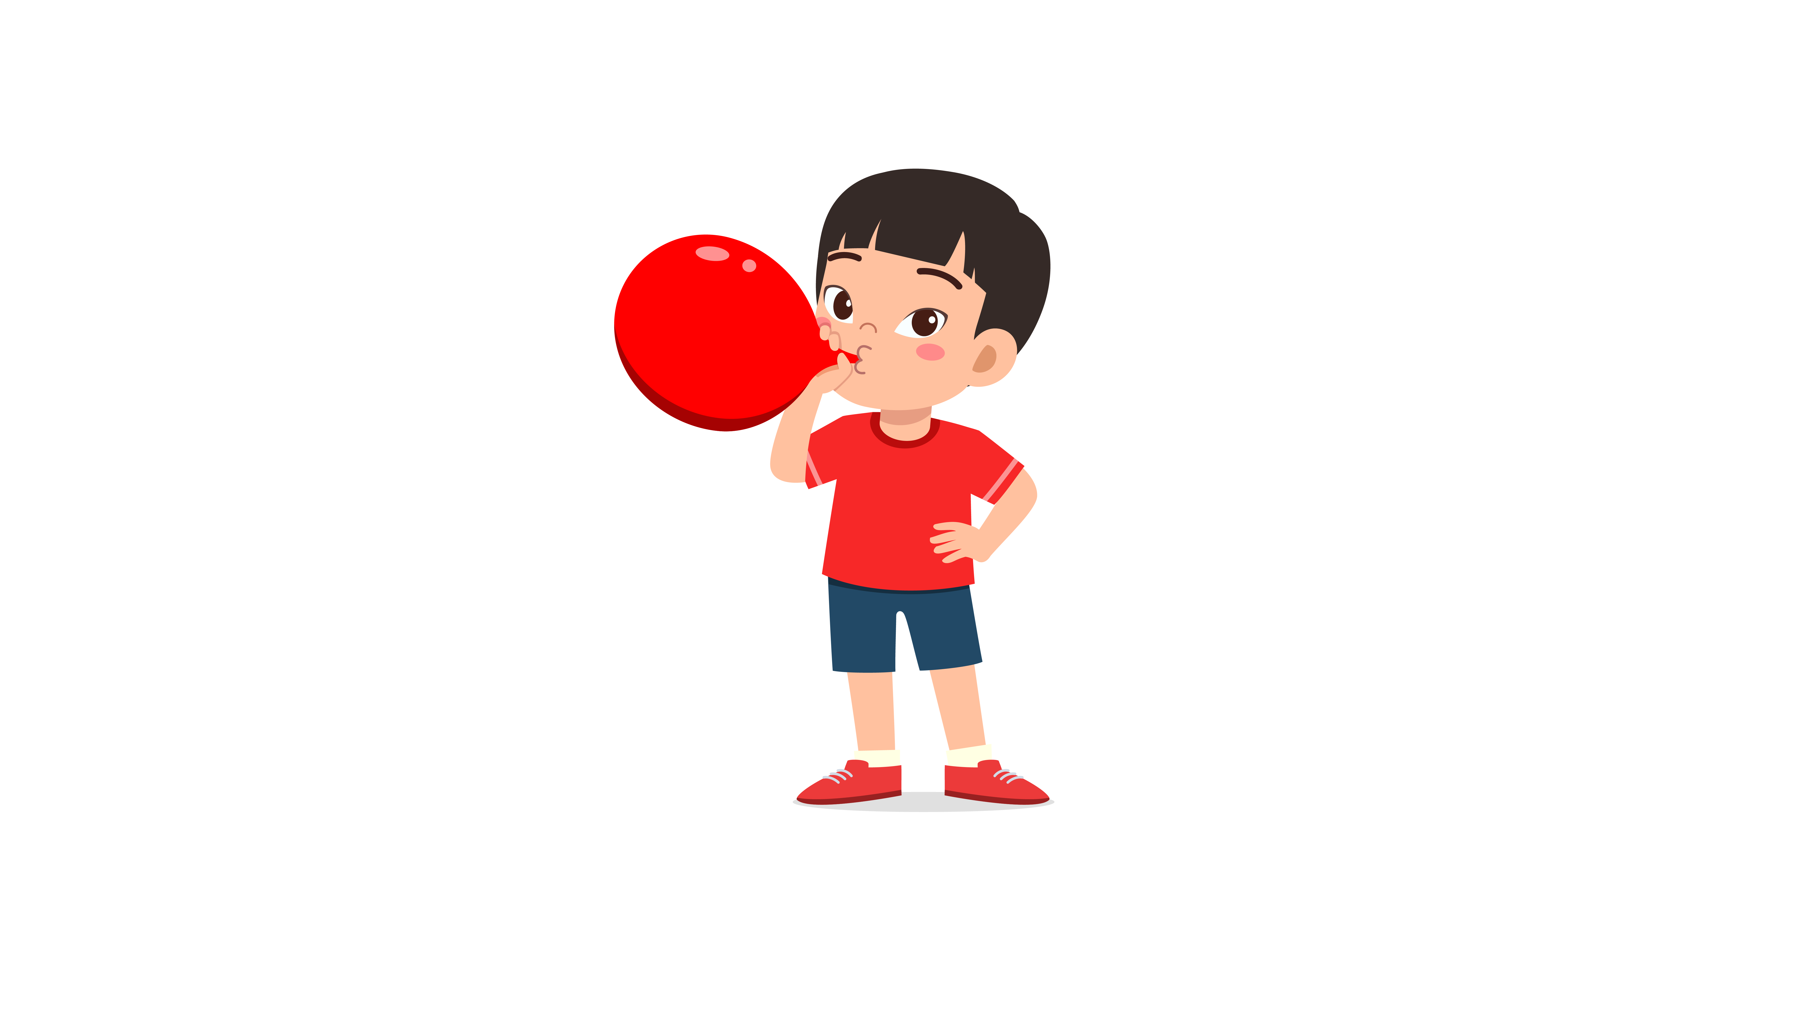
(A) | (B) | (C)
2.
 |  | 
(A) | (B) | (C)
3.
 | 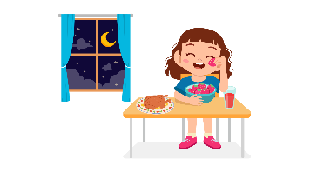 | 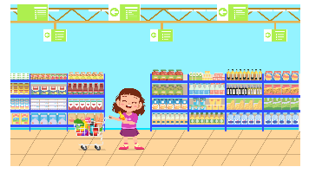
(A) | (B) | (C)
4.
 | 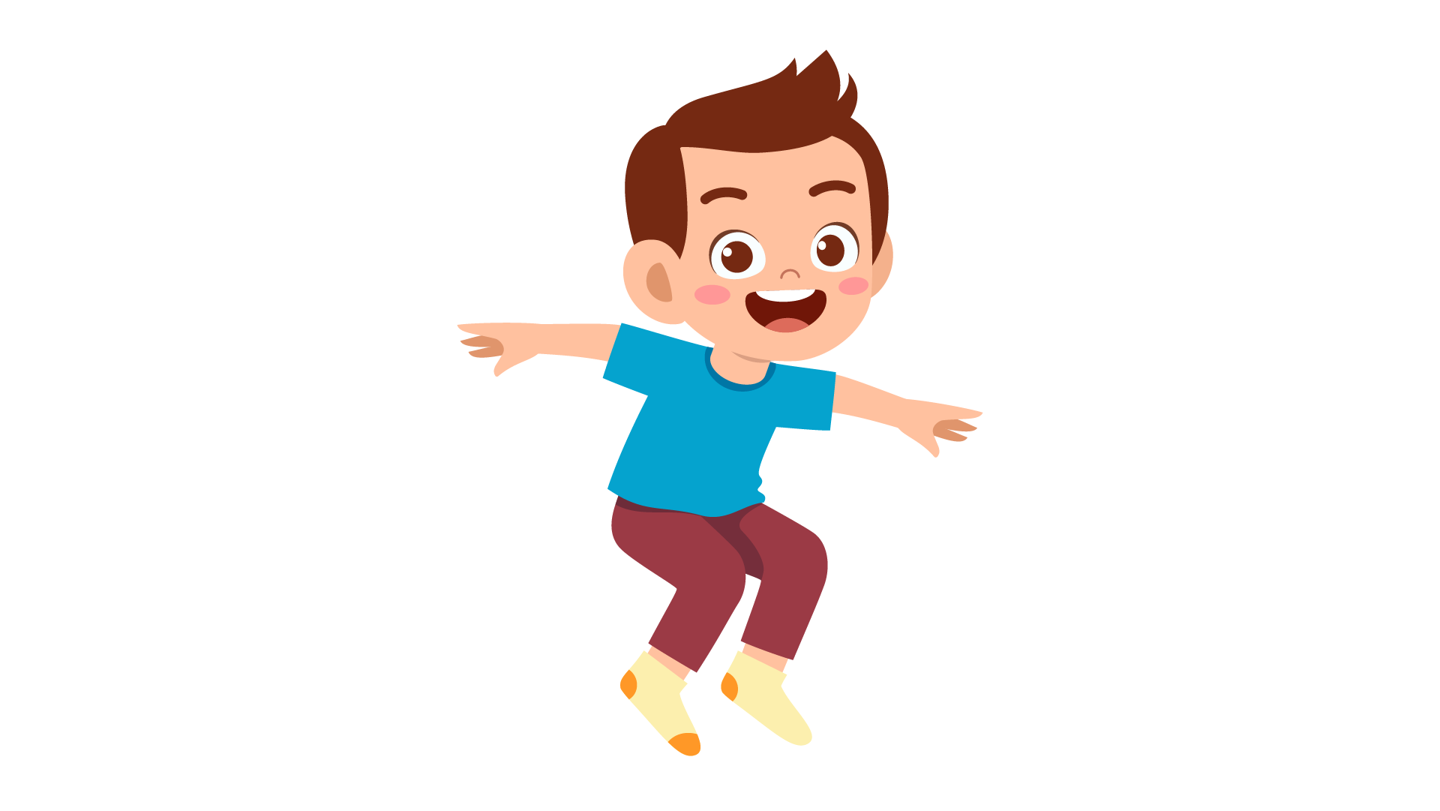 | 
(A) | (B) | (C)
5.
 | 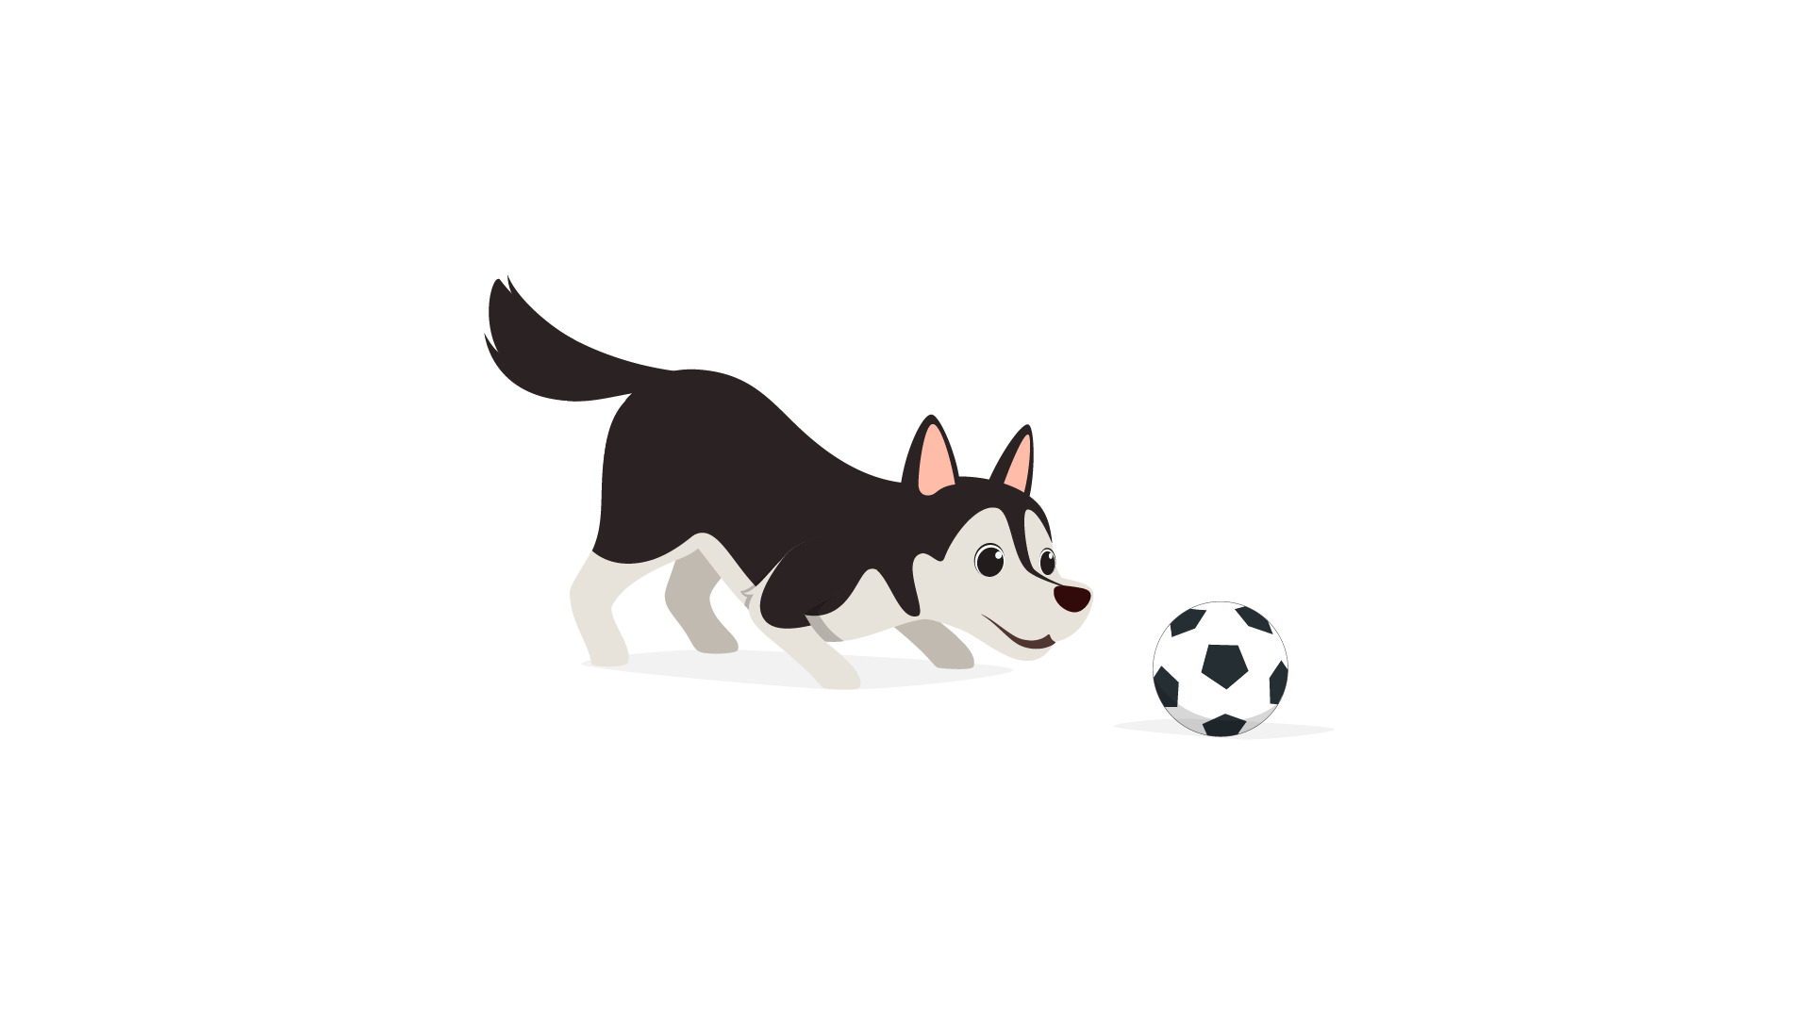 | 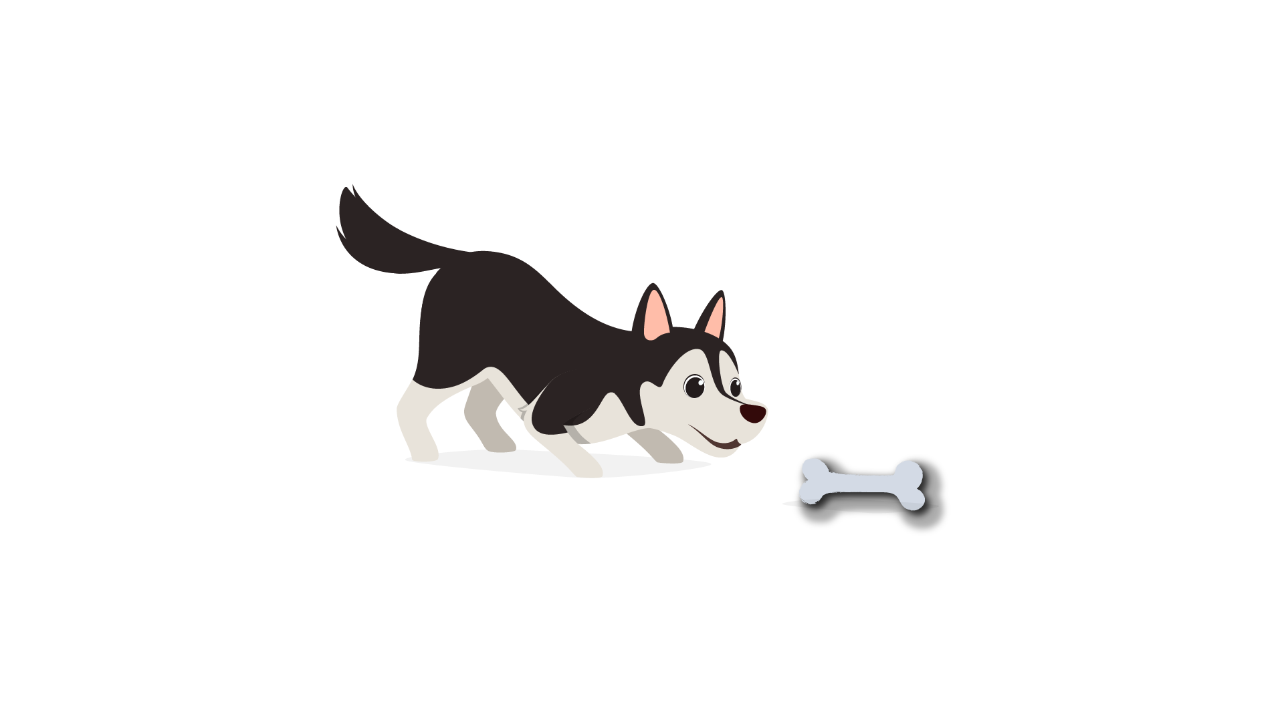
(A) | (B) | (C)
6.
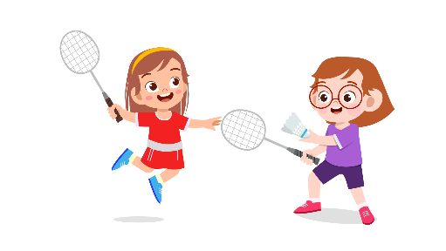 | 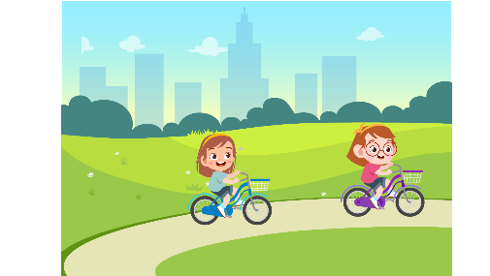 | 
(A) | (B) | (C)
7.
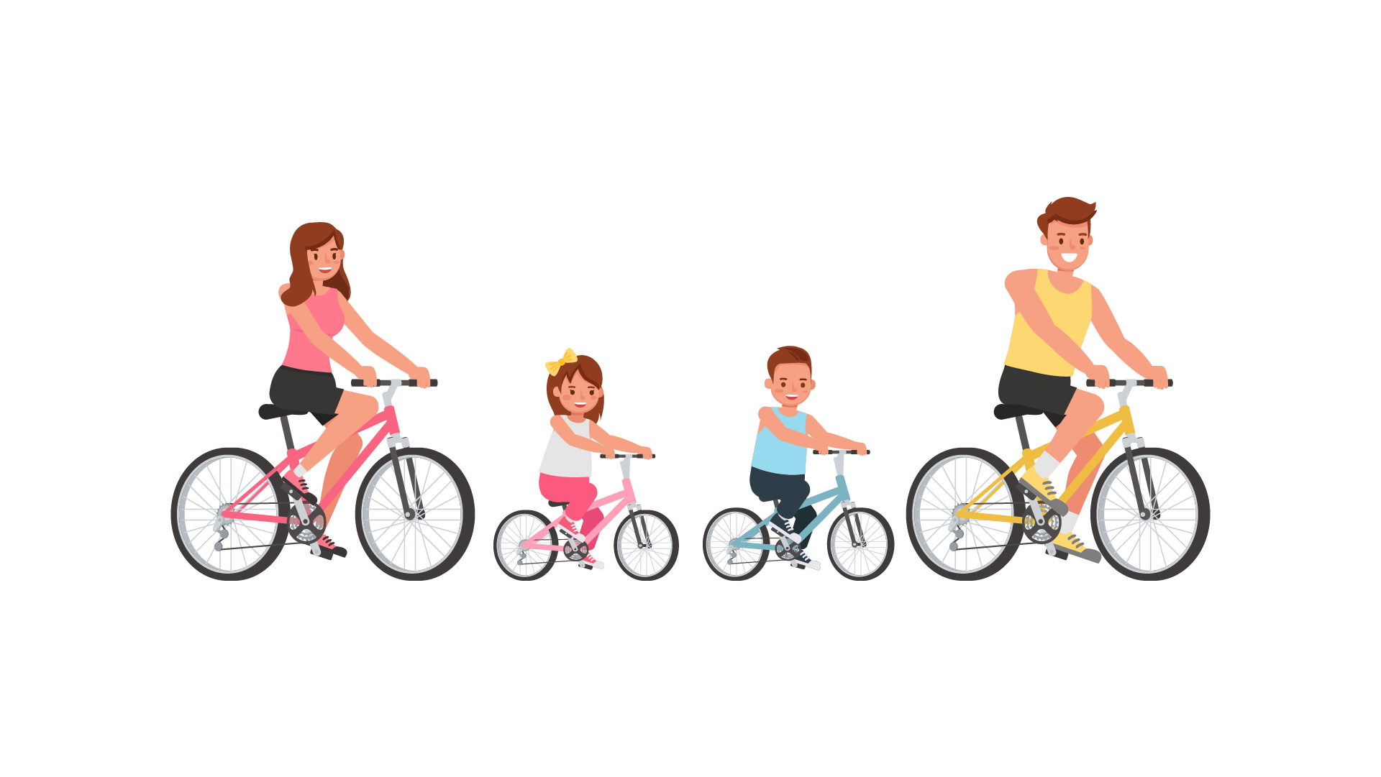 |  | 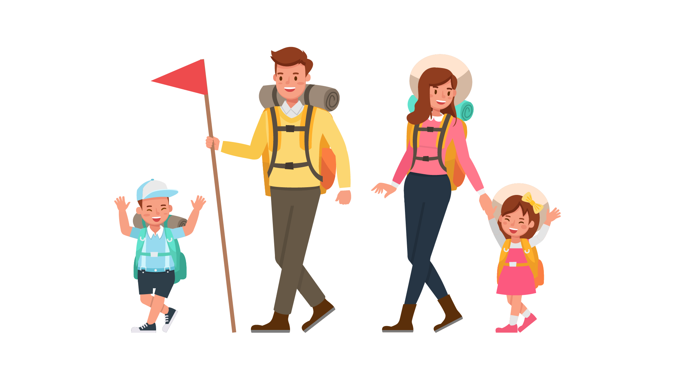
(A) | (B) | (C)
8.
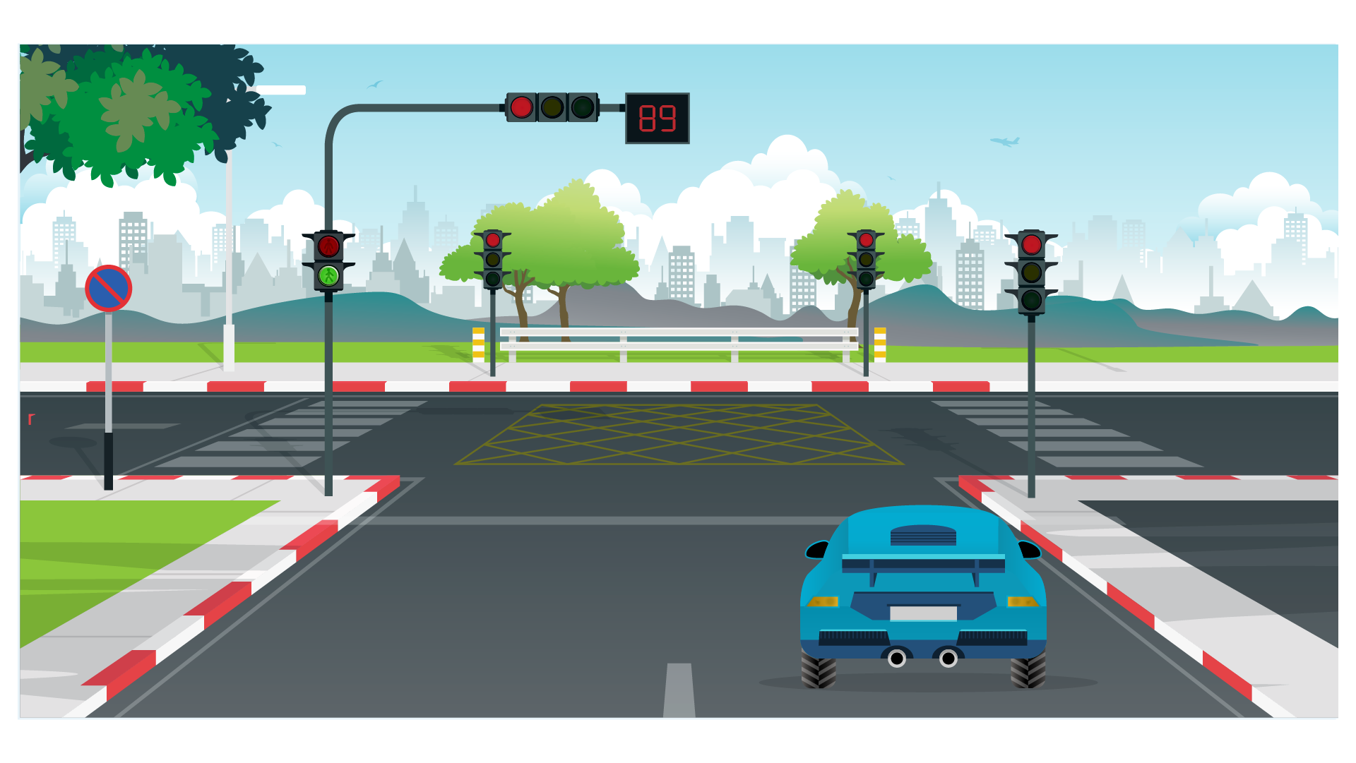 | 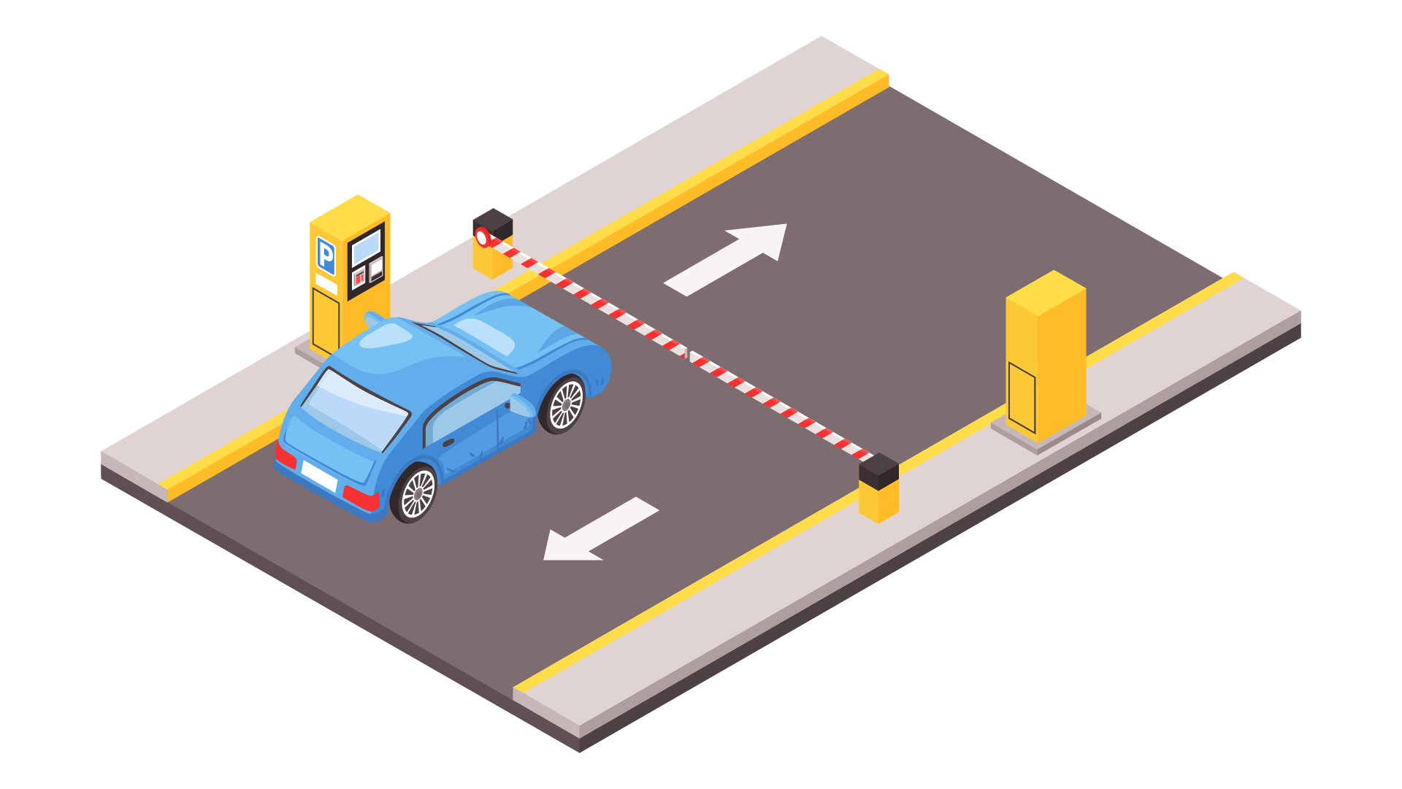 | 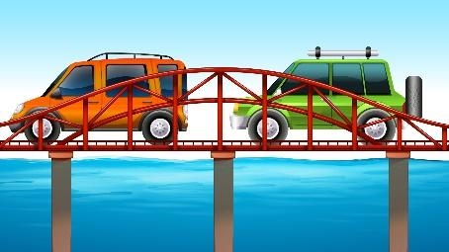
(A) | (B) | (C)

PART 2
Fill in the correct circles on your answer sheet.
9.
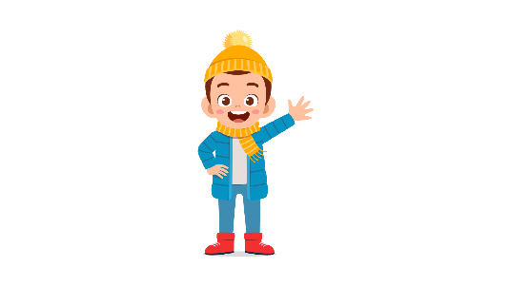 | 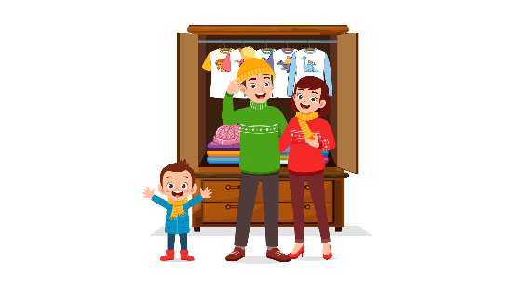 | 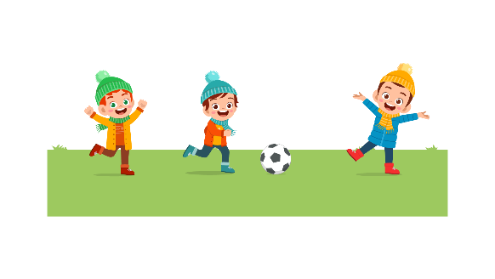
(A) | (B) | (C)
10.
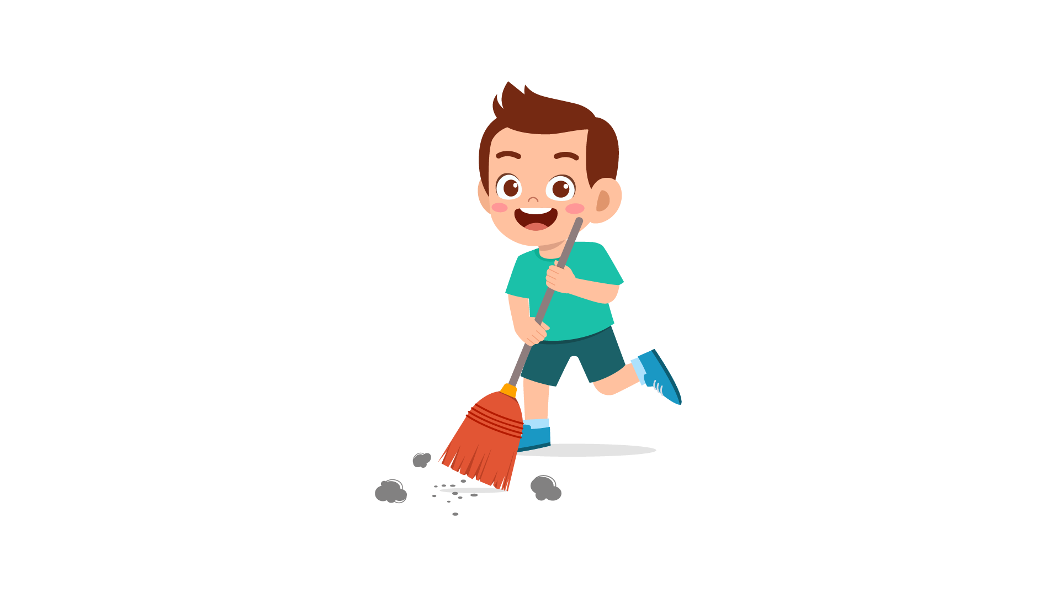 | 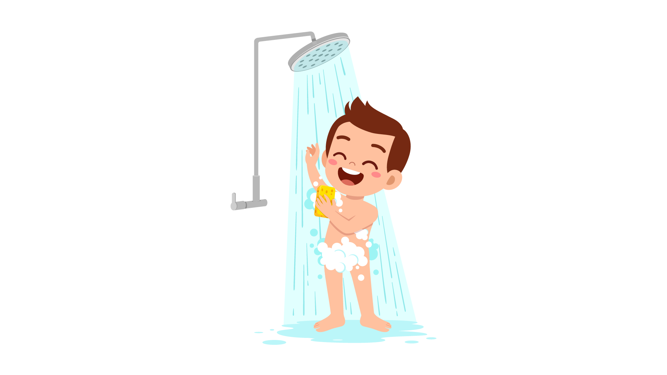 | 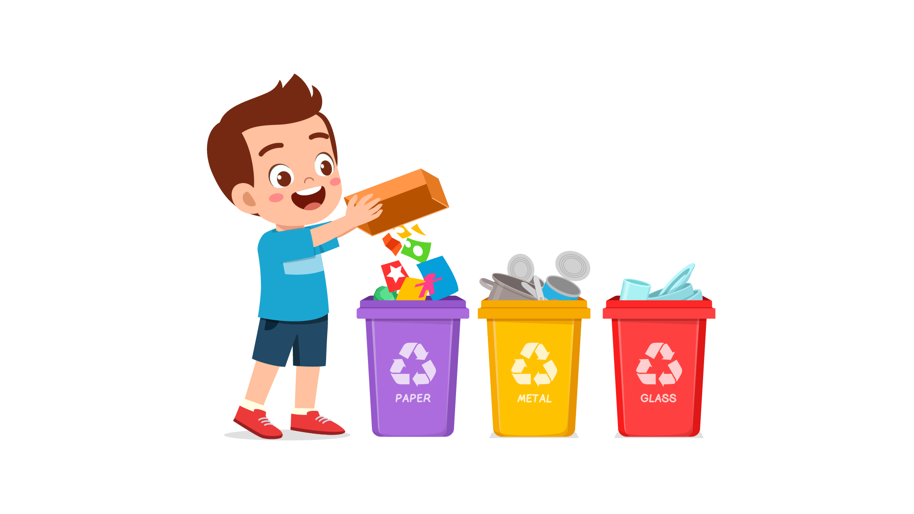
(A) | (B) | (C)
11.
 | 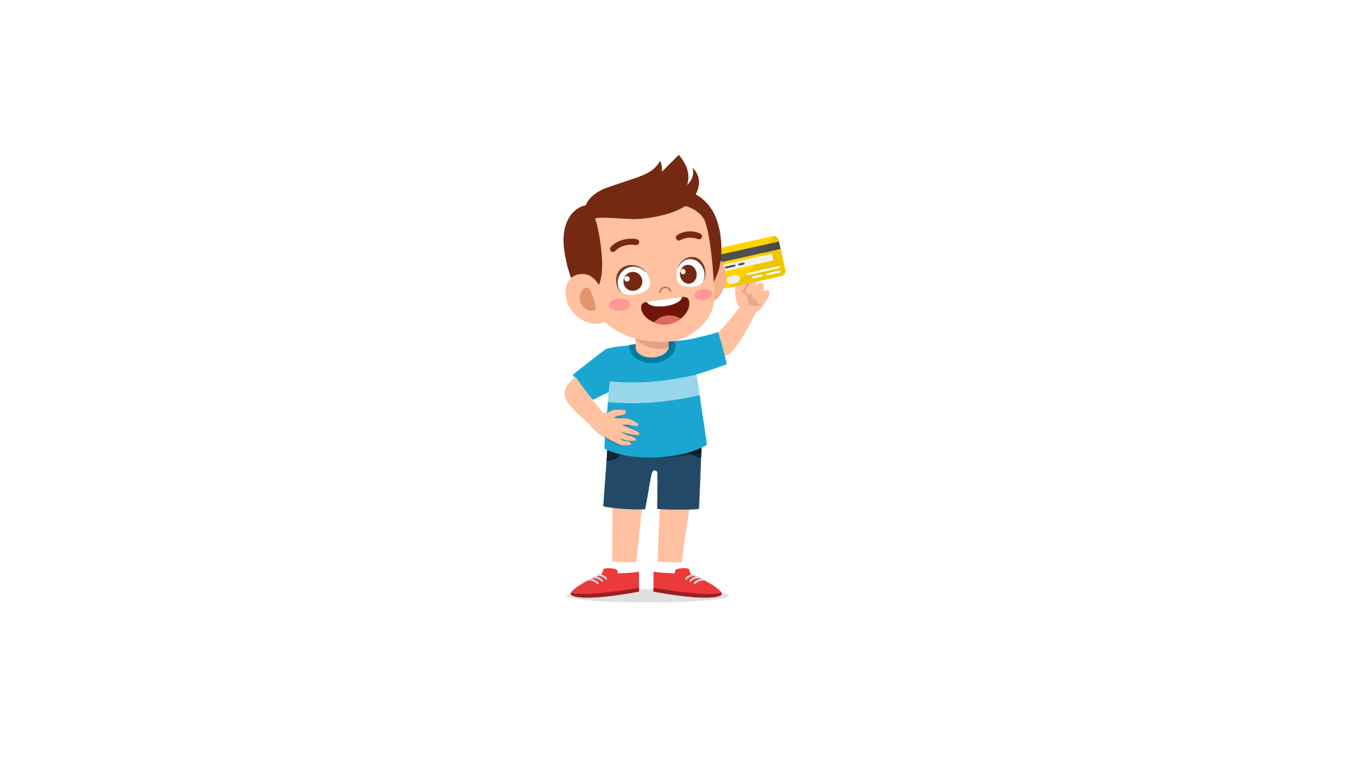 | 
(A) | (B) | (C)
12.
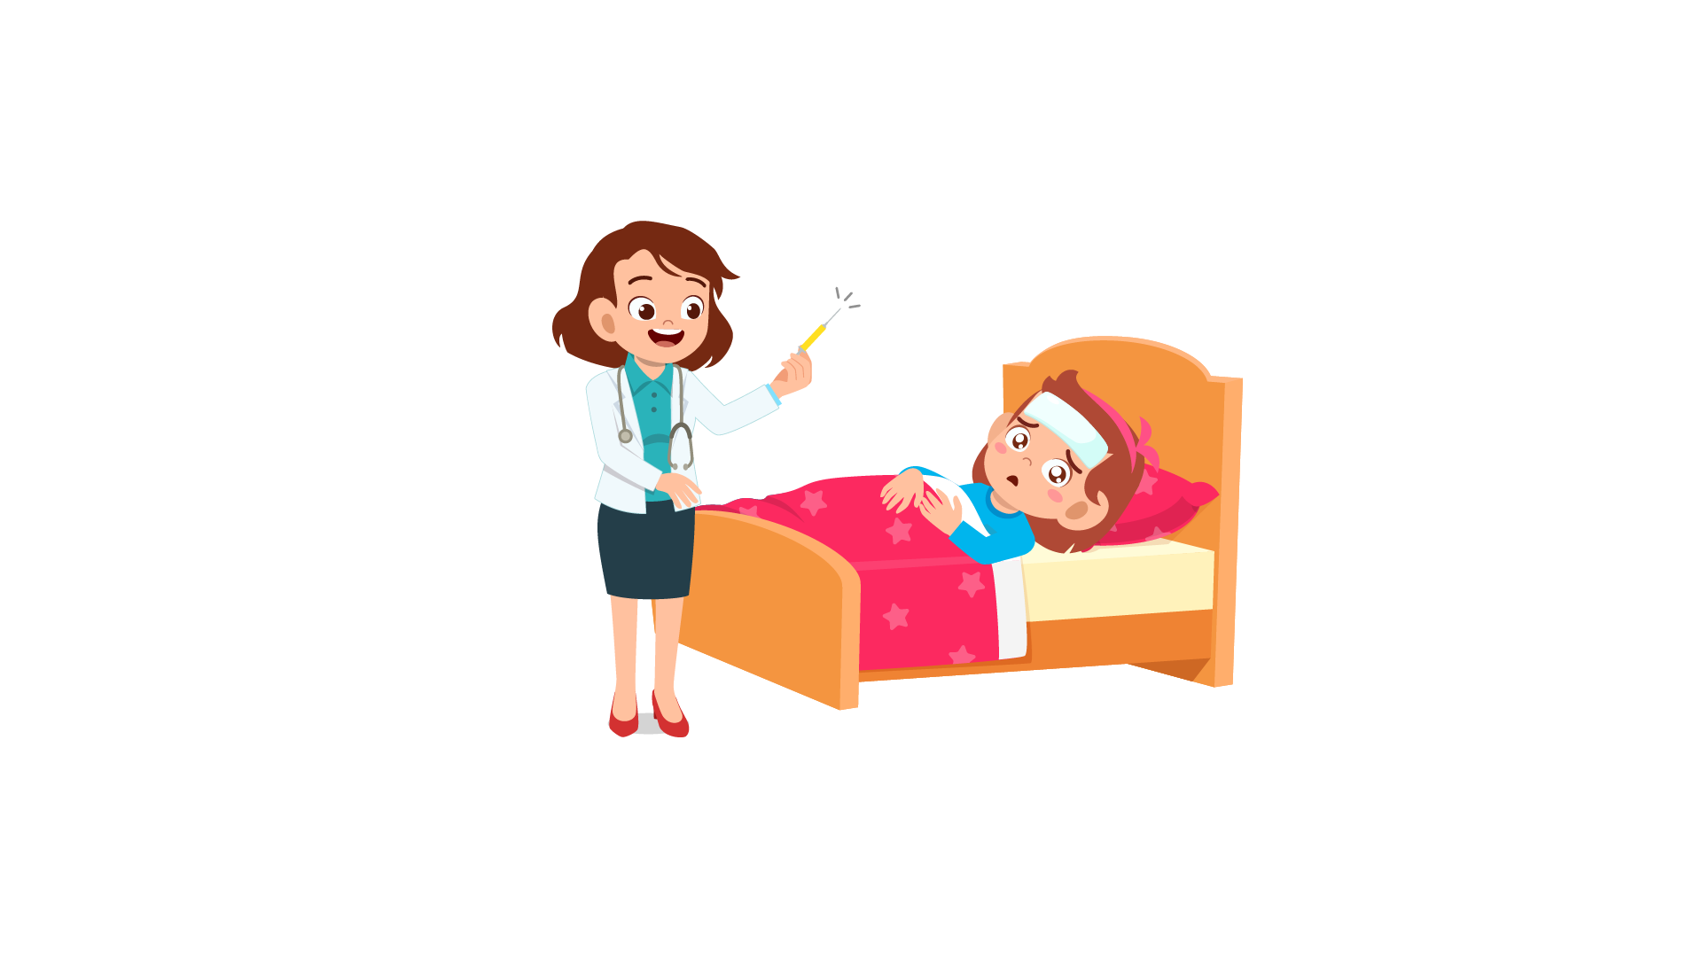 | 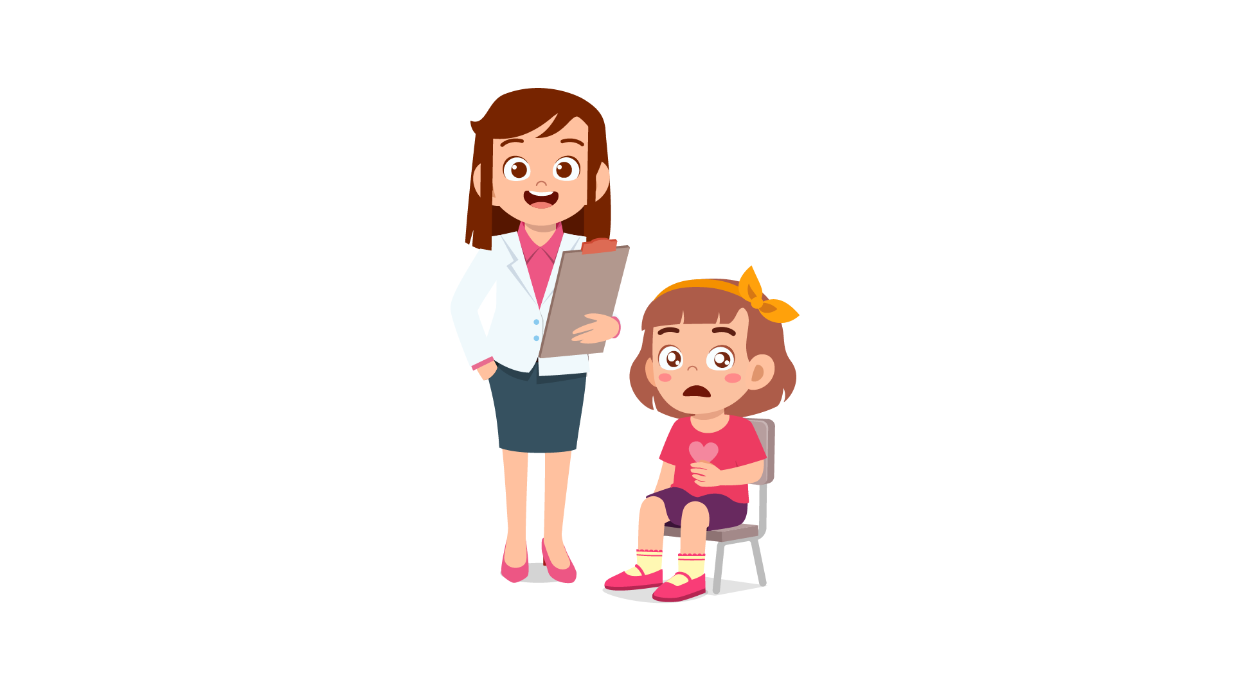 | 
(A) | (B) | (C)
13.
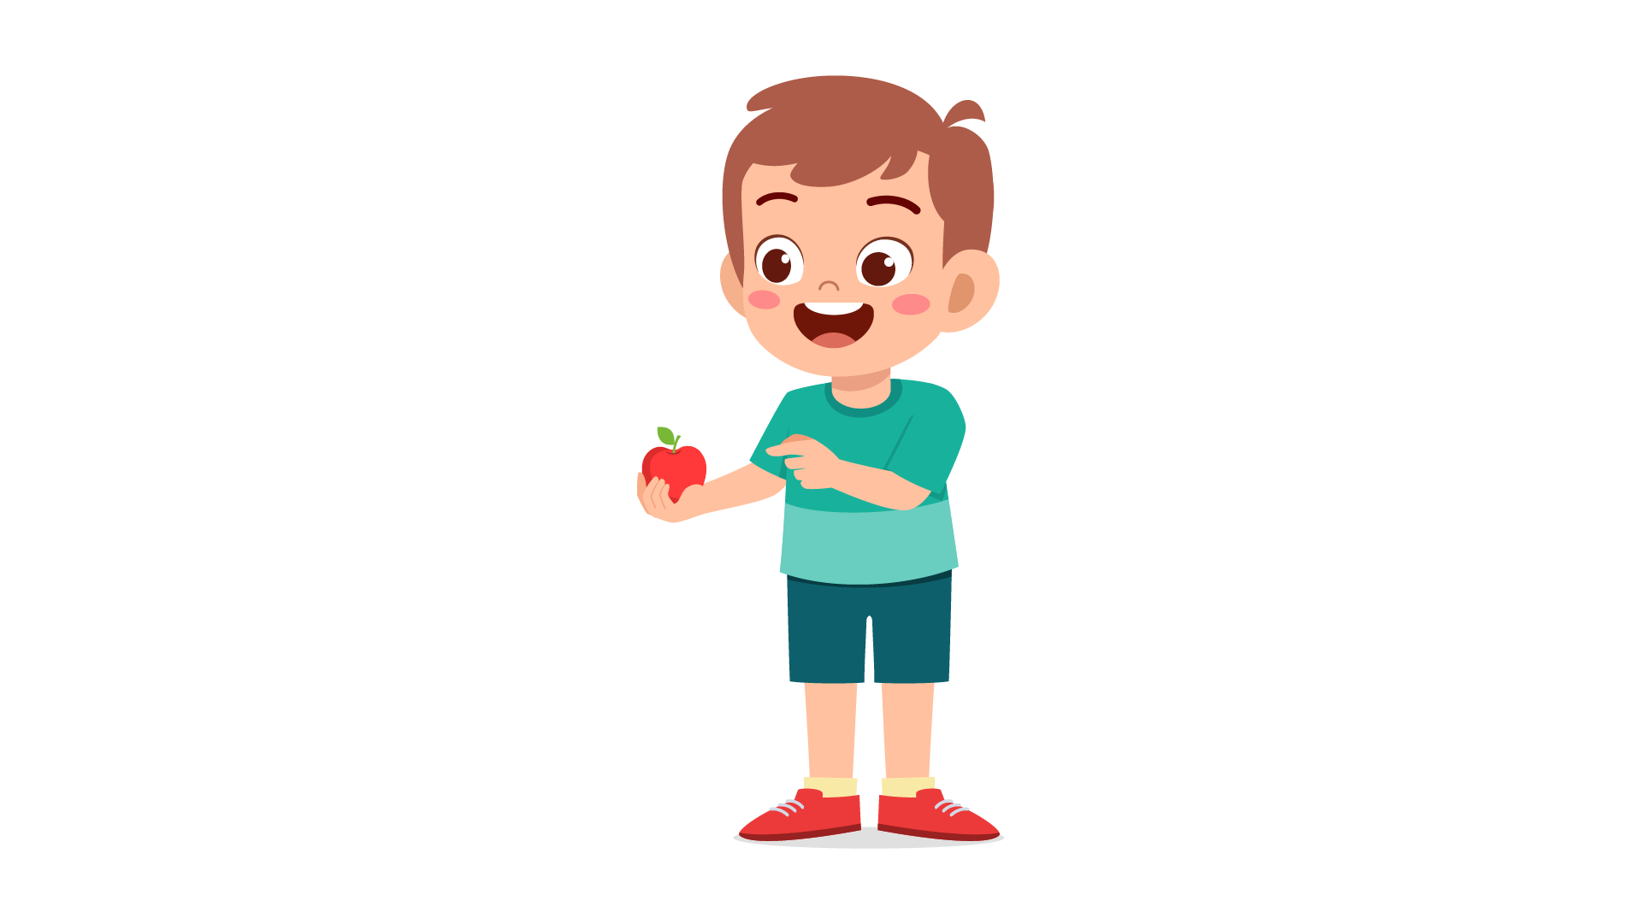 | 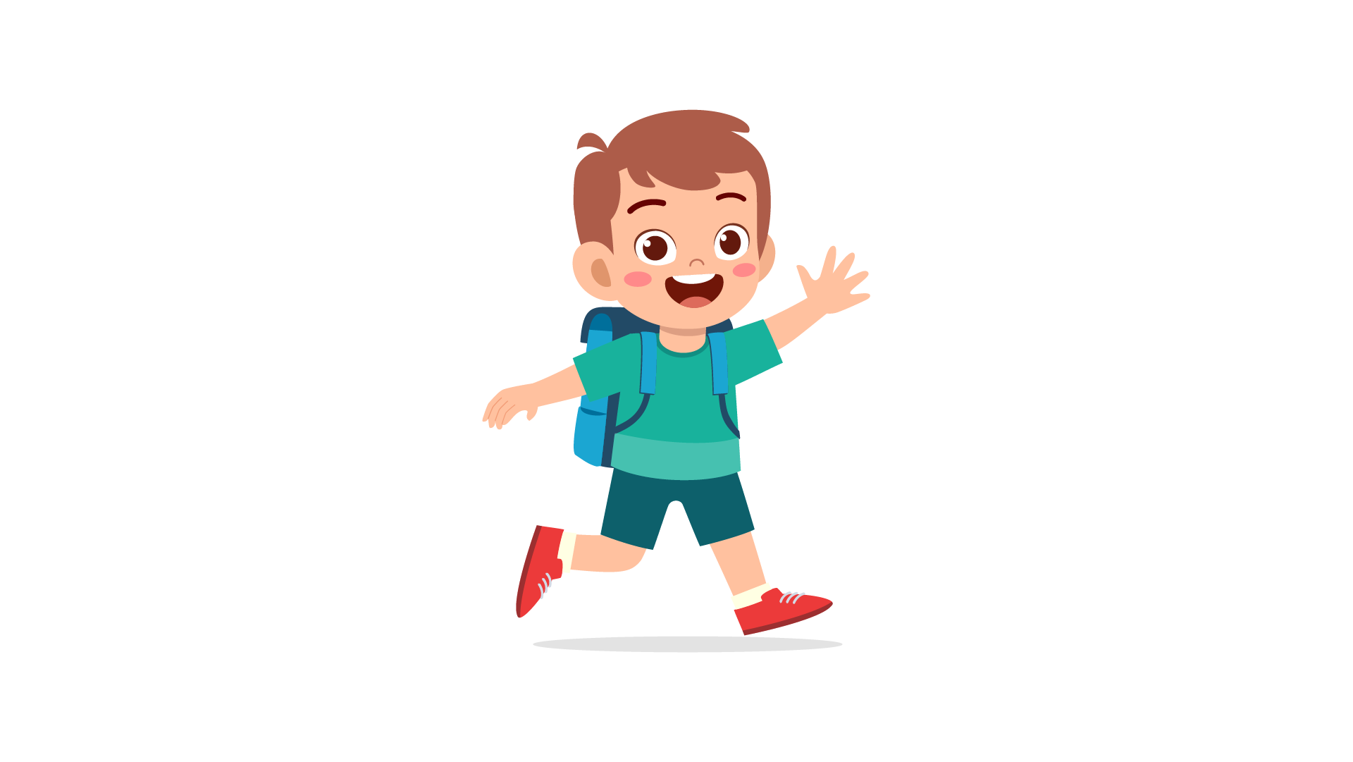 | 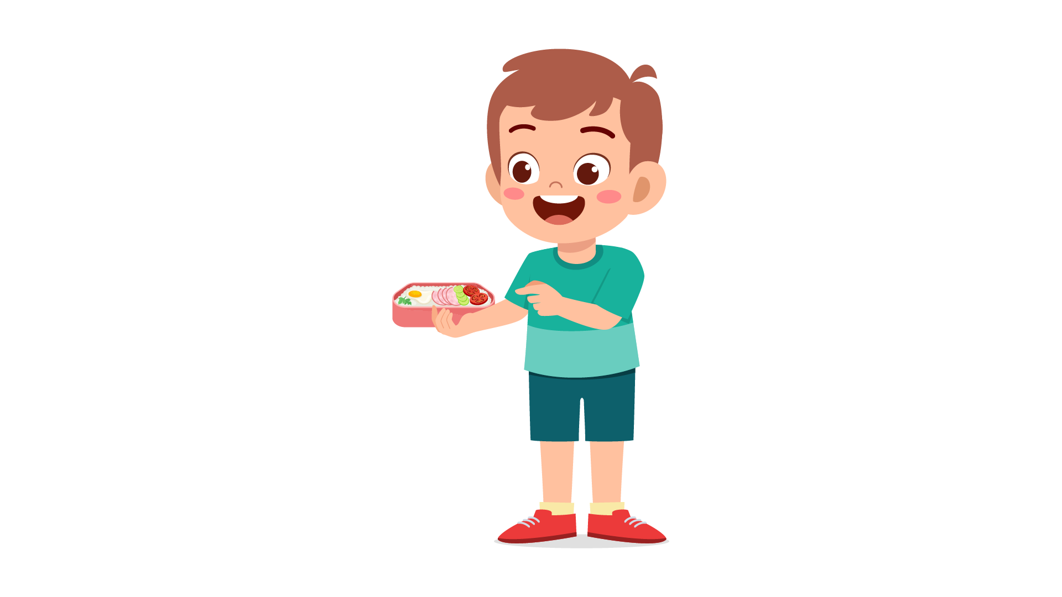
(A) | (B) | (C)
14.
 | 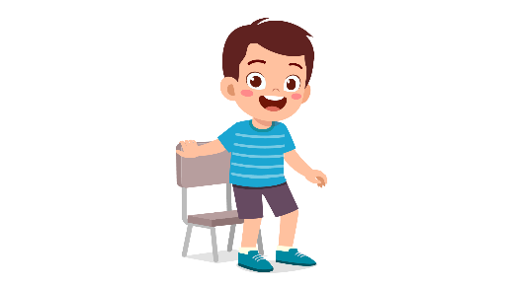 | 
(A) | (B) | (C)
15.
 |  | 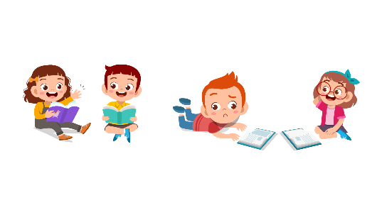
(A) | (B) | (C)
16.
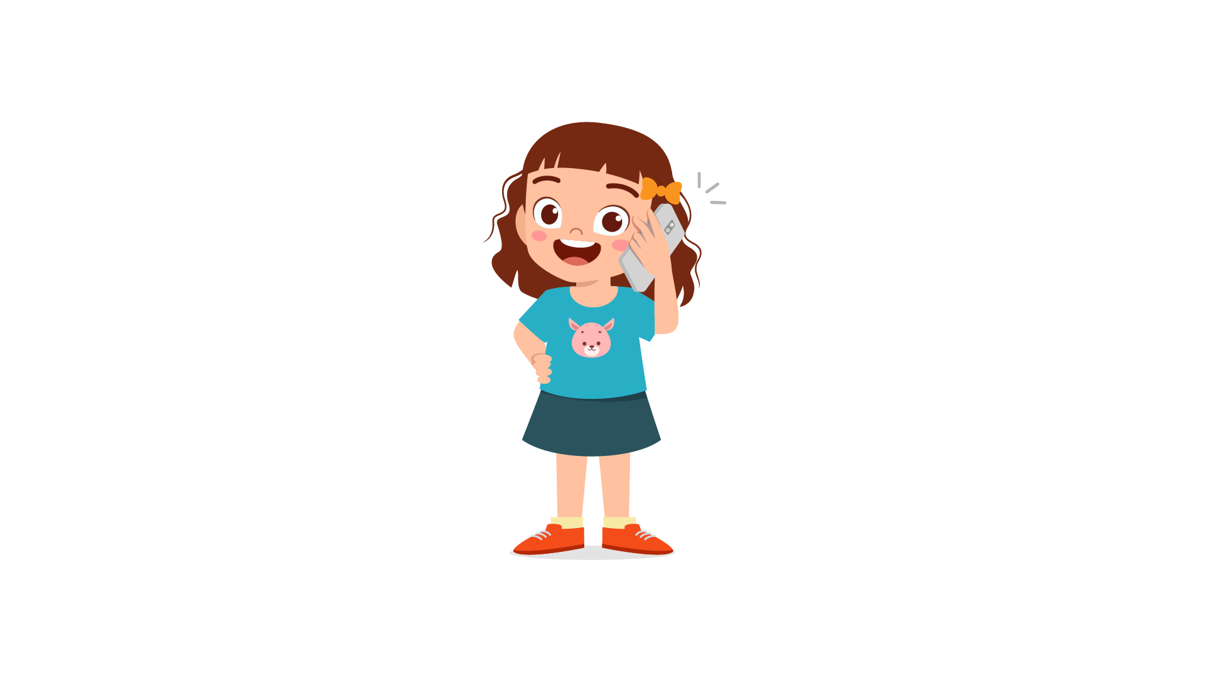 | 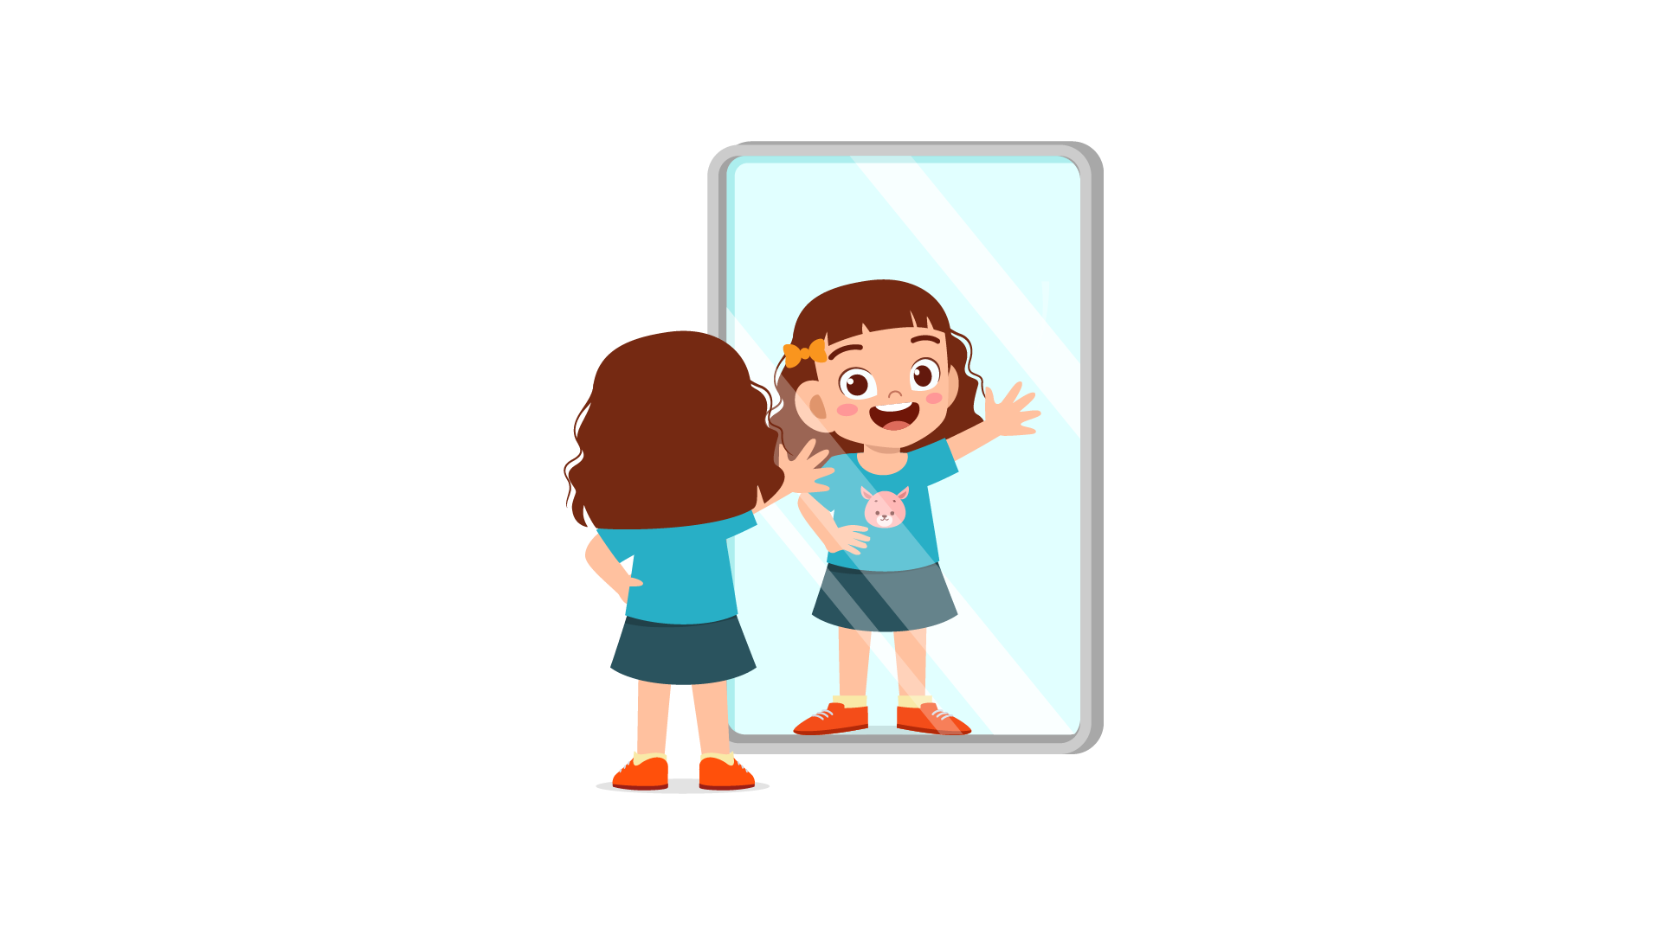 | 
(A) | (B) | (C)
17.
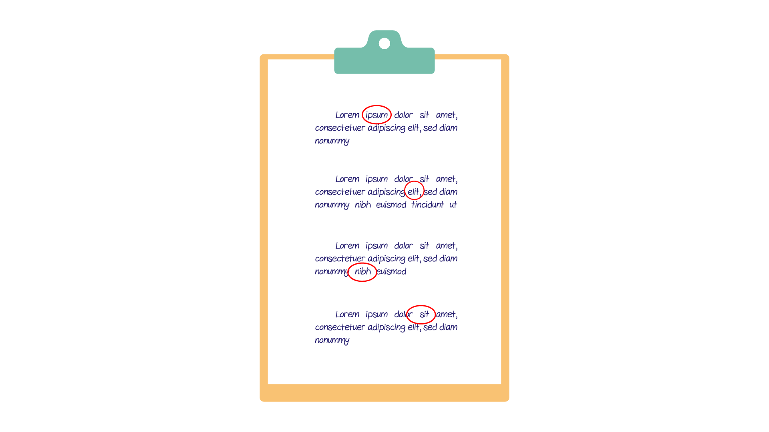 | 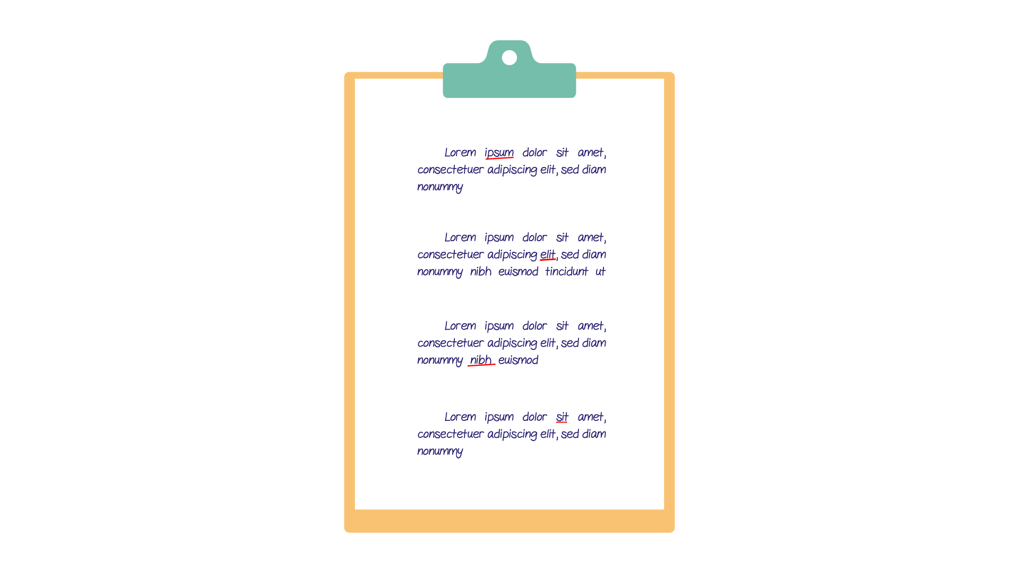 | 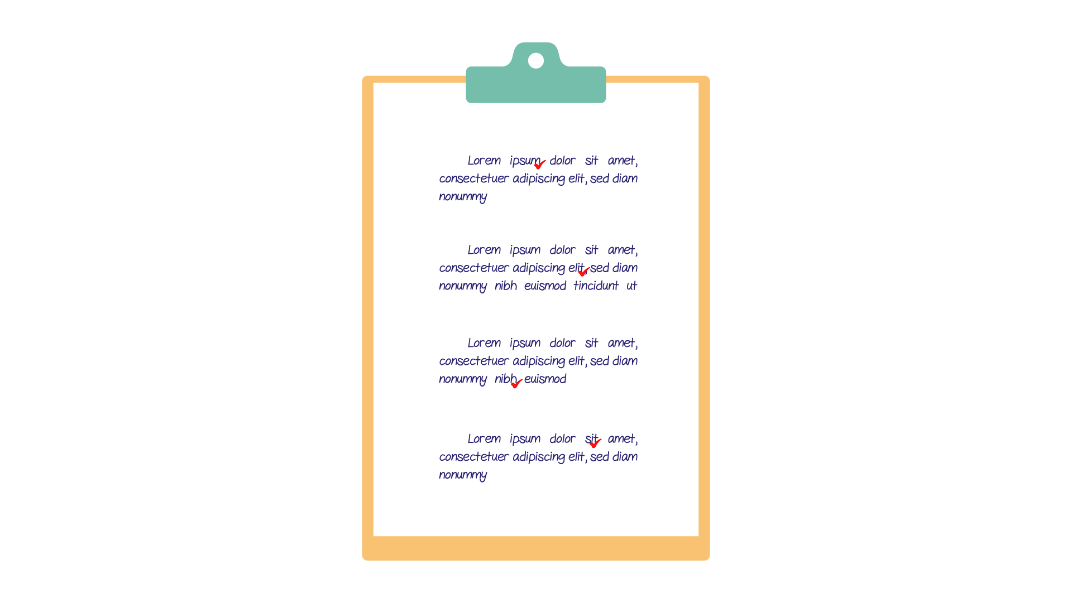
(A) | (B) | (C)
PART 3
Fill in the correct circles on your answer sheet.
Look at your answer sheet. Listen to a conversation. Which conversation sounds correct?
Let’s do an example.
(Narrator): A
(Boy): Hello. What’s your name?
(Girl): I’m fine, thanks.
(Narrator): B
(Boy): How are you today?
(Girl): I’m six years old.
(Narrator): C
(Boy): Nice to meet you!
(Girl): Nice to meet you, too!
The answer is "C." Fill in "C" on your answer sheet. Now, you do it.
18.
(A) | (B) | (C)
19.
(A) | (B) | (C)
20.
(A) | (B) | (C)
21.
(A) | (B) | (C)
22.
(A) | (B) | (C)
23.
(A) | (B) | (C)
24.
(A) | (B) | (C)
25.
(A) | (B) | (C)
26.
(A) | (B) | (C)
27.
(A) | (B) | (C)

PART 4
Listen to a conversation and answer the question. Fill in the correct circle on your answer sheet.
Let’s do an example.
28. When is the girl's party?
(A) Tonight
(B) Next week
(C) This weekend
The answer is "C." Fill in "C" on your answer sheet. Now, you do it.
29. What does the girl do in her free time?
(A) Chat with her friends online
(B) Draw paintings
(C) Play with friends outside
30. What do they want to buy?
(A) Some pens
(B) Some papers
(C) Some color papers
31*. How do they go to school?
(A) By car
(B) By bus
(C) By taxi
32*. Who is Jim talking to?
(A) A teacher
(B) A cousin
(C) A classmate
33. What is the girl trying to do?
(A) ask for a pair of shoes
(B) stay at home
(C) think of the answers
34*. What are the friends planning to do?
(A) finish homework
(B) play tennis
(C) go to the cinema

PART 5
Listen and answer the question.
Fill in the correct circle on your answer sheet.
Let’s do an example.
- What did Mike call about?
(A) Homework
(B) A movie
(C) A library book
The answer is "B." Fill in "B" on your answer sheet. Now, you do it.

36. Why did Madeline call?
(A) To ask about the English classes
(B) To tell him she can’t join the meeting
(C) To remind him about the club meeting
37. Why did Helena call?
(A) To invite her friend to the music concert
(B) To sing a song for her friend
(C) To buy tickets for the music concert
38. Why did the neighbor call?
(A) To inform about the mail
(B) To ask for the name
(C) To invite their neighbor over
39. Why did the teacher call?
(A) To tell Lan’s father about the new teacher
(B) To speak with Lan’s father
(C) To ask Lan’s father about her grades
40*. Why did the shop assistant call?
(A) To tell the customer about the grand opening
(B) To sell desserts online to the customer
(C) To give information about the baking process
41*. Why did Tim’s father call?
(A) To thank Jim for his kindness
(B) To ask Jim to come to their house
(C) To give Jim an apology

