Full name: .............................................  Class:5 ... | ENGLISH LANGUAGE TEST - CUỐI KỲ I  Time: 45 minutes
I. LISTENING
Task 1. Listen and match. There is one example (0).

A.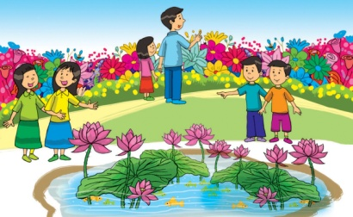 | 
B.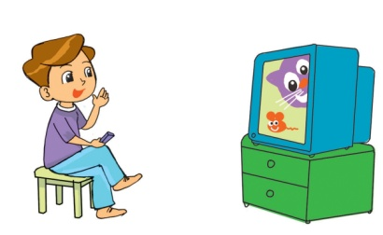
C.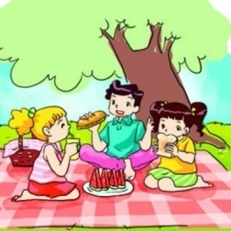
D.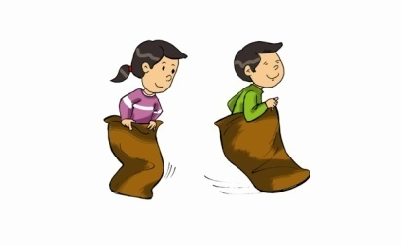
E.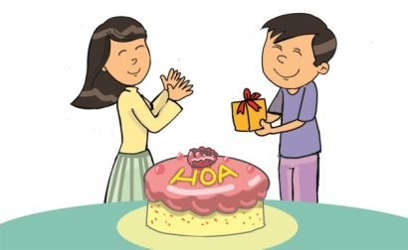
Task 2. Listen and tick  A, B or C. There is one example.

Example:
 | It’ll be on Saturday next week. | It’ll be fun on Teachers’ Day. | It’ll be rainy on Teachers’ Day.
 | A. | B.  | C.
1. | Yes, I am. | Yes, I can. | Yes, I will.
 | A. | B. | C.
2. | They’re going to have it. | They’re going to play music. | They’re going celebrate for the first day.
 | A. | B. | C.
3. | It’ll be in July. | It’ll be in August. | It’ll be in June.
 | A. | B. | C.
4. | I’m going to play badminton. | I’m playing badminton. | I’ll play badminton.
 | A. | B. | C.
Task 3. Listen and tick the correct pictures. There is one example.

Example: Where were you last weekend?
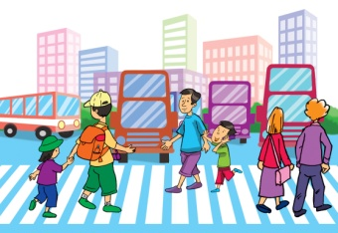 | 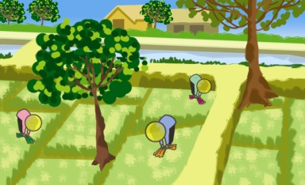 | 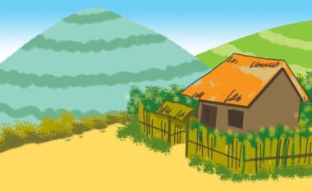
A. | B. | C.
1. Where did Sue go last Sunday?
 | 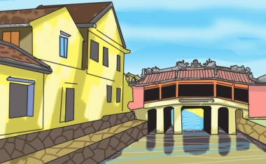 | 
A. | B. | C.
2. Where did Nick go last weekend?
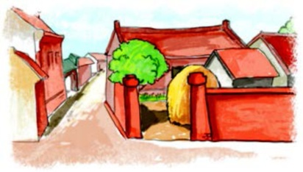 |  | 
A. | B. | C.
3. How did Jane get there?
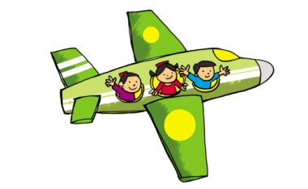 | 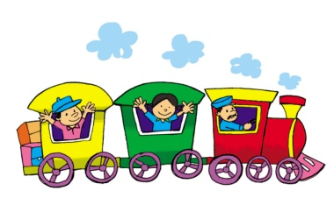 | 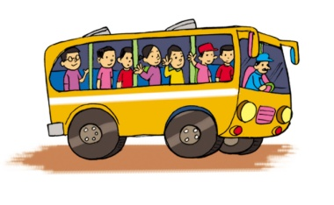
A. | B. | C.
4. How did Ann get there?
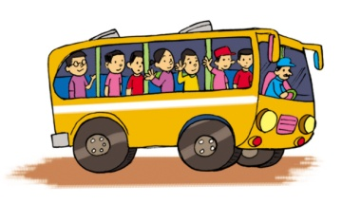 | 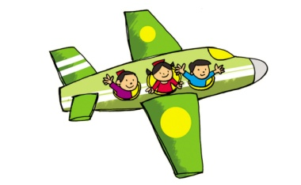 | 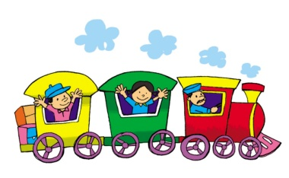
A. | B. | C.
Task 4. Listen and tick (V) Right or Wrong. There is one example (0).

 | Right | Wrong
0. Mid-Autumn Festival happens on the fifteenth of August, the lunar year.
1. People prepare lanterns, masks and mooncake for the event.
2. Children make their masks and lanterns to celebrate the festival.
3. When the moon goes up high in the sky, children go to bed.
4. After singing and dancing, children sit down and enjoy mooncake and fruit under the moon light.
II. READING
Task 1. Look and write the correct words. There is one example.

 |  | 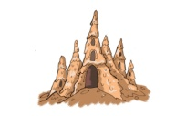 |  | 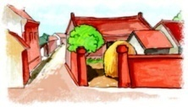
sea | cave | sandcastle | mountain | countryside

Example: It is very large and has a lot of water. | sea
1. It is outside cities and towns, with fields and trees. | _________
2. A very high hill, often with rocks near the top. | _________
3. It is of sand to look like a castle, usually built by a child on a beach. | _________
4. A large hole in the side of a hill, mountain or under the ground. | _________

Task 2. Read and tick (V) True or False. There is one example (0).

Vy likes English very much. At school, she has English four times a week. She often speaks English with her classmates. Sometimes, she talks with her foreign friend, Amy. They are happy because they can understand each other. Vy usually reads English comic books in her free time. At home, she practises listening by watching cartoons on TV. Vy wants to learn English well. She thinks English is necessary for her future.

 | True | False
0. Vy’s favourite subject is English.
1. She has English every day.
2. Amy can understand Vy’s English.
3. Vy usually reads comic books to practise listening.
4. English is necessary for Vy’s future.

Task 3. Read and number the sentences in the correct order. The conversation begins with 0.

 | A | Binh: Great! I’ll buy and read it tomorrow!
 | B | Hien: Who is the main character?
0 | C | Binh: What are you reading, Hien?
 | D | Hien: I’m reading The Legend of The Watermelon. The story’s very interesting.
 | E | Binh: It’s Mai An Tiem. He’s a brave and clever man.
Task 4. Look and read. Fill each gap with one word from the box. Write the word next to the number. There is one word that you do not need. There is one example (0).

 | 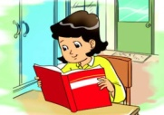 |  |  | 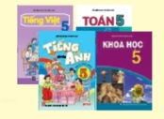 | 
summer | reading | university | home | books | bookshop

Hi Joe,
Are you enjoying your (0) summer holiday? This summer I’m staying at (1)______________. I’m (2)________________ a lot of story books. I didn’t have enough time to read them during the school year. Yesterday I went to the (3)____________ and bought a lot of story books. The characters in these books are great people. I like them very much. I’ll write more about my (4) ___________ in the next letter.
Write and tell me about your summer.
Hoa
III. WRITING
Task 1. Look at the pictures. Read and write one word for each gap. There is one example.

Example: | 
  Last month, I had a holiday in the mountains.

1. | Last year, we visited Hue Imperial ___________. | 

2. | Last holiday, she went to Hoi An Ancient ___________. | 

3. | We went to the countryside by ___________. | 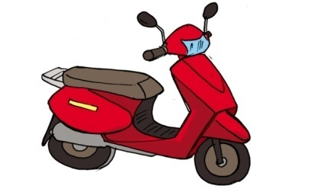

4. | They went to the railway station by ___________. | 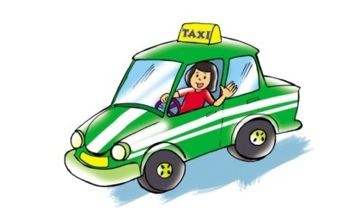

Task 2. Order the words. There is one example.

Example:
  lives / city / a / he / crowded / in
  He lives in a crowded city.

1. | you / do / live / where  __________________________________?

2. | your / is / what / address  __________________________________?

3. | is / your / new / like / place / what  __________________________________?

4. | hometown / what / is / your / like  __________________________________?

Task 3. Read the questions. Write about you. There is one example (0).

0. What do you usually do every day?
1. What are you going to do tomorrow?
2. What are you going to do next weekend?
0. I get up early and go to school every day.
1. Tomorrow, I_____________________________________________________.
2. Next weekend, I __________________________________________________.
IV. SPEAKING

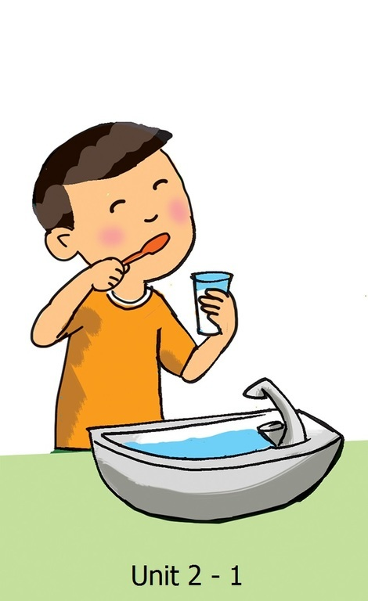 | 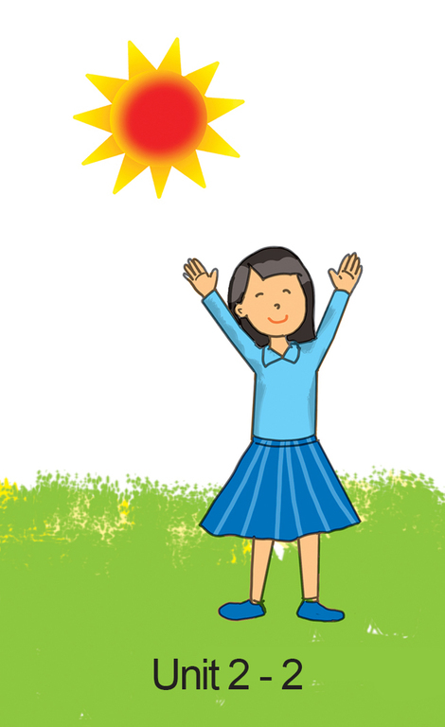
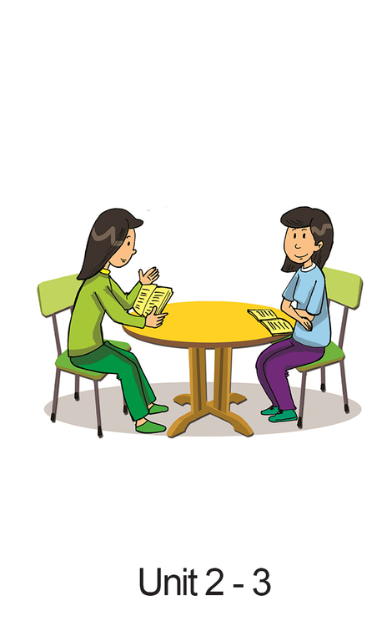 | 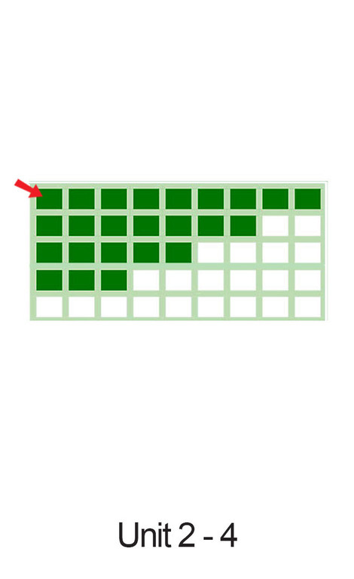
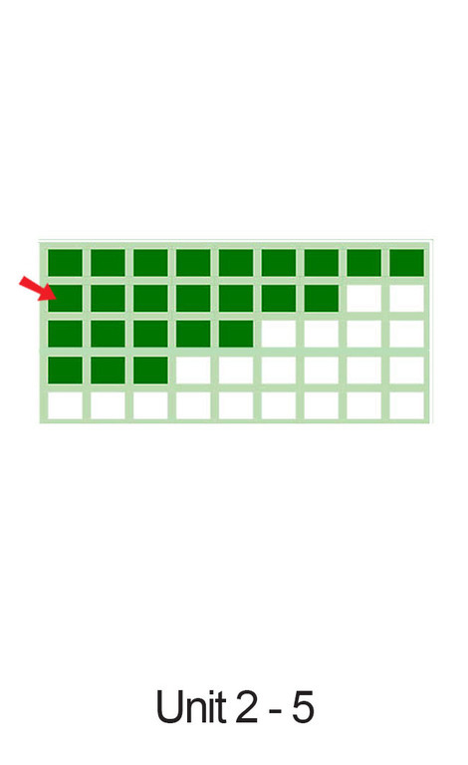 | 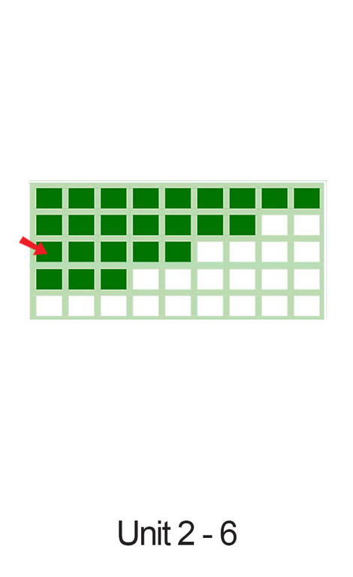
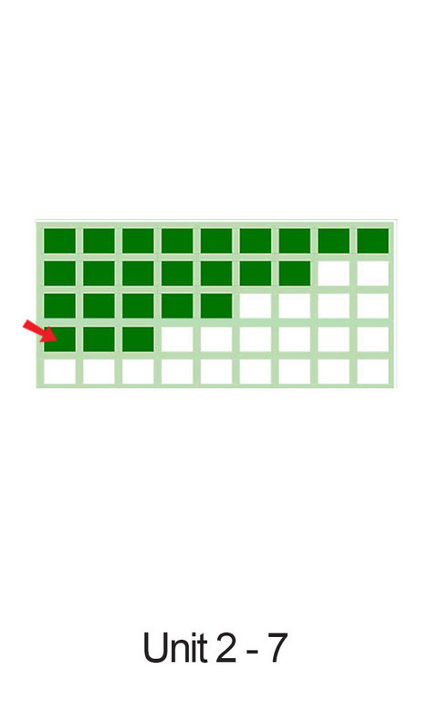 | 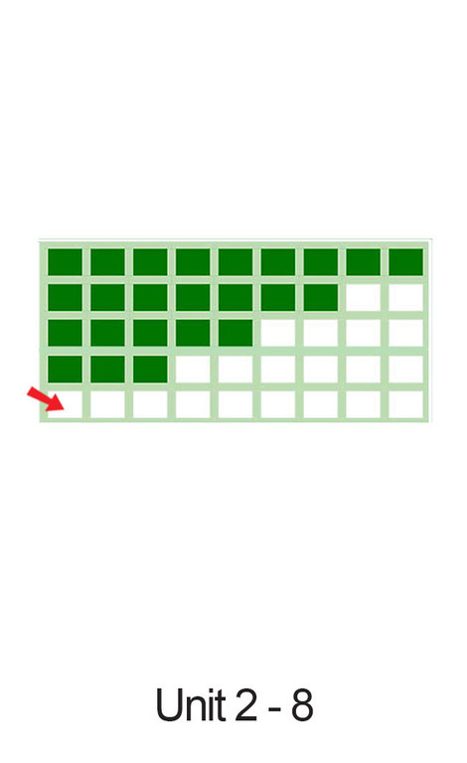
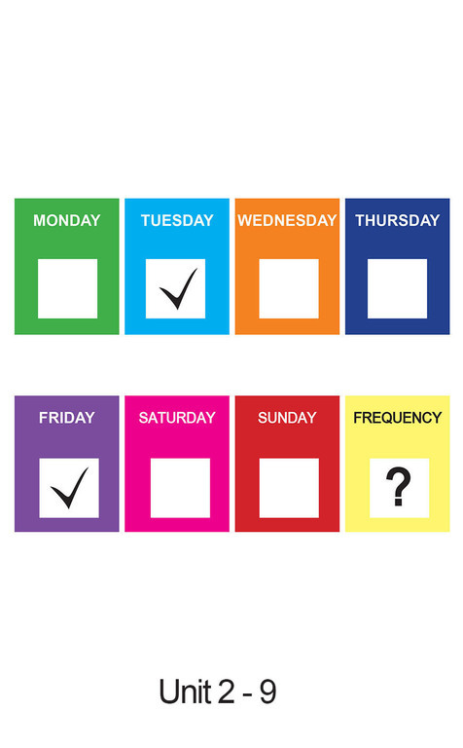 | 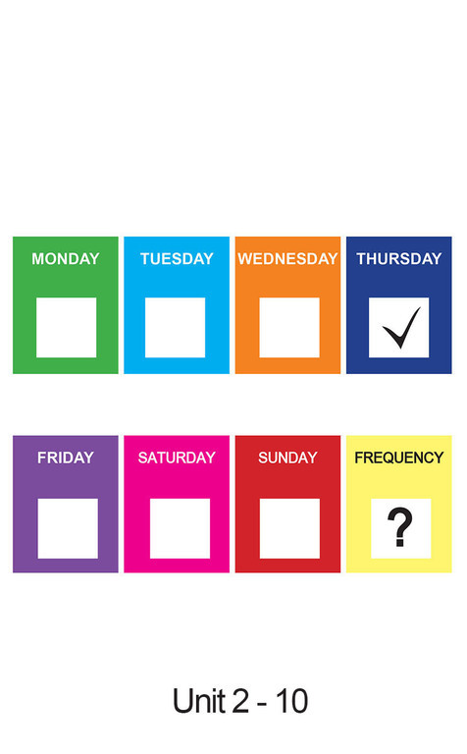
Task 1. Look, point and say. There is one example.

Teacher does this: | Teacher says this: | Minimum response expected from S: | Back-up questions:
Shows card 1. | Look at this card. Point and say the action. | Points to the cards. Says out the action.
Chooses 4 more in the left cards and shows them respectively. | Brush teeth.  Now you point and say, please.
 |  | (Card 2) Do morning exercise | What does he/she do? Does he/she do morning exercise?
 |  | (Card 3) Study with a partner | What does he/she do? Does he/she study with a partner?
 |  | (Card 4) Always/every day | How often? (Point to the 1st line)/Is it ‘always’?
 |  | (Card 5) Usually | How often? (Point to the 2nd line)/Is it ‘usually’?
 |  | (Card 6) Often | How often? (Point to the 3rd line)/Is it ‘often’?
 |  | (Card 7) Sometimes | How often? (Point to the 4th line)/Is it ‘sometimes’?
 |  | (Card 8) Never | How often? (Point to the 5th line)/Is it ‘never’?
 |  | (Card 9) Twice a week/sometimes | How often?/(Point to the ticks) How many times?/Is it ‘twice a week’?
 |  | (Card 10) Once a week/sometimes | How often?/(Point to the tick) How many times?/Is it ‘once a week’?
Task 2. Listen and answer the questions. There is one example.

Teacher does this: | Teacher says this: | Minimum response expected from S: | Back-up questions:
Shows card 1 & 4. | Now, answer the questions. | Listens to questions and answers.
Shows card 1 & 4. | What does he do in the morning? | He brushes his teeth. | Does he brush his teeth?/do morning exercise?
Shows card 1 & 4. | How often does he brush his teeth? | Always/He always brushes his teeth./He brushes teeth every day. | Does he always brush teeth?/Does he brush teeth every day?
Shows card 2. | What does she do in the morning? | She does morning exercise. | Does she do morning exercise?
Shows card 2 & 5. | How often does she do morning exercise? | Usually/She usually does morning exercise. | Does she usually do morning exercise?
Shows card 3 & 9. | How often does he/she study with a partner? | Twice a week.  He/She studies with a partner twice a week.  He/She sometimes studies with a partner. | Does he/she study with a partner twice a week?
Task 3. Let’s talk (Talk about your friend)

Teacher does this: | Teacher says this: | Minimum response expected from S: | Back-up questions:
T uses one set of  these questions to asks S. | Now let’s talk about your friend. OK? | Student listens and answers. S’s answers will vary.
Unit 6 | 1. Who’s your friend?/What’s her/his name?  2. How often does she/he go to school?  3. How many lessons does she/he have on Monday?  4. How often does she/he have Maths?
Unit 7 | 1. What’s her/his name?  2. Does she/he like English?  3. How does she/he learn it?
Unit 8 | 1. Is your friend a boy or a girl?  2. What’s her/his name?  3. What’s his/her favourite story?/What is she/he reading?  4. Who is the main character?  5. What is the main character like?
Unit 9 | 1. Who’s your friend?  2. Does your friend like animals?  3. When did she/he go to the zoo?  4. What animals did she /he see?  5. What’s her/his favourite animal? Why does she/he like it?
Unit 10 | 1. Tell me your friend’s name.  2. Which school event that she/he like?/Why?  3. When is it/When will it be?  4. What is she/he going to do for that event?
-- The end --
manual page break

Đáp án
I. LISTENING
Task 1. Listen and match. There is one example (0).
1. C 2. B 3. A 4. D
Task 2. Listen and tick A, B or C. There is one example.
1. C 2. B 3. C 4. A
Task 3. Listen and tick the correct pictures. There is one example.
1. B 2. C 3. B 4. A
Task 4. Listen and tick (V) Right or Wrong. There is one example (0).
1. Wrong 2. Right 3. Wrong 4. Right
II. READING
Task 1. Look and write the correct words. There is one example.
1.countryside 2. mountain 3. sandcastle 4. cave
Task 2. Read and tick (V) True or False. There is one example (0).
1. False 2. True 3. False 4. True
Task 3. Read and number the sentences in the correct order. The conversation begins with 0.
1. D 2. B 3. E 4. A
Task 4. Look and read. Fill each gap with one word from the box. Write the word next to the number. There is one word that you do not need. There is one example (0).
1. home 2. reading 3. bookshop 4. books
III. WRITING
Task 1. Look at the pictures. Read and write one word for each gap. There is one example.
1. City 2. Town 3. motorbike 4. taxi
Task 2. Order the words. There is one example.
- Where do you live?
- What is your address?
- What is your new place like?
- What is your hometown like?
Task 3. Read the questions. Write about you. There is one example (0).
Student’s answers vary with correct grammar.

