| UBND HUYỆN ……..  **Mã đề 6.1.2** | **ĐỀ KIỂM TRA GIỮA KÌ I**  **NĂM HỌC 2022-2023**  **MÔN: TIẾNG ANH 6**  ***Thời gian làm bài 60 phút***  *(Đề gồm: 04 trang)* |
| --- | --- |

**A. LISTENING**

***I. Listen and tick on the right picture.(1,0pt)***

*(Nghe 5 cuộc hội thoại ngắn và chọn đáp án tương ứng với bức tranh mô tả đúng nội dung câu trả lời của mỗi câu hỏi sau, mỗi câu hỏi được nghe 02 lần)*

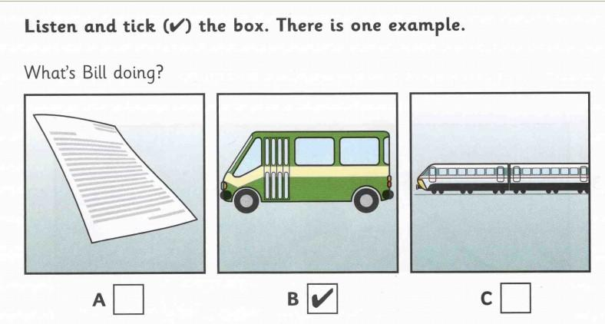 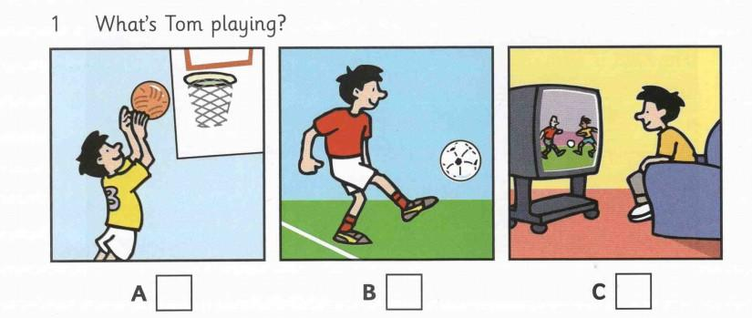 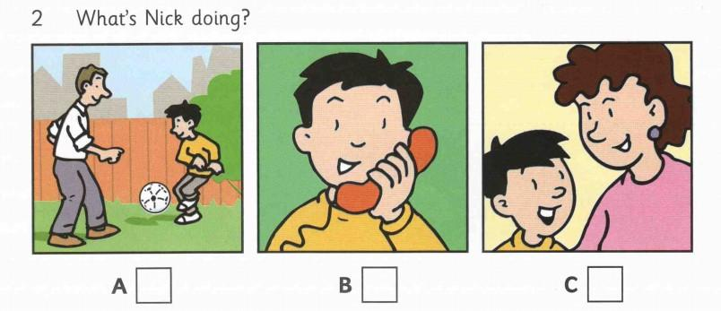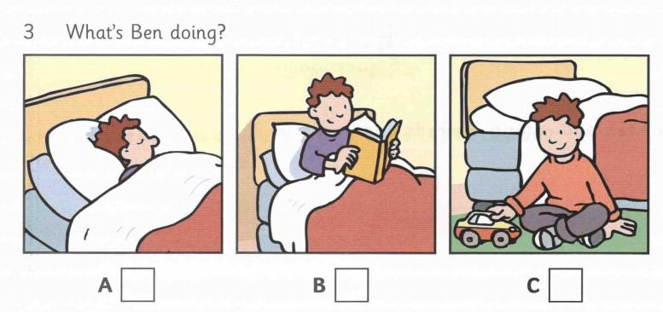 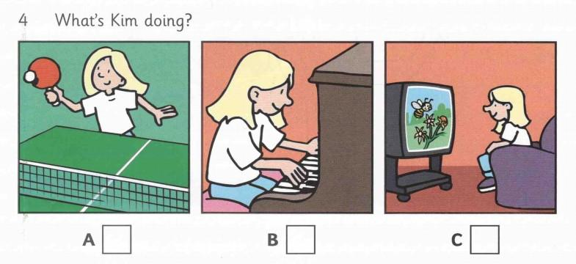 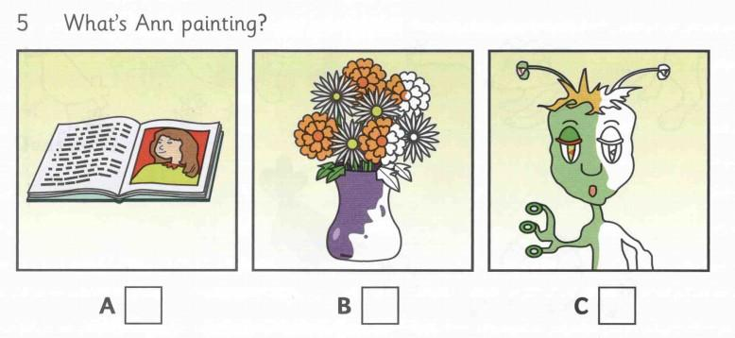

***II. Listen Charles talking about himself and complete the sentences below. (1,0pt)***

*(Nghe một đoạn tự thuật về nhân vật Charles và điền từ còn thiếu mà em nghe được vào những câu sau)*

* Charles’ hair is (1)……short………..and (2)………brown………..
* Charles’ complexion is (3)………………because he does not have time to lie in the sun.
* Charles wants his employees to be (4)………………….
* Charles believes that he himself is a (5)………..boss.

**B. VOCABULARY + GRAMMAR + LANGUAGE FUNCTION**

**Choose the best option to complete each sentence. (2, 0 pts)**

1. She often__________ to the radio in the morning.

A. listen B. watches **C. listens** D. listening

2. Miss Hoa has __________ hair.

A . black long **B. long black** C. a long black D. black and long

3. Listen! The parrot __________

**A. is talking** B. talking C. talk D. talks

4. - __________ you like to drink coffee? - Yes, please.

A. Why  **B. Would** C. Want D. What

5. This baby has……………… cheeks; everyone wants to kiss them.

A. round B.finger **C. chubby** D. fat

6. My school__________three floors and my classroom is on the first floor.

**A. has**  B. are C. to have D. have

7. Where is the cat? - It's ______ the table and the bookshelf.

**A. between** B. in C. under D. on

8. There ______ a book and two pens on the table.

A.are B. am C. be **D. is**

9. It’s quite noisy to live in a ……………house that stands on a busy street.

**A. town** B.country C. villa D. beach

10. We only have time for a snack at…………………

A. lunch B. gym **C.break time** D. dinner

11. Do you know where our new………..is? Our teacher wants to meet him.

A.poem **B. classmate**  C. swimming pool D. classroom

12. I……….an apartment with three friends.

**A. share**  B. move C. come D. live

13. A: What does she look like ? B:……………….

A. Good job! B. Wonderful! C. I’m fine, thanks.  **D. She’s beautiful.**

14. A: What about going to the cinema? B:…………………

**A. That’s a good idea.** B. No, thanks. I’m full.

C. You’re welcome. D. Yes, please.

15. A: Nga. This is Mai, my new friend.

B: Hi Mai,…………………………….

A. I’m well. Thanks B. It’s my pleasure.

**C. Nice to meet you.** D. Good bye. See you later.

**C. READING (3, 0 pts)**

**I. Read the passage below then circle the best answer A, B or C to each blank. (1,5 pts)**

*(Đọc đoạn văn sau và chọn câu trả lời đúng cho mỗi khoảng trống)*

I live in a house near the sea. It is ................. (1) old house, about 100 years old and ................. (2) very small. There are two bedrooms upstairs ................. (3) no bathroom. The bathroom is down stairs ................. (4) the kitchen. There is a living room where there is a lovely old fire place. There is a garden ................. (5) the house.

1. A. a **B. an** C. the D. Ø

2. **A. it’s** B. it C. there’s D. it is

3.A. so B. or **C. but** D. and

4. A. between **B. next to** C. next D. under

5. A. in front B. front of **C. in front of** D. the front of

**II. Read the passage and choose the correct answer A, B or C for each sentence. (1,5 pts)**

*(Đọc đoạn văn sau và chọn câu trả lời đúng cho mỗi câu hỏi)*

My name’s Nick. I’m from Australia. I live in the countryside with my family. My parents are farmers. I often help them to look after vegetables in the garden in my free time. I like growing vegetables and flowers. I’d like to be a farmer in the future and to work on a farm. I think farming is exciting and interesting. Now I’m studying Science hard at school. I want to be good at Science because it’s important for my future job.

***Questions:***

1. Nick’s parents work ________

A. in the garden **B. on the farm** C. in the city D. by the sea

2. He often helps ________ to look after vegetables in the garden.

**A. his parents** B. his grandparents C. his mother D. his father

3. He wants to be ________ in the future.

A. a worker B. a scientist **C. a farmer** D. a doctor

4. He ______ hard on Science at school.

**A. studies** B. work C. working D. learn

5. He thinks that ________ is exciting and interesting

**A. farming** B. job C. Science D. school

**C. WRITING (3,0 pts)**

**I. Write the second sentence so that it has a similar meaning to the first one. (1,5 pts)**

*(Viết lại câu bằng từ gợi ý sao cho nghĩa không thay đổi)*

1, My favorite room in the house is my bedroom.

🠢 I like my bedroom best.........................................................................................................................................

2, The dog is in front of the microwave.

🠢 The microwave is behind the dog.......................................................................................................................

3, Lan’s house has six rooms.

🠢 There **.are six rooms in Lan’s house.**...............................................................................................................................

4. Let’s go to the park.

→ What about going to the park.………………………………………………?

5. She has long black hair.

🠢 Her hair is long and black.………………………………………………………………………………

**II. Use the words given to make a complete passage about your new school. (1,5 pts)**

*(Viết câu hoàn chỉnh từ những cụm từ gợi ý để thành một đoạn văn)*

My new school/ be/ Sunflower Secondary School. It/ be/ big school/ the countryside. It/ have/ four floors/ modern equipments. There/ be/ over thirty teachers/ seven hundred students/ my school. school, /we/ study/ many interesting subjects/ join/ outdoor activities. I/ like/ school/ much.

………My new school is Sunflower Secondary school. It is a big school in the countryside. It have four floors and modern equipments. There are over thirty teachers and seven hundreds students in my school. At school, we often study many interesting subjects and join outdoor activities. I like my school very much. ………………………………………………………………………………………………………………………………………………………………………………………………………………………………………………………………………………………………………………………………………………………………………………………………………………………………………………………………………………………………………………………………………………………………………………………………………………………………………………………………………………………………………………………………………………………………………………………………………………………………………………………………………………………………………………………………………………………………

**===========The end ============**

| UBND HUYỆN ……..  **Mã đề 6.1.2** | **HƯỚNG DẪN CHẤM**  **ĐỀ KIỂM TRA GIỮA KÌ I**  **NĂM HỌC 2022-2023**  **MÔN: TIẾNG ANH 6**  *(Hướng dẫn chấm gồm: 01trang)* |
| --- | --- |

| **Questions** | **Keys** | **Points** |
| --- | --- | --- |
| **A. LISTENING** | **I. (0,2x5=1,0)**  1- A 2- B 3- A 4- A 5- C | 0,2 for each |
| **II. (0,2x5=1,0)**  1. short 2. brown 3. pale  4. hard-working 5. good | 0,2 for each |
| **B. VOCABULARY-GRAMMAR-LANGUAGE FUNCTION** | **(2,0pts)**   | 1C | 2B | 3A | 4 B | 5 C | | --- | --- | --- | --- | --- | | 6 A | 7 A | 8 D | 9 A | 10 C | | 11 B | 12 A | 13 D | 14 A | 15 C | | 0,2 for each |
| **C. READING** | **I. (1,5 pts)**   | 1B | 2 A | 3 C | 4B | 5C | | --- | --- | --- | --- | --- | | 0,3 for each |
| **II. (1,5 pts)**   | 1B | 2A | 3C | 4A | 5A | | --- | --- | --- | --- | --- | | 0,3 for each |
| **D. WRITING** | **I. Sentences building (1,5 pts)**  1, I like my bedroom best.  2, The microwave is behind the dog.  3 There are 6 rooms in Lan’s house.  4. What about going to the park?  5. Her hair is long and black. | 0,3 for each |
| **II. (1,5 pts)**  My new school is Sunflower Secondary School. It is a big school in the countryside. It has four floors and modern equipments. There are over thirty teachers and seven hundreds students in my school. At school, we usually/often study many interesting subjects and join outdoor activities. I like my school very much. | 0,1 for each words |

**Transcript Task 2 – Listening (Track 06 – Unit 3 – My friends)**

I’m Charles Taylor. I’m in my forties. My nickname is Charlie. I was born on 20th of July, 1971 in Budapest (the capital of Hungary). I’m 189 cm tall. I’m getting bald. My hair is short and brown. I’ve got brown eyes. I’ve got a round face with a snub nose. I haven’t got a moustache and a beard. I don’t really have time to lie in the sun or go to a solarium, so my complexion is rather pale. I think I’m a bit stocky. I usually wear a suit at work but I prefer casual clothes when I am at home.

I’m quite energetic and bossy. I’m a bit of a workaholic. I’m hard-working, and I want my employees to be the same. I believe that I’m a good boss. I try to help if someone has a problem. So you can say I’m a generous and helpful man. I’m also reliable as well as determined.

**(Bài tập cuối tuần Tiếng Anh lớp 6 – Tập 1 - Đại Lợi – NXB Đại học Quốc gia Hà Nội)**

**===========The end ============**