Chỉ 100k/12 tháng, bạn tải rất nhiều tài liệu tiếng anh file word hay tại: ***Giaoandethitienganh.info***  Mong bạn ghé ủng hộ !

**ĐỀ VIP 9+ - ĐỀ SỐ 1**

## Read the following article and mark the letter A, B, C, or D to indicate the correct option that best fits each of the numbered blanks from 1 to 6.

The term 'personal development' is often connected with activities like dieting or exercise, or perhaps learning a (1) . But while these things are undoubtedly important, there are many other (2)

skills which are often overlooked. Academic or cognitive skills (3) critical thinking, memorisation and creativity are important, as are (4) and emotional skills like friendliness, positive thinking, and self-esteem.

(5) skills not to be neglected include self-control, time management, and finding a balanced life. The important thing is to (6) a 'holistic approach' to personal development, meaning you should aim to develop yourself as a whole person rather than focusing on one aspect of yourself at the expense of the others.

(Adapted from *C21 Smart*)

|  |  |  |  |  |
| --- | --- | --- | --- | --- |
| **Question 1.** | **A.** new programme computer | | **B.** programme new computer | |
|  | **C.** new computer programme | | **D.** computer programme new | |
|  |  | |  | |
| **Question 2.** | **A.** worthwhile | **B.** potential | **C.** meaningful | **D.** ordinary |
| **Question 3.** | **A.** in place of | **B.** such as | **C.** regardless of | **D.** at least |
| **Question 4.** | **A.** sociable | **B.** society | **C.** socially | **D.** social |
| **Question 5.** | **A.** Other | **B.** The others | **C.** Others | **D.** Another |
| **Question 6.** | **A.** make | **B.** give | **C.** lead | **D.** take |

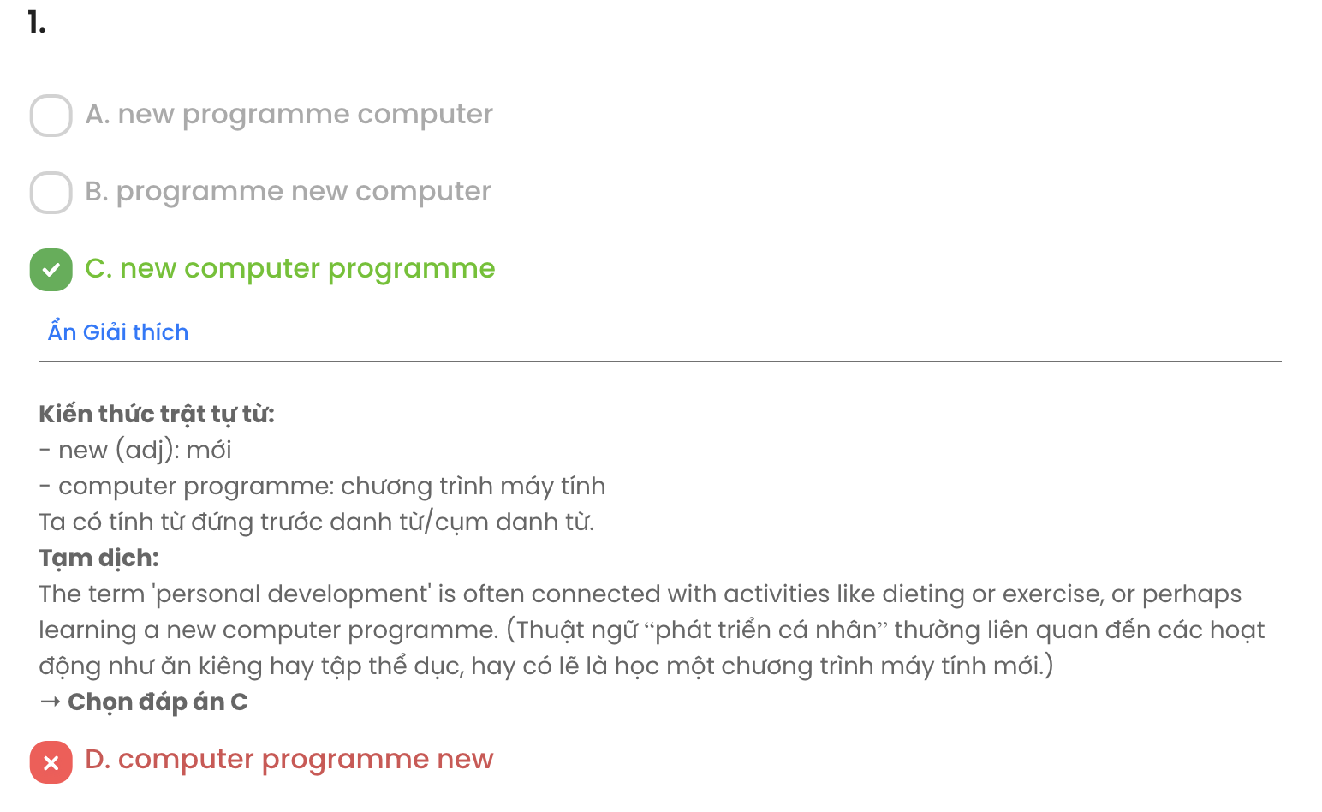

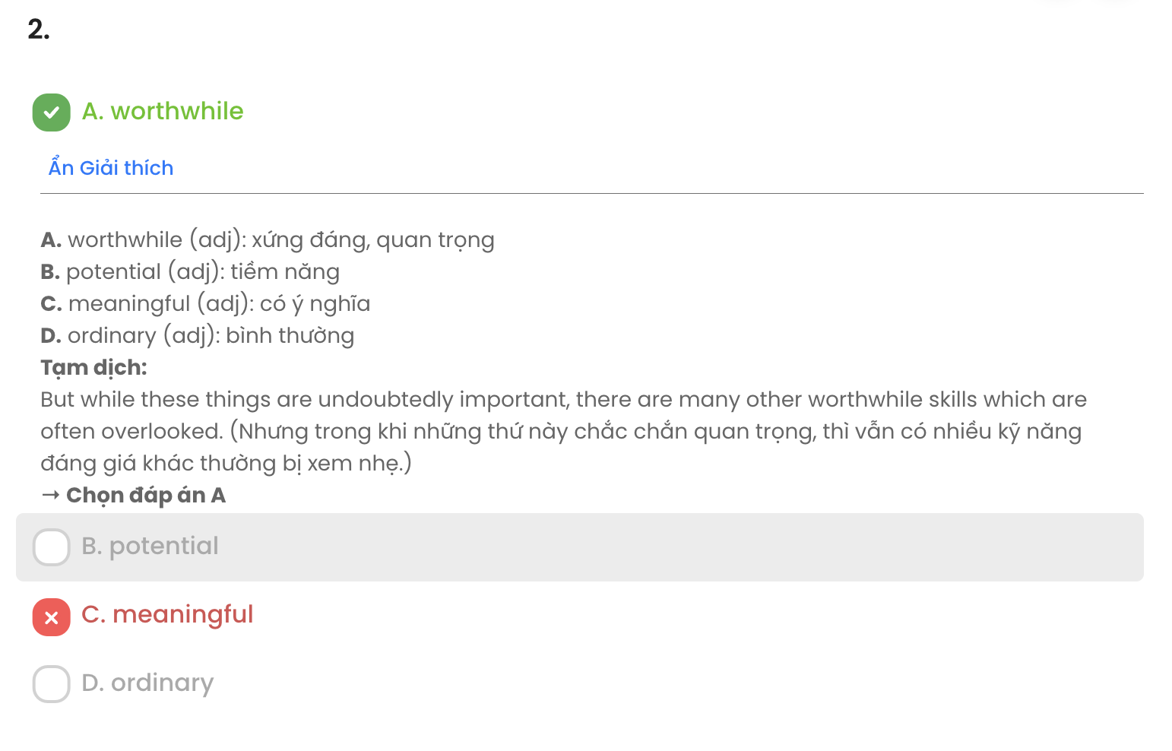

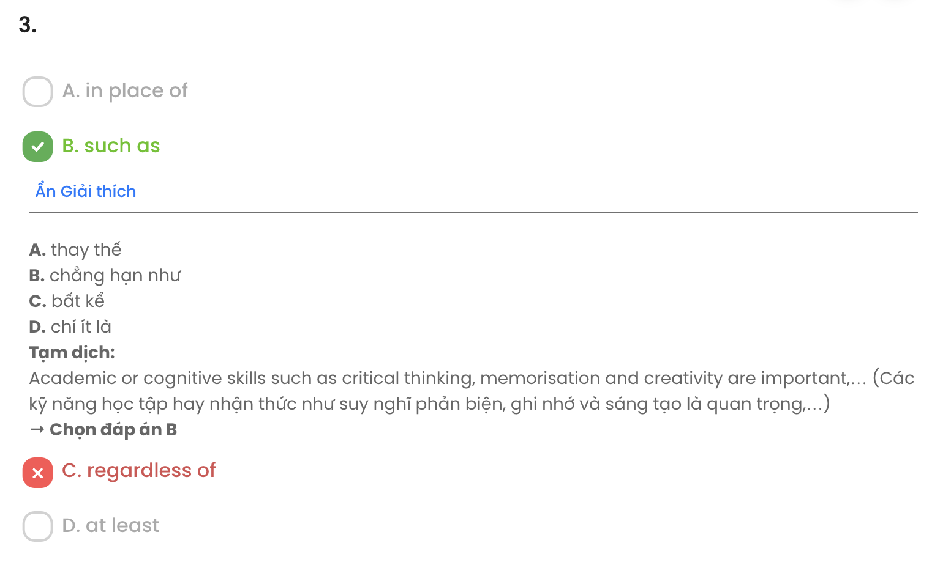

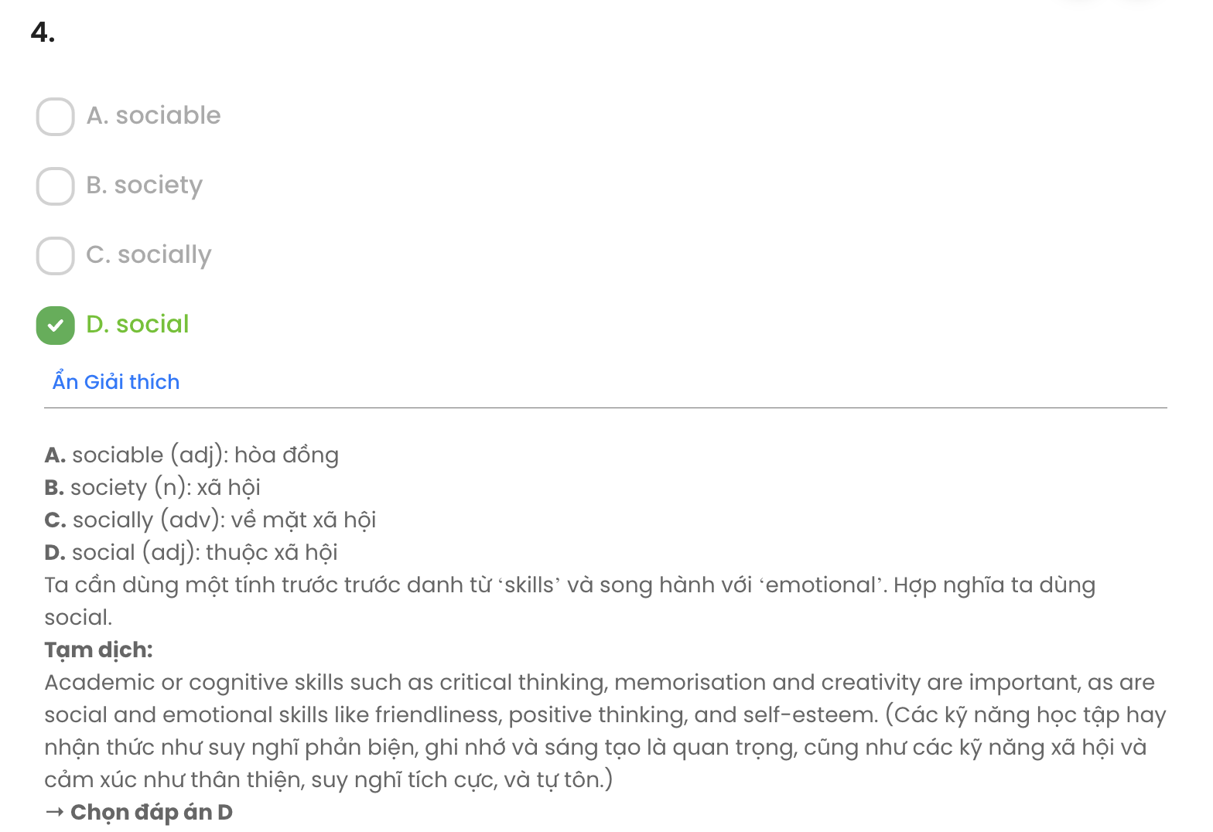

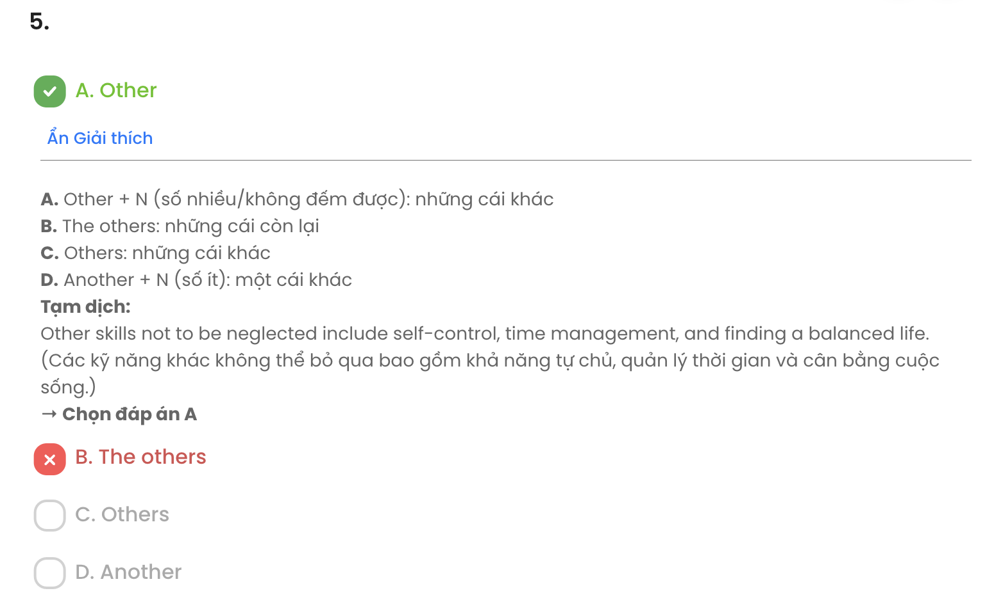

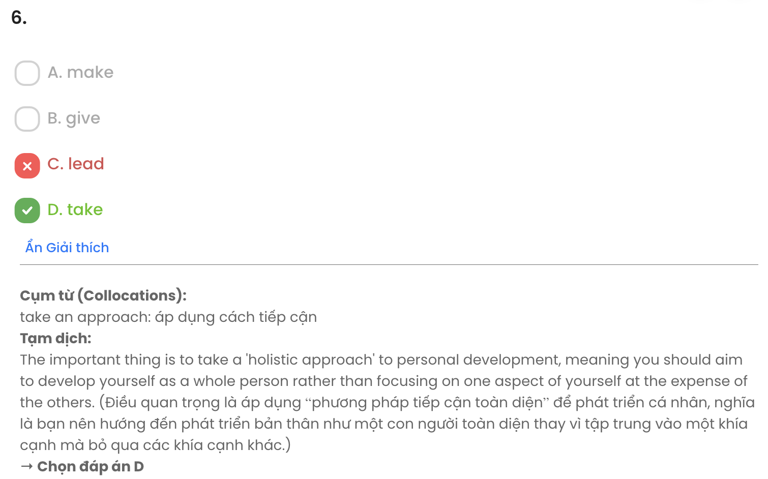

## 

## Read the following leaflet and mark the letter A, B, C, or D to indicate the correct option that best fits each of the numbered blanks from 7 to 12.

Here are some ways to help reduce global warming. Which of these do you regularly do?

* **Don't use private cars**. Your willingness (7) or cycle to nearby places can help reduce your own carbon footprint.
* **Make a decision to reduce, recycle, and reuse**. Reduce waste by buying reusable products. Don't forget to recycle plastics, glass, and paper products. You may wish to reuse some of your old items to (8) , too. Take unneeded items (9) a recycling centre.
* **Plant trees**. Plants and trees are nature's lungs. They produce the oxygen we breathe. They also can shade your home, (10) it cooler so you don't need to run your air conditioners as much.
* **Buy local goods**. When you buy goods imported from far-away places, it takes a large (11) of energy to transport them to your area. This means that if you don't buy local food and products, then more

(12) of carbon dioxide will happen during the transportation process.

(Adapted from *English Discovery*)

|  |  |  |  |  |
| --- | --- | --- | --- | --- |
| **Question 7.** | **A.** to walk | **B.** walking | **C.** to walking | **D.** walk |
| **Question 8.** | **A.** make out | **B.** turn out | **C.** help out | **D.** find out |
| **Question 9.** | **A.** with | **B.** for | **C.** at | **D.** to |
| **Question 10.** | **A.** which make | **B.** made | **C.** to make | **D.** making |
| **Question 11.** | **A.** level | **B.** amount | **C.** degree | **D.** number |
| **Question 12.** | **A.** scales | **B.** emissions | **C.** portions | **D.** purposes |

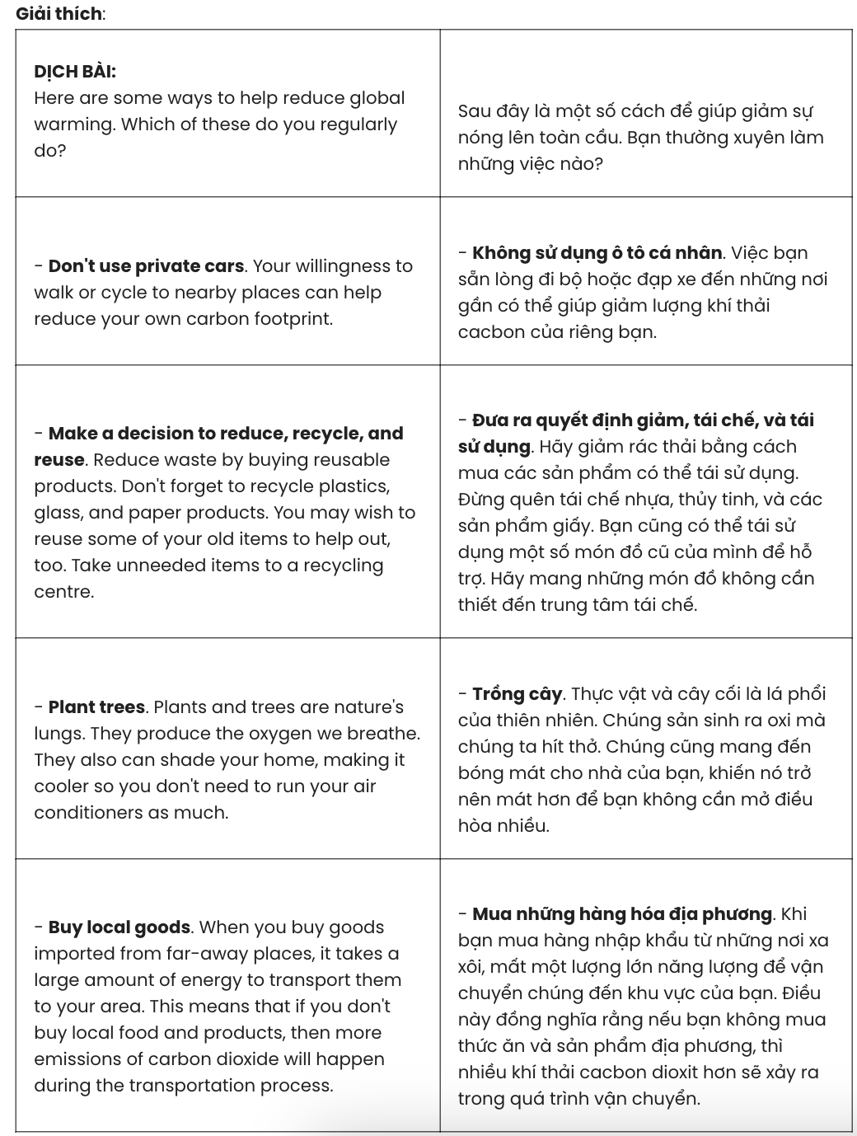

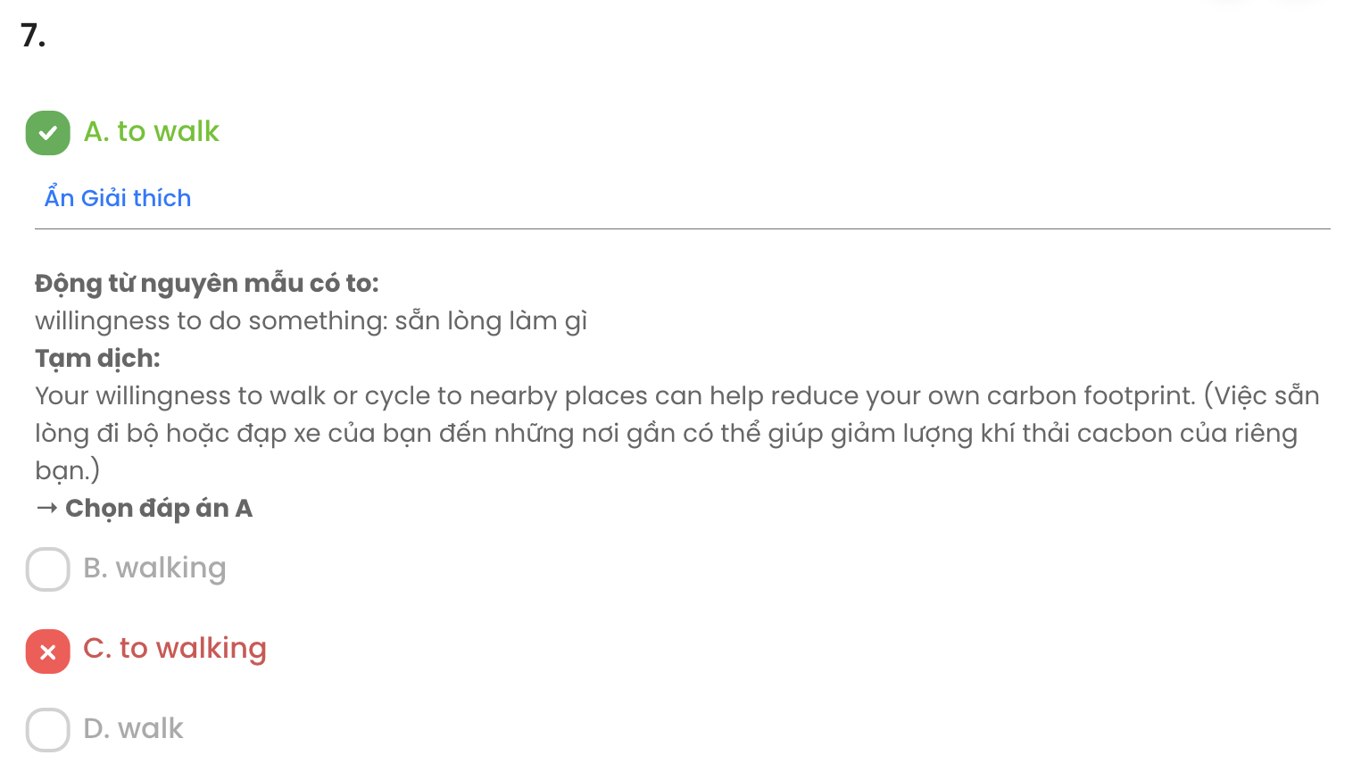

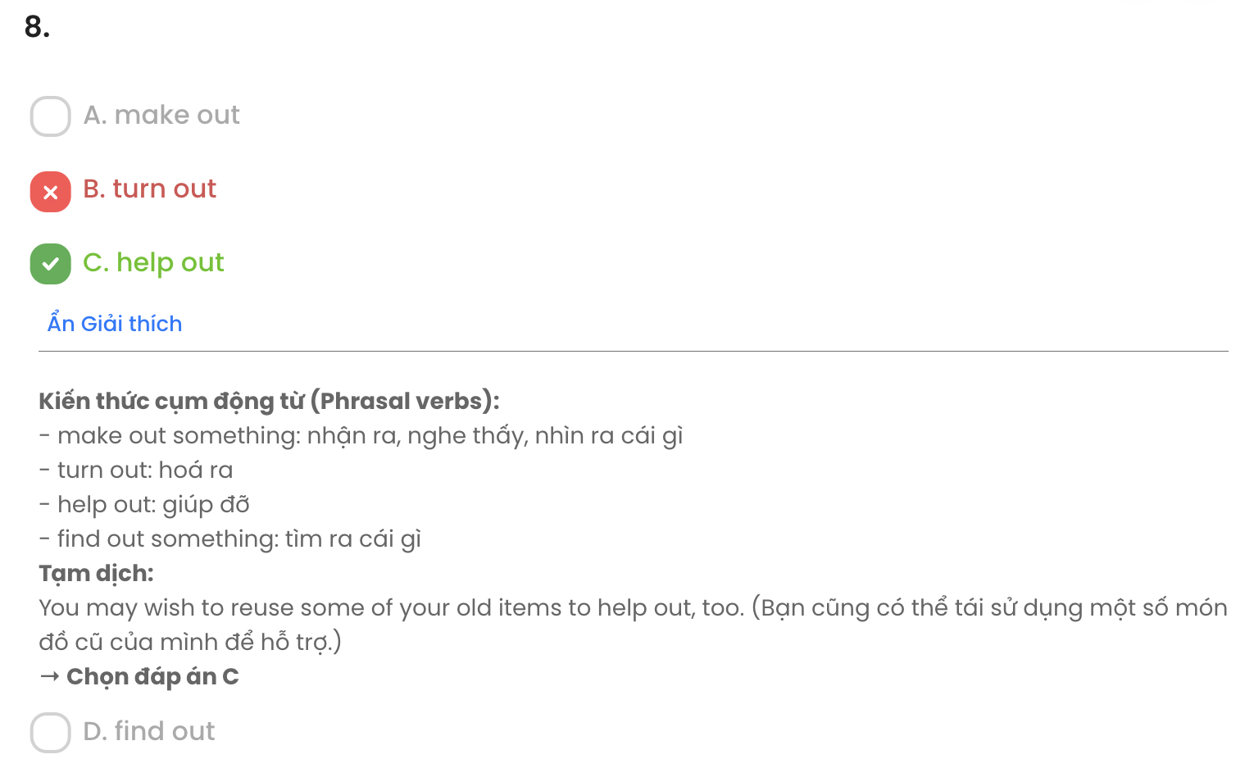

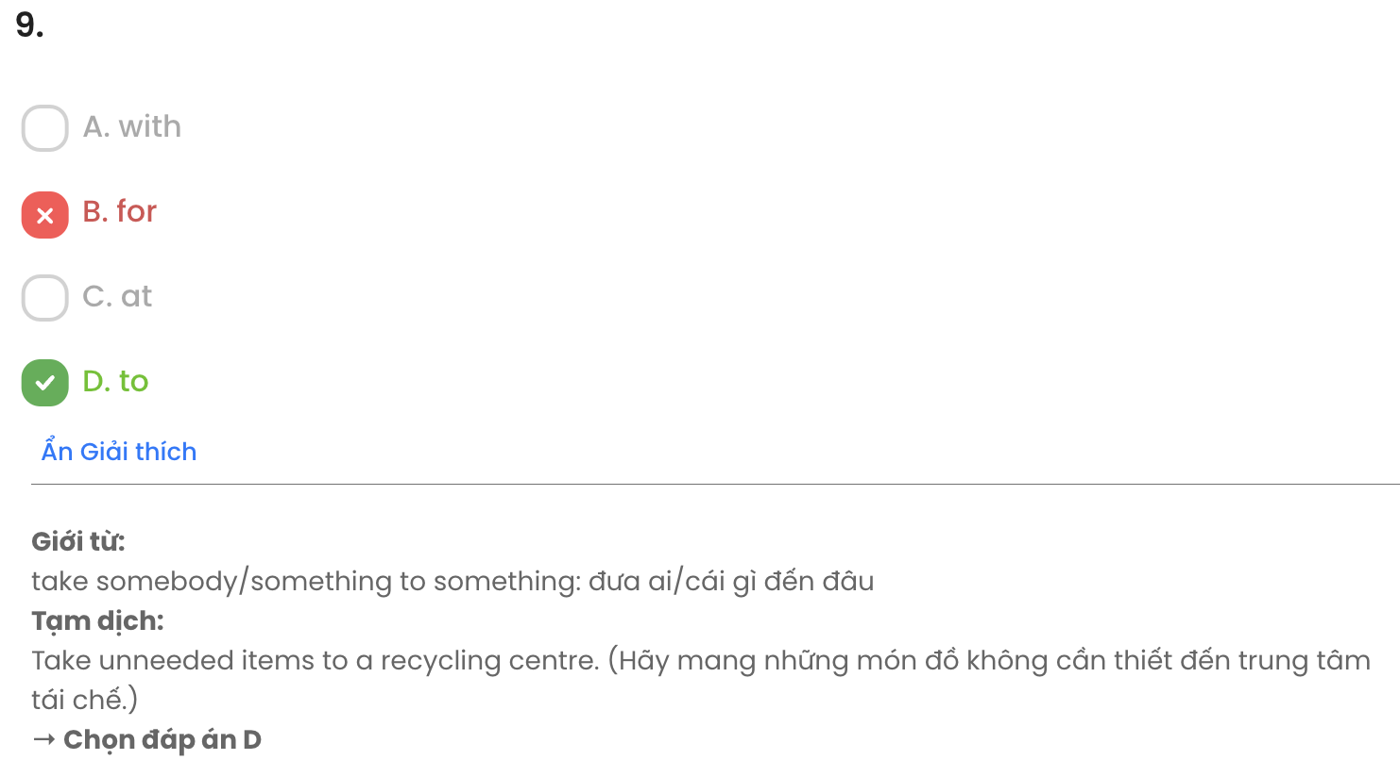

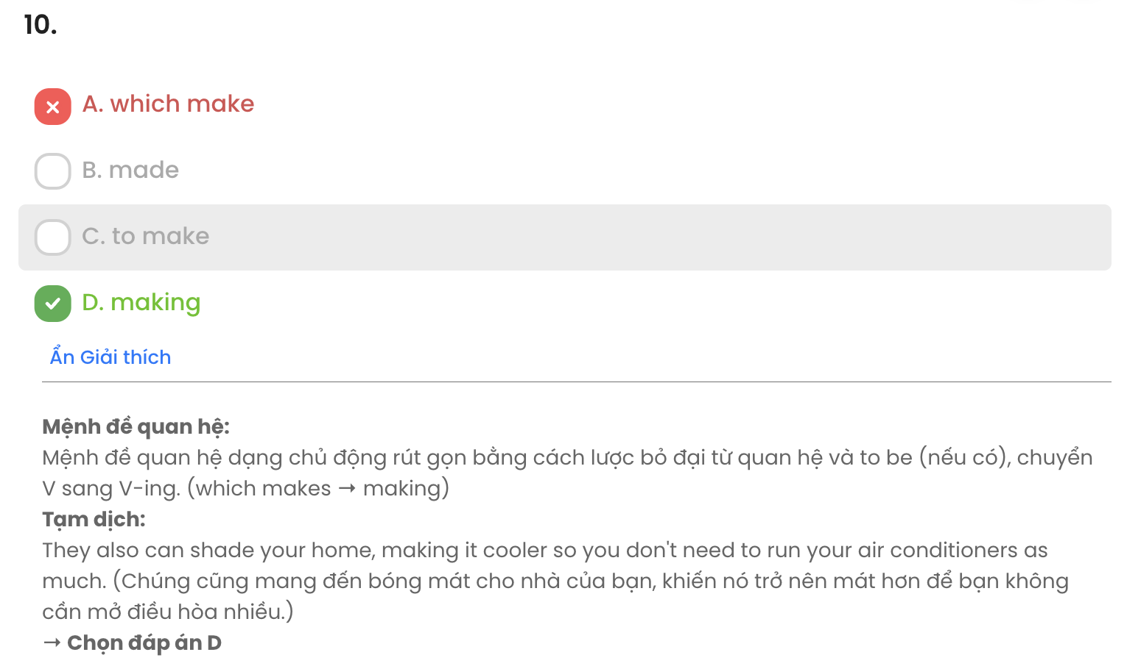

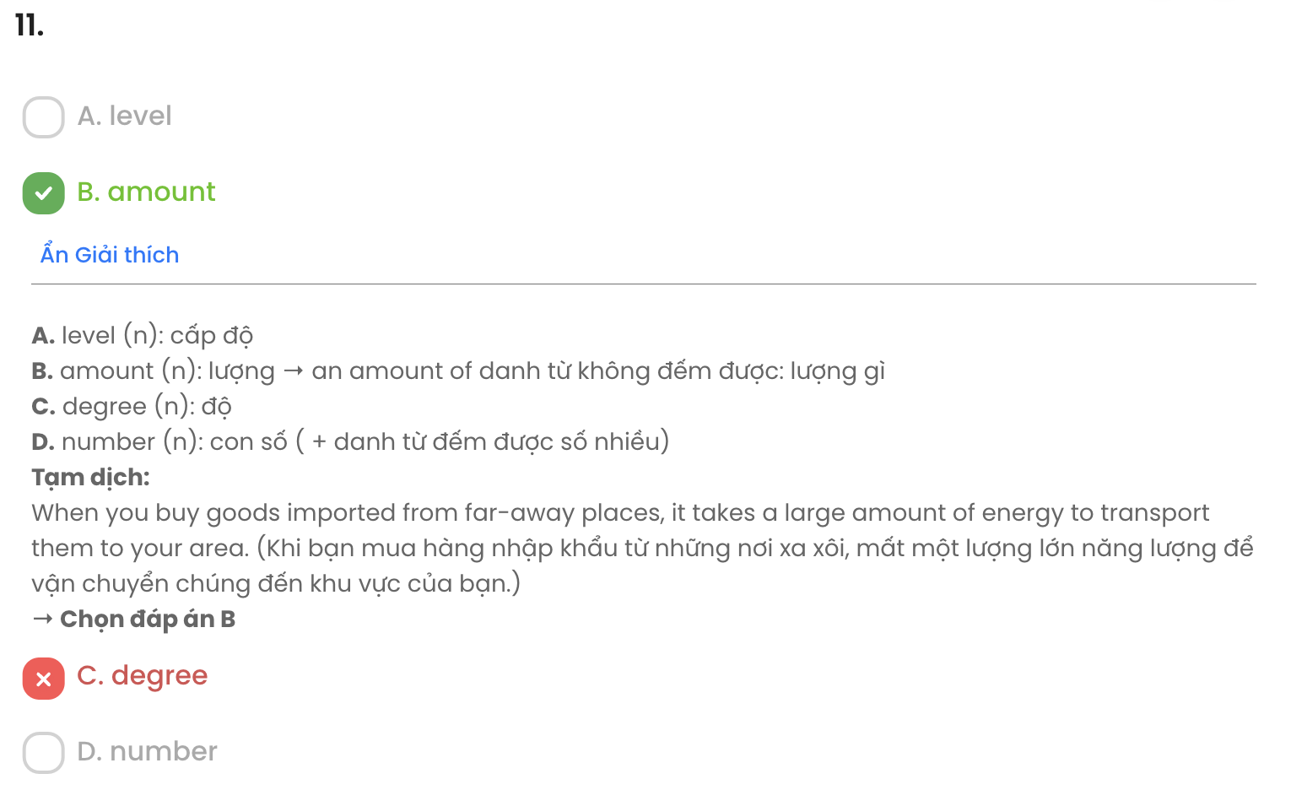

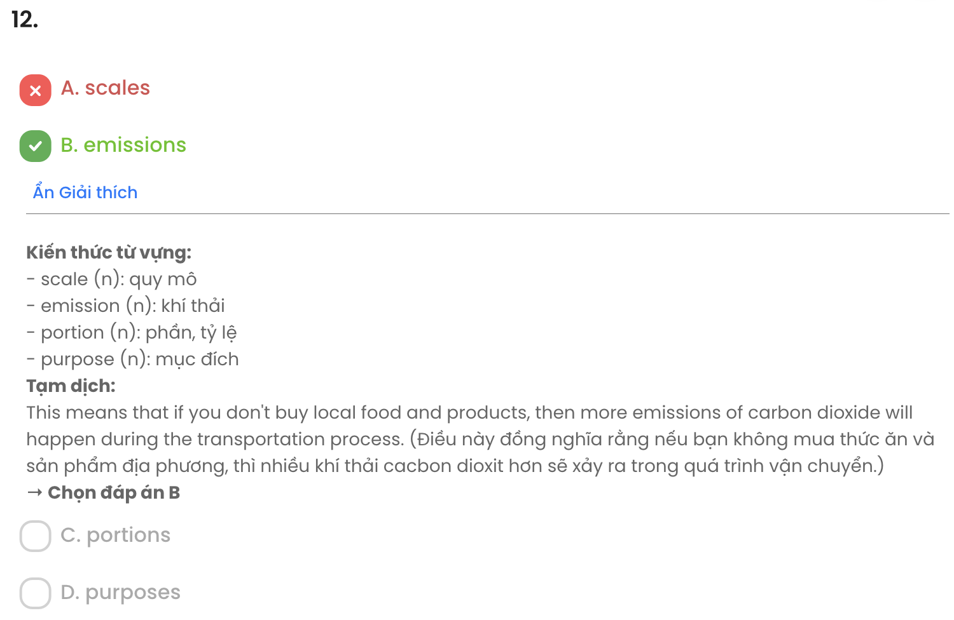

***Mark the letter A, B, C or D on your answer sheet to indicate the best arrangement of utterances or sentences to make a meaningful exchange or text in each of the following questions from 13 to 17.***

# Question 13.

1. Mai: No, I don't. Shall we do something together?
2. Ann: Do you have any plans for this Saturday evening?
3. Ann: Yes, let's. How about going to a music show? Let me check the weekend programme at the Modern Arts Centre.

(Adapted from *Global Success*)

**A.** b – c – a **B.** c – b – a **C.** b – a – c **D.** a – b – c

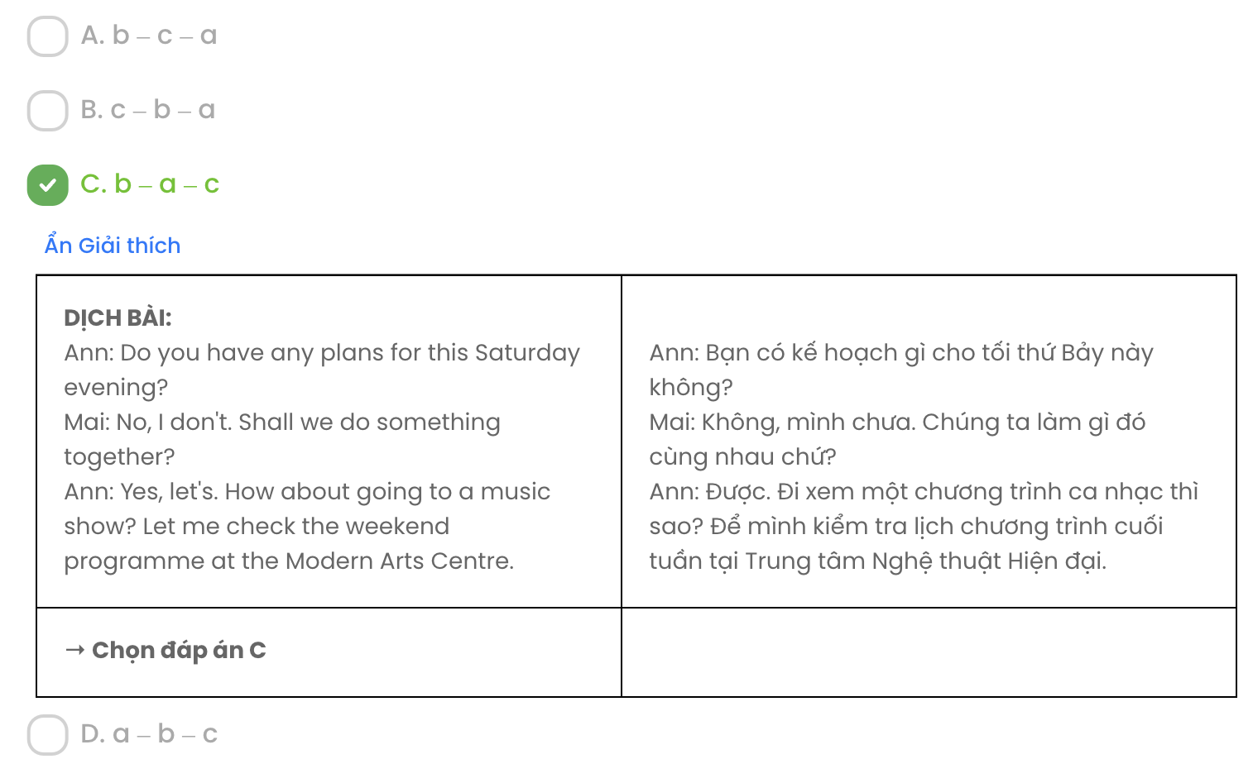

# Question 14.

1. Nam: Yes, we should all have these basic life skills to be adults.
2. Nam: Because doing housework helps them develop life skills.
3. Anna: It's true. Life skills such as cooking, cleaning, or taking care of others are really necessary for kids when they grow up.
4. Anna: Thank you for sharing your idea. It's very useful for my project.
5. Anna: Why do you think children should do housework?

(Adapted from *Global Success*)

**A.** e – b – c – a – d **B.** e – b – d – a – c **C.** d – a – e – b – c **D.** d – b – c – e – a

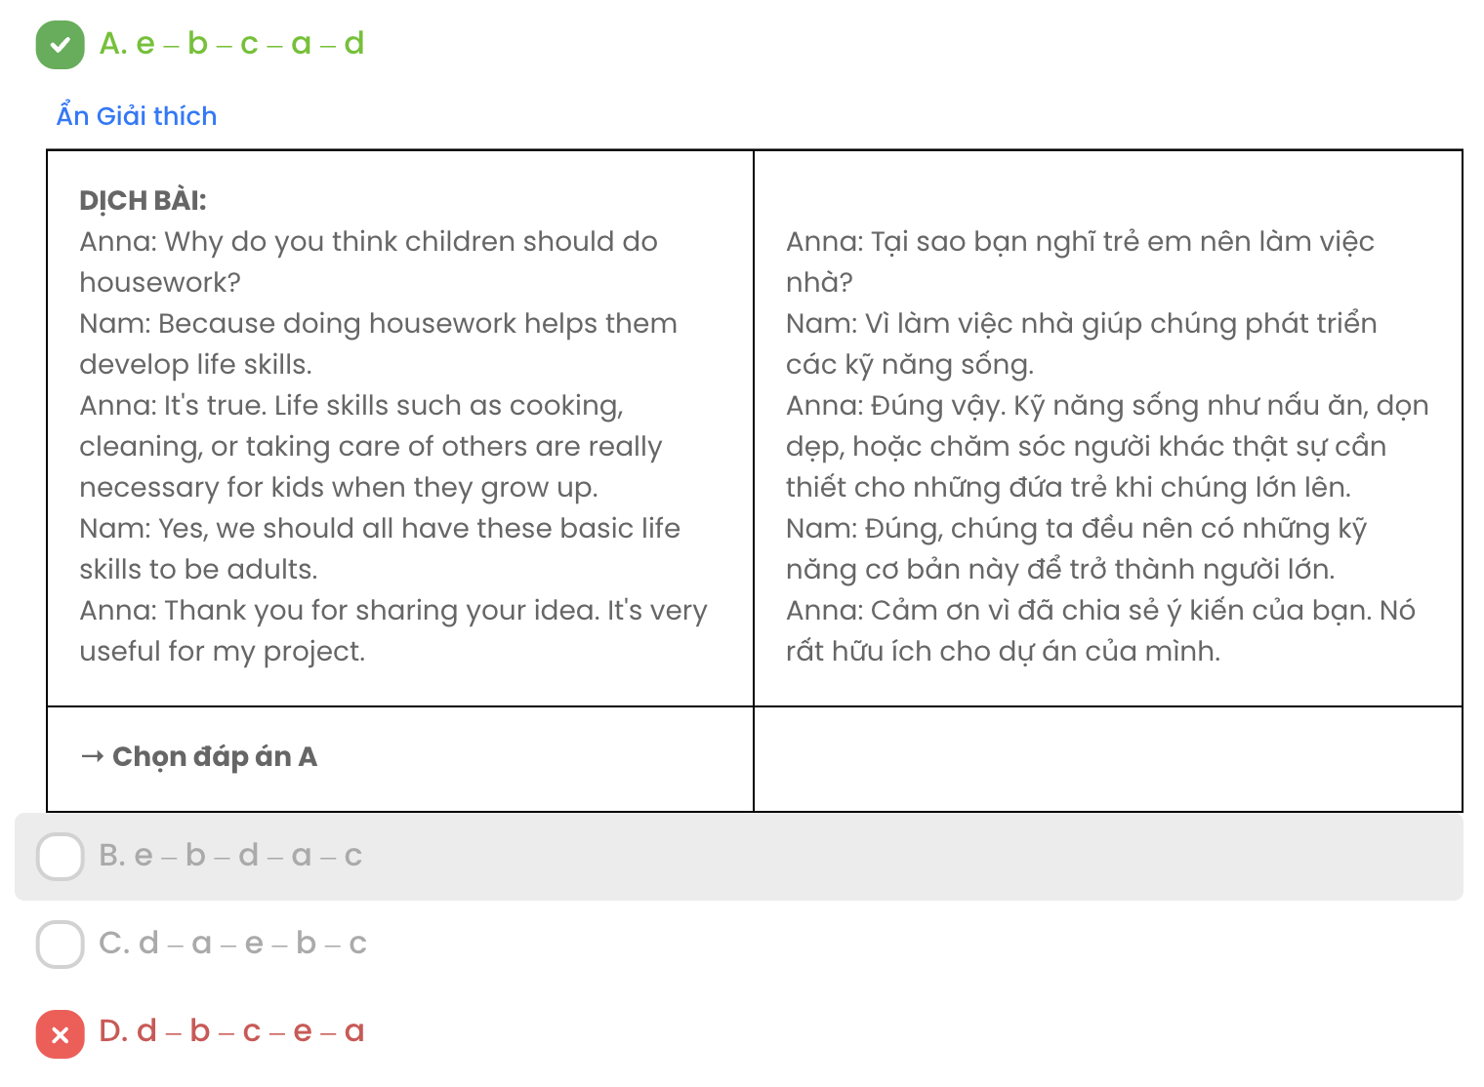

# Question 15.

Hi Jack,

* 1. I think we should try to help our parents because it's not fair for them to do everything.
  2. I make my bed every day and clean my room twice a week, which makes my parents happy.
  3. I'm sorry to hear that you're so busy with your studies and have too many chores to do.
  4. I am very busy with school and other activities, too, but I still help around the house.
  5. It's true that we don't have much free time, but doing a few chores doesn't take long. Talk to you soon!

Ryan

(Adapted from *Bright*)

**A.** a – e – c – d – b **B.** c – e – a – d – b **C.** d – a – c – e – c **D.** e – a – c – d – b

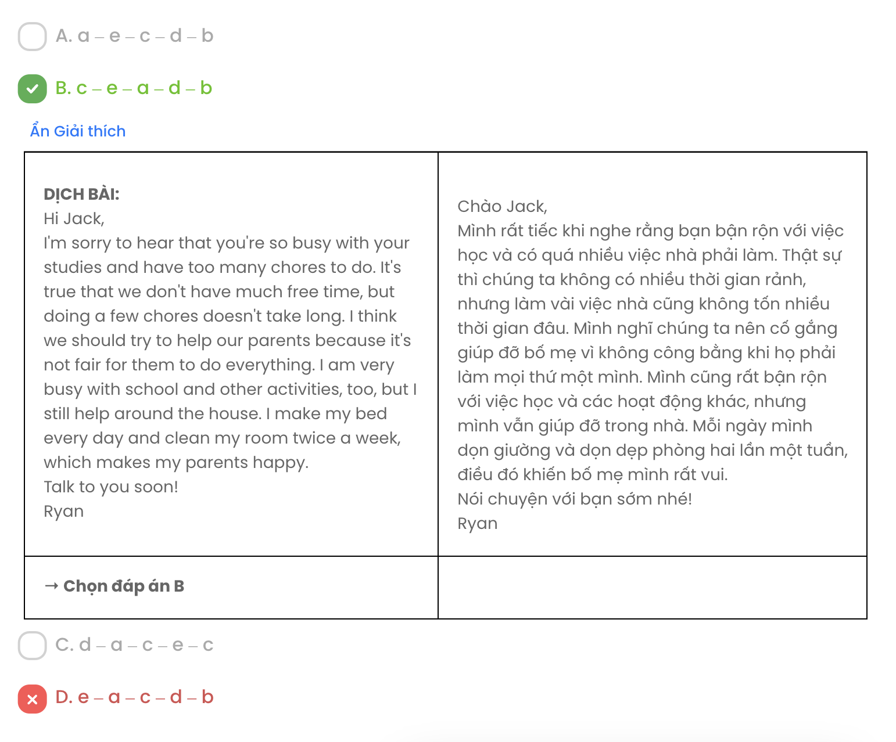

# Question 16.

* + 1. There are songs for special occasions, such as moving into a new home, and songs with stories about the history of the Muờng.
    2. In modern life, many of the Mường people still make their clothes themselves.
    3. The Muong people have their own style of music and they play the gong, one of the traditional musical instruments of the Mường culture.
    4. They need to be very creative, talented, and patient because their clothes have colourful patterns on them, which are difficult to make and take a lot of skill and time.
    5. The Mường people are proud of their traditions and culture.

(Adapted from *Bright*)

**A.** e – a – c – b – d **B.** c – a – e – d – b **C.** a – c – d – b – e **D.** b – d – c – a – e

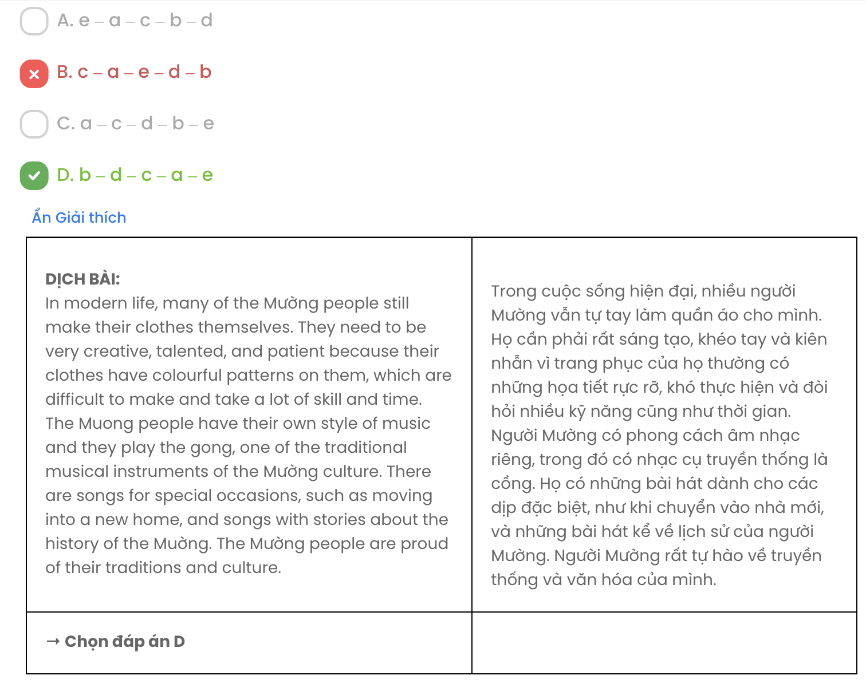

# Question 17.

* + - 1. The way they come together and help each other is a real inspiration, and something I think a lot of us here have forgotten.
      2. But I was also amazed at how positively people go about their everyday lives.
      3. It was the month when I volunteered at a hospital in Africa that changed my life.
      4. I was introduced to a world that is very different to mine in so many ways.
      5. I was horrified at how poor so many of the families over there are and how difficult their lives can be.

(Adapted from *THINK*)

**A.** c – d – e – b – a **B.** d – a – e – a – b **C.** c – e – d – b – a **D.** d – e – b – a – c

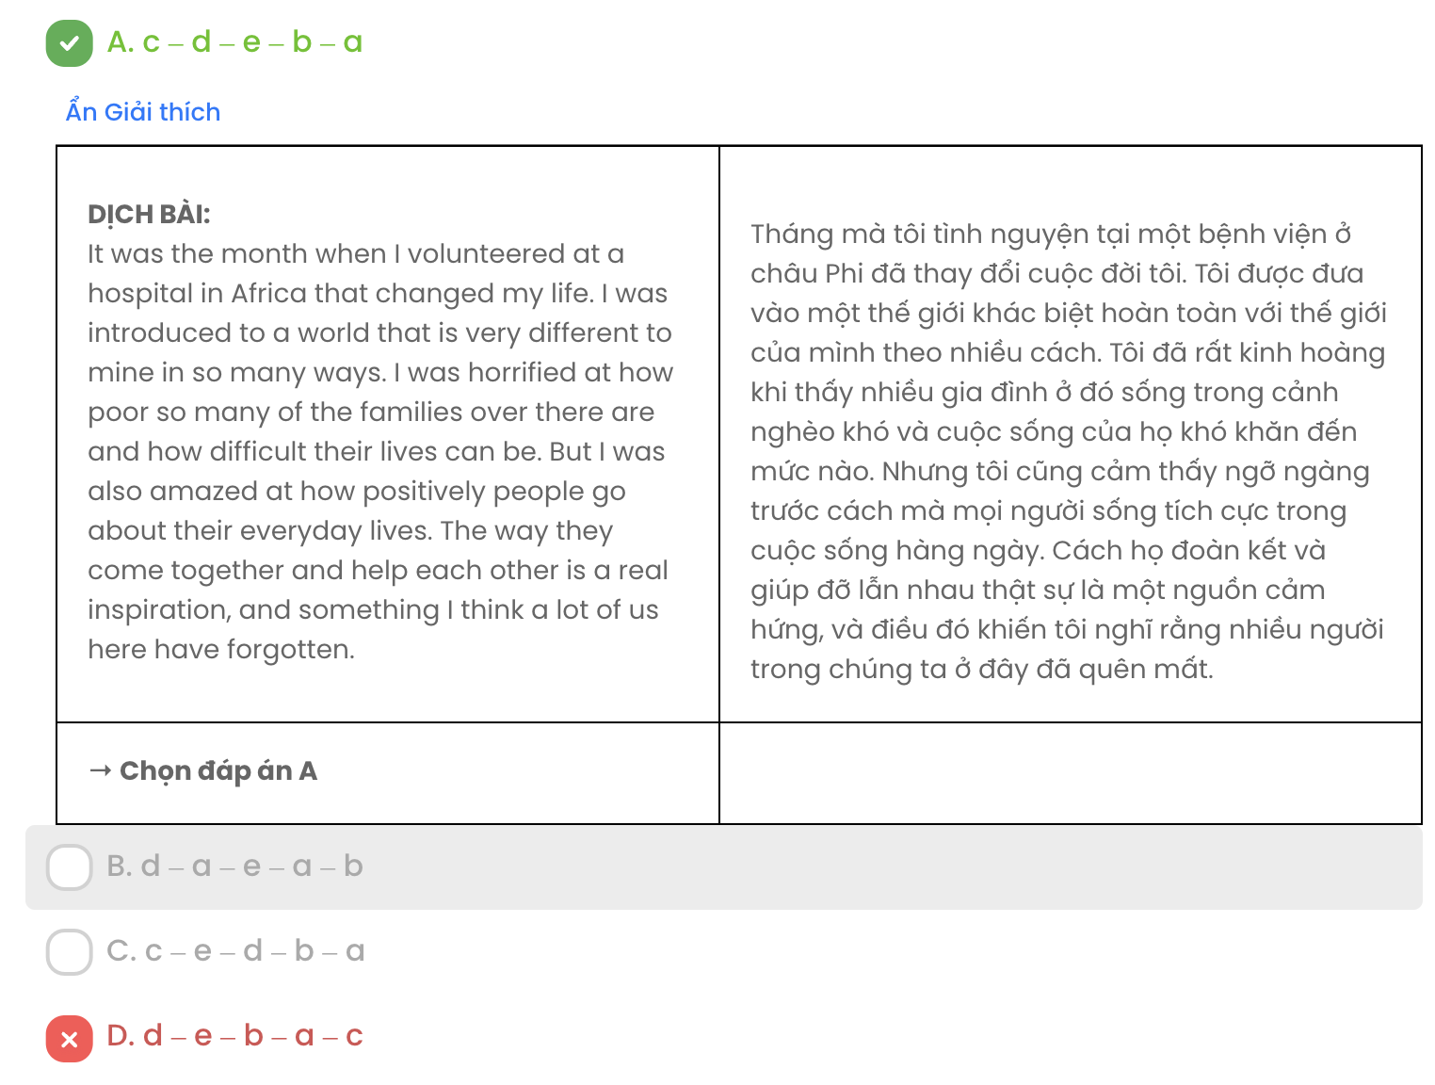

## Read the following passage about adolescence and mark the letter A, B, C, or D to indicate the correct option that best fits each of the numbered blanks from 18 to 22.

Adolescence is a difficult time for both parents and teenagers as it is a period of physical, social and emotional change. Physically, as a dependent pre-teen child, (18) . In general, emotionally and socially, adolescents like you are experiencing profound changes in terms of freedom, privacy, interests, decisions and opinions.

First, you want more freedom to choose who to see and when. (19) . Now you want to spend some more time on your own. Second, your parents made most decisions before adolescence. But now you want to decide things for yourselves. You hate being told what to do all the time. Above all, adolescents have strong opinions and are idealistic. (20) . You feel you have all the answers while adults don't.

All these perfectly normal changes will affect teenagers' relationship with their parents. (21)

? Firstly, let your parents know that you still love and value them. Secondly, try to agree to rules and boundaries and prove to be dependable. Keep your words and stick to rules. Thirdly, (22) _ . Show your parents that you are capable of an independent life by taking care of your own school work and maintaining a healthy lifestyle. Finally, it's all about communication! Keep talking to your parents.

(Adapted from *Friends Global*)

# 

# 

# Question 18.

1. on which the transformation into an independent young adult triggers
2. totally changed into an independent young adult
3. you are being transformed into an independent young adult
4. that the transition to an independent young adult finally occurs

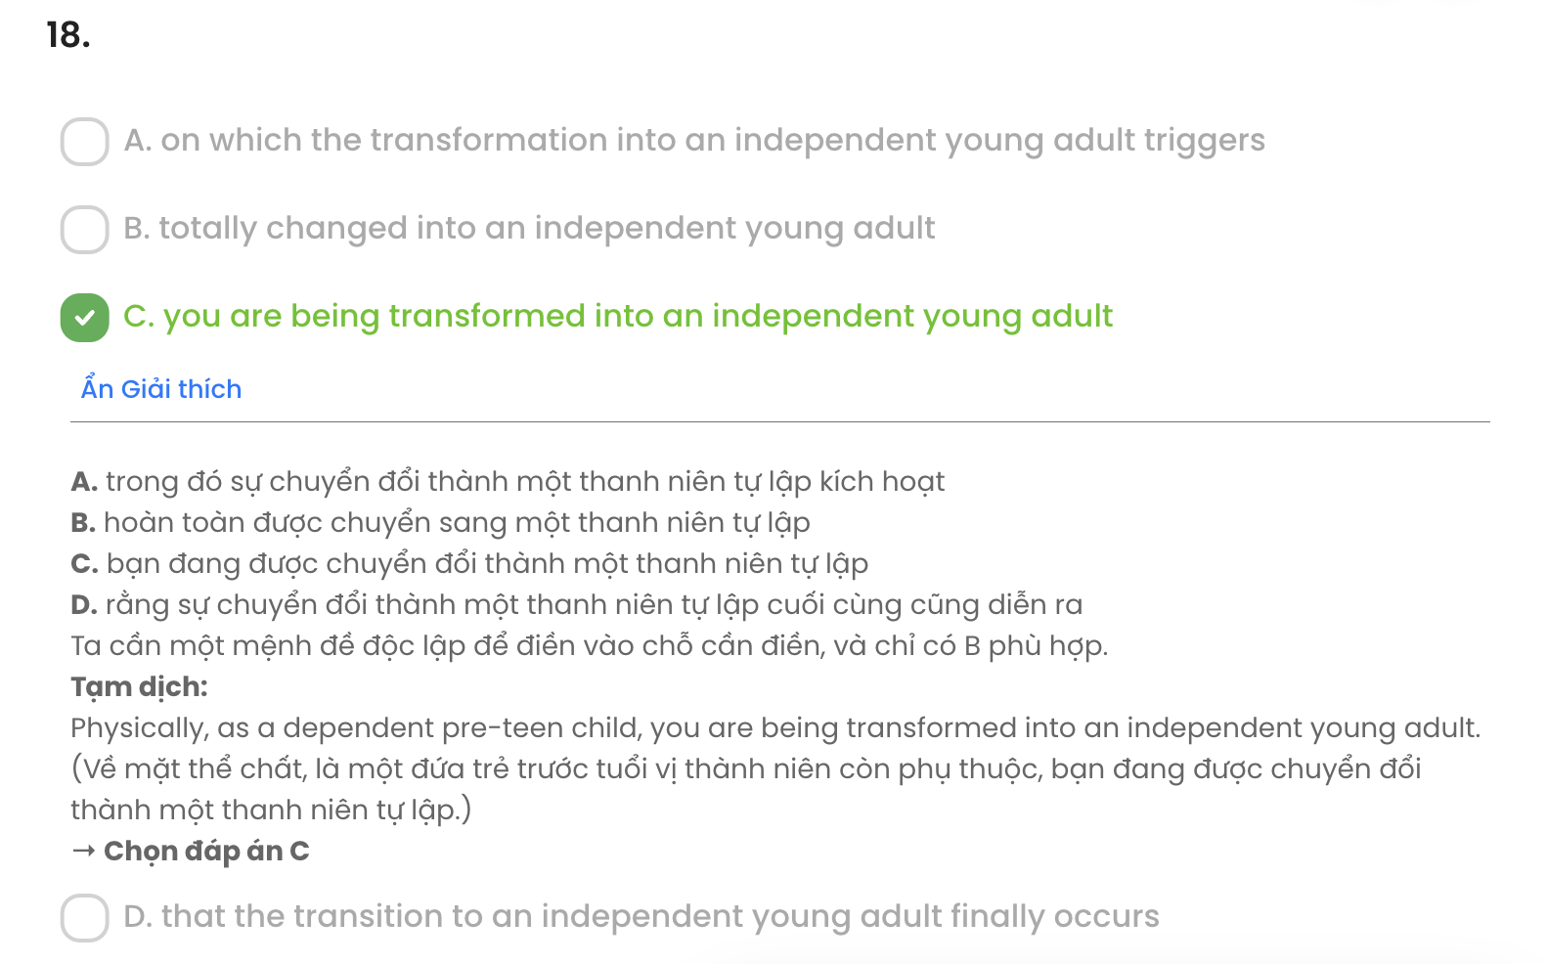

# Question 19.

1. Being in the company of your parents, you are thrilled
2. You used to be most happy in the company of your parents
3. You felt delighted without the company of your parents
4. The company of your parents hardly satisfied you

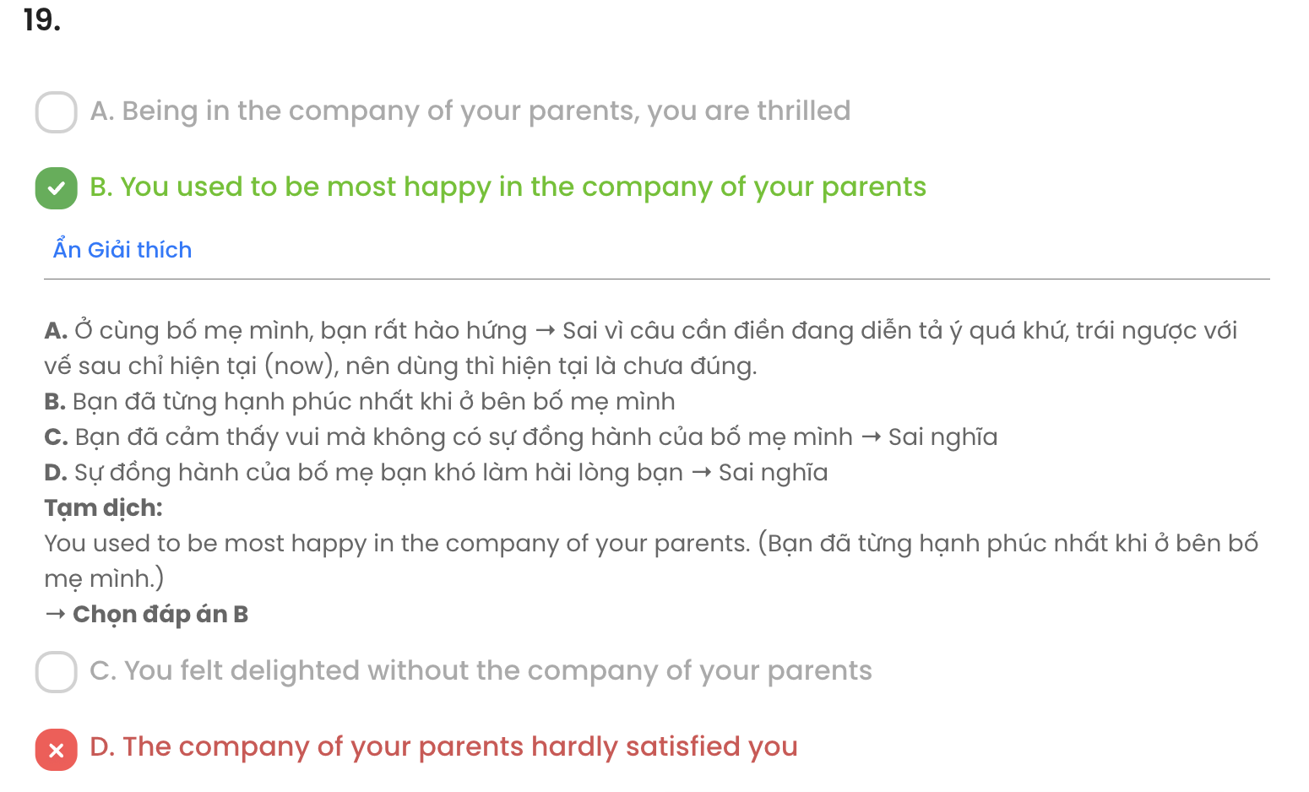

# Question 20.

1. You see the world differently, develop your own views and your own sense of right or wrong
2. Seeing the world differently, your own views and your own sense of right or wrong are developed
3. While you have developed your own views and your own sense of right or wrong, you now adopt a different viewpoint on the world
4. Your own views and your own sense of right or wrong are developed so that the way you see the world changes

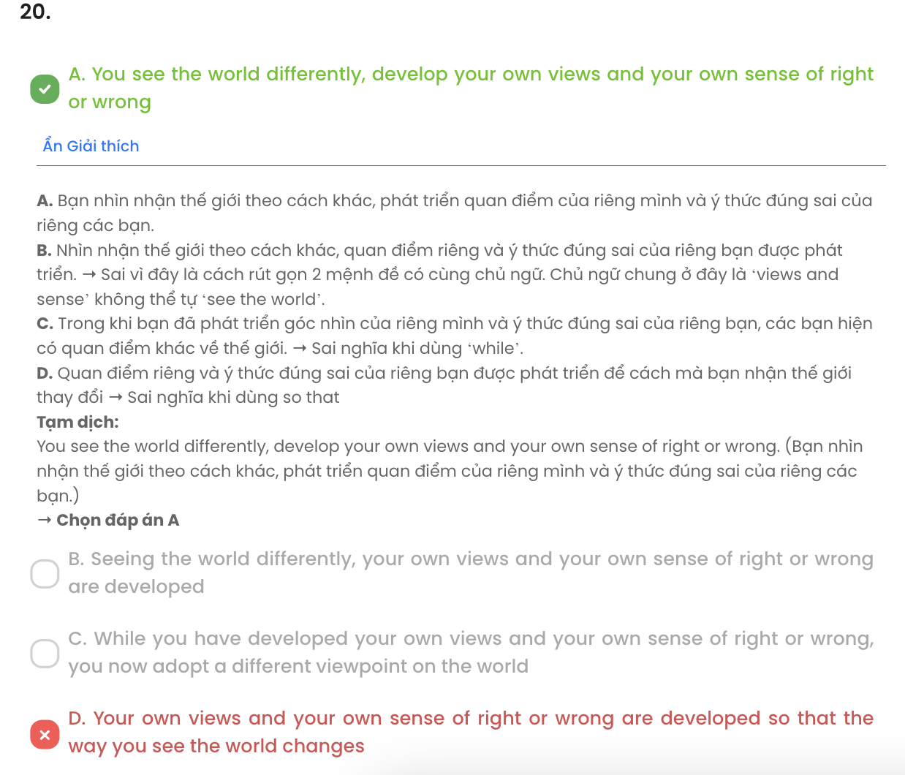

# Question 21.

1. But as adolescents, how do you struggle to get on well with your parents
2. So what should parents do to create a harmonious atmosphere in the family
3. But what if adolescents try to maintain a good relationship with their parents
4. So what can you, as adolescents, do to stay on good terms with your parents

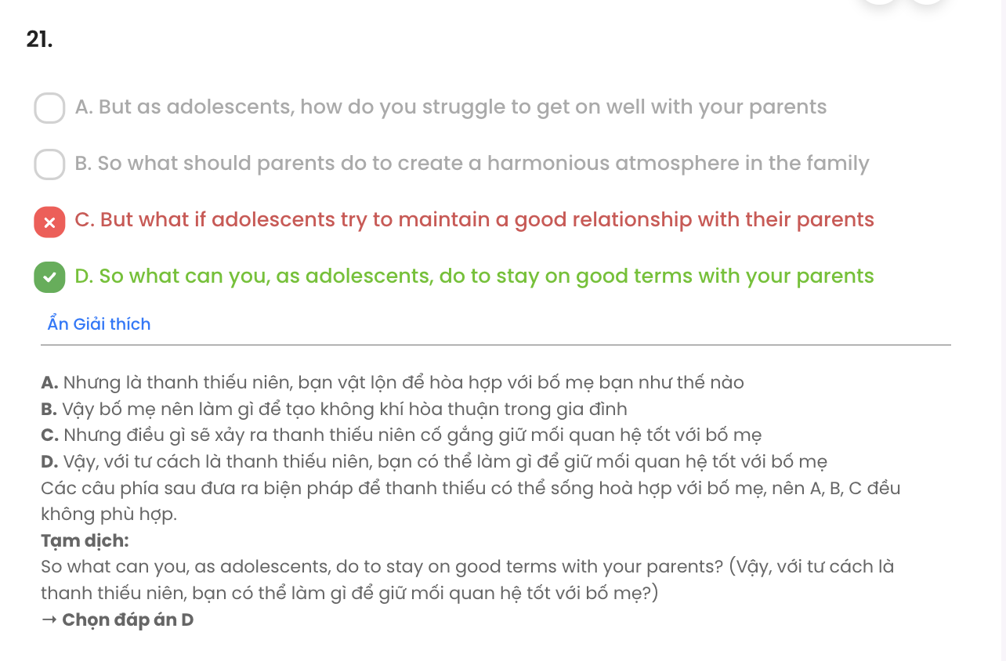

# Question 22.

1. having tried to see why your behaviour angers your parents
2. try to understand why they might be irritated by your behaviour
3. if you try to figure out why your parents are furious at your behaviour
4. understand why they are trying to be annoyed by your behaviour

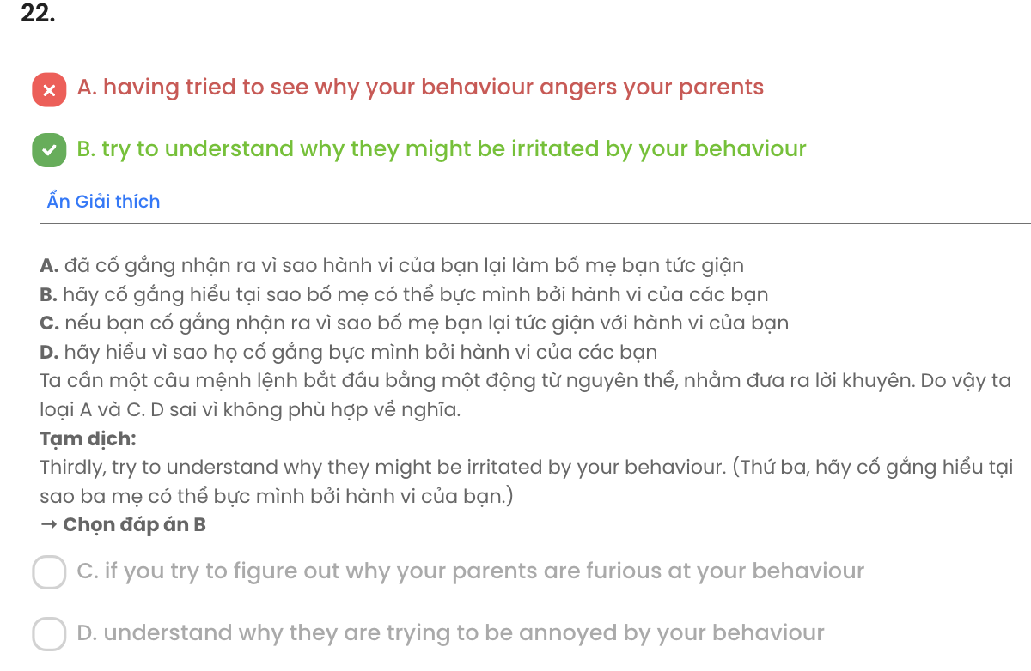

## Read the following passage about tourist graffiti and mark the letter A, B, C, or D to indicate the correct answer to each of the questions from 23 to 30.

People in China were angry and there was a big hunt to find the person responsible for the graffiti in Chinese on a 3,500-year-old monument in Luxor. The message wasn't very **imaginative** but basically 'Ding Jinhao was here', so Internet users easily found this particular Ding Jinhao, a teenager in Nanjing. His parents then told a local newspaper that their son was sorry for his actions.

It is a serious crime to write on a historic monument in Egypt. But in the past, people could write on monuments and no one was angry about **it**. At Giza there is an example of graffiti on a temple wall from 1244 BC. It says 'Hadnakhte came to make an excursion and amuse himself on the west of the

Memphis, together with his brother, Panakhti'.

In Roman times, one of the first Egyptologists, Giovanni Belzoni, was the first modern man to enter the pyramid of Khafre. Inside the pyramid today you can read his text celebrating the discovery. Later, in the second half of the 19th century, Europeans could travel around the world, and they could climb to the top of the Great Pyramid. There was graffiti in just about every language up there.

**Luckily, it wasn't difficult to make Ding Jinhao's graffiti disappear**. But China's National Tourism Administration is right to advise all tourists to act in a **civilised** way.

(Adapted from *Move On*)

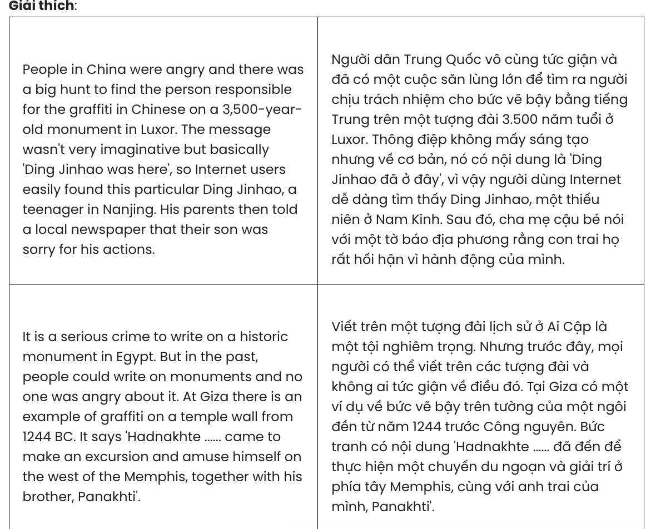

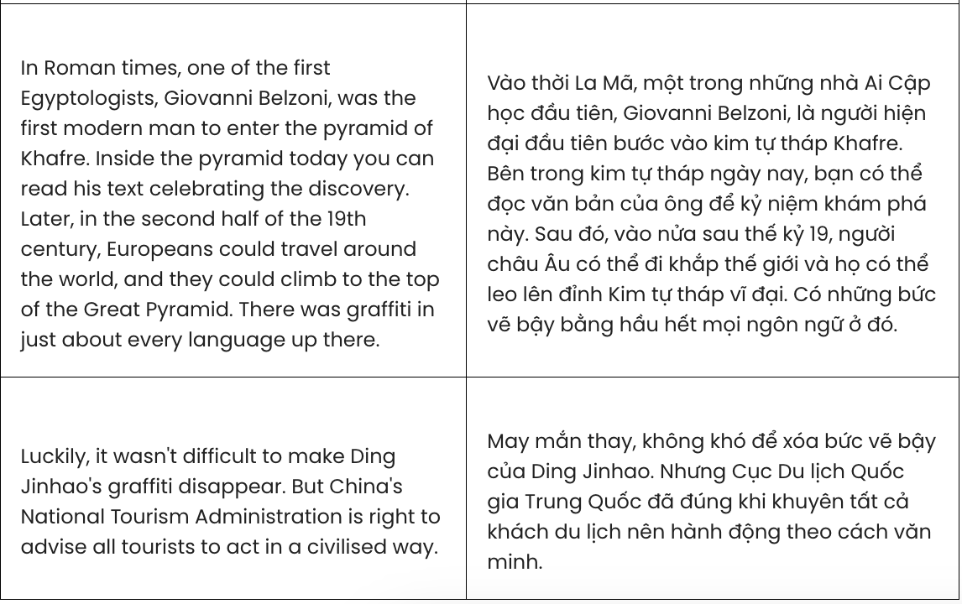

**Question 23.** As stated in paragraph 1, Chinese citizens were angry because .

1. there was a big hunt at a monument in Luxor
2. they saw the graffiti on an ancient monument
3. a teenager committed a violent crime
4. the graffiti artist didn’t feel sorry for his actions

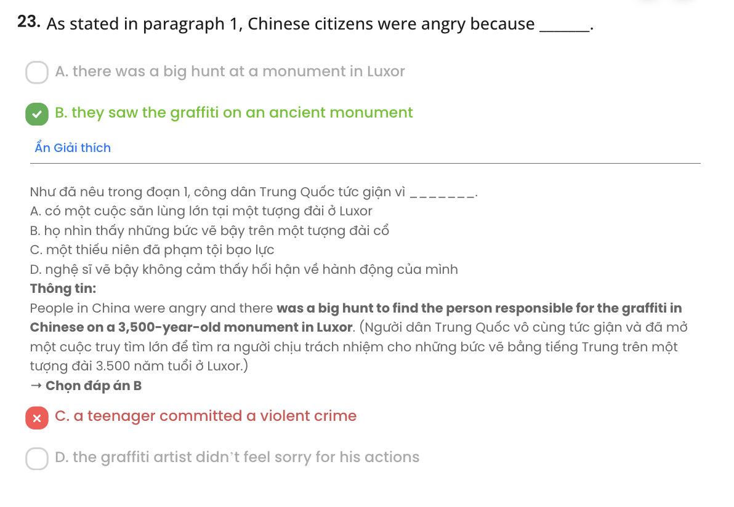

**Question 24.** The word **imaginative** in paragraph 1 can be best replaced by .

**A.** creative **B.** terrible **C.** unclear **D.** inspiring

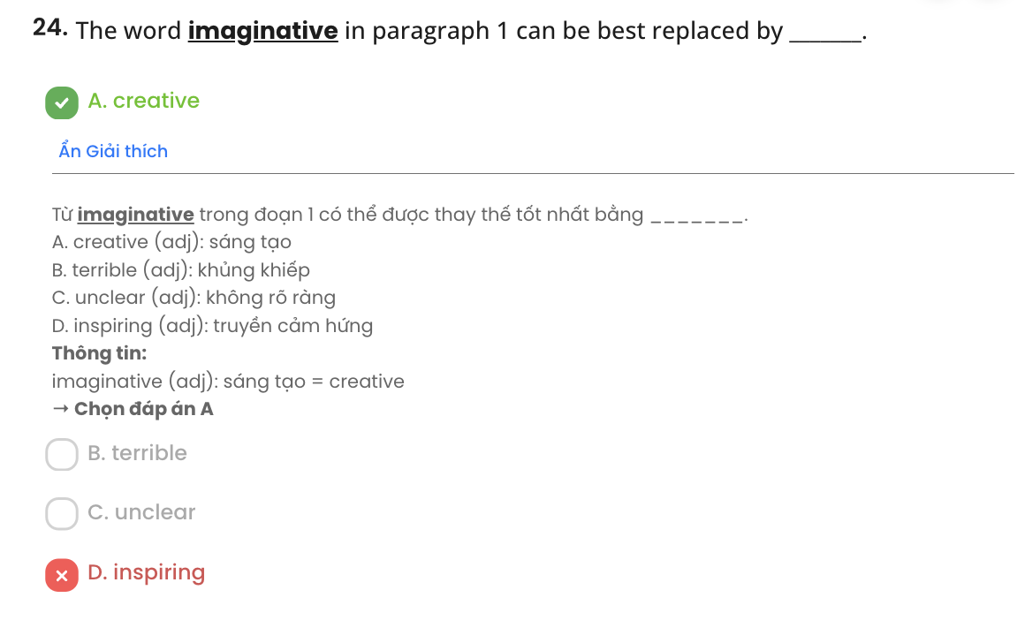

**Question 25.** The word **it** in paragraph 1 refers to .

**A.** a historic monument **B.** an example of graffiti

**C.** writing on monuments **D.** a temple wall

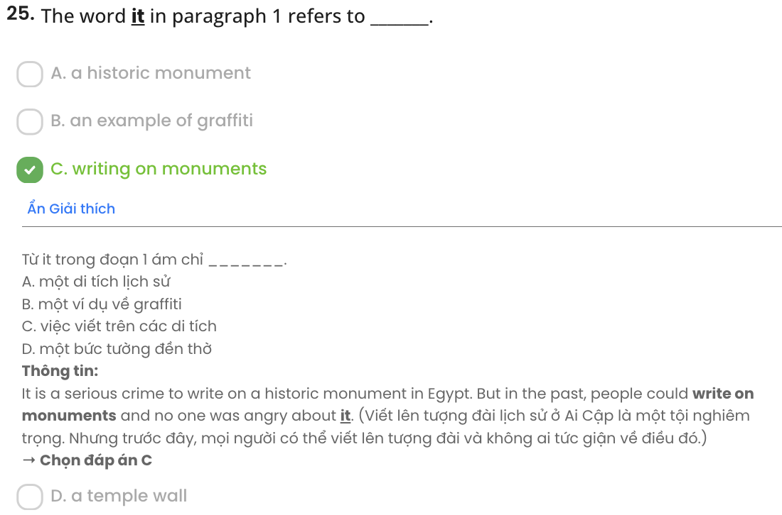

**Question 26.** Which of the following best paraphrases the underlined sentence in paragraph 4?

1. It was fortunate that Ding Jinhao’s graffiti was simple to remove.
2. Fortunately, erasing Ding Jinhao's graffiti was easier than expected.
3. It was fortunate that Ding Jinhao's graffiti was nearly possible to erase.
4. Luckily, Ding Jinhao’s graffiti became less visible thanks to efforts.

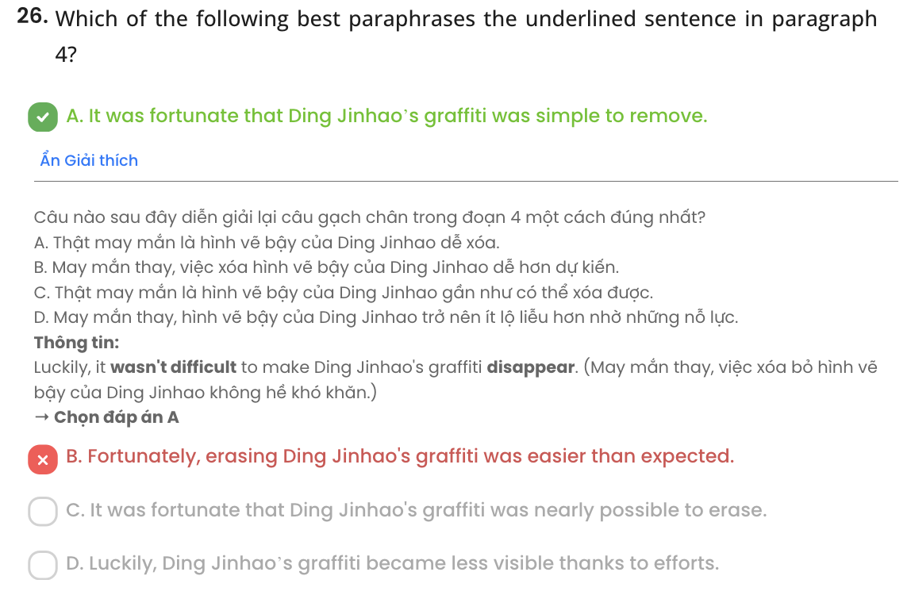

**Question 27.** The word **civilised** in paragraph 4 is OPPOSITE in meaning to .

**A.** normal **B.** unacceptable **C.** fair **D.** dangerous

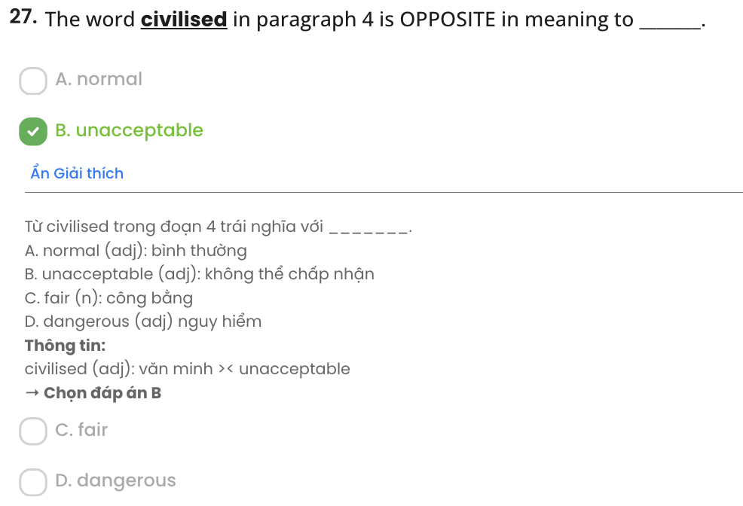

**Question 28.** Which of the following is TRUE according to the passage?

1. Ding Jinhao was identified online, and his actions were publicly criticised.
2. Writing on an ancient monument was regarded as a serious crime in Egypt.
3. Giovanni Belzoni’s writing in the pyramid of Khafre is hardly noticeable today.
4. The top of the Great Pyramid is now covered with writing in almost every language.

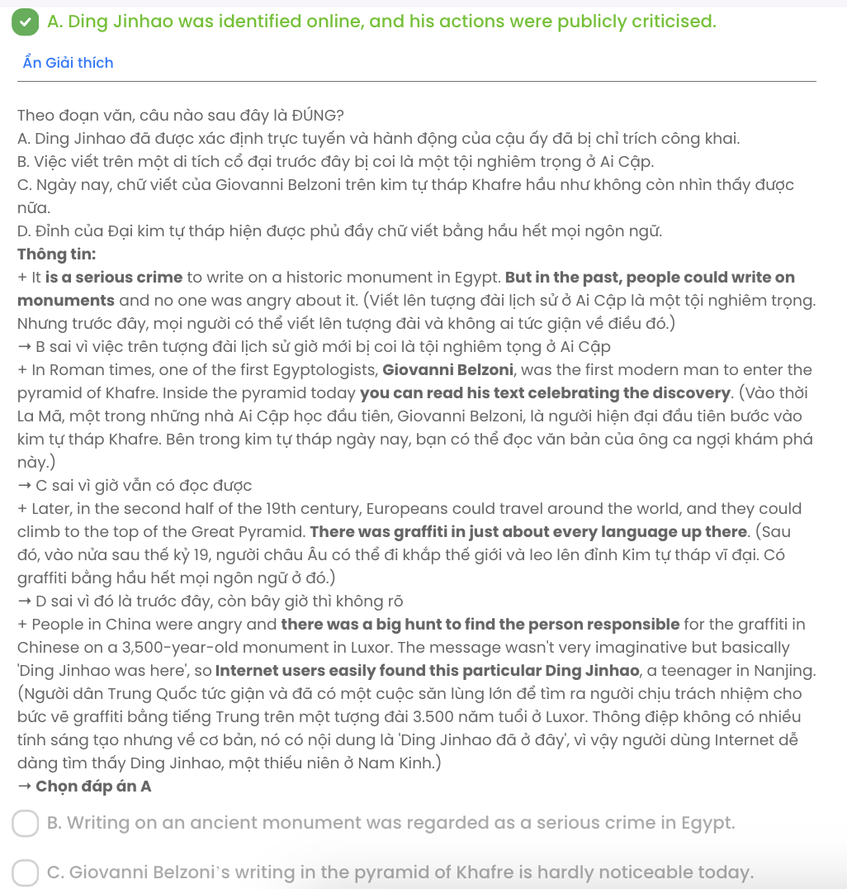

**Question 29.** In which paragraph does the author mention a contrast relationship?

**A.** Paragraph 1 **B.** Paragraph 2 **C.** Paragraph **D.** Paragraph 4

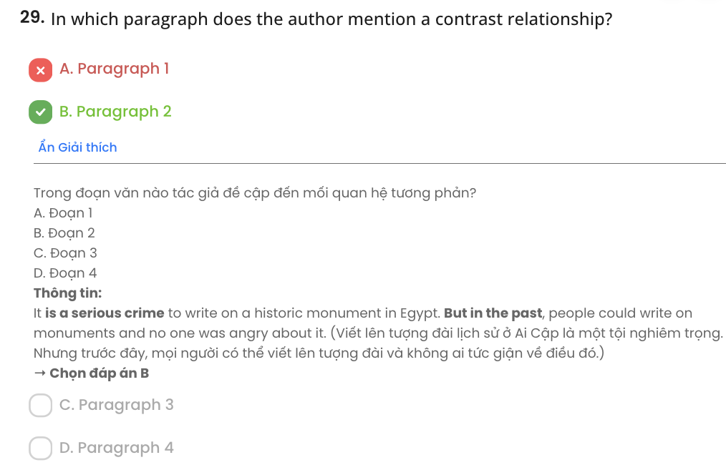

**Question 30.** In which paragraph does the author mention the outcome of a situation?

**A.** Paragraph 1 **B.** Paragraph 2 **C.** Paragraph 3 **D.** Paragraph 4

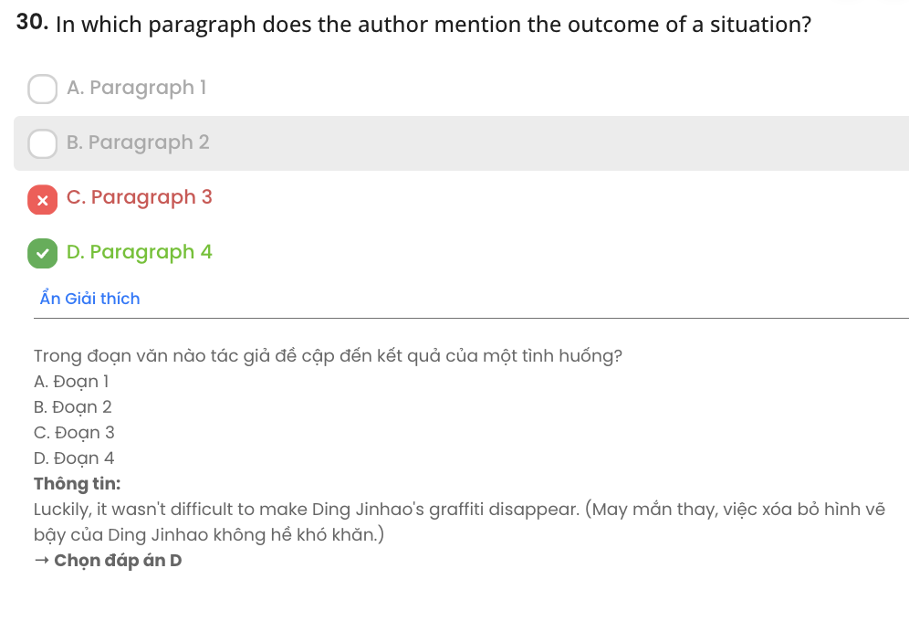

## Read the following passage about a cycling revolution in India and mark the letter A, B, C, or D to indicate the correct answer to each of the questions from 31 to 40.

Nibha Kumari, a resident of Bihar, India’s poorest state, recalls how a bicycle transformed her life when she turned 15. For two years, six days a week, she cycled two hours daily from home to school and coaching classes and back, using a bicycle provided by the state government. “If I didn’t have a cycle, I don’t think I could have finished high school. **It** changed my life,” says Nibha, now 27.

A new peer-reviewed study published in Journal of Transport Geography **reveals** remarkable insights about school-going children and cycling in rural India. The study by Srishti Agrawal, Adit Seth and Rahul Goel found that the most notable rise in cycling in India had occurred among rural girls - increasing more than two times from 4.5% in 2007 to 11% in 2017 - reducing the gender gap in the activity. “This is a silent revolution. We call it a revolution because cycling levels increased among girls in a country which has high levels of gender inequality in terms of female mobility outside the home, in general, and for cycling, in particular,” says Ms Agrawal.

**[I]** State-run free bicycle distribution schemes since 2004 have targeted girls, who had higher school dropout rates than boys due to household chores and exhausting long walks. **[II]** This approach isn’t unique to India - evidence from countries like Colombia, Kenya, Malawi and Zimbabwe also shows that bicycles effectively boost girls' school enrolment and retention. **[III]** Cycling to school in rural areas doubled over the decade, while in urban areas, it remained steady. Indian city roads are notoriously unsafe, with low urban cycling to school linked to poor traffic safety and more cars on the road. **[IV]**

American suffragist Susan B Anthony famously said that the bicycle “has done more to **emancipate** women than anything else in the world. It gives women a feeling of freedom and self- reliance". **Researchers wonder if women cycle less as they age due to shrinking job opportunities and workforce dropout**. Nibha stopped cycling after marriage and moving to her in-laws' home. While she still travels outside the house as she trains to become a teacher, when asked about her commute, she simply says, "I don't need the cycle anymore."

(Adapted from *https:*[*//w*](http://www.bbc.com/news))*ww*[*.bbc.com/news*)](http://www.bbc.com/news))

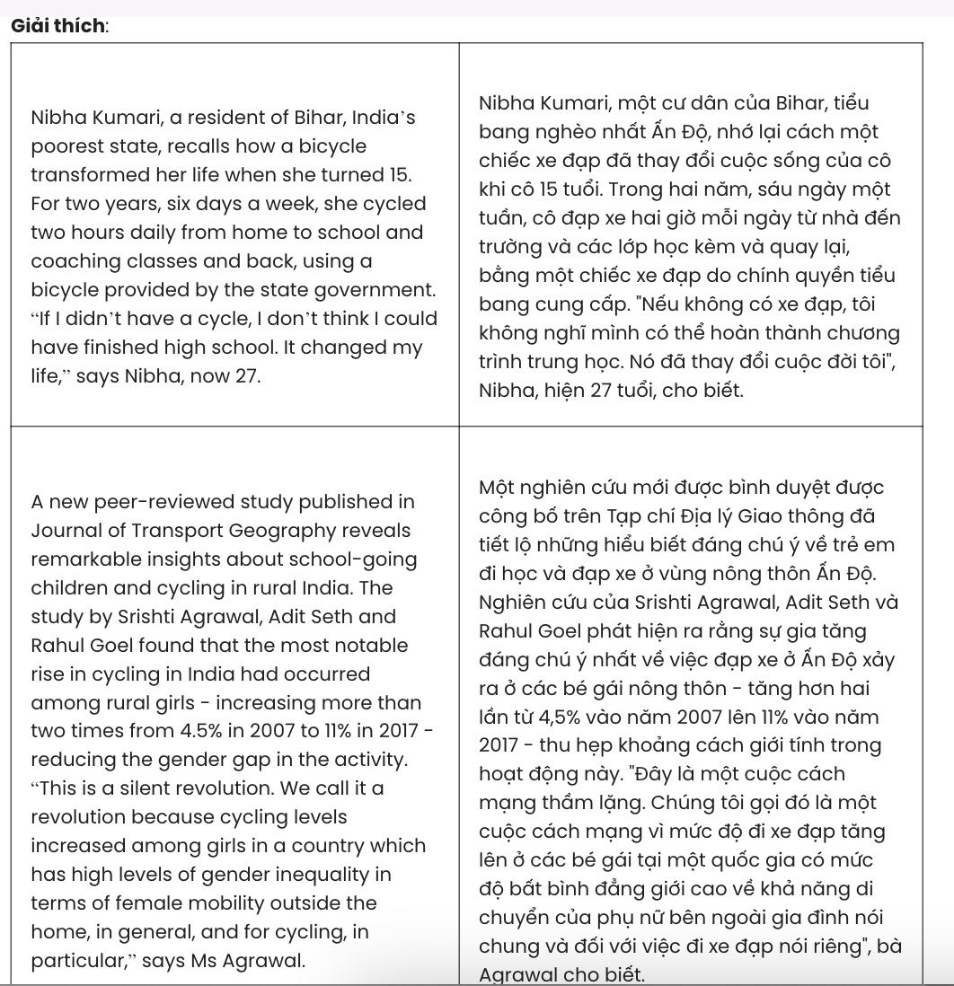

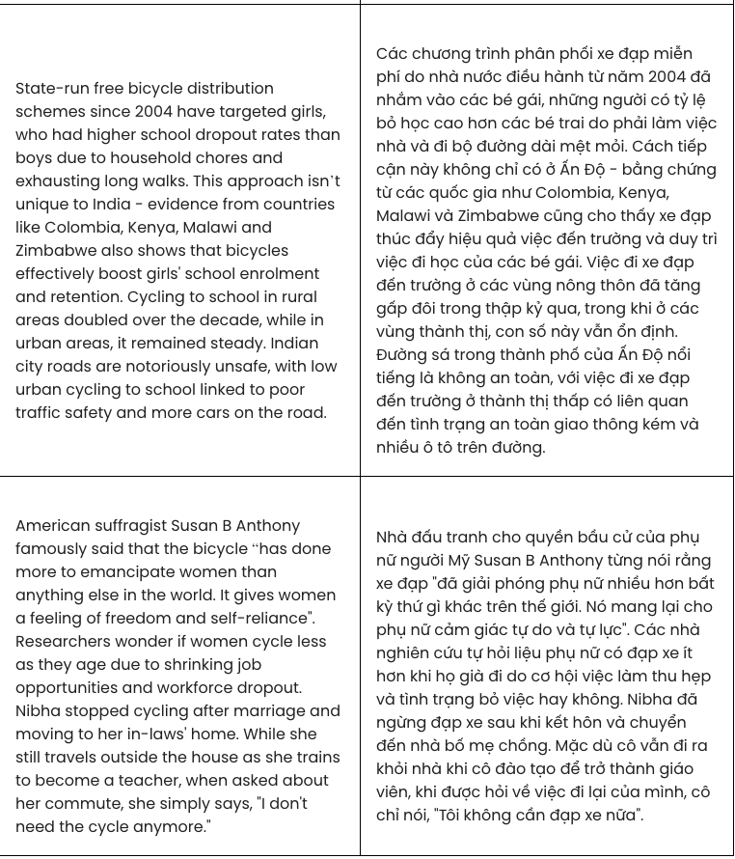

**Question 31.** The word **It** in paragraph 1 refers to .

**A.** high school **B.** a cycle **C.** state government **D.** life

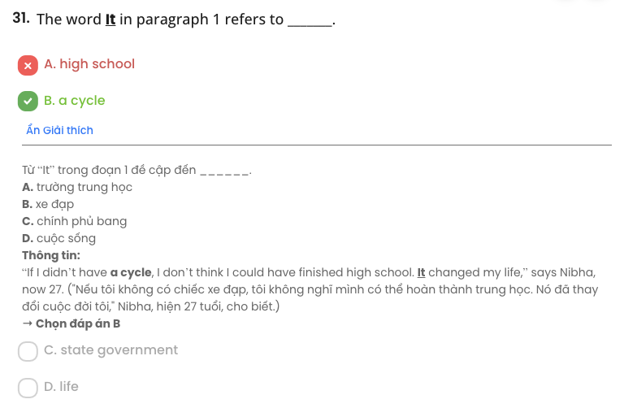

**Question 32.** The word **reveals** in paragraph 2 is closest in meaning to .

**A.** discloses **B.** assesses **C.** opposes **D.** controls

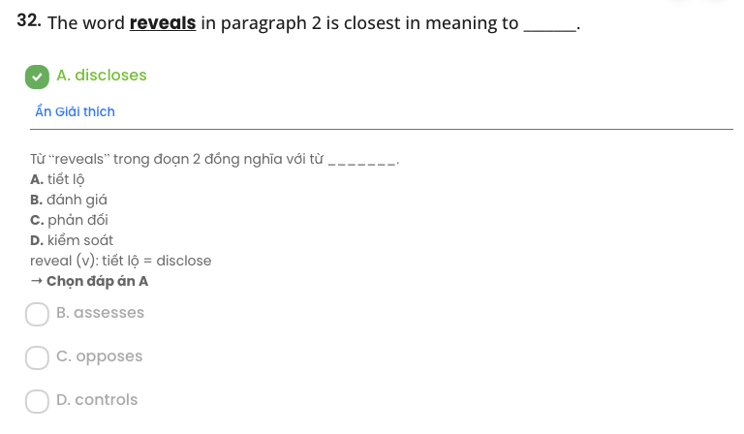

**Question 33.** According to paragraph 2, a sharp rise in cycling rates among schoolgirls in India indicates that .

**A.** a revolution in cycling is about to happen **B.** gender inequality is a pressing issue in India

**C.** the gender gap in cycling has been narrowed **D.** female mobility is limited in certain ways

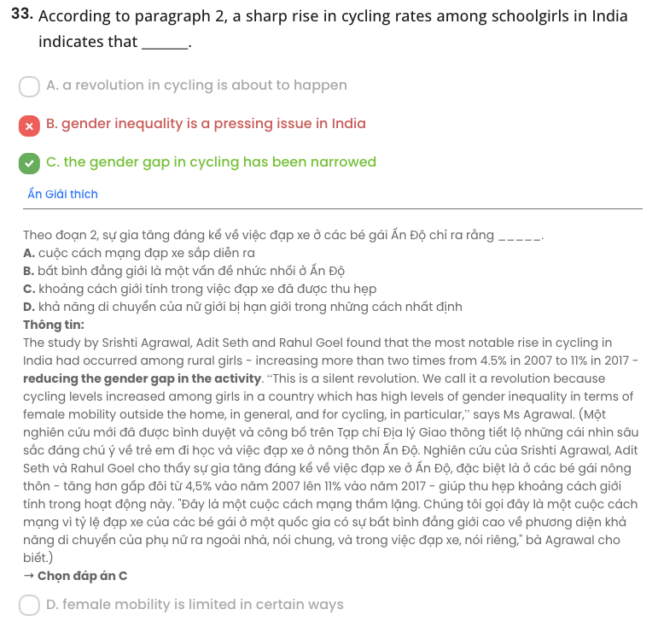

**Question 34.** Which of the following best summarises paragraph 2?

1. A study shows rural girls’ cycling in India doubled, reducing the gender gap in mobility
2. A study demonstrates how cycling has transformed the way Indian girls go to school
3. A study illustrates that cycling in India rose despite high levels of gender inequality
4. A study clarifies the positive effects of cycling on both boys and girls in India

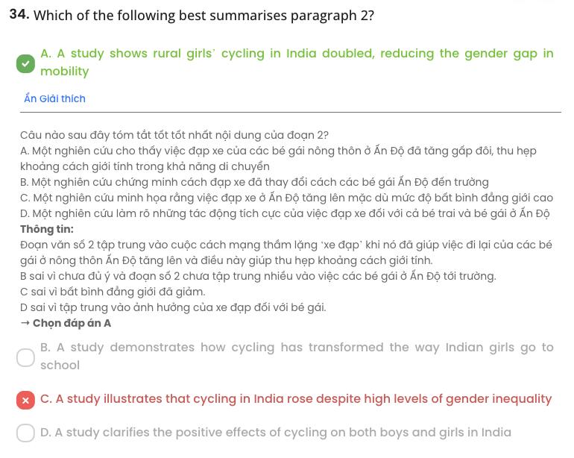

**Question 35.** Where in paragraph 3 does the following sentence best fit?

# But the scale here is unmatched.

**A.** [I] **B.** [II] **C.** [III] **D.** [IV]

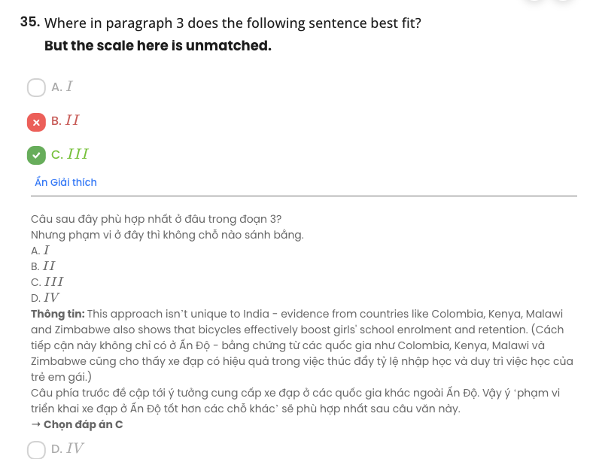

**Question 36.** Which of the following is true according to the passage?

1. Gender inequality regarding female cycling is still extremely high in India.
2. Nibha’s success is partly attributed to a bicycle provided by the government.
3. Indian girls had higher school dropouts rates than boys as they didn’t have a cycle.
4. The free bicycle distribution schemes have specifically targeted girls since 2004.

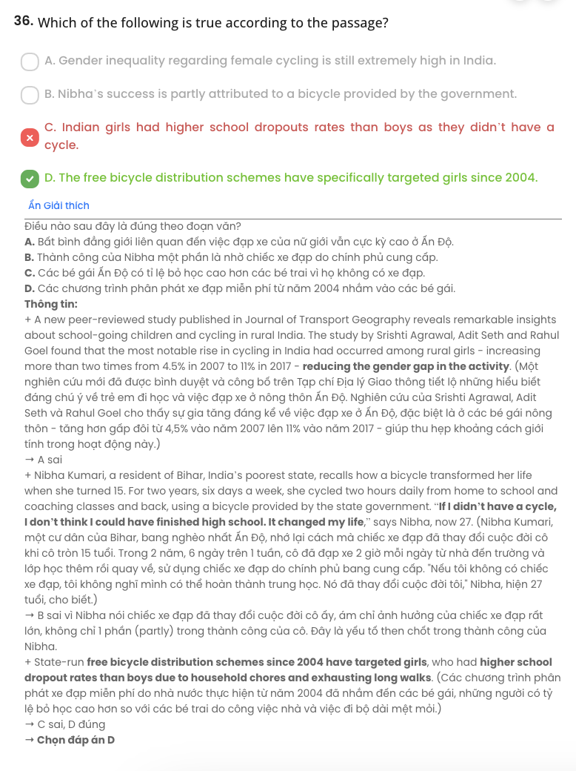

**Question 37.** The word **emancipate** in paragraph 4 is OPPOSITE in meaning to .

**A.** restrict **B.** reduce **C.** free **D.** object

Chỉ 100k/12 tháng, bạn tải rất nhiều tài liệu tiếng anh file word hay tại: ***Giaoandethitienganh.info***  Mong bạn ghé ủng hộ !

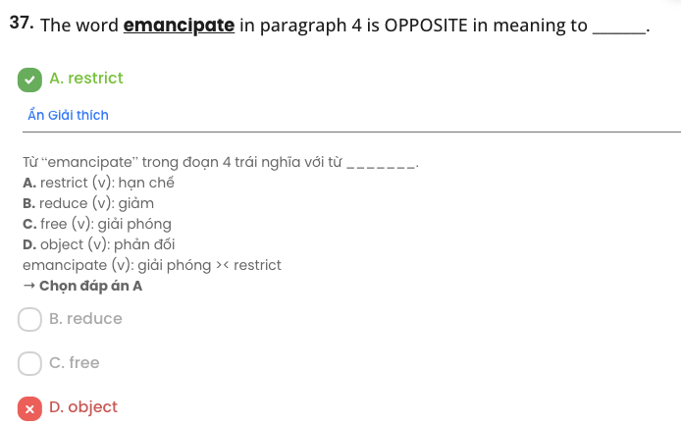

**Question 38.** Which of the following best paraphrases the underlined sentence in paragraph 4?

1. Researchers doubt if women cycle more with age due to gaining more career opportunities and rejoining the workforce.
2. Researchers believe women stop cycling more as they age because their job options reduce.
3. Researchers speculate whether fewer job prospects and workforce exit cause women to cycle less over time.
4. Researchers assume that as women age, declining job opportunities lead to less cycling.

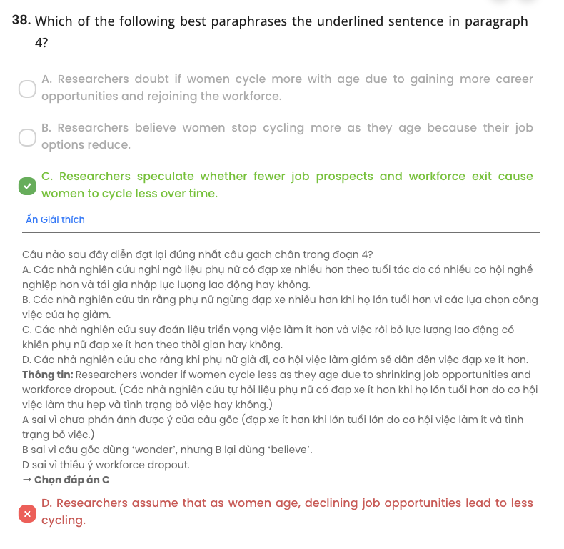

**Question 39.** It can be inferred from the passage that .

1. there is not much difference in cycling rates between rural and urban areas in India
2. a growth in car ownership in India is entirely to blame for low urban cycling
3. shifts in life priorities influence the continuation of cycling among women in India
4. cycling is not a preferred option for Indian women when they reach marriage age

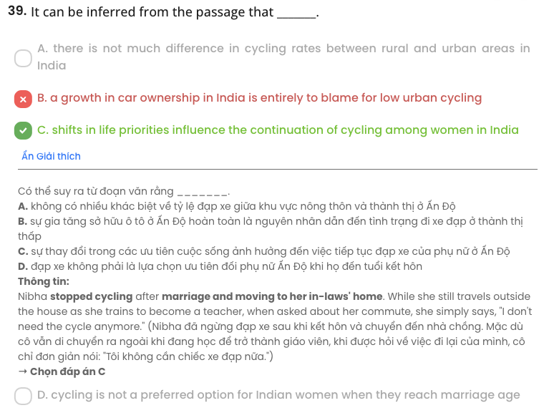

**Question 40.** Which of the following best summarises the passage?

1. State-run bicycle schemes in rural India helped boost school retention for girls, although the lack of significant infrastructure improvements continues to challenge the effectiveness of the program in increasing cycling.
2. Bicycle distribution in rural India, aimed at both boys and girls, significantly improved school attendance, but challenges like inadequate infrastructure and long commutes hindered long-term effectiveness, especially for girls.
3. The distribution of bicycles in rural India primarily benefited girls, dramatically reducing dropout rates and doubling their cycling participation, yet these efforts had little effect on boys' school retention.
4. Indian rural girls benefited the most from government bicycle schemes, with cycling rates increasing, leading to higher school retention, though life circumstances can limit the broader adoption of cycling for women.

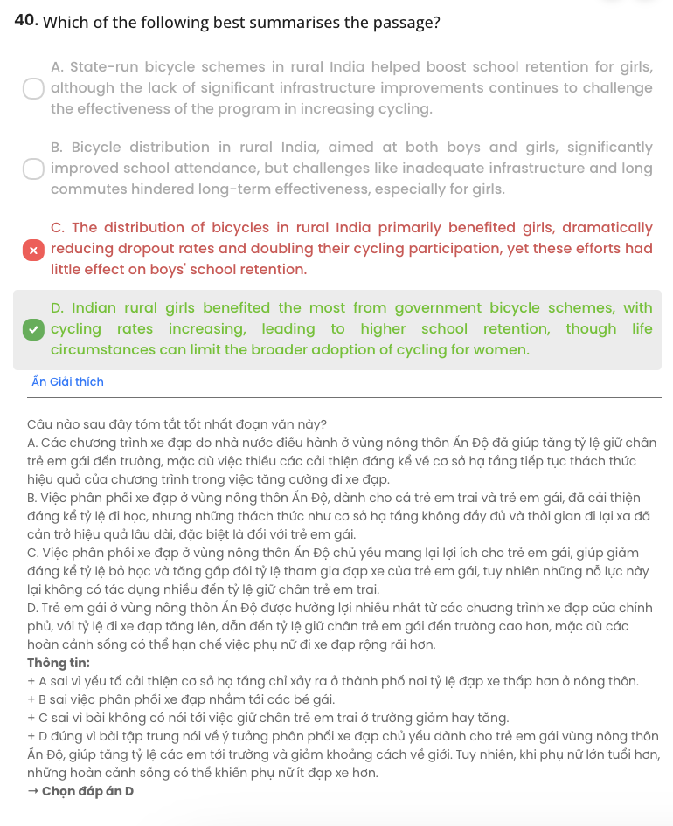

|  |  |  |  |  |
| --- | --- | --- | --- | --- |
| **BẢNG TỪ VỰNG** | | | | |
| **STT** | **Từ vựng** | **Từ loại** | **Phiên âm** | **Nghĩa** |
| **1** | worthwhile | adj | /ˌwɜːθˈwaɪl/ | đáng giá, quan trọng |
| **2** | overlook | v | /ˌəʊvəˈlʊk/ | bỏ qua, phớt lờ |
| **3** | cognitive | adj | /ˈkɒɡnɪtɪv/ | liên quan tới nhận thức |
| **4** | critical thinking | n | /ˌkrɪtɪkl ˈθɪŋkɪŋ/ | tư duy phản biệt |
| **5** | self-esteem | n | /ˌselfɪˈstiːm/ | lòng tự trọng |
| **6** | neglect | v | /nɪˈɡlekt/ | ngó lơ |
| **7** | balanced | adj | /ˈbælᵊnst/ | cân bằng |
| **8** | holistic | adj | /həˈlɪstɪk/ | tổng quát |
| **9** | willingness | n | /ˈwɪlɪŋnəs/ | sự sẵn lòng |
| **10** | unneeded | adj | /ˌʌnˈniːdɪd/ | không cần thiết |
| **11** | item | n | /ˈaɪtəm/ | món đồ, đồ đạc |
| **12** | shade | v | /ʃeɪd/ | che mát |
| **13** | horrified | adj | /ˈhɒrɪfaɪd/ | hoảng sợ |
| **14** | profound | adj | /prəˈfaʊnd/ | sâu sắc, mạnh mẽ |
| **15** | adolescence | n | /ˌædəʊˈlesns/ | tuổi vị thành niên |
| **16** | idealistic | adj | /aɪˌdɪəˈlɪstɪk/ | lý tưởng hoá |
| **17** | boundary | n | /ˈbaʊndᵊri/  /trænsˈfɔːm/ | ranh giới |
| **18** | value | v | /ˈvæljuː/ | trân trọng |
| **19** | imaginative | adj | /ɪˈmædʒɪnətɪv/ | sáng tạo |
| **20** | historic | adj | /hɪˈstɒrɪk/ | mang tính lịch sử |
| **21** | monument | n | /ˈmɒnjəmənt/ | tượng đài, di tích |
| **22** | graffiti | n | /ɡrəˈfiːti/ | chữ viết bậy |
| **23** | excursion | n | /ɪkˈskɜːʃn/ | chuyến du ngoạn |
| **24** | discovery | n | /dɪˈskʌvᵊri/ | sự khám phá |
| **25** | civilised | adj | /ˈsɪvᵊlaɪzd/ | văn minh |
| **26** | recall | v | /rɪˈkɔːl/ | nhớ lại |
| **27** | transform | v | /ɪˈmæʤɪnətɪv/ | làm thay đổi |
| **28** | remarkable | adj | /rɪˈmɑː.kə.bəl/ | đáng ngạc nhiên, đáng chú ý |
| **29** | reveal | v | /rɪˈviːl/ | tiết lộ |
| **30** | notable | adj | /ˈnəʊ.tə.bəl/ | đáng chú ý |
| **31** | revolution | n | /ˌrev.əˈluː.ʃən/ | cuộc cách mạng |
| **32** | emancipate | v | /iˈmæn.sɪ.peɪt/ | giải phóng |
| **33** | exhausting | adj | /ɪɡˈzɔːstɪŋ/ | gây mệt mỏi |
| **34** | notoriously | adv | /nəʊˈtɔː.ri.əs.li/  /nəˈtɔː.ri.əs.li/ | một cách khét tiếng |
| **35** | steady | adj | /ˈstedi/ | ổn định |
| **36** | empower | v | /ɪmˈpaʊər/ | trao quyền |
| **37** | mobility | n | /məʊˈbɪl.ə.ti/ | sự di chuyển |
| **38** | shrink | v | /ʃrɪŋk/ | sụt giảm |
| **39** | dropout | n | /ˈdrɒpaʊt/ | nghỉ, rời bỏ |

|  |  |  |  |  |
| --- | --- | --- | --- | --- |
| **40** | commute | n | /kəˈmjuːt/ | sự đi lại (giữa hai nơi) |

|  |  |  |
| --- | --- | --- |
| **BẢNG CẤU TRÚC** | | |
| **STT** | **Cấu trúc** | **Nghĩa** |
| **1** | be connected with something | liên kết, kết nối với |
| **2** | take an approach | có cách tiếp cận (thế nào) |
| **3** | at the expense at  somebody/something | gây hại, gây bất lợi cho ai (để mình được điều tốt) |
| **4** | stick to something | làm theo, bám sát, tuân theo |
| **5** | be capable of doing something | có khả năng làm việc gì |