School: ……………………………………….. | Date: ………………………………
Class: ……………………………..................... | Period: ……………………….........

UNIT 8: FESTIVALS AROUND THE WORLD
Lesson 3.1 - Listening and Reading (page 66)

I. OBJECTIVES
By the end of the lesson, Ss will be able to:
1.1. Language knowledge and skills
- talk about unusual festivals in Vietnam.
- practice listening and understanding a recording about a festival in Vietnam (for general and specific information).
- read and understand a festival blog post (for gist and details).
1.2. Competences
- improve communication, collaboration, analytical and critical thinking skills.
1.3. Attributes
- respect cultures and tradition of many provinces around Vietnam.

II. TEACHING AIDS AND LEARNING MATERIALS
1. Teacher’s aids: Student book and Teacher’s book, class CDs, Digital Book (DCR phần mềm tương tác SB, DHA (từ vựng/ cấu trúc) phần mềm trò chơi tương tác), projector/interactive whiteboard / TV (if any), PowerPoint slides.
2. Students’ aids: Student’s book, workbook, notebook.

III. ASSESSMENT EVIDENCE
Performance Tasks | Performance Products | Assessment Tools
- Let’s Talk: What kinds of festivals are there in your country? What is your favorite kind of festival? | - Ss’ answers / presentation. | - T’s feedback/Peers’ feedback.
- Listening: Listen to Carol talking about a festival in Vietnam. What's her job? | - Ss’ answers. | - T’s feedback/Peers’ feedback.
- Listen and answer the questions. | - Ss’ answers. | - T’s feedback/Peers’ feedback.
- Reading: Read the festival blog post and answer this question. | - Ss’ answers. | - T’s feedback/Peers’ feedback.
- Now, read and write True or False. | - Ss’ answers. | - T’s feedback/Peers’ feedback.
-Speaking: Would you like to try mud ball wrestling? Why (not)? | - Ss’ answers / presentation. | - T’s observation/ DCR and T’s feedback.

IV. PROCEDURES
A. Warm up: (5’)
a) Objective: Introduce the new lesson and set the scene for Ss to acquire new language; get students' attention at the beginning of the class by giving enjoyable and short activities as well as to engage them in the follow-up steps.
b) Content: Introduce the topic: Festivals in Vietnam.
c) Expected outcomes: Ss have general ideas about the topic “Festivals in Vietnam”, which they are going to listen and read in the new lesson.
d) Organization of the activity:
TEACHER’S ACTIVITIES | STUDENTS’ ACTIVITIES
- Option 1: Let’s Talk!  What kinds of festivals are there in your country? What is your favorite kind of festival?  - Use the “Let’s talk!” part in the textbook– page 66 for warm-up activity.  - Ask Ss to work in pairs to answer the questions: What kinds of festivals are there in your country? What is your favorite kind of festival?  - Call Ss to share their answers with the whole class.  - Give feedback and evaluation.  - Lead to the new lesson.  - Option 2:  - Have Ss watch a video clip about Mud Ball Wrestling festival in Bac Giang Province.  - Then, ask Ss some brainstorming questions:  1. Are there many people in the festival?  2. What do people do in this festival?  3. Where does this festival take place?  4. What do the men use in Mud Ball Wrestling festival?  5. Is this fun?  - Call Ss to give answers.  - Give feedback and lead to the new lesson: There are some unusual and interesting festivals in Vietnam.  *Illustration:  Link: https://www.youtube.com/watch?v=ZBE1rJqvV48  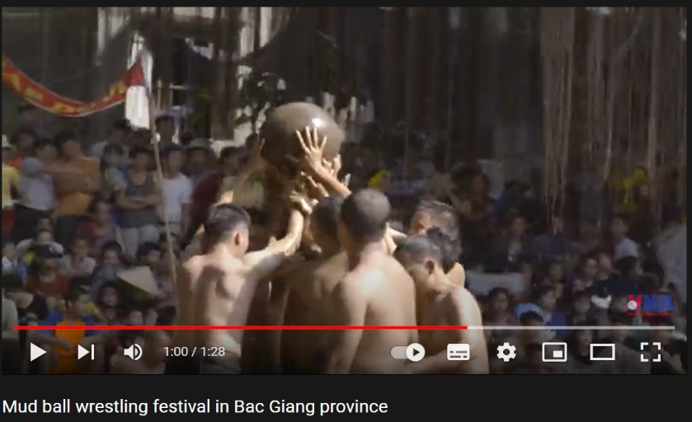 | - Work in pairs to discuss.  - Present.  - Watch a video clip and answer the questions.  - Listen.

B. New lesson (35’)
- Activity 1: Listening (17’)
a) Objective: Students can develop their listening skill.
b) Content:
- Listen to Carol talking about a festival in Vietnam. What's her job?
- Listen and answer the questions.
c) Expected outcomes: Students can practice listening and understanding general + specific information about a festival in Vietnam.
d) Organization of the activity:

TEACHER’S ACTIVITIES | STUDENTS’ ACTIVITIES
Task a. Listen to Carol talking about a festival in Vietnam. What's her job?  - Have Ss read the question.  - Play audio (CD2 - Track 11).  - Have Ss listen and circle the correct answer.  - Call Ss to give answer, explain.  - Play the audio again and check the answer as a whole class using DCR.  Task b. Listen and answer the questions.  - Have Ss read through the content in Task b first, underline the key words for listening.  - Play the audio again (CD2 – Track11).  - Have Ss listen and answer the questions.  - Have Ss check answers with their partners.  - Call Ss to give answers, explain.  - Check answers as a whole class using DCR. | - Listen and guess the answer.  - Read.  - Listen and circle the correct answer.  - Give answer, explain.  Answer keys    - Read, find and underline the key words.  - Listen and answer the questions.  - Exchange answers.  - Give answers.  Answer keys  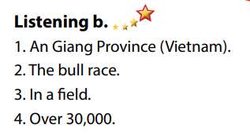

- Activity 3: Reading (18’)
a) Objective: Students can develop their reading skill.
b) Content:
- Read the festival blog post and answer this question.
- Now, read and write True or False.
- Would you like to try mud ball wrestling? Why (not)?
c) Expected outcomes: Students can read a festival blog post for gist and detail, and they can give their opinion about this festival.
d) Organization of the activity:
TEACHER’S ACTIVITIES | STUDENTS’ ACTIVITIES
Task a. Read the festival blog post and answer this question.  - Have Ss read the content in Task a.  - Ask Ss to scan the paragraph to choose the correct answer.  - Have Ss underline the supporting ideas.  - Call a student to give answer.  - Check answers as a whole class using DCR.  Task b. Now, read and write True or False.  - Have Ss read the content in Task b and underline the key words.  - Have Ss read the blog post again and write True or False.  - Have Ss check their answers with a partner.  - Call Ss to give answers.  - Check answers as a whole class using DCR.  Task c. Speaking: In pairs: Would you like to try mud ball wrestling? Why (not)?  - Have Ss discuss the questions in pairs.  - Call some Ss to share their answers with the whole class.  - Give feedback and evaluation. | - Scan the blog post to choose the correct answer.  - Underline the supporting ideas.  - Give answer.  Answer keys  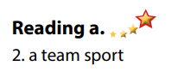  - Read and underline the key words.  - Read the blog post again for details.  - Exchange answers.  - Give answers.  Answer keys  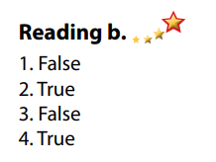  - Discuss in pairs.  - Present.

C. Consolidation and homework assignments (5’)
*Consolidation:
*Homework
- Do the exercises in WB: Listening and Reading (page 48).
- Do the vocabulary exercise in Tiếng Anh 7 i-Learn Smart World Notebook (page 52).
- Play consolation games in Tiếng Anh 7 i-Learn Smart World DHA App on www.eduhome.com.vn
- Find some more festivals in Vietnam.
- Prepare: Unit 8 - Lesson 3 – Writing and Speaking (page 67 – SB).

D. Reflection
a. What I liked most about this lesson today:
…………………………………………………………………………………………
- What I learned from this lesson today:
…………………………………………………………………………………………
c. What I should improve for this lesson next time:
…………………………………………………………………………………………

