Week 31 Preparing date: April ……., 2023
Period 121 Teaching date: April………, 2023

Unit 18: Playing and doing
Lesson 2 (4, 5, 6)
A. OBJECTIVES:
By the end of the lesson, Ss will be able to:
1. Knowledge:
- listen to and understand four communicative contexts in which pupils ask and answer questions about an action in progress and number the correct pictures.
- complete four gapped dialogues with the help of picture cues.
- sing the song What are you doing? with the correct pronunciation and melody.
- Vocabulary: Review
- Skills: speaking, listening, reading and writing.
2. Competences:
- Critical Thinking: talk about activity
- Co-operation: ready to help friends in pair work/ group work.
- Self-control and independent learning: perform listening tasks.
3. Attitude/ Qualities:
- Kindness: Help partners to complete learning tasks.
- Honesty: tell the truth about feelings and emotions.
- Diligence: complete learning tasks.
B. TEACHING AIDS:
- Teacher: Teacher’s guide Pages 227, 228; audio Tracks 79, 80; website sachmem.vn, posters, laptop, pictures, textbook, lesson plan, TV or projector.
- Students: Pupil’s book Page 55, notebooks, workbooks, school things.
C. PROCEDURES:
Teacher’s activities | Students’ activities
1.Warm- up: (5’)  Sing a song: “Matching pairs”  *Aims: to create a friendly and active atmosphere in the class to beginning the lesson.  *Procedure:  - Divide the class into two teams Tiger and Lion. Ask Ss to choose the matching pairs (words with pictures)  - Ss come to the front and choose the pictures in order to match with the words. Who can make it will have points for the team.  - Give points for the Ss.  - Encourage the Ss join the activity.  - Say “Open your book page 55” and look at “Unit 18, Lesson 2 (4,5,6)”.  2.Practice: (27’)  Activity 1. Listen and number:  *Aims: Ss will be able to listen to and understand four communicative contexts in which pupils ask and answer questions about an action in progress and number the correct pictures.  *Procedure:  - Have Ss look at the four picture cues and elicit the actions in progress.  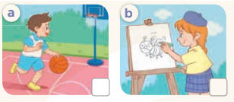  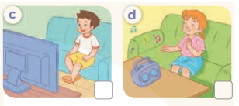  - T ask Ss to guess the answers.  + T writes Ss’guessing on the board.  - Listen to the tape:  + Play the recording  + Play the recording again and get Ss to swap books with their partners.  + Play the recording again to check answers together as a class.  + Write the answers on the board for Ss to correct their answers. Then checks Ss’ guessing.  - Play the recording, sentence by sentence, for the class to listen and repeat in chorus.  Key: 1.c 2. b 3.a 4d  Activity 2. Look, complete and read.  *Aims: Ss will be able to complete four gapped dialogues with the help of picture cues.  *Procedure:  - Have Ss look at the pictures and identify the actions in the picture.  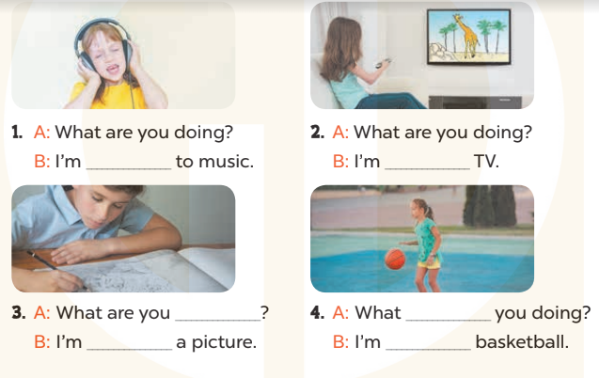  - T models with sentence 1.  + Have Ss look at the sentence.  + Ask them what is missing in the answer (listening).  + Have Ss complete the gap.  + Have Ss read the completed sentence in chorus.  -Have Ss work in pairs and complete the sentences 2, 3 and 4.  - Invite pairs of pupils to stand up and read aloud the sentences.  - T gives feedbacks.  Key: 1. listening 2. Watching  3. doing; drawing 4. are; playing  Activity 3. Let’s sing.  *Aims: Ss will be able to sing the song What are you doing? with the correct pronunciation and melody.  *Procedure:  - Introduce the title and lyrics of the song: “What are you doing?”  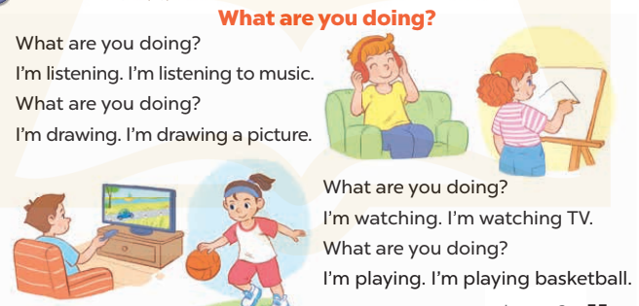  - Play the recording for Ss to listen to the whole song.  + Have them repeat the title and lyrics line by line.  + Tell Ss to point at the pictures while singing.  - Play the recording all the way through for Ss to listen to pronunciation and melody of the song.  - Play the recording line by line for Ss to listen, repeat and point to the pictures  - Play the recording for Ss to sing and do actions.  - Ask Ss to practice singing and doing actions in pairs or groups.  - Invite groups to the front of the classroom to perform the song  -T gives feedback.  *Consolidation  *Aims: Ss will be able consolidate and wrap up the content of the lesson.  *Procedure:  - T asks ss to answer the following questions:  + What have you learnt from the lesson today?  +What are the core values of the lesson? (if the teacher can take from the lesson).  - T praises some Ss who are hardworking / active/ good…. as well as encourage others to try more.  3. Homework. (3’)  - Prepare the new lesson: Unit 18, Lesson 3 (1,2,3). | - Ss listen and play the game  - Ss open their books  -Look at the pictures and say:  + Picture a: a boy is playing basketball  + Picture b: a girl is drawing picture  + Picture c: a boy is watching TV  + Picture d: a girl is listening to music  -Ss guess the answers  - Ss listen to the tape and write number  - Ss listen again, write number and swap books with their partners.  - Ss check their answers and guessing  -Ss listen and repeat.  -Ss look at the pictures and say  -Ss listen and answer  -Ss read and complete  -Ss work in pairs and do the task  -Ss read aloud  - Ss listen  -Ss listen to the song  - Ss listen and repeat line by line without the action.  -Ss point to the pictures while singing  -Ss listen to melody of the song  - Ss listen and sing line by line.  - Ss sing and do actions.  + Ss work in groups (two groups) to sing.  -Ss perform in front of the class.  -Ss listen  -Ss listen and answer  -Ss listen and take note

D. ADJUSTMENTS (if necessary):
………………………………………………………………………………………….…..……………………………………………………………………………...………………………………………….…..……………………………………………………………………………….……………………………………………………………………...

Week 31 Preparing date: April ……., 2023
Period 122 Teaching date: April………, 2023

Unit 18: Playing and doing
Lesson 3 (1, 2, 3)
A. OBJECTIVES:
By the end of the lesson, Ss will be able to:
1. Knowledge:
- correctly repeat the sounds of the letters n and ng in isolation, the words listen and singing and the sentences We listen to music at break time. and I’m singing my favourite song. with the correct pronunciation and intonation.
- identify the target words listen and singing while listening.
- say the chant with the correct rhythm and pronunciation.
- Vocabulary: Review
- Skills: speaking, listening, reading and writing.
2. Competences:
- Co-operation: ready to help friends in pair work/ group work.
- Self-control and independent learning: perform listening tasks.
3. Attitude/ Qualities:
- Kindness: Help partners to complete learning tasks.
- Honesty: tell the truth about feelings and emotions
B. TEACHING AIDS:
- Teacher: Teacher’s guide Pages 228, 229; audio Tracks 81, 82, 83; website sachmem.vn, posters, laptop, pictures, textbook, lesson plan, TV or projector.
- Students: Pupil’s book Page 56, notebooks, workbooks, school things.
C. PROCEDURES:
Teacher’s activities | Students’ activities
1.Warm- up: (5’)  Game: Find and circle the words  *Aims: to create a friendly and active atmosphere in the class to beginning the lesson.  *Procedure:  - Divide class into 2 groups  - Ask Ss to find and circle the words that they learnt.  - Which groups find the best correct words is winner.  - Give Ss time to play the game.  Rows: listen, train  Columns: singing, reading, ten.  -T checks who’s winner?  - Say “Open your book page 56” and look at “Unit 18, Lesson 3 (1,2,3)”.  2. Presentation(9’)  Activity 1. Listen and repeat:  *Aims: Ss will be able to correctly pronounce the sounds of the letters n and ng in isolation, the words listen and singing and the sentences We listen to music at break time. and I’m singing my favourite song. with correct pronunciation and intonation.  *Procedure:  - T gives instruction to the letters n and ng in isolation, the words listen and singing and the sentences We listen to music at break time. and I’m singing my favourite song  - Play the recording for the letter n and ng  - Encourage Ss to point at the letter/ word/ sentence while listening.  - Play the recording again and encourage Ss to listen and repeat.  - Do this several times until Ss feel confident.  - T calls some Ss to practice.  - T gives feedbacks.  3.Practice: (19’)  Activity 2. Listen and circle.  *Aims: Ss will be able to identify the target words listen and singing while listening.  *Procedure:  - Elicit the sentences and explain that they have to listen.  - T ask Ss to guess the answers.  + T writes Ss’guessing on the board.  - Listen to the tape:  + Play the recording  + Play the recording again and get Ss to swap books with their partners.  + Play the recording again to check answers together as a class.  + Write the answers on the board for Ss to correct their answers. Then checks Ss’ guessing.  - Play the recording, sentence by sentence, for the class to listen and repeat in chorus.  - Invite one or two Ss to stand up and read the completed sentences.  Key: 1.a 2.a  Activity 3. Let’s chant  *Aims: Ss will be able to say the chant with the correct rhythm and pronunciation.  *Procedure:  - Introduce the title and lyrics of the chant.  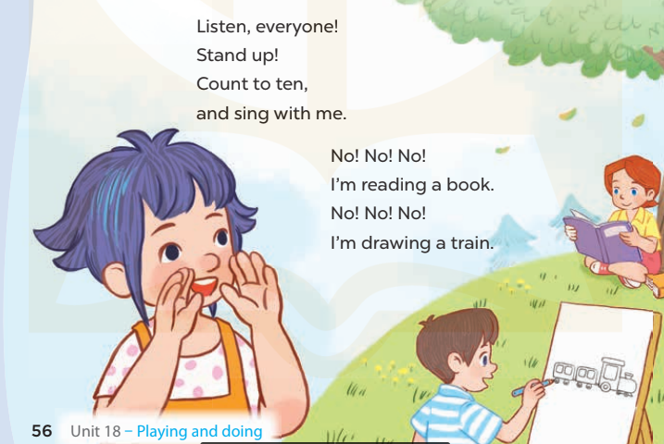  - Play the recording for Ss to listen to the whole chant.  + Have them repeat the title and lyrics line by line.  + Ask Ss to attend to the sounds of the letters n and ng and the words listen and singing.  - Play the recording all the way through for Ss to listen to pronunciation and melody.  - Play the recording line by line for Ss to listen and repeat  - Play the recording for Ss to chant and clap along.  - Ask Ss to practice chant and clap along in pairs or groups.  - Invite groups to the front of the classroom to perform the chant  -T gives feedback.  *Consolidation  *Aims: Ss will be able consolidate and wrap up the content of the lesson.  *Procedure:  - T asks ss to answer the following questions:  + What have you learnt from the lesson today?  +What are the core values of the lesson? (if the teacher can take from the lesson).  - T praises some Ss who are hardworking / active/ good…. as well as encourage others to try more.  4. Homework. (2’)  - Practice the chant more.  - Prepare two photos or pictures for the project.  - Prepare the new lesson: Unit 18, Lesson 3 (4,5,6). | - Ss listen  -Ss play game  - Ss open their books  - Ss recognize the differences about color of letter  - - Ss listen  - Ss listen and point  - Ss listen again and repeat  -Ss listen again and repeat  -Ss practice  -Ss listen  -Ss listen and say:  + Number 1: I….at break time  + Number 2: I’m…….a song.  -Ss guess the answers  - Ss listen to the tape and circle  - Ss listen again, circle and swap books with their partners.  - Ss check their answers and guessing  -Ss listen and repeat.  -Ss read the sentences  - Ss look and listen.  -Ss listen to the chant  - Ss listen and repeat line by line without clap their hands  -Ss note the sounds, words  -Ss listen to melody of the chant  - Ss listen and chant line by line.  - Ss chant and clap along.  - Ss work in groups (two groups) to chant  -Ss perform in front of the class.  -Ss listen  -Ss listen.  -Ss answer the questions  -Ss listen and clap their hands  -Ss listen and take note
  D | B | K | K | E | P | S | C | R | T
  G | E | S | E | E | D | D | X | E | H
  G | E | I | Y | Y | E | C | Z | A | I
  R | A | N | M | F | C | C | Y | D | N
  T | A | G | N | N | R | L | S | I | K
  G | L | I | S | T | E | N | W | N | B
  S | R | N | W | R | C | V | T | G | H
  M | M | G | K | K | C | S | E | A | Y
  D | P | P | T | R | A | I | N | S | M
  A | C | E | B | F | A | Z | Y | W

D. ADJUSTMENTS (if necessary):
………………………………………………………………………………………….…..……………………………………………………………………………...………………………………………….…..……………………………………………………………………………….……………………………………………………………………...

Week 31 Preparing date: April ……., 2023
Period 123 Teaching date: April………, 2023

Unit 18: Playing and doing
Lesson 3 (4, 5, 6)
A. OBJECTIVES:
By the end of the lesson, Ss will be able to:
1. Knowledge:
- read and match the pupils with the activities that they are doing.
- write a paragraph about what they are doing.
- present their photos and tell their friends what they are doing in the photos.
- Vocabulary: Review
- Skills: speaking, listening, reading and writing.
2. Competences:
- Co-operation: ready to help friends in pair work/ group work.
- Self-control and independent learning: perform reading tasks.
3. Attitude/ Qualities:
- Kindness: Help partners to complete learning tasks.
- Honesty: tell the truth about feelings and emotions.
- Diligence: complete learning tasks.
B. TEACHING AIDS:
- Teacher: Teacher’s guide Pages 230, website sachmem.vn, posters, laptop, pictures, textbook, lesson plan, TV or projector.
- Students: Pupil’s book Page 57, notebooks, workbooks, school things.
C. PROCEDURES:
Teacher’s activities | Students’ activities
1.Warm- up: (5’)  Game: Who’s faster?  *Aims: to review the vocabulary and structure about greet and respond to greetings.  *Procedure:  - Tell Ss that they are going to look at the cards in 60 seconds, memorise the words (listening to music, singing a song, watching TV, playing football, playing volleyball, drawing a picture) then remember as many of the words as possible.  - Put the cards on a desk or stick them on the board. Then cover them with a piece of cloth.  - Divide the class into 2 or 4 groups. - Remove the cloth and show the cards for 60 seconds. Then cover them again.  - In their groups, Ss try to say as many of the words as they can remember.  - Have the groups say the names of the things aloud.  - For each correct word, give them a star or a point.  - The group with the most stars / points wins.  - Say “Open your book page 57” and look at “Unit 18, Lesson 3 (4,5,6)”.  2.Practice: (8’)  Activity 1. Read and match:  *Aims: Ss will be able to read and match the pupils with the activities that they are doing.  *Procedure:  - Ask Ss to attendto the icons for listening, reading and drawing and elicit the words.  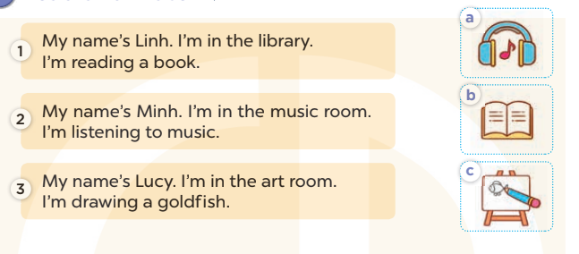  - Tell Ss about the activity. Give Ss time to read and match.  - Get S to swap books with a partner. Then check the answers as a class.  -Write the correct answers on the board for Ss to check and correct their answers.  - Invite Ss to read the texts aloud  -T gives feedbacks.  Key: 1.b 2.a 3.c  3.Production: (19’)  Activity 2. Let’s write  *Aims: Ss will be write a paragraph about what they are doing.  *Procedure:  - Tell the class the goal of this activity  - Have Ss fill in the first gap together as an example.  - Ask Ss to look at the first gap, ask What do you write here? and elicit their names (My name is….).  - Let Ss write down the word in the gap.  - Repeat the same procedure with the other incomplete sentences.  - Give Ss time to write the answers in their notebooks.  - Invite a few Ss to read aloud the paragraph they have completed in front of the class.  Key: Pupils’ own answers  Activity 3. Project.  *Aims: Ss will be able to present their photos and tell their friends what they are doing in the photos.  *Procedure:  - Point at the prompt drawing and explain what they should do to complete the project.  - Prepare two photos to share with Ss. Take a piece of paper and write the captions for the photos. Point at one photo and say: In this photo, I’m ……. and point at the other photo and say: And in this photo, I’m …….  - Have Ss show the photos or pictures that they have prepared for the project.  - Give the Ss time to practise their presentations by themselves.  - Invite some Ss to present in front of the class.  *Consolidation  *Aims: Ss will be able consolidate and wrap up the content of the lesson.  *Procedure:  - T asks ss to answer the following questions:  + What have you learnt from the lesson today?  - T praises some Ss who are hardworking / active/ good…. as well as encourage others to try more.  4. Homework. (3’)  - Prepare the new lesson: Unit 19- Lesson 1 (1,2,3). | - Ss listen  -Ss play game  -Ss play game  - Ss open their books  -Ss listen and answer  -Ss read and match  -Ss swap books and check  - Ss check their answer  -Ss read aloud  -Ss listen  -Ss listen  -Ss read and answer  -Ss listen and answer  -Ss write down  My name is………I’m in the….  I’m…………I like………………  What about you?  -Ss read aloud  -Ss listen and note  -Ss listen  -Ss show the photos  -Ss practise their presentation  -Ss perform in front of the class.  -Ss answer the questions  -Ss listen and clap their hands  -Ss listen and take note
D. ADJUSTMENTS (if necessary):
………………………………………………………………………………………….…..……………………………………………………………………………...…………
Week 31 Preparing date: April ……., 2023
Period 124 Teaching date: April………, 2023

Unit 19: Outdoor activities
Lesson 1 (1, 2, 3)
A. OBJECTIVES:
By the end of the lesson, Ss will be able to:
1. Knowledge:
- use the words play badminton, run, paint, walk in relation to the topic “Outdoor activities”
- use He’s / She’s…….. to talk about what someone is doing;
- enhance the correct use of He’s / She’s …… to ask and answer questions about what someone is doing
- Vocabulary: playing badminton, running, painting, walking
- Model sentences:
He’s/ She’s painting.

- Skills: speaking and listening
2. Competences:
-Critical Thinking: talk about friends.
- Co-operation: ready to help friends in pair work/ group work.
- Sociability: Talk to each other, say good words to others.
3. Attitude/ Qualities:
- Kindness: Help partners to complete learning tasks.
- Honesty: tell the truth about feelings and emotions
B. TEACHING AIDS:
- Teacher: Teacher’s guide Pages 231, 232, audio Tracks 84, 85, website sachmem.vn, posters, laptop, pictures, textbook, lesson plan, TV or projector.
- Students: Pupil’s book Page 58, notebooks, workbooks, school things.
C. PROCEDURES:
Teacher’s activities | Students’ activities
1.Warm- up: (3’)  Sing: Head, shoulders, knees and toes  *Aims: to create a friendly and active atmosphere in the class to beginning the lesson.  *Procedure:  - Show the song on the screen.  https://www.youtube.com/watch?v=WX8HmogNyCY  - Ask Ss to listen, sing and dance the song.  - Say “Open your book page 58” and look at “Unit 19, Lesson 1 (1,2,3)”.  2. Presentation(16’)  Activity 1. Vocabulary.  *Aims: Ss will be able to know the vocabulary in front of starting the new lesson.  *Procedure:  -T elicits the new words  + playing badminton : chơi cầu lông  (mime)  + running : chạy (mime)  + painting :tô màu (mime)  + walking : đi bộ (mime)  - T models (3 times).  - T writes the words on the board.  - Checking: Matching  Activity 2. Look, listen and repeat:  *Aims: Ss will be able to understand and correctly repeat the sentences in two communicative contexts (pictures) focusing on what someone is doing.  *Procedure:  - Have Ss look at Pictures a and b and identify names of the speakers in the pictures.  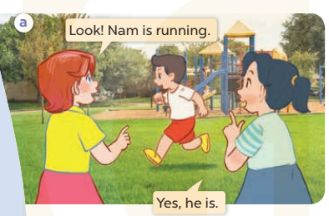  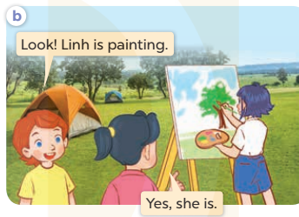  - Play the audio twice (sentence by sentence). Correct their pronunciation where necessary.  - Have Ss to practice the dialogue  - T invites a few pairs to the front of the class to practice.  - T checks pronunciation for ss.  Activity 3 Listen, point and say.  *Aims: Ss will be able to correctly use He’s / She’s …….to talk about what someone is doing.  *Procedure:  * Model sentences:  - T asks Ss look at picture a, b and helps Ss know the structure from the dialogue.  - T introduces new structure for Ss.  - T explains, models and gives meaning.  -Have Ss repeat the model sentences.  He’s/ She’s painting.  3.Practice: (7’)  *Drill pictures  - Elicit and identify the character (a boy or a girl) in each picture.  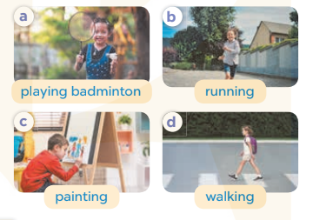  - Run through all the pictures.  - Run through model sentences.  - Have Ss to practise:  - Ask Ss to work in pairs.  - T controls and corrects.  - Invite a few pairs to come to the front of the classroom and point at the pictures and say the questions and answers in front of the class.  - T gives feedbacks.  4.Production: (7’)  Activity 4. Let’s talk.  *Aims: Ss will be able to enhance the correct use of He’s / She’s ….to ask and answer questions about what someone is doing.  *Procedure:  - Have Ss look at the picture and tell them about the activity.  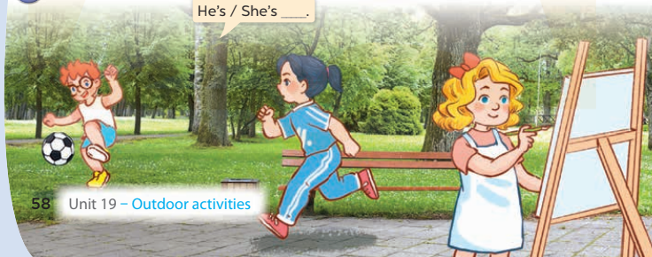  - Put Ss into groups of four.  - Ask Ss to say using He’s / She’s…..  - Invite some Ss to the front of the class to say about the activity.  *Consolidation  *Aims: Ss will be able consolidate and wrap up the content of the lesson.  *Procedure:  - T asks ss to answer the following questions:  + What have you learnt from the lesson today?  +What are the core values of the lesson? (if the teacher can take from the lesson).  - T review the vocabulary and model sentences.  - T praises some Ss who are hardworking / active/ good…. as well as encourage others to try more.  5. Homework. (2’)  - Learn the vocabulary and model sentences by heart  - Prepare the new lesson: Unit 19, Lesson 1 (4,5,6). | - Ss listen  - Ss sing a song  - Ss open their books  -Ss listen and answer  - - Ss listen and repeat  + Choral repetition (3 times).  + Individual repetition (3 ss)  - Ss take note  - Ss look, remember and match  -Look at the pictures and say  + In picture a: Lucy says: Look! Nam is running. Mai says: Yes, he is.  + In picture b: Lucy says: Look! Linh is painting. and Mai says: Yes, she is  -Ss listen and repeat in chorus (twice)  -Ss work in pairs to practice  -Ss practice the dialogue  -Ss listen  -Ss look at the picture and answer.  -Ss listen  -Ss listen and repeat  -Ss repeat  - Ss look, listen and answer  + Picture a: a girl is playing badminton.  + Picture b. a boy is running.  + Picture c. a boy is painting.  + Picture d. a girl is walking  -Ss listen and repeat  -Ss practice in chorus  -Ss work in pairs to practice  -Ss point and say  -Ss listen.  -Ss look at the picture and listen  -Ss look and answer  -Ss perform in front of the class.  -Ss answer the questions  - Ss listen  -Ss listen and clap their hands  -Ss listen and take note
D. ADJUSTMENTS (if necessary):
………………………………………………………………………………………….…..……………………………………………………………………………...………………………………………….…..……………………………………………………………………………….……………………………………………………………………...

