TRƯỜNG THCS-THPT HAI BÀ TRƯNG  ĐỀ CHÍNH THỨC | ĐỀ KIỂM TRA CUỐI KỲ 2  NĂM HỌC 2021 - 2022  MÔN :TIẾNG ANH – LỚP 7  Thời gian: 60 phút  (Không kể thời gian phát đề)

I./ Choose the word whose underlined part is pronounced differently from that of the the others: (1.0 PT)

1. A. chair B. cheap C. child D. chemist
2. A. earned B. washed C. played D. listened
3. A. practiced B. talked C. added D. laughed
4. A. mean B.weather C. head D. ready

II./ MULTIPLE CHOICE: (4.0 PTS)

5. Lan sang ___________________ last night.
A. beautiful B. nice C. beautifully D. lovely
6. Everybody wished ___________________ this activity.
A. keep B. to keep C. keeping D. to keeping
7. The number of participants ___________________ every week.
A. increase B. increases C. is increasing D. are increase
8. We are late thanks to you.
A. because B. because of C. instead D. instead of
9. They take a walk instead ___________________ bicycle trips.
A. take B. to take C. of take D. of taking
10. Summer is ___________________ its way.
A. on B. of C. in D. at
11. This is a very ___________________ river.
A. danger B. dangerous C. dangerously D. expensive
12. Nam speaks English very ___________________.
A. well B. good C. fluently D. both A and C
13. Walking is a good sports activity. It makes us ___________________.
A. health B. healthy C. healthily D. unhealthy
14. Lan wants Hoa ___________________ TV before dinner.
A. to watch B. watching C. watch D. watches
15. is a good sport activity.
A. Walk B. Walking C. Walker D. Walks
16. Would you like to drink orange juice, Mary ?- ________________
A. I’d love to B. Yes, I do C. No, I don’t D. I wouldn’t
17. Does Minh like to take part in our club ?
A. play B. go C. join D. enter
18. Nam has to finish this exercise this evening.
A. must B. can C. should D. will
19. ________ is a person who rides a bicycle.
A. Scientist B. Cyclist C. Member D. Typist
20. His uncle is a ________ football player.
A. skill B. skillful C. skillfully D. B & C

III./ SIGN: (1.0 PT)
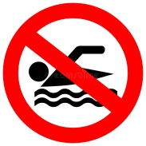  21/. What does this sign say? | - No fishing  - No diving  - No swimming  - No surfing
22/. What does the sign say?  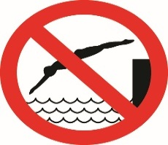 | A) No sailing.  B) No diving.  C) No jumping.  D) No catching fish here.
23/. What does this sign mean?  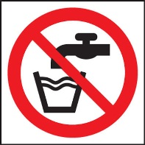 | - Drinking water.  - Washing water.  - Wash your hands.  - Water not for drinking.
24/. What does this sign mean?  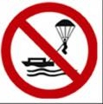 | A) No skydiving  B) No parasailing  C) No boating  D) No cycling

IV./ REARRANGEMENT: (2.0 PTS)
25./ in the living room / usually gathers / After dinner, my family / and watches TV
→ After dinner, …………………………………………………………...................
26./ maybe / In the evening / listen to / I’m going to / and / the radio / read a book/ ./
→ In the evening, ………………………………..................................................….
27./ TV viewers / and answer the questions / can join in / through telephone / In some contests, / or by mail/ ./
→ In some contests, …………………………..………………...........................................
28./ in watching TV / too much / Don’t spend / of your free time/ ./
→ Don’t spend ..……………………………………………...............................................

V./ TRANSFORMATION: ( 2.0 PTS)
29/ .She likes going shopping better than watching TV.
She prefers .............................................................................................................
30./ What about going to the arcade after school?
Would you like ………………………………….........................………………
31./ Please put your luggage under the seat.
Why don’t you .......................................................................................................
32./ I’m fond of watching cowboy film.
I................................................................................................................................

THE END

