School: ……………………………………….. | Date:…………………………………..
Class: ……………………………..................... | Period: …………………………..........

UNIT 8: TRADITIONS OF ETHNIC GROUPS IN VIETNAM
Review 2 (Page 105)

I. OBJECTIVES
By the end of the lesson, Ss will be able to:
1.1. Language knowledge and skills
- review vocabulary words (blouse, embroidery, steamed, cloth, pattern, apron, utensil, basket, product, corn)
- review grammar, pronunciation, and practice writing.
- practice listening and reading skills.
- practice test taking skills.
1.2. Competences
- improve writing skills and other skills related.
- improve the use of English.
- get used to the test format.
1.3. Attributes
- have positive attitude in English language learning so that they actively participate in all classroom activities.
- review the old lesson and have good preparation for the test.
II. TEACHING AIDS AND LEARNING MATERIALS
1. Teacher’s aids: Student book and Teacher’s book, class CDs, Digital Book (DCR phần mềm tương tác SB, DHA (từ vựng/ cấu trúc) phần mềm trò chơi tương tác), projector/interactive whiteboard / TV (if any), PowerPoint slides, handouts.
2. Students’ aids: Student’s book, workbook, notebook.
III. ASSESSMENT EVIDENCE
Performance Tasks | Performance Products | Assessment Tools
- Vocabulary: Match the words with the definitions.  - Grammar:  + Fill in the blanks with correct articles.  + Complete the sentences using reported speech for questions.  - Pronunciation: Choose the word that has the stress differ from the other.  - Write a short paragraph. | - Ss’ answers.  - Ss’ answers.  - Ss’ answers.  - Ss’ answers.  - Ss’ answers. | - T’s feedback/Peers’ feedback.  - T’s feedback/Peers’ feedback.  - T’s feedback/Peers’ feedback.  - T’s feedback/Peers’ feedback.  - T’s feedback/Peers’ feedback.

IV. PROCEDURES
A. Warm up: (10’)
a) Objective: Introduce the new lesson and set the scene for Ss to acquire new language; get students' attention at the beginning of the class by enjoyable and short activities as well as to engage them in the follow-up steps.
b) Content: Review vocabulary words. Ss work individually to write the words.
c) Expected outcomes: Ss write the words with correct spellings.
d) Organization of the activity:
TEACHER’S ACTIVITIES | STUDENTS’ ACTIVITIES
Look and write the words.  - Use DCR or PPT to show pictures of the keywords in the unit.  - Have Ss work individually.  - Show a picture to Ss. Ask Ss to write the correct name of the word on a piece of paper or a note.  - Set the time in 10 seconds.  - Ask the volunteer to say and spell the word aloud.  - Reward for each correct word. | - Look at the pictures.  - Work individually.  - Look and write the words down.  - Raise hand to give answer.

B. New lesson (30’)
- Activity 1: Vocabulary (10’)
a) Objective: Ss can review vocabulary about ethnic culture and customs.
b) Content: Match the words with the definitions.
c) Expected outcomes: Ss produce the new language successfully, and they can use these words in speaking and writing.
d) Organization of the activity:
TEACHER’S ACTIVITIES | STUDENTS’ ACTIVITIES
Fill in the blanks with the words from the box.  - Use DCR to show the task.  - Have Ss read the words on the left and the definition on the right.  - Ask Ss to work in pairs to match the words with the definitions.  - Have Ss give answers, tell the meaning of the words /phrase again.  - Check answers as a whole class.  Answer keys  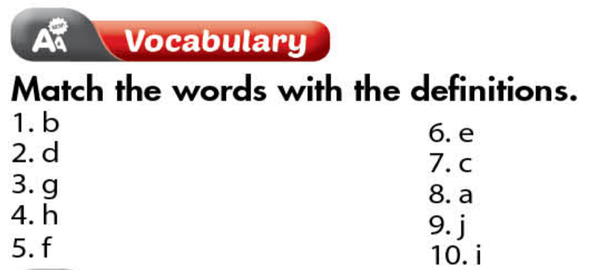 | - Read the sentences.  - Work in pairs.  - Give answers.
- Activity 4: Grammar (10’)
a) Objective: Ss can review the use of English: the article with a, the, and zero article, and the reported speech for questions.
b) Content:
- Fill in the blank with a, the, zero article.
- Complete the sentences to report what the people asked.
c) Expected outcomes: Ss produce the new language successfully, and they can use the grammar points in speaking and writing.
d) Organization of the activity:
TEACHER’S ACTIVITIES | STUDENTS’ ACTIVITIES
Task a. Fill in the blank with a, the, zero article.  - Use DCR to show the task.  - Have Ss retell the way to use articles: a, the, and zero article.  - Ask Ss to work individually to fill in the blanks.  - Have Ss work in pairs to check each other’s work.  - Call Ss to give answers, explain for their choice.  - Check answers as a whole class.  Answer keys  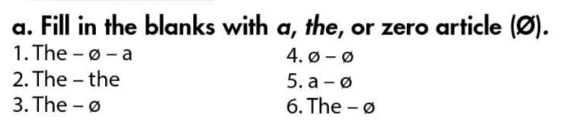  Task b. Complete the sentences to report what the people asked.  - Use DCR to show the task.  - Have Ss read the questions and recall Ss’s knowledge about the reported speech for questions.  - Have Ss write complete the report using reported speech for questions.  - Ask Ss to work in pairs to check each other’s work.  - Have Ss write answers on the board.  - Check Ss’ answers, give feedback.  Answer keys  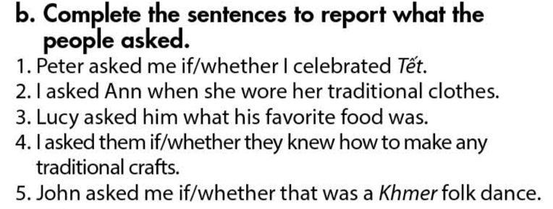 | - Review old knowledge.  - Work individually.  - Work in pairs.  - Give answers.  - Do the task.  - Read the questions.  - Do the task.  - Exchange answers.  - Write answers on the board.
- Activity 5: Pronunciation & Writing (10’)
a) Objective:
- Ss can review the word stress and vowels.
- Write a paragraph about customs and traditions.
b) Content:
- Circle the word that has different stress from the rest.
- Write a paragraph 80-100 words.
c) Expected outcomes: Ss produce the new language successfully.
d) Organization of the activity:
TEACHER’S ACTIVITIES | STUDENTS’ ACTIVITIES
Circle the word that differs from the other three in the position of primary stress in each of the following questions.  - Use DCR to show the task.  - Ask Ss to work individually to circle the answer.  - Have Ss work in pairs to check each other’s work.  - Call Ss to give answers, pronounce the words again.  - Give feedback, correct Ss’ pronunciation if necessary.  Answer keys  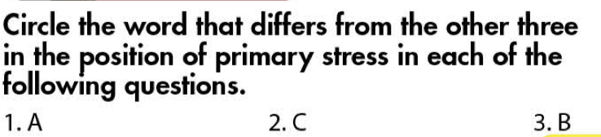  Writing: Write about the customs and traditions of an ethnic group that you know well. Write 80 to 100 words.  - Give Ss 8 minutes to write the paragraph themselves.  - Recall Ss memory about the types of giving supporting information.  - Ask some volunteers to read their passage in front of the class.  - Give feedback and evaluation. | - Listen.  - Work individually.  - Work in pairs.  - Give answers.  - Prepare an outline for the writing.  - Check on the knowledge in Lesson 3.  - Present in front of the class.

C. Consolidation and homework assignments (5’)
* Consolidation:
* Grammar of Unit 8: articles, reported speech for questions.
* Vocabulary of Unit 8: Vocabulary about different ethnic groups in Vietnm and their culture.

* Homework:
- Review vocabulary, grammar of unit 8.
- Do the exercises in WB: Review of Unit 8 – Part 2 (page 57).
- Do Review 2 in the notebook i-Learn Smart World 8 – (Pages 70 & 71)

V. Reflection
a. What I liked most about this lesson today:
…………………………………………………………………………………………
- What I learned from this lesson today:
…………………………………………………………………………………………
c. What I should improve for this lesson next time:
…………………………………………………………………………………………

Xem thêm tại Website VnTeach.Com
https://www.vnteach.com

