LỚP HỌC THẦY (CÔ) ___________________________ ĐỀ ÔN TẬP: READING SIGNS/ NOTICES – A2
Test 3
Thời gian làm bài: [Time]
Họ và tên: ________________________________________________ Lớp: 9/___
Nội dung:
Question 1: What does the sign say?

A. Everyone can enter the area freely without needing a pass.
B. You can only enter this area if you have a pass or permission.
C. You do not need a pass to enter this area; it is open to all.
D. Having a pass is not necessary; entry is allowed without one.

Question 2: What does the notice say?
"The dining area is closed for setup. It will be open after 1 PM"
A. The dining area only opens after 1 PM.
B. The dining area will be closed for preparation. Please eat within 1 hour.
C. You can eat within 1 hour while we finish preparing.
D. The dining area is closed for setup and will open after 1 PM.
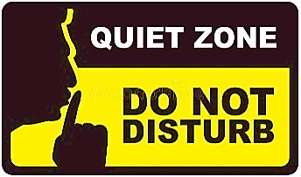
Question 3: What does the sign say?
A. You can make noise and talk loudly in this area.
B. This area is for quiet and no loud noises are allowed.
C. Making noise is encouraged and allowed in this area.
D. The area is not watched, so noise is not controlled.

Question 4: What does the notice say?
"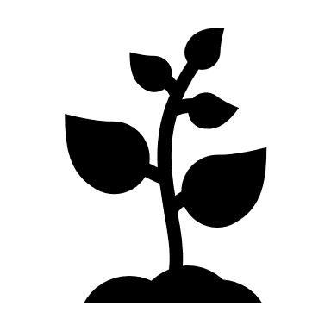The garden is closed for planting.  Will be open to visitors next week"
A. You can visit the garden any day, not just next week.
B. The garden is open for planting and visitors are allowed in now.
C. The garden is always open and is not closed for planting.
D. The garden will be open after planting is completed.
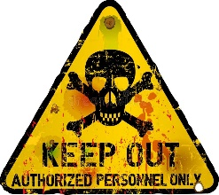
Question 5: What does the sign say?
A. You are allowed to go into this area anytime you want.
B. You should stay away and not enter this area.
C. This area is used for special events or activities.
D. You are allowed to enter only if you have a special pass or permission.

Question 6: What does the notice say?
"Please remember to keep your receipt.
The staff may ask to see your receipt if you want to exchange the item."

A. You need to bring your receipt. The staff may ask to see the receipt.
B. The staff will give you a new receipt if you need to exchange the item.
C. No receipt is required when shopping.
D. When exchanging the item, the staff will ask to check the receipt again.
Question 7: What does the sign say?
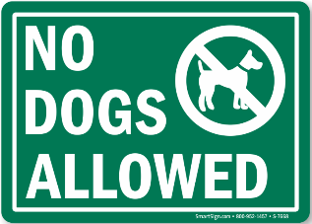
A. Dogs are welcome everywhere and can go anywhere.
B. Dogs are not allowed to enter or be in this area.
C. You may bring dogs here if they are on a leash.
D. Only small dogs are allowed in this area.

Question 8: What does the notice say?
"Please recycle paper and plastic in the bins provided
."
A. Throw paper and plastic in any trash can.
B. You should recycle paper and plastic in special bins.
C. Do not recycle paper and plastic.
D. Use the recycling bins only for glass.
Question 9: What does the sign say?
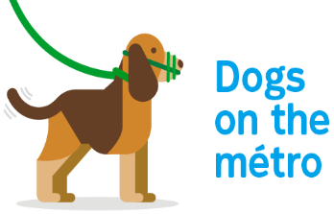
A. Dogs are allowed to roam without any rules.
B. Dogs must wear muzzles while they are in this area.
C. Only some dogs need to wear muzzles here.
D. Dogs do not need to wear muzzles in this area.

Question 10: What does the notice say?
"Please clean up the kitchen after using it. Throw away any leftover food and wash your dishes.
This helps keep the kitchen clean for everyone."

A. Just throw away leftovers in the trash.
B. Throw away leftover food and wash dishes immediately.
C. Only clean up if you make a mess.
D. You don’t need to clean up if you’re in a hurry.
[HẾT]

