|  |  |
| --- | --- |
|  |  |

**Họ tên thí sinh: .................................................................**

**Số báo danh: ......................................................................**

**Mã Đề: 016.**

**Câu 1.** **Look at the signs. Choose the best answer for the question.**

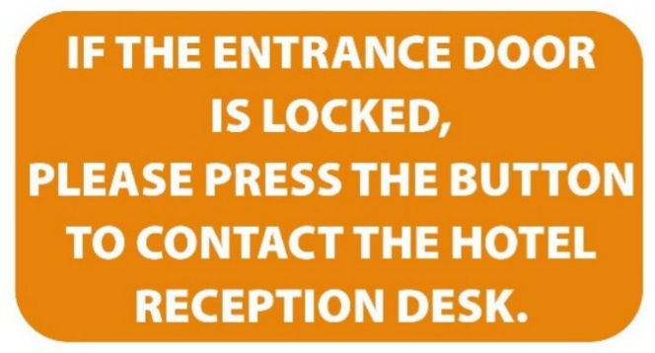

**A.** Contact the hotel reception if you want to press the button.

**B.** When the entrance door is locked, press the button to open it.

**C.** You need to contact the receptionist if you cannot lock the door.

**D.** Use this button to call the hotel staff when you can’t get in.

**Câu 2.** What is the offer at the Tennis Club?

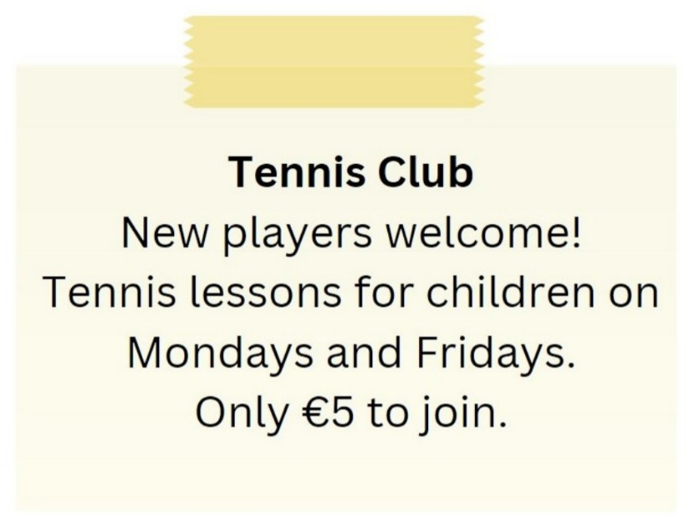

**A.** Tennis lessons for children on Mondays and Fridays for €5 to join

**B.** Tennis lessons for children on Tuesdays and Thursdays

**C.** Tennis lessons for adults on Mondays and Fridays

**D.** €10 to join the club

**Câu 3.** What has Tim booked for himself and Ben?

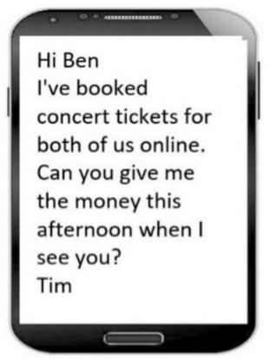

**A.** Concert tickets  **B.** Theater tickets  **C.** Movie tickets  **D.** Sports game tickets

**Câu 4.** **Look at the signs. Choose the best answer for the question.**

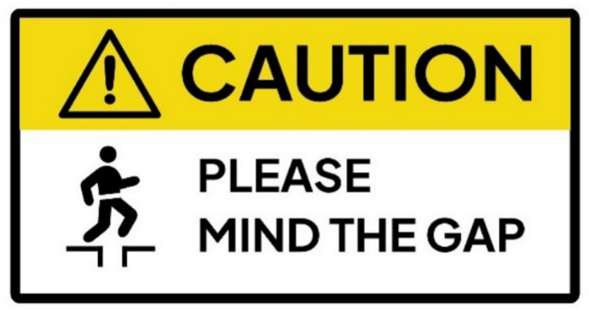

**A.** You need to remember the gap.  **B.** You need to stay away from the gap.

**C.** You need to think about the gap.  **D.** You need to be careful about the gap.

**Câu 5.** What subject does John need help with?

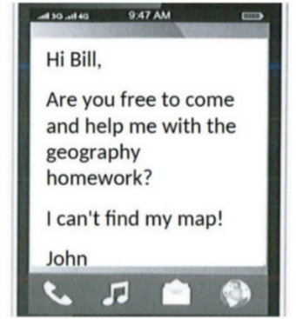

**A.** English  **B.** History  **C.** Math  **D.** Geography

**Câu 6.** Which of the following statements is true?

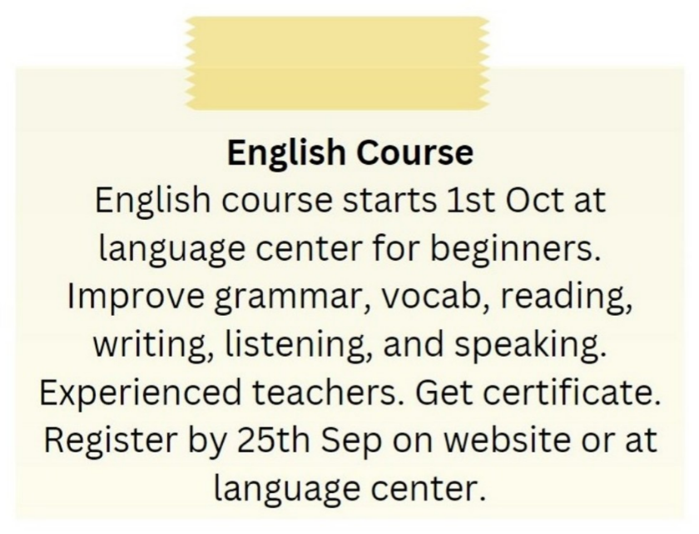

**A.** The English course is for advanced learners.

**B.** The English course starts on 1st September.

**C.** The English course is taught by experienced teachers.

**D.** The English course does not provide a certificate.

**Câu 7.** What is true about the New Zealand advertisement?

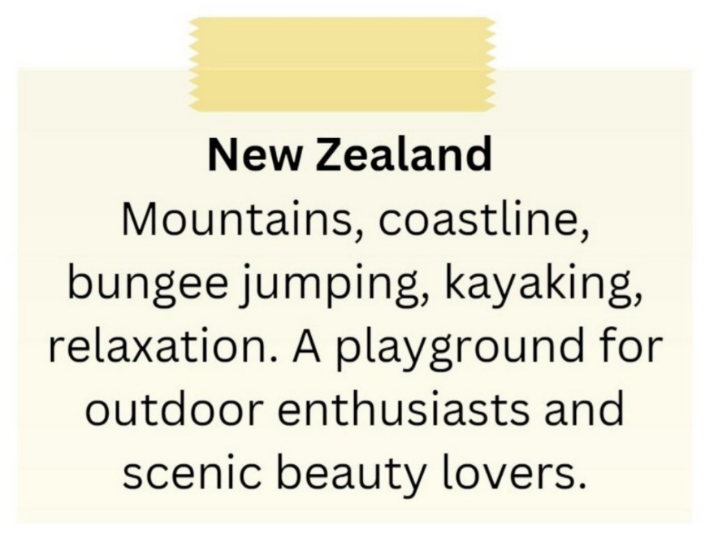

**A.** It is a destination for indoor activities and cultural experiences.

**B.** It is not suitable for outdoor enthusiasts.

**C.** It highlights mountains, coastline, bungee jumping, and kayaking.

**D.** It primarily appeals to relaxation enthusiasts.

**Câu 8.** **Look at the signs. Choose the best answer for the question.**

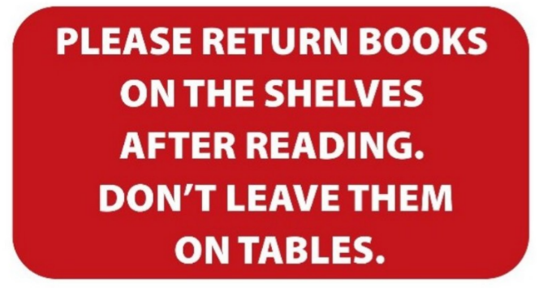

**A.** You need to put the books both on the table and the shelves.

**B.** Books should be left on the tables instead of the shelves.

**C.** You can leave books either on the shelves or on the tables.

**D.** After you finish reading, you have to put the books back on the shelves.

**Câu 9.** **Look at the signs. Choose the best answer for the question.**

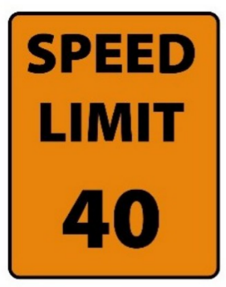

**A.** The minimum speed is 40 miles per hour.  **B.** You cannot drive faster than 40 miles per hour.

**C.** You can drive 40 miles per hour or more.  **D.** You must drive at 40 miles per hour.

**Câu 10.** **Look at the signs. Choose the best answer for the question.**

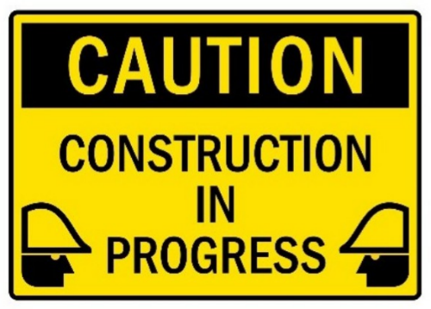

**A.** Be careful because building work is happening.  **B.** You have to construct buildings with caution.

**C.** There is careful construction.  **D.** Construction must be carefully done in progress.

**----HẾT---**