UNIT 5: FOOD AND DRINK
Lesson 2: A closer look 1

I. OBJECTIVES
By the end of this lesson, Ss will be able to:
1. Knowledge
- Use the lexical items related to the topic Food and Drink
- Know how to use the measurement words and phrases often used with food and drink
- Pronounce the sounds /ɒ/ and /ɔ:/ correctly
2. Core competence
- Be collaborative and supportive in pair work and team work
- Access and consolidate information from a variety of sources
- Actively join in class activities
3. Personal qualities
- Promote pride in the values ​​of Vietnamese culture
- Develop love for family
II. PREPARATIONS
1. Teacher
- Grade 7 textbook, laptop, TV/Projector/ pictures and cards, speakers, lesson plan, sachmem.vn…
2. Students
- Grade 7 textbook, notebooks, school things….
III. TEACHING PROCEDURES
ACTIVITY 1 – WARM – UP & INTRODUCTION (5’)
a) Aims:
- To set in the context of using the lexical items and measurement words/ phrases related to the topic Food and Drink
- To activate students’ knowledge
- To get students interested in the topic
b) Contents: Play the game “Cooking race”
c) Products: Ss’ answers
d) Teaching steps:
Teacher’s and students’ activities | Content
Deliver the task  -Teacher divides the class into 8 groups and gives instructions.  Implement the task  -In small groups, Ss write a ten-item shopping list on a piece of paper.  It must include the following things: something salty, something sweet, a tin of something, a jar of something, a kind of meat or fish, a green vegetable, another vegetable, a fruit, a dairy product, two herbs…  Discuss  -Ss then swap their lists with another group. Ss discuss and agree on a recipe for a main course using all the ingredients on their list. They can add only salt, pepper and oil and tell what dish they are going to cook in the class.  Giving comments or feedback  -Vote on which dish you would most like to eat. | Cooking race

ACTIVITY 2 – PRESENTATION (15’)
a) Aims:
- To revise and help Ss understand the measurement words and phrases often used with food and drink.
- To help Ss identify new words of dishes and ingredients.
b) Contents:
- Teach the vocabularies
- Listen and read
- Match the phrases with the pictures. Then listen, check, and repeat the phrases.
c) Products:
- Lists of vocabularies
- Answer key
d) Teaching steps:
Teacher’s and students’ activities | Content
Deliver the task  -T asks Ss to look at the photos and answer the question: What is this?  Implement the task  -Ss say the words.  Discuss  -Other Ss correct if the previous answers are incorrect.  - Teacher shows and says the words aloud and asks Ss to repeat them.  -Teacher asks Ss to translate the word “khoáng chất” into English  -Ss says the word  -Teacher gives the correct answer "mineral”  Giving comments or feedback  - Teacher checks and corrects if Ss spell or pronounce the words/ phrases incorrectly.  Deliver the task  * Teacher gives Ss instruction, lets Ss have time to work individually, in pairs and then supports them if necessary.  - a kilo (kg) of  - a teaspoon (tsp) of  - a litre (l) of  - a tablespoon (tbsp) of  - 200 grams (g) of  - 400 millilitres (ml) of  Implement the task  - Ss quickly match the phrases with the pictures individually.  Discuss  - Ss then swap their answers with their partners to check their answers by listening to the recording at the same time.  Giving comments or feedback  - Teacher observes, checks, gives correct answers as well as pauses the recording after each phrase and asks them to repeat chorally and individually.  - Teacher corrects Ss’ pronunciation.  - With weaker classes, teacher may ask for translations to check Ss’ understanding.  Audio script – Track 31:  1. a teaspoon (tsp) of salt  2. 400 millilitres (ml) of milk  3. a kilo (kg) of beef  4. a litre (l) of water  5. a tablespoon (tbsp) of sugar  6. 200 grams (g) of flour | Task 1. Listen and read  *Vocabulary  1. kilo (kg) /ˈkiːləʊ/: kí lô  2. teaspoon /ˈtiːspuːn/: thìa cà phê  3. litre /ˈliːtə/: lít  4. tablespoon /ˈteɪbəlspuːn/: thìa canh  5. gram /ɡræm/: gờ-ram  6. millimetre /ˈmɪlɪmiːtə(r)/: mi-li-mét  7. omelette /ˈɒmlət/: trứng ốp lết  8. pancake /ˈpænkeɪk/: bánh kếp  9. spring rolls /sprɪŋ rəʊlz/: nem rán  10. onion /ˈʌnjən/: hành tây  11. pepper /ˈpepə/: hạt tiêu  12. butter /ˈbʌtə/: bơ  Task 1: Match the phrases with the pictures. Then listen, check, and repeat the phrases.  Answer key:  1. b 2. f 3. a 4. c 5. d 6. e
    1 | 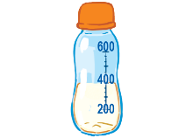  2 | 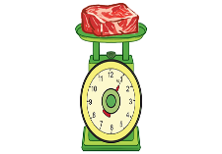  3
  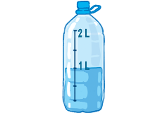  4 | 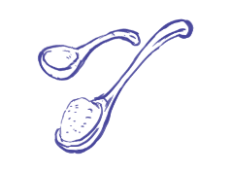  5 | 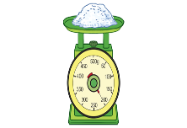  6
ACTIVITY 3 – PRACTICE (15’)
a) Aims:
To help Ss identify new words of dishes and ingredients.
To get Ss to practise asking and answering about the ingredients for a dish using measurement words and phrases they have learnt.
b) Contents:
- Write the words and phrases in the correct columns. Add any other dishes and ingredients you know.
- Work in pairs. Ask and answer about the ingredients for Linh’s apple pie, using the quantities in the recipe.
c) Products:
- Answer key
d) Teaching steps:
Teacher’s and students’ activities | Content
Deliver the task  -Teacher divides the class into 4 groups and gives instructions.  Implement the task  - Individually, Ss carefully and closely watch in order to write down the words for the items appearing on the screen.  Discuss  -Then, Ss discuss the meanings of the words given in groups.  Giving comments or feedback  -T observes and may explain their meanings or even translations.  Deliver the task  -Teacher divides the class into two groups named Mums and Daughters/ Sons and assign Mums, only using the information from the table, to prepare ingredients for an apple pie that they are going to instruct their daughters/ sons and daughters/ sons to prepare some questions to ask their Mums how to make the apple pie.  - After that, teacher pairs Ss to make conversation, asking and answering about the quantity of ingredients for an apple pie.  Implement the task  -Ss work in groups and then in pairs to practise.  Discuss  -Teacher nominates some pairs of Ss to model this activity in front of the class. The others vote the best pairs they like best.  Giving comments or feedback  - Teacher gives feedback to help students improve their talk later. | Task 2: Write the words and phrases in the correct columns. Add any other dishes and ingredients you know.  Key:  Task 3: Work in pairs. Ask and answer about the ingredients for Linh’s apple pie, using the quantities in the recipe.  Example  A: How many apples do we need?  B: We need 12.  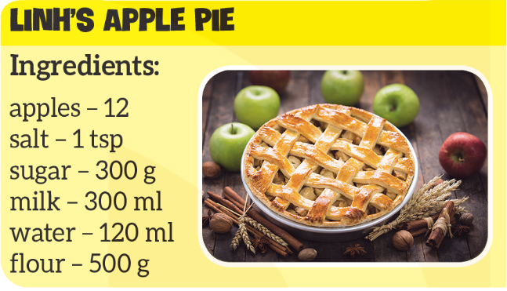
  Dishes | Ingredients
  spring rolls | butter
  omelette | onions
  pancake | pepper
ACTIVITY 4 – PRODUCTION (7’)
a) Aims:
To show, model and help Ss how to pronounce the sounds /ɒ/ and /ɔ:/ and practise pronouncing these sounds correctly in words.
To help Ss practise pronouncing the sounds /ɒ/ and /ɔ:/ correctly in context.
b) Contents:
- Listen and repeat the words. Pay attention to the sounds /ɒ/ and /ɔ:/.
- Listen and repeat, paying attention to the underlined words. Tick (✓) the sentences with the /ɒ/ sound.
c) Products:
- Answer key
d) Teaching steps:
Teacher’s and students’ activities | Content
Deliver the task  - Teacher plays the video modelling the sounds /ɒ/ and /ɔ:/ first and asks Ss to watch closely to see how the sounds are formed, and then gives them instruction to practise pronouncing the sounds.  Implement the task  - After watching the video, Ss listen and put the words in the correct columns.  Discuss  -Ss swap their notebooks with their partners to share their answers.  Giving comments or feedback  - Teacher plays the recording, show them the correct answers and asks Ss to listen and repeat. Teacher may play the recording as many times as necessary, asking Ss to repeat until they can pronounce the sounds correctly.  Audio script – Track 32:  Deliver the task  -Teacher asks Ss to listen twice and asks Ss to tick (√) the sentences with the /ɒ/ sound.  Implement the task  -Ss do as instructed individually  Discuss  - Ss share their answers with Ss who sit next to them.  Giving comments or feedback  - Then Teacher plays the recording again, checks and asks Ss to repeat and provides further practice if needed.  Audio script – Track 33:  1. I hate hot dogs.  2. It’s a very big pot.  3. Put the forks here.  4. This soup is very hot.  5. I like pork cooked with vegetables. | Task 4: Listen and repeat the words. Pay attention to the sounds /ɒ/ and /ɔ:/.  Answer key:  Task 5: Listen and repeat, paying attention to the underlined words. Tick (✓) the sentences with the /ɒ/ sound.  Key:  √: 1, 2, 4
  fond | short | call | water
  pork | sauce | lot | Not
  /ɒ/ | fond, lot, not
  /ɔ:/ | short, call, water, pork, sauce
IV. WRAP-UP & HOMEWORK (3’)
- Teacher asks Ss to summarise what they have learnt in the lesson by asking them some questions.
- What food have we learned to make today?
- What ingredients do we need to make it? How many/ How much of them do we need?
- What sounds do we learn today?
Teacher asks Ss to make sentences about the quantity of ingredients for a dish using the words and phrases they have learnt in the lesson in their workbook.
V. FEEDBACK

……………………….…, ngày………….tháng…………..năm 2022
Duyệt của Tổ chuyên môn

