School: ……………………………………….. | Date: ……………………………..
Class: ……………………………..................... | Period: ………………………......

UNIT 6: LIFE ON OTHER PLANETS
Lesson 2.1 – Vocabulary and Listening (pages 58 & 59)

I. OBJECTIVES
By the end of the lesson, Ss will be able to:
1.1. Language knowledge and skills
- know more words about life on other planets (appear, disappear, disk-shaped, flying saucer, huge, tiny, strange, terrified, UFO).
- listen to and understand interviews with people talking about strange things they saw (for specific details).
- know how to use functional English – Showing interests
1.2. Competences
- improve Ss’ communication, collaboration, analytical and critical thinking skills.
1.3. Attributes
- be aware of what will happen in the future
II. TEACHING AIDS AND LEARNING MATERIALS
1. Teacher’s aids: Student book and Teacher’s book, class CDs, Digital Book (DCR phần mềm tương tác SB, DHA (từ vựng/ cấu trúc) phần mềm trò chơi tương tác), projector/interactive whiteboard / TV (if any), PowerPoint slides.
2. Students’ aids: Student’s book, workbook, notebook.
III. ASSESSMENT EVIDENCE
Performance Tasks | Performance Products | Assessment Tools
- Do the word search. | - Ss’ answers. | - T’s feedback/Peers’ feedback.
- Read the text and number the definitions. Listen and repeat. | - Ss’ presentation. | - T’s feedback/Peers’ feedback.
- Talk about their predictions of UFOs and aliens. | - Ss’ presentation/ answers. | - T’s feedback/Peers’ feedback.
- Listen to two interviews with people talking about strange things they saw. How did the people feel? | - Ss’ answers. | - T’s feedback/Peers’ feedback.
- Listen and fill in the blanks.  - Listen to the conversation again and number the phrases in the order you hear them. | - Ss’ answers.  - Ss’ answers. | - T’s feedback/Peers’ feedback.  - T’s feedback/Peers’ feedback.
- Speak: What do you think Nancy and Jim saw? Why? | - Ss’ answers/ presentation. | - T’s observation and feedback.
IV. PROCEDURES
A. Warm up: (5’)
a) Objective: Introduce the new lesson and set the scene for Ss to acquire new language; get students' attention at the beginning of the class by enjoyable and short activities as well as to engage them in the follow-up steps.
b) Content: Introducing words about future life / Introduce: Language to show interest.
c) Expected outcomes: Ss get to know some new words / structures they are going to study in the lesson.
d) Organization of the activity:
TEACHER’S ACTIVITIES | STUDENTS’ ACTIVITIES
* OPTION 1: Watch a video and answer the question.  - Have Ss watch the video  https://www.youtube.com/watch?v=NnlYcTrqTBg  and give their answers to the question Can you see someone/ something special in the video?  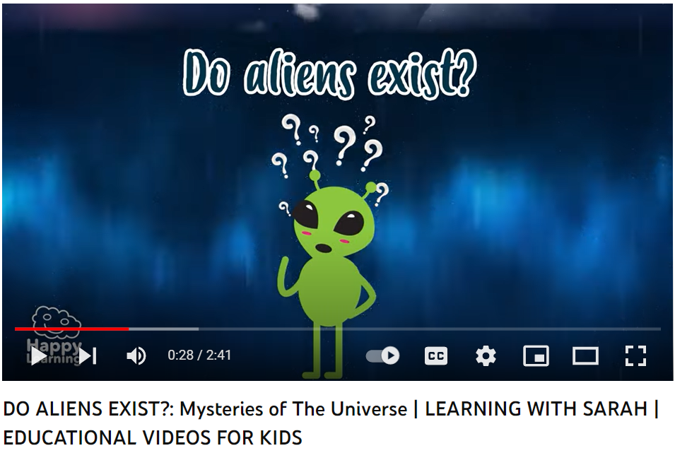  - Call Ss to give answers.  - Check Ss’s answers and give feedback.  - Lead to the new lesson.  * OPTION 2: Let’s Talk!  - Divide the class into pairs.  - Have Ss look at the picture and discuss the questions.  What do you think is happening?  Where can you see or hear about something like this?  Do you think the stories are real?  - Elicit answers from some Ss.  - Lead to the new lesson. | - Watch the video.  - Answer.  - Work in pairs.  - Answer the questions.

B. New lesson (35’)
- Activity 1: Pre-Listening (Vocabulary) (12’)
a) Objective: Ss get to know words about UFO and alien sightings.
b) Content:
- Vocabulary study (appear, disappear, disk-shaped, flying saucer, huge, tiny, strange, terrified, UFO).
- Speaking: Talk about UFOs and aliens.
c) Expected outcomes: Ss know how to pronounce the new words correctly and use them when they do other listening tasks.
d) Organization of the activity:
TEACHER’S ACTIVITIES | STUDENTS’ ACTIVITIES
Teach Vocabulary  - Introduce new words with the following techniques.  - alien (picture)  - appear >< disappear (antonym)  - disk-shaped (picture)  - flying saucer (picture)  - huge >< tiny (antonym)  - strange (explanation: not familiar)  - terrified (mime)  - UFO (picture)  + UFO stands for unidentified flying object.  * OPTION 1:  Task a. Read the text and number the definitions.  Listen and repeat.  - Demonstrate the activity using the example.  - Have students read the text and number the  definitions.  - Divide the class into pairs and have students check  their answers with their partners.  - Play audio (CD2 – Track 2). Have students listen and repeat.  - Check answers as a whole class using DCR.  - Correct Ss’ pronunciation.  * OPTION 2:  Choose the correct word for each sentence.  - Have Ss read the sentences regarding the words they have learned in Task a.  - Ask Ss to give answers and tell the meaning of words again.  - Check answers as a whole class.  - Call some Ss to read the words again.  - Correct Ss’ pronunciation if necessary.  *ILLUSTRATION (adapted from page 34 – WB)  Choose the correct word for each sentence.  1. Suddenly, a UFO appeared/ disappeared in the sky, and it made a strange sound.  2. The alien had ten huge/ tiny eyes on its head. They were so small!  3. I was walking home from school when I saw a disk-shaped/ round-shaped thing in the sky. It was round and thin.  4. I was running after the alien, but then it appeared/ disappeared. I couldn't see it anywhere.  5. The government doesn't know what flew over the city. They're calling it a (an) UFO/ alien.  6. I saw a (an) flying saucer/ airplane last night. It was round, and I'm sure it was from another planet.  7. I was laying in bed when I heard a strange/ pleasant sound. I didn't know what it was, but it sounded like  an animal.  8. My sister and I felt so scared when we saw the UFO. My sister was more scared than me. She was  huge/ tiny.  9. In the movie, an UFO/ alien from another planet visited Earth. It has two heads and long arms.  10. I can't believe how big the ship was. It was huge/ tiny!  Task b. In pairs: Do you think there are UFOs and aliens? What do you think they look like?  - Have pairs discuss the questions.  - Have some pairs share their ideas with the class.  - Go round and give help if necessary.  - Have some pairs demonstrate the activity in front of the class.  - Give feedback. | - Listen and write down.  - Look and listen.  - Work individually.  Answer keys  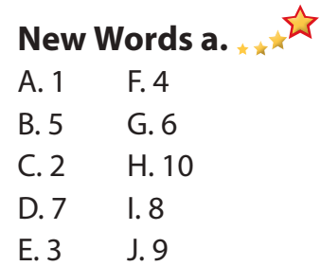  - Read the sentences and choose the correct word.  Answer keys  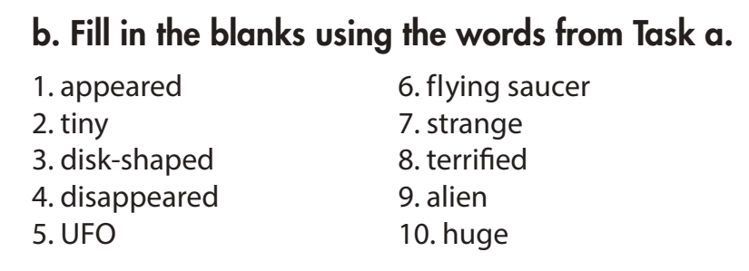  - Work in pairs to discuss.  - Present.  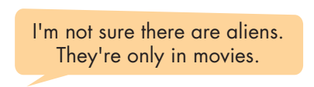  Sample answers  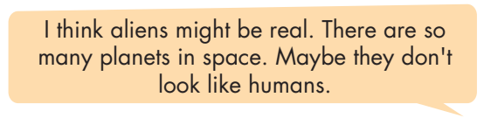
- Activity 2: While - Listening (17’)
a) Objective: Students can develop their listening skill.
b) Content: Listening to the audio and doing the tasks.
- Listen to two interviews with people talking about strange things they saw. How did the people feel?
- Listen again and number the phrases in the order.
c) Expected outcomes: Ss can listen to and understand the conversations of two people talking about about strange things they saw (for specific details).
d) Organization of the activity:
TEACHER’S ACTIVITIES | STUDENTS’ ACTIVITIES
Task a. Listen to two interviews with people talking about strange things they saw. How did the people feel?  - Have students read the question.  - Play audio (CD2 - Track 7). Have students listen and answer the question.  - Check answers as a whole class.  Task b. Now, listen and fill in the blanks  - Have Ss read the through the content of Task b and underline the key words.  - Demonstrate the activity using the example.  - Play the audio again (CD2 - Track 7). Have students listen and fill in the blanks.  - Check answers as a whole class.  - Have Ss check answers with their partners.  - Call Ss to give answers.  - Give feedback and show correct answers using DCR. | -Work individually.  - Listen.  - Give the correct answers.  Answer keys  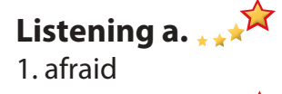  - Read and underline the key words.  - Do the task.  - Exchange answers.  Answer keys  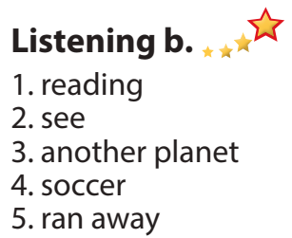

- Activity 3: Post - Listening (6’)
a) Objective: Students can use the vocabulary and the content in the listening part to develop their speaking skill.
b) Content: Speaking: How do you show interest in what other people say?
What do you think the speakers saw? Why?
c) Expected outcomes: Students can talk about their personal experiences in the past.
d) Organization of the activity:
TEACHER’S ACTIVITIES | STUDENTS’ ACTIVITIES
Task c. Read the Conversation Skill box. Then, listen and repeat  - Have Ss look at the Conversation skill box and read.  - Play audio (CD 2 - Track 8), have Ss listen and repeat (using DCR).  - Ask Ss to number  - Ask Ss to find more ways to show interest.  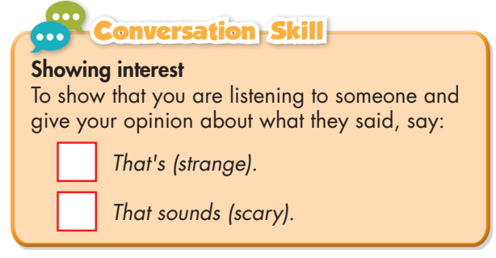  Task d. Listen to the conversation again and  number the phrases in the order you hear  them.  - Play audio (CD 2 - Track 7). Have students listen and number the sentences they hear.  - Check answers as a whole class.  Task e. In pairs: What do you think Nancy and Jim saw? Why?  - Have students discuss the questions.  - Elicit answers from some students.  - Observe and give help if necessary.  - Call some pairs to share their ideas with the class.  - Give feedback. | - Look and read.  - Listen and repeat.  - Give answers.  Answer keys  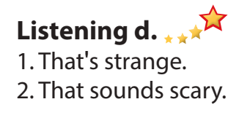  - Work in pairs.  - Present.  Suggested answer  I think they saw an airplane because no one else saw it. They didn't see aliens. I think they were normal people in strange clothes.

C. Consolidation and homework assignments (5’)
* Consolidation:
- Words relating life on other planets (appear, disappear, disk-shaped, flying saucer, huge, tiny, strange, terrified, UFO).
- Language to show interest
- Choose the correct word for each sentence.
1. Suddenly, a UFO appeared/ disappeared in the sky, and it made a strange sound.
2. The alien had ten huge/ tiny eyes on its head. They were so small!
3. I was walking home from school when I saw a disk-shaped/ round-shaped thing in the sky. It was round and thin.
Answer keys:
1. appeared 2. tiny 3. disk-shaped
* Homework
- Learn the new words.
- Practice talking about strange things you saw in the past.
- Do the exercises in WB: New words and Listening (pages 34 & 35).
- Do the exercises in Tiếng Anh 8 i-Learn Smart World Notebook (pages 49 & 50).

- Play the consolidation games in Tiếng Anh 8 i-Learn Smart World DHA App on www.eduhome.com.vn
- Prepare: Lesson 2.2 – Grammar (pages 59 & 60 – SB).

V. Reflection
a. What I liked most about this lesson today:
…………………………………………………………………………………………
- What I learned from this lesson today:
…………………………………………………………………………………………
c. What I should improve for this lesson next time:
…………………………………………………………………………………………

