REVIEW 2 (Units 4-5-6)
Lesson 1: Language
I. OBJECTIVES
By the end of this lesson, students will be able to:
1. Knowledge
- revise words related to music and arts; food and drinks; to school facilities and school activities;
- revise pronouncing the sounds /ʃ/, /ʒ/, /ɒ/, /ɔ:/, /tʃ/ and /dʒ/ correctly;
- revise the use of comparisons; some, a lot of, lots of; prepositions of time and place;
- express preferences;
- ask and answer about prices;
- ask for details.
2. Core competence
- Develop communication skills and cultural awareness
- Be collaborative and supportive in pair work and teamwork
- Actively join in class activities
3. Personal qualities
- Develop self-study skills

II. MATERIALS
- Grade 7 textbook, Review 2 - Language
- Computer connected to the Internet
- Projector /TV/ pictures and cards
- hoclieu.vn

Assumptions
Anticipated difficulties | Solutions
1. Students may find the lesson boring due to a large number of language exercises. | - Encourage students to work in pairs, in groups so that they can help each other.  - Design as many exercises as games as possible.  - Provide feedback and help if necessary.
2. Some students will excessively talk in the class. | - Define expectation in explicit detail.  - Have excessively talkative students practise.  - Continue to define expectations in small chunks (before every activity).
Board Plan
Date of teaching
REVIEW 2 (Units 4-5-6)
Lesson 1: Language
*Warm-up
Game: Finding keywords
I. Practice
*Pronunciation
Task 1: Circle the word in which the underlined part is pronounced differently.
*Vocabulary
Task 2: Match a word in A with a word or phrase in B. Then complete the sentences with the appropriate phrases.
Task 3: Underline the correct word to complete the sentences.
*Grammar
Task 4: Complete the passages about camping.
Task 5: Complete the second sentence.
*Homework

III. PROCEDURES
Notes:
In each activity, each step will be represented as following:
* Deliver the task
** Implement the task
*** Discuss
 Give comments or feedback

STAGE | Stage aim | Procedure | Interaction | Time
WARM-UP | To lead in the lesson. | GAME: FINDING KEYWORDS  * Teacher shows 3 sets of pictures (taken from lessons of Units 4-5-6) and asks students to find a keyword for each set of pictures.  ** Students raise hands to answer.  *** Teacher and students discuss the answers.   Teacher checks the answers as a class.  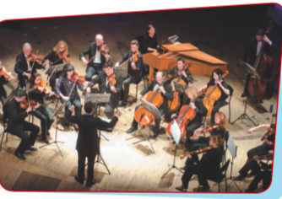   Set 1: MUSIC & ARTS    Set 2: FOOD & DRINKS  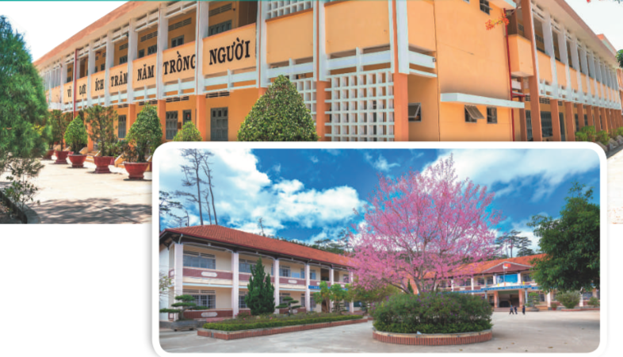  Set 3: SCHOOL FACILITIES | T-Ss  Ss  T-Ss  T-Ss | 5 mins
PRONUNCIATION | To help students review the pronunciation of the sounds learnt in Units 4 - 6. | TASK 1: CIRCLE THE WORD IN WHICH THE UNDERLINED PART IS PRONOUNCED DIFFERENTLY. THEN LISTEN, CHECK AND REPEAT. (Ex 1, p. 70)  * Teacher writes the sounds /ʃ/ and /ʒ/, /ɒ/ and /ɔ:/, /tʃ/ and /dʒ/on the board.  - Teacher writes one word containing the sound below each of them.  - Teacher asks students to read the words aloud.  ** Students do the task by reading aloud each group and circling the odd one out.  *** Teacher can invite some pairs of students to read aloud.   Teacher checks students’ pronunciation and gives feedback.  Answer key:  1. D  2. B  3. C  4. B  5. C | T-Ss  Ss  T-Ss  T-Ss | 15 mins
VOCABULARY | To help students review the phrases taught in Unit 4-6 and use them in different contexts. | TASK 2: MATCH A WORD IN A WITH A WORD / PHRASE IN B. THEN COMPLETE THE SENTENCES WITH THE APPROPRIATE PHRASES. (Ex 2, p. 70)  * Teacher asks Ss to read the verbs in A and match them with the nouns in B. Remind ss that they have learnt these phrases in the previous three units. Make sure they remember their meanings.  ** Students do this exercise individually.  *** Teacher allows students to share their answers in pairs before discussing as a class.   Teacher checks the answers as a class and gives feedback.  Answer key:  1. e  2. d  3. a  4. b  5. c  1. play the guitar  2. need some apples  3. perform a classical concert  4. drink juice  5. pass an entrance exam | T-Ss  Ss  Pair work  T-Ss
 | To help students identify the words through different context. | TASK 3: UNDERLINE THE CORRECT WORD TO COMPLETE THE SENTENCES. (Ex 3. p. 70)  * Teacher asks students to work individually to choose the correct words and complete the sentences.  ** Students work individually to complete the task.  *** Teacher allows students to share answers with a partner before discussing as a class.   Teacher asks students to say the sentences aloud and makes sure they pronounce the words and phrases correctly. Teacher can ask for translation to check their understanding.  Answer key:  1. composers  2. apples  3. concert  4. gifted  5. entrance | T-Ss  Ss  Pair work  T-Ss
GRAMMAR | To help students review grammar elements taught in Unit 5: How much, How many, some, a lot of. | TASK 4: COMPLETE THE PASSAGES ABOUT CAMPING. USE THE WORDS AND PHRASES FROM THE BOX. (Ex 4, p.70)  * Teacher asks students to work independently to fill in the blanks with the correct words from the box.  ** Students work individually to complete the task.  *** Teacher allows students to share answers before discussing as a class.   Teacher asks students to say the sentences aloud and makes sure they pronounce the words and phrases correctly. Teacher can ask for translation to check their understanding.  Answer key:  1. How much  2. How many  3. a lot of  4. much  5. some  6. many | T-Ss  Ss  Ss-Ss  T-Ss | 20 mins
 | To help students review grammar elements taught in Unit 4: more … than, different from, not as … as, the same as. | TASK 5: COMPLETE THE SECOND SENTENCE, USING THE WORDS IN BRACKETS. (Ex 5, p. 70)  * Teacher gives a brief revision of more … than, different from, not as … as, the same as then asks students to do the task individually.  ** Students do the task individually.  *** Teacher allows students to share answers before discussing as a class.   Teacher asks students to say the sentences aloud and makes sure they pronounce the words and phrases correctly. Teacher can ask for translation to check their understanding.  Answer key:  1. I think rock and roll is more exciting than classical music.  2. The poster in the gallery is not different from the one in my house.  3. A ticket to the theatre is not as expensive as I expected.  4. The painting in the museum is like the painting in the gallery. | T-Ss  Ss  T-Ss  T-Ss
WRAP-UP | To consolidate what students have learnt in the lesson. | Teacher asks students to talk about what they have learnt in the lesson. | T-Ss | 3 mins
HOMEWORK | To prepare vocabulary for the next lesson. | Prepare for Review 2 – Skills. | T-Ss | 2  min

REVIEW 2 (Units 4-5-6)
Lesson 2: Skills
I. OBJECTIVES
By the end of this lesson, Ss will be able to:
1. Knowledge
- practice reading for specific information about one’s favourite kind of music;
- practice talking about a visit to a lower secondary school;
- practice listening for specific information about a meal at a restaurant;
- practice writing a paragraph about a meal at a restaurant.
2. Core competence
- Develop communication skills and cultural awareness
- Be collaborative and supportive in pair work and teamwork
- Actively join in class activities
3. Personal qualities
- Develop self-study skills

II. MATERIALS
- Grade 7 textbook, Review 2 - Skills
- Computer connected to the internet
- Projector/ TV/ pictures and cards
- hoclieu.vn

Assumptions
Anticipated difficulties | Solutions
1. Students may find the lesson boring due to a large number of language exercises. | - Encourage students to work in pairs, in groups so that they can help each other.  - Design as many exercises as games as possible.  - Provide feedback and help if necessary.
2. Some students will excessively talk in the class. | - Define expectation in explicit detail.  - Have excessive talking students practice.  - Continue to define expectations in small chunks (before every activity).

Board Plan
Date of teaching
REVIEW 2 (Units 4-5-6)
Lesson 2: Skills
*Warm-up
What kind of music?
I. Practice
Reading
Task 1: Choose the appropriate option to fill in each gap of the paragraph.
Speaking
Task 2: Ask and answer the questions, using the suggestions.
Listening
Task 3: Listen to a man talking about his meal at a restaurant and tick the adjectives you hear
Task 4: Listen again and fill in each gap with ONE word
Writing
Task 5: Write a paragraph of about 60 words about a meal you had at a restaurant
*Homework

III. PROCEDURES
Notes:
In each activity, each step will be represented as following:
* Deliver the task
** Implement the task
*** Discuss
 Give comments or feedback

Stage | Stage aim | Procedure | Interaction | Time
WARM-UP | To lead in the lesson. | WHAT KIND OF MUSIC?  * Teacher lets Ss listen to some pieces of music and asks students to discuss what types of music they are.  ** Students raise hands to answer.  *** Teacher and students discuss the answers.   Teacher checks the answers as a class.  1. Country music  2. Classical music  3. Rock music  4. Hip hop music  5. Pop music | T-S  Ss  T-Ss  T-Ss | 3 mins
READING | To help students practise reading specific information. | TASK 1: CHOOSE THE APPROPRIATE OPTION (A, B, OR C) TO FILL IN EACH GAP OF THE PARAGRAPH. (Ex 1, p. 71)  * Teacher has Ss read the paragraph carefully and decides which option goes with which gap.  ** Students read the text fully and choose the correct answers.  *** Teacher asks students how they can choose the option.   Teacher confirms the answers as a class.  Answer key:  1. C  2. A  3. B  4. C  5. A | T-Ss  Ss  T-Ss  T-Ss | 7 mins
SPEAKING | To help students practise asking and answering about a visit to a lower secondary school. | TASK 2: WORK IN PAIRS. IMAGINE YOU HAVE JUST VISITED A LOWER SECONDARY SCHOOL. ASK AND ANSWER THE QUESTIONS, USING THE SUGGESTIONS. (Ex 2, p. 71)  * Teacher asks students to imagine that they have just visited a lower secondary school so that they can form their own ideas of where the school is, how many teachers and students there are, what school facilities are, what school outdoor activities students do.  Let Ss read the questions to focus on the information they are going to answer.  ** Students work in pairs, asking and answering the provided questions.  *** Teacher calls on some pairs to report their answers for the class. Each pair may answer just one question to allow room for more pairs.   Teacher checks the answers and adds more information if necessary. | T-Ss  Pair work  T-Ss  T-Ss | 8 mins
LISTENING | To help students practise listening for specific information. | TASK 3: LISTEN TO A MAN TALKING ABOUT HIS MEAL AT A RESTAURANT AND TICK THE ADJECTIVES YOU HEAR. (Ex 3, p. 71)  * Teacher allows Ss some time to read the words/adjectives. Check if the words/adjectives are new or not. Check comprehension, if necessary.  Play the recording once.  ** Students listen and do the task.  *** Teacher allows students to share answers before discussing as a class.   Teacher invites one student to read the words / adjectives they have ticked.  Answer key: 1, 2, 4  Audio script:  Last weekend, I went to a restaurant near my sister’s home. For a starter, I had a fresh salad. My main dish was fish. I really enjoyed the spices in it. The vegetables were good – very fresh and tasty. For dessert, I had an ice cream. It’s usually delicious but this time it wasn’t very sweet. So, I didn’t eat much. Then I had a glass of juice. I think the meal was OK. | T-Ss  Ss  Pair work  T-Ss | 8 mins
 | To help students practise listening for specific information. | TASK 4: LISTEN AGAIN AND FILL IN EACH GAP WITH ONE WORD. (Ex 4, p. 71)  * Teacher has Ss read the table. Draw their attention to the meanings of the words: starter, main dish, dessert, drink.  Play the recording once or twice for the ss to complete the table.  ** Students listen and do the task.  *** Teacher allows students to share answers with their partners before discussing as a class.   Teacher invites one student to read the words they have filled in. | T-Ss  Ss  Pair work  T-Ss
WRITING | To help students practise writing a paragraph about a meal in a restaurant. | TASK 5: WRITE A PARAGRAPH OF ABOUT 60 WORDS ABOUT A MEAL YOU HAD AT A RESTAURANT. (Ex 5, p. 71)  * Teacher asks students to read the instructions and allow them some time to read the first sentence of the paragraph to think about the information they need to write.  ** Students do the task individually.  *** Teacher goes around and checks if they are doing the task correctly and offers help if needed.   Teacher calls one or two volunteers to read aloud the paragraphs. Call for others’ comments.  Suggested paragraph:  Last weekend, my parents and I had a meal at a small restaurant in the centre of town. For a starter, I had a salad. It was fresh. My main dish included rice, beef, and vegetables. The beef was tasty, and the vegetables were fresh. For dessert, I had a big ice cream. Then I drank a glass of orange juice with ice. The meal was great. | T-Ss  Ss  T-Ss  T-Ss | 15 mins
WRAP-UP | To consolidate what students have learnt in the lesson. | Teacher asks students to talk about what they have learnt in the lesson. | T-Ss | 3 mins
HOMEWORK | To prepare vocabulary for the next lesson. | Prepare for Unit 7 – Getting started. | T-Ss | 1 min

