**TIẾNG ANH 9 FRIENDS PLUS**

**REVIEW 2 - TEST 1 - KEY**

**I. Pronunciation (1-4)**

**Câu 1.** Which word has the underlined part pronounced differently from that of the others?

**A.** pick**ed**  **B.** increas**ed**  **\*C.** air**ed**  **D.** shopp**ed**

**Câu 2.** Which word has the underlined part pronounced differently from that of the others?

**A.** r**a**pidly  **\*B.** sm**a**rtphone  **C.** imp**a**ct  **D.** f**a**shion

**Câu 3.** Which word has a different stress pattern from that of the others?

**A.** computer  **B.** excited  **\*C.** challenging  **D.** successful

**Câu 4.** Which word has a different stress pattern from that of the others?

**\*A.** career  **B.** feature  **C.** towel  **D.** passion

**II. Choose the answer (A, B, C or D) that best fits the space in each question. (5-14)**

**Câu 5.** I found a great _________ on a new jacket at the store. My friends loved it.

**A.** rip-off  **\*B.** bargain  **C.** contract  **D.** expense

**Câu 6.** Our teacher _________ reading by giving us interesting books.

**A.** discourages  **\*B.** promotes  **C.** hinders  **D.** prevents

**Câu 7.** A dove is often used as a _________ of peace.

**A.** badge  **B.** trophy  **\*C.** symbol  **D.** token

**Câu 8.** The concert tickets were a _________ because the seats were terrible.

**\*A.** rip-off  **B.** agreement  **C.** deal  **D.** bargain

**Câu 9.** She can’t _________ to go on vacation this year.

**\*A.** afford  **B.** deny  **C.** refuse  **D.** furnish

**Câu 10.** I was very tired after a long day at work, _______ I decided to go to bed early to get some rest.

**A.** but  **B.** therefore  **C.** as  **\*D.** so

**Câu 11.** She is extremely happy _______ she passed her difficult math exam with a high score.

**\*A.** because  **B.** but  **C.** although  **D.** so

**Câu 12.** We decided to stay inside all day _______ the heavy rain and strong winds outside.

**A.** despite  **B.** although  **C.** because  **\*D.** because of

**Câu 13.** He _______ work on weekends, so he spends time with his family and friends.

**A.** has to  **B.** should  **C.** mustn’t  **\*D.** doesn’t have to

**Câu 14.** Why do you think they closed the main entrance this morning? - ".............."

**\*A.** They were repairing it.  **B.** It’s so close to here.

**C.** I think they will do it.  **D.** Yes, they are very kind.

**III. Look at the signs. Choose the best answer (A, B, C or D). (15-16)**

**Câu 15.** What special offer is available for the first 100 customers?

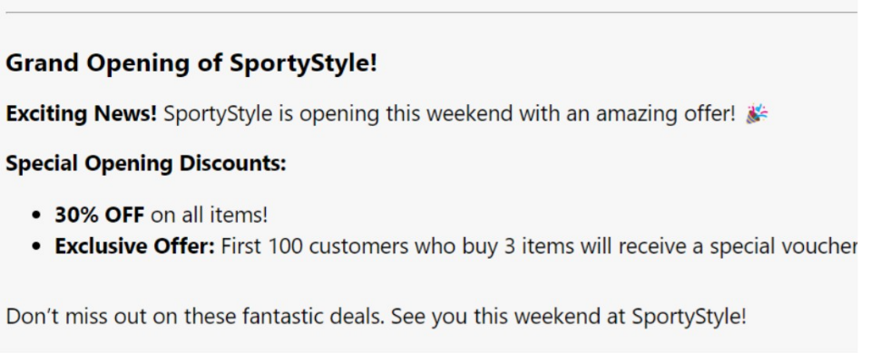

**\*A.** A special voucher if they buy 3 items  **B.** 50% off on their next purchase

**C.** A free gym membership  **D.** A free T-shirt

**Câu 16.** Choose the best answer for the question.

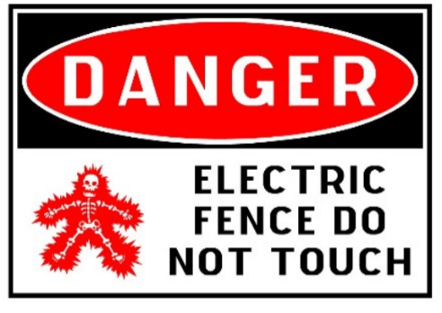

**A.** You don’t have to touch the electric fence.  **\*B.** You must keep away from the electric fence.

**C.** The dangerous electric fence can’t touch you.  **D.** It is dangerous to have an electric fence.

**IV. Read the following passage and do as direct. (17-22)**

**New Camping Gear Store Opening!**

**Great news for all campers! A new camping gear store is opening in town. The store will have everything you need for your outdoor adventures. You can find tents, sleeping bags, backpacks, and cooking tools. There are also clothes and shoes for hiking.**

**The grand opening is this Saturday at 10 AM. There will be special discounts and free gifts for the first 50 customers. You can also join a free workshop on how to set up a tent. Experienced staff will be there to help you choose the best gear.**

**The store is located at 123 Forest Road, near the big park. It will be open every day from 9 AM to 8 PM. Don't miss this chance to get top-quality camping gear at great prices. See you at the new store!**

**Câu 17.** The new camping gear store is opening this Sunday at 10 AM.

**A.** True  **\*B.** False

**Câu 18.** The store will have a free workshop on how to set up a tent.

**\*A.** True  **B.** False

**Câu 19.** The first 50 customers will receive special discounts and free gifts.

**A.** False  **\*B.** True

**Câu 20.** The store is located at 123 Forest Avenue, near the big park.

**A.** True  **\*B.** False

**Câu 21.** What time does the new camping gear store open on its grand opening day?

**A.** 11 AM  **B.** 9 AM  **\*C.** 10 AM  **D.** 12 PM

**Câu 22.** Which of the following items can you NOT find in the new camping gear store?

**\*A.** Kayaks  **B.** Tents  **C.** Cooking tools  **D.** Sleeping bags

**V. Choose the word (A, B, C or D) that best fits the blank space in the following passage. (23-28)**

**Hi Bao,**

**I hope you're doing well! I wanted to share my summer plans ________(23) you. I'm really excited because I've ________(24) to prepare for learning computer science. I think it's a great skill to have, and I'm looking forward to diving into it.**

**I'll be starting with some online courses. I've already signed up for a beginner's course on Python ________(25). It looks really interesting and user-friendly. I also found a few YouTube channels and websites that offer free tutorials and exercises.**

**________(26) that, I'm planning to read some books on the basics of computer science. I've heard "Computer Science Distilled" is a good one to start with. I'll also try to practice coding every day to get ________(27) to it.**

**Do you have any plans for the summer? Maybe we can catch ________(28) and study together sometime. It would be fun and motivating!**

**Take care and let's keep in touch!**

**Best,**

**Max**

**Câu 23.** Choose the correct answer.

**\*A.** with  **B.** of  **C.** about  **D.** on

**Câu 24.** Choose the correct answer.

**\*A.** decided  **B.** decide  **C.** decision  **D.** decides

**Câu 25.** Choose the correct answer.

**A.** programmable  **B.** programmer  **C.** program  **\*D.** programming

**Câu 26.** Choose the correct answer.

**A.** In addition  **B.** Opposite  **\*C.** Besides  **D.** Moreover

**Câu 27.** Choose the correct answer.

**A.** using  **B.** use  **\*C.** used  **D.** uses

**Câu 28.** Choose the correct answer.

**\*A.** up  **B.** in  **C.** over  **D.** out

**VI. Supply the correct form of the word given in each sentence. (29-34)**

**Câu 29.** To get that job, you need to have some ____________. (qualify)

**Lời giải**

qualifications

**Câu 30.** I was ____________ late for the meeting this morning due to the traffic jam. (terrible)

**Lời giải**

terribly

**Câu 31.** She is taking an ____________ English class this semester. (advance)

**Lời giải**

advanced

**Câu 32.** I like to ____________ in the school's sports events next month. (competitor)

**Lời giải**

compete

**Câu 33.** She always shows ____________ for her friends' feelings. (consider)

**Lời giải**

consideration

**Câu 34.** He was very ____________ when I told him about my problem. (sympathy)

**Lời giải**

sympathetic

**VII. Rearrange the groups of words in a correct order to make complete sentences. (35-36)**

**Câu 35.** weekend, / for / the test / you study hard / with good grades. / will pass / the exam / this / If / you/

______________________________________

**Lời giải**

If you study hard for the test this weekend, you will pass the exam with good grades.

**Câu 36.** can / homework before we / go out to / We must finish our / play./

______________________________________

**Lời giải**

We must finish our homework before we can go out to play.

**VIII. Rewrite each of the following sentences in another way so that it means almost the same as the sentence printed before it. (37-40)**

**Câu 37.** Susan can’t go to school today because she is ill.

If Susan _________________________________________________________________.

**Lời giải**

If Susan **were not ill, she could go to school today.**

**Câu 38.** The mother made her son go to bed on time.

The son _____________________________________________________________.

**Lời giải**

The son **was made to go to bed on time.**

**Câu 39.** The car was so expensive that my father didn’t buy it.

The car was too _____________________________________________________.

**Lời giải**

The car was too **expensive for my father to buy.**

**Câu 40.** My sister started to learn English when she was three years old.

My sister has ____________________________________________________________.

**Lời giải**

My sister has **been learning English since she was three years old.**

**(**My sister has **learnt English since she was three years old.**)

**IX. Listening: A new shopping mall is opening. Listen and choose the correct answer. (41-50)**

**Câu 41.** **When will the new shopping mall have its grand opening?**

**A.** Last Saturday  **B.** Last Sunday  **C.** Next Sunday  **\*D.** Next Saturday

**Câu 42.** Who will give a short speech at the grand opening ceremony?

**\*A.** The town mayor  **B.** The mall manager  **C.** A famous actor  **D.** A local businessman

**Câu 43.** **What will families enjoy doing at the new mall?**

**\*A.** Walking around and looking at new things  **B.** Watching movies

**C.** Attending a concert  **D.** Playing sports

**Câu 44.** **Which of the following will be available in the fashion stores?**

**A.** Free meals  **B.** Movie tickets

**C.** Sports equipment  **\*D.** Try-on options and item exchange

**Câu 45.** **What feature will help shoppers buy items quickly?**

**\*A.** Scan-and-shop screens  **B.** Personal shoppers

**C.** Online shopping only  **D.** Free delivery

**Câu 46.** **The grand opening ceremony will start at 10 AM.**

**\*A.** True  **B.** False

**Câu 47.** **The mall will have only clothing shops and toy stores.**

**A.** True  **\*B.** False

**Câu 48.** **Some shops will give away free samples on the opening day.**

**A.** False  **\*B.** True

**Câu 49.** **There will be no special offers or discounts on the opening day.**

**A.** True  **\*B.** False

**Câu 50.** **The new mall is expected to be a popular place for shopping and spending time with friends and family.**

**\*A.** True  **B.** False

**----HẾT---**