LỚP HỌC THẦY (CÔ) ___________________________ ĐỀ ÔN TẬP: READING SIGNS/ NOTICES – A2
Test 1

Thời gian làm bài: [Time]
Họ và tên: ________________________________________________ Lớp: 9/___
Nội dung:
Question 1: What does the sign say?

A. Anyone is allowed to enter without restrictions.
B. Only authorized personnel are permitted to enter.
C. No one is allowed to enter the area.
D. You should keep your dog on a leash while in the area.

Question 2: What does the notice say?
"Please keep your bus ticket with you at all times. The transport officers might ask to see it during your journey"
A. You need to keep your bus ticket with you. Officers might check it.
B. Transport officers will give you a bus ticket.
C. You do not need a bus ticket for the journey.
D. You can get your bus ticket from the transport officers.
Question 3: What does the sign say?
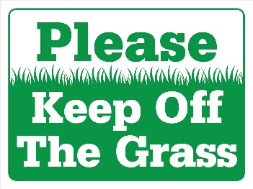
A. You can walk on the grass and play games there.
B. The grass should be kept clean and free of trash.
C. You should not walk on the grass to help keep it healthy.
D. The grass is for sitting and relaxing only.

Question 4: What does the notice say?
"No entry allowed without a valid pass.
You must show your pass to enter the building"
A. You need a valid pass to enter. Show it to get in.
B. You can enter the building without a pass.
C. Passes are not needed for entering the building.
D. The building is open to everyone.
Question 5: What does the sign say?
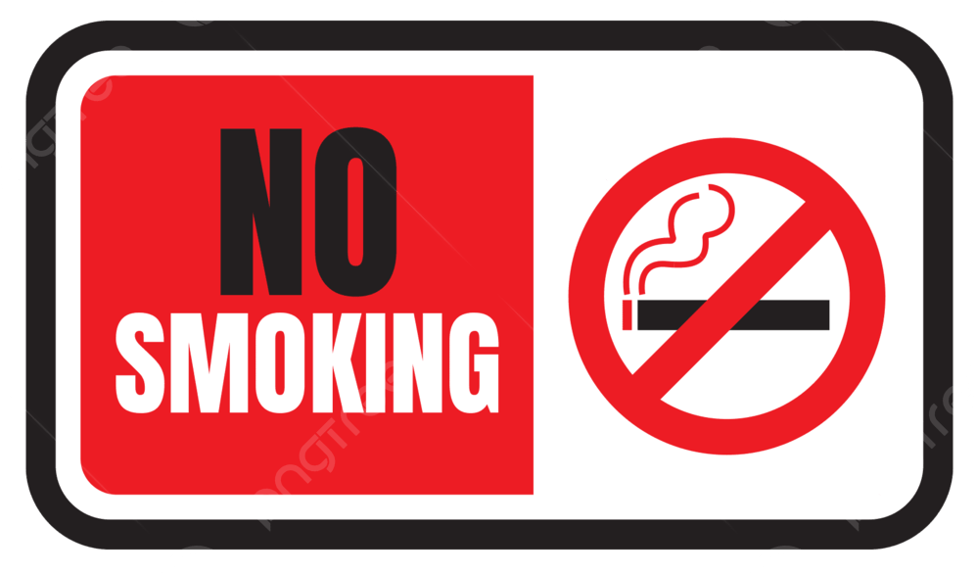
A. You can smoke anywhere, including in this area.
B. Smoking is only allowed in specific areas that are marked for it.
C. Smoking is not allowed at all in this area to keep it clean and safe.
D. Smoking is encouraged and welcome in this area.

Question 6: What does the notice say?
"No smoking is allowed inside this building.
Please use the designated smoking areas outside"
A. Do not smoke inside. Use smoking areas outside.
B. Smoking is allowed in any part of the building.
C. You can smoke anywhere inside the building.
D. Smoking is only allowed in specific rooms inside.
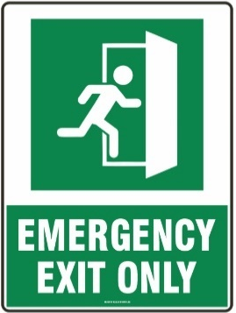
Question 7: What does the sign say?

A. You can use this door anytime you want to enter.
B. This door is only for use in emergencies when you need to leave quickly.
C. Everyone should use this door to enter the building.
D. This door is locked and cannot be opened at all.

Question 8: What does the notice say?
"Dogs must be leashed at all times in this area.
Please keep your dog on a leash to ensure safety"
A. Dogs need to be leashed here. It is for safety.
B. Dogs can run free without a leash.
C. Leashes are not necessary for dogs.
D. Only some dogs need leashes.
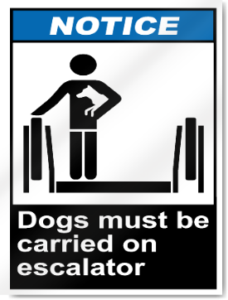
Question 9: What does the sign say?

A. Dogs are allowed to walk on the escalator.
B. Dogs should be carried when using the escalator.
C. Dogs are not allowed to use the escalator at all.
D. Dogs can ride the escalator without any restrictions.

Question 10: What does the notice say?
"The restroom is temporarily closed for maintenance.
It will open as soon as the work is finished"
A. The restroom is closed for maintenance and will open later.
B. The restroom is open but being cleaned.
C. The restroom is always open.
D. You can use the restroom in a different building.
[HẾT]

