School: ……………………………………….. | Date:……………………………………..
Class: ……………………………..................... | Period: 19

UNIT 2: LIFE IN THE COUNTRY
Lesson 3.2 – Speaking & Writing, page 23
1. Objectives
By the end of this lesson, students will be able to…
1.1. Language knowledge/ skills
- talk about festivals in the country
- write an announcement for a festival in the country
1.2. Competences
- improve Ss’ communication, collaboration, analytical, critical thinking skills.
1.3. Attributes
- love the country
- proud of the festivals of the country.
2. Teaching aids and materials
- Teacher’s aids: Teacher’s aids: Student’s book and Teacher’s book, class CDs, DCR– Phần mềm tương tác trực quan, DHA – Ứng dụng trò chơi tương tác, projector / interactive whiteboard /TV (if any), PowerPoint slides.
- Students’ aids: Student’s book, Workbook, Notebook.
3. Assessment Evidence
Performance Tasks | Performance Products | Assessment Tools
- Discuss some common activities and food at festivals in Vietnam  - Complete the mind map with the ideas you have discussed.  - Write the announcement (80-100 words) for the festival you planned in Speaking. | - Ss’ answers.  - Ss’ answers.  - Ss’ answers. | - Observation.  - Observation.  - Checking.
4. Procedures
A. Warm up: 5’
a. Objective: to review lesson 3.1 and lead in the new lesson.
b. Content: ordering sentences activity.
c. Expected outcomes: Ss can put the sentences of a passage in a logical order.
d. Organization
Teacher’s activities | Students’ activities
Ordering sentences  - Ask Ss to work in pairs, putting the sentences below in the correct order:  A. Try lots of traditional food, like bánh chưng, and enjoy live performances.  B. Come and enjoy a great day at the Peace Town Tết Festival.  C. We're pleased to announce the 2025 Peace Town Tết Festival will be at Main Street  Hall on Wednesday, January 29th at 2 p.m.  D. The 2025 Peace Town Tết Festival  E. Tickets cost 60,000 VND for adults and 30,000 VND for children.  - Call some pairs to give their answers.  - Give feedback. | -Work in pairs, putting the sentences below in the correct order.  -Give answers.  Answer keys:  A. 5 B. 3 C. 2 D. 1 E. 4
B. New lesson (35’)
1. Speaking: 10’
a. Objectives: to help Ss practice asking and answering about a traditional festival and get ideas for their writing task.
b. Content: tasks a and b.
c. Expected outcomes: Ss can talk about a traditional festival.
d. Organization
Teacher’s activities | Students’ activities
Task a: In pairs: Discuss some common activities and food at festivals in Vietnam.  - Ask Ss to work in pairs to make a list of festivals in Vietnam and their activities as well as traditional food.  - Elicit ideas from Ss.  - Give feedback. | - Work in pairs to make a list of festivals in Vietnam and their activities as well as traditional food  - Give ideas.
Task b: Now, imagine you are members of the cultural department of a small town in the country and are planning a traditional festival. In pairs: Use the questions to discuss the points on the mind map below and write in your own ideas.  - Explain the task.  - Give Ss time to discuss with their partners and complete the mind map.  - Go around to help if necessary.  - Pick some pairs to present about the festival they have discussed.  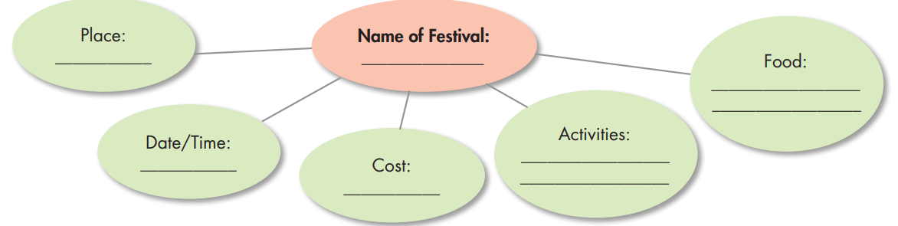 | - Discuss with their partners and complete the mind map.  - Present their chosen festival, using the ideas they have discussed.  Sample answer:  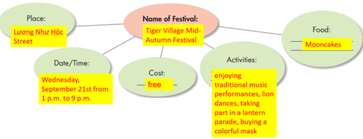
2. Write: 10 minutes
a. Objectives: to help Ss to practice writing a long-form announcement about a traditional festival in Vietnam.
b. Content: Let’s write.
c. Expected outcomes: Ss can produce a long-form announcement about a traditional festival in Vietnam.
d. Organization
Teacher’s activities | Students’ activities
Review:  -Ask Ss the following questions:  a) How many parts are there in a long-form announcement?  b) What is the function of each part?  Let’s write: Now, write the announcement  for the festival you planned in Speaking. Use the Writing Skill box and your speaking notes to help you. Write 80 to 100 words.  - Assign the task.  - Give Ss some time to write.  - Monitor the class and help them if necessary.  - Pick some Ss to show their writing and give feedback.  - Show sample passage. | - Give their answers  Answer Keys:  a) There are five parts: a heading, a summary sentence, a call to action, the cost, the different activities and food.  b) A heading: say what the event is.  A summary sentence: say what, where, and when the festival is.  A call to action: ask the readers to take part or join in.  The cost: say how much a ticket is  Activities and food: say the different activities and food at the festival.  - Write a long-form announcement, using the information they have discussed.  - Show their writing.  Sample passage:  Tiger Village Mid-Autumn Festival We are happy to announce the 2024 Tiger Village Mid-Autumn Festival will take place at Lương Như Hộc Street on Wednesday, September 21st from 1 p.m. to 9 p.m. Come and celebrate the Mid-Autumn Festival in Tiger Village next Wednesday. This is a free event for everyone. There are lots of activities and types of food to enjoy. Enjoy activities like traditional music performances and lion dances. Take part in a lantern parade or buy a colorful mask. Enjoy different types of traditional food like mooncakes. Bring your family and friends!
C. Consolidation and homework assignments: 5’
- Do exercises in workbook on page 13.
- Prepare the next lesson: Review Unit 1, page 86.
- Do the exercises in Tiếng Anh 8 i-Learn Smart World notebook (page 19).
5. Reflection

a. What I liked most about this lesson today:
…………………………………………………………………………………………
b. What I learned from this lesson today:
…………………………………………………………………………………………
c. What I should improve for this lesson next time:
…………………………………………………………………………………………

