|  |  |
| --- | --- |
|  |  |

**Họ tên thí sinh: .................................................................**

**Số báo danh: ......................................................................**

**Mã Đề: 020.**

**Câu 1.** **Look at the signs. Choose the best answer for the question.**

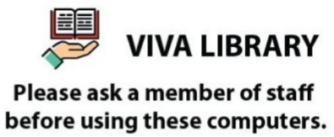

**A.** A member of staff will give you a computer.

**B.** You must ask for a computer when you go to Viva Library.

**C.** You need to ask for permission when you want to use the computer.

**D.** You have to be a member of staff in order to use the computers.

**Câu 2.** **Look at the signs. Choose the best answer for the question.**

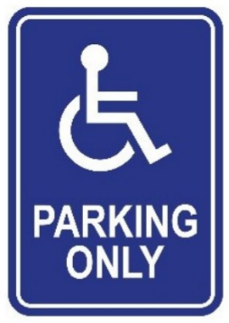

**A.** This parking space is for people with disabilities.  **B.** Disabled people are allowed to enter this place.

**C.** This place is used for parking vehicles.  **D.** People can put their wheelchairs here.

**Câu 3.** **Look at the signs. Choose the best answer for the question.**



**A.** This door must remain closed to prevent the spread of fire.

**B.** You should only shut the door when it is on fire.

**C.** You mustn’t put the door on fire.

**D.** You should keep the door open unless there is a fire.

**Câu 4.** Who is Andrew planning to go to the cinema with?

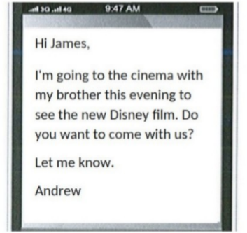

**A.** Alone  **B.** His parents  **C.** James  **D.** His brother

**Câu 5.** What activities will be allowed when the pool reopens?

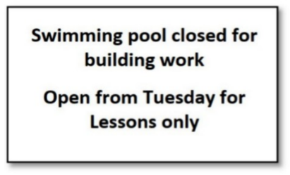

**A.** The notice doesn't specify allowed activities  **B.** All regular activities

**C.** Only swimming lessons  **D.** Building work and swimming lessons

**Câu 6.** Which of the following statements is true?



**A.** The English course is taught by experienced teachers.

**B.** The English course starts on 1st September.

**C.** The English course is for advanced learners.

**D.** The English course does not provide a certificate.

**Câu 7.** **Look at the signs. Choose the best answer for the question.**

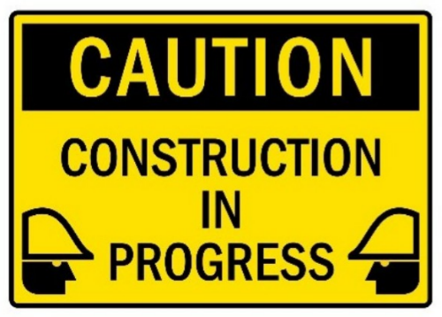

**A.** Be careful because building work is happening.  **B.** There is careful construction.

**C.** You have to construct buildings with caution.  **D.** Construction must be carefully done in progress.

**Câu 8.** What does this sign mean?

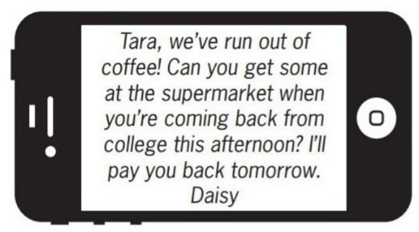

**A.** Daisy will buy coffee tomorrow when she returns home.

**B.** Daisy wants Tara to buy some coffee this afternoon.

**C.** Tara will go to the supermarket tomorrow.

**D.** Tara should give Daisy some money to buy coffee.

**Câu 9.** How much discount do students get on the smartphone?

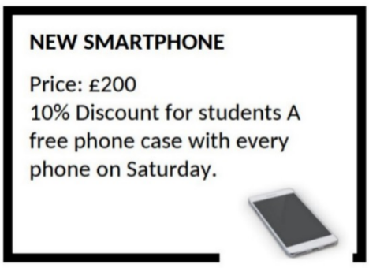

**A.** 20%  **B.** 5%  **C.** 15%  **D.** 10%

**Câu 10.** **Look at the signs. Choose the best answer for question.**

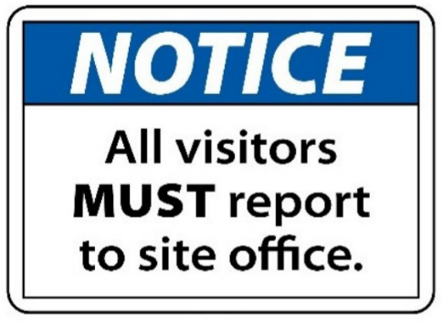

**A.** Anyone who visits must go to the site office and check in.

**B.** All visitors can enter the place through the site office.

**C.** Guests are reported to visit the site office.

**D.** The site office is for everyone to make a report.

**----HẾT---**