TA 6 RIGHT ON LESSON PLAN
UNIT 5: LONDON WAS GREAT Date: ________
Lesson 1: GETTING STARTED + VOCABULARY 1A (pp. 86, 87) Period: ________
- Objectives (learning outcomes):
By the end of this lesson, students will be able to:
- Knowledge:
- Learn vocabulary about famous people (Elizabeth I, Princess Diana, Margaret Thatcher, Charles Dickens, Audrey Hepburn, Vincent Van Gogh, Charlie Chaplin, Charles Dickens, Elvis Presley, Albert Einstein); Jobs (painter, stateswoman, actress, queen, princess, actor, writer, singer, physicist)
- Core competences & language skills:
- Listen for specific information
- Talk about famous people
- Develop generalization & conversation skills and creativity
- Be collaborative and supportive in pair work and teamwork
- Personal qualities:
- Appreciate others’ jobs
- Be responsible for the community
- Teaching aids:
- Teacher’s aids: student book and teacher’s book, class CDs, IWB software, projector/interactive whiteboard /TV (if any).
- Students’ aids: Student books, notebooks.
- Procedures:
A. Warm-up: (5 minutes)
a. Objectives: to introduce the new lesson and set the scene for Ss to acquire new language; to get students' attention at the beginning of the class by means of enjoyable and short activities as well as to engage them in the steps that follow.
b. Content: a guessing game about famous people
c. Expected outcomes: Ss can have some ideas about famous people and their jobs
d. Competences: communication, collaboration, analytical thinking skills
e. Organization:
T’s activities | Ss’ activities | Content
- Show the pictures. Ask Ss to guess who they are and tell their jobs.  - Check Ss’ answers | - Guess who they are and tell their jobs.  - Listen and take notes | - Guessing game:  Look at the pictures. Tell me who are they? What are their jobs?  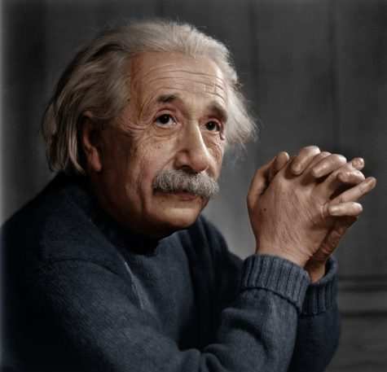  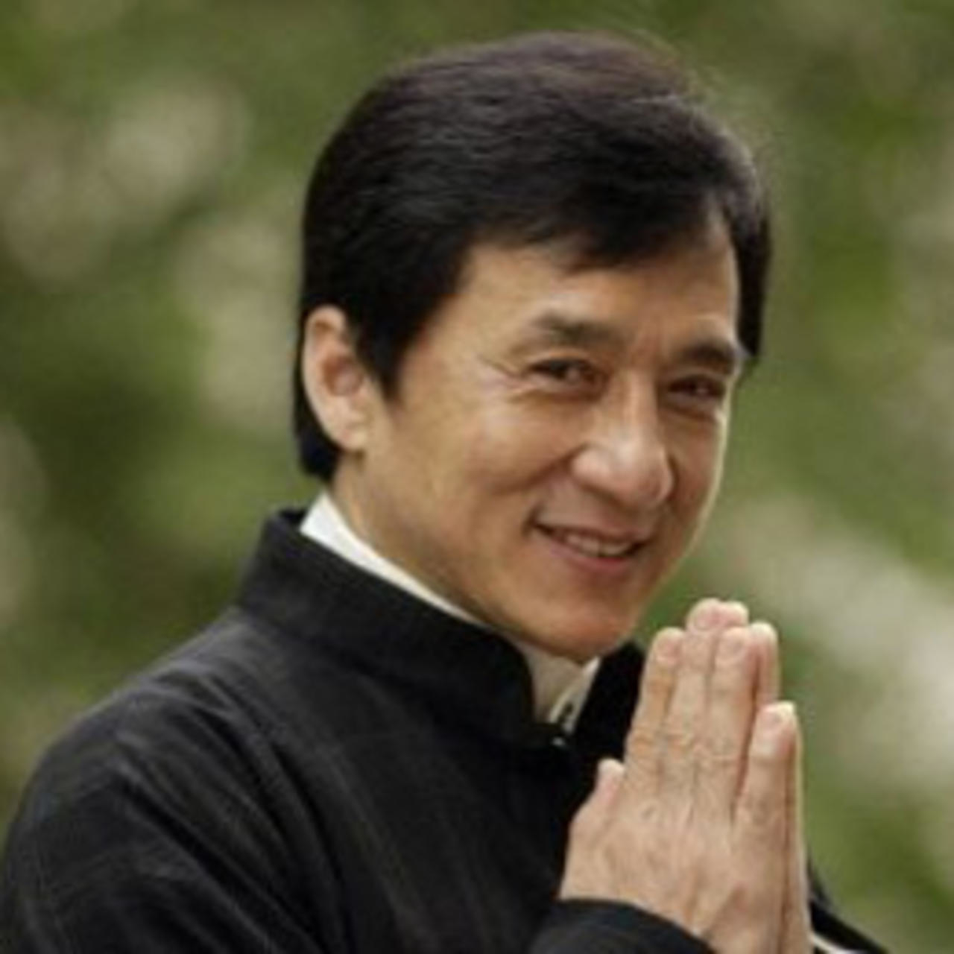    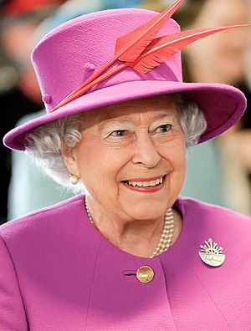  Answer key  1. Albert Einstein. He’s a physicist  2. Jacky Chan. He’s an actor  3. Son Tung MTP. He’s a singer  4. Elizabeth II. She’s Queen of England

B. New lesson: (35 minutes)
1. Activity 1: (15 minutes)
a. Objectives: to present famous people and their jobs, the year they were born/ died
b. Content: Task 1, Task 2, Task 3 on pp. 86 & 87
c. Expected outcomes: Ss can learn vocabularies about jobs, how to say the year
d. Competences: communication, collaboration, critical thinking and analytical thinking skills
e. Organization:
T’s activities | Ss’ activities | Content
- Ask Ss to look at the pictures and read the names and the dates.  - Play the recording.  - Check Ss’ answers around the class.  - Play the video for Ss and elicit their comments | - Look at the pictures and read the names and the dates.  - Listen and circle the correct year.  - Listen and take notes | Task 1: Listen and circle the  correct year. (3.1)  Answer key  A. 1603 B. 1997 C. 1853  D. 1889 E. 1870 F. 1993  G. 2013 H. 1935 I. 1955
- Explain the task.  - Ask two Ss to model the example exchanges.  Explain that we use was to refer to the past.  - Ask Ss to work in pairs and ask and answer similar exchanges for the remaining people.  - Monitor the activity around the class. | - Ask and answer as the model  - Work in pairs and ask and answer similar exchanges for the remaining people. | Task 2: Ask and answer as in the example.  Answer key  3 A: Was Charlie Chaplin American?  B: No, he wasn’t.  4 A: Was Charles Dickens a writer?  B: Yes, he was.  5 A: Was Vincent van Gogh a German painter?  B: No, he wasn’t.  6 A: Was Margaret Thatcher the Queen of England?  B: No, she wasn’t.
2. Activity 2: (10 minutes)
a. Objectives: to help Ss know how to say the year and practise asking about the jobs of famous people
b. Content: How to say the years
c. Expected outcomes: Ss can know how to say the year and ask and answer about the jobs of famous people
d. Competences: communication, collaboration, critical thinking skills
e. Organization:
T’s activities | Ss’ activities | Content
- Play the recording with pauses for Ss to repeat chorally and/or individually.  - Check Ss’ pronunciation and intonation.  - Ask Ss to look at the pictures again and then ask and answer in pairs following the example.  - Monitor the activity around the class. | - Listen and repeat chorally and individually.  - Look at the pictures again and then ask and answer in pairs following the example. | Task 3 a) Listen and repeat. (3.2)  1052 ten fifty-two  1246 twelve forty-six  1405 fourteen oh five  1500 fifteen hundred  2000 two thousand  2010 two thousand and ten  b) Look at the pictures. Discuss as in the example.  Answer key  A: Who was Vincent van Gogh?  B: He was a Dutch painter.  A: Who was Princess Diana?  B: She was an English princess.  A: Who was Charlie Chaplin?  B: He was an English actor.  A: Who was Charles Dickens?  B: He was an English writer.  A: Who was Audrey Hepburn?  B: She was a British actress.  A: Who was Margaret Thatcher?  B: She was a British stateswoman.  A: Who was Elvis Presley?  B: He was an American singer and actor.
3. Activity 3: (10 minutes)
a. Objectives: to help Ss use the knowledge and language in the real situation.
b. Content: one favourite person
c. Expected Outcomes: Ss can talk about one of their favourite people
d. Competences: communication, collaboration, critical thinking, presentation skills and creativity
e. Organization:
T’s activities | Ss’ activities | Content
- Ask Ss to work in groups of four to talk about their favourite people | - Work in groups of four to talk about their favourite people | Work in groups. Talk about one of your favourite people.  Suggested answer:  My favourite person is Jack. He was born in 1997. He’s a famous singer in Vietnam. I like his songs so much because they are touching.
C. Consolidation (3 minutes)
- Vocabulary about famous people
- Jobs (painter, stateswoman, actress, queen, princess, actor, writer, singer, physicist)
D. Homework assigned (2 minutes)
- Learn Vocabulary about sports and family members.
- Do exercises in the workbook (page 44)

Reflection:
1. What did I like from the lesson?
-
-
2. What should I improve in the next lesson?
-
-

TA 6 RIGHT ON LESSON PLAN
UNIT 5: LONDON WAS GREAT Date: ________
Lesson 2: 5A READING 1 (pp. 88, 89) Period: ________
- Objectives (learning outcomes):
By the end of this lesson, students will be able to:
- Knowledge:
- Learn vocabulary about means of transport
- Know more about transportation in London
- Core competences and language skills:
- Read for specific information
- Develop scanning and skimming skills
- Take notes and present their ideas
- Improve Ss’ critical thinking, communication and other skills
- Personal qualities:
- Appreciate the importance of means of transport
- Be collaborative and supportive in pair work and teamwork
- Teaching aids:
- Teacher’s aids: student book and teacher’s book, class CDs, IWB software, projector/interactive whiteboard/TV (if any).
- Students’ aids: Student books, notebooks.
- Procedures:
A. Warm-up: (5 minutes)
a. Objectives: to introduce the new lesson and set the scene for Ss to acquire new language; to get students' attention at the beginning of the class by means of enjoyable and short activities as well as to engage them in the steps that follow.
b. Content: popular means of transport.
c. Expected outcomes: Ss can think about popular means of transport in their country.
d. Competences: communication, collaboration, analytical thinking skills.
e. Organization:
T’s activities | Ss’ activities | Content
- Ask students to tell the popular means of transport in their country.  - Elicit more answer | - Think and answer individually and share with their partners | What are popular means of transport in your country?  Suggested answer  Bike, motorbike, car, train, plane, bus, boat, ship, …

B. New lesson: (35 minutes)
1. Activity 1: (15 minutes)
a. Objectives: to present some vocabulary about the text about London transport museum
b. Content: London transport museum.
c. Expected outcomes: Ss can learn some vocabulary and information about London transport museum.
d. Competences: communication, collaboration, critical thinking and analytical thinking skills
e. Organization:
T’s activities | Ss’ activities | Content
- Ask Ss to look at the text and elicit Ss’ guesses about where you would find it, what it is about and who it is for.  - Play the recording. | - Look at the text and elicit Ss’ guesses about where you would find it, what it is about and who it is for.  - Listen and read and find out. | Task 1: Look at the text. Where would you find it? What is it about? Who is it for?  Listen and read to find out (3.3)  Answer key  You would find this text on the Internet. It is about a museum in London. It is for visitors to London
- Give Ss time to look up the meanings of the words in the box.  - Elicit the meanings of the words if they don’t know.  - Divide the class into 2 teams  - Give Ss instructions  - Write the words on the board.  - T reads Vietnamese, Ss slap the words to get marks.  - The team that has a higher mark will be the winner. | - Look up the meanings of the words in the box.  - Listen and take notes  - Take part in the activity | Vocabulary  - transport  - move  - arrive  - later  - interactive  - tube station  - railway station  * Check understanding: Slap the board

2. Activity 2: (15 minutes)
a. Objectives: to improve Ss’ reading skill- scanning
b. Content: Reading
c. Expected outcomes: Ss can understand the content of the text and learn some prepositions going with means of transport.
d. Competences: communication, collaboration, critical thinking skills
e. Organization:
T’s activities | Ss’ activities | Content
- Ask Ss to look at the means of transport in the pictures.  - Ask Ss to underline the key words in each sentence.  - Play the recording with pauses for Ss to repeat  chorally and/or individually.  - Check Ss’ pronunciation and intonation. | - Look at the means of transport in the pictures and underline key words in each sentence.  - Listen and find out the answer. | Task 2: Read the text and decide if the sentences (1-5) are R (right), W (wrong) or DS (doesn’t say).  Answer key  1. W  2. W  3. DS  4. R  5. R
- Read out the Note! box. | - Listen and take notes | Note!  - by: bike/bicycle/bus/car/  helicopter/ motorcycle/ plane/ship/  taxi/train/tram  - on: a bike/bicycle/bus/  motorcycle/plane/ship/train/  tram (Also: on foot)  - in: a car/helicopter/ taxi

3. Activity 3: (5 minutes)
a. Objectives: to help Ss review the content of the text and improve Ss’ creativity.
b. Content: speaking
c. Expected outcomes: Ss can imagine the real situation and use their own language
d. Competences: communication, collaboration, critical thinking, presentation skills and creativity
e. Organization:

T’s activities | Ss’ activities | Content
- Allow Ss time to review the text again if necessary  and then compose their answers.  - Ask various Ss to tell the class. | - Review the text again if necessary  and then compose their answers. | Task 6: Imagine you are in the London Transport Museum. Why are you there? Who is with you? What can you see? How do you feel?  Suggested answer  I am in the London Transport Museum with my family. We are on holiday in London for the week, so we are tourists. I like going to museums. I can see all kinds of transport, both old and new. There are red London buses and underground trains. I feel very excited because I’m a train fan.

C. Consolidation (3 minutes)
- Vocabulary about means of transport
- Information about London Transport Museum

D. Homework assigned (2 minutes)
- Learn Vocabulary about means of transport
- Do exercises in the workbook (page 44)

Reflection:
1. What did I like from the lesson?
-
-
2. What should I improve in the next lesson?
-
-

TA 6 RIGHT ON LESSON PLAN
UNIT 5: LONDON WAS GREAT Date: ________
Lesson 3: 5A READING 2 (pp. 88, 89) Period: ________
- Objectives (learning outcomes):
By the end of this lesson, students will be able to:
- Knowledge:
- Learn vocabulary about means of transport
- Know more about transportation in London
- Core competences and language skills:
- Listen and read for gist
- Read for specific information
- Prepare a quiz
- Develop scanning and skimming skills
- Take notes and present their ideas
- Improve Ss’ critical thinking, communication skills and other skills
- Personal qualities:
- Appreciate the importance of means of transport
- Be collaborative and supportive in pair work and teamwork
- Teaching aids:
- Teacher’s aids: student book and teacher’s book, class CDs, IWB software, projector/interactive whiteboard/TV (if any).
- Students’ aids: Student books, notebooks.
- Procedures:
A. Warm-up: (5 minutes)
a. Objectives: to introduce the new lesson and set the scene for Ss to acquire new language; to get students' attention at the beginning of the class by means of enjoyable and short activities as well as to engage them in the steps that follow.
b. Content: means of transport
c. Expected outcomes: Ss can review vocabulary about means of transport
d. Competences: communication, collaboration, analytical thinking skills
e. Organization:
T’s activities | Ss’ activities | Content
- Divide class into 2 groups and in turns each group has to tell one means of transport.  - Which group having more correct answers will be the winners | - Work in groups to list as many means of transport as possible | List means of transport you know:  Suggested answer:  - bus, car, taxi, bike….
B. New lesson: (35 minutes)
1. Activity 1: (15 minutes)
a. Objectives: to present vocabulary about means of transport and improve Ss’ pronunciation
b. Content: means of transport
c. Expected outcomes: Ss can learn vocabulary about means of transport
d. Competences: communication, collaboration, critical thinking and analytical thinking skills
e. Organization:
T’s activities | Ss’ activities | Content
- Play the recording and ask Ss to listen and repeat chorally and individually  - Ask Ss to work in pairs and one student covers the word and point to the picture and ask the other to say the words | - Listen and repeat chorally and individually  - Take notes  - Work in pairs to complete the task | Task 3: Listen and repeat (3.4)  - Check Ss’ remembering
- Play the recording. Ss listen and identify the  means of transport.  - Check Ss’ answers | - Listen and identify the means of transport.  - Take notes | Task 4: Listen to the sounds. Which of the means of transport in Exercise 3 can you hear? (3.5)  Answer key  1 motorbike 2 plane 3 train 4 helicopter

2. Activity 2: (10 minutes)
a. Objectives: to provide some adjectives to compare the means of transport
b. Content: adjectives to compare the means of transport
c. Expected outcomes: Ss can compare the means of transport using some given adjectives
d. Competences: communication, collaboration, critical thinking skills
e. Organization:
T’s activities | Ss’ activities | Content
- Ask Ss to use the adjectives in the list to compare means of transport following the  example.  - Ask Ss to work in pairs and then ask various Ss to tell the class. | - Use the adjectives in the list to compare means of transport following the  example.  - Work in pairs and complete the task | Task 5: Use the adjectives in the list to compare the means of transport in Exercise 3. Tell your partner.  Suggested answer  Helicopters are more exciting than buses.  Trains are more relaxing than cars.  Bikes are more tiring than cars.  Ships are more boring than planes.  Buses are cheaper than taxis.  Planes are more expensive than trains.
3. Activity 3: (10 minutes)
a. Objectives: to help Ss review the lesson and use their knowledge in the real situation
b. Content: preparing a quiz
c. Expected outcomes: Ss can review the lesson and ask and answer about the information they have learnt.
d. Competences: communication, collaboration, critical thinking, presentation skills and creativity
e. Organization:
T’s activities | Ss’ activities | Content
- Ask Ss to work in small groups.  - Give them time to research online and prepare a quiz on the London Transport Museum for their classmates. |  | Task 7: Collect more information about the London Transport Museum. Prepare a quiz for your classmates.  Suggested answer  1 Where is the London Transport Museum?  A) near the River Thames  B) far from the River Thames  2 How old are the exhibits in the museum?  A) over 100 years old  B) less than 100 years old  3 What was the Covent Garden site first used as?  A) a vegetable, fruit and flower market  B) a train station  4 On which day is the museum closed?  A) the International Day of Free Public Transport  B) Christmas Day  5 Where was the Museum first opened?  A) in a market  B) in a garage

C. Consolidation (3 minutes)
- Vocabulary about means of transport
- Adjectives to compare means of transport

D. Homework assigned (2 minutes)
- Learn vocabulary about means of transport and adjectives to compare means of transport
- Do exercises in the workbook (page 44)
Reflection:
1. What did I like from the lesson?
-
-
2. What should I improve in the next lesson?
-
-

TA 6 RIGHT ON LESSON PLAN
UNIT 5: LONDON WAS GREAT Date: ________
Lesson 4: 5B GRAMMAR 1 (p. 90) Period: ________
- Objectives (learning outcomes):
By the end of this lesson, students will be able to:
- Knowledge: Learn the Past Simple of the verb to be and regular verb (affirmative & negative)
- Core competences and language skills:
- Improve Ss’ critical thinking, analytical thinking and presentation and other skills
- Express grammatical relationships in spoken utterances
- Be collaborative and supportive in pair work and teamwork
- Personal qualities:
- Have a reflection of their background (context) from that they can appreciate what they have.
- Be responsible for their community
- Teaching aids:
- Teacher’s aids: student book and teacher’s book, class CDs, IWB software, projector/interactive whiteboard/TV (if any).
- Students’ aids: Student books, notebooks
- Procedures
A. Warm-up: (5 minutes)
a. Objectives: to introduce the new lesson and set the scene for Ss to acquire new language; to get students' attention at the beginning of the class by means of enjoyable and short activities as well as to engage them in the steps that follow.
b. Content: past simple tense
c. Expected outcomes: Ss can have some ideas about past simple tense
d. Competences: communication, collaboration, analytical thinking skills
e. Organization:

T’s activities | Ss’ activities | Content
- Write the words on the board  - Give Ss time to arrange them into correct sentences  - Check Ss’ answer. Focus on verbs and adverbs of time | - Complete the task individually and then share with their partners  - Listen and take notes | Arrange these words in the right order to make sentences  1. played/ I/ yesterday / football  2. his grandparents/ he/ visited / last Sunday  3. Canada/I/ two years/ travelled/ ago/to  4. was/ in/ I/ born/ 2009  Answer key  1. I played football yesterday.  2. He visited his grandparents last Sunday  3. I travelled to Canada two years ago.  4. I was born in 2009
B. New lesson: (35 minutes)
1. Activity 1: (20 minutes)
a. Objectives: to present past simple tense with the verb be and ordinary verbs
b. Content: past simple tense with the verb be and ordinary verbs
c. Expected outcomes: Ss can know the rules of past simple tense and spelling rules of verbs adding ed and complete the tasks
d. Competences: communication, collaboration, critical thinking and analytical thinking skills
e. Organization:
T’s activities | Ss’ activities | Content
- Elicit that the verbs in bold refer to the past. Present the Past Simple affirmative of the verb to be.  - Present the Past Simple negative and interrogative of the verb to be.  - Explain the task and then allow Ss time to complete the task.  - Check Ss’ answers in open pairs. | - Listen and take notes  - Complete the task individually and then share with their partners | Past Simple (the verb to be)  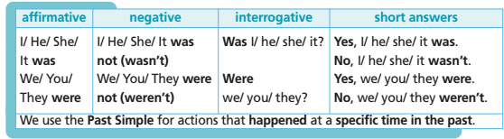  Task 1: Read the table. Then complete the gaps. Use was, wasn’t, were or weren’t.  Answer key  1 A: Were you at Madame Tussauds yesterday?  B: Yes, I was. My friends were there, too.  2 A: When was Elizabeth I Queen of England?  B: Between 1558 and 1603. Those were important years for England.  3 A: Steve and Mark weren’t at school yesterday.  B: I know. They were sick.  4 A: Was Charles Dickens a rich child?  B: No, he wasn’t. He was very poor.
- Read out the Spelling Rules! box.  - Explain/Elicit the spelling rules of the Past  Simple for regular verbs  - Present the Past Simple affirmative.  - Present the Past Simple negative  - Read out the theory box and then give Ss time  to complete the task.  - Ask Ss to work in pairs to complete the task  - Check Ss’ answers on the board. | - Listen and take notes  - Complete the task individually and then share with their partners  - Listen and take notes | Spelling rules  • Verbs ending in -e, add –d. arrive ➝ arrived  • Verbs ending in consonant + -y change -y to –i and add -ed. study ➝ studied  • Verbs ending in vowel + -y add -ed.  play ➝ played  • Verbs ending in a consonant after a stressed vowel, double the consonant and add -ed.  stop ➝ stopped  • Verbs ending in -l, double the l and add -ed.  travel ➝ travelled  Past Simple (regular verbs)  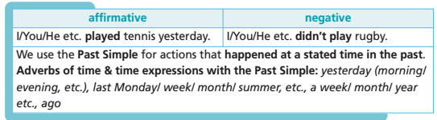  Task 2: Put the verbs in brackets into the Past Simple.  Answer key  1 Jane wanted to visit Scotland. (want)  2 She invited Jenny to go with her. (invite)  3 They stayed in a hotel. (stay)  4 Jane planned their trip down to the last detail. (plan)  5 They travelled to Scotland by train. (travel)  6 They tried local dishes. (try)  7 They enjoyed their trip. (enjoy)
2. Activity 2: (10 minutes)
a. Objectives: to give Ss a chance to practise past simple negative
b. Content: past simple negative
c. Expected outcomes: Ss can understand and use past simple negative correctly
d. Competences: communication, collaboration, critical thinking skills
e. Organization:
T’s activities | Ss’ activities | Content
- Explain the task and read out the example.  - Give Ss time to complete it.  - Check Ss’ answers on the board. | - Complete the task individually and then share with their partners  - Listen and take notes | Task 3: Rewrite the sentences in Exercise 2 in the negative.  Answer key  2. She didn’t invite Jenny to go with her.  3. They didn’t stay in a hotel.  4. Jane didn’t plan her trip down to the last detail.  5. They didn’t travel to Scotland by train.  6. They didn’t try local dishes.  7. They didn’t enjoy their trip
3. Activity 3: (5 minutes)
a. Objectives: to help Ss practise the grammar points using the words given
b. Content: past simple tense.
c. Expected outcomes: Ss can review and use the past simple tense correctly
d. Competences: communication, collaboration, critical thinking, presentation skills and creativity
e. Organization:
T’s activities | Ss’ activities | Content
- Write the verbs on the board  - Ask Ss to work in pairs to make sentences  - Call some Ss to read aloud their sentences | - Complete the task individually and then share with their partners  - Listen and take notes | Work in pairs. Make sentences with these verbs (to be, play, visit, travel, watch) in past simple tense.  Suggested answer  - I was at school yesterday.  - I played football with my friend yesterday.  - I visited my grandparents last week.  - I travelled to Da Lat last summer.  - I watched this news on Tv last night.

C. Consolidation (3 minutes)
- The Past Simple of the verb to be and regular verb (affirmative & negative)

D. Homework assigned (2 minutes)
- Learn the past simple of the verb to be and regular verb (affirmative & negative).
- Do exercises in the workbook (page 45)

Reflection:
1. What did I like from the lesson?
-
-
2. What should I improve in the next lesson?
-
-

TA 6 RIGHT ON LESSON PLAN
UNIT 5: LONDON WAS GREAT Date: ________
Lesson 4: 4B GRAMMAR 2 (p. 91) Period: ________
- Objectives (learning outcomes):
By the end of this lesson, students will be able to:
- Knowledge:
- Learn the Past Simple of irregular verbs (affirmative & negative)
- Core competences and language skills
- Collaborate and develop conversation skill
- Improve Ss’ analytical thinking and presentation skill
- Build collaboration and communication and other skills.
- Personal qualities:
- Have a reflection of their background (context) from that they can appreciate what they have
- Be collaborative and supportive in pair work and team work
- Teaching aids:
- Teacher’s aids: student book and teacher’s book, class CDs, IWB software, projector/interactive whiteboard/TV (if any).
- Students’ aids: Student books, notebooks.
- Procedures:
A. Warm-up: (5 minutes)
a. Objectives: to introduce irregular verbs and set the scene for Ss to acquire new language; to get students' attention at the beginning of the class by means of enjoyable and short activities as well as to engage them in the steps that follow.
b. Content: irregular verbs
c. Expected outcomes: Ss can remember and have some ideas about irregular verbs
d. Competences: communication, collaboration, analytical thinking skills
e. Organization:

T’s activities | Ss’ activities | Content
- Write some verbs on the board. Ask Ss to write the past simple of those verbs.  - Check Ss’ answers | - Complete the task individually and then share with their partners  - Listen and take notes | Write the past simple form of these verbs  - to be => was/were  - work => worked  - study => studied  - play => played  - want => wanted  - listen => listened  - watch => watched  - talk => talked  - cook => cooked  - use => used
B. New lesson: (35 minutes)
1. Activity 1: (10 minutes)
a. Objectives: to present and help Ss practise the irregular verbs
b. Content: irregular verbs
c. Expected outcomes: Ss can understand and remember irregular verbs.
d. Competences: communication, collaboration, critical thinking and analytical thinking skills
e. Organization:
T’s activities | Ss’ activities | Content
- Read out the grammar table and the cartoon.  - Explain that irregular verbs have different Past Simple forms and refer Ss to the irregular verbs list at the back of their books.  - Give Ss time to complete the task and then check  their answers. | - Listen and take notes  - Complete the task individually and then share with their partners | Past Simple (irregular verbs)  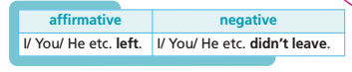  (See the list of Irregular verbs on page (151)  Task 4: Write the Past Simple of these verbs.  Answer key  2 break – broke  3 drink – drank  4 see – saw  5 do – did  6 think – thought  7 run – ran  8 can – could  9 bring – brought  10 write – wrote

2. Activity 2: (20 minutes)
a. Objectives: to help Ss practise the Past Simple (irregular verbs)
b. Content: Past Simple (irregular verbs)
c. Expected outcomes: Ss can understand and use the Past Simple (irregular verbs) correctly.
d. Competences: communication, collaboration, critical thinking skills
e. Organization:
T’s activities | Ss’ activities | Content
- Explain the task and read out the example.  - Give Ss time to complete the task and then check  their answers. | - Complete the task individually and then share with their partners  - Listen and take notes | Task 5: Complete the sentences. Use verbs from the list in the Past Simple.  Answer key  2 We didn’t pay for the tickets by credit card.  3 We left the house in plenty of time to get our flight.  4 We got in the car and drove to the airport.  5 When we got to Ho Chi Minh City, we rode around on bicycles.  6 Although it was cold, it didn’t feel like winter.  7 In the evenings, we ate delicious Vietnamese food.  8 Dad bought a Vietnamese hat (nón lá).  9 I took a lot of photos.  10 We had a great time.
- Show the task on the screen  - Give Ss time to complete the sentences.  - Check Ss’ answers | - Complete the task individually and then share with their partners  - Listen and take notes | Complete the sentences with the past simple tense.  1. It/ be/ cloudy/ yesterday.  2. In 1990/ we/ move/ to another city.  3. When/ you/ get/ the first gift?  4. She/ not/ go/ to the church/ five days ago.  5. How/ be/ he/ yesterday?  Answer key  1. It was cloudy yesterday.  2. In 1990, we moved to another city./ We moved to another city in 1990.  3. When did you get the first gift?  4. She did not go to the church five days ago./ She didn’t go to the church five days ago.  5. How was he yesterday?

3. Activity 3: (5 minutes)
a. Objectives: to help Ss use their language in the real situation
b. Content: last weekend activities
c. Expected outcomes: Ss can use the grammar point in the real situation
d. Competences: communication, collaboration, critical thinking, presentation skills and creativity
e. Organization:

T’s activities | Ss’ activities | Content
- Explain the task and read out the example.  - Give Ss time to complete the task and then check their answers. | - Complete the task individually and then share with their partners  - Listen and take notes | Task 6: Use the phrases in the list to say what you/your friends did/didn’t do last weekend. You can use your own ideas.  Suggested answer  I studied for a Maths exam.  I didn’t visit a friend.  I didn’t cook pasta. I cooked pizza.  I talked to my friend on the phone.  I walked the dog.  My friend Tom watched online videos.  He didn’t listen to a CD.  He didn’t go to a party.  He didn’t eat pizza. He ate fish and chips.  I didn’t meet my friends.  My friends Suzy and Christine didn’t buy a video game.  They sent emails.

C. Consolidation (3 minutes)
- Past Simple of irregular verbs (affirmative & negative)

D. Homework assigned (2 minutes)
- Learn past simple of irregular verbs (affirmative & negative).
- Do exercises in the workbook (page 45)

Reflection:
1. What did I like from the lesson?
-
-
2. What should I improve in the next lesson?
-
-

TA 6 RIGHT ON LESSON PLAN
UNIT 5: LONDON WAS GREAT Date: ________
Lesson 6: 5C VOCABULARY (p. 92) Period: ________
- Objectives (learning outcomes):
By the end of this lesson, students will be able to:
- Knowledge:
- Learn vocabulary about animals and body parts
- Know how to describe an animal
- Core competences and language skills:
- Practise describing animals
- Build critical thinking, communication skills
- Develop creativity and other skills
- Personal qualities:
- Build their love for animals
- Be collaborative and supportive in pair work and teamwork
- Teaching aids:
- Teacher’s aids: student book and teacher’s book, class CDs, IWB software, projector/interactive whiteboard/TV (if any).
- Students’ aids: Student books, notebooks.
- Procedures:
A. Warm-up: (5 minutes)
a. Objectives: to introduce the new lesson and set the scene for Ss to acquire new language; to get students' attention at the beginning of the class by means of enjoyable and short activities as well as to engage them in the steps that follow.
b. Content: animals
c. Expected Outcomes: Ss can review some vocabulary about animals
d. Competences: communication, collaboration, analytical thinking skills
e. Organization:

T’s activities | Ss’ activities | Content
- Divide the class into 2 groups  - Write names of animals on the paper and ask Ss to mime in front of the class for their friends to guess the words.  - The group having more correct answers is the winner. | - Take part in the game in 2 groups | Game: miming  - monkey  - elephant  - dog  - cat  - lion  - bird  - horse  - giraffe

B. New lesson: (35 minutes)
1. Activity 1: (10 minutes)
a. Objectives: to present vocabulary about animals
b. Content: vocabulary about animals
c. Expected outcomes: Ss can learn vocabulary about animals
d. Competences: communication, collaboration, critical thinking and analytical thinking skills
e. Organization:
T’s activities | Ss’ activities | Content
- Ask Ss to look at the pictures.  - Play the recording with pauses for Ss to listen and repeat chorally and/or individually.  - Check Ss’ pronunciation and intonation. | - Listen and repeat chorally and/or individually.  - Take notes | Task 1: Look at the pictures.  Listen and repeat. (3.6)
- Ask Ss around the class to say which animals are wild and which are pets. Alternatively, Ss do the task in closed pairs.  - Check Ss’ answers. | - Complete the task individually and then share with their partners  - Listen and take notes | Task 2: Which of these animals are pets? wild animals?  Answer key  A lion/elephant/duck isn’t a pet.  A cat/horse/snake/parrot/rabbit is a pet.  A lion/ elephant/ giraffe/ duck/ snake/ parrot is a wild animal.

2. Activity 2: (15 minutes)
a. Objectives: to present body parts of animals
b. Content: body parts of animals
c. Expected outcomes: Ss can learn vocabulary about body parts of animals
d. Competences: communication, collaboration, critical thinking skills
e. Organization:
T’s activities | Ss’ activities | Content
- Explain the task and the example.  - Give Ss time to complete the task in closed pairs.  - Check Ss’ answers. | - Complete the task individually and then share with their partners  - Listen and take notes | Task 3: Match the letters (A-L) to  the parts of the body.  Answer key  2.A 3.B 4.L 5.K 6.H 7.G  8.D 9.I 10.F 11.E 12.J

3. Activity 3: (10minutes)
a. Objectives: to help Ss practice extensive speaking
b. Content: describing animals
c. Expected outcomes: Ss can apply the lesson in a real situation.
d. Competences: communication, collaboration, critical thinking, presentation skills and creativity
e. Organization:
T’s activities | Ss’ activities | Content
- Ask Ss to follow the directions and play the  game in pairs as in the example.  - Monitor the activity around the class. | - Work in pairs to play the game | Game: Choose an animal from the ones in the pictures and describe it to your partner. He/She guesses which animal it is.  Suggested answer  A: It’s got long wings, small eyes and a sharp beak.  B: It’s a parrot. etc.

C. Consolidation (3 minutes)
- Vocabulary about animals and body parts
- Describing animals

D. Homework assigned (2 minutes)
- Learn vocabulary about animals and body parts
- Do exercises in the workbook (page 46)

Reflection:
1. What did I like from the lesson?
-
-
2. What should I improve in the next lesson?
-
-

TA 6 RIGHT ON LESSON PLAN
UNIT 5: LONDON WAS GREAT Date: ________
Lesson 7: 6D EVERYDAY ENGLISH (p. 93) Period: ________
- Objectives (learning outcomes):
By the end of this lesson, students will able to:
- Knowledge:
- Pronounce -ed ending (Past Simple)
- Learn and practice structures to talk about holidays
- Core competences and language skills:
- Practise describing their holidays, act out a dialogue
- Build up communication and other skills
- Listen for specific information
- Sustain communitive dialogue
- Read for cohesion and coherence
- Personal qualities: Build their love for animals
- Teaching aids:
- Teacher’s aids: student book and teacher’s book, class CDs, IWB software, projector/interactive whiteboard/TV (if any).
- Students’ aids: Student books, notebooks.
- Procedures:
A. Warm-up: (5 minutes)
a. Objectives: to introduce the new lesson and set the scene for Ss to acquire new language; to get students' attention at the beginning of the class by means of enjoyable and short activities as well as to engage them in the steps that follow.
b. Content: animals in a zoo
c. Expected outcomes: Ss can review the previous lesson
d. Competences: communication, collaboration, analytical thinking skills
e. Organization:
T’s activities | Ss’ activities | Content
- Ask Ss to tell some animals they see in a zoo  - Elicit more answers | - Complete the task individually and then share with their partners  - Listen and take notes | Can you tell me some animals you see in a zoo?  Suggested answer  Tiger, monkey, bear, giraffe, snake, lion, crocodile,…

B. New lesson: (35 minutes)
1. Activity 1: (15 minutes)
a. Objectives: to improve Ss’ communication and collaboration
b. Content: a dialogue
c. Expected outcomes: Ss can act out a dialogue
d. Competences: communication, collaboration, critical thinking and analytical thinking skills
e. Organization:
T’s activities | Ss’ activities | Content
- Read out the phrases and give Ss time to use them to complete the dialogue. | - Complete the task individually and then share with their partners | Task 1: Complete the dialogue. Use the sentences (A-E)  Andy: Hi, Emma. 1) _____________?  Emma: It was great, thanks. We went to London.  Andy: Oh! 2) _____________?  Emma: It was nice and sunny.  Andy:3) _____________?  Emma: We visited London Zoo. It was amazing!  Andy:Wow! 4) _____________.  Emma:Yes, it was perfect. I took lots of photos.  Andy: 5) _____________?  Emma: Sure!
- Play the recording. Ss listen and check their answers in Exercise 1.  - Then Ss take roles and act out the dialogue. | - Listen and take notes  - Work in pairs to act out the dialogue | Task 2: Listen and check. Take roles and read the dialogue aloud. Mind the sentence stress.  Suggested answer  Andy: Hi, Emma. 1) How was your holiday?  Emma: It was great, thanks. We went to London.  Andy: Oh! 2) What was the weather like?  Emma:It was nice and sunny.  Andy: 3) What did you do there?  Emma:We visited London Zoo. It was amazing!  Andy: Wow! 4) It sounds like you had a great time.  Emma:Yes, it was perfect. I took  Andy: lots of photos.  Emma:5) Can I see them?  Andy: Sure!

2. Activity 2: (15 minutes)
a. Objectives: to introduce a model dialogue and how to pronounce the -ed ending (Past Simple)
b. Content: talking a holiday
c. Expected outcomes: Ss can ask and answer about their holidays in the past and learn to pronounce the -ed ending (Past Simple)
d. Competences: communication, collaboration, critical thinking skills
e. Organization:
T’s activities | Ss’ activities | Content
- Read out the Note! box.  - Ask Ss to read the dialogue and complete it using the phrases from Exercise 1 as well as their own ideas.  - Have Ss work in pairs to complete the task and ask some pairs to act out their dialogue in front of the class. | - Read the dialogue and complete it using the phrases from Exercise 1 as well as their own ideas.  - Work in pairs to act out the dialogue | Note!  There was/were is the Past Simple of there is/ are  Task 3: Imagine you went on holiday. Complete the dialogue. Use phrases from the dialogue in Exercise 1 as well as your own ideas.  Answer key  A: Hi, John. Nice to see you. 1) How was your holiday?  B: It was great, thanks. We went to 2) Ho Chi Minh City.  A: Oh! 3) What was the weather like?  B: It was nice and sunny.  A: 4) What did you do there?  B: We went 5) Ho Chi Minh City Museum and 6) the Reunification Palace.  A: Wow! Lucky you!
- Ask Ss to write the verbs in the correct box in the Past Simple.  - Check Ss’ answers.  - Play the recording with pauses for Ss to repeat chorally and/or individually. | - Complete the task individually and then share with their partners  - Listen and repeat chorally and/or individually. | Pronunciation  Write the verbs in the correct box in the Past Pimple. Listen and repeat. (3.8)  Answer key  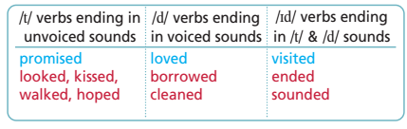
3. Activity 3: (5 minutes)
a. Objectives: to help Ss apply the lesson in the real situation sustain communitive dialogue
b. Content: a dialogue about Ss’ real holiday
c. Expected outcomes: Ss can talk about their real holidays
d. Competences: communication, collaboration, critical thinking, presentation skills and creativity
e. Organization:
T’s activities | Ss’ activities | Content
Work in pairs. Act out a dialogue similar to the one in Exercise 1 and 3 about your last holiday. | - Ask Ss to work in pairs to make a similar dialogue as in Exercise 1 and 3  - Give Ss time to prepare and talk in pairs.  - Call some pairs to talk in front of the class. | - Role play a dialogue  - Develop Ss’ collaboration
C. Consolidation (3 minutes)
- Pronunciation of -ed ending (Past Simple)
- Talking about holidays.
D. Homework assigned (2 minutes)
- Practise pronouncing -ed ending (Past Simple)
- Do exercises in the workbook (page 47)

Reflection:
1. What did I like from the lesson?
-
-
2. What should I improve in the next lesson?
-
-

TA 6 RIGHT ON LESSON PLAN
UNIT 5: LONDON WAS GREAT Date: ________
Lesson 8: 5E GRAMMAR (p. 94) Period: ________
- Objectives (learning outcomes):
By the end of this lesson, students will be able to:
- Knowledge: Tearn the Past Simple (interrogative & short answers)
- Core competences and language skills:
- Improve their communication skill, self-evaluation skills
- Improve their analytical skill, note-taking and other skills
- Personal qualities:
- Have a reflection of their background (context) from that they can appreciate what they have
- Teaching aids:
- Teacher’s aids: student book, workbook and teacher’s book, class CDs, IWB software, projector/interactive whiteboard/TV (if any).
- Students’ aids: Student books, workbooks and notebooks.
- Procedures:
A. Warm-up: (5 minutes)
a. Objectives: to review the previous lesson and set the scene for Ss to acquire new language; to get students' attention at the beginning of the class by means of enjoyable and short activities as well as to engage them in the steps that follow.
b. Content: past simple tense
c. Expected outcomes: Ss can review the grammar points
d. Competences: communication, collaboration, analytical thinking skills
e. Organization:
T’s activities | Ss’ activities | Content
- Ask Ss to make sentences with “yesterday”  - Call some Ss to read aloud their sentences. | - Make sentences and then read aloud their sentences. | Make sentences with “yesterday”  Suggested answers  - I played football yesterday.  - I went to school yesterday.  - I listened to music yesterday.  - I did homework yesterday  -……..
B. New lesson: (35 minutes)
1. Activity 1: (15 minutes)
a. Objectives: to present past Simple (interrogative/short answers)
b. Content: Past Simple (interrogative/short answers)
c. Expected outcomes: Ss can understand and use the grammar point correctly
d. Competences: communication, collaboration, critical thinking and analytical thinking skills
e. Organization:
T’s activities | Ss’ activities | Content
- Explain that we use Did + personal pronoun + base form of the main verb to form questions in the Past Simple.  - Focus Ss’ attention on the position of did (before the personal pronoun).  - Point out that we answer in the short form with Yes/No, personal pronoun + did/didn’t.  - Ask Ss to read the grammar table and the cartoon.  - Explain the task and read out the example.  - Give Ss time to complete the task.  - Check Ss’ answers. | - Listen and take notes  - Complete the task individually and then share with their partners | Past Simple (interrogative/short answers)  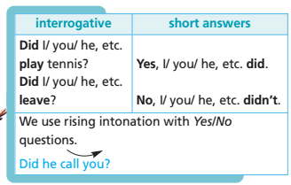  Task 1: Look at what Peter did/didn’t do yesterday. Write questions, then answer them.  Answer key  2 play basketball (✗) Did Peter play basketball? No, he didn’t.  3 meet his friends (✓) Did Peter meet his friends? Yes, he did.  4 watch a film (✓) Did Peter watch a film?  Yes, he did.  5 listen to music (✗) Did Peter listen to music? No, he didn’t.  6 go to the park (✗) Did Peter go to the park?  No, he didn’t.  7 chat online (✓) Did Peter chat online?  Yes, he did.  8 go to bed late (✓) Did Peter go to bed late?  Yes, he did.

2. Activity 2: (15 minutes)
a. Objectives: to help Ss practise the Past Simple (interrogative/ short answers) and question word
b. Content: Past Simple (interrogative/ short answers) and question word
c. Expected outcomes: Ss can understand and use the grammar point correctly
d. Competences: communication, collaboration, critical thinking skills
e. Organization:
T’s activities | Ss’ activities | Content
- Read out the theory box and then explain the task.  - Explain the rules and give some more examples if necessary.  - Give Ss time to complete the sentences.  - Check Ss’ answers around the class. | - Listen and take notes  - Complete the task individually and then share with their partners | Task 2: Use the phrases to ask and answer questions.  Answer key  2. Did your mum go to work yesterday? Yes, she did./No, she didn’t.  3. Did your teacher give you lots of homework last week? Yes, he/she did./No, he/she didn’t.  4. Did you go on holiday last summer? Yes, I did./ No, I didn’t.  5. Did your best friend call you last night? Yes, he/she did./No, he/she didn’t.  6. Did your dad drive you to school this morning? Yes, he did./No, he didn’t.
- Read out the Note! box.  - Explain the task and read out the example.  - Give Ss time to complete the task.  - Check Ss’ answers. | - Listen and take notes  - Complete the task individually and then share with their partners  - Listen and take notes | Note!  Past Simple (question words)  We always put the question words  before did to form Wh- questions in the Past Simple. We use falling intonation with Wh-questions.  Task 3: Use the words in brackets to write questions as in the example. Read them aloud.  Answer key  2 He went to the theatre last night. (Where?) Where did he go last night?  3 Ann met Harry yesterday. (Who?) Who did Ann meet yesterday?  4 He called Bob to invite him to his party. (Why?) Why did he call Bob?  5 The film started at 7:00 p.m. (What time?) What time did the film start?  6 I went to the cinema on foot. (How) How did you go to the cinema?  7 They wore coats. (What?) What did they wear?

3. Activity 3: (5 minutes)
a. Objectives: to help Ss wrap up the lesson
b. Content: last weekend activities
c. Expected outcomes: Ss can ask and answer about last weekend activities.
d. Competences: communication, collaboration, critical thinking, presentation skills and creativity
e. Organization:

T’s activities | Ss’ activities | Content
- Ask Ss to work in pairs to ask and answer about their last weekend.  - Call some pairs to talk in front of the class | - Work in pairs to ask and answer about their last weekend. | Work in pairs. Ask and answer about your last weekend  Suggested answer  Ss1: What did you do last weekend?  Ss 2: I played football.  Ss 1: Who did you play with?  Ss 2: I played with my friends.  Ss 1: How long did you play?  Ss 2: We played for about an hour.  Ss 1: Were you happy?  Ss 2: Yes, we were  ………………

C. Consolidation (3 minutes)
- The Past Simple (interrogative & short answers) and question words

D. Homework assigned (2 minutes)
- Learn past Simple (interrogative & short answers) and question words
- Do exercises in the workbook (page 48)

Reflection:
1. What did I like from the lesson?
-
-
2. What should I improve in the next lesson?
-
-

TA 6 RIGHT ON LESSON PLAN
UNIT 5: LONDON WAS GREAT Date: ________
Lesson 9: 8E GRAMMAR 2 (p. 94) Period: ________
- Objectives (learning outcomes):
By the end of this lesson, students will be able to:
- Knowledge: Review the past simple
- Core competences and language skills:
- Ask and answer about the past activities
- Improve their communication, critical thinking and analytical skills and other skills
- Write a letter about your trip
- Personal qualities:
- Encourage them to study hard
- Have a reflection of their background (context) from that they can appreciate what they have
- Teaching aids:
- Teacher’s aids: student book and teacher’s book, class CDs, IWB software, projector/interactive whiteboard/TV (if any).
- Students’ aids: Student books, notebooks.
- Procedures:
A. Warm-up: (5 minutes)
a. Objectives: to review the previous lessonand set the scene for Ss to acquire new language; to get students' attention at the beginning of the class by means of enjoyable and short activities as well as to engage them in the steps that follow.
b. Content: past simple tense
c. Expected outcomes: Ss can review the previous lesson
d. Competences: communication, collaboration, analytical thinking skills
e. Organization:
T’s activities | Ss’ activities | Content
- Show the picture. Ask Ss to make questions about it.  - Call other Ss to answer.  - Elicit more questions. | - Complete the task individually and then share with their partners | Look at the picture about Peter’s family two years ago. Make questions about it, using the past simple  INCLUDEPICTURE "http://newyork.cbslocal.com/wp-content/uploads/sites/14578484/2012/06/july-4-beach-feature.jpg" \* MERGEFORMATINET INCLUDEPICTURE "http://newyork.cbslocal.com/wp-content/uploads/sites/14578484/2012/06/july-4-beach-feature.jpg" \* MERGEFORMATINET INCLUDEPICTURE "http://newyork.cbslocal.com/wp-content/uploads/sites/14578484/2012/06/july-4-beach-feature.jpg" \* MERGEFORMATINET INCLUDEPICTURE "http://newyork.cbslocal.com/wp-content/uploads/sites/14578484/2012/06/july-4-beach-feature.jpg" \* MERGEFORMATINET INCLUDEPICTURE "http://newyork.cbslocal.com/wp-content/uploads/sites/14578484/2012/06/july-4-beach-feature.jpg" \* MERGEFORMATINET INCLUDEPICTURE "http://newyork.cbslocal.com/wp-content/uploads/sites/14578484/2012/06/july-4-beach-feature.jpg" \* MERGEFORMATINET 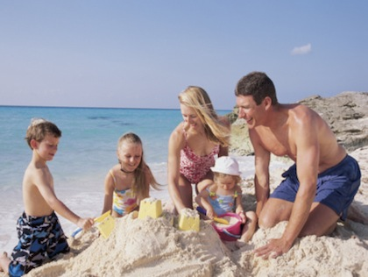  Suggested answer  - Where were they?  => They were at the beach.  - What did they do?  => They built a sand castle.  - Was the weather good?  = Yes, it was  …………..

B. New lesson: (35 minutes)
1. Activity 1: (15 minutes)
a. Objectives: to help Ss practise the Past Simple
b. Content: the Past Simple (question)
c. Expected outcomes: Ss can make questions using past simple tense.
d. Competences: communication, collaboration, critical thinking and analytical thinking skills
e. Organization:
T’s activities | Ss’ activities | Content
- Explain the task and read out the example.  - Give Ss time to complete the task.  - Check Ss’ answers. | - Complete the task individually and then share with their partners  - Listen and take notes | Task 4: Put the verbs in brackets into the Past Simple, then complete the answers.  Answer key  2 A: Did you enjoy (you/enjoy) the party?  B: Yes, we did. We stayed (stay) there until midnight.  3 A: Did Tony pay (Tony/pay) for the concert tickets?  B: No, he didn’t. We each bought (buy) our own.  4 A: Did you book (you/book) a table at the restaurant?  B: Yes, I did. I booked (book) it last night.  5 A: Why didn’t Louise come (not/Louise/come) with you?  B: She wasn’t (not/be) well.  6 A: Did you have (you/have) a barbecue last Saturday?  B: Yes, we did. Paul didn’t come (not/come) because he was (be) sick.
- Explain the task and read out the example.  - Give Ss time to complete the task.  - Check Ss’ answers. | - Complete the task individually and then share with their partners  - Listen and take notes | Task 5: Use verbs from the list and time words/phrases to ask and answer as in the example.  Suggested answer  A: Did you walk to school last Friday?  B: No, I didn’t. Did you stay in yesterday?  A: Yes, I did. Did you meet Jane a month ago?  B: Yes, I did. Did you come home late yesterday evening?  A: Yes, I did. Did you send a parcel last weekend?  B: No, I didn’t. Did you go to France a week ago?  A: No, I didn’t. Did you have dinner yesterday evening?  B: Yes, I did. Did you try sailing last summer?  A: Yes, I did. Did you do your homework at noon?  B: No, I didn’t. etc.

2. Activity 2: (10 minutes)
a. Objectives: to help Ss practise the past simple
b. Content: past simple tense
c. Expected Outcomes: Ss can understand and use the grammar point correctly
d. Competences: communication, collaboration, critical thinking skills
e. Organization:
T’s activities | Ss’ activities | Content
- Explain the task and give Ss time to complete  the task.  - Check Ss’ answers. | - Complete the task individually and then share with their partners  - Listen and take notes | Task 6: Put the verbs in brackets into the Past Simple.  Answer key  Hi Sam,  Hope you 1) had (have) a great weekend. Mine 2) was (be)  fantastic. We 3) went (go) to Ho Chi Minh City. Ann 4) didn’t  come (not/come) with us. She 5) spent (spend) the weekend at our grandparents’ house. We 6) stayed (stay) at a hotel in the centre and we 7) travelled (travel) around by bus. It 8) was (be) cold but it  9) didn’t rain (not/rain). We 10) visited (visit) all the sights such as the Reunification Palace, Tao Đan Park and the History Museum.  Write back and tell me your news.  Bao

3. Activity 3: (10 minutes)
a. Objectives: to help Ss practise writing a letter using past simple tense
b. Content: writing a letter
c. Expected outcomes: Ss can use the grammar point in the real situation
d. Competences: communication, collaboration, critical thinking, presentation skills and creativity
e. Organization:
T’s activities | Ss’ activities | Content
- Ask Ss to write a letter to tell them about their trip.  - Give Ss time to write.  - Deliver Ss handout to check their friends’ mistakes | - Complete the task individually and then share with their partners  - Read and take notes | Write a letter to your friend to tell them/ him/ her about your trip, using Exercise 6 as an example.  * Peer correction Guide
  Criteria | Yes | No
  Greeting
  Introduction
  Body
  Closing
  Signature
  Spelling mistakes | Circle the words
  Grammar mistakes | Underline the mistakes

C. Consolidation (3 minutes)
+ Review the past simple

D. Homework assigned (2 minutes)
- Learn past simple and write the letter again.
- Do exercises in the workbook (page 48)

Reflection:
1. What did I like from the lesson?
-
-
2. What should I improve in the next lesson?
-
-

TA 6 RIGHT ON LESSON PLAN
UNIT 5: LONDON WAS GREAT Date: ________
Lesson 10: 5F SKILLS 1 (p. 96) Period: ________
- Objectives (learning outcomes):
By the end of this lesson, students will be able to:
a. Knowledge: Learn vocabulary: Verb (snore); Nouns (torch, scientist); Adjective (informative); Phrase (set up camp)
b. Core competences & language skills:
- Listen and read for key information
- Listen and read for specific information
- Improve their scanning skill, problem solving skill, research skill, comparing and contrasting skills
c. Personal qualities: Build their love and appreciate history
- Teaching aids:
- Teacher’s aids: student book and teacher’s book, class CDs, IWB software, projector/interactive whiteboard/TV (if any).
- Students’ aids: Student books, notebooks.
- Procedures:
A. Warm-up: (5 minutes)
a. Objectives: to introduce the new lesson and set the scene for Ss to acquire new language; to get students' attention at the beginning of the class by means of enjoyable and short activities as well as to engage them in the steps that follow.
b. Content: asking and answering about a museum
c. Expected outcomes: Ss can have some ideas about a museum
d. Competences: communication, collaboration, analytical thinking skills
e. Organization:
T’s activities | Ss’ activities | Content
- Ask Ss to answer the questions  - Elicit more answers | - Complete the task individually and then share with their partners  - Listen and take notes | Ask and answer the questions  - Have you ever visited a museum?  - What did you see in the museum?  - How did you feel?  Suggested answer  1. Yes / No  2. Antiques and old photos, Precious metals and jewelry, Ancient bones of extinct animals,…  3. I feel interested

B. New lesson: (35 minutes)
1. Activity 1: (15 minutes)
a. Objectives: to improve Ss’ reading skill and enrich Ss’ vocabulary
b. Content: an article about a museum
c. Expected outcomes: Ss can expand their vocabulary and improve their reading skill.
d. Competences: communication, collaboration and analytical thinking skills
e. Organization:
T’s activities | Ss’ activities | Content
- Ask Ss to look at the title of the text and the  pictures.  - Read out the question and play the recording.  - Check Ss’ answers | - Look at the title of the text and the  pictures.  - Listen and read the text and find out the answer.  - Listen and take notes | Task 1: Read the title of the text and look at the pictures. Why did Jenny go to this museum?  Listen and read to find out (3.9)  Answer key  Jenny went to this museum to spend the night there. It was her birthday present.
- Explain the vocabulary. Teacher can translate into Vietnamese to make sure that Ss can understand them clearly.  - Divide the class into 2 teams.  - Give Ss instructions  - Write the words on the board.  - T reads Vietnamese, Ss slap the words to get marks.  - The team that has more marks will be the winner. | - Listen and take notes  - Play the game in groups | Vocabulary  - snore  - set up camp  - torch  - scientist  - informative  * Check understanding: Slap the board

2. Activity 2: (15 minutes)
a. Objectives: to improve Ss’ reading skill- scanning
b. Content: Jenny’s World article
c. Expected outcomes: Ss can read for specific information and consolidate information in a text
d. Competences: communication, collaboration, critical thinking skills
e. Organization:
T’s activities | Ss’ activities | Content
- Ask Ss to read questions 1-3 and the answer choices.  - Give Ss time to complete the  task.  - Check Ss’ answers. | - Read questions 1-3 and the answer choices.  - Listen and take notes | Task 2: Read the text. For the questions (1-3), choose the correct answer (A, B or C)  Answer key  1.C 2.A 3.C
- Give Ss time to read the text again if necessary and answer the questions.  - Check Ss’ answers. | - Read the text again if necessary and answer the questions.  - Listen and take notes | Task 3: Answer the questions.  Answer key  1. The tour was ‘quite scary’ because there were no lights except torches.  2. Jenny really enjoyed her night in the museum.
3. Activity 3: (5 minutes)
a. Objectives: to help Ss improve presentation skill and develop critical thinking skills
b. Content: explanation
c. Expected outcomes: Ss can talk about the reasons why they would spend a night in a museum.
d. Competences: communication, collaboration, critical thinking, presentation skills and creativity
e. Organization:
T’s activities | Ss’ activities | Content
Task 4: Why would you spend a night in this museum? Give two reasons.  Suggested answer  I would love to spend the night in this museum. It is a great experience – and very educational. | - Read the rubric aloud and elicit answers from Ss  around the class | - Develop critical thinking skills
C. Consolidation (3 minutes)
- Vocabulary: Verb (snore); Nouns (torch, scientist); Adjective (informative); Phrase (set up camp)
D. Homework assigned (2 minutes)
- Learn vocabulary in the lesson
- Do exercises in the workbook (page 49)

Reflection:
1. What did I like from the lesson?
-
-
2. What should I improve in the next lesson?
-
-

TA 6 RIGHT ON LESSON PLAN
UNIT 1: HOME AND PLACES Date: ________
Lesson 11: 5F SKILLS 2 (p. 97) Period: ________
- Objectives (learning outcomes):
By the end of this lesson, students will be able to:
a. Knowledge: Learn colocations
b. Core Competences and language skills:
- Raise Ss’ cross-culture awareness.
- Improve their listening and writing skill, analytical skill, critical thinking skill
- Listen for specific information
- Write a letter describing an experience of yours
c. Personal qualities: Build their love and appreciate history of their country
- Teaching aids:
- Teacher’s aids: student book and teacher’s book, class CDs, IWB software, projector/interactive whiteboard/TV (if any).
- Students’ aids: Student books, notebooks.
- Procedures:
A. Warm-up: (5 minutes)
a. Objectives: to introduce some museums in Vietnam and set the scene for Ss to acquire new language; to get students' attention at the beginning of the class by means of enjoyable and short activities as well as to engage them in the steps that follow.
b. Content: museums in Vietnam
c. Expected Outcomes: Ss can have some information about some famous museums in Vietnam
d. Competences: communication, collaboration, analytical thinking skills
e. Organization:

T’s activities | Ss’ activities | Content
- Ask Ss to tell some famous museums in Viet Nam  - Elicit the answers if Ss don’t know. | - Tell some famous museums in Vietnam | Can you tell me some museums in Vietnam and their purposes?  Suggested answer  - Ho Chi Minh Museum (Ha Noi): to commemorate president Ho Chi Minh  - Vietnam History Museum (Ha Noi): to show relics from ancient dynasties.  - War Remnants Museum (Ho Chi Minh City): to memorise the events during Vietnam War

B. New lesson: (35 minutes)
1. Activity 1: (10 minutes)
a. Objectives: to develop Ss’ critical thinking skill
b. Content: collocations
c. Expected outcomes: Ss can learn and practise collocations
d. Competences: communication, collaboration, critical thinking and analytical thinking skills
e. Organization:
T’s activities | Ss’ activities | Content
- Read out the Study Skills box.  - Explain the task and give Ss time to complete the collocations.  - Check Ss’ answers.  - Give Ss time to make sentences and elicit answers from Ss around the class. | - Listen and take notes  - Complete the task individually and then share with their partners | Study skill  Collocations  Collocations are words that go together. List collocations in your notebook and  revise regularly. This will help you  sound more natural in English  Task 5: Fill in the gaps with main, give, birthday, guided, real and sleeping. Use the collocations to make sentences based on the text.  Answer key  1 real life  2 birthday present  3 main galleries  4 sleeping bags  5 guided tour  6 give a talk  Suggested answer  1 I can’t believe you can spend the night in a museum in real life!  2 Spending the night in the Natural History Museum was a great birthday present.  3 There’s a Brontosaurus in one of the main galleries.  4 We slept in sleeping bags.  5 People learn more on a guided tour of the museum.  6 A scientist gave a talk on dinosaurs.

2. Activity 2: (15 minutes)
a. Objectives: to improve Ss’ listening skill and give Ss some information about The Vietnam National Fine Arts Museum
b. Content: Frances’ holiday and culture spot
c. Expected outcomes: Ss can listen for specific information and have some information about The Vietnam National Fine Arts Museum
d. Competences: communication, collaboration, critical thinking skills
e. Organization:
T’s activities | Ss’ activities | Content
- Read the rubric aloud and ask Ss to read the questions 1-4 and underline the key words.  - Play the recording.  - Play the recording again if necessary and check Ss’ answers. | - Read the questions 1-4 and the answer choices.  - Listen and complete the task.  - Listen and take notes | Task 6: Listen to Frances talking to Tim about her holiday. Then decide if  the statements (1-4) are R (right), W (wrong) or DS (doesn’t say). (3.10)  Answer key  1.W 2.W 3.R 4.DS
- Read out the box and then give Ss time to think of a popular museum in the capital city of the UK and what people can see and do there. Ask Ss to present them to the class. | - Listen and take notes  - Complete the task individually and then share with their partners  - Present in front of the class | Culture spot  The Vietnam National Fine Arts Museum is a popular museum in Hanoi,  Vietnam. Visitors can see traditional  and modern Vietnamese art there, go on guided tours and join in with educational activities  What is a popular museum in the capital city of the UK? What can people see and do there?  Suggested answer  The British Museum is a popular museum in London, UK. People can see objects from ancient Egypt, Greece, Rome and more. They can go on guided tours, eat at the museum café and buy souvenirs at the shop.
3. Activity 3: (10 minutes)
a. Objectives: to help use the language in the real situation
b. Content: a letter descibing an experience of yours
c. Expected outcomes: Ss can write a letter describing an experience
d. Competences: communication, collaboration, critical thinking, presentation skills and creativity
e. Organization:
T’s activities | Ss’ activities | Content
- Give Ss time to write their letter including all the points.  - Ask various Ss to read their letter to the class.  - Alternatively, assign the task as HW and ask Ss to read out their letters in the next lesson. | - Complete the task individually and then share with their partners | Task 7: Imagine you spent the night in the Natural History Museum or another museum. Write a letter to your English friend, Mark (about 50-60 words).  Write about where you went, who you were with, what you did and how  you felt.  Suggested Answer:  Hi Mark!  How are you? Last night, I spent the night in the Natural History Museum in London! I was with my friend Nadia and lots of other children. First, there was a guided tour of the museum. Then, we made T-shirts and learned about dinosaurs. We slept in one of the main galleries. It was one of the best nights of my life!  Write soon.  Natasha
C. Consolidation (3 minutes)
- Collocations
- A letter describing an experience of yours

D. Homework assigned (2 minutes)
- Learn collocations and write the letter again
- Do exercises in the workbook (page 49)

Reflection:
1. What did I like from the lesson?
-
-
2. What should I improve in the next lesson?
-
-

TA 6 RIGHT ON LESSON PLAN
UNIT 5: LONDON WAS GREAT Date: ________
Lesson 12: CLIL (Art and design) (p. 98) Period: ________
- Objectives (learning outcomes):
By the end of this lesson, students will be able to:
- Knowledge:
- Learn vocabulary about materials
- Make a poster about landmarks around the world
- Core competences and language skills:
- Listen and read for specific information
- Listen and read for key information
- Develop Ss’ conversation skills, presentation skills and creativity
c. Personal qualities: Build their awareness of protecting landmark.
- Teaching aids:
- Teacher’s aids: student book and teacher’s book, class CDs, IWB software, projector/interactive whiteboard/TV.
- Students’ aids: Student books, notebooks.
- Procedures
A. Warm-up: (5 minutes)
a. Objectives: to introduce the new lesson and set the scene for Ss to acquire new language; to get students' attention at the beginning of the class by means of enjoyable and short activities as well as to engage them in the steps that follow.
b. Content: famous landmarks
c. Expected outcomes: Ss can have some information about the topic
d. Competences: communication, collaboration, analytical thinking skills
e. Organization:
T’s activities | Ss’ activities | Content
 | - Show the pictures. Ask Ss where they are  - Check Ss’ answers | Where are these landmarks?    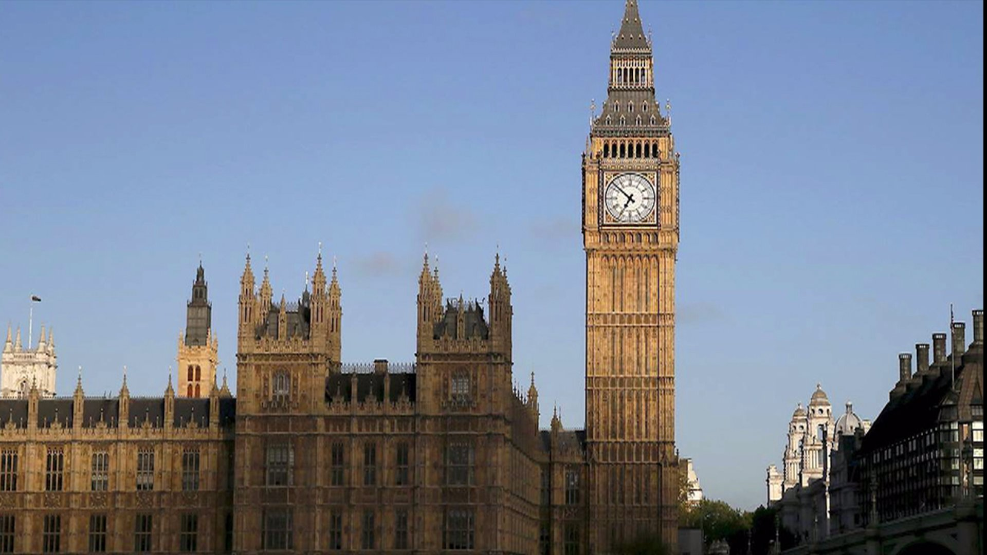      - Eiffel Tower in Paris  - Big Ben Tower in London  - Landmark 81 in Ho Chi Minh City  - Statue of Liberty in New York

B. New lesson: (35 minutes)
1. Activity 1: (10 minutes)
a. Objectives: to present the vocabulary about materials and improve Ss’ listening skill
b. Content: famous landmarks
c. Expected outcomes: Ss can improve their listening skill and expand their vocabulary
d. Competences: communication, collaboration, critical thinking and analytical thinking skills
e. Organization:
T’s activities | Ss’ activities | Content
- Play the recording with pauses for Ss to repeat chorally and/or individually.  - Elicit Ss’ guesses as to which material was used to build which building and then give Ss time to  read the text and find out the answer  - Check Ss’ answer | - Listen and repeat chorally and/or individually.  - Note down vocabulary  - Complete the task individually and then share with their partners  - Listen and take notes | Task 1: Listen and repeat. Which of these materials did they use to build each landmark (1-4) in the text? Read through to find out. (3.11)  1. marble  2. glass  3. brick  4. wood  5. steel  6. stone  7. plastic  8. bronze  Answer Key  1 They used stone to build Nelson’s Column. They used bronze to build the lions at the base.  2 They used marble to build the Taj Mahal.  3 They used stone to build the Pyramids of Giza.  4 They used steel to build the Golden Gate Bridge.
- Give Ss time to look up the meanings of the words in the box.  - Ask Ss to look through the text again and try to  identify the false piece of information in each text.  - Play the recording. Ss listen and check if their guesses were correct.  - Check Ss’ answers around the class.  - Play the video for Ss and elicit their comments | - Listen and take notes  - Look through the text again and try to  identify the false piece of information in each text | Vocabulary  - hero  - in memory of  - tomb  - connect  - fog  Task 2: Each text contains one incorrect fact. Can you see what it is?  Listen to the radio quiz to check if you are right (3.12)  Answer key  1 There aren’t three lions at the base of Nelson’s Column. There are four.  2 Shah Jahan didn’t build the Taj Mahal for his mother. He built it for his wife.  3 The largest pyramid of Giza wasn’t for Menkaure. It was for Khufu.  4 The Golden Gate Bridge isn’t 27 km long. It’s 2.7 km long

2. Activity 2: (15 minutes)
a. Objectives: to develop Ss’ research skill and improve the presentation skill
b. Content: making a poster
c. Expected Outcomes: Ss can prepare and make a poster
d. Competences: communication, collaboration, critical thinking skills
e. Organization:
T’s activities | Ss’ activities | Content
- Ask Ss to work in small groups and give them time to research online and collect information  about various landmarks around the world under the headings provided.  - Give Ss time to use this information to prepare a poster.  - Ask various groups to present their posters to the class and then display them around the classroom. | - Work in small groups and research online and collect information  about various landmarks around the world under the headings provided. | Task 3: Work in groups of three. Collect information about various landmarks around the world under the headings: Name – Location – History/Interesting facts. Prepare a poster  Suggested answer  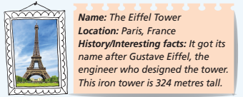
- Ask Ss to look at the posters from other groups and then ask various Ss to tell the class which landmark they think are the most impressive and why. | - Look at the posters from other groups and then ask various Ss to tell the class which landmark they think are the most impressive and why. | Task 4: Look at other groups’ posters. Which landmark do you find most impressive? Why?  Suggested answer  I think Stonehenge is the most impressive because it is so old and they brought the huge stones from far away.

3. Activity 3: (10 minutes)
a. Objectives: to give Ss a chance to apply what they have learnt.
b. Content: writing a postcard
c. Expected Outcomes: Ss can present their poster about a famous landmark.
d. Competences: communication, collaboration, critical thinking, presentation skills and creativity
e. Organization:
T’s activities | Ss’ activities | Content
- Give Ss some time to look around the classroom and draw a map of their classroom, and then present it in front of the class.  - Elicit answers from Ss around the class. | - Look around the classroom and draw a map of their classroom, and then present it in front of the class.  - Work in groups and prepare their answers. | Task 5: Imagine you are at one of these landmarks. Write a postcard to your English friend (about 50-60 words). Write about where you are, when you arrived and what you did/saw yesterday  Suggested answer  Hi Mary,  Greetings from Athens, Greece. I’m having a great time. Yesterday we visited the Parthenon. It’s a marble temple they built to honour the goddess Athena. It’s 2,500 years old. It’s amazing.  Talk soon.  Cam  How can we protect and preserve landmarks?  Suggested answer  S1: I think we shouldn’t write on the walls.  S2: You’re right. We shouldn’t throw rubbish,
C. Consolidation (3 minutes)
- Vocabulary about materials
- Writing a postcard
D. Homework assigned (2 minutes)
- Learn vocabulary about materials
- Do exercises in the workbook (page 50)

Reflection:
1. What did I like from the lesson?
-
-
2. What should I improve in the next lesson?
-
-

TA 6 RIGHT ON LESSON PLAN
UNIT 5: LONDON WAS GREAT Date: ________
Lesson 13: RIGHT ON! 1 (p. 99) Period: ________
- Objectives (learning outcomes):
By the end of this lesson, students will be able to:
- Knowledge:
- Create a poster about famous national wonders,
- Present famous natural wonders
- Learn about the value of responsibility (protect national wonders)
- Core competences:
- Reading for specific information
- Practise presentation skill
- Develop communication skills, critical thinking skills, presentation skills
- Build Ss’ imagination and creativity
- Personal qualities: Build their love and appreciate national wonder
- Teaching aids:
- Teacher’s aids: student book and teacher’s book, class CDs, IWB software, projector/interactive whiteboard/TV (if any).
- Students’ aids: Student books, notebooks.
- Procedures:
A. Warm-up: (5 minutes)
a. Objectives: to introduce the new lesson and set the scene for Ss to acquire new language; to get students' attention at the beginning of the class by means of enjoyable and short activities as well as to engage them in the steps that follow.
b. Content: national wonders of Vietnam
c. Expected outcomes: Ss can think about the topic
d. Competences: communication, collaboration, analytical thinking skills
e. Organization:
T’s activities | Ss’ activities | Content
- Ask Ss to tell some national wonders of Vietnam  - Elicit more answer | - Tell some national wonders of Vietnam | Can you tell me some national wonders of Vietnam?  Suggested answer  - Ha Long Bay  - Phong Nha – Ke Bang National Park  - Son Doong Cave  -……….

B. New lesson: (35 minutes)
1. Activity 1: (10 minutes)
a. Objectives: to develop Ss’ analytical skill and improve Ss’ creativity
b. Content: national wonders
c. Expected outcomes: Ss can read for key information and create a poster
d. Competences: communication, collaboration, critical thinking and analytical thinking skills
e. Organization:
T’s activities | Ss’ activities | Content
- Ask Ss to work in small groups and then give them time to research online and find information about four national wonders.  - Ask Ss to copy the headings from the table into their notebooks and make notes and then add  pictures and use their notes to make a poster. | - Work in small groups and research online and find information about four national wonders.  - Copy the headings from the table into their notebooks and make notes and then add pictures and use their notes to make a poster. | Task 2: Choose national wonders from around the world. The students in your group decide on four. Copy the table in Exercise 1 into your notebook and make notes under the headings. Find pictures of the national wonders and create a poster.  Suggested answer  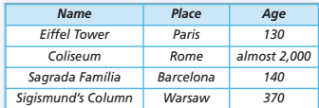  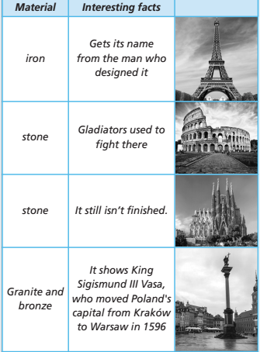
2. Activity 2: (20 minutes)
a. Objectives: to develop Ss’ presentation skill
b. Content: national wonders
c. Expected outcomes: Ss can present national wonders and learn about the value of responsibility
d. Competences: communication, collaboration, critical thinking skills and creativity
e. Organization:
T’s activities | Ss’ activities | Content
- Ask various groups of students around the class to present their national wonders from Exercise 2 to the class. | - Present their national wonders from Exercise 2 to the class | Task 3: Present your national wonders to the class. Describe and compare them.  Suggested answers  Good morning. Today I want to tell you about some famous landmarks. Perhaps you will know some of them.  The Eiffel Tower is an iron landmark in Paris. It is around 130 years old. It gets its name from the man who designed it.  The Coliseum is a stone landmark in Rome. It is almost 2,000 years old. Gladiators used to fight there.  The Sagrada Família is a stone landmark in Barcelona. It is around 140 years old, and it still isn’t finished.  Sigismund’s Column is a granite and bronze landmark in Warsaw. It is around 370 years old, and it shows King Sigismund III Vasa, who moved  Poland's capital from Kraków to Warsaw in 1596.  If you get the chance to visit them, you should.  Thanks for listening.
- Ask Ss to read the rules. Explain/Elicit the meanings of any unknown words and then elicit why we have these rules from Ss around the class. | - Read the rules.  - Complete the task individually and then share with their partners | Task 4: Read the rules. Why do we have these rules?  Suggested answer  We have these rules to protect our monuments and ancient ruins

3. Activity 3: (5 minutes)
a. Objectives: to help Ss express the idea and develop their critical thinking skill
b. Content: two other rules
c. Expected outcomes: Ss can create and talk about their rules.
d. Competences: communication, collaboration, critical thinking, presentation skills and creativity
e. Organization:

T’s activities | Ss’ activities | Content
- Give Ss time to think of other rules relating to responsibility for protecting ancient ruins and monuments and then ask various Ss to tell the class. | - Think of other rules relating to responsibility for protecting ancient ruins and monuments and then ask various Ss to tell the class. | Task 5: Can you think of two other rules? Tell the class.  Answer key  Don’t drop litter.  Respect the local culture and traditions.

C. Consolidation (3 minutes)
+ Create a poster about famous national wonders,
+ Present famous natural wonders
+ Learn about the value of responsibility (protect national wonders)

D. Homework assigned (2 minutes)
- Learn vocabulary about wonders
- Do exercises in the workbook (page 51)

Reflection:
1. What did I like from the lesson?
-
-
2. What should I improve in the next lesson?
-
-

TA 6 RIGHT ON LESSON PLAN
UNIT 5: LONDON WAS GREAT Date: ________
Lesson 14: PROGRESS CHECK (pp. 100, 101) Period: ________
- Objectives (learning outcomes):
By the end of this lesson, students will be able to:
- Knowledge: Review vocabulary related to famous places and grammar and structures in unit 5
- Core competences:
- Develop self-study skills
- Self-evaluate their progress
- Develop conversation skills and creativity and other skills
- Personal qualities: Build their love for famous places in their country
- Teaching aids:
- Teacher’s aids: student book and teacher’s book, class CDs, IWB software, projector/interactive whiteboard/TV (if any).
- Students’ aids: Student books, notebooks.
- Procedures:
A. Warm-up: (3 minutes)
a. Objectives: to review the previous lesson; to get students' attention at the beginning of the class by means of enjoyable and short activities as well as to engage them in the steps that follow.
b. Content: body parts of animals
c. Expected outcomes: Ss can remember the vocabulary in the lesson
d. Competences: communication, collaboration, analytical thinking skills
e. Organization:
T’s activities | Ss’ activities | Content
- Ask Ss to do the exercise individually and then share it with their partners.  - Check Ss’ answer. | - Do the exercise individually and then share it with their partners.  - Take notes | 1. Look at the picture and choose the correct answer  1 Look at the picture and choose the correct answer.  Answer keys  1. mane  2. tail
B. New lesson: (40 minutes)
1. Activity 1: (15 minutes)
a. Objectives: to review vocabulary and grammar points in the lesson
b. Content: collocations, vocabulary means of transport and materials and past simple
c. Expected outcomes: Ss can remember vocabulary and knowledge they have learnt
d. Competences: communication, collaboration, critical thinking and analytical thinking skills
e. Organization:
T’s activities | Ss’ activities | Content
- Ask Ss to do the exercise individually and then share it with their partners.  - Check Ss’ answer. | - Do the exercise individually and then share it with their partners. | 2. Match the adjectives (1-4) to their  opposites (a-d)  Answer key  1. b 2. d 3. a 4. c
- Ask ss to do the exercise individually and then share it with their partners.  - Check Ss’ answer. | - Do the exercise individually and then share it with their partners. | 3. Look at the pictures and choose the  correct answer  Answer key  1 Lucy goes to school by bus/car.  2 We went to London on the ship/train.  3 He goes to work on foot/a bicycle.  4 She went to the airport in a tram/taxi.
- Ask Ss to do the exercise individually and then share it with their partners.  - Ask Ss to explain the rules.  - Check Ss’ answer. | - Do the exercise individually and then share it with their partners.  - Take notes | Grammar  4. Write the Past Simple of the verbs.  Answer key  1 think => thought  2 study => studied  3 eat => ate  4 buy=> bought  5 book=> booked  6 enjoy => enjoyed  7 decide => decided  8 want=> wanted  9 take=> took  10 have=> had
- Ask Ss to do the exercise individually and then share it with their partners.  - Ask Ss to explain the rules  - Check Ss’ answer. | - Do the exercise individually and then share it with their partners.  - Take notes | 5. Put the verbs in brackets into the  affirmative or negative form of the Past  Simple.  Answer key  1 Darren booked (book) his holiday  online. (✓)  2 He didn’t visit (visit) any museums  during his trip. (✗)  3 He ate (eat) local dishes at a restaurant. (✓)  4 He didn’t have (have) a very good time. (✗)
- Ask Ss to do the exercise individually and then share it with their partners.  - Check Ss’ answer. | - Do the exercise individually and then share it with their partners.  - Take notes | 6. Use the words in brackets to write questions.  Answer key  1. What time did the flight leave?  2. How did you get to work?  3. Where did you go on holiday last summer?  Why did he pack his suitcase?
- Ask Ss to do the exercise individually and then share it with their partners.  - Ask Ss to explain the rules.  - Check Ss’ answer. | - Do the exercise individually and then share it with their partners.  - Take notes | 7. Look at what Sarah did/didn’t do on her holiday. Write questions, then answer them  Answer key  1. Did she go sightseeing? Yes, she did.  2. Did she stay in a hotel? No, she didn’t.  3. Did she eat local dishes? Yes, she did.  4. Did she go to the cinema? No, she didn’t.
2. Activity 2: (25 minutes)
a. Objectives: to improve Ss’ presentation, reading, listening and speaking skills
b. Content: Speaking, listening, reading and writing
c. Expected outcomes: Ss can review the lesson and improve skills and reflect their study
d. Competences: communication, collaboration, critical thinking skills
e. Organization:
T’s activities | Ss’ activities | Content
- Ask Ss to do the exercise individually and then share it with their partners.  - Check Ss’ answer.  - Ask Ss to practice in pairs and then present in front of the class. | - Do the exercise individually and then share it with their partners.  - Take notes | Everyday English  8. Complete the dialogue.  Answer key  Lucy: Hi, Jake. Welcome back! 1) How was your holiday?  Jake: It was amazing. We went to Spain.  Lucy: Wow! 2) What was the hotel like?  Jake: It was fantastic! It was close to the beach and our room was huge!  Lucy: 3) What did you do?  Jake: In the morning, we went sightseeing. Then, in the afternoon, we went snorkeling.  Lucy: 4) It sounds like you had a great time
- Ask Ss to do the exercise individually and then share it with their partners.  - Check Ss’ answer | - Do the exercise individually and then share it with their partners.  - Take notes | Reading  9: Read the text and decide if the sentences are R (right), W (wrong) or DS (doesn’t say).  Answer key  1. DS 2. R 3. W 4. R
- Play the recording twice and ask Ss to listen and try to find out the answer individually.  - Check Ss’ answer. | - Do the exercise individually and then share it with their partners.  - Take notes | Listening  10. Listen to Ben talking to Molly  about his holiday. Then decide if the  statements (1-4) are R (right), W (wrong) or DS (doesn’t say). (3.13)  Answer key  1. W 2. W 3. DS 4. R
- Ask Ss to do the exercise individually and then share it with their partners.  - Check Ss’ answer. | - Do the exercise individually and then share it with their partners.  - Take notes | 11. Write a letter to your English-speaking pen-friend about a recent trip of yours (about 50-60 words). Write about where you went, who you were with and what you saw/did.  Answer key  Hi Mike,  Guess what? I went to Italy last week with my mum and my sister. We had a great time. The weather was warm and sunny. In the mornings, we went to museums. In the afternoons, we went for walks. In the evenings, we ate pizza or pasta at restaurants. Delicious! How are you?  Write soon.  Violeta
- Ask Ss to reflect on what they have learnt and rank how well they master the lesson.  - Explain more whatever Ss don’t understand. | - Do the exercise individually and then share it with their partners.  - Take notes | 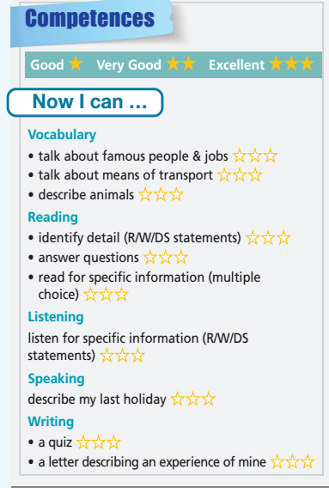

C. Homework assigned (2 minutes)
- Do exercises in the workbook (pages 52,53)
Reflection:
1. What did I like from the lesson?
-
-
2. What should I improve in the next lesson?
-
-

