Week:……………..  Period:……………. | Date of planning : …/… / 2023  Date of teaching : …/… / 2023
UNIT 4: ETHNIC GROUPS OF VIET NAM
Lesson 2 : A CLOSER LOOK 1

I. OBJECTIVES: * By the end of this lesson, Ss will be able to gain the following:
1. Knowledge:
- The lexical items related to the life of the ethnic people.
- Pronunciation: Correctly pronounce words that contain the sounds /k/ and /g/
+ Vocabulary:- Use The lexical items related to the life of Ethnic groups of Viet Nam
+ Correctly pronounce sounds /k / and / g / .
+ Grammar:- Yes/ No and Wh- questions
2. Competence:
- Students will be able to know more new words about Ethnic groups of Viet Nam
- Develop communication skills and cultural awareness.
- Be cooperative and supportive in pair work and teamwork.
- Be actively join in class activities.
3. Personal qualities:
- Love talking about Ethnic groups of Viet Nam
- Develop self-study skills.
II. MATERIALS:
- Teacher: Grade 8 text book, laptop, projector / TV.....
- Students : Text books, workbook…
- Computer connected to the Internet
- Sach mem.vn ; Or hoclieu.vn .
III. PROCEDURES:
1. WARM UP ( 5mins )
a. Objectives:
- To create an active atmosphere in the class before the lesson;
- To lead into the new lesson.
b. Content:
To have some warm-up activities to create a friendly and relaxed atmosphere to inspire Ss to warm up to the subject and new lesson.
c. Expected outcomes: Having a chance to speak English. Students get some vocabulary from the lesson and be ready for the lesson.
d. Organisation : Teacher’s instructions …
TEACHER AND STUDENTS’ ACTIVITIES | CONTENTS
+ Greeting  + Game: Kim’s game  - Teacher asks Ss to work in 2 groups.  - Teacher shows some pictures related to ethnic groups in 2 minutes.  - Ss look at the pictures and remember (no writing)  - As soon as teacher stops showing the pictures, Ss work in groups and write the words for the pictures they have seen  - The group with more correct answers becomes the winner.  Lead into this lesson .  OR: Show some pictures of people, costumes, and landscapes (for example: wooden statue at the grave yard, terraced fields, bamboo flute, Rong house...), and ask if Ss know them.  - Lead into this lesson which focuses on words and phrases about the life of ethnic minority groups in Viet Nam and sounds /k/ and /g/.  - Share with Ss the lesson objectives. Write the objectives in a corner of the board and leave them there till the end of the lesson, or put them on a slide to show Ss. | + Greeting ; - T_Ss.  + Game: Kim’s game  * Suggested answers:    (a) bamboo house, costume(s), five-colour sticky rice, folk dance, musical instrument(s), post(s), stilt house, terraced field(s)…
2. ACTIVITY 1: PRESENTATION (10mins)
a. Objectives:
1. To introduce visually some nouns/ nounphrases related to the life of ethnic people.
b. Content:
Write a word or phrase from the box under each picture;
c. Expected outcomes: Knowing more new words. Ss know how to pronounce the new words correctly and use them in appropriate situations.
d. Organisation : Teacher’s instructions.
TEACHER AND STUDENTS’ ACTIVITIES | CONTENTS
Task 1: Write a word or phrase from the box under each picture.
* Teach vocabulary:  + Teacher uses different techniques to teach vocab (situation, realia, translation.)  + Teacher introduces the vocabulary by:  - providing the pictures  - eliciting the definition of the words  + Teacher do the checking “What and where?”  ** Teacher asks Ss to look at each picture and say the word or phrase describing it if they know.  - Have Ss to read the words and phrases and do the matching. Ss can start matching the phrases they can easily recognise like terraced fields, Rong house, bamboo flute, wooden statue. The two remaining words on the list (gong and weaving) are different as one is an activity (weaving) and the other is an object (gong)  - Teacher checks the answers as a class.  - Have Ss read the words or phrases aloud. Correct their pronunciation if needed.  - T may ask Ss for the Vietnamese equipvalents of these words or phrases. | - T_Ss  * New words:  1. communal house (n) nhà rông, nhà sinh hoạt cộng đồng.  2. minority group (n) dân tộc thiểu số  3. livestock (n) gia súc  4. raise (v) chăn nuôi  5. gong (n) cái cồng, cái chiêng  *** Answer key:  1. wooden statue  2. Rong house (Nhà Rông )  3. weaving  4. bamboo flute  5. gong  6. terraced fields
3. ACTIVITY 2: PRACTICE ( 15mins)
a. Objectives:
1. To help Ss understand more clearly the meaning of some words and phrases.
2. To help Ss use the words in specific contexts.
b. Content:
Match the words and phrases with their meanings.; Complete the sentences with the words and phrases from the box.
c. Expected outcomes: Know more new words and phrases. Know how to use the words/ phrases in context.
d. Organisation :
TEACHER AND STUDENTS’ ACTIVITIES | CONTENTS
Task 2: Match the words and phrases with their meanings.
- Ask Ss to read the words and phrases that have been provided in the fist column and meanings in the secondcolumn.  - Teacher guides Ss if needed: Two words (gong, gardening) have appeared in the previous tasks and lessons. Two are similar (hourse- room, group- group)  -Ss can easilyfind the remaining items.  - Ss work individually, match suitable words/ phrases with their meanings.  - Teacher checks the answers as a class. | - T_Ss  * Key:  1. c 2. a  3. e 4. d  5. b
Task 3: Complete the sentences with the words and phrases from the box.
- Ss should have no difficullty completing the sentences since the words and phrases in the box have been taught in the previous activities.  - Teacher asks Ss to work individually, discuss and choose suitable words/ phrases to fill in the gaps.  - Ss go to the board and write their answers.  - Teacher checks the answers as a class.  - Teacher checks the answers as a class and gives feedback. | - T_ Ss  * Answer key:  1. unique features  2. weave  3. raise  4. communal house  5. minority group  6. livestock
4. ACTIVITY 3: PRODUCTION: ( 10mins)
PRONUNCIATION /k/ and /g /
a. Objectives:
- To help students identify how to pronounce the sounds /k/ and /g/.
- To help students practise pronouncing these sounds correctly in words and in sentences.
b. Content:
Listen and repeat the words. Pay attention to the sounds /k/ and /g/. Listen and repeat the sentences. Pay attention to the underlined words.
c. Expected outcomes: Students repeats the words correctly. Learn how to pronounce the words correctly. Ss distinguish and pronounce the sound /k/ and /g/ correctly in their speaking.

d. Organisation:
TEACHER AND STUDENTS’ ACTIVITIES | CONTENTS
Task 4: Listen and repeat the words. Pay attention to the sounds /k/ and /g/.
+ Have Ss read the sentences, paying attention to the underlined words /k/ and /g/.  - Play the recording and ask them repeat each sentence  - Teacher asks Ss to listen and pay attention to the sounds /k/ and /g/.  - Ss repeat the words as a class, in groups and individually.  - Call on some Ss to read the sentence individually.  - Play the recording as many times as necessary.  * Teacher gives corrections and feedbacks to students’ pronunciation . | - T_ Ss. Ss- Ss  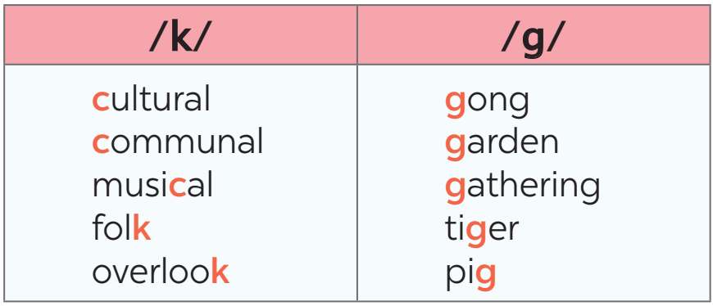
Task 5: Listen and repeat the sentences. Pay attention to the underlined words.
- Have Ss read the sentences, paying attention to the underlined words with the sounds /k/ and /g/.  - Play the recording and ask Ss to repeat each sentence. Correct them if needed.  - Call on some Ss to read the sentences individually.  - Teacher asks some students to read the sentences individually.  ** Teacher’s observation and feedback. | * Answer:  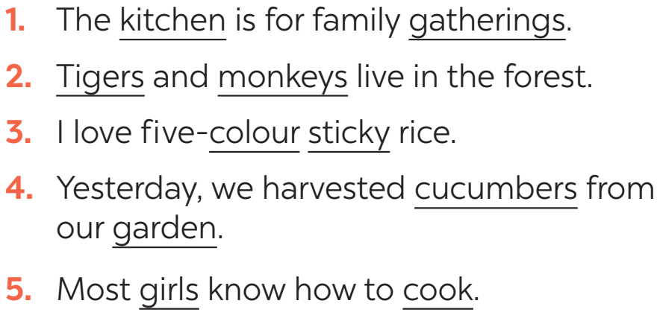
5. CONSOLIDATION ( 5mins )
a. Wrap-up
- Teacher asks Ss to summarise what theynhave learnt in the lesson.
b. Homework
- Learn by heart all the words that they have just learnt.
- Do more exercises in workbook.
- Prepare project.
- Prepare new lesson: Lesson 2: A CLOSER LOOK 2 .
==============================================

