**TIẾNG ANH 8 – FRIENDS PLUS**

**REVIEW (UNITS 3-4) – TEST 1**

**I. PRONUNCIATION**

**Câu 1.** Which word has the underlined part pronounced differently from that of the others?

**A.** crystal **B.** island **C.** waste **D.** insect

**Câu 2.** Which word has the underlined part pronounced differently from that of the others?

**A.** teenage **B.** beach **C.** leave **D.** ocean

**Câu 3.** Which word has a different stress pattern from that of the others?

**A.** pesticide **B.** coconut **C.** plantation **D.** skydiving

**Câu 4.** Which word has a different stress pattern from that of the others?

**A.** inspiration **B.** automatic **C.** evaporation **D.** ecological

**II. Choose the answer (A, B, C or D) that best fits the space in each question.**

**Câu 5.** What’s the longest time you’ve been ______ from home?

**A.** on **B.** into **C.** away **D.** out of

**Câu 6.** Coconut oil for hair is a really ______ item for ladies.

**A.** should-have **B.** can-have **C.** must-have **D.** may-have

**Câu 7.** We ______ in Egypt to visit Abu Simbel temples.

**A.** carried on **B.** stopped off **C.** sailed around **D.** hiking across

**Câu 8.** The next talk show will be about how to inspire others to ______ their dreams.

**A.** take **B.** run **C.** see **D.** live

**Câu 9.** The permanent ______ to environmental pollution lies in purification of human conscience.

**A.** news **B.** advantage **C.** ecology **D.** solution

**Câu 10.** The idea of eating insects is not new. In fact, Asian and African people ______ do.

**A.** already **B.** just **C.** yet **D.** still

**Câu 11.** Have you been speaking ______ Japanese recently?

**A.** a lot **B.** a lot of **C.** lot of **D.** lots

**Câu 12.** How ______ equipment do we need for underwater hockey?

**A.** much **B.** many **C.** little **D.** few

**Câu 13.** Barbara ______ a parachute jump because she is scared that she’ll be unable to open the parachute.

**A.** has never done **B.** never did **C.** has never been doing **D.** never do

**Câu 14.** Jason: “Have we got any peaches?” – Bean: “______ ”

**A.** I want to make a cake. **B.** There are three in the bowl.

**C.** How about eggs? **D.** What do you think?

**III. Look at each sign or notice. Choose the best answer (A, B, C or D) that matches its meaning.**

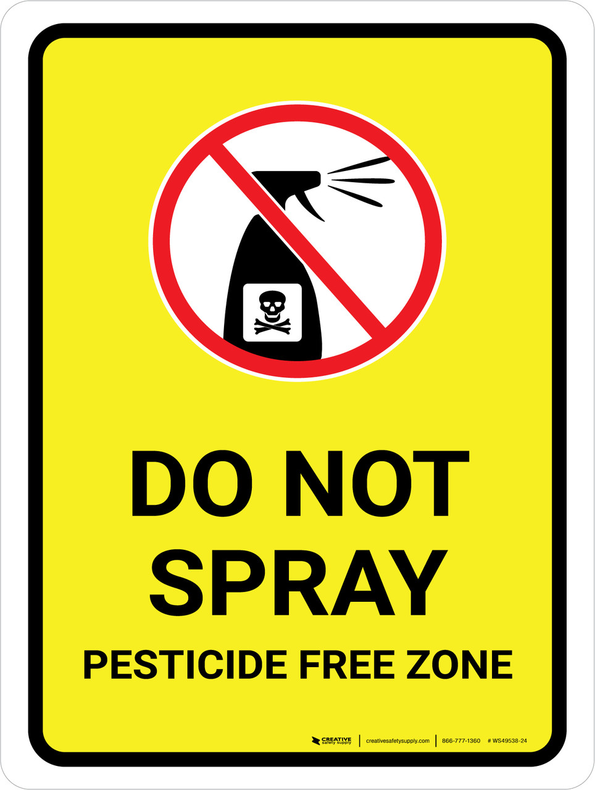**Câu 15.** What does the sign mean?

**A.** Do not park your car here! **B.** Do not enter this private area!

**C.** Do not spray pesticides here! **D.** Do not drink water in the river!

**Câu 16.** What does the message say?

|  |
| --- |
| Hi, Alice! Your flight No. 23T9 to Bali is delayed by 3 hours. So plan your departure to the airport accordingly. If you have already left, you can always check in at the visitor lounge and start your holiday in style! |

**A.** Alice’s flight will arrive three hours later than scheduled.

**B.** Alice is going to return to her country from Bali.

**C.** Alice should arrive at check-in at least three hours before departure.

**D.** Alice is not allowed to wait in the lounge because her flight is delayed.

**IV. Read the following and do as directed.**

For adrenaline junkies, the thrill of zorbing goes beyond description. **It** was invented and developed by two New Zealand friends, Andrew and David Akers, in 1994. Since then, the sport has become popular among visitors to New Zealand and available in other countries worldwide including the US, Australia, Canada, UK and India.

I still recall the first time I and my friend gave it a try. The cool thing about zorbing is that you can do it alone or with other people, so we decided to do it together. At first, neither of us managed to stay upright very long. Then, we began sliding about inside the ball when the ball dived off the hill. I was on my back for most of the ride. It was like what I’d imagine being inside a washing machine. We were so excited that our laughter echoed inside the ball. To my relief, the two of us had plenty of room and didn’t collide into each other. At the end of the ride, the assistant titled the zorb and we stepped out of the ball. We began talking it over, swapping stories of whose feet got soaking wet during the ride. For me, zorbing was amazing. It might be worth a 17-hour flight back to New Zealand just to do it again.

**True/False Questions:**

**Câu 17.** The history of zorbing dates back to the early 1990s.

**A.** True **B.** False

**Câu 18.** You are not allowed to go zorbing in pairs.

**A.** True **B.** False

**Câu 19.** The author could stand up till the end of the ride.

**A.** True **B.** False

**Câu 20.** Staying inside the zorb was like being in a washing machine.

**A.** True **B.** False

**Choose the correct answer to each question:**

**Câu 21.** What does the word “it” in the first paragraph refer to?

**A.** thrill **B.** zorbing **C.** description **D.** New Zealand

**Câu 22.** What can be inferred from the passage?

**A.** The activity is not so popular in European countries.

**B.** The author went for a solo zorbing ride.

**C.** The author hurt herself during the ride.

**D.** The author hopes to try zorbing again.

**V. Choose the word (A, B, C or D) that best fits each blank space in the following passage.**

Technology has become an (23) ______ part of our lives and has given us significant advantages. Social media is typical of a high-tech product. It (24) ______ a platform for businesses to build their brands and engage with customers. Through social networking sites (25) ______ Facebook and TikTok, many companies find it easy to promote their products and convince their users to make a (26) ______. Moreover, online platforms allow them to get valuable feedback so (27) ______ they can improve their products and services. Lastly, using social media helps companies stay competitive in the current market by reaching a wider (28) ______.

**Câu 23.** Choose the correct answer.

**A.** useful **B.** integral **C.** irrelevant **D.** impossible

**Câu 24.** Choose the correct answer.

**A.** offers **B.** supplies **C.** provides **D.** affords

**Câu 25.** Choose the correct answer.

**A.** with **B.** for **C.** as **D.** like

**Câu 26.** Choose the correct answer.

**A.** bargain **B.** discount **C.** coupon **D.** purchase

**Câu 27.** Choose the correct answer.

**A.** that **B.** as to **C.** long **D.** if

**Câu 28.** Choose the correct answer.

**A.** spectator **B.** reviewer **C.** audience **D.** publicity

**VI. Supply the correct form of the word given in each sentence.**

**Câu 29.** The whole family pitches in to make ______ pizza from scratch, with all their favorite toppings. **(HOME)**

**Câu 30.** How did you ______ your friends to try fried caterpillars? **(PERSUASION)**

**Câu 31.** Fungi play a vital role in decomposing dead material and ______ the nutrients to make them available for the growth of other plants. **(CYCLE)**

**Câu 32.** With more colours than most 4K televisions, this series is a ______ immersive dream machine capable of generating over a billion intense colours. **(POWER)**

**Câu 33.** SEA Games brings together more than 12,000 ______ from 11 countries, taking part in 38 sports from May 5-17in the capital city of Phnom Penh. **(PARTICIPATE)**

**Câu 34.** At night, lights twinkle in ______ villages across the valley of the Kings. **(DISTANCE)**

**VII. Rearrange the groups of words in a correct order to make complete sentences.**

**Câu 35.** by dangerous pesticides. / farmers can / working long hours / get harmed / As a direct consequence of

**Câu 36.** worn out now / hiking across the jungle / as they have been / All the crew members are / all day.

**VIII. Rewrite each of the following sentences in another way so that it means almost the same as the sentence printed before it.**

**Câu 37.** I started travelling around the world 3 years ago. I’m still on the way to explore the world. **(FOR)**

🡪 I

**Câu 38.** Natural resources are being used up. **(OF)**

🡪 We

**Câu 39.** Is it necessary for them to be fitter to play soccer? **(SHAPE)**

🡪 Do they

**Câu 40.** Rugby is a ball game. It is popular in New Zealand. ***(Use relative clause)***

🡪 Rugby is

**------ HẾT ------**