UNIT 6.
OUR TET HOLIDAY
PART 1. THEORY
I. VOCABULARY
No. | English | Pronunciation | Vietnamese
1 | apricot blossom | /’eɪprɪkɒt ‘blɒsəm/ | hoa mai
2 | calendar | /’kælɪndə(r)/ | lịch
3 | dragon dance | /’drægən dɑːns/ | múa lân
4 | dress up | /’dres ʌp/ | ăn diện
5 | dried candied fruits | /’draɪd ‘kændid fru:ts/ | mứt
6 | exchange new year's  wishes | /‘ɪks’tʃeɪdʒ nju: jɪə(r) wɪtʃɪz/ | chúc Tết nhau
7 | fireworks | /’faɪəwɜ:ks/ | pháo hoa
8 | first caller | /fɜ:st ‘kɔ:lə(r)/ | người xông đất
9 | furniture | /’ fɜ:nɪtʃə(r)/ | đồ nội thất
10 | go to pagodas to  pray for | /’gəʊ tu: pə’gəʊdəz tu: preɪ fə(r)/ | đi chùa để cầu
11 | jellied meat | /’dʒelɪd mi:t/ | thịt đông
12 | kumquat tree | /’kʌmkwɒt tri:/ | cây quất
13 | lean pork paste | /li:n pɔ:k peɪst / | giò lụa
14 | pagoda | /pə’gəʊdəz/ | chùa
15 | parallel | /’pærəlel/ | câu đối
16 | peach blossom | /pi:tʃ ‘blɒsəm / | hoa đào
17 | pickled onion | /’pɪkld ʌnjən/ | dưa hành
18 | pickled small leeks | /’pɪkld smɔ:l li:ks/ | củ kiệu
19 | present | /’preznt/ | quà tặng
20 | relative | /’relətɪv/ | họ hàng
21 | roasted watermelon  seeds | /rəʊstɪd ‘wɔ:təmelən si:dz/ | hạt dưa
22 | shopping | /’ʃɒpɪη/ | việc mua sắm
23 | special food | /’speʃl fu:d/ | đồ ăn đặc biệt  (trong ngày nào đó)
24 | spring festival | /sprɪη ‘festɪvl/ | hội xuân
25 | sticky rice | /’stɪkɪ raɪs/ | gạo nếp
26 | sweep the floor | /swi:p ðə flɔ:(r)/ | quét nhà
27 | the Kitchen God | /ðə kɪtʃɪn gɒd/ | ông Táo (Táo quân)
28 | the new year tree | /ðə nju: jɪə(r) tri:/ | cây nêu
29 | wish | /wɪʃ/ | ước, cầu
II. GRAMMAR
1. SHOULD and SHOULDN’T
a. Form (Cấu trúc)
(+) S + should + V-inf
(-) S + shouldn’t + V-inf
(?) Should + S + V-inf?
Ex: Students should wear uniform.
(Học sinh nên mặc đồng phục)
We should wear warm coats in this weather.
(Chúng ta nên mặc áo ấm trong thời tiết này.)

b. Usage (Cách sử dụng)
Should và shouldn’t được dùng để khuyên ai đó nên hay không nên làm điều gì.
Ex: She should go to the doctor.
(Chị ấy nên đến gặp bác sĩ.)
He shouldn’t smoke here.
(Anh ấy không nên hút thuốc ở đây.)
They should study hard.
(Họ nên học hành chăm chỉ.)
2. Some, any for amount - Some, any dùng để diễn tả số lượng
a. Some (một số, một vài, một ít, một chút)
Usage (Cách sử dụng)
- Ta dùng some trong câu khẳng định, trước danh từ đếm được số nhiều hoặc danh từ không đếm được.
Ex: I buy some pens.
(Tôi mua vài chiếc bút.)
Linda often drinks some milk in the evening.
(Linda thường uống một chút sữa vào buổi tối.)
- Ta cũng dùng some trong câu yêu cầu, lời mời hoặc lời đề nghị lịch sự.
Ex: Would you like some coffee?
(Bạn có muốn uống một chút cafe không?)
May I have some noodles?
(Cho tôi một chút mì được không?)
Let’s eat some food and drink some tea.
(Chúng ta hãy ăn một chút đồ ăn và uống một chút trà.)
b. Any: một chút, một ít
Usage (Cách sử dụng)
- Ta thường dùng any trong câu phủ định hoặc nghi vấn, trước danh từ đếm được số nhiều hoặc danh từ không đếm được.
Ex: Do you have any rulers? (Bạn có chiếc thước kẻ nào không?)
There isn’t any milk in the fridge. (Không có sữa trong tủ lạnh.)
Lưu ý: Đôi khi ta cũng gặp any trong câu khẳng định, trước danh từ số nhiều hoặc danh từ không đếm được.
Ex: You can catch any buses. They all go to the zoo.
(Bạn có thể đón bất cứ chiếc xe buýt nào. Tất cả chúng đều đến sở thú.)
He is very strong. He can beat any competitors.
(Anh ta rất mạnh. Anh ta có thể đánh bại bất cứ đối thủ nào.)
iii. PHONETICS
Cách phát âm âm /s/ và /ʃ/.

1. Âm /s/

a. Cách phát âm âm /s/
/s/ là một phụ âm vô thanh. Để phát âm âm này, các em làm như sau.
- Đặt lưỡi chạm vào mặt trong của răng cửa trên, đầu lưỡi đưa ra ngoài gần chạm vào ngạc trên. Sau đó đẩy luồng hơi từ từ ra ngoài qua khe giữa đầu lưỡi và răng cửa trên. Ta phát âm âm /s/ gần giống âm "x" trong tiếng Việt.

Các em tập thực hành phát âm các từ sau:
six /sɪks/  star /stɑːr/  bus/bʌs/  class /klæs/  song /sɔ:η/ | city /'sɪtɪ/  pencil /’pensl/  sister /'sɪstər/  science /'saɪəns/  century /'sentʃərɪ/

b. Dấu hiệu nhận biết âm /s/
- “c” được phát âm là /s/ khi nó đứng trước e, i hoặc y
Examples | Transcription | Meaning
city | /'sɪtɪ/ | thành phố
bicycle | /'baɪsɪkl/ | xe đạp
recycle | /ri:'saɪkl/ | tái sinh, tái chế
center | /'sentə(r)/ | trung tâm
century | /'sentʃərɪ/ | thế kỷ
- "s" được phát âm là /s/ khi nó đứng đầu một từ
Examples | Transcription | Meaning
see | /si:/ | nhìn thấy
sad | /sæd/ | buồn
sing | /sɪη/ | hát
song | /sɔ:η/ | bài hát
- "s" được phát âm là /s/ khi nó ở giữa một từ và không ở giữa hai nguyên âm
Examples | Transcription | Meaning
most | /məʊst/ | hầu hết
haste | /heɪst/ | vội vàng, hấp tấp
describe | /dɪ'skraɪb/ | miêu tả
display | /dɪ'spleɪ/ | trưng bày
- "s” được phát âm là /s/ khi từ có tận cùng là f, k, p, t và gh
Examples | Transcription | Meaning
roofs | /ru:fs/ | mái nhà
stuffs | /stʌfs/ | vật liệu
books | /bʊks/ | sách
kicks | /kɪks/ | cú đá
maps | /mæps/ | bản đồ
2. Âm /ʃ/
a. Cách phát âm âm /ʃ/
Âm /ʃ/ là một phụ âm vô thanh. Để phát âm âm này, ta làm như sau:
- Đầu tiên ta đưa lưỡi lên và lùi lại một chút, sau đó đẩy môi về phía trước thành một vòng tròn. Sau đó phát âm /ʃ/. Âm này gần giống âm "s" trong tiếng Việt nhưng mạnh hơn.
Các em hãy tập thực hành phát âm các từ sau:
she /ʃɪ/  shop /ʃɒp/  sure /ʃʊər/  fish /fɪʃ/  push /pʊʃ/ | special /'speʃəl/  ocean /'əʊʃn/  nation /'neɪʃn/  machine /mə' ʃi:n/  musician /mju:’zɪʃn/
b. Dấu hiệu nhận biết âm /ʃ/
- “c” được phát âm là /ʃ/ khi đứng trước ia, ie, io, iu, ea
Examples | Transcription | Meaning
special | /'speʃəl/ | đặc biệt
social | /'səʊʃəl/ | thuộc xã hội
artificial | /,ɑːtɪ'fɪʃəl/ | nhân tạo
musician | /mju:’zɪʃn/ | nhạc sĩ
- "s" phát âm là /ʃ/
Examples | Transcription | Meaning
ensure | /ɪn'ʃɔ:(r)/ | đảm bảo
insure | /ɪn'ʃɔ:(r)/ | bảo hiểm
pressure | /'preʃə(r)/ | áp lực, sức ép
insurance | /ɪn' ʃʊrəns/ | sự bảo hiểm
- "t” phát âm là /ʃ/ khi nó ở bên trong một chữ và đứng trước ia, io
Examples | Transcription | Meaning
nation | /'neɪʃən/ | quốc gia
intention | /ɪn'tenʃn/ | ý định
ambition | /æm'bɪʃən/ | tham vọng
potential | /pəʊ'tentʃəl/ | tiềm lực
- “ch" được phát âm là /ʃ/
Examples | Transcription | Meaning
machine | /mə’ʃi:n/ | máy móc
chemise | /ʃə'mi:z/ | áo lót
chevalier | /ʃevə’lɪə/ | kỵ sĩ, hiệp sĩ
- “sh" luôn được phát âm là /ʃ/
Examples | Transcription | Meaning
shake | /ʃeɪk/ | lắc, rũ
show | /ʃəʊ/ | trình diễn
shout | /ʃaʊt/ | kêu, la lớn
sheet | /ʃi:t/ | lá, tờ
shop | /ʃɒp/ | cửa hàng

PART 2. LANGUAGE
I. VOCABULARY
Exercise 1. Complete the rest of each phrase with the following words.
pickled | Kitchen | small leeks | dragon | jellied
lean pork | tree | new year | peach | festival

1. ________ blossom  2. kumquat ________  3. the ________ tree  4. ________ meat  5. ________ onion | 6. spring ________  7. ________ dance  8. ________ God  9. ________ paste  10. pickled ________
Exercise 2. Look at the picture and write the correct word
 | 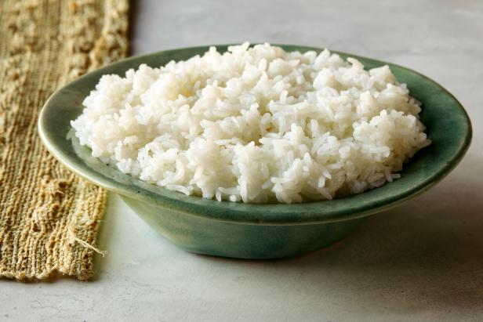 | 
1. ___________________ | 2. ___________________ | 3. ___________________
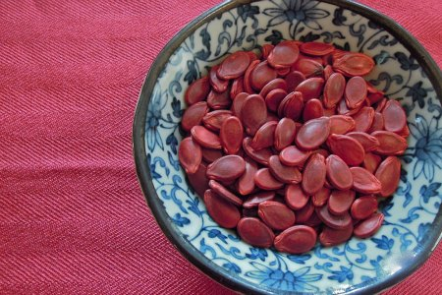 |  | 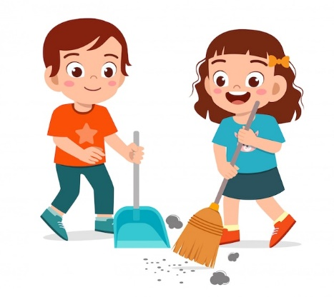
4. ___________________ | 5. ___________________ | 6. ___________________
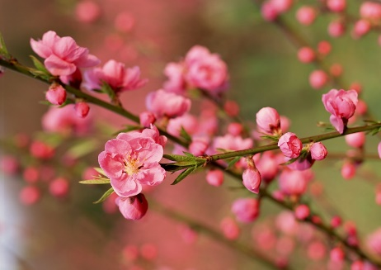 | 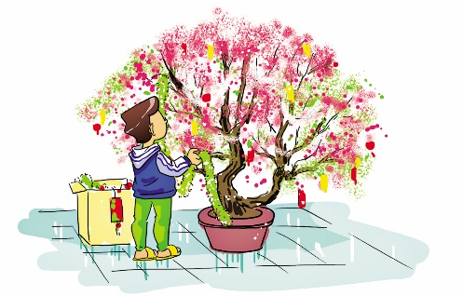 | 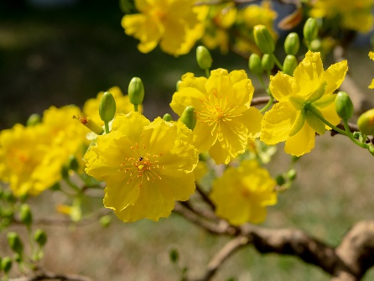
7. ___________________ | 8. ___________________ | 9. ___________________
Exercise 3. Put the words from the box in the appropriate rows of verbs.
front door | a pagoda | pine tree | a temple | banh chung
friends | old teachers | a calendar | peach blossoms | apricot blossoms
the house | home village | special food | decorations | jellied meat
relatives | a church | the led lights | a market | flowers
the living room | sticky rice | traditional food | chicken

Go to | Decorate | Hang | Buy | Visit | Cook
Exercise 4. Complete the sentences with the verbs in the box.
make | decorate | buy | visit | hang
clean | cook | go | give | celebrate
1. This year we will __________ Tet in the middle of February.
2. My father __________ our house with flowers and plants.
3. My grandma and my aunts __________ Chung cakes.
4. My mother __________ a lot of special food.
5. We __________ apricot blossoms and kumquat trees.
6. My brother __________ new calendars, lanterns and scrolls.
7. My sister and I __________ the house and furniture.
8. On the first days of Tet, my family __________ our relatives.
9. My parents __________ us lucky money in the morning of the first day.
10. On the first day of Tet, we __________ to the pagoda to pray for a good year.
Exercise 5. Complete the sentences with the word/ phrase in the box.
sweep | sticky rice | lucky money | fireworks | first footer
decorate | visit | special food | dried candied fruit | pagodas
1. At New Year's Eve, people gather at Hoan Kiem Lake to see ___________.
2. At Tet holiday, Vietnamese people ___________ their houses with peach blossoms and apricot blossom.
3. At Tet holiday, Vietnamese people go to ___________ to wish for success, money, health in New Year.
4. At Tet holiday, Vietnamese people cook ___________ such as Chung Cake, boiled chicken, lean pork paste.
5. Chung Cake is made from ___________.
6. The person who set the first foot is called ___________.
7. Do not ___________ the floor at Tet, or you will sweep away all your luck.
8. At Tet holiday, Vietnamese people ___________ their relatives and friends.
9. At Tet holiday, Vietnamese children usually get some money from their parents, grandparents, .... That is called ___________
10. At Tet holiday, Vietnamese children usually eat Tet jam, or it is also called ___________.
II. GRAMMAR
Exercise 1. Complete the sentences with should or should not (shouldn't).
1. People ___________ always fasten their seatbelts in cars.
2. I think we ___________ give food to people in need as often as possible.
3. If you are that sick, then you ___________ stay in bed and call the doctor.
4. Men ___________ stop polluting the planet to avoid more climatic disasters.
5. When you light a barbecue, you ___________ use petrol because it is dangerous.
6. Sam ___________ go on a diet if he does not want to have health problems.
7. The bank manager ___________ put his money back in the safe.
8. These two boys ___________ be fighting just because of some bad words.
9. If it is that cold today, you ___________ wear a coat over your sweater.
10. I don't think you ___________ smoke that much.
11. The kids ___________ spend that much time on TV.
12. ___________ I tell her the truth or should I say nothing?
13. You are overweight. You ___________ go on a diet.
14. I think you ___________ try to speak to her instead of keeping silence.
15. If you don't want to get up late tomorrow, you ___________ stay up late tonight.
Exercise 2. Complete the short conversation with should or should not (shouldn't).
1. A: I don’t feel very well.
B: You ___________ go to bed early.
2. A: We’re bored.
B: You ___________ watch TV so much.
3. A: There’s a new girl at school called Susanna.
B: You ___________ invite her to our class.
4. A: I don't understand my Maths homework.
B: You ___________ ask your teacher to explain it again.
5. A: I can’t fall asleep at night.
B: You ___________ drink so much coffee.
6. A: I don’t have any money.
B: You ___________ buy so many DVDs.
7. A: I’m going to live in France for a year.
B: You ___________ learn some French.
8. A: I got a bad mark in my Science test.
B: You ___________ study more.
Exercise 3. Write the pieces of advice for these situations, using should or shouldn't and the words given in brackets.
1. My tooth is aching again. (not eat so many sweet things)
_______________________________________________________________________________
2. Tom has to get up very early tomorrow. (set the alarm clock)
_______________________________________________________________________________
3. Mary is putting on weight. (do more exercise)
_______________________________________________________________________________
4. Phong and Linh don’t feel well. (stay at home)
_______________________________________________________________________________
5. My sister is short-sighted. (go to the doctor's)
_______________________________________________________________________________
6. I have a pain in my chest. (see a doctor)
_______________________________________________________________________________
7. My grandfather has a backache. (not carry heavy things)
_______________________________________________________________________________
8. My children have decayed teeth. (not eat sweets)
_______________________________________________________________________________
Exercise 4. List four things that you should and shouldn't do in Tet, the first one has been done for you as an example. (The answer may vary.)
Should | Should not
Wear colourful clothes | Sweep the floor
Exercise 5. Complete the following sentences with some or any.
1. I am going to ask my mother for ___________ money.
2. Could you give me ___________ sugar? I am making a cake.
3. There are ___________ people who want to meet you personally.
4. Do you have ___________ experience with the job?
5. She needs ___________ paper to write on.
6. I always have ___________ housework to do. I am never free to do anything.
7. ___________ people show their interest in the project.
8. You can visit me ___________ time you want. I have lots of free time these days.
9. Could you give me ___________ advice?
10. I don't have ___________ money in my pocket now.
11. We need ___________ bananas.
12. You can’t buy ___________ posters in this shop.
13. We haven’t got ___________ oranges at the moment.
14. Peter has bought ___________ new books.
15. She always takes ___________ sugar with her coffee.
16. I have seen ___________ nice postcards in this souvenir shop.
17. There aren’t ___________ folders in my bag.
18. I have ___________ magazines for you.
19. There are ___________ apples on the table.
20. Pam does not have ___________ pencils on her desk.
Exercise 6. Complete the sentences with some/ any/ a/ an,
1. There is ___________ banana in the basket.
2. I need ___________ tea.
3. Are there ___________ tomatoes in the fridge?
4. We have ___________ rice, but we don't have ___________ meat.
5. There’s ___________ orange on the table.
6. I’d like ___________ apple juice.
7. He has ___________ TV and ___________ computer.
8. Would you like ___________ ice-cream?
9. I have ___________ friends in Hue.
10. Do you have ___________ dogs or cats at home?
11. Would you like ___________ cup of tea?
12. I would like ___________ cakes, please.
13. Can I have glass of milk?
14. Thank you. And ___________ box of chocolate would be fine.
III. PHONETICS
Exercise 1. Divide the words into two columns.
sandcastle | shine | shoot | shock
solve | sunny | shake | summer
shuffle | shark | snowy | shoulder
shut | sooner | sound | soap

/s/ | /ʃ/
Exercise 2. Choose the word that has the underlined part pronounced differently for the rest.
1. A. cover B. pencil C. place D. police
2. A. same B. see C. sister D. sure
3. A. stripe B. science C. usually D. stop
4. A. Russia B. class C. glass D. pass
5. A. fix B. exam C. six D. next
6. A. student B. sugar C. stainless D. slang
7. A. summer B. singer C. study D. tables
8. A. sure B. stupid C. spring D. snail
9. A. ocean B. ceiling C. city D. circle
10. A. ache B. school C. machine D. chemical

PART 3. COMMUNICATION SKILLS
I. LISTENING
Listen and do the tasks followed.
Exercise 1. Listen and decide if each statement is True (T) or False (F). Track 11
1. People buy lots of pork rolls during Tet. _______
2. Boats bring flowers go down the Red River. _______
3. People do not care much about food during Tet. _______
4. There is not much of demand of tourism during Tet. _______
5. This year, domestic bookings are 15 per cent higher than last year. _______
Exercise 2. Listen again and answer the question. Track 12
1. What are people working overtime to prepare?
____________________________________________________________________________
2. How many flower markets opened on the 3rd of February?
____________________________________________________________________________
3. What do flower markets sell?
____________________________________________________________________________
4. Where do boats bring flowers go toward?
____________________________________________________________________________
5. What do villagers in Dong Thap province sell?
____________________________________________________________________________
II. SPEAKING
Exercise 1. Complete the conversation with the questions from the box then practise speaking it.
How do you celebrate?
Will you help your mother with cooking?
What do you do on the next days?
Will you buy Chung cakes?
What will you do for this New Year?
Tom: (1) _________________________________________________________________________
Linh: I will clean and decorate our house.
Tom: (2) _________________________________________________________________________
Linh: Yes, I will. My mother usually cooks lots of traditional food.
Tom: (3) _________________________________________________________________________
Linh: No. We won't buy Chung cakes. My grandma will make Tet cakes.
Tom: (4) _________________________________________________________________________
Linh: In the morning of the first day, we wear our new clothes, make wishes to our parents and get lucky money. Then my family go to some pagodas to pray for a happy new year.
Tom: (5) _________________________________________________________________________
Linh: On the second day of Tet, we often visit our relatives. And I go out with my friends on the third day.
Tom: It sounds great! I hope you enjoy yourself this year.
Exercise 2. Read the sentences and give advice with should or shouldn't to talk about what we should or shouldn't do at Tet.
0. Smile a lot and avoid arguments
At Tet, you should smile a lot and avoid arguments.
1. Dress up in colorful clothes
At Tet, you
2. Say words of wishes to grandparents
At Tet, you
3. Go to pagodas and churches
At Tet, you
4. Visit relatives and friends
At Tet, you
5. Break things such as dishes, cups
At Tet, you
6. Have conflicts with your parents
At Tet, you
7. Set the first foot in other people's house without being asked to.
At Tet, you
8. Sweep floor on the first three days of Tet
At Tet, you
9. Ask for lucky money
At Tet, you
10. Eat shrimps and squids
At Tet, you
III. READING
Exercise 1. Read the following text and answer the questions by choosing the option A, B, C or D.
The traditional New Year’s food in Japan is called "osech-ryori”, and it consists of numerous little dishes based on region and history. Here is a list of some common and not-so-common foods found in osechi-ryori.
A traditional local New Year’s food known as osechi-ryori is commomly consumed on New Year’s Day (which is referred to in Japanese as "Ganjitsu”). Osechi-ryori, or often called just "osechi”, is a food that consists of various colorful dishes.
As the New Year symbolizes a new beginning, osechi-ryori consists of food with auspicious meanings. The dishes are stored in a three or four - tiered container called “Jubako”. On Ganjitsu, people are not supposed to work, including the housewives. Hence, osechi is prepared in advance for Ganjitsu.
1. What does the word "osech-ryori"in Japnese mean?
A. New Year B. traditional food
C. name of a dish D. name of a region
2. Which word means New Year's Day?
A. Osech B. Ryori C. Jubako D. Ganjitsu
3. When is osechi-ryori commonly consumed?
A. New Year's Day B. beginning of the days
C. the first month of the year D. last month of the year.
4. Which of the following words best replace the word "auspicious” in the last paragraph?
A. understanding B. astonishing
C. promising D. interesting
5. How many tiers does Jubako container have?
A. two to three B. three to four
C. four to five D. more than five
6. Which of the following is NOT true?
A. Osechi-ryori consists of numberous little dishes based on region and history.
B. Osechi-ryori is a food that consists of various colorful dishes.
C. On Ganjitsu, housewives are supposed to work.
D. Osechi is prepared in advance for Ganjitsu.
Exercise 2. Read and do the tasks followed.
Lunar New Year, or Tet, is Vietnam’s main holiday. It is the most important occasion in the year which falls sometime between 19th January and 20th February on the Western calendar. Tet marks the beginning of spring and the start of a new year.
Tet's preparations and celebrations nowadays is shorter than those of in the past. Streets are decorated with coloured lights and red banners. Shops are full of goods. People are busy buying gifts, cleaning and decorating their houses and cooking traditional foods.
Homes are often decorated with plants and flowers at this time. Peach blossom is traditional at Tet in the North while apricot blossom is traditional in the South. The kumquat tree with its ripe deep orange fruits is popular throughout the country. One of Tet’s most special foods is Chung cake, which is made from sticky rice, green beans and fatty pork. Mut, which is candied fruits such as sugared apples, plums or tomatoes, is also popular.
Exercise 2a. Answer the question.
1. What is another name of Tet?
_________________________________________________________________________________
2. When does Tet falls sometime?
_________________________________________________________________________________
3. What does Tet mark?
_________________________________________________________________________________
4. What do people decorate streets with?
_________________________________________________________________________________
5. What do people do at Tet?
_________________________________________________________________________________
Exercise 2b. Decide if each statement is True (T) or False (F).

T or F
1. People often decorated their homes with plants and flowers at Tet in the past, but now they don’t.
2. Peach blossom is traditional at Tet in the North.
3. The kumquat tree is only popular in the South.
4. Chung cake is made from sticky rice, beef and green peas.
5. Some types of Mut are sugared apples, plums or tomatoes.
Exercise 3. Read the following text and decide which answer best fits each numbered blank.
New Year (shogatsu or oshogatsu) is the most (1) ____________ holiday in Japan. Most businesses shut down (2) ____________ January 1 to January and families typically together to spend the days (3) ____________.
Years (4) ____________ traditionally viewed as completely separate, with (5) ____________ new year providing (6) ____________ fresh start. Consequently, all duties are supposed to be completed (7) ____________ the end of the year, while bonenkai parties ("year forgetting parties”) are held with the (8) ____________ of leaving the old year's worries and troubles (9) ____________.
Homes and entrance gates are decorated (10) ____________ ornaments made of pine, bamboo and plum trees, and clothes and houses are cleaned.
1. A. difficult B. difficulty C. important D. importance
2. A. from B. until C. with D. at
3. A. although B. though C. together D. altogether
4. A. am B. is C. are D. to be
5. A. each B. one C. none D. many
6. A. a B. an C. the D. No article
7. A. with B. over C. under D. by
8. A. point B. purpose C. understanding D. view
9. A. beside B. behind C. next D. between
10. A. to B. from C. with D. of
IV. WRITING
Exercise 1a. Rearrange the given words or phrases to make meaningful sentences.
1. next year/ will/ foreign language/ learn/ more/ one/ I
_________________________________________________________________________________
2. won’t/ unless/ with me/ the movie/ you go/I/ go to.
_________________________________________________________________________________
3. to go to/ want/ a new bicycle/ next year/ to have/I/ school.
_________________________________________________________________________________
4. interesting/ tomorrow/ will tell/ when/ something/ see you/I/ you/I.
_________________________________________________________________________________
5. until/ talk to/ won't/ her/ go home/ see/I/I/ and/ can
_________________________________________________________________________________
Exercise 1b. Underline the mistake in each of the following sentences and rewrite the correct sentences.
1. I will have a present when my father come back from work.
_________________________________________________________________________________
2. You mustn’t leaving until I tell you to.
_________________________________________________________________________________
3. I won’t to tell you the truth.
_________________________________________________________________________________
4. She want to have a new school bag.
_________________________________________________________________________________
5. Children must to go to bed early to have a good health.
_________________________________________________________________________________
Exercise 2. Read the sentences and give advice with should or shouldn't.
1. It’s a good idea to get up early and do exercise.
You should
2. It’s not good to drink too much coffee every day.
You shouldn’t
3. We have great time when you come and see me regularly.
You should
4. It’s not a good idea to have a party outdoors when the weather is not fine.
We shouldn’t
5. I appreciate your participation in the discussion tomorrow.
You should
6. It’s good if students prepare lessons well before going to school.
Students should
7. It’s not a good idea when students are late for school.
Students shouldn’t
8. l am not happy when you take my bike without asking me first.
You shouldn’t
9. It’s good if you help friends when they are in trouble.
You should
10. It is not a good idea that she tells lies to her mother.
She shouldn’t
Exercise 3. Write a paragraph (about 100 words) to describe how your family prepares for Tet.
_________________________________________________________________________________
_________________________________________________________________________________
_________________________________________________________________________________
_________________________________________________________________________________
_________________________________________________________________________________
_________________________________________________________________________________
_________________________________________________________________________________
_________________________________________________________________________________
_________________________________________________________________________________
_________________________________________________________________________________
_________________________________________________________________________________
_________________________________________________________________________________

