School: ……………………………………….. | Date:……………………………………..
Class: ……………………………..................... | Period: …………………………….........

UNIT 1: FREE TIME
Lesson 2.1 – New words and Listening (Page 7)

I. OBJECTIVES
By the end of the lesson, Ss will be able to:
1.1. Language knowledge and skills
- talk about their free time activities, using words about places of entertainment: sports center, bowling alley, theater, ice rink, water park, market, fair.
- practice listening to 2 students having a phone call to make plans to meet each other (for general and specific details).
- know how to start a friendly conversation and practice using it.
1.2. Competences
- improve communication, collaboration, and critical thinking skills.
1.3. Attributes
- entertain themselves after study hard.
- know how to make plans for an informal meeting.

II. TEACHING AIDS AND LEARNING MATERIALS
1. Teacher’s aids: Student book and Teacher’s book, class CDs, Digital Book (DCR phần mềm tương tác SB, DHA (từ vựng/ cấu trúc) phần mềm trò chơi tương tác), projector/interactive whiteboard / TV (if any), PowerPoint slides.
2. Students’ aids: Student’s book, Workbook, Notebook.

III. ASSESSMENT EVIDENCE
Performance Tasks | Performance Products | Assessment Tools
- Activate some places of entertainment that Ss may know.  - Match the words with the pictures in a.  - Listen and repeat.  - Talk about activities students can do in these places of entertainment.  - Listen to 2 students having a phone call to make plans to meet each other, then circle the right answer.  - Speak: Where do you like to meet friends? What do you do there? | - Ss’ answers.  - Ss’ answers.  - Ss’ performance.  - Ss’ answers/ presentation.  - Ss’ answers.  - Ss’ answers/ presentation | - T’s feedback.  - T’s observation/ DCR.  - T’s observation.  - T’s feedback/Peers’ feedback.  - T’s feedback/Peers’ feedback.  - T’s feedback/Peers’ feedback.

IV. PROCEDURES
A. Warm up: (5’)
a) Objective: Introduce the new lesson and set the scene for Ss to acquire new language; get students' attention at the beginning of the class by enjoyable and short activities as well as to engage them in the follow-up steps.
b) Content: Introduce words about places of entertainment.
c) Expected outcomes: Ss get to know some new words they are going to study in the lesson.
d) Organization of the activity:
TEACHER’S ACTIVITIES | STUDENTS’ ACTIVITIES
- Give greetings.  - Check attendance.  - Option 1: Match the words with the pictures  - Use the “New words” part a.– page 7 for the warm-up activity (using DCR).  - Show pictures and words, have Ss match the words with the pictures (in pairs).  - Call Ss to give answers.  - Give feedback and show correct answers.  - Lead to the new lesson.  - Play the audio (CD1 – Track 06), have Ss listen and repeat.  - Correct Ss’ pronunciation if necessary.  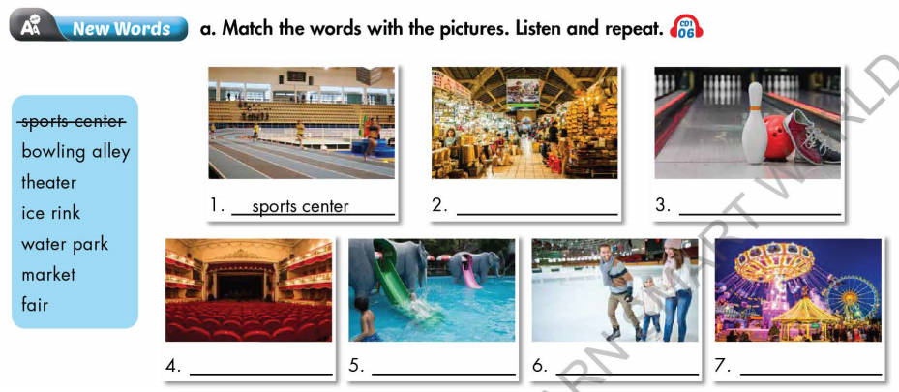  - Option 2: Fill in the blanks  - Have Ss work in pairs to fill in the blanks.  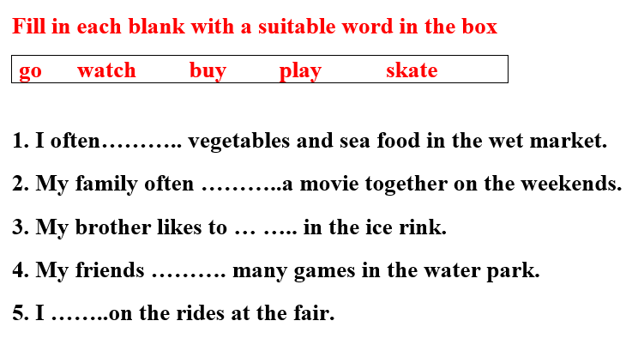  - Call Ss to give answers.  àLead to the new lesson. | - Greet T.  - Work in pairs.  - Give answers.  - Listen.  - Listen and repeat.  Answer keys  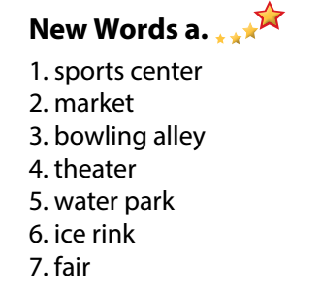  - Work in pairs.  - Give answers.  - Listen.  Answer keys  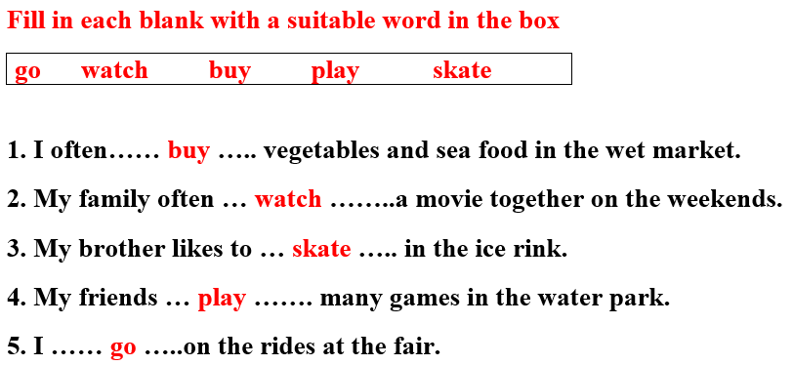

B. New lesson (35’)
- Activity 1: Pre-Listening (Vocabulary) (12’)
a) Objective: Ss get to know words about places of entertainment.
b) Content:
- Vocabulary study (sports center, bowling alley, theater, ice rink, water park, market, fair).
- Speaking: Say what activities you can do at each place using the verbs in the box (page 7).
c) Expected outcomes: Ss know how to pronounce the new words correctly and use them in appropriate situations.
d) Organization of the activity:
TEACHER’S ACTIVITIES | STUDENTS’ ACTIVITIES
Task a. Match the words with the pictures. Listen and repeat.  - Option 1 (If the teacher hasn’t used this part for the Warm-up activity.)  - Demonstrate the activity (using DCR), using the example  - Have Ss number the pictures.  - Divide class into pairs and have them check their answers with their partners.  - Call Ss to give answers (read or write).  - Check answers as a whole class.  - Play audio (CD1 – Track 06). Have Ss listen and repeat.  - Correct Ss’ pronunciation.  - Option 2: Matching (If the teacher has used part a. for the Warm-up activity.)  - Have Ss review the words they have known in the warm-up activity by filling in the blanks (T uses different pictures from those in the textbook).  - Call Ss to give answers (read or write).  - Check answers as a whole class.  - Call some Ss to read the words again.  - Correct Ss’ pronunciation if necessary.  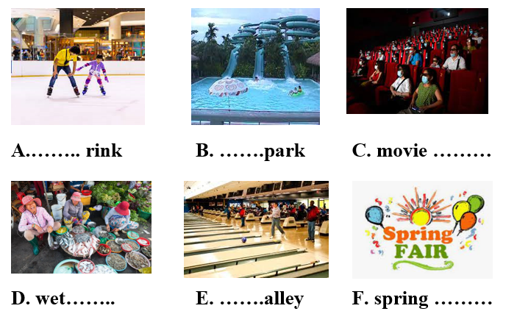  Task b. Say what activities you can do at each place using the verbs in the box.  - Use DCR to show the task.  - Have Ss work in pairs to talk about activities they can do at each place using the verbs in the box.  - Have some pairs share their ideas with the class.  - Give feedback and evaluation. | - Look and listen.  - Work individually.  - Work in pairs.  - Give answers.  - Listen and repeat.  Answer keys  - Work in pairs.  - Give answers.  - Read.  Answer keys  A. ice  B. water  C. theater  D. market  E. bowling  F. fair  - Work in pairs.  - Present.  Suggested ideas  - I watch movies in a movie theater.  - I play sports in the sports center.  - I play bowling in the bowling alley  - I skate in the ice rink.  …
- Activity 2: While - Listening (17’)
a) Objective: Students can develop their listening skill.
b) Content: Listening to 2 students having a phone call to make plans to meet each other (for general and specific details).
c) Expected outcomes: Students can listen and understand general and specific information about making plans for an informal meeting with friends.
d) Organization of the activity:
TEACHER’S ACTIVITIES | STUDENTS’ ACTIVITIES
Task a. Listen to Becky calling Toby to make plans to meet. Which place will they visit together?  - Use DCR to show the task.  - Have Ss read the question.  - Play audio (Track 1.07).  - Have Ss listen and answer the question.  - Check answer as a whole class.  Task b. Now, listen and circle  - Use DCR to show the task.  - Have Ss read the questions, underline key words and guess the answers.  - Play the audio again (Track 1.07).  - Have Ss listen and circle the correct answer.  - Have Ss check answers with their partners.  - Call Ss to give answers.  - Give feedback and show correct answers. | -Work individually.  - Circle the correct answers.  Answer keys  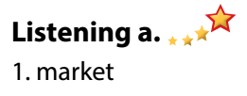  - Read and underline.  - Do the task.  - Check answers.  Answer keys  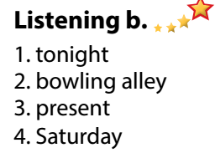

- Activity 3: Post - Listening (6’)
a) Objective: Students can use the vocabulary and the content in listening part to develop their speaking skill.
b) Content: Speaking: Where do you like to meet you friends? What do you do there?
c) Expected outcomes: Students can have a free-talk about things to do when hanging out with friends.
d) Organization of the activity:
TEACHER’S ACTIVITIES | STUDENTS’ ACTIVITIES
Conversation skill  - Use DCR to show the task.  - Have Ss look at the Conversation box and read.  - Play audio (Track 08), have Ss listen and repeat.  - Ask Ss to find more ways to start a friendly conversation.  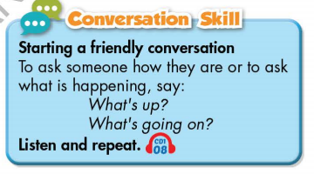  Task c. Where do you like to meet you friends? What do you do there?  - Have Ss work in pairs to discuss.  - Observe and give help if necessary.  - Call some pairs to share their ideas with the class.  - Give feedback and evaluation.  - For more practice, have Ss play vocabulary games with DHA. | - Look and read.  - Listen and repeat.  - Give answers.  - Work in pairs.  - Present.

C. Consolidation and homework assignments (4’)
* Consolidation:
- Words about places of entertainment: sports center, bowling alley, theater, ice rink, water park, market, fair.
- Language to start a friendly conversation: What’s up? / What’s going on? / Hi there! / Hey! …

* Homework
- Learn the new words by heart.
- Practice making a plan.
- Do the exercises in WB: New words and Listening (pages 4,5).
- Do the vocabulary exercise in Tiếng Anh 7 i-Learn Smart World Notebook (page 6).
- Play consolation games in Tiếng Anh 7 i-Learn Smart World DHA App on www.eduhome.com.vn
- Prepare: Lesson 1 – Grammar (page 8 – SB).

D. Reflection
a. What I liked most about this lesson today:
…………………………………………………………………………………………
- What I learned from this lesson today:
…………………………………………………………………………………………
c. What I should improve for this lesson next time:
…………………………………………………………………………………………

