Mã đề 6.1.18 | ĐỀ KIỂM TRA GIỮA HỌC KÌ I  NĂM HỌC 2022 - 2023  Môn: Tiếng Anh 6  Thời gian làm bài: 60 phút  Đề gồm có 03 trang
A. LISTENING
Part I. Listen and tick () the picture you hear . (1.0pt)
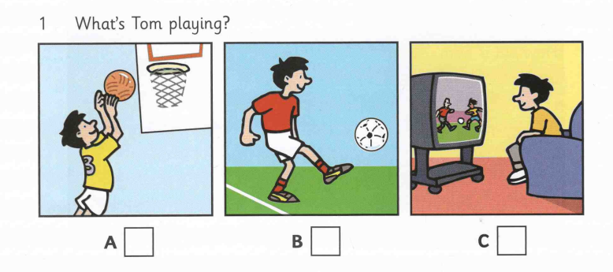  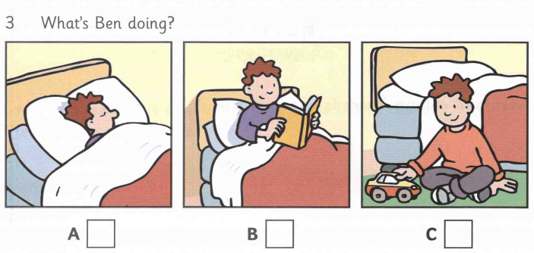  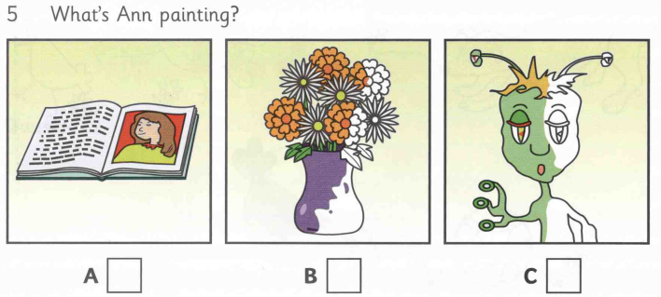 | 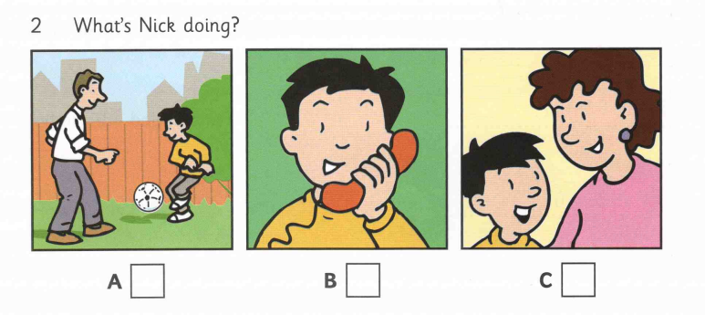  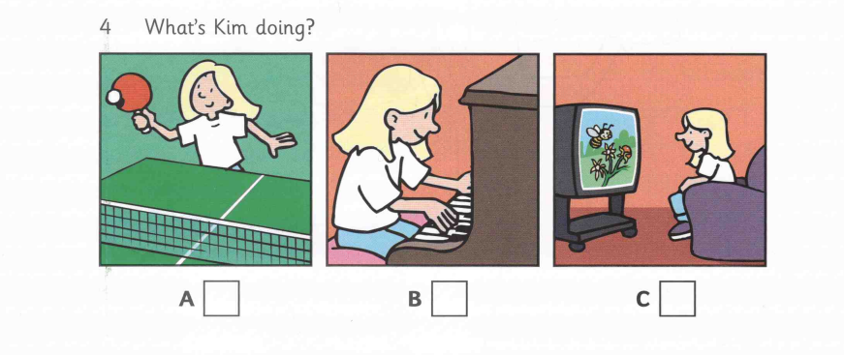
Part II. Listen write a name and a number. (1.0pt)
1. Which class is Sam in?  2. What’s the name of Sam’s teacher?  3. Who sits next to Sam in class?  4. How many books are in Sam’s bag?  5. How old is Sam’s sister? | ……………………..  Mr………………….  ……………………..  ……………………..  ……………………..

B. VOCABULARY – GRAMMAR – LANGUAGE FUNCTIONS (3pts)
Choose the correct answer.
1. I _____________ English lessons on Tuesday and Friday every week.
A. have | B. is having | C. has | D. had
2. Alex usually ____________ his work at 8 p.m.
A. finish | B. finishing | C. finished | D. finishes
3. Look! He ________ football now.
A. is playing | B. plays | C. played | D. was playing
4. Nam and Ba ________ ice cream at the moment.
A. eating | B. is eating | C. was eating | D. are eating
5. It’s very ________ of you to help me.
A. talkative | B. active | C. nice | D. confident
6. Andrea lives next my door so we …………….her.
A. never see | B. see never | C. often see | D. see often
7. Do you often _________ team games during the break?
A. play | B. do | C. have | D. make
8. We don’t usually _______ a picnic on Saturday.
A. do | B. have | C. study | D. play
9. My friend, Lan is a ________ student. She always finishes homework on time.
A. hard-working | B. confident | C. shy | D. reliable
10. The room my family often get together and watch TV is ___________.
A. hall | B. bathroom | C. toilet | D. living room
11. The wardrobe is _________ the fridge and the bed.
A. next | B. behind | C. between | D. front
12. _________ is the machine used to wash the dishes.
A. dishwasher | B. furniture | C. apartment | D. wardrobe
13. When you go to your friends at 7 p.m, you greet “.........!”
A. Good morning | B. Good noon | C. Good evening | D. Good night
14. “What does your father look like?” “He is .............”
A. tall | B. in his office | C. an engineer | D. going swimming
15. “...................?” “He is kind and friendly.”
A. Is Jack short | B. How is Jack | C. What is Jack like | D. What’s Jack
C. READING:
I. Choose the letter A, B, C or D to complete the passage below. (1.5 pts)
My dream house is a cottage not far from the sea. On the ground-floor, there (1) ………. four rooms. The first room is my (2) ……….. It has a white sofa, a black armchair and a coffee table. There are lots of paintings (3) ………. the wall. There is also a lamp, French windows with a view of the garden, television set and a phone in the living room. My dream house (4) ………. a fully-equipped kitchen, including a fridge and a door to the garden. There is a bathroom with a (5) ………. and toilet. There is also a study room with a desk and a computer. On the first floor, there are three bedrooms and a bathroom.
1. A. is | B. are | C. be | D. being
2. A. living room | B. bedroom | C. bathroom | D. kitchen
3. A. at | B. in | C. of | D. on
4. A. have | B. has | C. to have | D. having
5. A. table | B. dishwasher | C. shower | D. table
II. Choose the letter A, B, C or D to answer these following questions (1.5 pts)
I’m Max. My friend Helen is very beautiful. She is taller than me. She has blonde hair, chubby check and round blue eyes. She’s clever, patient and funny. She loves telling jokes. Her jokes are so funny that they make us laugh a lot. I love being with her because she helps me with a lot of things. On the weekend, she often goes to my house and does homework with me. But this weekend, we are going to the cinema to see a new film, Frozen. It would be fun.
1. Is the writer taller than Helen?
A. No, Helen is shorter than Max.
B. Yes, Helen is taller than Max.
C. Yes, Max is taller than Helen.
D. No, Max isn’t taller than Helen.
2. Which word is closest meaning to the word “clever”?
A. funny | B. smart | C. kind | D. beautiful
3. Which of the following statements is TRUE?
A. Helen doesn’t like telling jokes.
B. Helen and Max go to the zoo at the weekend.
C. Helen often does homework with Max.
D. Helen has black hair, chubby check and round blue eyes.
4. What is Helen like?
A. hard-working | B. confident | C. shy | D. humorous
5. What is the main idea of this passage?
A. Helen’s appearance | B. Max’s friend | C. Max’s appeance | D. Helen’s friend
C. WRITING:
I. Rewrite the following sentences, beginning as shown, so that the meanings stays the same. (1.0pt)
1. The house is in front of the garden.
=> The garden ………………………………………………………
2. There are 25 classrooms in my school.
=> My school has …………………………………………………..
3. Her mother’s hair is long.
=> Her mother has ………………………………………………….
4. Let’s go out for dinner.
=> How about ………………………………………………………
5. What’ s your new friend’s appearance?
=> What does …………………………………………………….....
II. Write a short paragraph (about 40-50 words) describing a new school year in Vietnam, using the cues below (1.0 pt)
A new school year/ Vietnam/ begin/ September. At school / students / often/ wear/ school uniform. schoolgirl/ often wear/ white dress/ boy/ wear/ white shirt/ red kerchief. secondary school day/ usually/ last/ 7:00 a.m / to / 11:00 p.m. Students / study / many / interesting subject / in / school year. At break times / students /play / the playground / read books / in / library.

-------- The end --------

