|  |  |
| --- | --- |
| **Mã đề 9.1.51** | **ĐỀ KIỂM TRA CUỐI HỌC KÌ I**  **MÔN: TIẾNG ANH 9 – HỆ 10 NĂM**  Thời gian làm bài: 45 phút  *(Đề bài gồm có 04 trang)* |

**A. LISTENING (2.0 POINTS)**

**I. Listen to the five short conversations and choose the correct answer for each question (1.0 point)**

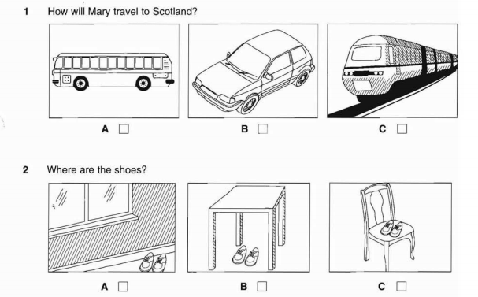

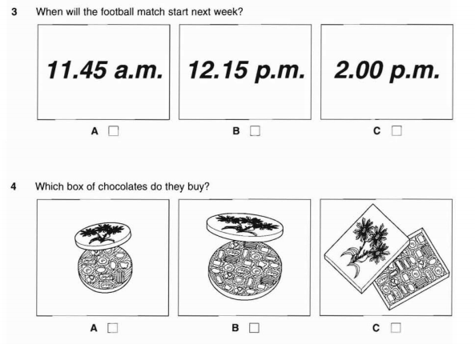

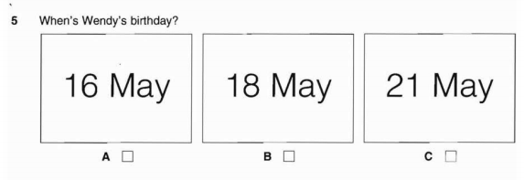

**II. Listen to the man giving information about a city bus tour. Write the answer in the gap. (1.0 point)**

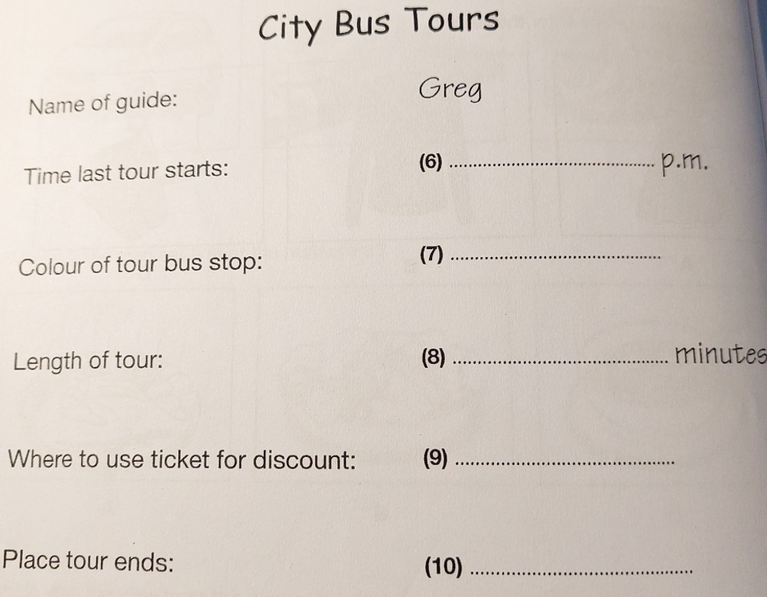

**B. VOCABULARY, GRAMMAR AND LANGUAGE FUNCTION (2.0 POINTS).**

11. Choose a word in each line that has a different stress pattern.

A. drawback B. ancient C. feature D. conduct

12. I ………………… a long hair, but I have short one now.

A. use to have B. used to have

C. used to having D. was used to have

13. My roommate suggested that we ……………. more vegetables and fruit.

A. should eat B. eating C. ate D. eaten

14. He asked her to marry him but she turned him .

A. up B. down C. out D. on

15. When did your grandparents set ………………. this workshop?

A. up B. off C. out D. in

16. This laptop is much more user-friendly, but it costs the …….. other one.

A. so much as B. twice as much as C. as many as D. twice as many

17. Jane said that she …………. come to my house the following day.

A. can B. will C. would D. was

18. ………………. she was tired, she finished the homework before going to bed.

A. Because B. So C. But D. Although

19. After I found all the information I needed, I ………………. the computer.

A. looked for B. switched on C. turned off D. put off

20. **Catherine**: “What a beautiful dress!” **Hoa**: “________”

A. Thanks for your compliment. B. Congratulations!

C. Thanks for your help. D. That’s a good idea.

**C. READING (2.0 POINTS)**

**I. Read the passage. Choose the option A, B or C that best fits each gap. (1.0 point)**

My mother came from Baffin Island. She used (21)______ in an igloo: a domed house built from blocks of ice. The house had only one room for all the generations: grandparents, parents, brothers, unmarried sisters, and sometimes other relatives. Everyone (22) ……….together to survive the Arctic winter. Men went out hunting (23)______ women stayed at home making clothes and preparing food. When they had to travel far, they (24)______ on dogsleds. At night they used to entertain themselves by telling and (25)______ out stories. They danced to drum music, too. (*Akycha from Canada)*

21. A. live B. to live C. to living

22. A. swam B. sang C. worked

23. A. while B. during C. before

24. A. walked B. rode C. drove

25. A. going B. knocking C. acting

**II. Read and choose the best answer for each question below. (1.0 point)**

New York has Central Park; London has Hyde Park while Kuala Lumpur has its own piece of green belt amidst the **hustle and bustle** of city life. It's an ideal place for a leisurely stroll in a tranquil setting, all without having to leave the city. The Lake Gardens was created by Sir Alfred Venning, who persuaded the ruling government to allow him to turn a swamp land into rambling trails with **man-made** lakes, spanning 60 hectares. However, as the city expanded, the Lake Gardens reduced in size. However, it is still a sizeable area and boasts of more than just grass and water within its grounds.For example, the gardens incorporate the National Monument, Bird Park, Hibiscus Garden as well as Malaysia's Parliament House.Additionally, Carcosa Seri Negara is on a hilltop overlooking the Lake Gardens. Today, the nineteenth-century British colonial mansion has been **converted** into an exclusive hotel.

26. In the Lake Gardens, you can visit the following spaces except _____.

A. The Bird Park B. Hyde Park

C. the National Monument D. the Hibiscus Garden

27. Over time, the Lake Gardens has become smaller because _____.

A. it is swampy B. it is getting overpopulated

C. of development D. of the heat and noise

28. The Carcosa Seri Negara is now a _____.

A. hotel B. mansion

C. park D. museum

29. The word **hustle and bustle** can best be replaced with _____.

A. busy B. easy

C. dirty D. noisy

30. The synonym of the word **man-made** is _____.

A. natural B. original C. artificial D. available

**D. WRITING (2.0 POINTS):**

**I. Complete the second sentence so that it has similar meaning to the first sentence (1.0 p)**

31. (I can’t speak English fluently.)

🡪 I wish _...........

32. “I must go to London tomorrow.”, Tony said.

## 🡪Tony said he ……….

|  |
| --- |
| 33. Local people can earn their livings by providing tourists with necessary services. (LIVE)  →Local people …………..  34. After leaving college, he started his own business with a bank loan. (SET)  →After ………  35. She promised to meet me at the cinema this evening, but she didn’t arrive. (TURN)  → She promised to meet ……. |

**II. Write an email**

Your friend is going to finish his junior secondary school. His mother told you via the phone that he is now experiencing a stress. Write an email to him to give him some advice on how to deal with the stress. You should write 100-120 words. You should start with the following opening:

Dear Harry,

You are going to finish your junior secondary school, so you must be working very hard. I know you may feel very stressed as I do now. However, I think there are several ways we may do to deal with this.

…………………………………………………………………………………………………

…………………………………………………………………………………………………

…………………………………………………………………………………………………

Love,

Hoa

***Guide****: learn to relaxe a calm mind makes us stable/ take pride in work / should not stay up too late. stay calm and believe in yourself/ . Hope you spare some time to relax/*

***Remember*** *to organize your idea by using: First/ Second/ Third/ Finally…*

**-----------The end -------------**

|  |  |
| --- | --- |
|  | **HƯỚNG DẪN CHẤM ĐỀ KIỂM TRA CUỐI HỌC KÌ I**  **MÔN: TIẾNG ANH 9 – HỆ 10 NĂM**  Thời gian làm bài: 45 phút  *(Hướng dẫn chấm gồm có 01 trang)* |

**A. LISTENING (2.0 PONTS)**

**I. 1.0 point (0.2 point/ each correct answer)**

1B 2A 3C 4B 5B

**II. 1.0 point (0.2 point/ each correct answer)**

6. 4.20 7. blue 3. 90/ ninety 4. museum 5. theatre/ theater

**B. VOCABULARY, GRAMMAR AND LANGUAGE FUNCTION (2.0 POINTS).**

11.D 12.B 13.A 14.B 15.A 16.B 17.C 18.D 19C 20. A

**C. READING (2.0 POINTS)**

**I. 1.0 point (0.2 point/ 1 correct answer)**

21B 22C 23A 24B 25C

# II. 1.0 point (0.2 point/ 1 correct answer)

26B 27C 28A 29A 30B

**D. WRITING (2.0 POINTS)**

**I. 1.0 point (0.2point/ 1 correct answer)**

31. I wish I could speak English fluently.

32. Tony said (that) he had to go to London the next day/ the following day.

|  |
| --- |
| 33. Local people can live on by providing tourists with necessary services. |

34. After leaving college, he set up his own business with a bank loan.

35. She promised to meet me at the cinema this evening, but she didn’t turn up.

*(Nếu sai đông từ của câu/ vếcâu: trừ toàn bộ điểm của câu/ vế đó. Nếu sai mạo từ/ giới từ/ chính tả…: trừ 0.1 điểm/ 2 lỗi)*

**II. Write a passage about drawbacks of living in the city.(1.0 point)**

**\* Task fulfillment: (0.5 point)**

- complete the passage with all relevant information

- well-organized.

**\*Language: (0.5 point)**

- accurate grammar

- appropriate vocabulary

**Note:** Sai chính tả/ mạo từ/ giới từ…: trừ 0.1 đ/2 lỗi. Sai động từ: trừ 0.1 đ/1lỗi

**Suggested writing**

*Dear Harry,*

*You are going to finish your junior secondary school, so you must be working very hard. I know you may feel very stressed as I do now. However, I think there are several ways we may do to deal with this.*

**First,** you should learn to relax because a calm mind makes us stable. **Second,** we should take pride in any work we can do with our best even though we may not come best. **Moreover,** because we have to work harder, we may lack of sleep. So you can stop your work for a day to have a sound sleep, or at least we should not stay up too late. Most importantly, sometimes we may need to bear in mind that failure is not the end of the world. **Finally,** if you stay calm and believe in yourself, you will get rid of all that unwanted feelings. **Hope you spare some time to relax and write to me soon.**Love,

Thu **-----------The end --------------**