|  |
| --- |
| **TA7 i-Learn Smart World_Ss_Unit 1 Time allotted: 60** |

**PART 1**  **PRONUNCIATION (5 questions)**

**Choose the word that has the underlined part pronounced differently from the others.**

1. A. f**a**rm B. l**a**rge C. dw**a**rf D. M**a**rch

2. A. f**a**lse B. c**a**lm C. w**a**rm D. p**a**lm

3. A. st**a**rt B. **a**rgue C. p**a**rty D. sug**a**r

4. A. c**a**rpet B. pil**a**r C. al**a**rm D. f**a**rmer

5. A. g**a**rden B. f**a**ther C. rew**a**rd D. qu**a**rter

**PART 2**  **VOCABULARY (10 questions)**

**Match the phrases with the sentences. (5 questions)**

6. Anna often looks at funny storybooks with words and pictures. a. builds models

7. Mike usually creates video blogs and shares them online. b. reads comics

8. Andy sometimes finds sticky labels related to football as an interest. c. makes vlogs

9. Kate likes to make tiny objects that look like the real ones. d. bakes cakes

10. Jane sometimes cooks mixtures of flour, eggs, and sugar in an oven. e. collects soccer stickers

**Complete the dialogue using the verbs in the boxes. (5 questions)**



**Tom**: What do you do in your free time, Anna?   
**Anna**: I often (11) read comics and (12) bake cupcakes. How about you?   
**Tom**: I am interested in models, so I usually (13) build some to relax. Look! This is one of mine.   
**Anna**: How amazing! Do you ever (14) collect soccer stickers?   
**Tom**: Yes, of course. And I sometimes (15) make vlogs about it. Well, this makes me busy.   
**Anna**: Wow! That is great.

**PART 3**  **GRAMMAR (10 questions)**

**Look at the map. Choose the correct options. (5 questions)**

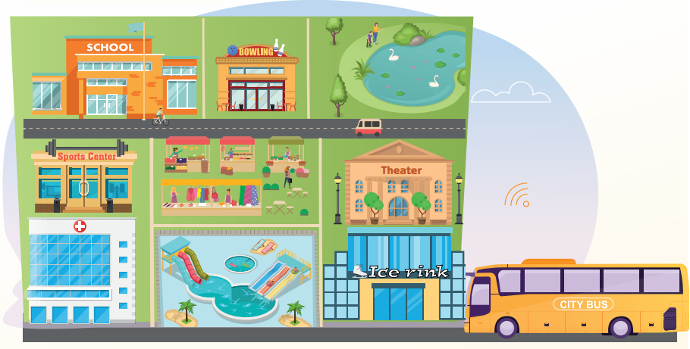

16. The theater is ______________ the ice rink.

A. behind B. in front of C. between D. next to

17. The hospital is ______________ the sports center.

A. behind B. in front of C. next to D. between

18. The bowling alley is ______________ the lake and the school.

A. behind B. next to C. between D. in front of

19. The fair is ______________ the bowling alley.

A. behind B. in front of C. next to D. opposite

20. The water park is ______________ the ice rink.

A. in front of B. behind C. opposite D. next to

**Complete the text using the correct forms of the verbs in the Present Continuous. (5 questions)**

Today is my father's birthday. This time, we (21) are not/aren’t holding **(not/hold)** a party for him at our house as usual. We (22) are celebrating **(celebrate)** his birthday at a restaurant. Tomorrow morning, my family (23) is traveling **(travel)** to the beach for scuba diving. My father is a huge fan of scuba diving. My mom and dad (24) are staying **(stay)** at a hotel near the beach for the whole weekend. I (25) am leaving **(leave)** early because I have an important test at school next Monday.

**PART 4**  **READING (10 questions)**

**Read the email from Jack to Mark. Answer each question with NO MORE THAN THREE WORDS AND/OR A NUMBER. (5 questions)**

|  |
| --- |
| To: mark06@abcmail.com  Subject: Rock climbing next Sunday?  Hey Mark,  Are you doing anything next Sunday?  My friends and I are going rock climbing at the Dawn Sports Center. I believe you love this sport, too.  So, you should join us.  The center has everything we need for the sport. The entrance fee is about $15 each. I'm taking a bus to the water park opposite the sports center. We want to meet you there at 7 a.m. Bookings are available this week only. Let me know if you can come by Tuesday. I hope you can come.  Write back soon,  Jack |

26. When are they going rock climbing?   
→ next Sunday   
27. How much is an entrance ticket?   
→ $ 15/15 dollars/$15   
28. Where do they want to meet Mark?   
→ the water park   
29. What time should Mark arrive?   
→ 7 a.m   
30. When does Mark need to reply?   
→ by Tuesday

**Read Mark’s response to Jack’s email. Choose True, False or NI (no information). (5 questions)**

|  |
| --- |
| To: jackbrown@abcmail.com  Subject Re: Rock climbing next Sunday?  Hi Jack,  Thank you for your email. I am very excited about that. I can go with you next Sunday.  The good news is that we can now buy one ticket and get another one for free. It's great, isn't it? We need to hurry because the promotion ends tomorrow. The center does not provide helmets, so we need to bring our own ones. It can be hot on the day we go rock climbing. Remember to bring enough water and a change of clothes just in case. Mom is going to drive me to the meeting place. I can't wait to see you there.  Cheers,  Mark |

| **Answers** | **True** | **False** | **Not given** |
| --- | --- | --- | --- |
| 31. Mark can’t join Jack and his friends for rock climbing. | **◯** | **◯** | **◯** |
| 32. The promotion ends the day after tomorrow. | **◯** | **◯** | **◯** |
| 33. When someone gets a ticket, the center gives them a helmet. | **◯** | **◯** | **◯** |
| 34. The weather can be hot when they meet for the sport. | **◯** | **◯** | **◯** |
| 35. Mark is going to the meeting place by himself. | **◯** | **◯** | **◯** |

**PART 5**  **LISTENING (10 questions)**

**Listen to five conversations. Match them with the places where they are. (5 questions)**

36. Conversation 1 a. bowling alley

37. Conversation 2 b. theater

38. Conversation 3 c. market

39. Conversation 4 d. sports center

40. Conversation 5 e. water park

**Listen to the conversations again. Choose True or False. (5 questions)**

| **Answers** | **True** | **False** |
| --- | --- | --- |
| 41. Conversation 1: The two friends do not bring their tickets. | **◯** | **◯** |
| 42. Conversation 2: The two friends are going to try the water slides. | **◯** | **◯** |
| 43. Conversation 3: The boy does not play the game well the first time. | **◯** | **◯** |
| 44. Conversation 4: The man wants to buy two kilos of sugar. | **◯** | **◯** |
| 45. Conversation 5: Ryan is an excellent soccer player. | **◯** | **◯** |

**PART 6**  **SPEAKING (5 questions)**

**Match to complete the conversation. (5 questions)**

|  |  |
| --- | --- |
| 46. David: What do you like doing in your free time, Katie? | a. Katie: I love talking about my everyday life through videos. |
| 47. David: Why do you like it? | b. Katie: I also enjoy collecting stickers of my Korean idols. |
| 48. David: How often do you make vlogs? | c. Katie: Well, I don’t think so. It’s nice to have pictures of your idols. |
| 49. David: What else do you like doing? | d. Katie: Well, quite a lot, but I’m really into making vlogs. |
| 50. David: Really? To me, it’s a waste of money. | e. Katie: Twice a week. |

46D 47A 48E 49B 50C

**PART 7**  **WRITING (5 questions)**

**Read Andy’s email. Complete each gap with a phrase or sentence from the box. (5 questions)**

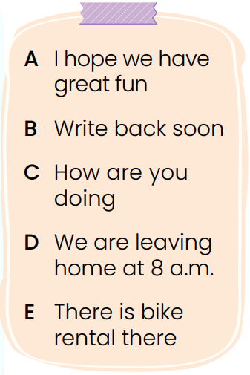

To: mike@abcmail.com   
Subject: Going mountain biking next weekend?   
--------------------   
Hi Mike,   
Are you doing anything next weekend?   
 (51) C/How are you doing? My brother and I are biking in the mountains, and I think you might want to join us. (52) D/We are leaving home at 8 a.m and taking a bus to Green Valley Mountain.   
We can meet at our house and go together. (53) E/There is bike rental there, and we can rent bikes and other equipment. It costs about $20 per person. The cost may be high, but (54) A/I hope we have great fun. Let me know if you can go.   
 (55) B/Write back soon,   
Andy

**---THE END---**