Period
LESSON PLAN
TIẾNG ANH 10 FRIENDS GLOBAL
UNIT 1: FEELINGS
LESSON 1C: PROBLEMS, PROBLEMS!
I. OBJECTIVES:
By the end of the lesson, Ss will be able to:
1. Knowledge:
- Vocabulary: panic, calm, honest, silly, advice, excuse, ask somebody out (phrasal verb), have a word with somebody (idiom)
- Grammar: use ‘should’ in giving advice
- listen for gist
2. Ability:
- main skills: listening and speaking skills
- sub skills: reading and writing skills
- give advice to solve problems
3. Quality:
- have positive attitude in English language learning so that they can participate enthusiastically in all classroom activities, especially with the topic conducted by the teacher
- know how to listen for gist and give advice to friends
II. TEACHER AIDS AND LEARNING MATERIALS:
Lesson plan, PPT slides, student’s book, workbook, notebook, personal computer (if any), projector/TV, speakers, IWB software.
III. PROCEDURES:
A. Warm-up (5’)
a) Objective: Introduce the new lesson and set the scene for Ss to acquire new language; get students' attention at the beginning of the class by means of enjoyable and short activities as well as to engage them in the steps that followed.
b) Content: Game ‘Hot-air’ Balloon ‘How did you feel when…?’
c) Outcomes: Students can gain more confidence and interest in the lesson.
d) Competence: communication, collaboration, critical thinking
e) Organisation of the activity:
TEACHER’S ACTIVITIES | STUDENT’S ACTIVITIES | CONTENTS
WARM-UP. T-Ss/ S-S/ Indiv  Game ‘Hot-air’ balloon  - Divide class into groups to play this game. Students choose the correct air balloon. If the student gets it wrong, the incorrect one will disappear, and ‘next’ button won’t appear. Click on the balloon to check answer.  - Ask students to read a complete sentence. Give bonus to the group gets the most correct answers.  - Lead in the topic today: ‘Listening: Problems, problems’. | - Play the game in groups.  - Choose the correct balloon to get bonus. Read the sentence aloud.  - With the most correct answers, that group can get bonus points. | 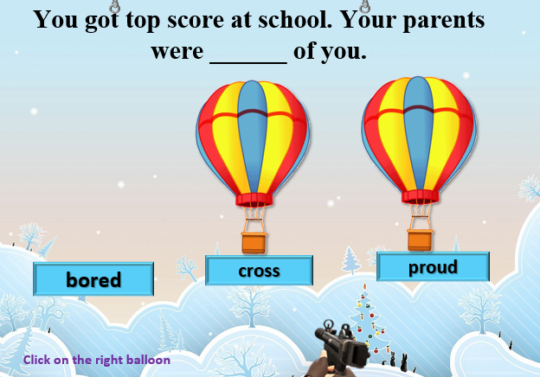  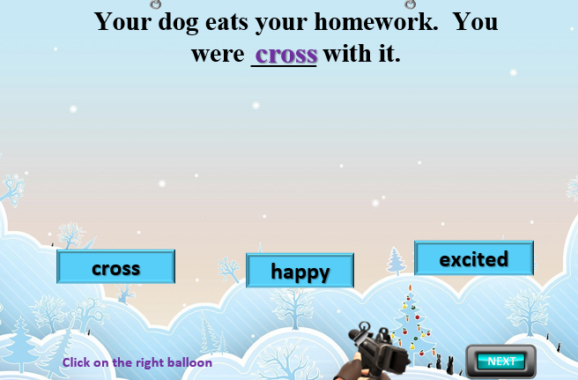  

B. New lesson (35’)
- Activity 1: Presentation (9’)
a) Objective: Students know some new words and phrases
b) Content:
Vocabulary study
Speaking
c) Outcomes: Students know how to pronounce words correctly and use them in appropriate contexts.
d) Competence: communication, presentation
e) Organisation of the activity:

TEACHER’S ACTIVITIES | STUDENT’S ACTIVITIES | CONTENTS
PRESENTATION. T-Ss/ S-S/ Indiv.  Teach new vocabulary: (7’)  - Use pictures and explanations to present new words and phrases.  - Ask students to practice their pronunciation drills.  New words:  Panic (a/v/n)  Calm (a/v/n)  Honest (a)  Silly (a)  Advice (n)  Excuse (n)  Ask somebody out (phrasal verb)  Have a word with somebody (idiom)  - Introduce ‘listening strategy’ to students. Highlight main points. (2’) | - Look, listen and repeat in chorus and individuals.  - Take note.  - Listen to the teacher and highlight main ideas. | 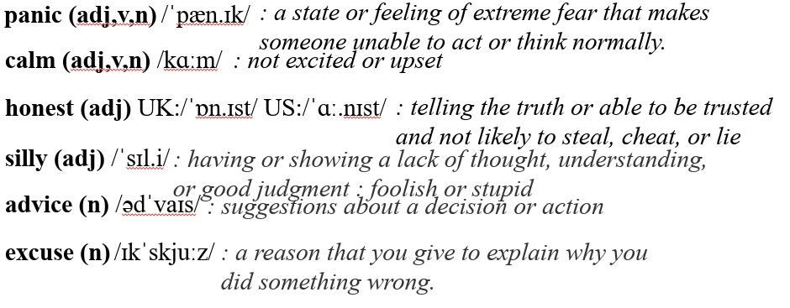  New words:  Ask somebody out: to invite someone to come with you to a place such as the cinema or a restaurant, especially as a way of starting a romantic relationship  Have a word with somebody: to talk to someone quickly, especially because you need their advice about something, or you want to tell them to do something  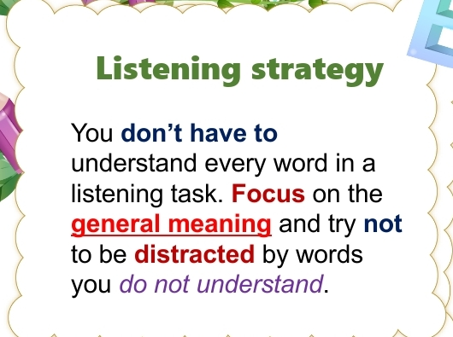
- Activity 2 Practice (20’)
a) Objective: Students can answer the questions to critical thinking, and they can finish the tasks in the textbook. Critical thing skills (guessing/ reasoning) and communication can also be practiced.
b) Content: Students read and choose the correct answer, practice speaking. Then, listen and match.
Listening
Speaking
c) Outcomes: Students read and listen, and they can apply the useful language in everyday conversations.
d) Competence: communication, collaboration, presentation
e) Organisation of the activity:
TEACHER’S ACTIVITIES | STUDENT’S ACTIVITIES | CONTENTS
PRACTICE. T-Ss/ S-S/ Indiv.  Activity 1 (6’): Task 2 page 13. Read the three summaries of a dialogue below. Then listen to the dialogue. Choose the best summary.  - Ask students to read three statements to make sure they understand all three.  - Play the audio.  - Check the answer.  - Present ‘Learn this! Should’ box to students. Show students how to use the structures ‘I think/ I don’t think …+ should…’ to give advice. Give examples to clarify.  - Notice that for the negative, use ‘I don’t think…+ should’ NOT ‘I think + shouldn’t).  Activity 2 (4’): Work in pairs. Apply the structures I (don’t) think and the phrases to say what Zak should do.  - Ask students to work in pairs. Take turns saying what Zak should do with cues.  - Call out some pairs to present their talks.  Activity 3 (5’): Listen to four dialogues and match A-D with the sentences.  - Play the audio and pause after each dialogue.  - Check the answers.  Activity 4 (5’): Listen again and complete the collocations (1-6) with the verbs below.  - Play the audio for students to complete the task.  - Check the answers. | - Read three statements.  - Listen to the dialogue carefully.  - Check the answers with the teacher  - Listen to the teacher  - Take note.  - Highlight to use the expressions precisely.  - Work in pairs and take turns using the structures.  - Volunteer to present.  - Listen and match.  - Check the answers with the teacher.  - Listen and complete the collocations.  - Check the answers with the teacher. | Answer:  b. Zak is anxious about his exams and decides not to go out with Tom.  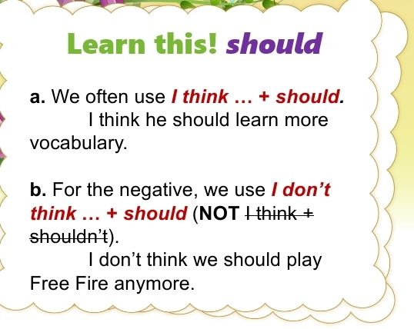  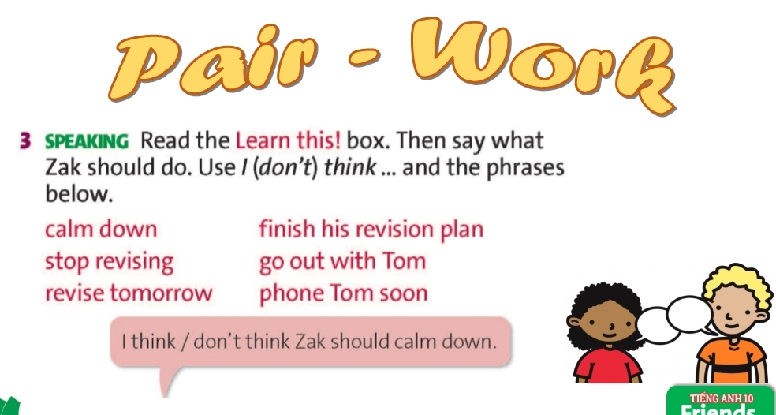  Answers:  - C  - A  - B  - D  Answers:  2. give  3. tell  4. have  5. make  6. tell

- Activity 3: Outcomes (6’)
a) Objective: Ss can ask and answer about problems, give advice, reject or accept the advice. Communication is also be practiced.
b) Content: ‘Lucky Number’ Game
c) Outcomes: Ss speak and listen mutually, they can apply the structures they have learnt in their daily conversations.
d) Competence: Collaboration, communication, guessing
e) Organisation of the activity:
TEACHER’S ACTIVITIES | STUDENT’S ACTIVITIES | CONTENTS
PRODUCT. T-Ss/ S-S  Game ‘Lucky Number’  - Ask students to work in pairs and pick a number from 1 to 6 to plan a dialogue with suggestion in each number.  - Let students discuss with their partners before calling out some pairs to present their ideas. Check students’ pronunciation. After students finish talking, use the wheel to give them points. | - Work in pairs and pick a number to plan a dialogue. Try to use the new expressions properly.  - Volunteer to present their ideas. | 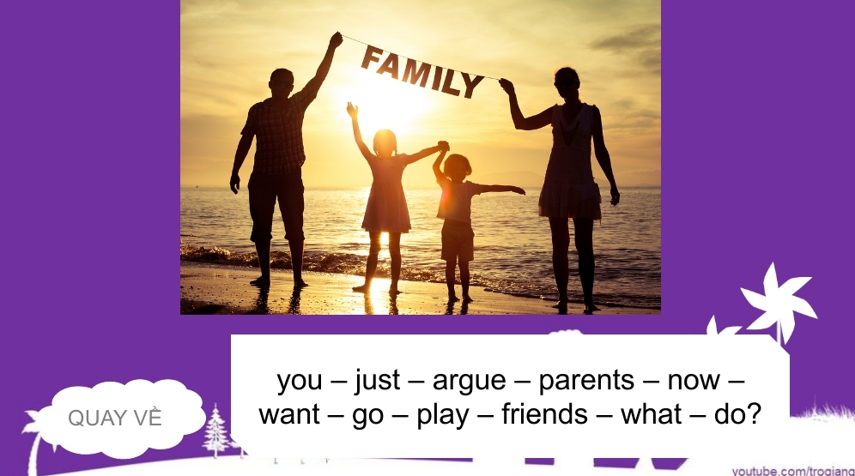  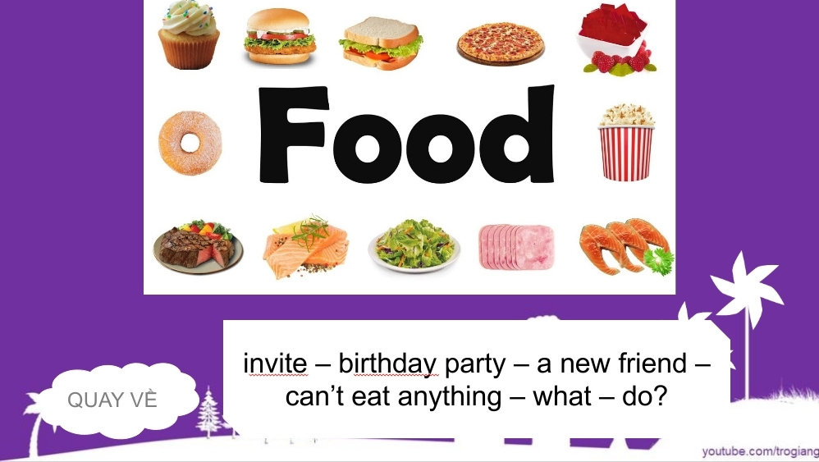
C. Consolidation (3’)
a) Vocabulary: panic, calm, honest, silly, advice, excuse, ask sb out, have a word with sb.
b) Grammar: I think/ I don’t think…+ should…
D. Homework (2’)
- Learn by heart new words
- Review some expressions to give advice
- Do exercise
- Prepare: Unit 1 – D-Grammar (page 14 – SB)

