|  |  |  |
| --- | --- | --- |
| Phòng GD&ĐT TP Hà Tiên  Trường Tiểu học Thuận Yên  Lớp:..................................................................  Họ và tên:……………………………………. | | Bài kiểm tra cuối học kỳ II  Năm học: 2021 – 2022  Môn: Tiếng Anh  Khối: 4- Thời gian: 40 phút  Ngày kiểm tra:…………………… |
| Điểm | Nhận xét của giáo viên | Chữ ký giám thị:……………………  Chữ ký giám khảo: ………….…….. |

**SPEAKING: ..............**

**LISTENING:**

**Part 1: Questions 1 – 4: Listen and circle *(Nghe và khoanh tròn* *)*.**

**Example: *You hear: “I want to see monkeys”****.*

The answer is:

**0. a/ 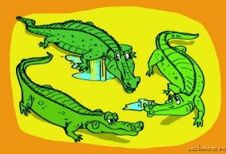 b/**  **c/** 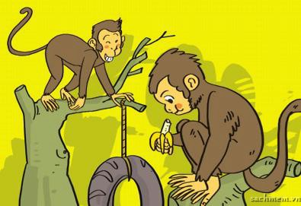

1. a/ 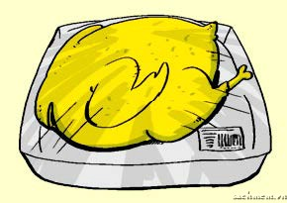 b/ 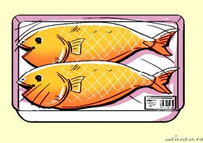 c/ 

2. a/ 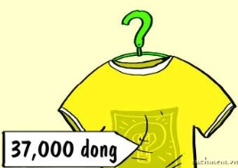 b/ 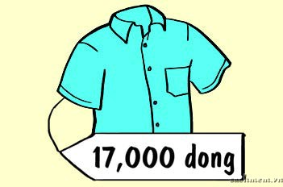 c/ 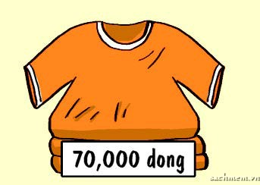

3. a/ 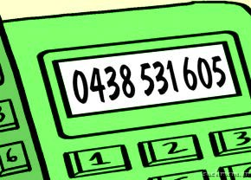 b/  c/ 

4. a/ 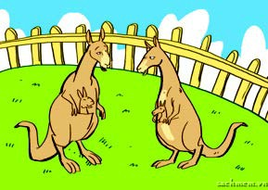 b/ 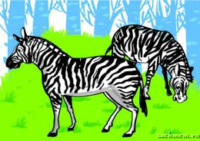 c/ 

**Part 2: Listen and number. *(Nghe và đánh số)***

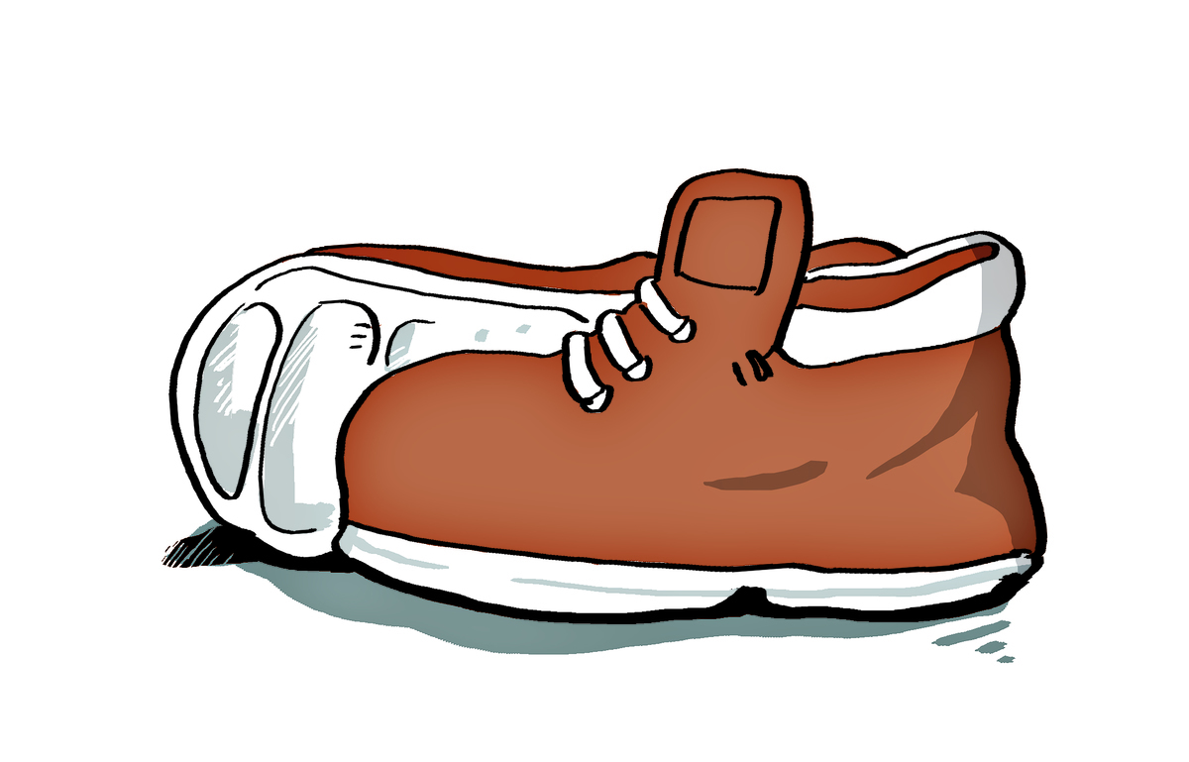

**a/**  **b/ c/ d/**

**READING**

**Part 1: Read and Match:** ***(Đọc và nối cột I với cột II)***

|  |  |  |
| --- | --- | --- |
| **I** | **II** |  |
| 1. How are you? 2. What’s your phone number? 3. Why do you want to go to the bakery? 4. What animal do you want to see? 5. How much are the jeans? | 1. I want to see elephants. 2. Because I want to buy some bread. 3. It’s 0916 714 678 4. They’re 175000 dong. 5. I’m fine, thanks. | 0 - E  1 - …  2 - …  3 - …  4 - … |

**Part 2: Read and tick: *(✓) (True or False)***

It is Sunday today. Phong and Mai go to many places. First, they go to the bookshop because Mai wants to buy some books and pens. Then they go to the pharmacy because Phong wants to buy some medicine. After that, they go to the zoo because they want to see the animals. Finally, they go to the bakery. They want to buy something to eat because they are hungry.

|  |  |  |
| --- | --- | --- |
| ***Sentences:*** | ***True ( T )*** | ***False ( F )*** |
| ***0) It is Sunday today.*** | **✓** |  |
| 1) First, they go to the bookshop |  |  |
| 2) Phong wants to buy some books and pens. |  |  |
| 3) Phong and Mai go to the bakery. |  |  |
| 4) They want to buy something to drink because they are thirsty. |  |  |

**WRITING**

Part 1: ***Write*** (Viết)

1. ***What do you like doing? I like reading.***
2. What’s your phone number? _____________________________________________________
3. How much is the scarf?

_____________________________________________________

Part 2: ***Arrange the following words to make meaningful sentences***: (Sắp xếp những từ sau thành câu có nghĩa)

1. **like/ Do /fish/ you? 🡪 Do you like fish?**
2. Where/ this/ you/ going/ summer?/are/

.....................................................................

1. monkeys./want/ see/ to/ I/

.....................................................................

1. animal/What/ she/ see?/ to/ want/does/

.....................................................................

1. you/what/ do/at/do/Tet?

.....................................................................

**_The end_**