WEEK 1
Class | Date of teaching
4A | September 9th, 2025
4B | September 10th, 2025
PERIOD 1
INTRODUCTION ENGLISH 4
A. OBJECTIVES
By the end of the lesson, Ss will be able to:
1. Knowledge:
- Use the allocation in their study (at school + at home) and basic classroom language.
2. Skills: Speaking and listening
3. Attributes:
- Actively participate in activities with their classmates in pairs, groups or class. Educate Ss to become studious and obedient students, love learning English.
- Honesty, patience and friendliness.
4. Digital Competence (1.1CB2a): Identify the need for using e-books (digital textbooks) to access audio, interactive activities, and search for lesson content.
B. INSTRUCTIONAL RESOURCES
- Teacher: Posters, laptop, pictures, textbook, lesson plan, TV or projector.
- Students: Textbooks, notebooks, workbooks, school things.
C. LEARNING PLAN:
Teacher’s activities | Students’ activities
1. Warm- up (5’)  * Goals: To create a friendly and active atmosphere in the class to beginning the lesson.  * Procedure:  - Greet the class.  - Encourage Ss to say their names  - Sing a song  2. Presentation (10’)  Activity 1.  *Goals: Ss will be able to know about the English 3 progamme and textbook.  * Procedure:  - Introduce about subject “English 4” has 3 books. (two student books and one exercise book)  - Introduce the student’s book and workbook.  - Digital Competence Integration (1.1CB2a): Ask Ss: "When you study at home, if you forget how to pronounce a word or want to hear the song again, what do you need?"  - Say the main contents: There are 20 Units, each Unit has 3 lessons  Lesson 1:  - Look, listen and repeat  - Listen, point and say  - Let’s talk  - Listen and circle/ tick/ number  - Look, complete/ match and read  - Let’s sing / play  Lesson 2:  - Look, listen and repeat  - Listen, point and say  - Let’s talk  - Listen and number/ tick  - Read (match) and complete/ match/ tick/ circle/ write.  - Let’s sing/ play  Lesson 3:  - Listen and repeat  - Listen and circle/ tick  - Let’s chant  - Read and match/ circle/ compete/ write the answer.  - Let’s write  - Project  After 5 Units has a Review  - The disabled: Get how to use the Englishbook.  3. Practice (10’)  Activity 2.  * Goals: Ss will be able to review and do action about classroom languages.  * Procedure:  - Say and model some classroom languages  + Open/ close your books, please!  + Stand up/ Sit down, please!  + Be quiet/ Don’t talk, please!  + Pick up your pen  + Put your pen down  + Raise your hands  + Go to the board  + Look  + Complete  + Let’s play  + Ask/ answer the question  + Work in pairs/groups  + ….  4. Production (8’)  Activity 3  * Goals: Ss will be able to sing and dance a song.  * Procedure:  - Sing and model the “Hello” song:  Hello!  Hello, hello, hello, how are you?  Hello, hello, hello, how are you?  I’m good.  I’m great!  I’m wonderful!  I’m good.  I’m great!  I’m wonderful!  Hello, hello, hello, how are you?  Hello, hello, hello, how are you?  I’m tired.  I’m hungry.  I’m not so good.  I’m tired.  I’m hungry.  I’m not so good.  Hello, hello, hello, how are you?  Hello, hello, hello, how are you?  Hello, hello, hello, how are you?  Hello, hello, hello, how are you?  5. Homework (2’)  - Practice more at home.  - Prepare for “Starter” | - Greet and introduce  - Ss greet and say their names  - Listen, sing and dance the song in chorus  - Listen to the teacher  - Listen to the teacher  - Listen to the teacher  - Look and do action  - Listen to the song through the tape.  - Listen and repeat sentence by sentence link the action.  - Sing all the text link the action in the chorus.  - Work in groups (two groups) to sing  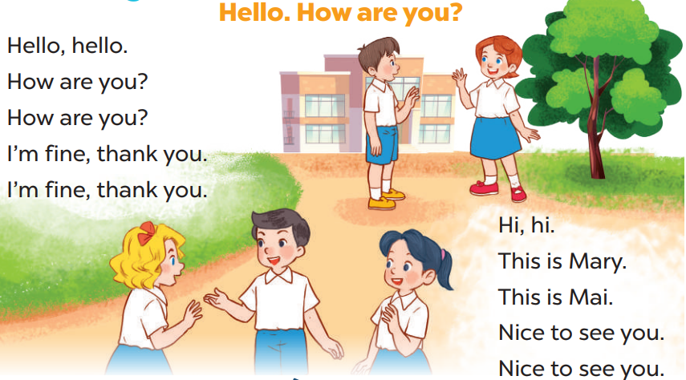  - Listen to the teacher.

D. Recommendation
………………………………………………………………………………………….…..……………………………………………………………………………...………………………………………….…..………………………………………………
WEEK 1
Class | Date of teaching
4A | September 9th, 2025
4B | September 10th, 2025
PERIOD 2
STARTER
A. HELLO AGAIN
A. OBJECTIVES:
By the end of the lesson, pupils will be able to:
1. Knowledges:
- Sing the song “Hello. How are you?” with the correct pronunciation, rhythm and melody.
- Listen to and understand a short text in which Ms Hoa greets the characters, introduces herself and introduces the characters in the classroom and tick the correct pictures.
- Spell some words learnt in Grade 3 by playing the game Spelling Bee.
2. Skills: Listening and speaking
3. Attributes:
- Communication
- Self-control & independent learning: perform listening tasks.
4. Digital Competency (2.5CB2a): Identify and choose appropriate digital classroom rules (e.g., focusing on the screen, sitting properly, and keeping silence while listening to audio) when interacting with digital resources (Computer, Projector, Hoclieu.vn).
B. INSTRUCTIONAL RESOURCES
- Audio tracks 1 - 2
- Teacher’s guide: Pages 10 - 16
- Flash cards/ pictures and posters (Starter)
- Hoclieu.vn
- Computer, projector
C. LEARNING PLAN:
eacher’s activities | Student’s activities
1. Warm up (5’)  Greet the class.  - Greet the class: Hello. / Hi. How are you? and encourage pupils to respond and introduce themselves.  - Digital Rule Integration (2.5CB2a): Point to the projector/computer and ask: "What should we do when we use the big screen today?" Lead pupils to choose rules: 1. Eyes on the screen; 2. Listen to the sound; 3. Don't touch the cables.  - Ask pupils to open their books at page 7 and look at Starter. A. Hello again!  - Tell pupils what they will learn in this lesson.  2. Preseantation (5’)  Activity 1-1. Let’s sing.  * Goal: To sing the song “Hello. How are you?” with the correct pronunciation, rhythm and melody.  - Draw pupils’ attention to the lyrics of the song. Encourage them to point at the pictures to reinforce their understanding.  * Procedure:  - Have pupils read the first verse of the lyrics. Explain that Minh meets and greets Lucy on the first day of school. Have pupils listen to the first verse, drawing their attention to the pronunciation, rhythm and melody. Then let them listen to and practise singing it, line by line, while clapping their hands.  - Repeat Step 2 for the second verse. Explain that Nam introduces Mary and Mai. Check comprehension and give feedback.  - Ask pupils to listen to and go around the classroom and offer help where necessary.  - Invite a few groups to the front of the class to sing the song. The class may sing along and clap to reinforce the activity.  - The disabled: Sing a song: Hello. How are you? with their classmates.  3. Practice (20’)  Activity 2-2. Listen and tick.  * Goals: To listen to and understand a short text in which Ms Hoa greets the characters, introduces herself and introduces the characters in the classroom and tick the correct pictures.  * Procedure:  - Draw pupils’ attention to the pictures and ask questions such as Who is he / she? and Where is he / she? Check comprehension.  - Digital Competency (2.5CB2a): Remind students to maintain "digital silence" and focus on the audio source to perform the task effectively.  - Play the recording all the way through. Then play the recording for pupils to listen and tick the pictures.  - Get pupils to swap books with a partner to check their answers before checking as a class. Correct the answers if necessary.  Extension: If time allows, play the recording, sentence by sentence, for pupils to listen and repeat in chorus. Correct their pronunciation where necessary.  a. Linh b. Ben c. Lucy  d. Nam e. Mary f. Minh  Activity 3-3. Let’s play.  * Goals: To spell some words learnt in Grade 3 by playing the game Spelling bee.  * Procedure:  - Befor e playing the game, have pupils look at the English alphabet and sing The Alphabet song or spell the letters of the song.  - Tell pupils that they are going to spell some words they have learnt. Explain how to play the game. Check comprehension and give feedback.  - Write the words on a piece of paper or on the board.  - Call a group of four pupils to the front of the class. Give the piece of paper to one of the group members. Ask him / her to say one word (e.g. friend). The other members spell the word (e.g. F-R-I-E-N-D). The pupil who correctly spells the word first gets one point or star. The pupil who has the most points or stars at the end of the game wins.  Game: Lie detector  - The students must look at the pictures and choose words to make a sentence that matches the picture.  - Give points if pupils make a correct sentence. Give the turn to the other teams if their answer is not correct.  - Check the answer with the whole class.  4. Consoladation (3’)  - Ask students to answer the following questions:  ? What have you learnt from the lesson today?  5. Homework (2’)  - Learn the song by heart  - Prepare the new lesson: B. Classroom activities | - Listen to the teacher  - Whole class/ Individual work  - Listen to the T's instruction.  - Individual work  - Individual work  - Listen and repeat  - Whole class/ Individual work  - Listen to the T's instruction.  - Individual work  - Listen to the techer  - Whole class/ Individual work  - Group work  - Pair work  - Group work  - Group work  - Whole class  - Listen to the T's instruction.
D. Recommendation
………………………………………………………………………………………….…..……………………………………………………………………………...………………………………………….…..………………………………………………
WEEK 1
Class | Date of teaching
4A | September 11th, 2025
4B | September 12th, 2025
PERIOD 3
STARTER
B. CLASSROOM ACTIVITIES
A. OBJECTIVES:
By the end of the lesson, pupils will be able to:
- Knowledges:
- Say the chant with the correct rhythm and pronunciation.
- Listen to and understand four sentences describing what the characters are doing in the classroom at break time and number the correct pictures.
- Listen to and understand a chant with seven sentences describing what the characters usually do in the classroom, and act out the chant.
2. Skills: Listening and speaking
3. Attributes:
- Communication
- Self-control & independent learning: perform listening tasks
4. Digital Competency 2.5CB2a: Recognize and follow simple behavioral standards when using digital devices (projectors, computers) and interacting with digital learning materials (Hoclieu.vn, audio tracks).
B. INSTRUCTIONAL RESOURCES
- Student’s book: Page 8
- Audio tracks 3 - 5
- Teacher’s guide: Pages 12 - 14
- Flash cards/ pictures and posters (Starter)
- Hoclieu.vn
- Computer, projector
C. LEARNING PLAN:
Teacher’s activities | Student’s activities
1. Warm up (5’)  Greet the class.  - Greet the class, then spend a few minutes revising the previous lesson by inviting a group of pupils to play the game Spelling bee.  - Invite two groups of pupils to the front of the class to take turns singing the song on page 7. Each group sings one verse of the song. The class sings along and claps their hands.  - Ask pupils to open their books at page 8 and look at Starter, B. Classroom activities.  2. Presenttion (5’)  Activity 1-1. Let’s chant.  * Goal: To say the chant with the correct rhythm and pronunciation.  * Procedure:  - Have pupils read the chant and elicit its meaning. Explain that these commands are usually used in the classroom. Check comprehension.  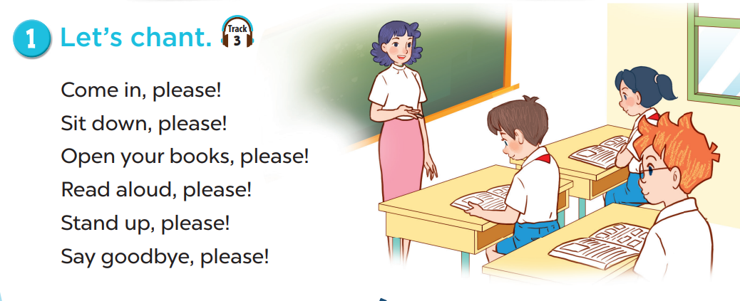  - Play the recording for pupils to listen to and repeat the chant, line by line. Draw their attention to the rhythm and pronunciation. Encourage them to clap while chanting.  - Digital Competency Focus (2.5CB2a): Before playing the audio, remind students of "Digital Etiquette": Keep quiet when the recording plays and do not touch the speaker/projector cables.  - Play the recording all the way through for pupils to chant and clap. Go around the classroom and correct pronunciation if necessary.  - Invite a few groups of pupils to listen to and repeat the chant in front of the class. Praise them to encourage their performance.  - The disabled: Chant with their classmates.  3. Practice (20’)  Activity 2-2. Listen and number.  * Goals: To listen to and understand four sentences describing what the characters are doing in the classroom at break time and number the correct pictures.  * Procedure:  - Play the recording all the way through for pupils to listen and familiarise themselves with the speaker’s voice. Then play the recording again for pupils to listen and number the pictures.  - Get pupils to swap books with a partner to check their answers before checking as a class. Correct the answers where necessary.  Extension: If time allows, play the recording, sentence by sentence, for pupils to listen and repeat in chorus. Correct their pronunciation where necessary.  Picture cues:  a. Bill wearing headphones, listening  b. Mary doing a word puzzle  c. Lucy reading a book  d. Ben writing in a notebook  Audio script:  1. He’s listening to the chant.  2. She’s reading a book.  3. He’s writing new words.  4. She’s doing a word puzzle.  Key: 1. a 2. c 3. d 4. b  Activity 3-3. Listen and act out.  * Goals: To listen to and understand a chant with seven sentences describing what the characters usually do in the classroom, and act out the chant.  * Procedure:  - Draw pupils’ attention to the picture and ask questions such as Who are they? and What are they doing? Remind pupils to look at the activities the characters are doing in the classroom.  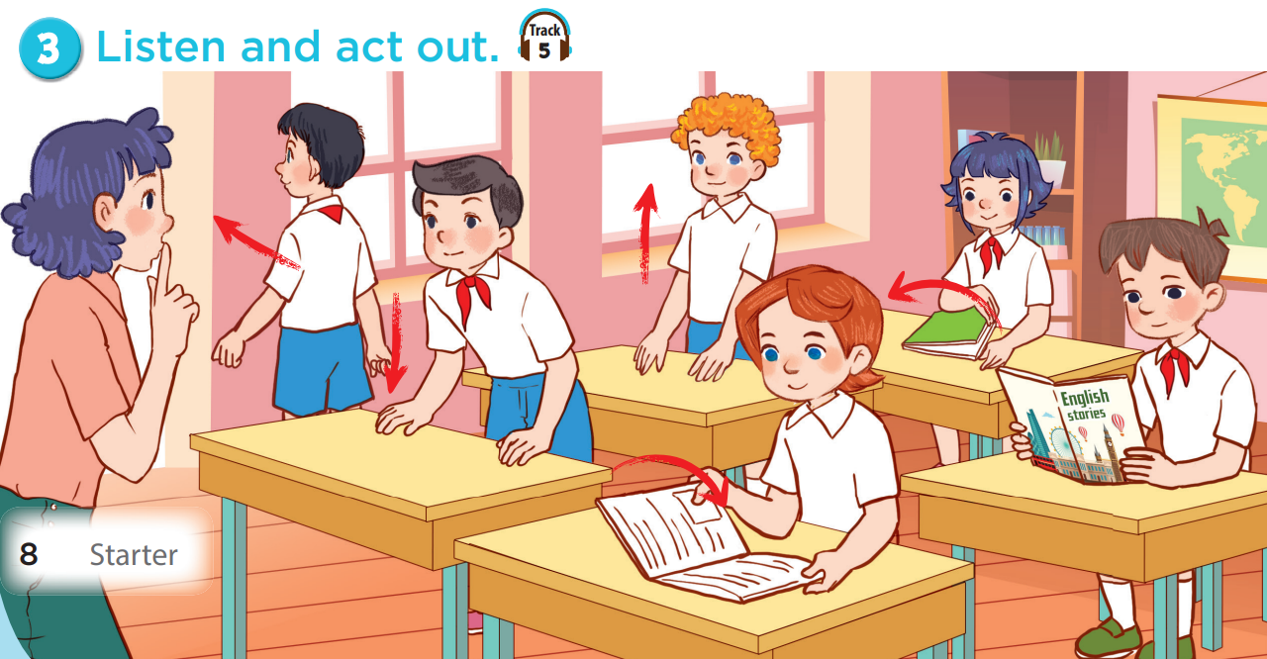  - Play the recording all the way through for pupils to listen and familiarise themselves with the speaker’s voice. Then play the recording again for pupils to listen and point at the pictures.  - Have pupils listen to the recording, line by line, and act out. Then invite a group to listen and act out in front of the class.  Extension: If time allows, play the recording, line by line, for pupils to listen and repeat in chorus. Correct their pronunciation where necessary.  Audio script:  Quiet.  Sit down.  Open your books.  Read aloud.  Close your books.  Stand up.  Let’s go out.  Game: Miming game  - Teacher divides the class into teams.  - One student in each team stands in front of the screen and faces his/ her team.  - Teacher spins the wheel.  - The rest pupils mime the action on the wheel while their teammates guess the action and give the answer. The teams that guess the correct answer first get one point.  - Digital Competency Focus (2.5CB2a): Instruct students to wait for the digital wheel to stop before shouting answers and to stand at a safe distance from the projector screen.  - The team with the most points is the winner.  4. Consolidation (3’)  - Ask students to answer the following questions:  ? What have you learnt from the lesson today?  5. Homework (2’)  - Learn the chant by heart  - Prepare the new lesson: C. Outdoor activities | - Listen to the teacher  - Whole class/ Individual work  - Whole class/Individual work  - Listen to the T's instruction  - Individual work  - Individual work  - Listen and repeat  Whole class/  Individual  work  - Listen to the T's instruction.  - Individual work  - Listen to the techer  - Whole class/ Individual work  - Listen  - Group work  - Group work  - Whole class  - Listen to the T's instruction
D. Recommendation
………………………………………………………………………………………….…..……………………………………………………………………………...………………………………………….…..………………………………………………
WEEK 1
Class | Date of teaching
4A | September 11th, 2025
4B | September 12th, 2025
PERIOD 4
STARTER
C. OUTDOOR ACTIVITIES

A.OBJECTIVES:
By the end of the lesson, pupils will be able to:
- Knowledges:
- Practise the names of outdoor activities by playing Miming game.
- Match the pupils with the pictures and say about their hobbies.
read the chant aloud and act out with the help of the lyrics and picture cues.
2. Skills: Listening and speaking
3. Attributes:
- Communication and collaboration: work in pairs and groups to complete the learning tasks
- Self-control & independent learning: perform listening tasks.
4. Digital Competence 2.5CB2a (Integrated): Select simple behavioral norms for recess activities (e.g., playing safely, following game rules, and showing respect to others during outdoor play).
B. INSTRUCTIONAL RESOURCES
- Student’s book: Page 9
- Teacher’s guide: Pages 14, 15, 16
- Flash cards/ pictures and posters
- Hoclieu.vn
- Computer, projector,
C. LEARNING PLAN:
Teacher’s activities | Student’s activities
1. Warm up (5’)  Greet the class.  - Greet the class.  - Then spend a few minutes revising the previous lesson by inviting a group of pupils to the front of the class to say the chant on page 8. Then class claps along.  - Ask pupils to open their books at page 9 and look at Starter, C. Outdoor activities.  - Review vocabulary: Action verbs  2. Presentation (5’)  Activity 1-1. Let’s play.  * Goal: To practise the names of outdoor activities by playing Miming game.  * Procedure:  - Elicit the language that pupils need to talk about break time activities, e.g. What are they doing? – They’re ., swimming, running, singing, skating, skipping. Check comprehension.  - Integration of 2.5CB2a: Before playing, ask: "Is running fast in a crowded corridor a good behavior?" (No). Ask pupils to choose "Good" or "Bad" behaviors for the mimed activities (e.g., playing fair, not pushing others).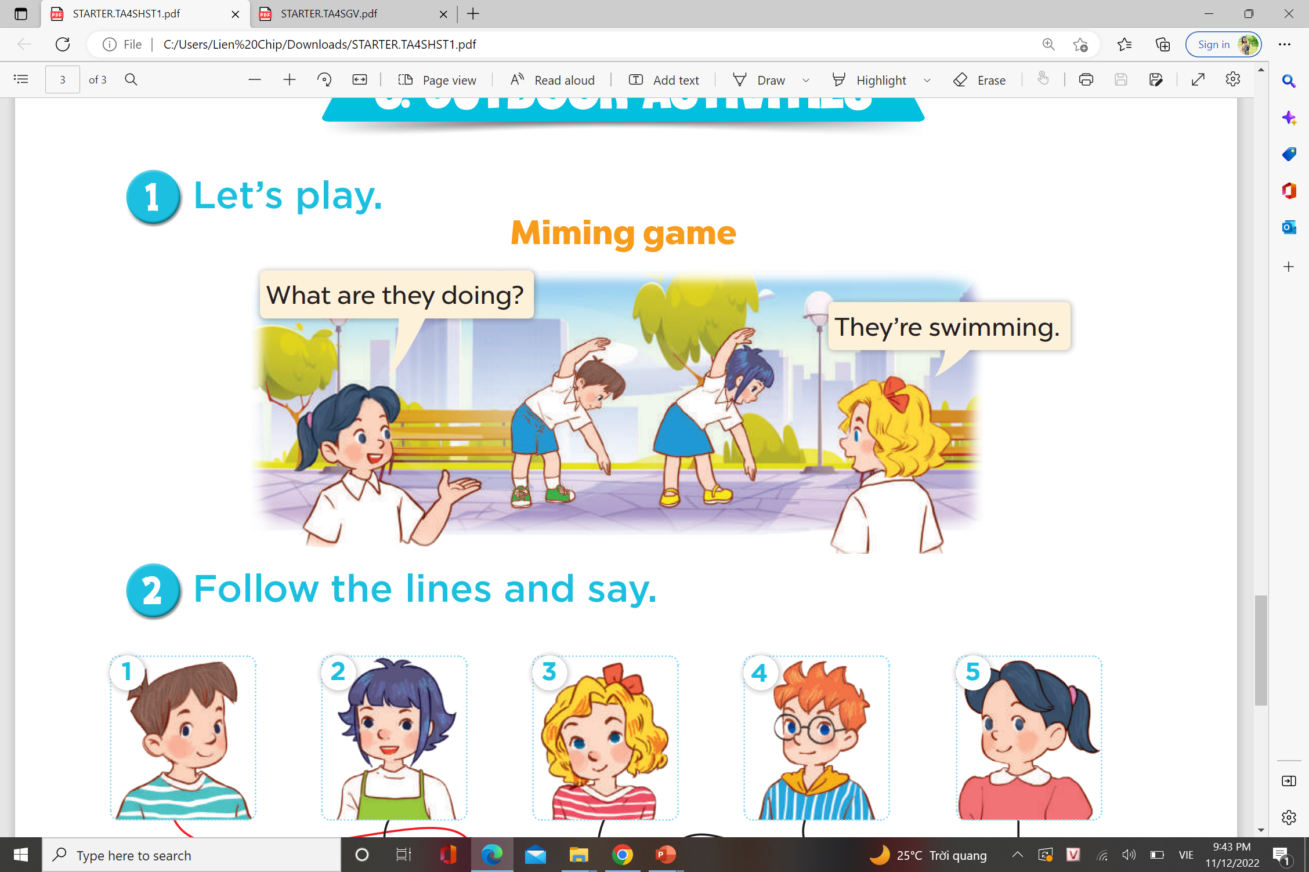  - Explain how the game is played: Two pupils mime the action of an activity. One pupil asks What are they doing? and the other pupils guess the action and answer.  - Divide the class into groups of five. Select two pupils to do the actions and one pupil to ask the questions, while the rest guess the actions and give the answers. The team that guesses the correct answer first gets one point or star. The team with the most points or stars is the winner.  3. Practice (15’)  Activity 2-2. Follow the lines and say.  * Goals: To match the pupils with the pictures and say about their hobbies.  * Procedure:  - Tell pupils the goal of the activity and explain that they should follow the lines to match the pupils with the pictures, point to the pupils and say what their hobbies are. Check comprehension.  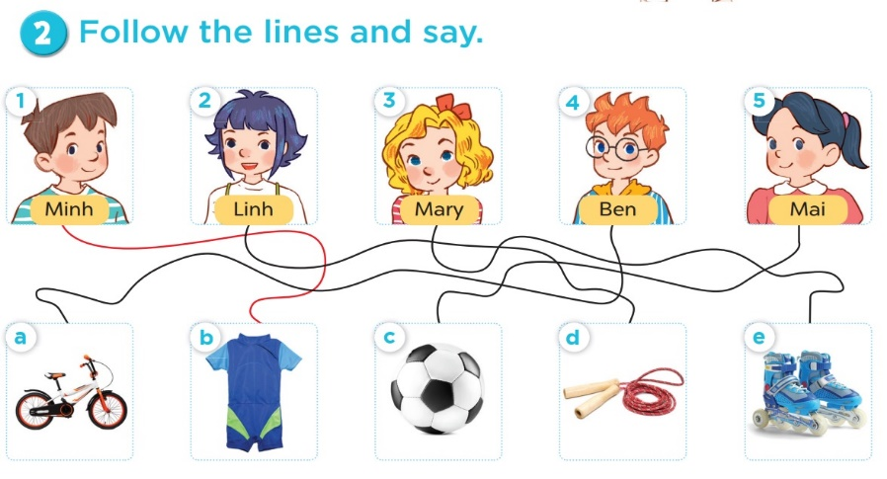  - Do the first picture as an example. First, have pupils look at the pupil (Minh) and follow the line to Picture b (a swimsuit). Then have them say: Look at Minh. His bobby is swimming. Remind pupils that they have learnt the structure in Grade 3.  - Set a time limit for pupils to do the activity independently. Go around the classroom and offer help if necessary.  - Get pupils to swap their books with a partner and check their answers before checking as a class. Correct the answers where necessary.  Extension: Invite some pupils to look at the task they have done and say about the pupils' hobbies in front of the class.  Answer key: 1. b 2. d 3. e 4. a 5. c  1. Look at Minh. His hobby is swimming.  2. Look at Linh. Her hobby is skipping.  3. Look at Mary. Her hobby is roller skating.  4. Look at Ben. His hobby is cycling.  5. Look at Mai. Her hobby is running.  Fun Game:  - Divide the class into 2 teams: Boys and Girls.  - Pupils take turns to answer the questions.  - They look at the pictures and choose the correct answers.  - If they have the correct answers they get the points for their teams. If the answer is not correct, the other team answers.  Activity 3-3. Read and act out  * Goals: To read the chant aloud and act out with the help of the lyrics and picture cues.  * Procedure:  - Give pupils a time limit to read the first verse and act out in pairs or groups. Go around the classroom and give support to pupils who find it difficult to do the task.  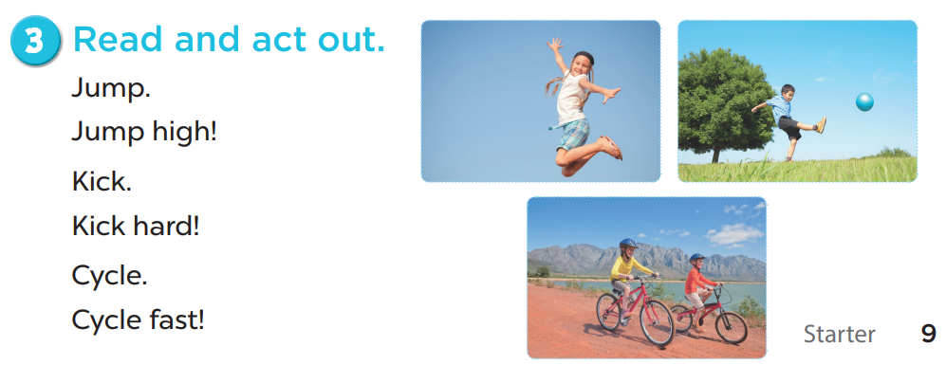  - Repeat Steps 1 to 3 with the other verse of the chant. Draw their attention to the meaning of the verses with the help of the picture cues.  - Integration of 2.5CB2a: While acting out, T emphasizes: "When we skip or cycle together, we wait for our turn." Ask pupils to demonstrate a "polite" way to join a game.  - When pupils are familiar with the verses and actions, ask them to read the whole chant aloud and act out. Then invite a few groups to the front of the class to say the chant and act out. The class may chant along and do actions or clap hands to reinforce the activity.  - The disabled: Read and act out with the classmates.  4. Consolidation (3’)  - Ask students to answer the following questions:  ? What have you learnt from the lesson today?  5. Homework (2’)  - Review how to say the hobby.  - Prepare the new lesson: Lesson 1 of Unit 1. | - Listen to the teacher  Whole class/ Individual work  - Whole class/Individual work  - Listen to the T's instruction  - Individual work  - Listen and repeat  - Listen to the T's instruction.  - Individual work  - Listen to the techer  - Whole class/ Individual work  - Group work  - Individual work  - Group work  - Group work  - Whole class  - Listen to the T's instruction  - Whole class/ Individual work
D. Recommendation
………………………………………………………………………………………….…..……………………………………………………………………………...………………………………………….…..………………………………………………
WEEK 2
Class | Date of teaching
4A | September 16th, 2025
4B | September 17th, 2025

PERIOD 5
UNIT 1: MY FRIENDS
LESSON 1 (1-3)
A. OBJECTIVES:
By the end of the lesson, pupils will be able to:
1. Knowledges:
- Understand and correctly repeat the sentences in two communicative contexts (pictures) in which pupils ask and answer questions about where someone is from;- Correctly say the words and use Where are you from? – I’m from _____. to ask and answer questions about where someone is from;
- Enhance the correct use of Where are you from? – _____. to ask and answer questions about where someone is from in a freer context.
2. Skills: Listening and speaking
3. Attributes:
- Show pride in where they come from and great respect for where someone comes from by using appropriate gestures and intonation when asking and answering about nationality.
4. Digital Competence (1.1CB2b): Find and identify country information (names and flags) by observing and interacting with digital images on the e-book and PowerPoint slides.
B. INSTRUCTIONAL RESOURCES
- Student’s book: Page 10
- Audio tracks 6, 7
- Teacher’s guide: Pages 17, 18, 19
- Hoclieu.vn
- Flash cards/ pictures and posters (Unit 1)
- Computer, projector
C. LEARNING PLAN:
Teacher’s activities | Student’s activities
1. Warm up (5’)  Greet the class.  - Spend a few minutes revising the previous lesson by having pupils sing the song on page 7 and clap hands or do actions.  - Elicit that there are many countries around the world.  - Ask pupils to name as many countries as they know.  2. Presentation (10’)  Activity 1-Vocabulary  * Goals: Ss will be able to know the name of the countries, before starting the new lesson.  * Procedure:  - T elicits the new words  + Britain : Nước Anh (picture)  + Viet Nam : Nước Việt Nam (picture)  + America : Nước Mỹ (picture)  + Australia : Nước Úc (picture)  + Be from…: Đến từ (Explain)  - T models (3 times).  - T writes the words on the board.  - Checking: Rub out and remember  - The disabled: Practice reading vocab.  - Digital Competence (1.1CB2b): T shows a digital image of a flag/landmark and asks: "Which country is this?" Pupils find the name based on the digital visual data.  Activity 2-1. Look, listen and repeat.  * Goals: To understand and correctly repeat the sentences in two communicative contexts (pictures) in which pupils ask and answer questions about where someone is from.  * Procedure:  - Ask pupils to look at Picture a and identify the characters. Ask Who is he / she?, Where is he / she?  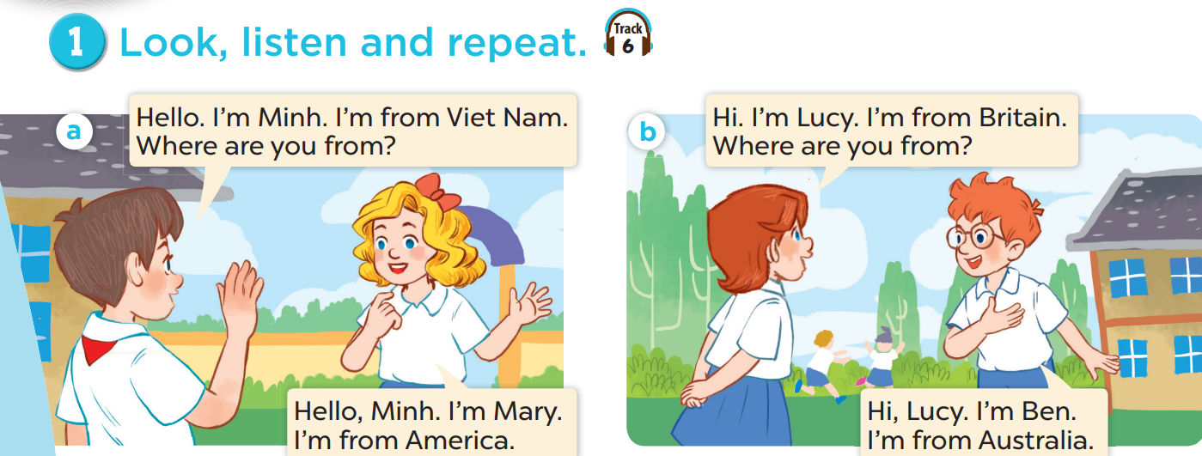  - Draw pupils’ attention to the question Where are you from? and the answer I’m from America. Explain that they are used to ask and answer questions about where someone is from.  - Play the recording and encourage pupils to point at the characters while listening.  - Play the recording again, sentence by sentence, for pupils to listen, point to the sentences and repeat. Correct their pronunciation where necessary.  - Repeat Steps 1 to 4 for Picture b.  Extension: Invite a few pairs of pupils to act out the conversations in front of the class.  3. Practice (15’)  Activity 3-2. Listen, point and say.  * Goals: To correctly say the words and use Where are you from? – I’m from _____. to ask and answer questions about where someone is from.  * Procedure:  - Ask pupils to look at Pictures a, b, c, and d and identify the characters, the flags and the names of the countries.  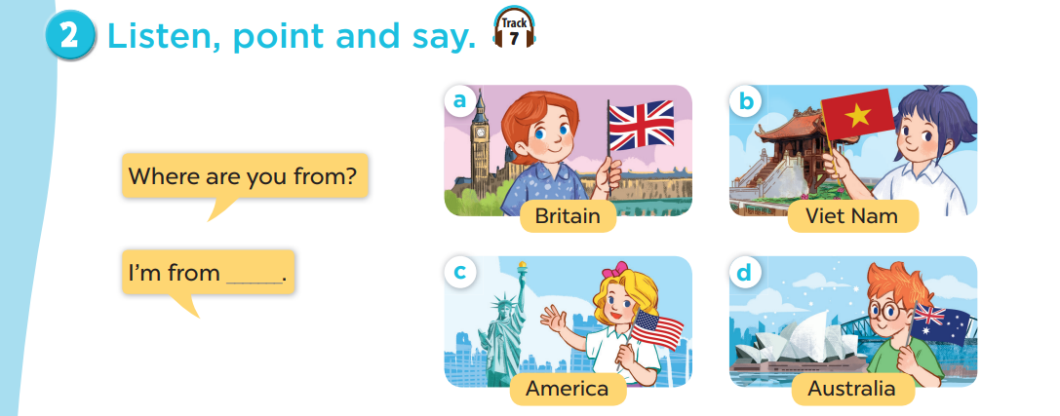  - Play the recording for pupils to listen to and repeat the words under the pictures in chorus and individually until they feel confident.  - Draw pupils’ attention to the speech bubbles and elicit the missing words by pointing at Picture a. Play the recording for pupils to repeat the sentences in both bubbles a few times.  - Repeat Step 3 with Pictures b, c, and d. Then have pupils practise asking and answering questions in pairs. Go around the classroom to offer help if necessary.  - Invite a few pairs to point at the pictures and ask and answer questions about where someone is from.  – Picture cues:  a. Lucy holding the British flag b. Linh holding the Vietnamese flag  c. Mary holding the American flag d. Ben holding the Australian flag  – Speech bubbles: Where are you from? – I’m from _____.  Audio script:  a. Britain b. Viet Nam c. America d. Australia  a. A: Where are you from?  B: I’m from Britain.  b. A: Where are you from?  B: I’m from Viet Nam.  c. A: Where are you from?  B: I’m from America.  d. A: Where are you from?  B: I’m from Australia.  Activity 3-3. Let’s talk.  * Goals: To enhance the correct use of Where are you from? – _____. to ask and answer questions about where someone is from in a freer context.  * Procedure:  - Draw pupils’ attention to the picture. Ask questions to help them identify the context (see Input).  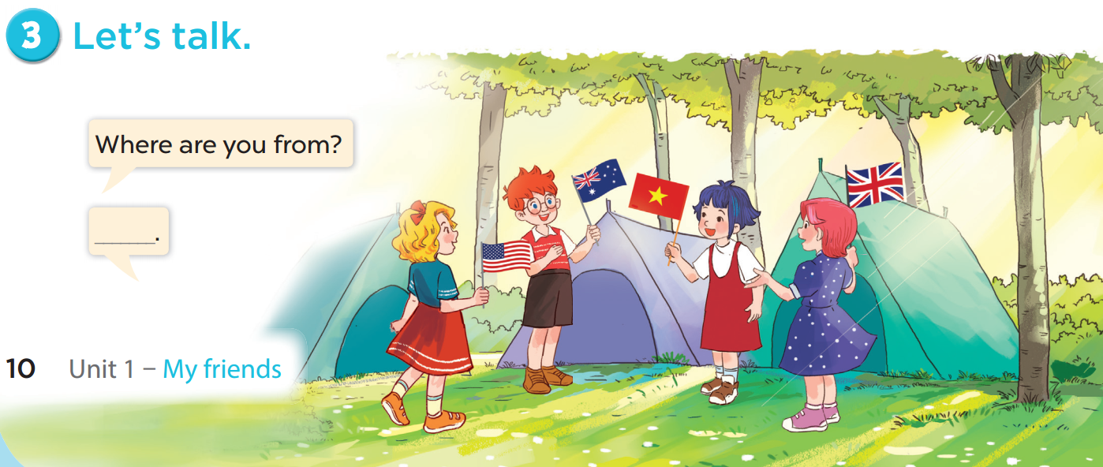  - Elicit the answer in the speech bubble and write it on the board. Get pupils to say the completed sentences.  - Put pupils into pairs to practise the exchanges. Go around the classroom to offer support where necessary.  - Invite a few pairs to point at the pictures and ask and answer questions about where the pupils are from.  Game:  Lucky number game (ppt)  - Divide the class into 3 teams.  - Pupils from each team choose a number (or throw sticky balls on the grid to choose the number), then have 2 pupils from each team ask and answer with the picture behind that number.  - Pupils or teacher click the flag to reveal the icons indicating the points for that team.  - After 9 numbers, the team with the most points is the winner.  4. Consolidation (3’)  - Ask students to answer the following questions:  1. What have you learnt from the lesson today?  (Use the words America, Australia, Britain and Viet Nam and the model Where are you from? – I’m from … to say where someone is from.)  2. What are the core values of the lesson?  (Proud of our country; Respect others’ countries)  5. Homework (2’)  - Learn vocab and structure by heart.  - Prepare the new lesson: Lesson 1 (4,5,6) of Unit 1. | -Listen to the techer  Whole class/ Individual work  - Ss listen and answer  - Ss listen and repeat  + Choral repetition (3 times).  + Individual repetition (3 ss)  - Ss take note  - Ss look, remember and write  - Listen  - Listen to the T's instruction  - Listen to the recording  - Individual work  - Listen and repeat  - Whole class/Pair work  - Listen to the T's instruction  - Pair work  - Listen to the teacher  Whole class/ Pair work  - Listen and repeat  - Group work  - Pair work  - Listen to the teacher  - Practice in front of class  - Listen to the T's instruction.  - Play game in group  - Answer the qs  - Whole class/ Individual work
D. Recommendation
………………………………………………………………………………………….…..……………………………………………………………………………...………………………………………….…..………………………………………………

WEEK 2
Class | Date of teaching
4A | September 16th, 2025
4B | September 17th, 2025

PERIOD 6
UNIT 1: MY FRIENDS
LESSON 1 (4-6)
A.OBJECTIVES:
By the end of the lesson, pupils will be able to:
1. Knowledges:
- Listen to and understand four communicative contexts in which pupils ask and answer questions about where someone is from and number the correct pictures;
- Complete two gapped sentences and two gapped exchanges with the help of picture cues;
- Sing the song Where are you from? with the correct pronunciation, rhythm and melody.
2. Skills: Listening, speaking and writing
3. Attributes:
- Show pride in where they come from and great respect for where someone comes from by using appropriate gestures and intonation when asking and answering about nationality.
4. Digital Competency (2.1CB2a): Select and use simple digital functions (e.g., play/pause icons on Hoclieu.vn or digital books) to listen to English models and repeat them accurately.
B. INSTRUCTIONAL RESOURCES
- Student’s book: Page 11
- Audio tracks 8, 9
- Teacher’s guide: Pages 20, 21
- Flash cards/ pictures and posters (Unit 1)
- Hoclieu.vn
- Computer, projector
C. LEARNING PLAN:
Teacher’s activities | Student’s activities
1. Warm up (5’)  Greet the class.  - Invite a few pairs of pupils to come to the front of the class to ask and answer questions about where they are from, using Where are you from? – I’m from _____.  - Ask pupils to open their books at page 11 and look at Unit 1, Lesson 1, Activity 4.  - Have pupils look at a picture of a boy. Draw pupils’ attention to the Big Ben Tower in the background. Ask Where are you from? Pupils look at the background then guess the country (Britain) and answer the question. Encourage pupils to use full sentence I’m from _____. to answer  - Repeat with 3 more pictures.  2. Practice (15’)  Activity 1-4. Listen and number.  Goals: To listen to and understand four communicative contexts in which pupils ask and answer questions about where someone is from and number the correct pictures.  * Procedure:  - Draw pupils’ attention to the pictures and ask questions such as Who is he / she? and Where’s he / she from? Remind them to look at the flags while listening.  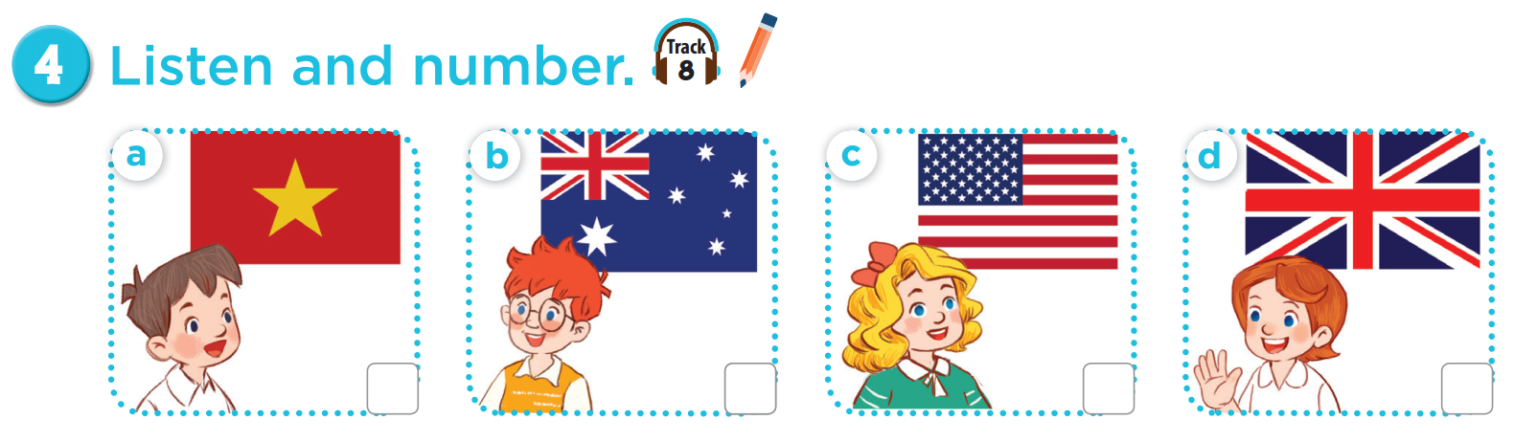  - Play the recording all the way through. Then play the recording again for pupils to listen and number the pictures.  - Digital Integration (2.1CB2a): Introduce the audio player interface on the screen. Show pupils the "Repeat" icon and explain that they can choose this function to listen again.  - Get pupils to swap books with a partner to check their answers before checking as a class. Correct the answers, if necessary.  Extension: If time allows, play the recording, sentence by sentence, for pupils to listen and repeat in chorus. Correct their pronunciation where necessary.  Picture cues:  a. Minh from Viet Nam b. Ben from Australia  c. Mary from America d. Lucy from Britain  Audio script:  1. A: Hi. Where are you from?  B: Hi. I’m from Australia.  2. A: Hello. Where are you from?  B: Hi. I’m from Britain.  3. A: Where are you from?  B: I’m from America.  4. A: Where are you from?  B: I’m from Viet Nam.  Key: 1. b 2. d 3. c 4. a  Activity 2-5. Look, complete and read.  * Goals: To complete two gapped sentences and two gapped exchanges with the help of picture cues.  * Procedure:  - Model gapped Sentence 1 as an example. Have pupils read the sentence and guess the missing word. Then draw pupils’ attention to the picture (the flag) and elicit the name of the country that can be used to fill in the gap (Viet Nam).  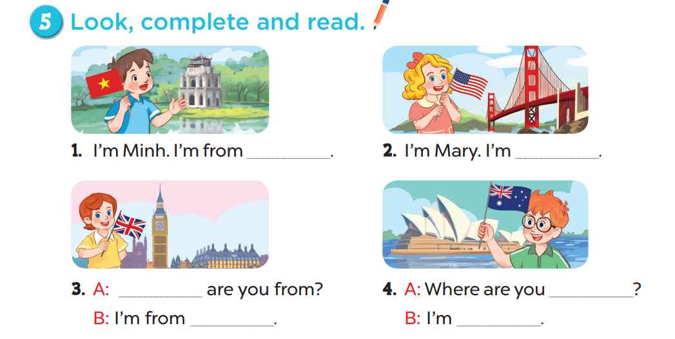  - Give pupils time to do the task independently. Go around the classroom to offer help where necessary.  - Get pupils to swap books with a partner and check their answers before checking as a class. Nominate a pupil to write the answers on the board. Give further support to those pupils who find it difficult to do the task.  - Invite one pupil to read aloud Sentences 1 and 2 and a pair of pupils to act out Exchanges 3 and 4 in front of the class. Correct their pronunciation where necessary.  Key: 1. Viet Nam 2. from America  3. Where; Britain 4. from; from Australia  Activity 3-6. Let’s sing.  * Goal: To sing the song Where are you from? with the correct pronunciation, rhythm and melody.  the song. Encourage them to point at the picture to reinforce their understanding.  * Procedure:  - Have pupils read the first verse of the lyrics. Explain that Minh is from Viet Nam. Have pupils listen to the first verse, drawing their attention to the pronunciation, rhythm and melody. Then let them listen to and practise singing it, line by line while clapping their hands.  - Digital Integration (2.1CB2a): Use the "Line-by-line" (Karaoke mode) on the digital platform. Show students how to select a specific verse to "listen and repeat" before singing the whole song.  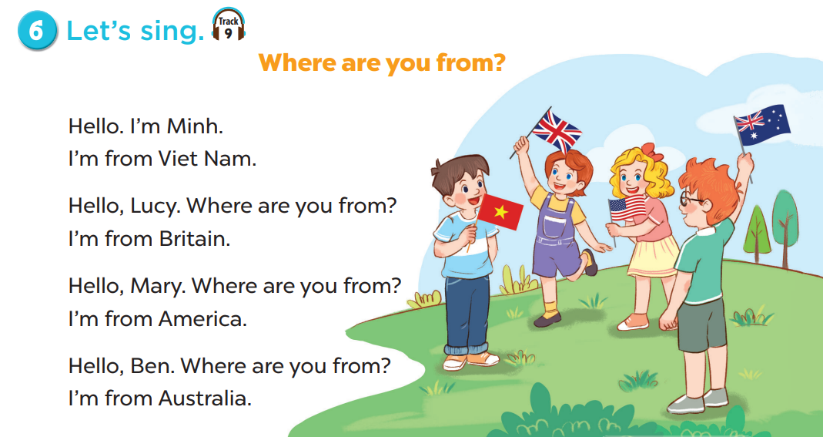  - Repeat Steps 1 and 2 for the other verses. Explain that Minh asks Lucy, Mary and Ben where they are from and each of them answers. Check comprehension and give feedback.  - Ask pupils to listen to and go around the classroom and offer help where necessary.  - Invite a few groups to the front of the class to sing the song. The class may sing along and clap to reinforce the activity.  - The disabled: Sing a song: Where are you from? with the classmates.  Game: Board Game  - Put pupils into pairs.  - Give pupils the handouts (attached below).  - Pupils take turns to roll the dice and move their piece according to the number of dots on the dice. Pupils say the sentence I’m (name). I’m from (country) according to the information inside the grid.  - The pupil who reaches the Finish box first is the winner  3. Consolidation (3’)  - Ask students to answer the following questions:  1. What have you learnt from the lesson today?  2. What are the core values of the lesson?  4. Homework (2’)  - Learn a song by heart.  - Do Part A, B in the workbook (P4, 5)  - Prepare the new lesson: Lesson 2 (1,2,3) of Unit 1. | - Listen to the techer  Whole class/ Individual work  - Whole class/Individual work  - Listen to the T's instruction  - Listen to the recording  - Individual work  - Listen and repeat  - Whole class/Pair work  - Listen to the T's instruction  - Listen to the teacher  Whole class/ Individual work  - Listen to the teacher  - Group work  - Group work/Whole class  - Pair work  - Listen to the T's instruction.  - Clap to reinforce the activity.  - Answer
D. Recommendation

WEEK 2
Class | Date of teaching
4A | September 18th, 2025
4B | September 19th, 2025

PERIOD 7
UNIT 1: MY FRIENDS
LESSON 2 (1-3)
A.OBJECTIVES:
By the end of the lesson, pupils will be able to:
1. Knowledges:
- Understand and correctly repeat the sentences in two communicative contexts (pictures) in which pupils ask and answer questions about where someone is from;
- Correctly say the words and use Where’s he / she from? – He’s /She’s from _____. to ask and answer questions about where someone is from;
- Enhance the correct use of Where’s he / she from? – _____. to ask and answer questions about where someone is from in a freer context.
2. Skills: Listening and speaking
3. Attributes:
- Show pride in where they come from and great respect for where someone comes from by using appropriate gestures and intonation when asking and answering about nationality.
4. Digital Competency 2.1CB2b: Identify suitable means of communication (e.g., video calls, social apps, or face-to-face) to greet and talk to new friends from different geographical locations.
B. INSTRUCTIONAL RESOURCES
- Student’s book: Page 12
- Audio tracks 10, 11
- Teacher’s guide: Pages 22, 23, 24
- Flash cards/ pictures and posters (Unit 1)
- Hoclieu.vn
- Computer, projector
C. LEARNING PLAN:
Teacher’s activities | Student’s activities
1. Warm up (5’)  Greet the class.  - Invite four groups of pupils to the front of the class to take turns singing the song Where are you from? Each group sings one verse of the song. The class sings along and claps hands.  - Ask pupils to open their books at page 12 and look at Unit 1, Lesson 2. Tell pupils what they will learn in this lesson.  - Review vocabulary  Game: Role play  - Call 2 pupils for each turn to come to the board.  - One pupil holds up a flag picture and asks Where are you from?, the other looks and answers the questions.  - Do the same with some more pairs.  2. Presentation (10’)  Activity 1-Vocabulary  * Goals: Ss will be able to know the name of the countries, before starting the new lesson.  * Procedure:  - T elicits the new words  + Singapore : Nước Singapo (picture)  + Malaysia : Nước Ma lai si a (picture)  + Thailand : Nước Thái Lan (picture)  + Japan : Nước Nhật Bản (picture)  + New : Đến từ (Explain)  - T models (3 times).  - T writes the words on the board.  - Checking: Rub out and remember  - The disabled: Practice reading vocab.  Activity 2-1. Look, listen and repeat.  * Goal: To understand and correctly repeat the sentences in two communicative contexts (pictures) in which pupils ask and answer questions about where someone is from.  * Procedure:  - Ask pupils to look at Pictures a and b and identify the characters. Check comprehension.  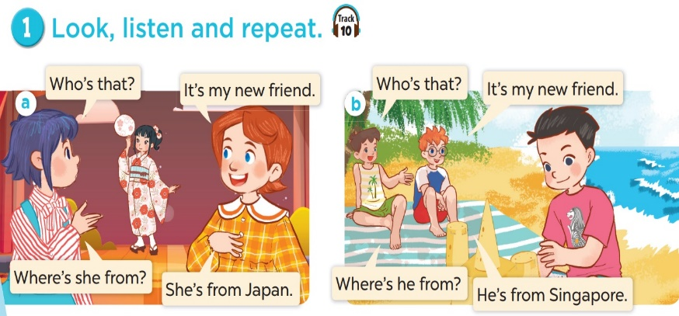  - Ask pupils to look at Picture a. Play the recording for them to listen and familiarise themselves with the characters’ voice. Play the recording again, sentence by sentence, for pupils to listen and repeat. Correct their pronunciation where necessary.  - Repeat the same procedure with Picture b.  - Invite a few pairs to the front of the class to listen to and act out the exchanges. Draw pupils’ attention to the questions Where’s she from? and Where’s he from?, and the answers She’s from Japan. and He’s from Singapore. Explain that they are used to ask and answer questions about where someone is from.  Extension: Nominate pairs of pupils to act out the exchanges.  3. Practice (15’)  Activity 3-2. Listen, point and say.  * Goal: To correctly say the words and use Where’s he / she from? – He’s / She’s from _____. to ask and answer questions about where someone is from.  * Procedure:  - Ask pupils to look at Picture a and identify the boy, the flag and the name of the country. Play the recording for pupils to listen to and repeat the word under the picture in chorus and individually until they feel confident.  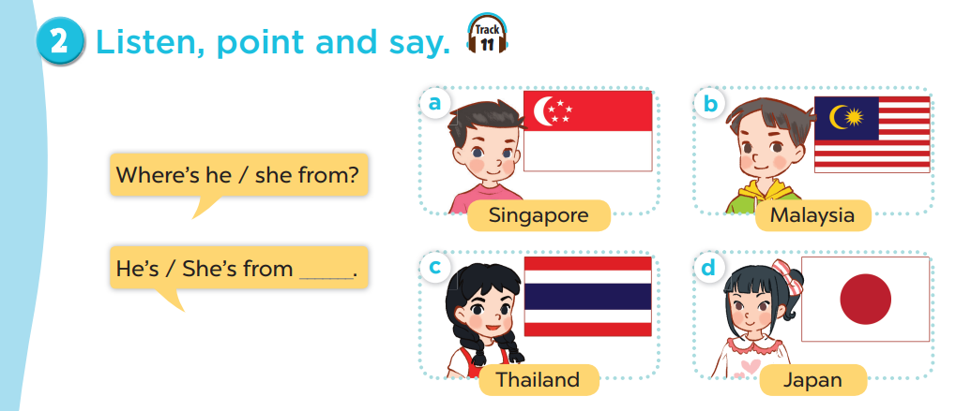  - Draw pupils’ attention to the speech bubbles and elicit the missing words. Play the recording for pupils to repeat the sentences in both bubbles a few times. Remind pupils to point at the relevant pictures when they are repeating.  - Repeat Steps 1 and 2 for Pictures b, c and d. Go around the classroom and offer help where necessary.  - Invite a few pairs to act out the exchanges in front of the class.  – Picture cues:  a. a boy with the Singaporean flag  b. a boy with the Malaysian flag  c. a girl with the Thai flag  d. a girl with the Japanese flag  – Speech bubbles: Where’s he / she from? – He’s / She’s from _____.  Audio script:  a. Singapore b. Malaysia c. Thailand d. Japan  a. A: Where’s he from?  B: He’s from Singapore.  b. A: Where’s he from?  B: He’s from Malaysia.  c. A: Where’s she from?  B: She’s from Thailand.  d. A: Where’s she from?  B: She’s from Japan.  Activity 4-3. Let’s talk.  * Goal: To enhance the correct use of Where’s he / she from? – _____. to ask and answer questions about where someone is from in a freer context.  * Procedure:  - Ask pupils to look at the picture and identify the characters. Ask Who can you see? Where are they from? Remind pupils that Where’s he / she from? – _____. are used to ask and answer questions about where someone is from. Check comprehension.  - Integration of Competency 2.1CB2b: Ask pupils: "These friends are far away at a campsite. If you want to greet a friend in Japan from your home, what device can you use?" (Expected: Smartphone, Laptop, Video call).  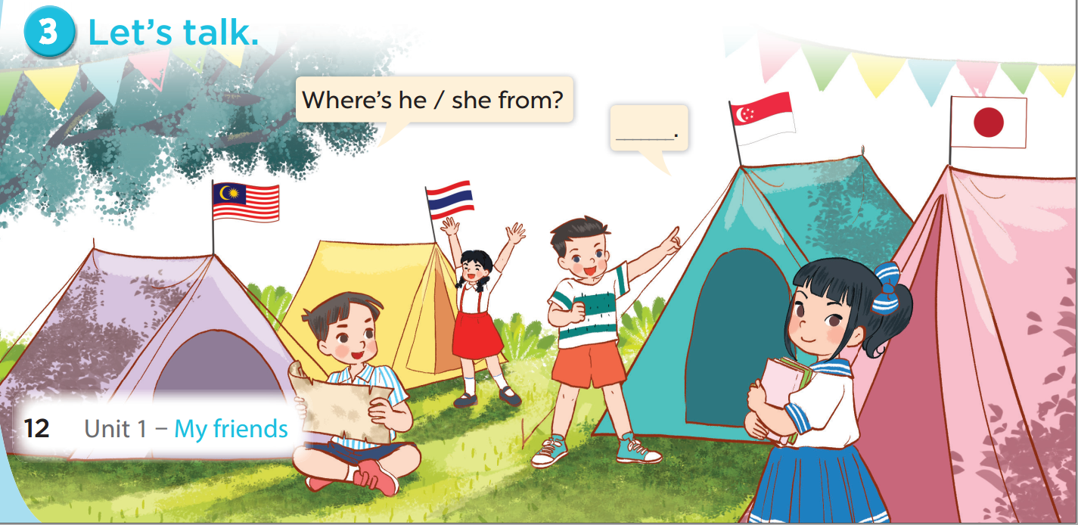  - Give pupils time to work in pairs and take turns saying the role of each character in the picture. Remind them to look at the flags on the tents to identify where the pupils come from.  - Invite a few pairs to come to the front of the classroom and act out the roles.  Game: Angry birds Game  - Divide the class into 2 teams: Boys and Girls.  - Pupils take turns to choose the numbers and answer the questions.  - They look at the pictures and answer the questions. If they have the correct answers, they get the points for their teams. If the answer is not correct, the other team answers and gets points.  4. Consolidation (3’)  - Ask students to answer the following questions: What have you learnt from the lesson today? (correctly say the words and use Where’s he/ she from? – He’s/ She’s from _____. to ask and answer about where someone comes from.)  5. Homework (2’)  - Learn a song by heart.  - Prepare the new lesson: Lesson 2 (4,5,6) of Unit 1. | - Listen to the techer  Whole class/ Individual work  - Whole class/Individual work  - Listen to the T's instruction  - Individual work  - Ss listen and repeat  + Choral repetition (3 times).  + Individual repetition (3 ss)  - Ss take note  - Ss look, remember and write  - Look at the pictures.  - Listen and repeat  - Listen to the T's instruction  - Listen to the teacher  - Whole class/ Individual work  - Pair work  - Listen to the teacher  - Pair work  - Clap to reinforce the activity.  - Answer  - Listen to the T's instruction.
D. Recommendation
………………………………………………………………………………………….…..……………………………………………………………………………...………………………………………….…..………………………………………………

WEEK 2
Class | Date of teaching
4A | September 18th, 2025
4B | September 19th, 2025
PERIOD 8
UNIT 1: MY FRIENDS
LESSON 2 (4-6)
A. OBJECTIVES:
By the end of the lesson, pupils will be able to:
1. Knowledges:
- Listen to and understand two communicative contexts in which pupils ask and answer questions about where someone comes from and tick the correct pictures;
- Complete two gapped sentences and two gapped exchanges with the help of picture cues;
- Revise the target vocabulary items through the game Find someone who is from …
2. Skills: Listening, speaking and writing
3. Attributes:
- Show pride in where they come from and great respect for where someone comes from by using appropriate gestures and intonation when asking and answering about nationality.
4. Digital Competence 1.2CB2a: Detect the accuracy of heard information (country names) by cross-referencing audio input with visual data (flags/symbols).
B. INSTRUCTIONAL RESOURCES
- Student’s book: Page 13
- Audio track 12
- Teacher’s guide: Pages 24, 25, 26
- Flash cards/ pictures and posters (Unit 1)
- hoclieu.vn
- Computer, projector
C. LEARNING PLAN:

Teacher’s activities | Student’s activities
1. Warm up (5’)  Greet the class.  - Greet the class, then spend a few minutes revising the previous lesson by inviting a few pairs of pupils, holding flag flashcards to ask and answer questions about where they or their classmates are from, using Where are you from? – I’m from _____. and Where’s he / she from? – He’s / She’s from _____.  - Ask pupils to open their books at page 13 and look at Unit 1, Lesson 2, Activity 4.  - Have pupils look at some symbols of some countries they have learnt. Pupils look at the pictures then guess the country and answer the question.  - Repeat with 7 more countries.  2. Practice (25’)  Activity 1-4. Listen and tick.  * Goal: To listen to and understand two communicative contexts in which pupils ask and answer questions about where someone comes from and tick the correct pictures.  * Procedure:  - Ask pupils to look at Pictures 1a and 1b and identify the characters. Ask Who’s he? and Where’s he from? Draw their attention to the flags to answer the questions. Check comprehension.  - Integration of 1.2CB2a: Before playing the audio, T says: "I will play the recording. Your job is to check if the country mentioned matches flag 'a' or flag 'b'. Be careful, don't just tick, verify the name!"  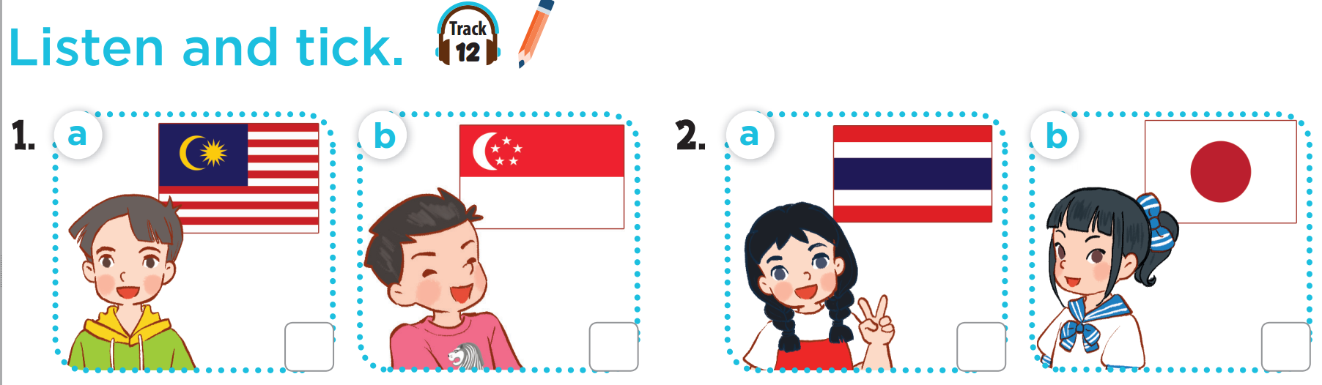  - Play the recording of the first dialogue for pupils to listen and tick the correct box. Play the recording again for pupils to check their answers.  - Repeat Steps 1 and 2 with Pictures 2a and 2b.  - Get pupils to swap their books with a partner and check their answers before checking as a class. Correct the answers if necessary.  Extension: If time allows, play the recording, sentence by sentence, for the class to listen to and repeat the dialogues. Correct pronunciation if necessary.  Picture cues:  1a. a boy and the Malaysian flag  1b. a boy and the Singaporean flag  2a. a girl and the Thai flag  2b. a girl and the Japanese flag  Audio script:  1. A: Who’s that? 2. A: Who’s that?  B: It’s my new friend. B: It’s my new friend.  A: Where’s he from? A: Where’s she from?  B: He’s from Malaysia. B: She’s from Thailand.  Key: 1. a 2. a  Activity 2-5. Look, complete and read.  * Goal: To complete two gapped sentences and two gapped exchanges with the help of picture cues.  * Procedure:  - Model the first gapped exchange as an example. Have pupils read the exchange and guess the missing word. Then draw pupils’ attention to the picture and elicit the name of the country that can be used to fill in the gap (Japan).  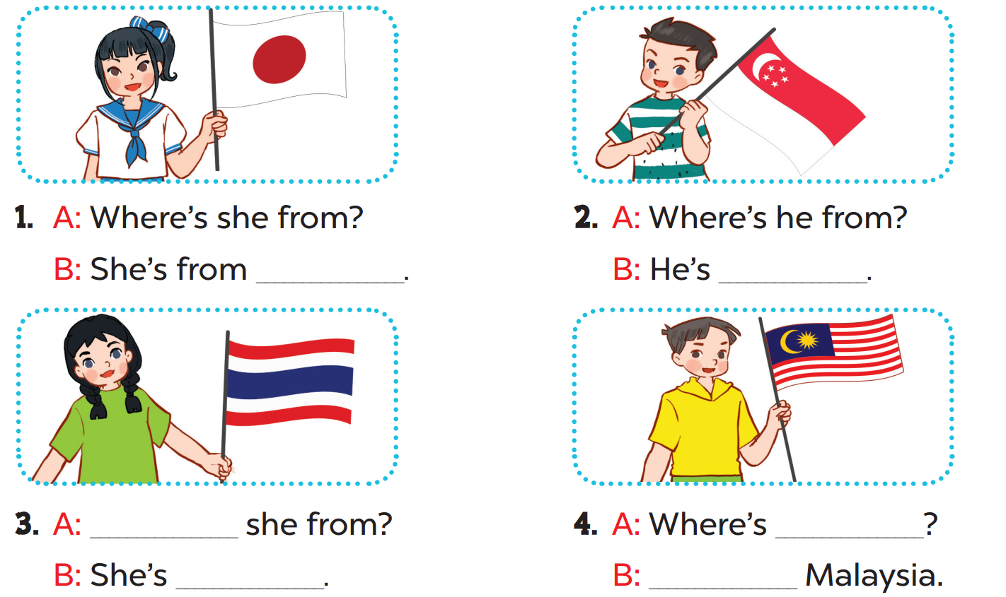  - Give pupils a time limit to read the gapped exchanges 2, 3 and 4, look at the pictures and fill in the gaps independently. Go around the classroom and give further support to pupils who find it difficult to do the task.  - Integration of 1.2CB2a: T purposely reads a sentence wrong (e.g., "He's from Britain" while pointing to the Thai flag). Pupils must shout "Inaccurate!" and correct the teacher.  - Get pupils to swap books with a partner and check their answers before checking as a class. Invite one pupil to write the answers on the board.  Key: 1. Japan 2. from Singapore  3. Where’s; from Thailand 4. he from; He’s from  Activity 3-6. Let’s play.  * Goals: To revise the target vocabulary items through the game Find someone who is from …  * Procedure:  - Tell pupils that they are going to revise the target vocabulary items they have learnt in Lessons 1 and 2. Explain how the game is played. Check comprehension.  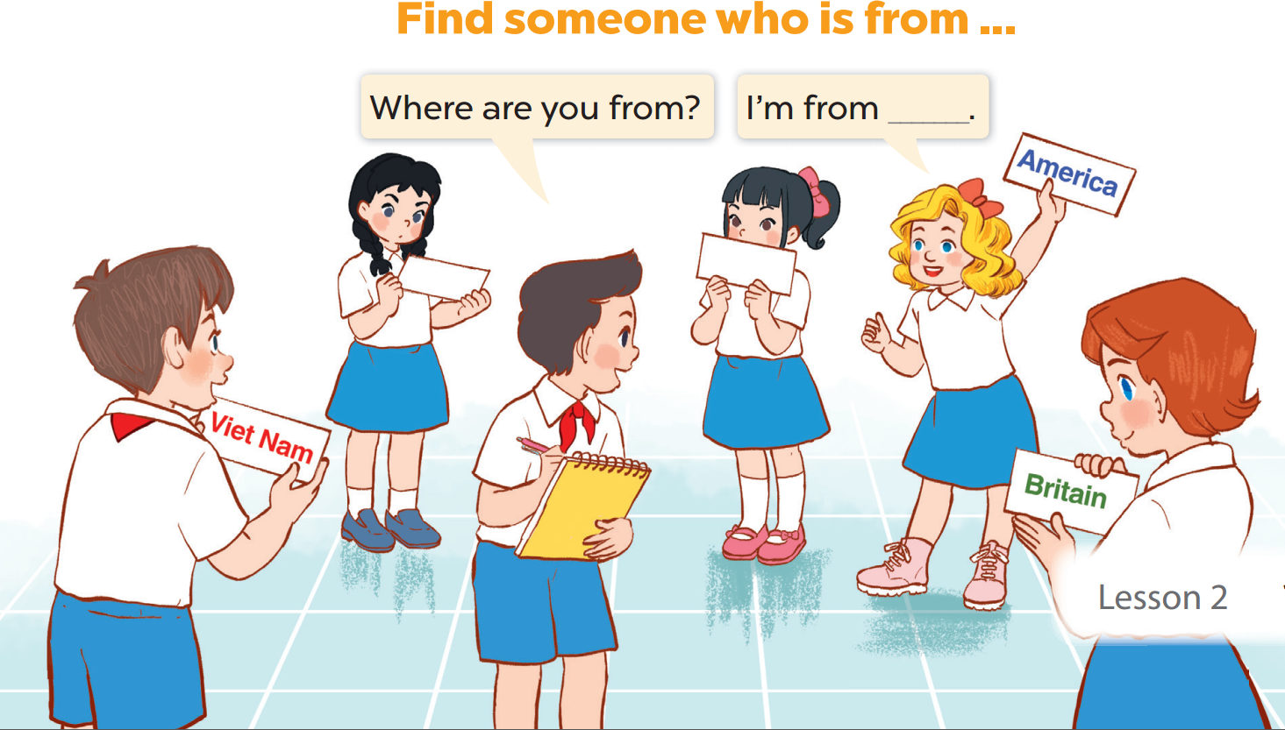  - Divide pupils into groups of six and give each group a set of five flashcards. One player in each group points to the other players and asks Where are you from? The other players take turns looking at the flash cards and answering (e.g. I’m from Britain.). If the player has the correct answer, he / she gets a point / star. If the answer does not match the flash card, he / she will be out.  - The disabled: Play a game: Find someone who is from.  - The game ends when all the flashcards are gone.  Game: OpGame “Among us”  - Teacher divides the class into 2 teams (boys and girls).  - Each team takes turns to choose a Among us and answer the question.  - The team that has more points is the winner.  3. Consolidation (3’)  - Ask students to answer the following questions:  1. What have you learnt from the lesson today?  2. What are the core values of the lesson?  4. Homework (2’)  - Redo Ex.1, 2 at home.  - Do parts C, D in the workbook.  - Prepare the new lesson: Lesson 3 (1,2,3) of Unit 1. | - Listen to the techer  Whole class/ Individual work  - Whole class/Individual  work  - Listen to the T's instruction  - Listen and tick  - Whole class  - Listen to the T's instruction  - Whole class/ Individual work  - Pair work  - Listen to the teacher  Group work  - Whole class  - Listen to the T's instruction.  - Play in group  - Whole class/ Individual work
D. Recommendation
………………………………………………………………………………………….…..……………………………………………………………………………...………………………………………….…..………………………………………………

Tổ Trưởng ký duyệt Giáo viên Thực hiện

Nguyễn Thị Thu Hiền Nguyễn Thị Thu Hà

