UNIT 8 | SPORTS AND GAMES
❖ A. VOCABULARY
No. | Word / Phrase | Type | IPA | Meaning
1 | aerobics | (n) | /eəˈrəʊbɪks/ | thể dục nhịp điệu
2 | athlete | (n) | /ˈæθliːt/ | vận động viên
3 | badminton | (n) | /ˈbædmɪntən/ | cầu lông
4 | basketball | (n) | /ˈbɑːskɪtbɔːl/ | bóng rổ
5 | boxing | (n) | /ˈbɒksɪŋ/ | quyền anh
6 | champion | (n) | /ˈtʃæmpiən/ | nhà vô địch
7 | competition | (n) | /ˌkɒmpəˈtɪʃn/ | cuộc thi đấu
8 | court | (n) | /kɔːt/ | sân thi đấu
9 | cycling | (n) | /ˈsaɪklɪŋ/ | môn đạp xe
10 | equipment | (n) | /ɪˈkwɪpmənt/ | thiết bị, dụng cụ
11 | fit | (adj) | /fɪt/ | cân đối, khỏe mạnh
12 | football | (n) | /ˈfʊtbɔːl/ | bóng đá
13 | goggles | (n) | /ˈɡɒɡlz/ | kính bơi
14 | gym | (n) | /dʒɪm/ | phòng tập thể dục
15 | karate | (n) | /kəˈrɑːti/ | võ karate
16 | marathon | (n) | /ˈmærəθən/ | cuộc chạy ma-ra-tông
17 | match | (n) | /mætʃ/ | trận đấu
18 | racket | (n) | /ˈrækɪt/ | vợt
19 | referee | (n) | /ˌrefəˈriː/ | trọng tài
20 | score | (v/n) | /skɔː(r)/ | ghi bàn; tỉ số
21 | skiing | (n) | /ˈskiːɪŋ/ | môn trượt tuyết
22 | stadium | (n) | /ˈsteɪdiəm/ | sân vận động
23 | swimsuit | (n) | /ˈswɪmsuːt/ | đồ bơi
24 | tournament | (n) | /ˈtʊənəmənt/ | giải đấu
25 | volleyball | (n) | /ˈvɒlibɔːl/ | bóng chuyền
❖ B. WORD FORM
1. sport (n): thể thao; sporty (adj): yêu thể thao; sportsman / sportswoman (n): vận động viên | 2. compete (v): thi đấu; competition (n): cuộc thi; competitor (n): người thi đấu; competitive (adj)
3. act (v): hành động; action (n): hành động; active (adj): năng động; activity (n): hoạt động; actively (adv) | 4. win (v): chiến thắng; winner (n): người thắng; winning (adj): giành chiến thắng
5. health (n): sức khỏe; healthy (adj): khỏe mạnh; unhealthy (adj); healthily (adv)
❖ C. GRAMMAR
1. The past simple
• Dùng để diễn tả hành động đã xảy ra và kết thúc trong quá khứ. Dấu hiệu: yesterday, last ..., ... ago.
(+) S + V2 / V-ed. (-) S + did not + V. (?) Did + S + V?
• Với động từ be: I/he/she/it was; we/you/they were.
2. Imperatives
• Dùng động từ nguyên mẫu để ra lệnh hoặc hướng dẫn; thêm Don't trước động từ để tạo mệnh lệnh phủ định.
V-inf ...! / Don't + V-inf ...!

❖ EXERCISES
❖ PHONETICS
Exercise 1: Choose the word whose underlined vowel sound is pronounced differently (/e/ or /æ/).
1.
A. chess | B. tennis | C. exercise | D. match
2.
A. racket | B. marathon | C. active | D. member
3.
A. helmet | B. chess | C. ten | D. track
4.
A. athlete | B. badminton | C. match | D. medal
5.
A. send | B. event | C. left | D. stadium
6.
A. captain | B. fantastic | C. racket | D. tennis
7.
A. well | B. medal | C. exercise | D. basket
8.
A. hand | B. land | C. champion | D. help
9.
A. rest | B. step | C. member | D. match
10.
A. bad | B. ran | C. swam | D. went
Exercise 2: Mark the letter A, B, C, or D to indicate the word that differs in stress pattern.
1.
A. football | B. tennis | C. boxing | D. karate
2.
A. athlete | B. racket | C. stadium | D. referee
3.
A. marathon | B. volleyball | C. basketball | D. competition
4.
A. active | B. healthy | C. famous | D. event
5.
A. winner | B. cycling | C. swimming | D. complete
❖ VOCABULARY AND GRAMMAR
Exercise 3: Mark the letter A, B, C, or D to indicate the correct answer to each question.
1. Which word or phrase means 'thể dục nhịp điệu'?
A. aerobics | B. athlete | C. badminton | D. basketball
2. Which word or phrase means 'vận động viên'?
A. boxing | B. athlete | C. champion | D. competition
3. Which word or phrase means 'cầu lông'?
A. court | B. cycling | C. badminton | D. equipment
4. Which word or phrase means 'bóng rổ'?
A. fit | B. football | C. goggles | D. basketball
5. Which word or phrase means 'quyền anh'?
A. boxing | B. gym | C. karate | D. marathon
6. Which word or phrase means 'nhà vô địch'?
A. match | B. champion | C. racket | D. referee
7. Which word or phrase means 'cuộc thi đấu'?
A. score | B. skiing | C. competition | D. stadium
8. You need a _____ to play tennis or badminton.
A. swimsuit | B. tournament | C. volleyball | D. racket
9. The _____ blew his whistle and stopped the match.
A. referee | B. aerobics | C. athlete | D. badminton
10. Thousands of fans cheered inside the _____.
A. basketball | B. stadium | C. boxing | D. champion
11. Wear _____ to protect your eyes when you swim.
A. competition | B. court | C. goggles | D. cycling
12. The final _____ was 2-1 to our school.
A. equipment | B. fit | C. football | D. score
13. Mai does _____ to music every morning.
A. aerobics | B. gym | C. karate | D. marathon
14. The school bought new sports _____ for the gym.
A. match | B. equipment | C. racket | D. referee
15. After months of training, he became the national _____.
A. score | B. skiing | C. champion | D. stadium
16. We _____ basketball after school yesterday.
A. play | B. played | C. plays | D. are playing
17. Lan _____ to the gym last Sunday.
A. go | B. goes | C. went | D. going
18. They _____ the match because it rained.
A. didn't finish | B. don't finish | C. weren't finish | D. not finished
19. _____ you watch the final last night?
A. Do | B. Did | C. Were | D. Are
20. Our team _____ very happy after the victory.
A. was | B. were | C. is | D. be
21. The players _____ tired after the marathon.
A. was | B. is | C. were | D. are
22. _____ your shoes before entering the gym.
A. Changing | B. Changed | C. Change | D. Changes
23. _____ run near the swimming pool.
A. Not | B. Don't | C. Doesn't | D. Didn't
24. Please _____ the ball to your teammate.
A. pass | B. passed | C. passes | D. passing
25. My brother _____ three goals two days ago.
A. score | B. scores | C. scored | D. scoring
26. Where _____ you play badminton yesterday?
A. do | B. did | C. were | D. are
27. The tournament _____ at nine o'clock last Saturday.
A. start | B. started | C. starts | D. starting
28. _____ careful when you use this equipment.
A. Be | B. Are | C. Being | D. Was
29. The athlete _____ a new record last year.
A. set | B. sets | C. setting | D. was set
30. We _____ any medals in the competition.
A. didn't win | B. don't won | C. weren't win | D. not win
Exercise 4: Choose the word(s) CLOSEST in meaning to the underlined word(s).
1. The athlete was fit and strong.
A. healthy | B. slow | C. tired | D. weak
2. Our team won the final match.
A. last game | B. first lesson | C. training plan | D. sports club
3. The stadium was crowded.
A. full of people | B. very quiet | C. quite small | D. closed
4. He takes part in a cycling competition.
A. watches | B. joins | C. leaves | D. organises
5. The referee stopped the game.
A. player | B. official | C. fan | D. coach
Exercise 5: Choose the word(s) OPPOSITE in meaning to the underlined word(s).
1. Our team won the match.
A. played | B. lost | C. started | D. watched
2. She is a strong swimmer.
A. fit | B. weak | C. fast | D. active
3. The gym is open today.
A. large | B. busy | C. closed | D. clean
4. This sport is dangerous.
A. safe | B. popular | C. exciting | D. difficult
5. The runners moved quickly.
A. carefully | B. slowly | C. quietly | D. happily
Exercise 6: Put the verbs in brackets in the past simple or complete the imperative.
1. We _____ football in the park yesterday. (PLAY)
2. My father _____ me a new racket last week. (BUY)
3. Lan _____ swimming because the water was cold. (NOT GO)
4. _____ Nam _____ the cycling race? (WIN)
5. The match _____ at 5 p.m. (FINISH)
6. They _____ at the stadium on Sunday. (BE)
7. I _____ very tired after the run. (BE)
8. The referee _____ the game for ten minutes. (STOP)
9. Our class _____ three medals. (GET)
10. Hoa _____ a volleyball match on TV. (WATCH)
11. _____ your helmet before cycling. (WEAR)
12. _____ the ball with your hands in football. (NOT TOUCH)
13. _____ water after exercise. (DRINK)
14. _____ late for the competition. (NOT BE)
15. _____ the instructions carefully. (READ)
Exercise 7: Rewrite the sentences in the past simple or as imperatives.
1. We play basketball every Friday. (last Friday)
➜ ________________________________________________________________________________________
2. Nam does not go cycling today. (yesterday)
➜ ________________________________________________________________________________________
3. Does Mai win the race? (last week)
➜ ________________________________________________________________________________________
4. The players are tired. (after the match yesterday)
➜ ________________________________________________________________________________________
5. You should wear a helmet.
➜ ________________________________________________________________________________________
6. You must not run by the pool.
➜ ________________________________________________________________________________________
7. It is necessary to warm up before exercise.
➜ ________________________________________________________________________________________
8. You should not use broken equipment.
➜ ________________________________________________________________________________________
Exercise 8: Complete each sentence with the correct form of the word in brackets.
1. My sister is very _____. She plays three sports. (SPORT)
2. The school football _____ begins next Monday. (COMPETE)
3. All the _____ trained hard for the race. (COMPETE)
4. Regular exercise keeps us _____. (HEALTH)
5. Walking is a simple physical _____. (ACT)
6. The _____ received a gold medal. (WIN)
7. The children played _____. (ACTIVE)
8. Swimming helps build your _____. (STRONG)
9. The event was a great _____. (SUCCEED)
10. The team celebrated their _____. (VICTORIOUS)
❖ COMMUNICATION
Exercise 9: Choose the option that best completes each exchange.
1. 'What sport do you play?' - '_____.'
A. Badminton | B. At school | C. Yesterday | D. With Nam
2. 'Did your team win?' - '_____.'
A. Yes, we did | B. Yes, we do | C. No, we aren't | D. At 4 p.m.
3. 'Don't run near the pool.' - '_____.'
A. You're welcome | B. Sorry, I won't | C. Yes, I did | D. No, it isn't
4. 'How was the match?' - '_____.'
A. It was exciting | B. At the stadium | C. Two hours | D. Our teacher
5. 'Let's play volleyball.' - '_____.'
A. Great idea! | B. It was yesterday | C. I am a referee | D. No score
Exercise 10: Arrange the sentences to make a meaningful conversation.
1.
a. Did you watch the match last night?
b. Yes. Our school won 2-0.
c. That's wonderful!
A. a-b-c | B. b-c-a | C. c-a-b | D. a-c-b
2.
a. What sport do you like?
b. I like badminton.
c. How often do you play it?
d. Three times a week.
A. a-c-b-d | B. a-b-c-d | C. b-a-d-c | D. c-d-a-b
3.
a. Please wear your helmet.
b. I left it at home.
c. Then you should not ride your bike.
A. b-a-c | B. a-b-c | C. c-a-b | D. a-c-b

❖ READING
Exercise 11: Look at each sign or notice. Choose the best answer.
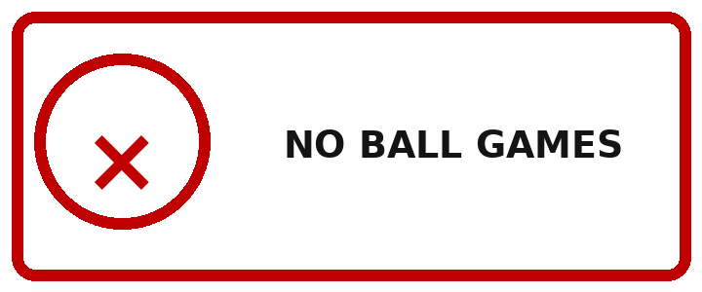 | 1. What does the sign mean?  A. You can play football here.  B. Ball games are not allowed.  C. Only tennis is allowed.  D. Buy a ball here.
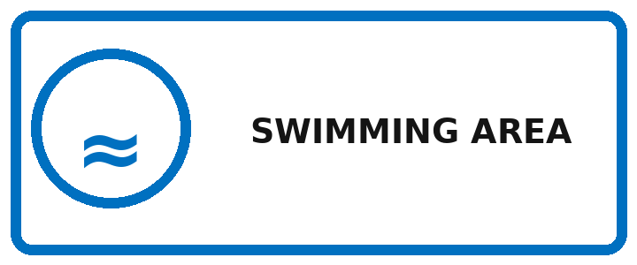 | 2. What can people do here?  A. Go swimming  B. Play chess  C. Go skiing  D. Play basketball
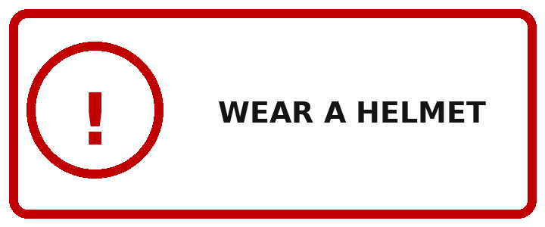 | 3. What must cyclists do?  A. Ride faster  B. Wear a helmet  C. Carry a racket  D. Stop cycling
 | 4. What does this sign show?  A. The finishing point  B. The changing room  C. The starting point  D. The ticket office
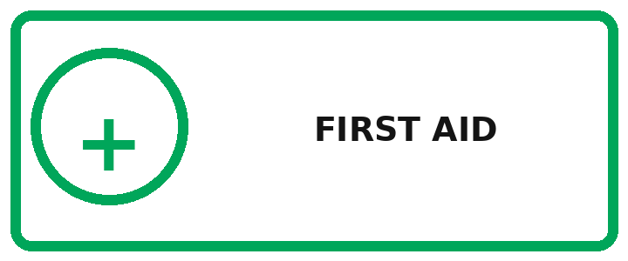 | 5. Where can an injured player get help?  A. At this point  B. At the scoreboard  C. At the car park  D. At the café
Exercise 12: Read the advertisements / announcements and choose the best option for each blank.
1.
SCHOOL SPORTS DAY
Come to our Sports Day (1) _____ Saturday, 18 March. Students can join running, badminton and basketball events. Please (2) _____ sports shoes and bring water. Each event begins (3) _____ time, so arrive early. Register with your PE teacher (4) _____ Thursday.
1.
A. in | B. on | C. at | D. for
2.
A. wear | B. wore | C. wearing | D. wears
3.
A. in | B. on | C. at | D. by
4.
A. after | B. before | C. during | D. between
2.
BEGINNER BADMINTON CLUB
Would you like to learn badminton? Our friendly coach (1) _____ beginners every Tuesday. You do not need your own racket because the club (2) _____ all equipment. Sessions start at 4 p.m. and (3) _____ one hour. Join us and become fitter (4) _____ stronger!
1.
A. teach | B. teaches | C. taught | D. teaching
2.
A. provides | B. provided | C. provide | D. providing
3.
A. last | B. lasts | C. lasting | D. lasted
4.
A. but | B. or | C. and | D. so
Exercise 13: Read each passage and choose the correct word for each blank.
1.
MY FIRST MARATHON
Last Sunday, I (1) _____ in a five-kilometre race with my father. We arrived early and (2) _____ up carefully. At nine o'clock, the race (3) _____. My father ran faster than me, (4) _____ he waited near the finish. I was tired but very happy when I (5) _____ the line.
1.
A. join | B. joined | C. joins | D. joining
2.
A. warm | B. warms | C. warmed | D. warming
3.
A. start | B. starts | C. started | D. starting
4.
A. and | B. because | C. but | D. so
5.
A. cross | B. crossed | C. crosses | D. crossing
2.
A VOLLEYBALL FINAL
Our school volleyball team played the final yesterday. The players (1) _____ nervous at first, but their coach told them to stay calm. They (2) _____ the first set and won the next two. In the last set, Mai (3) _____ five points. The crowd cheered loudly when our team (4) _____. After the match, the captain thanked everyone (5) _____ their support.
1.
A. was | B. were | C. are | D. be
2.
A. lose | B. lost | C. loses | D. losing
3.
A. score | B. scored | C. scores | D. scoring
4.
A. win | B. wins | C. won | D. winning
5.
A. to | B. for | C. with | D. at
Exercise 14: Read each passage and choose the correct answer to each question.
1. A MEMORABLE SPORTS DAY
Last Friday, Green Hill School held its annual Sports Day. The morning began with a 100-metre race. Hoa finished first, only one second ahead of Mai. After that, students took part in long jump, basketball and tug of war. It rained briefly at noon, so the teachers moved badminton matches into the gym. Class 6B won the most medals, but every class received a prize for teamwork. The head teacher said good sportsmanship was more important than winning. Students ended the day by cleaning the field together.
1. When was Sports Day held?
A. Thursday | B. Friday | C. Saturday | D. Sunday
2. Who won the 100-metre race?
A. Hoa | B. Mai | C. A teacher | D. Class 6B
3. Why did badminton move indoors?
A. It was too hot | B. It rained | C. The gym was new | D. Students were tired
4. What prize did every class receive?
A. A gold medal | B. A ball | C. A teamwork prize | D. A trophy
5. What lesson did the head teacher stress?
A. Winning is everything | B. Team spirit matters | C. Only running is useful | D. Clean fields are expensive
2. MINH'S NEW SPORT
Minh used to think table tennis was easy until he joined the school club. In his first lesson, he learned how to hold the racket and serve the ball. At first, he missed many shots. The coach told him to watch the ball carefully and bend his knees. Minh practised twice a week and played short games with older students. After two months, he entered a beginners' tournament. He did not win the final, but he reached the semi-final and made several new friends. Now table tennis is his favourite sport.
1. What did Minh think at first?
A. Table tennis was easy | B. The club was closed | C. He could not exercise | D. The coach was old
2. What did he learn in his first lesson?
A. How to swim | B. How to hold a racket and serve | C. How to be a referee | D. How to run a marathon
3. How often did Minh practise?
A. Every day | B. Once a month | C. Twice a week | D. At weekends only
4. How far did he go in the tournament?
A. First round | B. Quarter-final | C. Semi-final | D. He won
5. What was an important result for Minh?
A. He stopped playing | B. He made friends and enjoyed the sport
C. He bought a stadium | D. He became a coach
Exercise 15: Choose the sentence that best completes each text.
1. Our basketball team prepared for the district tournament. (1) _____. We practised passing and shooting after school. (2) _____. On match day, everyone arrived early. (3) _____. We lost the first game but won the next two. (4) _____.
A. The coach made a clear training plan.
B. He also taught us to work as a team.
C. We warmed up before entering the court.
D. The experience made us more confident.
2. Last summer, Lan learned to swim. (1) _____. At first, she was afraid to put her face in the water. (2) _____. Soon she could float and kick well. (3) _____. At the end of the course, she swam across the small pool. (4) _____.
A. She joined a beginners' class at the community pool.
B. Her instructor encouraged her patiently.
C. Then she practised breathing with a board.
D. Her parents were very proud of her.

❖ WRITING
Exercise 16: Complete the sentences using the guided words and phrases.
1. we / play / football / school yard / yesterday / .
➜ ________________________________________________________________________________________
2. Nam / not go / swimming / last Sunday / .
➜ ________________________________________________________________________________________
3. did / your team / win / match / ?
➜ ________________________________________________________________________________________
4. wear / helmet / when / cycle / .
➜ ________________________________________________________________________________________
5. not run / swimming pool / .
➜ ________________________________________________________________________________________
Exercise 17: Put the words and phrases in the correct order to make meaningful sentences.
1. played / we / yesterday / badminton / .
➜ ________________________________________________________________________________________
2. did / where / the match / watch / you / ?
➜ ________________________________________________________________________________________
3. won / our school / three / medals / .
➜ ________________________________________________________________________________________
4. careful / be / equipment / with / the / .
➜ ________________________________________________________________________________________
5. near / don't / pool / run / the / .
➜ ________________________________________________________________________________________
6. was / final / exciting / the / very / .
➜ ________________________________________________________________________________________
7. last week / Lan / a new racket / bought / .
➜ ________________________________________________________________________________________
8. were / after / tired / runners / the race / the / .
➜ ________________________________________________________________________________________
9. didn't / the team / first game / win / the / .
➜ ________________________________________________________________________________________
10. warm up / exercise / before / always / .
➜ ________________________________________________________________________________________
Exercise 18: Rewrite each sentence so that it is closest in meaning to the original one.
1. I go jogging every morning. (yesterday)
➜ ________________________________________________________________________________________
2. She does not play tennis today. (last Sunday)
➜ ________________________________________________________________________________________
3. Do they practise after school? (yesterday)
➜ ________________________________________________________________________________________
4. The match is exciting. (last night)
➜ ________________________________________________________________________________________
5. You should drink water after running.
➜ ________________________________________________________________________________________
6. You must not touch this machine.
➜ ________________________________________________________________________________________
7. Nam began playing football at 4 p.m.
➜ ________________________________________________________________________________________
8. Our team defeated Class 6A.
➜ ________________________________________________________________________________________
9. The tournament took place two days ago.
➜ ________________________________________________________________________________________
10. How was the football match?
➜ ________________________________________________________________________________________
Exercise 19: Choose the correct arrangement of the sentences to make a meaningful paragraph / letter.
1.
a. Playing sports is good for young people.
b. First, regular exercise keeps the body strong.
c. Second, team sports teach cooperation.
d. They also help students relax after lessons.
e. For these reasons, everyone should choose a suitable sport.
A. a-b-c-d-e | B. b-a-d-c-e | C. a-c-b-e-d | D. d-a-b-c-e
2.
a. Dear Hoa,
b. Our school held a Sports Day last Friday.
c. I joined the 200-metre race and finished second.
d. My classmates cheered loudly, so I felt very happy.
e. Best, Mai
A. a-c-b-d-e | B. a-b-c-d-e | C. b-a-c-d-e | D. a-b-d-c-e
Exercise 20: Choose the best sentence to complete each short text.
1.
BEFORE A MATCH
Arrive early, change into suitable sports clothes and warm up carefully. Listen to your coach's final instructions. (1) _____.
1. Which sentence best concludes the text?
A. Then you will be ready to play safely and confidently. | B. The stadium sells many drinks.
C. Yesterday was a school day. | D. Badminton uses a racket.
2.
TRY A NEW SPORT
Mai wanted a new weekend activity, so she tried badminton at the community centre. The coach lent her a racket and showed her the basic rules. (1) _____.
1. Which sentence best completes the text?
A. After one lesson, she decided to join the club. | B. She never visited the centre.
C. The football stadium was far away. | D. Her television was broken.

❖ LISTENING
Exercise 21: Listen to the recording and choose the best answer A, B, C, or D.
1. How often does the club practise?
A. Once a week | B. Twice a week | C. Three times a week | D. Every day
2. Where should new members meet Coach Long?
A. Beside the gym | B. At the gate | C. In the library | D. On the bus
3. What must students bring?
A. A football | B. A whistle | C. Water | D. A racket
4. Who will the school play against?
A. Blue School | B. Green School | C. City Club | D. Class 6A
5. What time should students arrive for the bus?
A. 7:30 | B. 7:45 | C. 8:00 | D. 8:15
Exercise 22: Listen and decide whether the statements are TRUE (T) or FALSE (F).
1. The sports festival was held on Sunday. _____
2. Phong's sister played table tennis. _____
3. The field was wet because it rained on Saturday. _____
4. Phong won the final. _____
5. Both children enjoyed the festival. _____
--- THE END ---

