Thời gian làm bài: 40 phút (Không kể thời gian giao đề)
-------------------------
Họ tên thí sinh: .................................................................
Số báo danh: ......................................................................
Mã Đề: 032.
Câu 1. Look at the signs. Choose the best answer for the question.
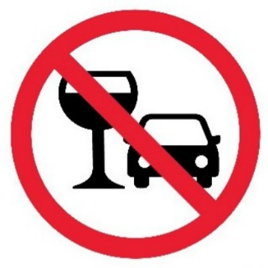
A. You cannot use glasses in the car.
B. You mustn’t drink anything while you are driving.
C. You should stop driving if you want to drink water.
D. You are not allowed to drink alcohol before and while driving.
Câu 2. When does the science club meet?
Science Club Notice:
Science club opening soon! Meets Tues/Thurs after school in room 205. First meeting on Sept. 14th at 3:30 pm.
A. Monday and Wednesday after school B. Sunday afternoon
C. Tuesday and Thursday after school D. Saturday morning
Câu 3. What does this sign mean?
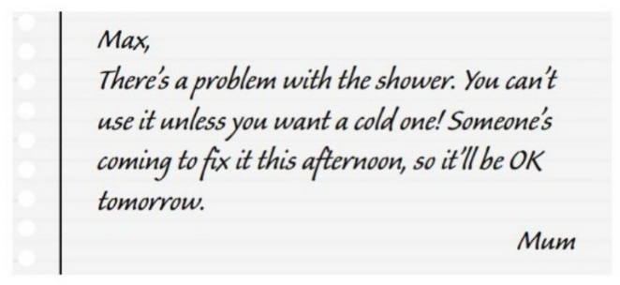
A. Max can take a hot shower now. B. Someone helped Max fix the shower.
C. Max can only have hot shower tomorrow. D. Mum needs Max to fix the shower.
Câu 4. What is true about the New Zealand advertisement?
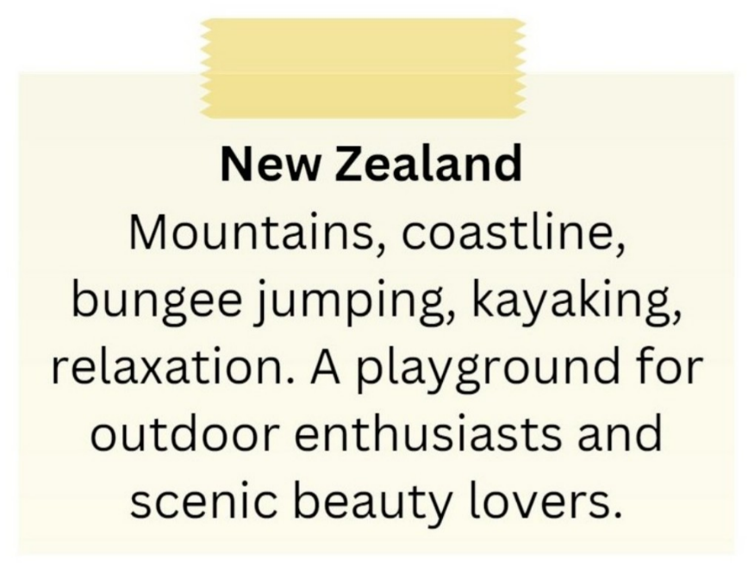
A. It highlights mountains, coastline, bungee jumping, and kayaking.
B. It primarily appeals to relaxation enthusiasts.
C. It is not suitable for outdoor enthusiasts.
D. It is a destination for indoor activities and cultural experiences.
Câu 5. What does it say?
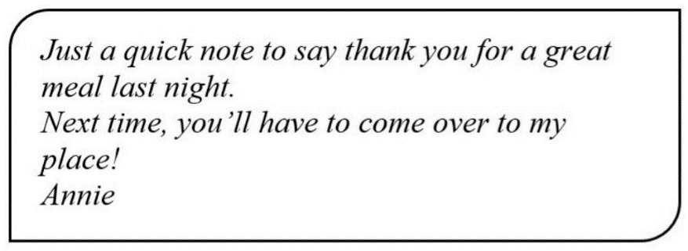
A. Annie invited her friend to her house last night. B. Annie cooked a great meal last night.
C. Annie went to her friend’s house last night. D. Annie went to a restaurant last night.
Câu 6. What does Rachel offer to do?
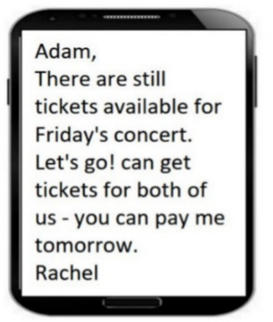
A. Get tickets for both of them B. Reserve tickets for Adam
C. Buy tickets for Adam D. Pay for both tickets
Câu 7. What did the person forget at home?
“Hey, I hope you’re doing well. I realized this morning that I left my calculator at home and we have a math test today. I was wondering if you could lend me yours for the test? I promise to return it as soon as the test is over. Thank you so much!”
A. Calculator B. Pen C. Notebook D. Textbook
Câu 8. Where is the proposed meeting location for the activity?
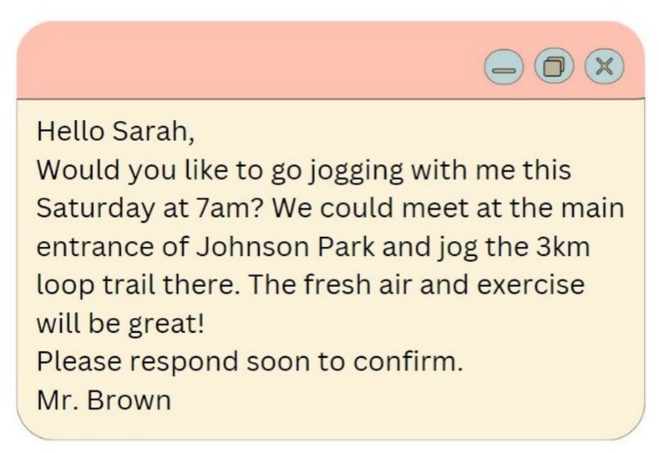
A. Johnson Park B. Hyde Park C. Central Park D. Smith Park
Câu 9. Look at the signs. Choose the best answer for the question.
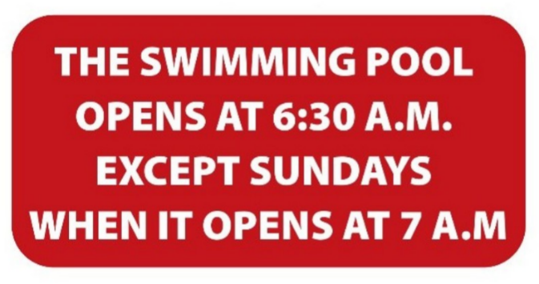
A. The swimming pool opens at 6:30 every morning.
B. The opening hour of the swimming pool on Sunday is 7 a.m.
C. The swimming pool opens earlier on Sundays.
D. The swimming pool opens later during the week.
Câu 10. What is true about this notice?
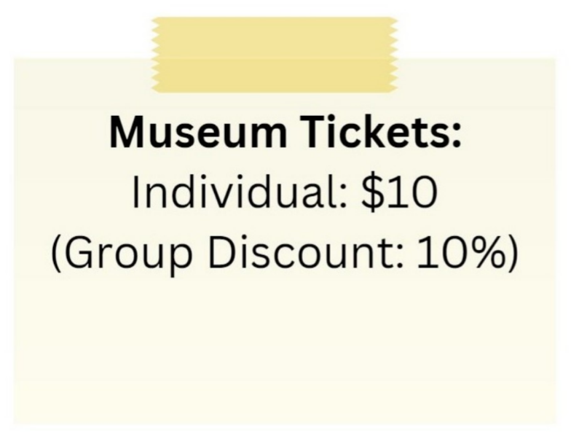
A. The individual ticket price is $10 and there is a 10% group discount.
B. The group discount is 20%.
C. There is no group discount available.
D. The individual ticket price is $5.
----HẾT---

