School: ……………………………………….. | Date:……………………………………..
Class: ……………………………..................... | Period: 46

Review Unit 4, page 92
1. Objectives
By the end of this lesson, students will be able to…
1.1. Language knowledge/ skills
- review the target language learnt in the unit
- practice test taking skills
1.2. Competences
- improve Ss’ communication, collaboration, analytical, critical thinking skills.
1.3. Attributes
- know the dangers of natural disasters and how to keep safe.
2. Teaching aids and materials
- Teacher’s aids: Student’s book and Teacher’s book, class CDs, DCR– Phần mềm tương tác trực quan, DHA – Ứng dụng trò chơi tương tác, projector / interactive whiteboard /TV (if any), PowerPoint slides.
- Students’ aids: Student’s book, Workbook, Notebook.
3. Assessment Evidence
Performance Tasks | Performance Products | Assessment Tools
- Listen to a boy talking to his classmate about a disaster and complete questions.  - Read an announcement about a wildfire and choose the correct answer (A, B, or C). | - Ss’ answers.  - Ss’ answers. | - Observation.  - Observation.
4. Procedures
A. Warm up: 5’
a. Objectives: review the vocabulary related to disasters learnt in the unit.
b. Content: miming games.
c. Expected outcomes: Ss can name the activity mimed by their friends.
d. Organization
Teacher’s activities | Students’ activities
WORDSEARCH  - Explain the game: T divides the class into 2 teams; 2 Ss from 2 teams go to the board, listen to the teacher’s definition, find the word in the wordsearch shown on the board and circle it; the faster will get a point for their team; the team with more correct guesses will win.  - Get Ss to play in 2 teams.  - Decide the winner.  1. EMERGENCY SERVICES  2. ESCAPE PLAN  3. SUPPLIES  4. FIRE EXTINGUISHER  5. BATTERIES  6. FIRST AID KIT  7. BOARD UP  8. STOCK UP  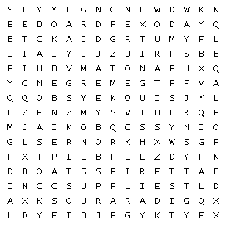 | 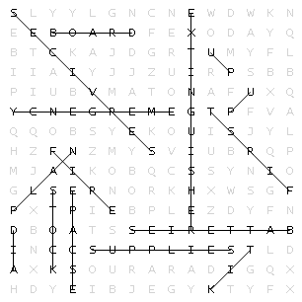
B. New lesson
1. Listening: 15’
a. Objectives: to help Ss listen for details and understand the conversation.
b. Content: listening task
c. Expected outcomes: Ss can complete the questions correctly.
d. Organization:
Teacher’s activities | Students’ activities
Pre-listening  You will hear a boy talking to his classmate about a disaster. Listen and complete questions 1–5. You will hear the conversation twice.  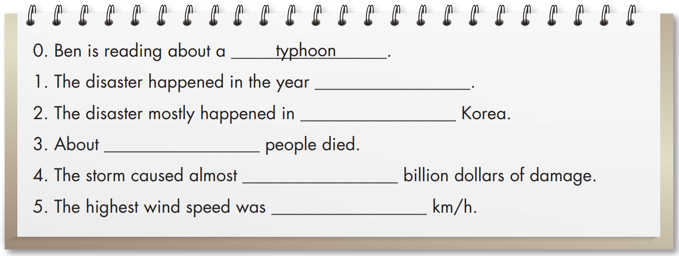  - Ask Ss to read the questions carefully and guess the missing information: noun, adjective, verb, or number.  - Pick some Ss to answer the questions.  - Give feedback.  While – listening  - Ask Ss to listen and complete the questions.  - Let Ss check answers with their partners after the first listening.  - Check Ss’ answers after the second listening. | - Read the questions carefully and guess the missing information.  -Give answers.  Possible answers:  - Number (year)  - Place  - Number  - Number  - Number  -Listen and complete the questions.  - Check answers with their partners.  - Check their answers.  Answer Keys:  0. typhoon  1. 2003  2. North and South  3. 120  4. 5  5. 280
2. Reading: 20’
a. Objectives: to help Ss practice reading for gist and specific information.
b. Content: reading task.
c. Expected outcomes: Ss can read and choose the correct words to complete the sentences.
d. Organization
Teacher’s activities | Students’ activities
Pre-reading:  - Ask Ss to work look at the title and guess what information they may find in the text.  - Pick some Ss to answer the questions.  - Give feedback.  Vocabulary:  - National Weather Service (n phr): /næʃənəl ˈweðər ˌsɜːvɪs/ dịch vụ thời tiết quốc gia  - spread (n): / spred /: lan rộng  - Ask Ss to read the text and underline the words above.  - Get Ss to try to guess their meanings in the context first.  - Explain the meanings of the words.  - Ask Ss to listen and repeat chorally and individually.  - Check Ss’ remembering.  - Ask Ss to read the questions and underline key words.  0. The announcement is about __________.  1. The wildfire warning __________.  2. People should have __________.  3. People should __________.  4. People should follow __________ | - Look at the title and guess what information they may find in the text.  Possible answers:  The name of the disaster, location, time, dangers, instructions to keep safe.  - Read the text and underline the words.  - Try to guess their meanings in the context.  - Listen to the teacher and take notes the meanings of those words.  - Listen and repeat chorally and individually  - Answer the teacher.  - Read the questions and underline key words.  0. The announcement is about __________.  1. The wildfire warning __________.  2. People should have __________.  3. People should __________.  4. People should follow __________
While-Reading  Look and read. Choose the correct answer (A, B, or C)  0. The announcement is about __________.  A. a flood  B. wildfires  C. an earthquake  1. The wildfire warning __________.  A. is for the city of Riverview  B. ends the next day  C. ends the same day at 1 p.m.  2. People should have __________.  A. lots of food  B. lots of fresh water  C. batteries  3. People should __________.  A. stay in their homes  B. turn off the electricity  C. go to the store to buy what they need  4. People should follow __________.  A. their neighbors  B. their escape plans  C. the smoke  - Ask Ss to read the text messages; scan the key words and choose the correct answer  - Monitor the class and help them if necessary.  - Let Ss check the answers with their partners.  - Pick some Ss to give their answers.  - Give feedback. | -Read the text messages and choose the correct answer.  - Check the answers with their partners.  - Give their answers.  Answer keys:  0. B. wildfires (What: wildfires)  1. B. ends the next day (When: from 21:00 August 11th to 23:00 August 12th)  2. C. Batteries (Instructions: line 4: Have flash light and batteries.)  3. A. stay in their homes (Instructions: line 6: Stay inside your home, and …)  4. B. their escape plans (Instructions: line 8: … and follow your escape plan.)
Post-reading  In pairs: tell your partner what instruction you think is the most important and why.  -Ask Ss to tell your partner what instruction they think is the most important and why.  -Pick some Ss to share their ideas.  - Give feedback. | -Ask their partners tell your partner what instruction you think is the most important and why.  -Share their ideas.
C. Consolidation and homework assignments: 5 minutes
- Vocabulary: National Weather Servive, spread.
- Do exercises in workbook on page 53.
- Prepare the next lesson: Review Unit 4, page 93.
5. Reflection

a. What I liked most about this lesson today:
…………………………………………………………………………………………
b. What I learned from this lesson today:
…………………………………………………………………………………………
c. What I should improve for this lesson next time:
…………………………………………………………………………………………

