**LỚP 8 GHK1 FORM 2026 TEST 3**

***Mark the letter A, B, C or D on your answer sheet to indicate the word whose underlined part differs from the other three in pronunciation in each of the following questions.***

**Question 1.** A. cook B. cool C. good D. football

**Question 2.** A. invited B. unloaded C. surrounded D. arrived

***Mark the letter A, B, C or D on your answer sheet to indicate the word that differs from the other three in the position of primary stress in each of the following questions.***

**Question 3.** A. enjoy B. connect C. fancy D. prepare

**Question 4.** A. bullying B. activity C. harvester D. teenager

***Mark the letter A, B, C or D on your answer sheet to indicate the correct answer to each of the following questions.***

**Question 5.** It usually rains __________ in my country than in yours.

A. heavier B. more heavier C. more heavily D. most heavily

**Question 6.** Linh: “You look so great with a tan, Nam!” - Nam: “ ____________”

A. Thank you. I’ve come back from my summer holiday.

B. Sorry. You don’t like tans.

C. What a pity! I’ve just travelled here and there.

D. Oh, I envy you.

**Question 7.** In his free time, my younger brother is crazy__________ taking photos and doing puzzles.

A. in B. on C. of D. about

**Question 8.** Posting personal pictures on social media is fun; __________, sometimes it can bring many problems.

A. therefore B. but C. however D. so

**Question 9.** I’m not fond of ____________ our class photos to the forum.

A. uploading B. surfing C. messaging D. browsing

**Question 10.** Does Tom enjoy ____________ in the park with his friends?

A. cycle B. to cycle C. to cycling D. cycling

**Question 11.** We have ____________ from our exams, peers, and parents. This makes us feel very stressed.

A. interests B. pressure C. friends D. expectations

**Question 12.** There are many ____________ leisure activities such as mountain biking or skateboarding.

A. exciting B. excited C. excite D. excitation

***Read the following announcement and mark the letter A, B, C or D on your answer sheet to indicate the correct option that best fits each of the numbered blanks from 13 to 16.***

|  |  |  |  |
| --- | --- | --- | --- |
| **UNDERSTANDING COMMON HEALTH PROBLEMS**  It’s important to know about common health problems so we can deal with them effectively.   * One common issue is the flu. When you (13) the flu, you might have a fever, cough, and sore throat. Remember to rest a lot. * Another problem can be a headache. If you often get headaches, make sure you (14) enough water and don't spend too much time in front of screens. * Sometimes, students get a stomachache. This can happen if you eat unhealthy food or eat too   quickly. It’s always best to eat (15) and chew your food well.   * If you feel unwell, don't hesitate to talk to your parents or a doctor. They can give you the best advice (16) how to get better. | | | |
| **Question 13**. A. catch  **Question 14.** A. drink | B. caught  B. drinking | C. catching  C. drank | D. catches  D. to drink | |
| **Question 15.** A. quick | B. slow | C. slowly | D. fast | |
| **Question 16.** A. on | B. about | C. with | D. for | |

***Question 17:******Put the sentences (a-c) in the correct order, then fill in the blank to make a logical text.***

We decided to have a picnic by the lake last Sunday. Everything was perfect until something unexpected happened. _________  
**a.** As soon as we finished setting up, dark clouds appeared in the sky.  
**b.** We packed all the food and drinks and headed to the lake early in the morning.  
**c.** Suddenly, it started raining heavily, and we had to rush back to the car.

**A**. b-a-c **B.** c-b-a  
**C**. a-c-b **D**. b-c-a

***Question 18: Choose the sentence that you can end the text (in Question 05) most appropriately.***

**A.** The rain stopped, and we enjoyed the rest of the day by the lake.  
**B.** Despite the rain, we still managed to have fun indoors.  
**C**. We didn’t let the rain ruin our day, so we continued the picnic in the rain.  
**D**. We decided to drive home and have the picnic inside instead.

***Read the following passage and mark the letter A, B, C or D on your answer sheet to indicate option that best fits each numbered blank from 19 to 24.***

Breakfast is the (19) important meal of the day. It provides the nutrients your body needs for good health, the calories it needs for (20) and helps to maintain your blood sugar level. Studies have shown that people who don't have breakfast have a low blood sugar level and are often slow, tired, hungry and

(21) to concentrate. Surprisingly, breakfast actually plays a part in weight control. It's easier to (22)

weight if you eat in the morning rather than later in the day. Dividing the day's calories (23) three meals helps take-off weight more efficiently than (24) breakfast and having two larger meals a day does.

**Question 19.** A. healthy B. tasty C. main D. most **Question 20.** A. strength B. power C. energy D. effort **Question 21.** A. able B. enable C. unable D. capable **Question 22.** A. lose B. put C. gain D. drop **Question 23.** A. in B. into C. up D. for **Question 24.** A. skipping B. making C. buying D. serving

***Mark the letter A, B, C or D on your answer sheet to indicate the sentence that closest in meaning to the original sentence in each of the following questions.***

**Question 25.** If you often go swimming, you will keep fit.

* + 1. Swimming will help you keep fit.
    2. Swimming will make you happy
    3. Swimming is a good hobby
    4. You should go swimming as much as possible.

**Question 26.** It is bad for your heart if you eat too much meat.

1. Eating too much meat is best for your heart
2. Eating too much meat is bad for your heart
3. Eating too much meat is beneficial for your heart
4. Your heart says bad when you eat meat.

***Mark the letter A, B, C or D on your answer sheet to indicate the sentence that is made from the given cues in each of the following questions.***

**Question 27.** Watch/ TV/ too much/ not/ be/ good/ your eyes

1. Watch TV too much is not good for your eyes.
2. Watch TV too much is not good enough for your eyes.
3. Watching TV too much is not good for your eyes.
4. Watching TV too much is not be good for your eyes.

**Question 28.** Many towns/ be/ full / shopping malls/ and/ fast food restaurants

1. Many towns be full of shopping malls and fast food restaurants.
2. Many towns are full in shopping malls and fast food restaurants.
3. Many towns are full on shopping malls and fast food restaurants.
4. Many towns are full of shopping malls and fast food restaurants.

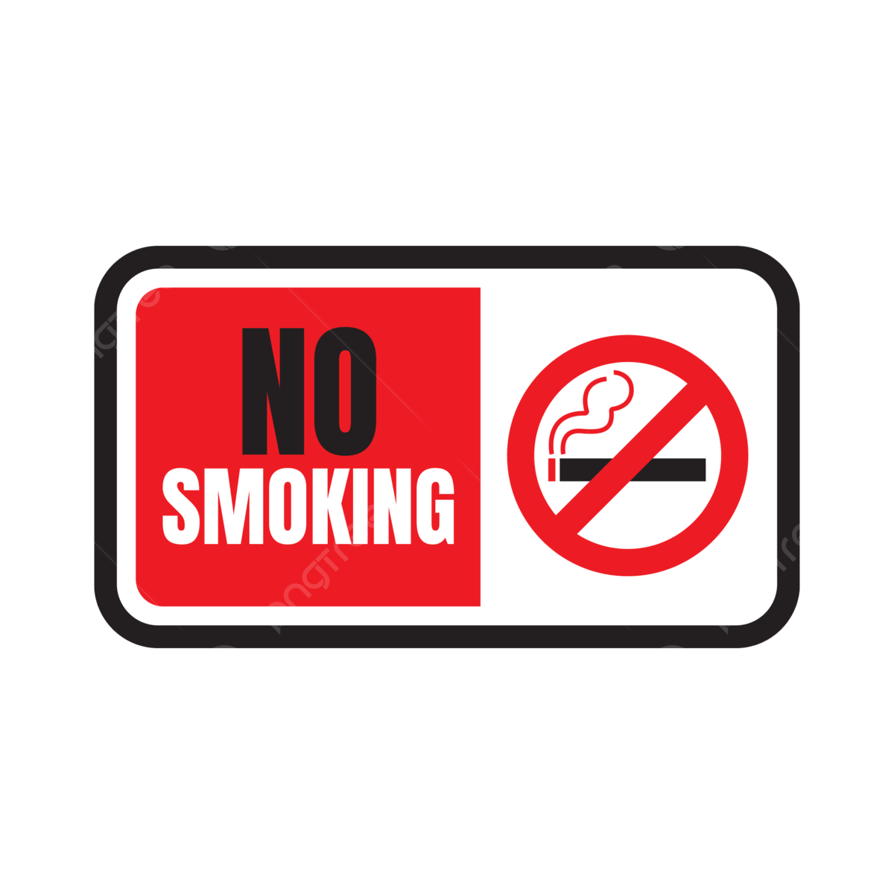Question 3: What does the sign say?

A. You can smoke anywhere, including in this area.  
B. Smoking is only allowed in specific areas that are marked for it.  
C. Smoking is not allowed at all in this area to keep it clean and safe.  
D. Smoking is encouraged and welcome in this area.

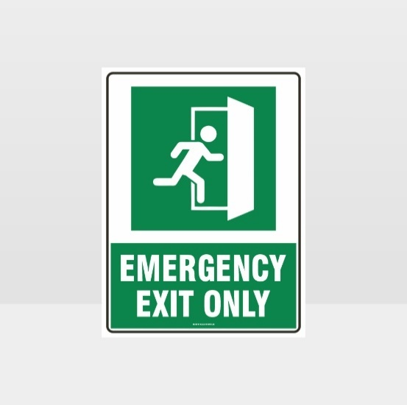Question 4: What does the sign say?

A. You can use this door anytime you want to enter.

B. This door is only for use in emergencies when you need to leave quickly.

C. Everyone should use this door to enter the building.

D. This door is locked and cannot be opened at all.

***Read the following passage and mark the letter A, B, C or D on your answer sheet to indicate the correct answer to each of the following questions from 31 to 36.***

**WE ALL NEED EXERCISE**

The body needs exercise. Exercise uses up food and keeps the body strong. It makes your heart and muscles strong. Exercise also makes you feel good. If you exercise a few times a week, you will stay healthy and happy.

Some people in America do not get enough exercise. They work in office buildings sitting in a chair all day in front of computers. They live far from their offices, and they have to drive their cars to get to work. Therefore, when they get home at night, they don't want to exercise after work.

Today, many Americans are overweight. This causes health problems for some people. Doctors say that exercise can help people both **lose weight** and improve their health. So, many people are trying to get more exercise. But it takes time to change, and when people do not see a difference right away, they lose **interest** in exercising.

**Question 31.** The writer says that exercise .

A. only makes your muscles strong.

B. send blood to your muscle.

C. is only done in a gym.

D. makes your heart work hard to send blood to your muscles.

**Question 32.** The writer mentions that in America, .

A. many people spend much time driving to work.

B. most office workers can get a lot of exercise.

C. many people are overweight because they don't get enough exercise.

D. Americans don't like doing exercise.

**Question 33.** Why don't the Americans get enough exercise?

A. They find it difficult to exercise. B. They don't have enough time to exercise.

C. They feel tired of exercising. D. They don't want to lose weight.

**Question 34.** According to the reading, which fact is NOT TRUE?

A. Exercise makes you feel good.

B. Some people do not get enough exercise.

C. Many people have to drive their cars to work.

D. Many people don't want to get exercise after work because they are lazy.

**Question 35.** The word “**interest**’’ is CLOSEST in meaning to .

A. Love B. talent C. time D. effort

**Question 36.** The phrases “**lose weight**” is OPPOSITE in meaning to .

A. Have weight B. gain weight C. get weight D. weigh more

***Four phrases/ sentences have been removed from the text below. For each question, mark the letter A, B, C or D on your answer sheet to indicate the correct option that best fits each of the numbered blanks from 37 to 40.***

**THE BENEFITS OF VOLUNTARY WORK**

Nowadays, volunteer work attracts a large number of attendants from different age groups (37) . Firstly,

(38) , foster independence and form the ability to deal with difficulties in different situations. Secondly, every member will be taught how to work in a team, the way to make conversation or the responsibility of finishing a task. (39) , helping you tackle serious problems in later life. In addition, volunteer work can help US adapt to something new and make many new friends through regular activities of clubs or organizations. We can also have a chance to travel more and explore more interesting things we have not experienced before. (40) .

A. The experience you gain will be valuable for your future

B. voluntary work provides the adolescents many precious opportunities to develop social skills

C. In conclusion, it is very good to do voluntary work

D. because of its huge benefits

**Question 37. Question 38. Question 39. Question 40.**