WEEK: … Date of planning: …
PERIOD: … Date of teaching: …

UNIT 7: ENVIRONMENTAL PROTECTION
Lesson 3: A closer look 2

I. OBJECTIVES
By the end of this lesson, Ss will be able to:
1. Knowledge
- use the Complex sentences with adverb clauses of time;
2. Competences
- Develop communication skills and creativity
- Be collaborative and supportive in pair work and teamwork
- Actively join in class activities
3. Personal qualities
- Love talking about environment
II. MATERIALS
- Grade 8 textbook, Unit 7, A closer look 2
- Computer connected to the Internet
- Projector / TV
- hoclieu.vn
III. PROCEDURES
1. WARM-UP (6 mins)
a. Objectives:
- To review the adverb clauses of time.
- To introduce the term of adverb clauses of time
b. Content:
- Show sentences to lead in the lesson.
- Students identify the adverb clauses of time.
c. Expected outcomes:
- Students’ answers.
d. Organisation
TEACHER’S AND STUDENTS’ ACTIVITIES | CONTENTS
Leading in:  - Teacher shows some sentences on the screen  - Teacher asks students to identify the time in each sentence.  - Teacher give some follow-up questions to lead in the introduction of the target grammar point.  - T sets the context for the lesson. | Questions:  1. I always take a bath before I go to bed.  2. Will you wait here until I am ready?  3. I was not at home when he came to see me.  4. Do not disturb me when I am busy with my work.  5. As soon as she finished that project, she started working on the next.  6. After I have finished my work, I will accompany you to the park.  Suggested answers:  1. I always take a bath before I go to bed.  2. Will you wait here until I am ready?  3. I was not at home when he came to see me.  4. Do not disturb me when I am busy with my work.  5. As soon as she finished that project, she started working on the next.  6. After I have finished my work, I will accompany you to the park.
2. ACTIVITY 1: PRESENTATION (10 mins)
a. Objectives:
- To help Ss identify the form of complex sentences with adverb clauses of time.
b. Content:
- Introduce the grammar point of the lesson.
- Ss do the task 1
c. Expected outcomes:
- Students know how to use the target grammar.
d. Organisation
TEACHER’S AND STUDENTS’ ACTIVITIES | CONTENTS
Introduction of complex sentences with adverb clauses of time
- Have Ss study the Remember! box for a few minutes.  - Explain to Ss the form of a complex sentence: it contains one independent clause and at least one dependent clause. Then give them one or two examples.  - Introduce a complex sentence with an adverb clause of time: it contains one independent clause (main clause) and an adverb clause of time.  - Tell Ss that an adverb clause of time shows when something happens. Introduce to them the time connectors taught in this unit: before, after, when, while, till / until, as soon as, etc. | 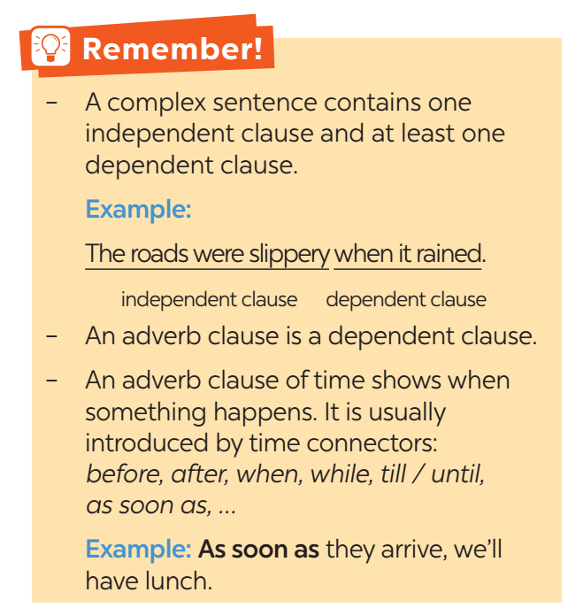
Task 1: Read the sentences and write I.C if the underlined clause is an independent clause or D.C if it is a dependent clause. (5 mins)
- Have Ss study the example first.  - Give Ss some time to read the sentences and write down the answers. T observes and helps when and where necessary.  - Ask Ss to read their sentences and give their answers.  - T corrects Ss’ mistakes.  - Teacher checks students’ understanding by asking some checking questions. |  | Answer key:  1. I.C  2. D.C  3. I.C  4. D.C  5. D.C
3. ACTIVITY 2: PRACTICE (16 mins)
a. Objectives:
- To teach Ss the use of the time connectors (before, after, when, while, till / until, as soon as, …) in complex sentences.
- To help Ss review the form and use of complex sentences with adverb clauses of time;
- To help them know how to match the main clause and adverb clause of time to make complex sentences
b. Content:
- Task 2 : Choose A, B, or C to complete each sentence.
- Task 3: Match the clauses in the two columns to form complex sentences.
- Task 4 : Combine each pair of sentences, using the conjunction in brackets.
c. Expected outcomes:
- Students understand how to use the target grammar.
d. Organisation
TEACHER’S AND STUDENTS’ ACTIVITIES | CONTENTS
Task 2: Choose A, B, or C to complete each sentence. (5 mins)
- Have Ss do these exercises individually and then compare their answers with a partner.  - Ask some Ss to write their answers on the board.  - Check the answers with the whole class.  - Confirm the correct answers. | Answer key:  1. A  2. A  3. C  4. C  5. B
Task 3: Match the clauses in the two columns to form complex sentences.
(5 mins)
- Have Ss do these exercises individually and then compare their answers with a partner.  - Ask some Ss to write their answers on the board.  - Check the answers with the whole class.  - Confirm the correct answers. | Answer key:  1. b  2. d  3. e  4. c  5. a
Task 4: Combine each pair of sentences, using the conjunction in brackets. (6 mins)
- Teacher asks Ss to read the situations carefully. If necessary, T may explain each situation to Ss.  - Ask Ss to complete the sentences individually and then compare their answers with a partner.  - Ask some Ss to write their answers on the board.  - Check the answers with the whole class. Confirm the correct answers.  - Teacher corrects students as a whole class. | Answer key:  1. I will call you as soon as I arrive at the station.  (As soon as I arrive at the station, I will call you.)  2. Many Vietnamese women wear conical hats when they work in the field.  3. My father taught me how to use the computer before he bought one for me.  (Before my father bought me a computer, he taught me how to use it.)  4. Nick is reading a novel while Jack is reading a cartoon.  (While Nick is reading a novel, Jack is reading a cartoon.)  5. After the tornado hit, there were only a few houses left standing.  (There were only a few houses left standing after the tornado hit.)
4. ACTIVITY 3: PRODUCTION (8 mins)
a. Objectives:
- To give Ss fun practice on how to make sentences with adverb clauses of time.
b. Content:
- Task 5: Matching game.
- Group work (Group A write main clauses; Group B write adverb clauses of time.)
c. Expected outcomes:
- Students’ funny sentences
d. Organisation
TEACHER’S AND STUDENTS’ ACTIVITIES | CONTENTS
Task 5: Matching game: Work in two groups, A and B. Group A write main clauses. Group B write adverb clauses of time. (8 mins)
- Have each student from group A write a main clause, and each student from group B write an adverb clause of time.  - Give them some time to work independently and write down their answers.  - Tell Ss to make sentences by matching their clauses from the two groups. Some clauses may make funny sentences.  - Teacher gives corrections and feedback. | Suggested outcome:  A: You must be careful  B: When you cross the street  -> You must be careful when you cross the street.
5. CONSOLIDATION (5 mins)
a. Wrap-up
- Ask one or two Ss to tell the class what they have learnt.
- Ask Ss to say aloud about using the complex sentences with adverb clauses of time
b. Homework
- Make 5 sentences about the complex sentences with adverb clauses of time
- Do ex. B 4,5,6 (P 56-57 in workbook)
- Prepare lesson 4: Communication
===================================

