Unit 6 Test
I. Listening
Listen to the Tet plan and fill in each blank with ONE word or a number.
Time | Activity | Details
8:00 | Clean the house | Mai helps her family clean the (1) __________.
9:30 | Go shopping | They buy peach flowers and a kumquat (2) _________.
11:00 | Cook special food | Her mother makes (3) __________ rolls.
15:00 | Visit grandparents | Mai says New Year (4) __________ to them.
20:00 | Watch fireworks | Children must not play with (5) …………..

II. Pronunciation
A. Choose the word whose bold part is pronounced differently.
6. A. sugar B. sure C. should D. sweets
7. A. rice B. city C. celebrate D. shopping
B. Choose the word that has a different stress pattern from the others.
8. A. decorate B. family C. relative D. tradition
9. A. furniture B. holiday C. behaviour D. festival

III. Language use
Choose the best answer A, B, C or D.
10. At Tet, children often get __________ from adults.
A. lucky money B. homework C. furniture D. rain
11. Children __________ behave well when they visit relatives.
A. should B. shouldn't C. are D. does
12. There is not __________ milk in the fridge.
A. some B. any C. many D. a few
13. You __________ break things during Tet.
A. should B. shouldn't C. do D. are
14. My mother buys __________ peach flowers before Tet.
A. some B. any C. much D. a little
15. Tet is a time for family __________.
A. gatherings B. waterfalls C. channels D. cartoons

IV. Signs & Notices
Look at the signs and choose the best explanation.

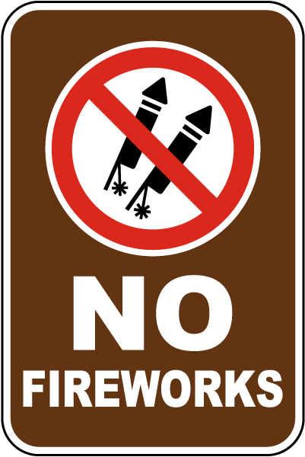 | 16. What does this sign mean?  A. You can buy colorful toy rockets at this place.  B. You should look at the beautiful lights in the sky.  C. You must not light or use fireworks in this area.  D. You need to call the firefighters if you see a fire.
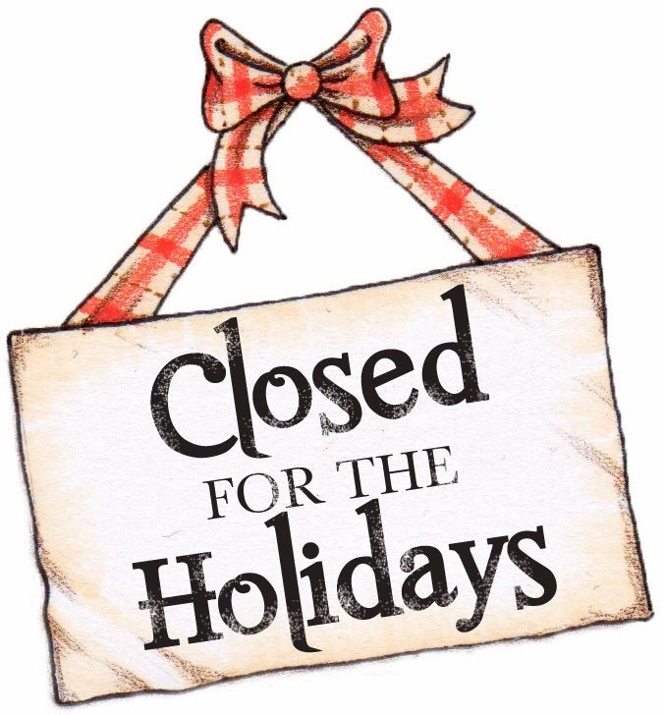 | 17. Read the notice. What is TRUE?  A. This shop is open all day to sell decorations for the festive season.  B. You should wrap your holiday gifts with a red and white ribbon.  C. You can only come into this place if you are on vacation.  D. You cannot go inside this place right now because it is a holiday.
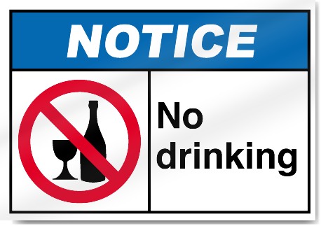 | 18. What does this sign mean?  A. You must not drink alcohol or wine in this area.  B. You should wash your glasses before you leave.  C. You need to open the bottles before entering this room.  D. You can buy fruit juice and cold water here.
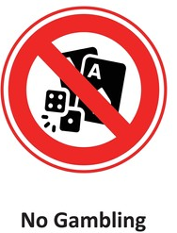 | 19. What can’t people do here?  A. You can buy new playing cards and dice at this shop.  B. You should practice playing board games before you go home.  C. You need to bring your own games to this room.  D. You must not play card or dice games for money in this area.
V: LOGIC
Rearrange the sentences (a-d) to make a complete conversation.
20.
a. Phong: I love it because it is a special time for family gatherings.
b. Vy: What do you like most about Tet, Phong?
c. Phong: Yes, they do. They usually get lots of lucky money from adults.
d. Vy: Me too! Do children enjoy this traditional holiday as well?
A. b - d - a - c B. b - a - d - c C. d - b - c - a D. c - d - a - b
21.
a. Tom: That's true. But should we eat too many sweets and drink soda?
b. Anna: What should children do to prepare for Tet, Tom?
c. Tom: We should help our parents clean the house and behave well.
d. Anna: No, we shouldn't. It's not good for our teeth.
A. b - a - c - d B. a - b - c - d C. c - d - b - a D. b - c - a - d
22.
a. Mai: Great idea! What time shall we meet?
b. Tom: Let's visit our English teacher this afternoon.
c. Mai: Sure, see you then. I will bring a beautiful flower pot.
d. Tom: How about three o'clock at the school gate?
A. b - a - d - c B. b - d - c - a C. c - d - b - a D. a - b - c - d
23.
a. Phong: Yes, my family always cooks banh chung and boiled chicken.
b. Vy: Does your family have any special food for Tet?
c. Vy: That sounds delicious! Do you have any traditional desserts?
d. Phong: We also have some dried candied fruits and melon seeds.
A. b - a - d - c B. a - b - c - d C. b - a - c - d D. d - c - b - a
VI: READING
A. Read and choose the correct word for each blank.
Tet is the most important holiday in Viet Nam. Before Tet, families clean their houses and decorate them with peach flowers. Children often get (24) _________ from adults. They should say New Year (25) _________ and behave well. People need (26) _________ food for family meals, but children should not eat too many sweets. They (27) _________ break things or fight during Tet.
24.
A. lucky money B. homework C. furniture D. sunscreen
25.
A. wishes B. caves C. rivers D. channels
26.
A. any B. some C. many D. a few
27.
A. should B. must C. shouldn't D. can
B. Read the text and choose the best answer A, B, C or D.
My name is Linh. I love Tet because it is a special time for my family. A week before Tet, we clean our house and decorate the living room with peach flowers and a kumquat tree. My mother cooks banh chung and other special food. My father buys some sweets and fruit. On the first day of Tet, we visit our grandparents. They give me lucky money in a red envelope. I always say wishes for their health and happiness. My parents say children should behave well, help with housework and say polite words. We should not break things, fight or eat too many sweets. In the evening, my family often watches fireworks together.
28. What is the text mainly about?
A. Linh's Tet holiday B. Linh's school C. A natural wonder D. A TV programme
29. What does Linh's family decorate the living room with?
A. Books and notebooks B. A compass and a map
C. A tent and a torch D. Peach flowers and a kumquat tree
30. What does Linh's mother cook?
A. Sandwiches only B. Pizza C. Banh chung and special food D. Banh chung
31. Who gives Linh lucky money?
A. Her teachers B. Her grandparents C. Tourists D. Guides
32. What does Linh say to her grandparents?
A. Wishes for health and happiness B. Directions to a market
C. Rules in a museum D. A shopping list
33. What should children do at Tet?
A. Eat too many sweets B. Break things
C. Fight with friends D. Behave well and help with housework
34. What should children not do?
A. Break things or fight B. Say polite words C. Visit grandparents D. Help parents
35. What does Linh's family often watch in the evening?
A. Football B. Fireworks C. A cartoon D. A weather forecast

VII: WRITING
A. Rearrange the words to make complete sentences.
36. do / What / people / before Tet / do /?
______________________________________________________________________
37. should / Children / behave well / during Tet /.
______________________________________________________________________
B. Rewrite the sentences without changing their meanings.
38. It is not good for children to break things during Tet.
Children ________________________________________________________________.
39. We need colour paper for the decorations.
We need ________________________________________________________________.
40. There isn't any milk in the fridge.
There is ________________________________________________________________.

AUDIO SCRIPT (PHẦN I: LISTENING)
Hello, everyone. This is Mai. Today I want to tell you about my family's Tet plan. At eight o'clock in the morning, I help my parents clean the house. We want our home to be nice and tidy before Tet. At nine-thirty, we go shopping. We buy peach flowers and a kumquat tree for the living room. At eleven o'clock, my mother makes spring rolls, our traditional food. In the afternoon, at three o'clock, we visit my grandparents. I say New Year wishes to them and wish them good health. In the evening, at eight o'clock, my family watches fireworks together. They are beautiful, but children must not play with fireworks because it is dangerous.
*************************************
Đáp án tham khảo
Listening: 1. house | 2. tree | 3. banh | 4. wishes | 5. fireworks
II. Pronunciation: 6. D | 7. D | 8. D | 9. C
III. Language use: 10. A | 11. A | 12. B | 13. B | 14. A | 15. A
IV. Signs & Notices: 16. C | 17. D | 18. A | 19. D
V. Logic: 20. B | 21. D | 22. A | 23. C
VI.A Cloze Test: 24. A | 25. A | 26. B | 27. C
VI.B Reading Comprehension: 28. A | 29. D | 30. C | 31. B | 32. A | 33. D | 34. A | 35. B
VII. Writing:
36. What do people do before Tet?
37. Children should behave well during Tet.
38. Children shouldn't break things.
39. We need some colour paper for the decorations.
40. There is no milk in the fridge.

