Date of preparing: ………………………………….
Date of teaching: ………………………………….

Period …
UNIT 5: AROUND TOWN
Lesson 3 - Part 1 (Page 44) - Vocabulary and Listening
Social Studies

I. OBJECTIVES
By the end of the lesson, Ss will be able to…
1. Knowledge
- know more vocabularies about food and ingredients.
- know more information about some food around the world.
2. Ability
- improve the use of English, speaking and listening skills.
3. Quality
- have positive attitude in English language learning so that they actively participate in all classroom activities.
- eat healthy food.

II. TEACHING AIDS AND LEARNING MATERIALS
Lesson plan, PPT slides, student’s book, workbook, notebook, personal computer (if any), projector/TV, speakers, DCR & DHA on Eduhome, handouts…
III. PROCEDURES
A. Warm up: (5’)
a) Objective: Introduce the new lesson and set the scene for Ss to acquire new language; get students' attention at the beginning of the class by means of enjoyable and short activities as well as to engage them in the steps that follow.
b) Content: Introduction of some dishes and ingredients
c) Product: Ss get to know some new words they are going to study in the lesson
d) Competence: collaboration, critical thinking, communication
e) Organization of the activity:
Teacher’s Activities | Students’ Activities
- Give greetings  - Check attendance  - Option 1: Dishes and ingredients  - Divide the board into 2 parts: Dishes and Ingredients  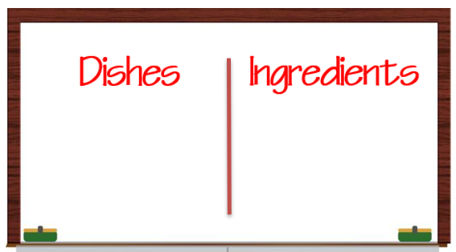  - Explain the word “ingredients”  - Prepare some pictures about food and ingredients    - Have Ss work in groups to decide which pictures are dishes and which ones are ingredients  - Have Ss hang them on the board  - Check and have Ss give names of the dishes and ingredients (as many as they can)  - Give feedback and lead to the new lesson.  - Option 2: Dishes and ingredients  - Have Ss work in groups to choose right ingredients that go with each dish  - Remind Ss that some ingredients can go with more than 1 dish  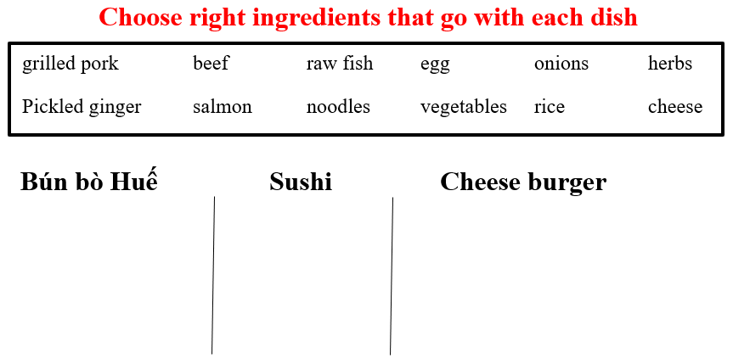  - Have Ss give answers  - Give feedback and lead to the new lesson | - Greet T  - Observe and listen  - Work in groups  Answer key  Dishes: pasta, sandwich, hamburger, pizza, beefsteak, soup  Ingredients: beef, spring onion, pork, vegetables, herbs, vinegar  -Work in groups, then read answers  Answer keys  1. Bún Bò Huế: beef, onions, herbs, noodle, vegetables  2. Sushi: raw fish, onions, herbs, pickled ginger, salmon, rice  3. Cheese burger: grilled pork, egg, onions, herbs, vegetables, cheese

B. New lesson (35’)
- Activities 1: Vocabulary (15’)
a) Objective: Ss know more vocabularies about ingredients in cooking
b) Content:
- Filling in the blanks
- Listening and repeating
- Making sentences with the new words
c) Products: Ss know how to pronounce the new words correctly and use them in appropriate situations.
d) Competence: communication, collaboration, presentation
e) Organization of the activity:
Teacher’s Activities | Students’ Activities
a. Fill in the blanks. Listen and repeat  - Demonstrate the activity using the example  - Have Ss look at the pictures and fill in the blanks with the words in the box  - Ask Ss to work in pairs to check their answers with their partners.  - Call Ss to give answers  - Check answers as a whole class.  - Play audio (CD1 – Track 64). Have Ss listen and repeat  - Call some Ss to read the words again  - Correct Ss’ pronunciation if necessary  b. Take turns to use the words in sentences  - Option 1:  - Demonstrate the activity using the example  - Have Ss take turns to make sentences with the new words they have learnt.  - Call Ss to give answers  - Give feedback and evaluation  - Option 2:  - Have work in groups and make sentences with the new words they have learnt.  - Have groups write their answers on the board  - Check and correct Ss’ mistakes  - Give feedback and evaluation | - Look and write  - Work in pairs  - Give answer  - Listen and repeat  - Read the words again  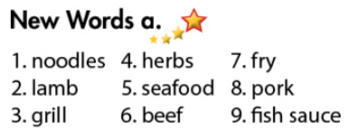  Answers keys  - Listen  - Do the task  - Give answers  - Work in groups  - Write answers  - Listen and check
- Activity 2: Listening (10’)
a) Objective: Ss can develop their listening comprehension skills
b) Content: Listening to a man talking about popular food from around the world
c) Products: Ss can listen for main ideas and details.
d) Competence: collaboration, communication, analytical and synthesizing skills.
e) Organization of the activity:

Teacher’s Activities | Students’ Activities
a. Listen to a man talking about popular food from around the world. Who is the speaker? a student / a customer or a chef?  - Have Ss look at the request of the task  - Play audio (CD1 – Track 65)  - Have Ss listen and answer the question by circling the right option  - Check answers as a whole class.  b. Listen and fill in the blanks, then match with the correct pictures  - Have Ss read the task and make a guess which words to be written in the spaces  - Demonstrate the activity  - Play audio (CD1 – Track 65) again.  - Have Ss listen and fill in the blanks  - Call Ss to read their answers  - Check answers as a whole class.  - Have Ss match the information with the correct pictures  - Check answers as a whole class | - Read  - Listen and give answer  Answer key  A chef  - Read and guess  - Listen and fill in the blanks  - Read answers  - Match  Answer keys  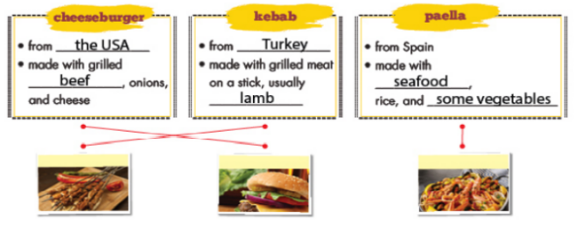
- Activity 3: Grammar – Useful language (10’)
a) Objective: Ss can use some useful language in their speaking
b) Content: structures to ask and answer about dish and ingredients
c) Products: Ss use this structure in communication.
d) Competence: collaboration, communication, public speaking.
e) Organization of the activity:
Teacher’s Activities | Students’ Activities
Listen then practice  - Option 1:  - Have Ss look at the Useful Language box  - Explain  - Explain the structure:  What do people make it with?  - Play audio (CD1 – Track 66)  - Have Ss practice the useful language  - Call some pairs to present, give feedback and evaluation  - Option 2:  - Follow the same steps as option 1  - Have Ss practice the conversation, using other vocabularies from “New words” and Listening”, and their own ideas  - Have Ss act out the conversation as naturally as they can (without using the textbook)  - Give feedback and evaluation | - Look  - Listen and take notes  - Listen  - Practice in pairs  - Present  Suggested conversation  A: What’s cheese burger?  B: It’s a dish from the USA  A: What do people make it with?  B: grilled beef / pork, onions and cheese  - Work in pairs  - Present

C. Consolidation (3’)
* Vocabularies about dishes and ingredients
* Structures:
What is + name of the dish?
What do people make it with?

D. Homework (2’)
- Practice asking and answering about dishes and ingredients.
- Do exercises in Workbook: Lesson 3 - New words – Listening (page 30).
- Prepare: Lesson 3 – Reading, Speaking and Writing (page 45 – SB).

