School: ……………………………………….. | Date: ………………………………..
Class: ……………………………..................... | Period: ………………………..........

UNIT 8: FESTIVALS AROUND THE WORLD
Lesson 4 – Review (pages 104, 105)

I. OBJECTIVES
By the end of the lesson, Ss will be able to:
1.1. Language knowledge and skills
- review words about festival and its activities (lantern, midnight, competition, exchange, sculpture, bonfire, tradition, wish, …) and talk about them.
- review grammar: the Simple Future, different from, like.
- talk about festivals, compare how different countries celebrate festivals.
- pronoun some vowels correctly: /ɪ/, / aɪ /, / æ/, / eɪ/.
- put stress on nouns (common nouns & proper nouns) and verbs with two and three syllables.
1.2. Competences
- improve speaking, listening, reading and writing skills.
- improve the use of English.
1.3. Attributes
- have positive attitude in English language learning so that they actively participate in all classroom activities.
- review the old lesson and have good preparation for any assessment.

II. TEACHING AIDS AND LEARNING MATERIALS
1. Teacher’s aids: Student book and Teacher’s book, class CDs, Digital Book (DCR phần mềm tương tác SB, DHA (từ vựng/ cấu trúc) phần mềm trò chơi tương tác), projector/interactive whiteboard / TV (if any), PowerPoint slides, handouts.
2. Students’ aids: Student’s book, workbook, notebook.

III. ASSESSMENT EVIDENCE
Performance Tasks | Performance Products | Assessment Tools
- Listening: You will hear five short conversations. You will hear each conversation twice. There is one question for each conversation. For each question, choose the correct answer (A, B, or C). | - Ss’ answers. | - T’s feedback/Peers’ feedback.
- Reading: . Read about the festival. Write one word for each blank. | - Ss’ answers. | - T’s feedback/Peers’ feedback.
- Vocabulary: Match the words with the definitions. | - Ss’ answers. | - T’s feedback/Peers’ feedback.
- Grammar: Write sentences using the Future Simple  - Write sentences with different from or like using the table. | - Ss’ answers. | - T’s feedback/Peers’ feedback.
-Pronunciation: Circle the word that has the underlined part pronounced differently from the others.  + Circle the word that differs from the other three in the position of primary stress in each of the following questions. | - Ss’ answers/ presentation. | - T’s observation, T’s feedback/Peers’ feedback.

IV. PROCEDURES
A. Warm up: (5’)
a) Objective: Introduce the new lesson and set the scene for Ss to acquire new language; get students' attention at the beginning of the class by enjoyable and short activities as well as to engage them in the follow-up steps.
b) Content: Review: Festivals around the world.
c) Expected outcomes: Ss are ready for the new lesson.
d) Organization of the activity:
TEACHER’S ACTIVITIES | STUDENTS’ ACTIVITIES
- Option 1: Chatting  - Ask Ss some questions about festival:  1. What is your favorite festival?  2. What do you know about it?  3. Can you tell some famous festivals around the world?  4. Which festival in the world would you like to take part in? Why?  5. What is the ideal duration for a festival?  - Call Ss to give answers.  - Give feedback.  - Lead to the new lesson.  - Option 2: Review: Festivals around the world  - Have Ss work in groups to divide the given festivals into 3 groups: music festivals, religious festivals and food festivals.  - Call Ss to give answers.  - Give feedback, show correct answers.  - Ask Ss whether they know any information of these festival.  - Lead to the new lesson.  *Illustration:  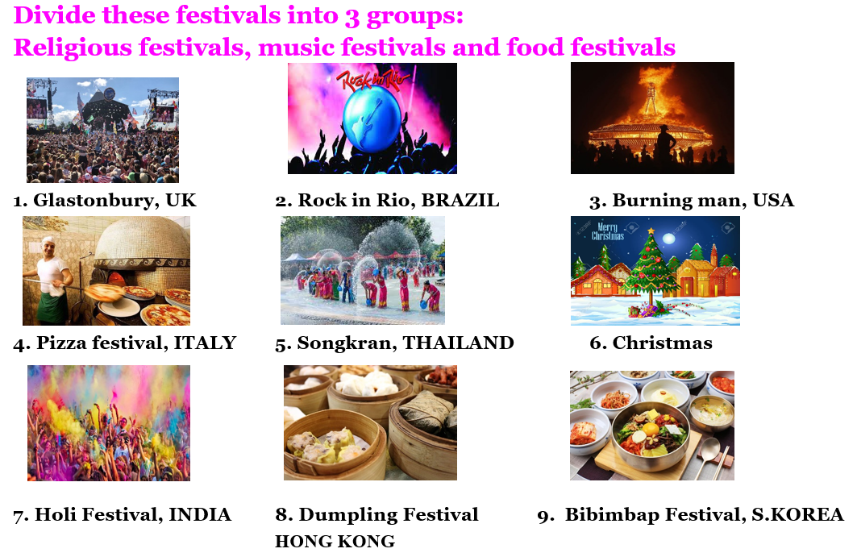 | - Listen and give answers.  - Listen.  - Work in groups.  - Give answers.  - Listen .  Answer keys  - Religious festivals: Christmas, Songkran Festival, Holi Festival  - Music festivals: Glastonbury Festival, Rock in Rio Festival, Burning man Festival  - Food festivals: Pizza Festival, Dumpling Festival, Bibimbap Festival

B. New lesson (35’)
- Activity 1: Listening (7’)
a) Objective: Help Ss improve their listening skill.
b) Content:
- You will hear five short conversations. You will hear each conversation twice. There is one question for each conversation. For each question, choose the correct answer (A, B, or C).
c) Expected outcomes: Ss listen in details and get familiar with the listening test format.
d) Organization of the activity:
TEACHER’S ACTIVITIES | STUDENTS’ ACTIVITIES
You will hear five short conversations. You will hear each conversation twice. There is one question for each conversation. For each question, choose the correct answer (A, B, or C).  - Have Ss read through the listening part.  - Demonstrate the activity by using the example.  - Play the audio (CD 2 – Track 42). Have Ss listen and choose the correct answer.  - Have Ss check answers with pairs, then read answers.  - Check answers as a whole class using DCR. | - Read in silence.  - Listen and read answers.  Answer keys
- Activity 2: Reading (7’)
a) Objective: Students can improve their reading skill.
b) Content:
- Read about the festival. Write one word for each blank.
c) Expected outcomes: Ss read for comprehension and get familiar with the reading test format.
d) Organization of the activity:

TEACHER’S ACTIVITIES | STUDENTS’ ACTIVITIES
Read about the festival. Write one word for each blank.  - Demonstrate the activity on DCR by using the example.  - Have Ss look and read, then write 1 word for each blank.  - Call Ss to give answers, explain.  - Give feedback and evaluation. | - Observe and listen.  - Work individually.  - Give answers, explain.  Answer keys  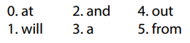

- Activity 3: Vocabulary (7’)
a) Objective: Ss can review vocabulary about festivals.
b) Content: Match the words with the definitions.
c) Expected outcomes: Ss produce the new language successfully, and they can use these words in speaking and writing.
d) Organization of the activity:
TEACHER’S ACTIVITIES | STUDENTS’ ACTIVITIES
Match the words with the definitions.  - Have Ss read the sentences.  - Ask Ss to work in pairs match the words with the definitions.  - Have Ss give answers, tell the meaning of the words /phrase again.  - Check answers as a whole class using DCR. | - Read the sentences.  - Work in pairs to match.  - Give answers.  Answer keys  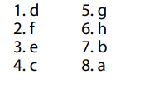
- Activity 4: Grammar (10’)
a) Objective: Ss can review the use of English: Future Simple, different from and like.
b) Content:
- Write sentences using the Future Simple.
- Write sentences with different from or like using the table.
c) Expected outcomes: Ss produce the new language successfully, and they can use the grammar points in speaking and writing.
d) Organization of the activity:
TEACHER’S ACTIVITIES | STUDENTS’ ACTIVITIES
Task a. Write sentences using the Future Simple.  - Have Ss tell the form and usage of the simple future again.  - Ask Ss to work individually to write sentences using the Future Simple.  - Have Ss work in pairs to check each other’s work.  - Call Ss to give answers, explain for their choice.  - Check answers as a whole class using DCR.  Task b. Write sentences with different from or like using the table.  - Ask Ss to read the information in the table.  - Have Ss write sentences with different from or like using the table.  - Have Ss work in pairs to check each other’s work.  - Call Ss to give answers.  - Check answers as a whole class using DCR. | - Retell.  - Work individually.  - Work in pairs.  - Give answers.  Answer keys  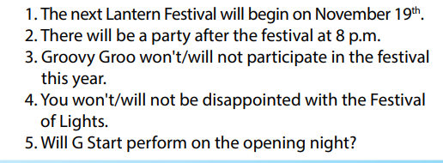  - Read.  - Work individually.  - Work in pairs.  - Give answers.  Answer keys  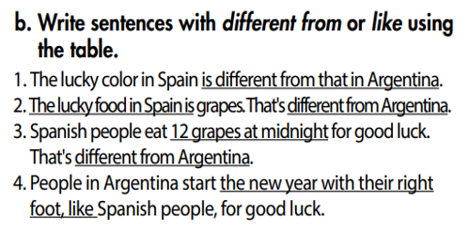
- Activity 5: Pronunciation (4’)
a) Objective: Ss can review the stress of nouns and adjectives with 2 and 3 syllables, /ɪ/, / aɪ /, / æ/, / eɪ/.
b) Content:
- Circle the word that has the underlined part pronounces differently from the others.
- Circle the word that differs from the other three in the position of primary stress in each of the following questions.
c) Expected outcomes: Ss produce the new language successfully.
d) Organization of the activity:
TEACHER’S ACTIVITIES | STUDENTS’ ACTIVITIES
Task a. Circle the word that has the underlined part pronounced differently from the others.  - Have Ss distinguish 3 vowels: /ɪ/, / aɪ /, / æ/, / eɪ/  (review).  - Ask Ss to work individually to circle the answer.  - Have Ss work in pairs to check each other’s work.  - Call Ss to give answers, pronounce the words again.  - Give feedback, correct Ss’ pronunciation if necessary.  Task b. Circle the word that differs from the other three in the position of primary stress in each of the following questions.  - Remind Ss some basic rules of putting stress on nouns and verbs with 2 or 3 syllables.  - Ask Ss to work individually.  - Have Ss work in pairs to check each other’s work.  - Call Ss to give answers, pronounce the words again.  - Give feedback, correct Ss’ pronunciation if necessary. | - Review.  - Work individually.  - Work in pairs.  - Give answers.  Answer keys    - Listen.  - Work individually.  - Work in pairs.  - Give answers.  Answer keys

C. Consolidation and homework assignments (5’)
* Consolidation:
* Grammar of Unit 8: The Simple Future, different from, like.
* Vocabulary of Unit 8: words about festival and its activities (lantern, midnight, competition, exchange, sculpture, bonfire, tradition, wish, …).

* Homework:
- Review vocabulary, grammar of unit 8.
- Do the exercises in WB: Review of Unit 8 (page 69).
- Prepare: Unit 9 – New words and Reading (page 68 – SB).

D. Reflection
a. What I liked most about this lesson today:
…………………………………………………………………………………………
- What I learned from this lesson today:
…………………………………………………………………………………………
c. What I should improve for this lesson next time:
…………………………………………………………………………………………

