ĐỒNG KHỞI- ĐỀ THAM KHẢO TS10

I. Choose the word / phrase / sentence (A, B, C or D) that best fits the space or best answers the question given in each sentence. (3.5 pts).
1. Which word has the underlined part pronounced differently from that of the others?
A. podcast B. owner C. follow D. office
2. Which word has the underlined part pronounced differently from that of the others?
A. myths B. talks C. facts D. blogs
3. Which word has a different stress pattern from that of the others?
A. plumber B. owner C. direct D. traffic
4. Which word has a different stress pattern from that of the others?
A. detox B. preserve C. demand D. expect
5. Simon: The local park is so dirty today.
Trang: Yeah, __________ people keep littering, no one will go and exercises there.
A. As B. While C. If D. Though
6. Vivien: It was frustrating that we got __________ in the traffic for nearly two hours this morning.
Tom: I know, I was almost late for school because of it too.
A. stuck B. impossiple C. divorced D. overcrowded
7. The talented musician captivated the __________ with her outstanding performance.
A. viewer B. audience C. producer D. actor
8. When the lights turn green, I cross the street at a __________.
A. sidewalk B. roundabout C. crosswalk D. normal
9. __________ allows users to immerse themselves in interactive and simulated environments.
A. Movie B. Media C. Technology D. Virtual reality
10. We need to call a ______________ as the kitchen sink is completely clogged and water is everywhere.
A. mechanic B. plumber C. architect D. designer
11. I __________ at 11 o'clock last night when I __________ a strange noise outside the window.
A. was sleeping - was hearing B. slept - heard C. was sleeping - heard D. slept - was hearing
12. There are __________ many vehicles on the road __________ traffic jams happen every day.
A. so - that B. such - as C. so - as D. such – that
13. More people are __________ to find a job as artificial intelligence is becoming more popular.
A. directing B. encouraging C. staying D. struggling
14. Linh: I think people won't be able to grow crops in the future.
Mai: __________
Linh: Well, because they are polluting the land, there won’t be any fields left.
A. What are we going to do? B. Sorry, can you explain that?
C. Do you know who did it? . D. Why do they grow crops?
FB: Thầy Đình (Dạy Tiếng Anh)
Answers: 1. ______ 2. ______ 3. ______ 4. ______ 5. ______ 6. ______ 7. ______
8. ______ 9. ______ 10. ______ 11. ______ 12. ______ 13. ______ 14. ______

II. Look at the sign or the notice. Choose the best answer (A, B, C or D) for questions 15 and 16. (0.5 pt)
15. What does the sign tell you to do? 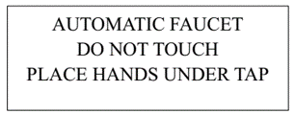 | A. You touch the faucet as it isn't automatic.  B. You need to put your hands under the sensor to start the water flow.  C. The faucet under the tap is automatic.  D. There are hands under the automatic faucet.
16. What does the notice mean?  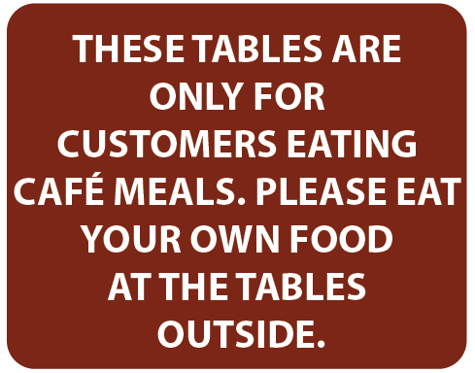 Answers: 15. __________ 16. __________ | A. The tables outside are for people who don’t eat food.  B. You cannot eat food at the tables outside.  C. If you want to eat at the tables, you have to bring your own food.  D. You can eat at the café tables if you buy food there.

III. Choose the word (A, B, C or D) that best fits each space in the following passage. (1.5 pts)
Urban Life
For thousands of years, most people in the world lived in small villages. Historians say that, in 1500 CE, less than 5% of the world’s people lived in cities. This was because the main job for thousands of years was farming. People lived next to the (17) __________ which had their animals or their food plants. There were famous cities in the old days, like Athens and Rome, but (18) ___________ these cities only had a small number of people. Athens never had more than about half a million people. When the Romans ruled about 70 million people in Europe, Africa and Asia, only about one million lived in the (19) __________ of their empire. People started to move to cities in large numbers about 400 years ago. Cities had better jobs, (20) ___________
young people wanted to move away from their villages. Then, new machines for farming started to take jobs away, so villagers had to move. Thirdly, people liked cities because they had things (21) ___________ schools, hospitals and theatres.
Now, about 55% of the world’s people live in cities. The UN thinks that, by 2060, nearly 70% of people will live in cities. We (22) ___________ make sure our cities are good places to live in.
17. A. houses B. fields C. villages D. towns
18. A. even B. yet C. as D. already
19. A. suburbs B. city C. capital D. cities
20. A. because B. if C. but D. so
21. A. such B. example C. like D. as
22. A. must B. have C. has to D. need
Answers: 17. __________ 18. __________ 19. __________
20. __________ 21. __________ 22. __________
FB: Thầy Đình (Dạy Tiếng Anh)
IV. Read the following passage carefully. Decide whether the statements from 23 to 26 are True or False and choose the correct answer (A, B, C or D) to complete the statements in the questions 27 and 28.
(1.5 pts)
Jobs in the Future
Some web articles about jobs talk a lot nowadays about artificial intelligence (AI). You might think that AI will soon replace people in all high-paid jobs like lawyers, surgeons or company directors. AI certainly brings a whole new range of IT skills to the world of work. For example, data analysis can find the reason for sales rising or falling or the illness which a person is probably suffering from. However, it is possible that AI will become a valuable tool for people with top jobs, not replace them, because there are still limits to the power of AI.
Take a lawyer, for example. While an AI system may have access to every law and similar case in history, it cannot, at present, talk to a person in court and decide, for example, how honest the person is.
In the case of a surgeon, she may benefit from an AI system’s complete knowledge of the way the human body works. But, at the moment, AI cannot use medical instruments in the way that a surgeon needs to be able to.
A company director can use an AI system to find out why something is happening to sales of a product, but the system does not have the ability to think of a solution.
Of course, all of these issues are about AI right now. In the future, it may be possible, for example, to add the ability to carry out complicated operations to an AI system for surgeons.

23. The first paragraph gives four examples of high-paid jobs.
24. An example in the second paragraph is about an issue with AI knowledge.
25. In the third paragraph, the writer says that AI at present cannot do, for example, a heart operation.
26. The fourth paragraph says that AI is good at suggesting reasons for business results from data analysis.
27. The writer chooses the examples of high-paid jobs because __________.
A. their jobs don’t only involve data analysis
B. they have the highest salaries
C. they already use AI systems
D. they will never benefit from AI systems
28. The writer __________.
A. thinks AI will replace all high-paid jobs in the future
B. doubts the ability of AI to help with high-paid jobs
C. is not sure whether AI can develop enough to replace people

D. does not give an opinion on AI and high-paid jobs.
Answers: 23. __________ 24. __________ 25. __________
26. __________ 27. __________ 28. __________

V. Use the correct form of the word given in each sentence: (1.5 pts)
29. I think fitness trackers are one of the most useful ______________. (INNOVATE)
30. If you want to be a successful video producer, you'll need a lot of __________. (CREATE)
31. The discovery of water on Mars has profound __________ for the possibility of life beyond Earth. (IMPLY)
32. Our team hopes to develop __________ solutions to environmental challenges. (INNOVATE)
33. Many jobs, __________ in the tech industry, are becoming increasingly popular. (SPECIAL)
34. I study with a tutor who provides __________ lessons to help me improve my English skills. (PERSON)
Answers: 29. ________________ 30. ________________ 31. ________________
32. ________________ 33. ________________ 34. ________________

VI. Look at the entry of the word ‘COMFORT’ in a dictionary. Use what you can get from the entry to complete the sentences with two or three words. (0.5 pt)
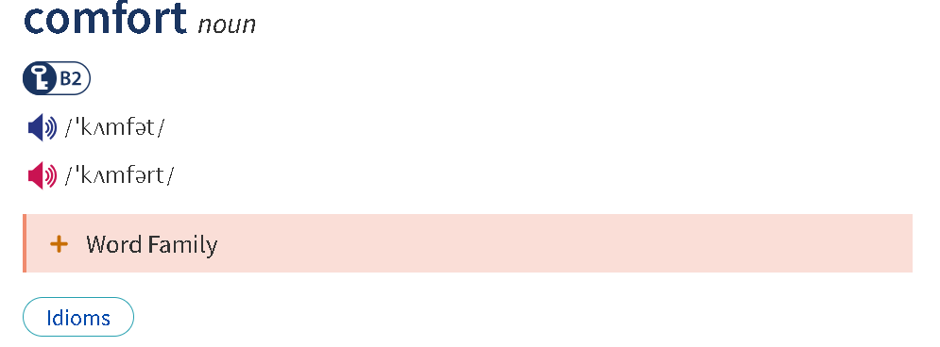
- In comfort: is used to refer to being in a state of ease, relaxation, or physical/emotional comfort.
Ex: He lives in comfort thanks to his well-paying job.
- In the comfort of something: is used to refer to being in a specific place or environment that provides comfort, safety, or relaxation.
Ex: They spent the weekend in the comfort of a luxury hotel.
- From the comfort of something: is used to refer to doing or experiencing something while staying in a comfortable location, typically without needing to move elsewhere.
Ex: You can shop online from the comfort of your home.

35. He attended the virtual meeting __________ of his office chair.
36. She spent her retirement _________, enjoying the peaceful countryside.
Answers: 35. ________________ 36. ________________
FB: Thầy Đình (Dạy Tiếng Anh)
VII. Rewrite the following sentences using the given words. (1.0 pt)
37. The pollution in the city is very severe. It poses serious health risks to the residents. (SO)
The pollution ________________________________________________________________
38. As the office was noisy, I moved to a quieter corner to finish my work.
Because of ___________________________________________________________________
39. “I don’t know what to wear at the party tonight,” Mary said.
Mary said that_________________________________________________________________
40. People think that many jobs will be replaced by artificial intelligence in the future.
Many jobs are expected _________________________________________________________

THE END OF THE TEST

