LỚP HỌC THẦY (CÔ) ___________________________ ĐỀ ÔN TẬP: READING SIGNS/ NOTICES – A2
Test 16
Thời gian làm bài: [Time]
Họ và tên: ________________________________________________ Lớp: 9/___
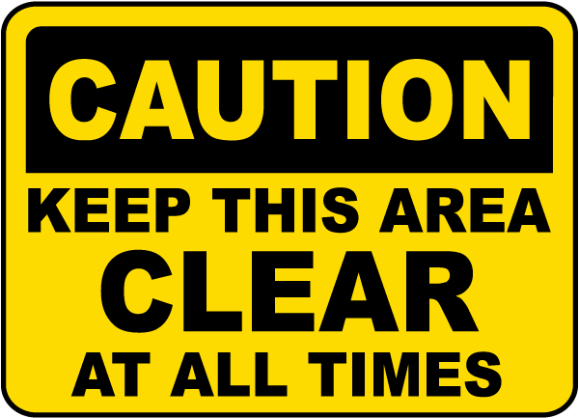
Question 1: What does this sign mean?
A. You are allowed to place objects in this area and block it off.
B. This area must be kept clean to ensure that the area is always well ventilated.
C. This area is not very important and can be used for storage or other purposes.
D. This area is not currently in use and does not need to be kept clean.

Question 2: Which of the following statements is true?
Speaking Contest
Speaking contest on 20th Oct at auditorium. Open to all students and professionals. Topic: "Future of Technology." Winner gets $150. Register by 15th Oct on website or at auditorium.
A. The topic of the speaking contest is "Future of Technology."
B. The winner of the speaking contest gets $100.
C. The speaking contest is only open to students.
D. The speaking contest is on 15th October.
Question 3: What does this sign mean?
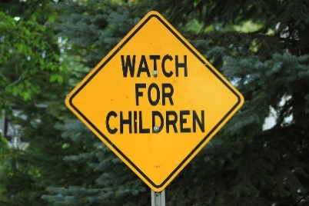
A. There are no children in this area at the moment.
B. Be careful and look out for children who may be in this area.
C. Children are not permitted to be in this area.
D. Children are playing in this area right now.

Question 4: What should you do according to the notice?
The library will be closed for a special event on Monday. Please return all borrowed items by Sunday.
A. Return all borrowed items by Sunday.
B. The library is closed only on public holidays.
C. The library will be open on Monday.
D. Return all borrowed items on Monday.
Question 5: What does this sign mean?
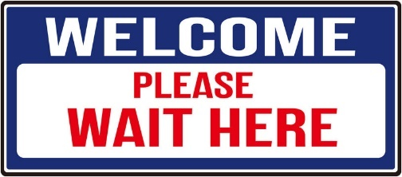
A. Go to a different place or location.
B. You can leave right away without waiting.
C. There is no need to wait in this area.
D. Stay and wait at this specific spot or location.

Question 6: Which of the following statements is true?
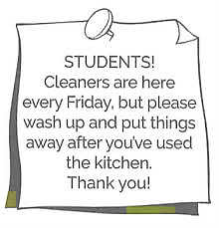
A. Students are not required to clean up after using the kitchen because cleaners come every Friday.
B. Students should clean up and put things away after using the kitchen, even though cleaners come every Friday.
C. Students can leave their things in the kitchen until the cleaners arrive on Friday.
D. The kitchen is cleaned every day by the cleaners, so students do not need to clean up after themselves.
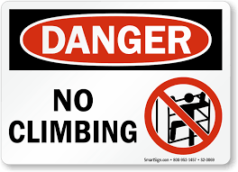
Question 7: What does this sign mean?
A. You are allowed to climb here.
B. Climbing is not suggested or recommended here.
C. Climbing is encouraged and you should do it here.
D. Climbing is not allowed or permitted in this area.

Question 8: Which of the following statements is true?
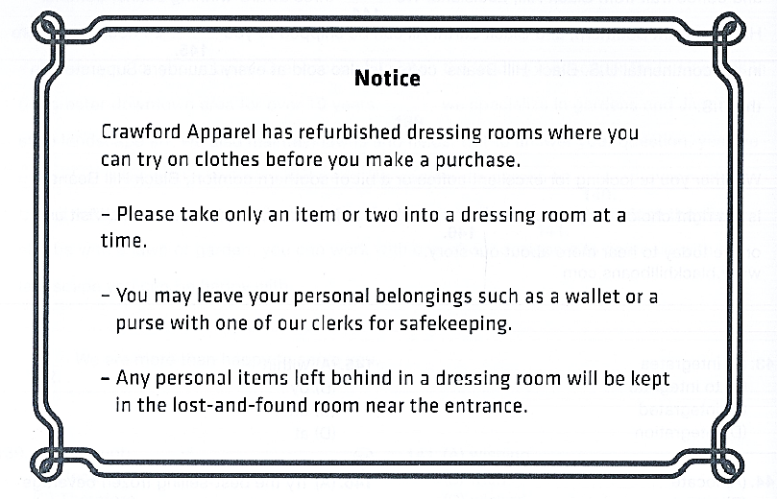
A. Customers can take many items into the dressing room at the same time.
B. Personal items left in the dressing room will be thrown away.
C. Customers should leave their personal items with a clerk for safety.
D. The lost-and-found room is in the dressing rooms.
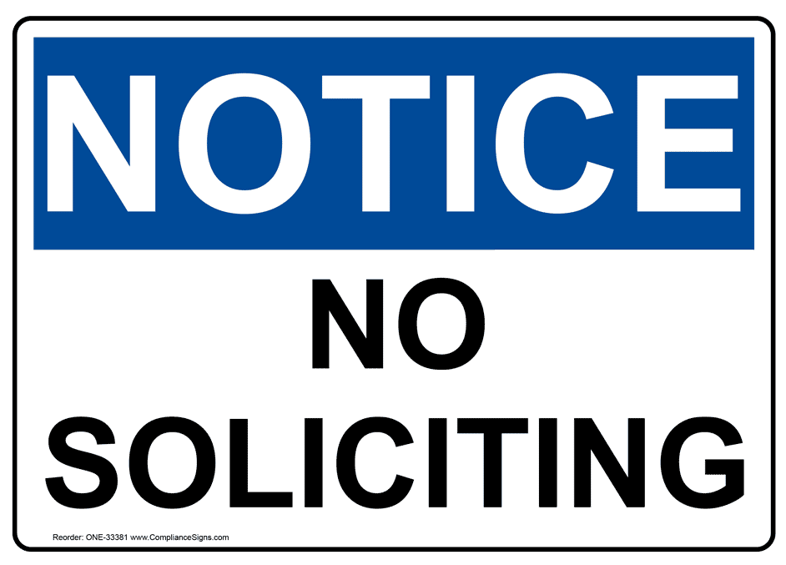
Question 9: What does this sign mean?
A. Soliciting cannot be done in this area without a permit.
B. Soliciting is only allowed in some areas.
C. Soliciting is not allowed or permitted in this area.
D. Soliciting is allowed and you can do it here.

Question 10: Which of the following statements is true according to the notice?
Notice
The Library has new rules for borrowing books.
- You can borrow up to five books at a time.
- Books must be returned within two weeks.
- Late fees apply if books are returned after the due date.

A. You can borrow more than five books at a time.
B. Books must be returned within two weeks.
C. You do not pay late fees for overdue books.
D. You can keep books forever.
[HẾT]

