**LỚP HỌC THẦY (CÔ) ___________________________** **ĐỀ ÔN TẬP: READING SIGNS/ NOTICES – A2**

**Test 2**

*Thời gian làm bài: [Time]*

Họ và tên: ________________________________________________ Lớp: 9/___

**Nội dung:**

**Question 1:** What does the sign say?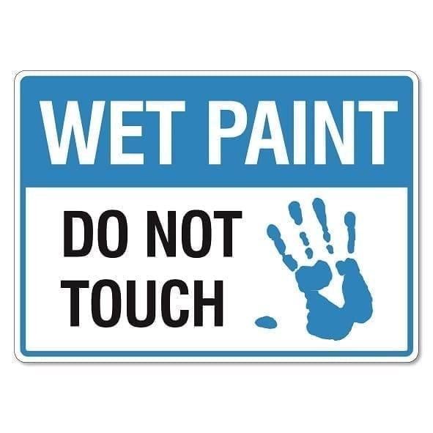

**A.** The paint is dry and safe to touch.  
**B.** The paint is still wet, so please do not touch it.  
**C.** You are encouraged to touch the paint.  
**D.** The paint is not for public use.

**Question 2:** What does the noticesay?



**A.** Wait in this area and do not move around**. B.** You can wait anywhere.

**C.** Moving around while waiting is allowed**. D.** Waiting is not required here.

**Question 3:** What does the sign say?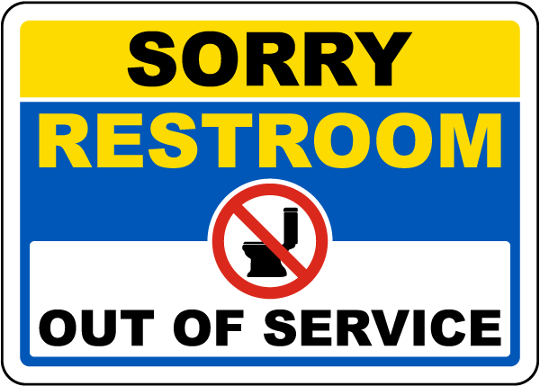

**A.** The restroom is working properly and is available for everyone to use.  
**B.** The restroom is open and ready for use by anyone who needs it.  
**C.** The restroom is being repaired or cleaned and cannot be used right now.   
**D.** The restroom is only for people with special permission to use.

**Question 4:** What does the notice say?



**A.** Only food is not allowed; drinks are fine.

**B.** You can eat and drink inside this area**.**

**C.** Do not bring food or drinks inside. Finish them first.

**D.** You can bring food but no drinks are allowed**.**

**Question 5:** What does the sign say?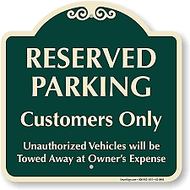

**A.** Anyone can park here without any restrictions.  
**B.** Only customers are allowed to park in these spaces.  
**C.** Parking is not allowed in this area at all.  
**D.** There are no rules for parking; it is open for everyone.

**Question 6:** What does the notice say?



**A.** There is no need to be careful on the floor.

**B.** The floor is wet, stand still and avoid moving.

**C.** The floor is always wet and slippery.

**D.** The floor is wet, walk carefully to avoid slipping.

**Question 7:** What does the sign say?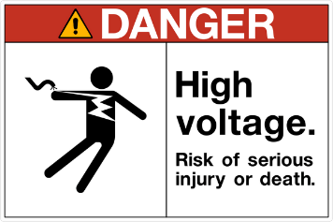

**A.** This area is safe with no electrical problems or dangers.  
**B.** There is high voltage electricity in this area; be very careful.  
**C.** All electrical equipment is turned off and not working.  
**D.** The voltage here is low and it is safe to touch the equipment.

**Question 8:** What does the notice say?



**A.** Everything you need is covered here if you are a customer.

**B.** The help desk is closed and not in use.

**C.** You can get help here for any questions or problems.

**D.** The help desk is only for staff.

**Question 9:** What does the sign say?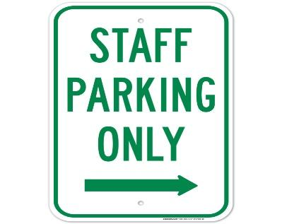



**A.** Anyone, including visitors and staff, can park here without restrictions.  
**B.** Only employees or staff members are allowed to park in these spaces.  
**C.** Parking is not allowed in this area under any circumstances.  
**D.** The parking area is open to all people, without any specific rules.

**Question 10:** What does the notice say?



**A.** You must have permission to use the phone in this area**.**

**B.** You may not turn off your phone if you are not using it.

**C.** Cell phones are only for emergency use here.

**D.** Cell phones must be turned off or silenced in this area**.**

**[HẾT]**