**The natural world**

**Task 1. Match the sentence halves.**

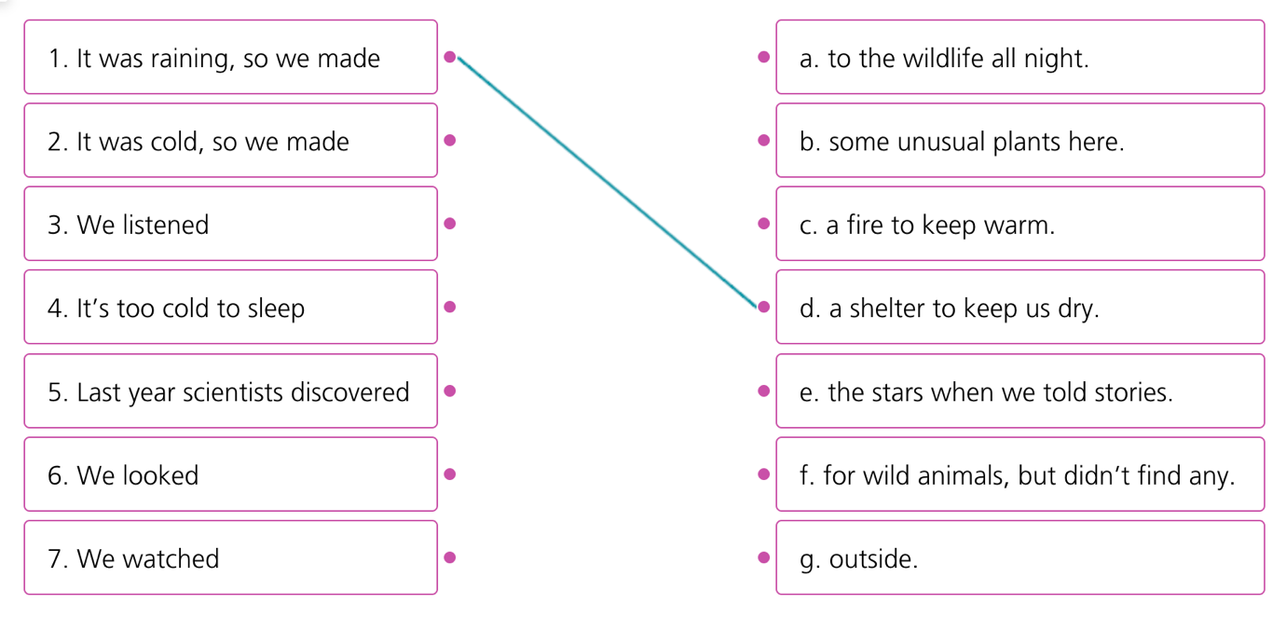

**Task 2. Complete the sentences with the words in the box.**

| **icy** | **cold** | **rising** | **cave** | **wildlife** |
| --- | --- | --- | --- | --- |
| **path** | **sky** | **degree** | **stars** | **thunders** |

1. The roads are_______ today, so please drive carefully.  
2. There were only a few clouds in the __________.

3. The weather forecast said it will be thirty _______ Celsius today. That’s hot!  
4. At night you can see the_______ shining.

5. I can hear _________. Can you see any lightning?

6**.** It was very dark at the back of the _______.

7. The river is _________ quickly because of all the rain. I hope there won’t be a flood.

8. There is a lot of interesting __________in the forest.

9. We followed the __________ until we came to a river.

10. It’s freezing _________  today, so wear your warmest clothes.

**Task 3. Choose the correct options to complete the sentences.**

1. A bird had built a nest on the *branches / roots* of the tree.

2. More and more people are choosing *solar / sustainable* energy to heat their homes.

3. In the jungle, the explorers saw the *falls / waves* and stopped to get some drinking water.

4. At home, you should sort your *leaves / rubbish* into glass, aluminium and paper.

5. The sun went *down / out* at around 8 p.m. and soon the sky was dark.

6. In the woods, there was a lovely *clearing / pond* where we sat to have a picnic.

7. Water is made up *with / of* hydrogen and oxygen.

8. Air and water pollution are *damaging / disturbing* the environment.

9. We were still swimming when the tide came *in / up* and made our towels wet.

10. At my supermarket, there’s a section with *organic / reusable* food.

**Task 4. Complete the sentences with the correct forms of the word in capitals.**

1. Humans are responsible for the ______ of the planet. DESTROY

2. The ______ of the wildfire had lost their homes and were all in shock. SURVIVE

3. The accident should not have happened – it was completely ______. AVOID

4. Did you know that the sun is ______ to your skin and can cause cancer? HARM

5. What is the ______ of the water in the middle of the river? DEEP

6. K2, the world’s second tallest mountain, has a ______ of 8,611 metres. HIGH

7. They ignored all the ______ about the dangerous current and nearly drowned. WARN

8. They’re going to ______ this road as it’s too narrow. WIDE

**ANSWER KEY**

**Task 1.**

1. d 2. c 3. a 4. g

5. b 6. f 7. e

**Task 2.**

1. icy 2. sky 3. degree 4. stars 5. thunders

6. cave 7. rising 8. wildlife 9. path 10. cold

**Task 3.**

1. branches 2. solar 3. falls 4. rubbish 5. down

6. clearing 7. of 8. damaging 9. in 10. organic

**Task 4.**

1. destruction 2. survivors 3. avoidable 4. harmful

5. depth 6. height 7. warnings 8. widen

**WORDLIST**

| **Word** | **Pronunciation** | **Meaning** |
| --- | --- | --- |
| Avoidable (adj) | /əˈvɔɪdəbl/ | Có thể tránh được |
| Branch (n) | /brɑːntʃ/ | Cành cây |
| Degree celsius | / dɪˈɡriː ˈselsiəs/ | Độ C |
| Freezing cold | / ˈfriːzɪŋ kəʊld / | Lạnh cóng |
| Icy (adj) | /ˈaɪsi/ | Đóng băng |
| Lightning (n) | /ˈlaɪtnɪŋ/ | Chớp |
| Path (n) | /pɑːθ/ | Con đường nhỏ, ngõ |
| Survivor (n) | /səˈvaɪvə(r)/ | Người sống sót |
| Thunder (n) | /ˈθʌndə(r)/ | Sấm |