|  |  |
| --- | --- |
| **School: ……………………………………..** | **Date: ……………………………..** |
| **Class: ………………………….....................** | **Period: …………………….........** |

**UNIT 6: EDUCATION**

**Lesson 2.2 - Grammar (Page 48)**

**I. OBJECTIVES**

By the end of the lesson, Ss will be able to:

**1.1. Language knowledge and skills**

- listen to and understand a short conversation between 2 people talking about feeling.

- use subordinating conjunction “*because*” and intensifiers “*so*”, “*really*” correctly.

**1.2. Competences**

- improve speaking, listening and writing skills.

- improve the use of English.

**1.3. Attributes**

- overcome studying pressure and negative feelings.

- have a balance between studying and relaxing.

**II. TEACHING AIDS AND LEARNING MATERIALS**

**1. Teacher’s aids:** Student book and Teacher’s book, class CDs, Digital Book (DCR phần mềm tương tác SB, DHA (từ vựng/ cấu trúc) phần mềm trò chơi tương tác), projector/interactive whiteboard / TV (if any), PowerPoint slides, handouts.

**2. Students’ aids:** Student’s book, workbook, notebook.

**III. ASSESSMENT EVIDENCE**

|  |  |  |
| --- | --- | --- |
| **Performance Tasks** | **Performance Products** | **Assessment Tools** |
| - Listen and repeat. | **-** Ss’ performance. | - T’s feedback. |
| **-** Study the grammar box. | - Ss’ task. | - T’s observation. |
| - Unscramble the sentences. | - Ss’ answers. | - T’s feedback/Peers’ feedback. |
| - Write sentences using the pictures and the prompts. | - Ss’ answers. | - T’s feedback/Peers’ feedback. |
| - Talk about how you feel at school and why. Use the adjectives in the box. | - Ss’ performance/ presentation. | - T’s observation, T’s feedback/Peers’ feedback. |

**IV. PROCEDURES**

**A. Warm up: (5’)**

**a) Objective:** Introduce the new lesson and set the scene for Ss to acquire new language; get students' attention at the beginning of the class by enjoyable and short activities as well as to engage them in the follow-up steps.

**b) Content:** Review words about feelings / Introduce: *because.*

**c) Expected outcomes:** Ss review old knowledge and have general ideas about the grammar point they are going to study in the new lesson.

**d) Organization of the activity:**

|  |  |
| --- | --- |
| **TEACHER’S ACTIVITIES** | **STUDENTS’ ACTIVITIES** |
| * **Option 1: Introduce “*because*”**   - Have Ss do the matching exercise: Match the consequences with the causes.  - Call Ss to give answers.  - Check Ss’ answers, correct Ss’s answers if necessary  - Have Ss think of a word / phrase to connect clause of consequences with clause of causes.  - Lead to the new lesson: We use subordinating conjunction “*because*” to join consequences and causes clauses.  **\*Illustration:**     * **Option 2: Review vocabularies about feelings**   - Give some adjectives about feelings Ss have learnt in the previous lesson, have some volunteers express that feeling by using body language in front of the class.  - Have the whole class guess the adjectives.  - Call Ss to give answers.  - Give feedback and evaluation.  - Lead to the new lesson.  \***Suggested adjectives**: *annoyed, delighted, surprised, pleased, upset, disappointed* | - Work in groups.  - Give answers.  - Listen.  **Answers keys**  *1e 2a 3d 4c 5b*  - Do the task.  - Give answers. |

**B. New lesson (35’)**

* **Activity 1: Presentation (10’)**

**a) Objective:** Introduce “because”, “so” and “really”.

**b) Content:**

**-** Listen and repeat.

**-** Introduce the grammar point: “because”, “so” and “really”.

**c) Expected outcomes:** Ss know how to use “because”, “so” and “really” to do some following exercises.

**d) Organization of the activity:**

|  |  |
| --- | --- |
| **TEACHER’S ACTIVITIES** | **STUDENTS’ ACTIVITIES** |
| **Task a. Listen and repeat**  - Have Ss look at the picture using DCR.  - Play audio (CD1 – Track 65) and have Ss listen and read the speech bubbles.  - Play the audio again and have Ss listen and repeat.  **Grammar box**  - Have Ss look at the grammar explanation and read: **Because**    - Have Ss look the grammar explanation and read: **Intensifiers**    - Briefly explain the grammar point.  - Ask Ss to make sentences with “because”, “so” and “really”. | - Look.  - Listen, then read.  - Listen and repeat.  - Look and read.  - Look and read.  - Listen and take notes.  **-** Make sentences, using “because”, “so” and “really”. |

* **Activity 2: Practice (19’)**

**a) Objective:** Students can use “because”, “so” and “really” correctly.

**b) Content:**

- Unscramble the sentences.

- Write sentences using the pictures and the prompts.

**c) Expected outcomes:** Students can use “because”, “so” and “really” in their speaking.

**d) Organization of the activity:**

|  |  |
| --- | --- |
| **TEACHER’S ACTIVITIES** | **STUDENTS’ ACTIVITIES** |
| **Task b. Unscramble the sentences**  - Demonstrate the activity on DCR, using the example.  - Have Ss unscramble the sentences.  - Have Ss work in pairs to check each other’s work.  - Have some Ss share their answers with the whole class.  - Give feedback, correct Ss’ answers if necessary.  **Task c. Write sentences using the pictures and the prompts**  - Demonstrate the activity on DCR, using the example.  - Have students write sentences using the pictures and the prompts.  - Have Ss check answers with their partners.  - Call Ss to read or write answers.  - Check Ss’ answers, give feedback. | - Look and listen.  - Work individually.  - Work in pairs.  - Write answers on the board.  **Answer keys**    - Look and listen.  - Work individually.  - Work in pairs.  - Read or write answers.  **Answer keys** |

* **Activity 3: Production (6’)**

**a) Objective:** Students master the grammar point they study in the lesson.

**b) Content:**  Speaking: Talk about how you feel at school and why. Use the adjectives in the box.

**c) Expected outcomes:** Ss produce the new language successfully, and they can apply the grammar point they have learnt in speaking and writing.

**d) Organization of the activity:**

|  |  |
| --- | --- |
| **TEACHER’S ACTIVITIES** | **STUDENTS’ ACTIVITIES** |
| **Task d. Talk about how you feel at school and why. Use the adjectives in the box.**    - Divide class into pairs.  - Have Ss ask and answer, explain.  - Have some pairs demonstrate the activity in front of the class.  - Give feedback and evaluation. | - Work in pairs.  - Have conversation in pairs.  - Present.  - Listen.  **Suggested idea** |

**C. Consolidation and homework assignments (5’)**

**\*Consolidation**

**- Because**

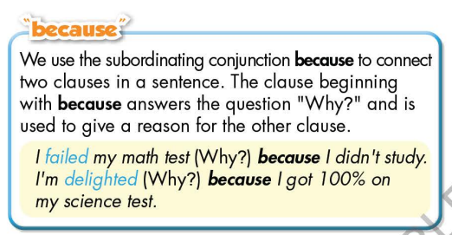

**- Intensifiers**

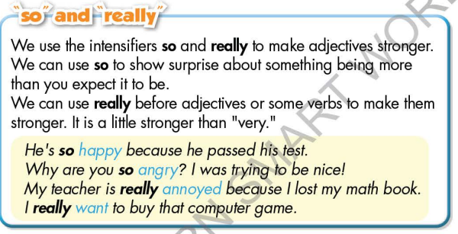

*.*

**\* Homework:**

- Make 3 sentences, use “because”, “so” and “really”.

- Do the exercises in WB: Grammar (page 35).

- Complete the grammar notes in Tiếng Anh 7 i-Learn Smart World Notebook (page 39).

- Play consolation games in Tiếng Anh 7 i-Learn Smart World DHA App on [www.eduhome.com.vn](http://www.eduhome.com.vn)

- Prepare: Lesson 2.3 – Pronunciation and Speaking (page 49 – SB).

**D. Reflection**

a. What I liked most about this lesson today:

…………………………………………………………………………………………

1. What I learned from this lesson today:

…………………………………………………………………………………………

c. What I should improve for this lesson next time:

…………………………………………………………………………………………