ĐỀ VIP 9+ - ĐỀ SỐ 9
Read the following notice and mark the letter A, B, C, or D to indicate the correct option that best fits each of the numbered blanks from 1 to 6.

JOIN OUR ENVIRONMENTAL GROUP!
Are you passionate about protecting the environment? We are looking to recruit new members for our (1)
focused on environmental protection projects. Each event provides a (2) experience as we work to make a positive difference in our community.
We (3) into account the diverse backgrounds and interests of our members, allowing everyone to contribute in unique ways. A large (4) of dedicated members have already joined, and we welcome others who share our enthusiasm for sustainability and (5) .
- benefits of joining include developing new skills, meeting like-minded people, and contributing to important environmental causes. If you’re ready to join us in these efforts, please apply today!
For more information, contact us at Lakewoodgreengroup@gmail.com or 555-6831.
Let’s create a greener future together!
Question 1. | A. vibrant team volunteer |  | B. vibrant volunteer team
 | C. volunteer vibrant team |  | D. team vibrant volunteer
Question 2. | A. satisfaction | B. satisfyingly | C. satisfied | D. satisfying
Question 3. | A. make | B. take | C. put | D. bring
Question 4. | A. number | B. amount | C. deal | D. volume
Question 5. | A. renovation | B. conservation | C. restoration | D. preservative
Question 6. | A. A little | B. Each | C. Other | D. Others
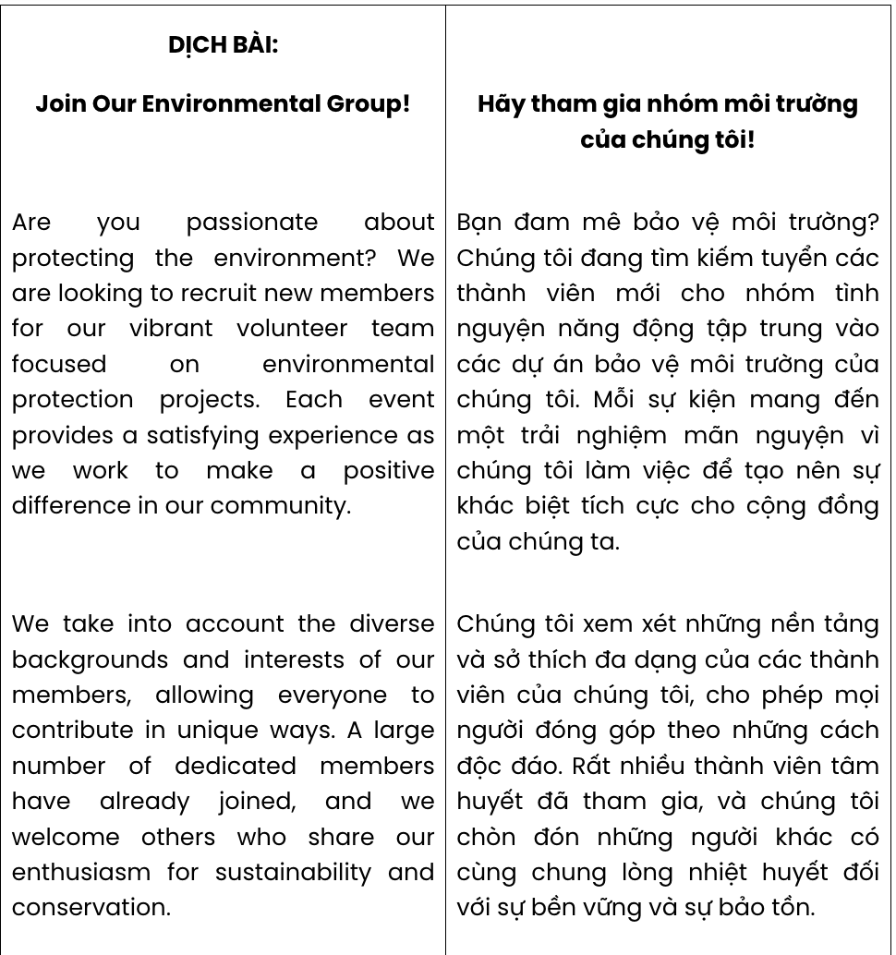
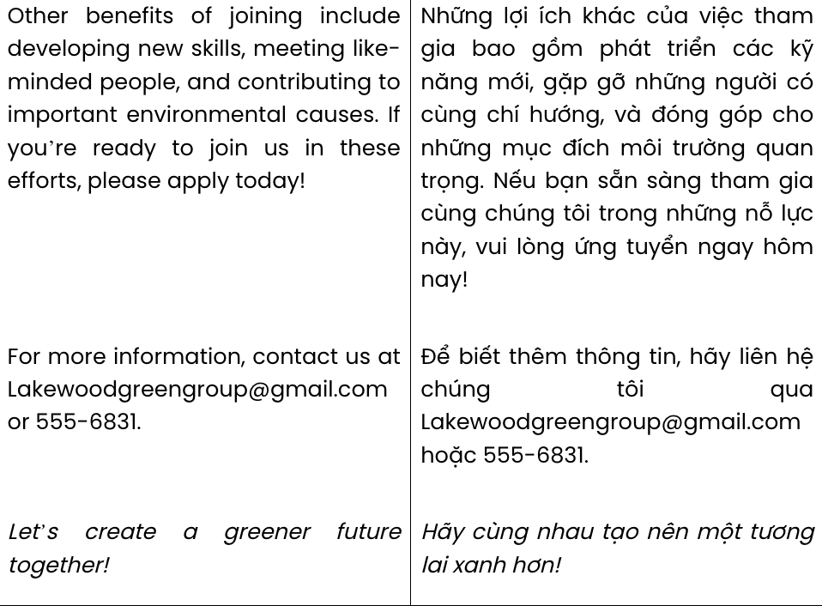
GIẢI CÂU 1:
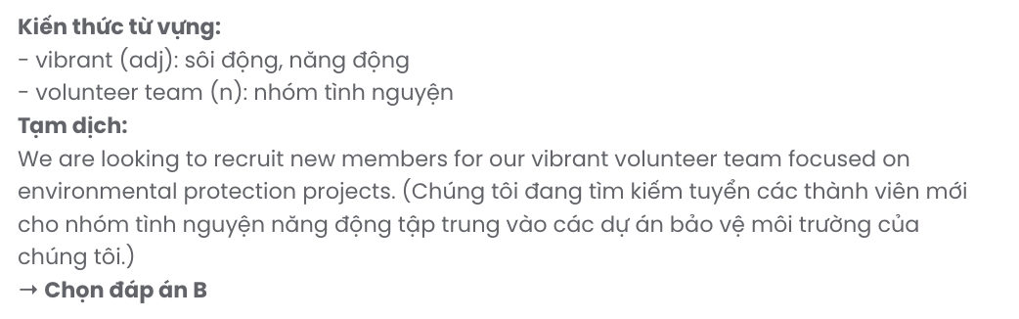
GIẢI CÂU 2:
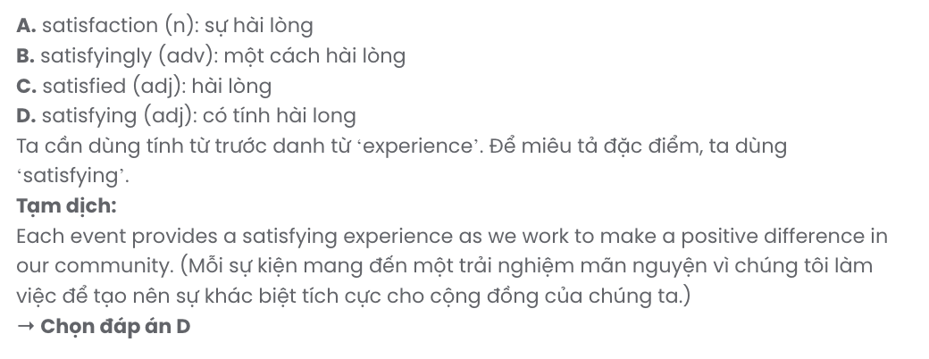
GIẢI CÂU 3:
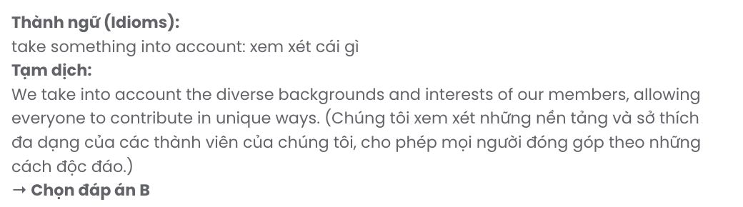
GIẢI CÂU 4:
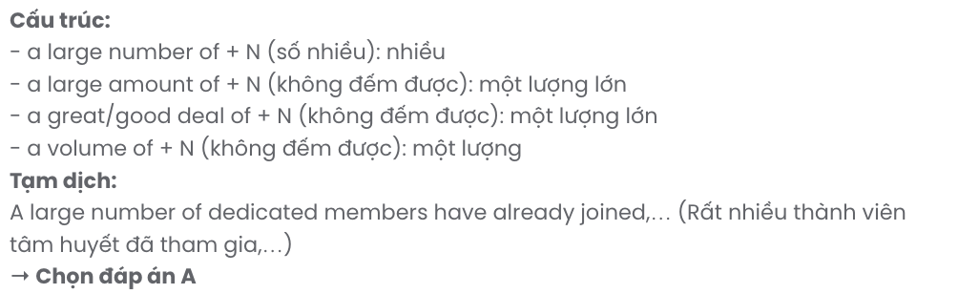
GIẢI CÂU 5:
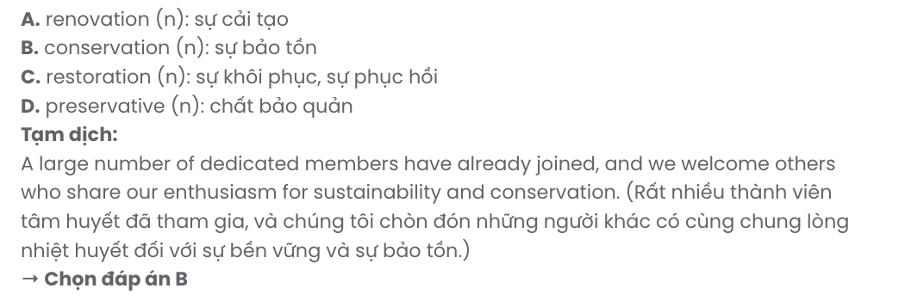
GIẢI CÂU 6:
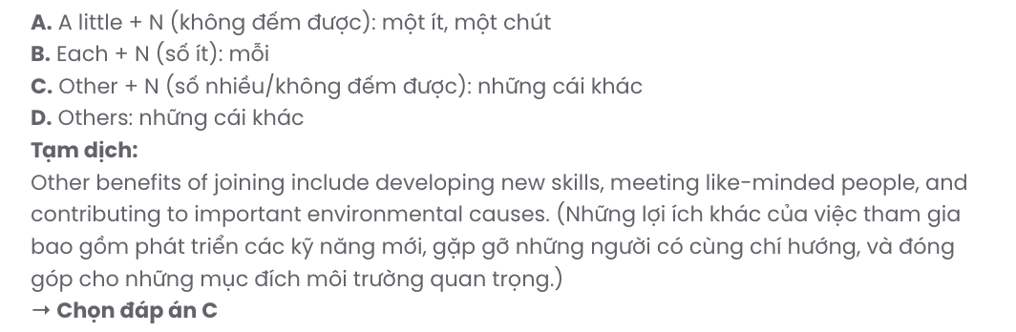
Read the following article and mark the letter A, B, C, or D to indicate the correct option that best fits each of the numbered blanks from 7 to 12.

RECENT CHANGES IN GREENFIELD VILLAGE
Greenfield Village, a quiet rural area, has experienced several recent changes while striving to keep its original charm. The local council intends (7) infrastructure to attract more visitors, bringing new amenities and facilities to the area.
Modern cafes and shops, (8) to serve both residents and tourists, add convenience for all. (9)
moving to bigger cities, many young locals now prefer to stay, taking advantage of the updated facilities.
Previously, residents enjoyed peaceful surroundings, (10) traffic noise only on rare occasions. Now, increased traffic has become a part of everyday life, requiring a little more patience.
These changes provide residents with easier access (11) essential services, including healthcare and education, right within the village. However, as development continues, Greenfield strives to balance modern growth with its cherished rural (12) .

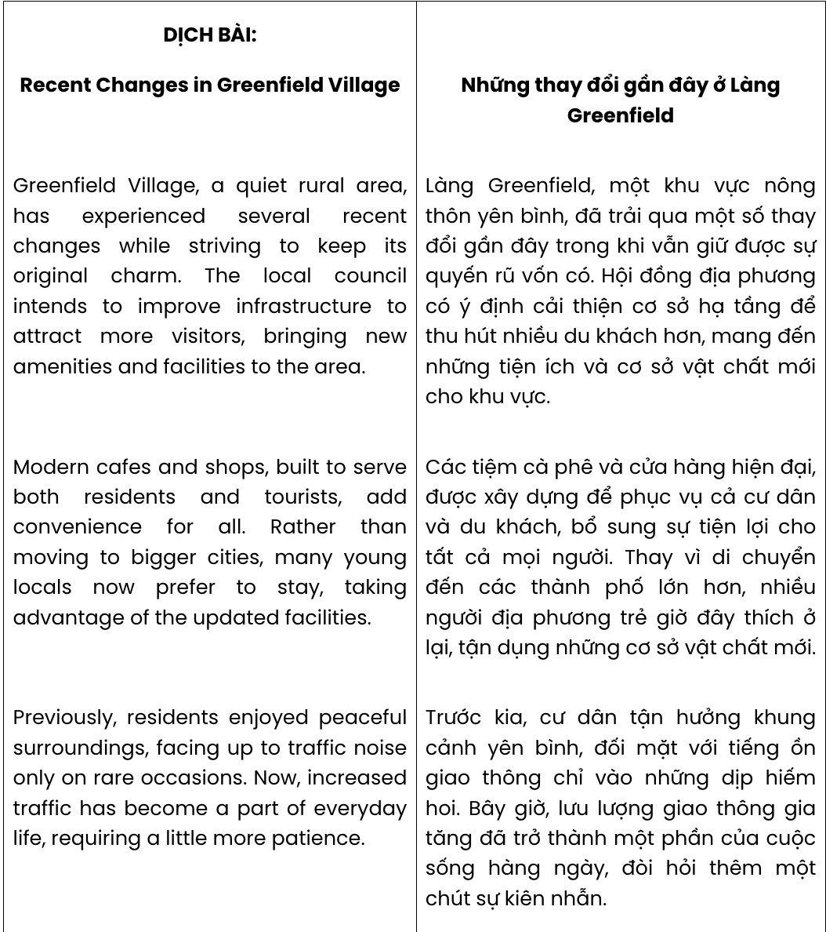

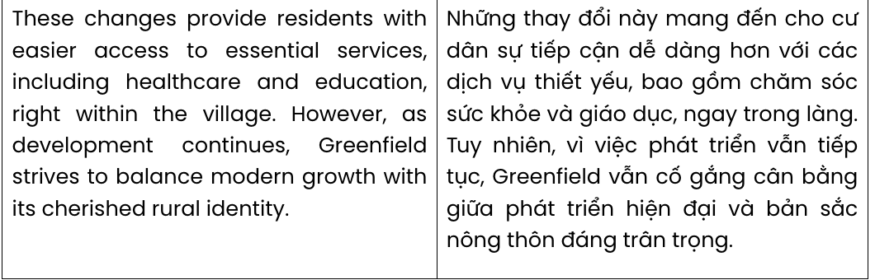

Question 7. | A. to improving | B. improving | C. to improve | D. improve
Question 8. | A. which built | B. building | C. are built | D. built
Question 9. | A. In the light of | B. Rather than | C. Regardless of | D. Except for
Question 10. | A. making up for |  | B. getting on with
 | C. facing up to |  | D. putting up with
Question 11. | A. for | B. at | C. with | D. to
Question 12. | A. manners | B. identity | C. landscape | D. duty
GIẢI CÂU 7:
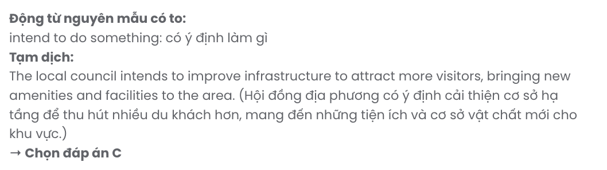
GIẢI CÂU 8:
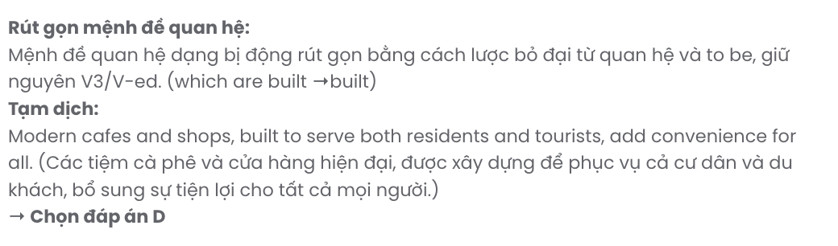
GIẢI CÂU 9: GIA SƯ TẠI HUẾ (079.3833.272)
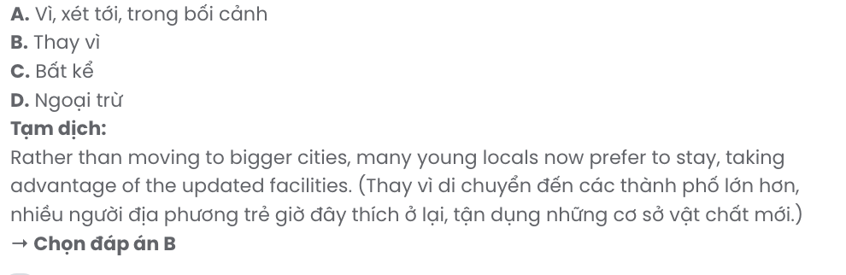
GIẢI CÂU 10:
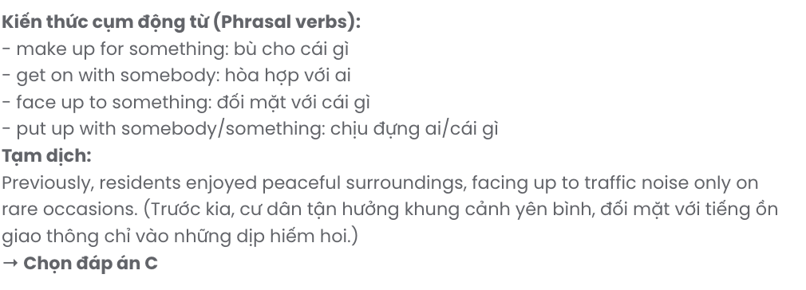
GIẢI CÂU 11:
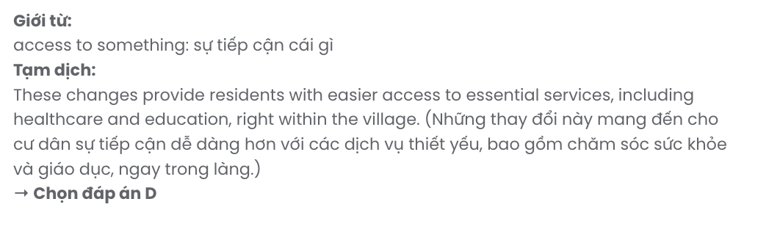
GIẢI CÂU 12:
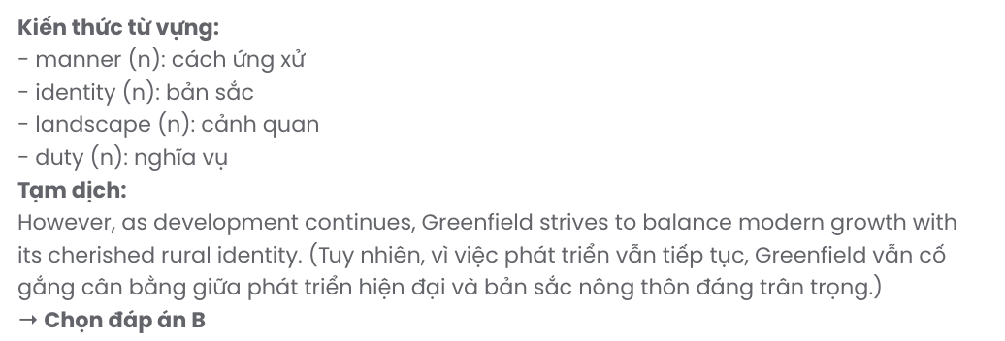
Mark the letter A, B, C or D to indicate the best arrangement of utterances or sentences to make a meaningful exchange or text in each of the following questions from 13 to 17.

Question 13.
  - As a result, workers are urged to adapt and reskill, preparing for roles that demand creativity and complex problem-solving.
c. Advancements in AI-powered technology have brought dramatic changes to the labour market.
  - This trend has also caused some traditional roles to become obsolete, as automation handles repetitive tasks more efficiently.
- This transformation continues to reshape industries, pushing companies to redefine their workforce needs.
- These advancements have led to a shift in job requirements, with employers now seeking workers skilled in data analysis and machine learning.
A. c – d – a – e – b B. c – e – b – a – d C. c – a – e – b – d D. c – b – d – e – a
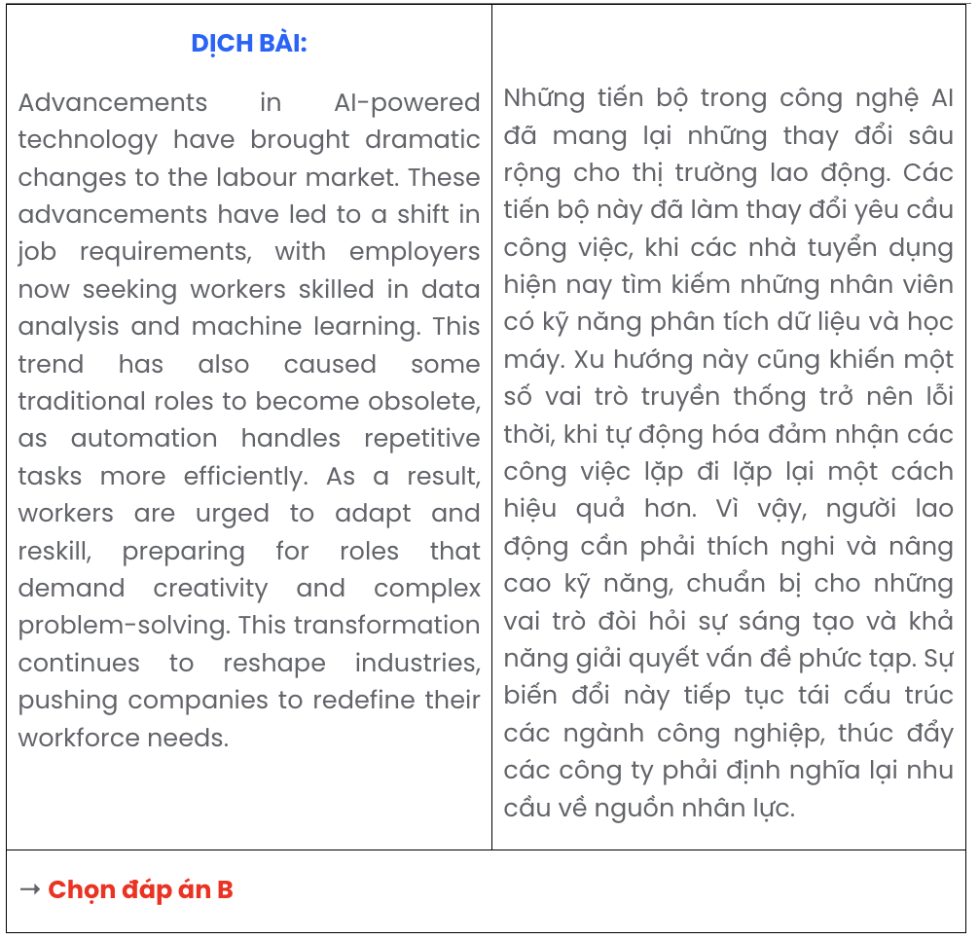

Question 14.
- Maggie: Yes, it’s quite worrying. I didn’t expect our neighbourhood to have these issues.
- Sam: We should bring that up at the next neighbourhood meeting.
- Maggie: Maybe it’s a lack of activities for them. The community centre used to organise events, but they've stopped recently.
- Sam: Have you heard about the recent rise in youth crime rates around here?
- Sam: Me neither. I wonder what’s causing this increase in crime among young people.
A. d – c – b – a – e B. b – a – d – c – e C. d – a – e – c – b D. b – c – e – a – d
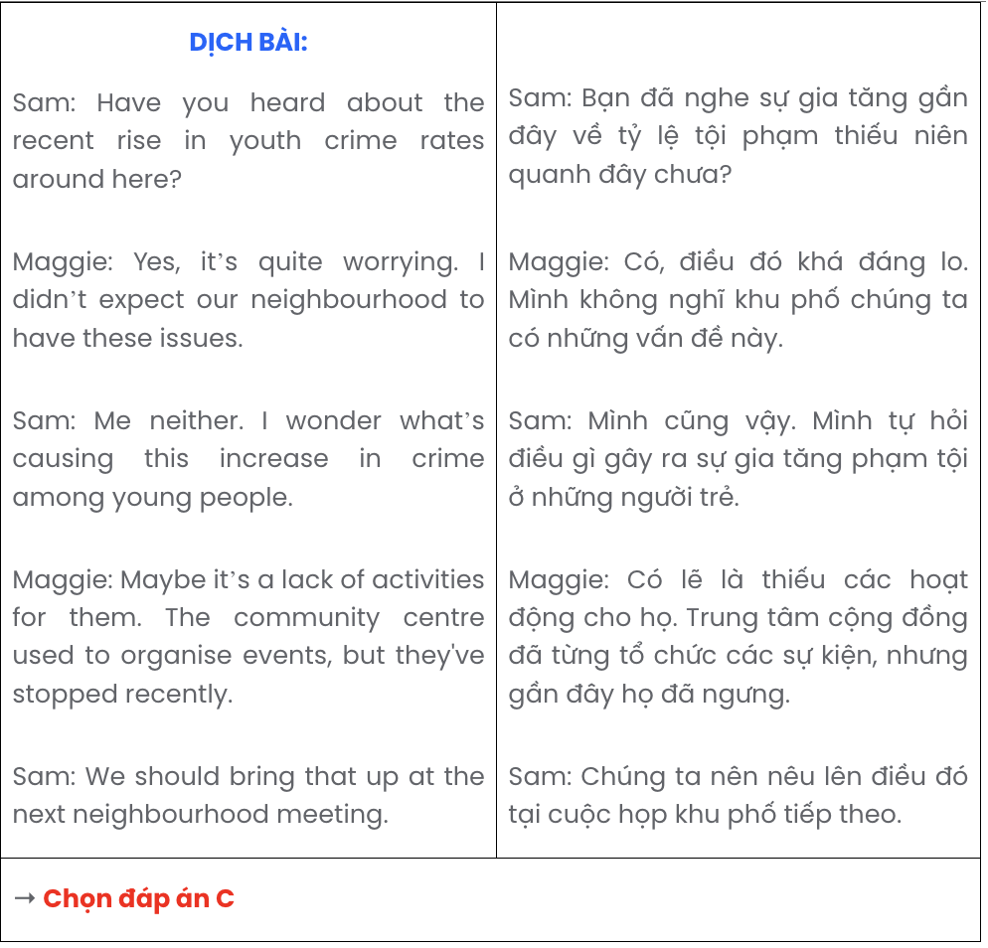

Question 15.
- While enduring these harsh words, I tried to focus on my studies, though their insults constantly echoed in my mind.
- Teachers noticed my struggle after a while, stepping in to support me, but by then, the experience had already affected my confidence.
- It started slowly, with a few comments here and there, but eventually, this behaviour escalated, and I was mocked for my appearance almost every day.
- Overall, this painful time taught me the importance of speaking up and seeking help, even when facing challenges alone.
- In middle school, I found myself the target of verbal bullying that I hadn’t anticipated.
A. a – b – e – c – d B. c – b – a – e – d C. e – c – a – b – d D. b – a – e – c – d

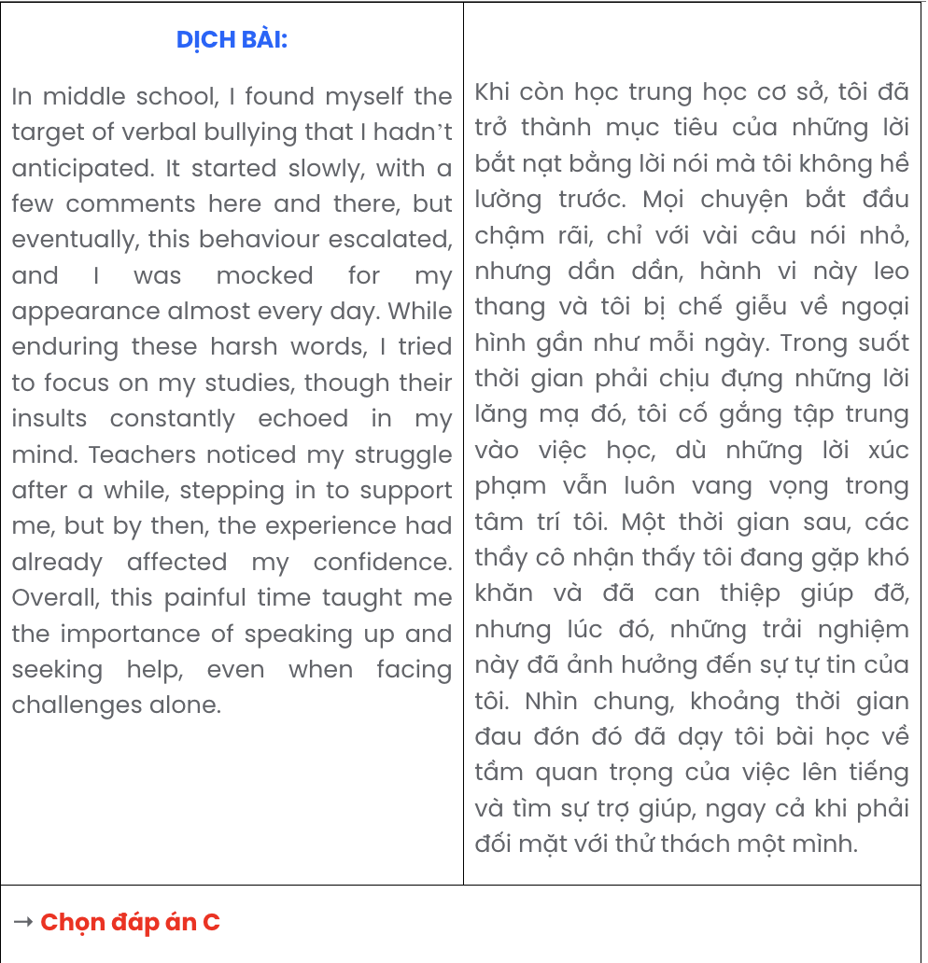

Question 16.
- James: Definitely! I heard we’re going to the science museum this time.
- Lily: I can’t wait! I hope we get to try out those interactive exhibits they have.
- Lily: Hey, are you excited about our next field trip?
A. c – a – b B. b – a – c C. a – c – b D. c – b – a
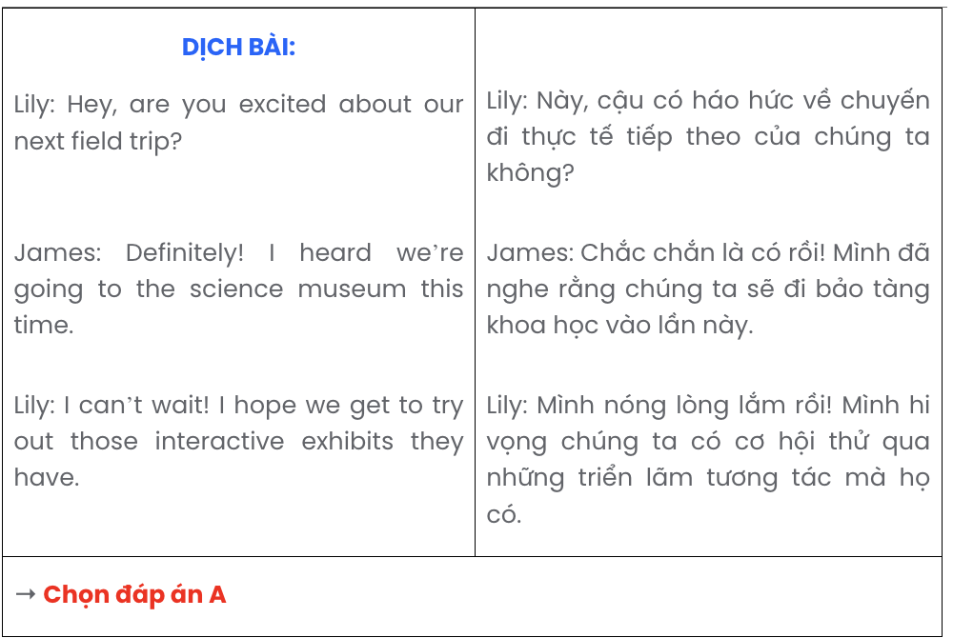

Question 17.
Dear Animal Shelter Team,
- Please let me know if there are specific requirements or steps for moving forward with this application.
- Having a strong passion for animal welfare, I would like to apply for a volunteer position at your shelter.
- These responsibilities align with my commitment to creating a safe and supportive environment for every animal in your care.
- My love for animals and experience in caring for pets have motivated me to take this step toward helping animals in need.
- I am available to assist with daily tasks, including feeding, cleaning, and providing companionship for the animals.
Sincerely, Laura
A. a – b – d – e – c B. e – a – b – d – c C. d – b – a – e – c D. b – d – e – c – a
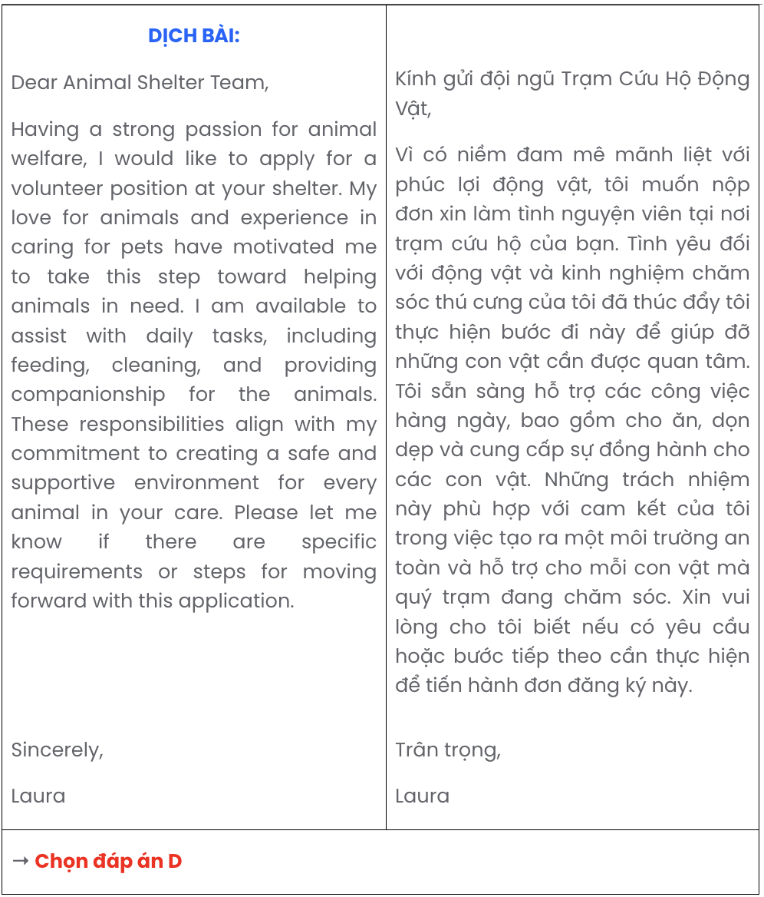

Read the following passage about the future of printed books and mark the letter A, B, C, or D to indicate the correct option that best fits each of the numbered blanks from 18 to 22.
The future of printed books remains a topic of much debate in an increasingly digital world. With the rise of e-books and audiobooks, many wonder if physical books, traditionally enjoyed by readers for centuries, (18) . While digital formats provide convenience and portability, printed books offer a tangible experience that digital devices often lack. The unique qualities of printed books, (19) , continue to attract readers who appreciate the sensory aspects of reading.
Having been cherished by generations, (20) . This attachment to physical books has fuelled a niche market of collectors and enthusiasts who value their permanence and aesthetic appeal. Furthermore, research shows that reading physical books may lead to better comprehension and retention, allowing readers to immerse themselves fully in the content.
As digital publishing has rapidly evolved, (21) . This shift demonstrates the efforts made to keep printed books relevant despite the digital age's demands. Although the role of printed books may change, (22) .
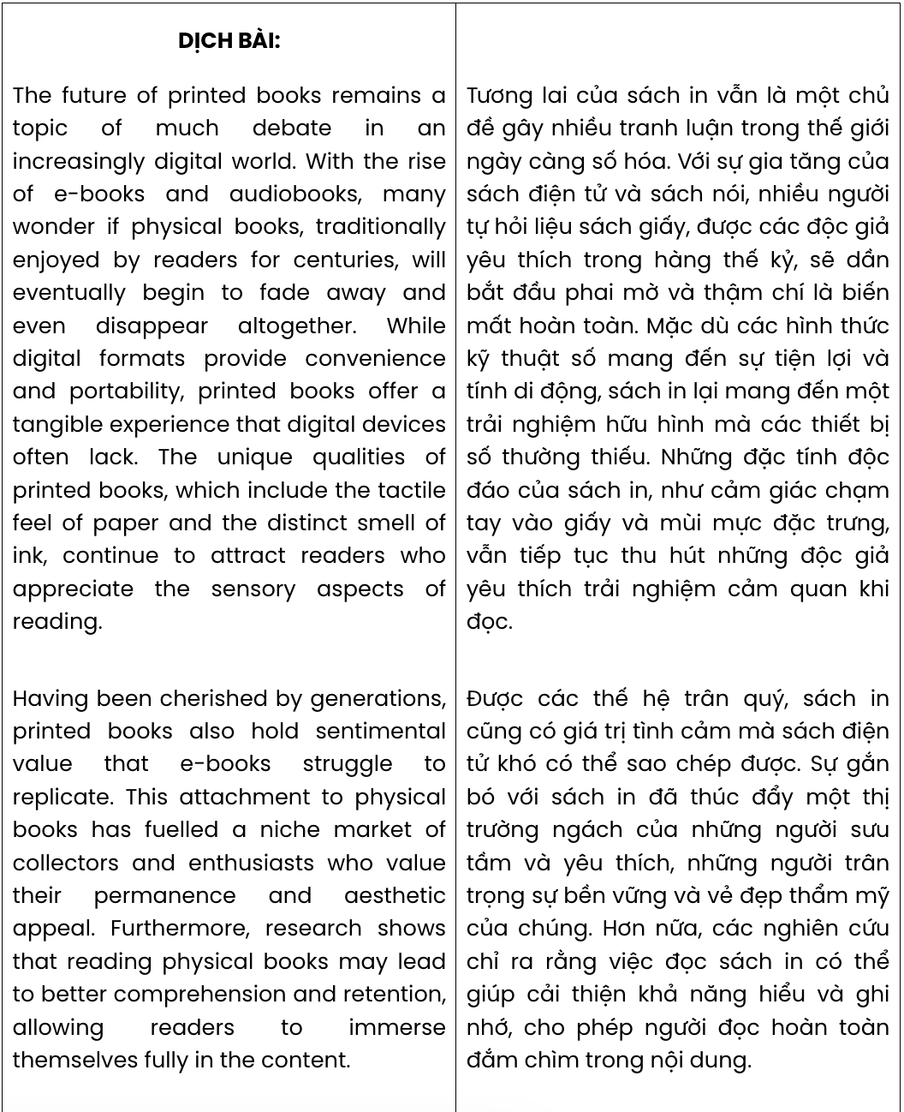
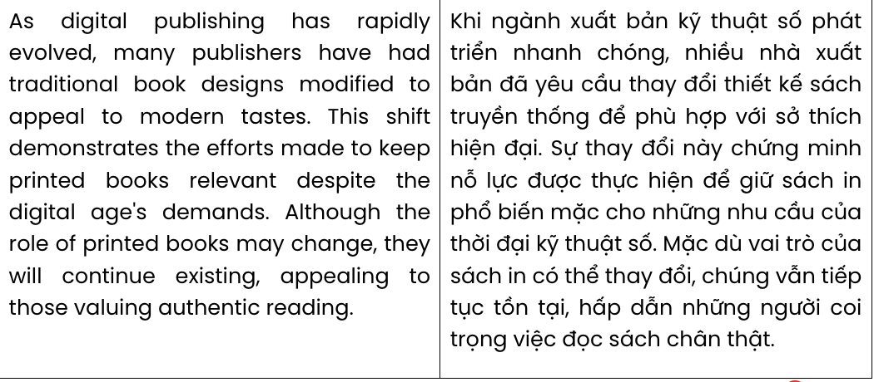

Question 18.
  - having slowly declined and ultimately been phased out
  - will eventually begin to fade away and even disappear altogether
  - which will gradually start to vanish and eventually cease to exist
  - whose presence may slowly diminish and ultimately fade from existence
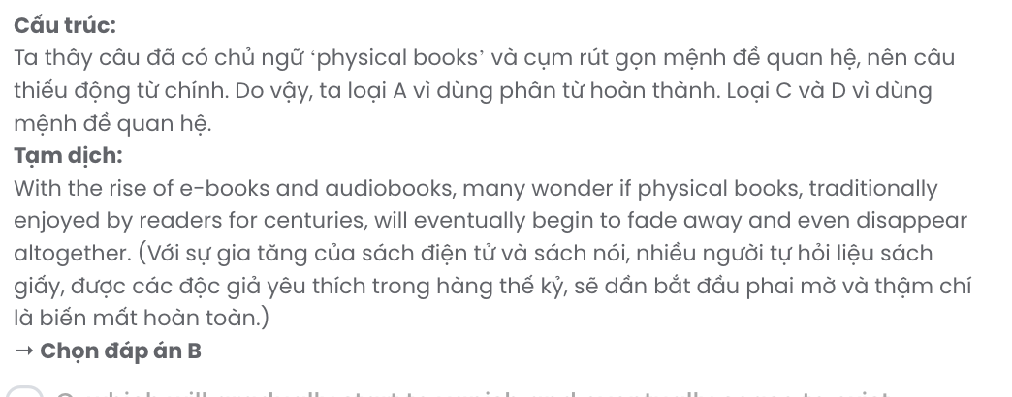

Question 19.
- which include the tactile feel of paper and the distinct smell of ink
- whose combination of tactile feel of paper and distinct smell of ink
- blended the tactile feel of paper and the distinct smell of ink
- encompassed the tactile feel of paper and the distinct smell of ink

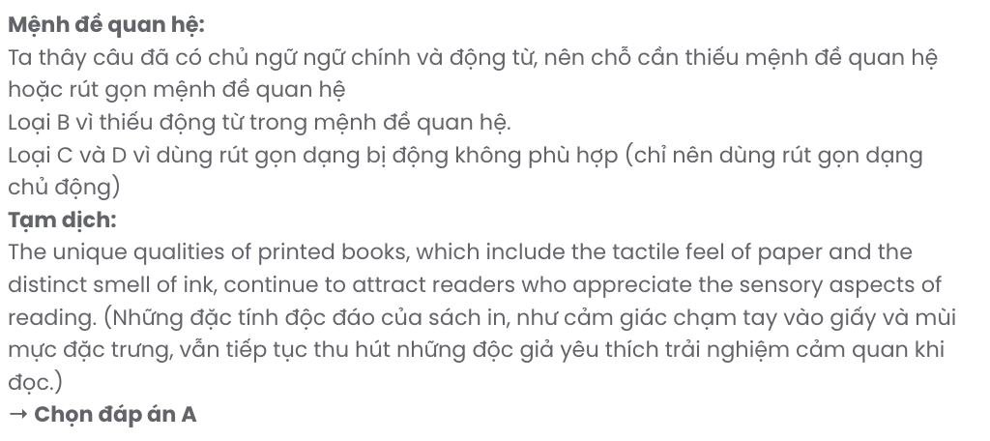

Question 20.
- sentimental value is a thing that e-books struggle to replace printed books
- e-books struggle to take over printed books due to a lack of sentimental value
- generations hold sentimental value that printed books overshadow e-books
- printed books also hold sentimental value that e-books struggle to replicate
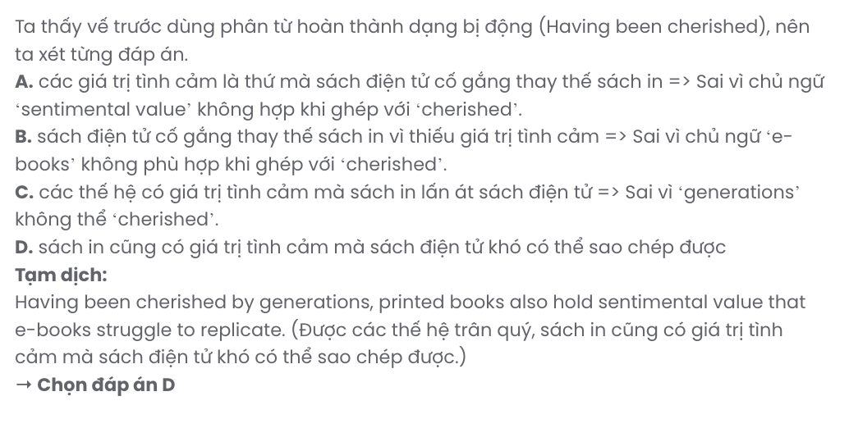

Question 21.
- many publishers have had traditional book designs modified to appeal to modern tastes
- traditional books designs have been modified, attracting modern taste of many publishers
- the appeal of modern tastes has transformed traditional book designs of many publishers
- modern tastes fascinated by many publishers have modified traditional book designs
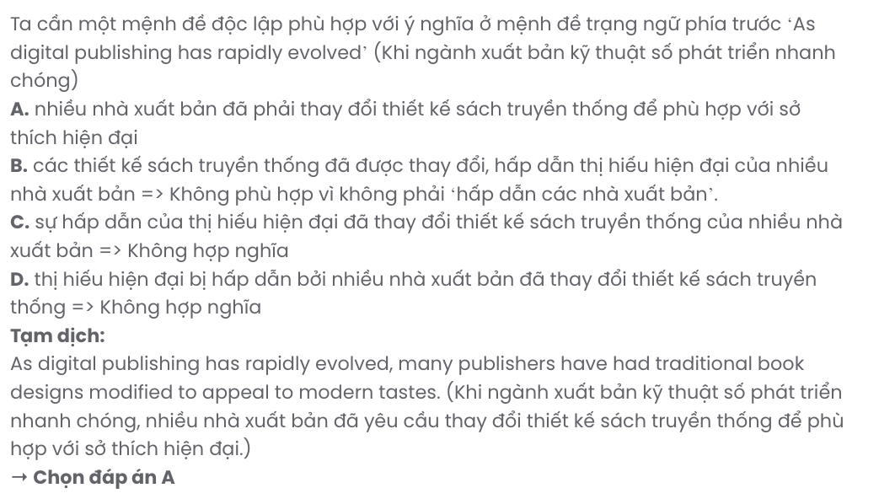

Question 22.
- they will continue existing, appealing to those valuing authentic reading
- those valuing authentic reading finds their continued existence appealing
- those appealed by authentic reading will value their continued existence
- they will appeal to those valuing authentic reading so as to continue existing
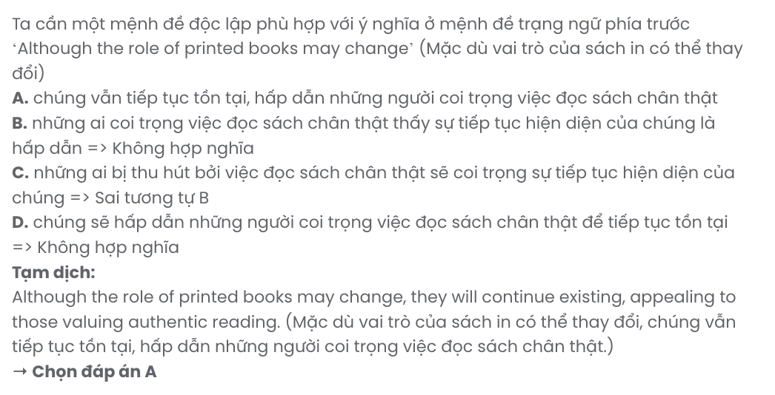
Read the following passage about dangers at the ends of the earth and mark the letter A, B, C, or D to indicate the correct answer to each of the questions from 23 to 30.
Welcome to Nunavik - a beautiful landscape of forests, blue skies and clear waters. You might think that Nunavik's geographical position at the ends of the Earth keeps it safe from big city problems like air and water pollution.
Unfortunately, the pretty villages of Nunavik have not escaped the problems that the rest of the world is facing, too. Some years ago, scientists made a worrying discovery. An extremely dangerous group of chemicals known as 'persistent organic pollutants' (or POPs) were attacking the Arctic environment. POPs are used everywhere - in TVs, in lights and in paint. They are also sprayed onto crops as pesticides. Over time, they become gas and go into the air, and the wind carries them thousands of kilometres.
POPs can cause cancer and allergies, as well as other damage. They can also cause developmental problems in babies and children. Clearly, something had to be done about the problem and so in the 1990s, the United Nations held a meeting called the Stockholm Convention to discuss banning lots of the POP chemicals. Since then, many countries have agreed to start producing fewer POP chemicals, and as a result, levels of POPs in the Arctic are diminishing.
It will take many years for the problem to go away. For one thing, buildings around the world still have many tons of POPs in their paint and wiring. For all the people and animals in the Arctic regions, their only hope is the work of scientists and the help of the rest of the world in putting an end to POPs once and for all.
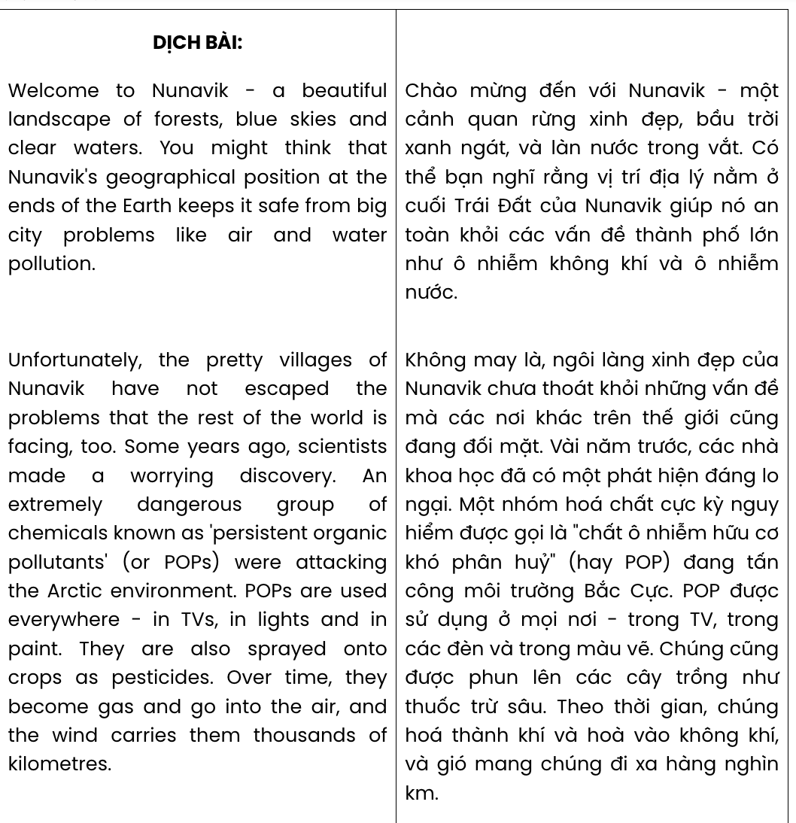(Adapted from Close-up)

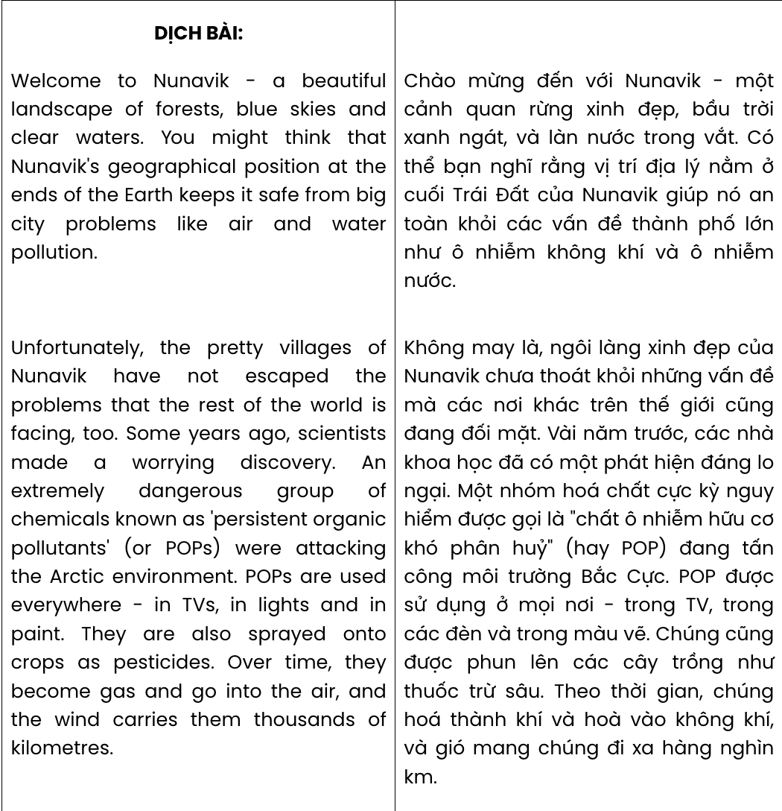

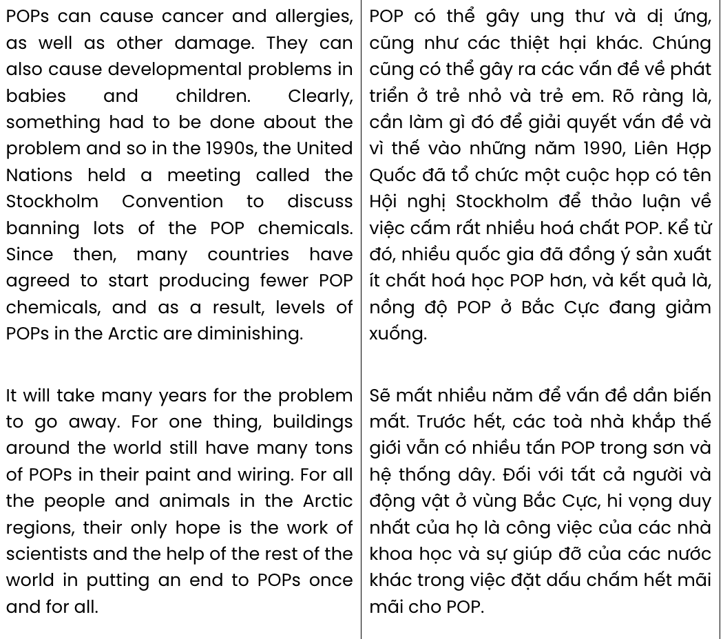
Question 23. The word escaped in paragraph 2 is closest in meaning to .
A. responded B. managed C. affected D. avoided

Question 24. According to paragraph 2, what is said about POPs?
- They are mainly used by farmers. B. They become toxic gas in a few days.
C. They had a bad impact on the Arctic. D. They were discovered by chance.
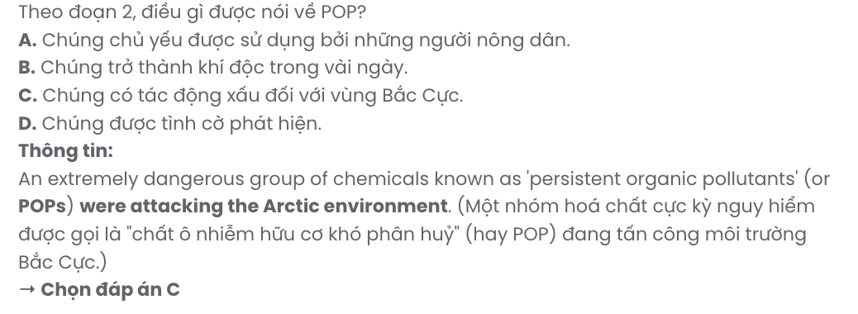
Question 25. The word them in paragraph 2 refers to . GIA SƯ TẠI HUẾ (079.3833.272)
A. crops B. POPs C. pesticides D. chemicals

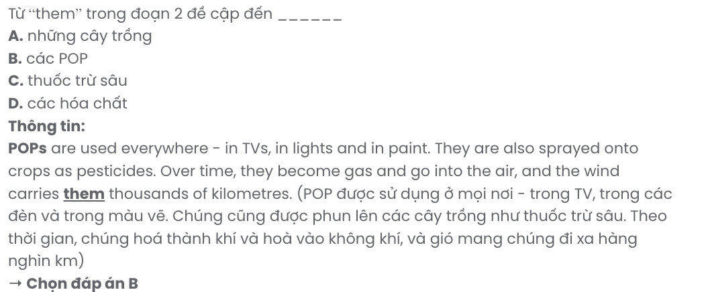
Question 26. The word diminishing in paragraph 3 is OPPOSITE in meaning to .
A. declining B. increasing C. recycling D. changing
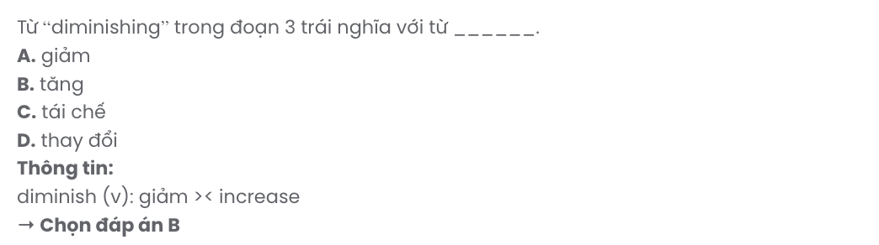
Question 27. Which of the following best paraphrases the underlined sentence in paragraph 4?

It will take many years for the problem to go away.
A. The issue will need considerable time before it is fully resolved.
B. The problem will eventually be gone within a few years.
C. The problem won’t be completely avoided for a long time.
D. The issue will require many efforts to gradually decrease.
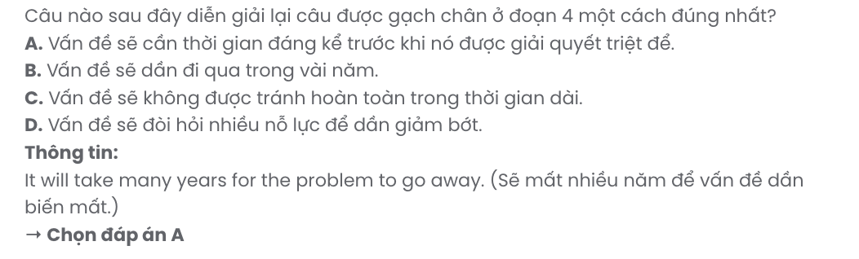
Question 28. Which of the following is NOT true according to the passage?
A. People who are exposed to POPs are likely to suffer from cancer and allergies.
B. When POPs go into the air, they can be carried by the wind thousands of kilometres.
C. The Stockholm Convention was organised in order to deal with the POP chemicals.
D. Many countries have still produced POPs despite the ban enacted by the United Nations.
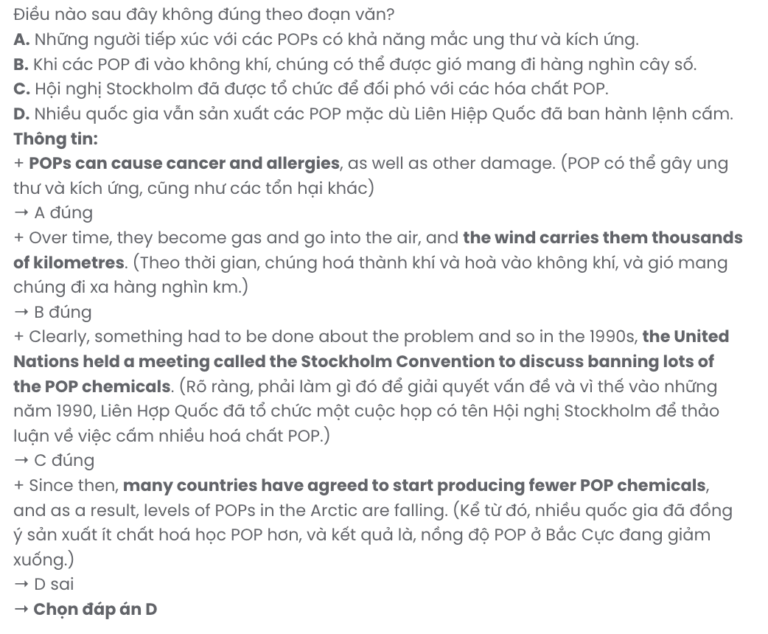
Question 29. In which paragraph does the writer discuss health problems caused by a group of chemicals?
A. Paragraph 1 B. Paragraph 2 C. Paragraph 3 D. Paragraph 4
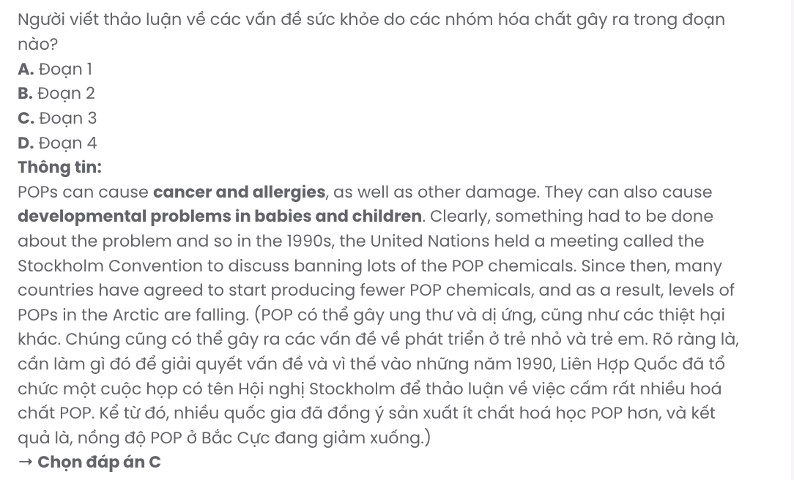
Question 30. In which paragraph does the writer emphasise the urgent need for collective action?
A. Paragraph 1 B. Paragraph 2 C. Paragraph 3 D. Paragraph 4

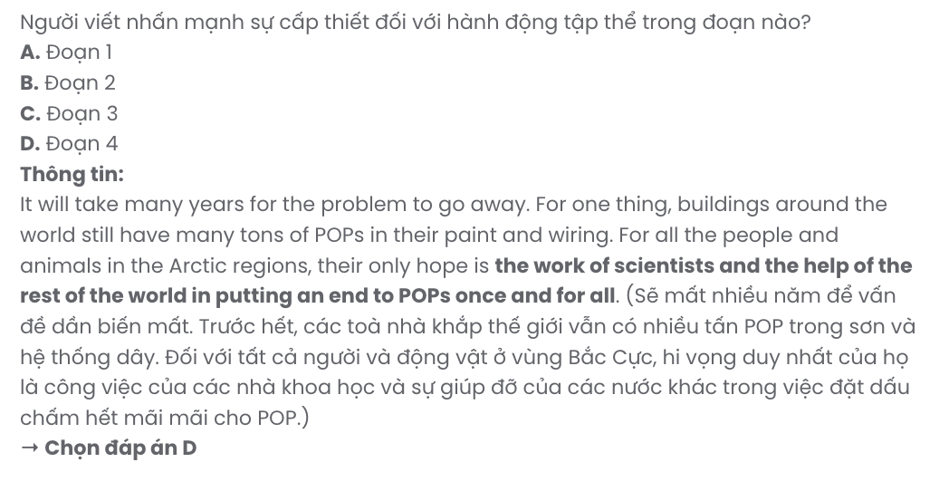
Read the following passage about megacities in China and mark the letter A, B, C, or D to indicate the correct answer to each of the questions from 31 to 40.
[I] Right now, an important transformation has already begun and it looks like it will continue for years to come. [II] China is a country where the population is in movement. Some experts calculate that over 260 million people are moving, more than the entire population of a huge country like Brazil! [III] At the moment, less than half the population of China lives in cities, but that situation is changing and it is changing fast. [IV]
Traditionally, the majority of the population of China has lived in quiet, rural areas. But industry is growing so fast that there is constant need for new workers in the city, in factories, construction sites, shops and offices. Until recently there was no need to build such enormous cities in China. But now there is an urgent need to build, to build big, tall and fast.
Few Chinese people live in detached or semi-detached houses. So, many large blocks of flats have appeared in the suburbs of these new Chinese megacities to accommodate the new arrivals. Day by day, these lively new megacities keep expanding. As cities increase in size, they eat up historic old buildings and invade the quiet villages nearby. Nearly 160 Chinese cities have passed one million inhabitants in the last 20 years and they continue to grow today. The future consequences of these enormous changes are still difficult to predict, both for China and for the whole planet.
Luckily, China has already realised the impact that megacities could have on the environment. So they have started designing and building new 'eco-cities'. In these eco-cities there is an emphasis on clean, renewable energy. For example, in one eco-city engineers have just started work on the construction of the world's tallest and greenest skyscrapers, the Phoenix Towers. The idea of these stunning towers is to use solar power for electricity and to collect rainwater for the use of the residents. Hopefully, with plans like this China's megacities can be attractive, clean, modern and good for the environment.
(Adapted from Gateway)

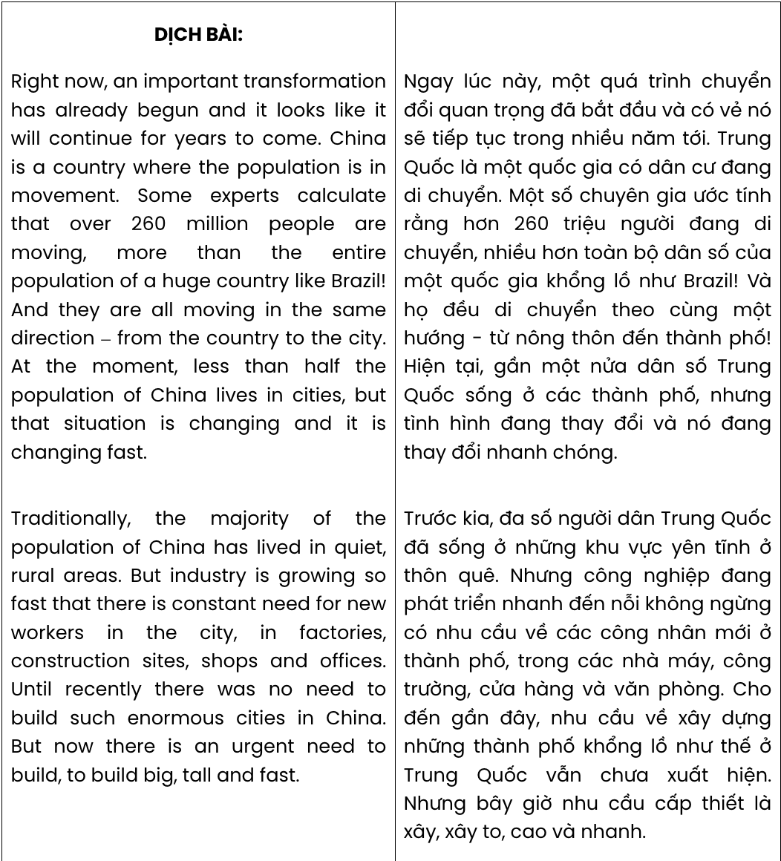

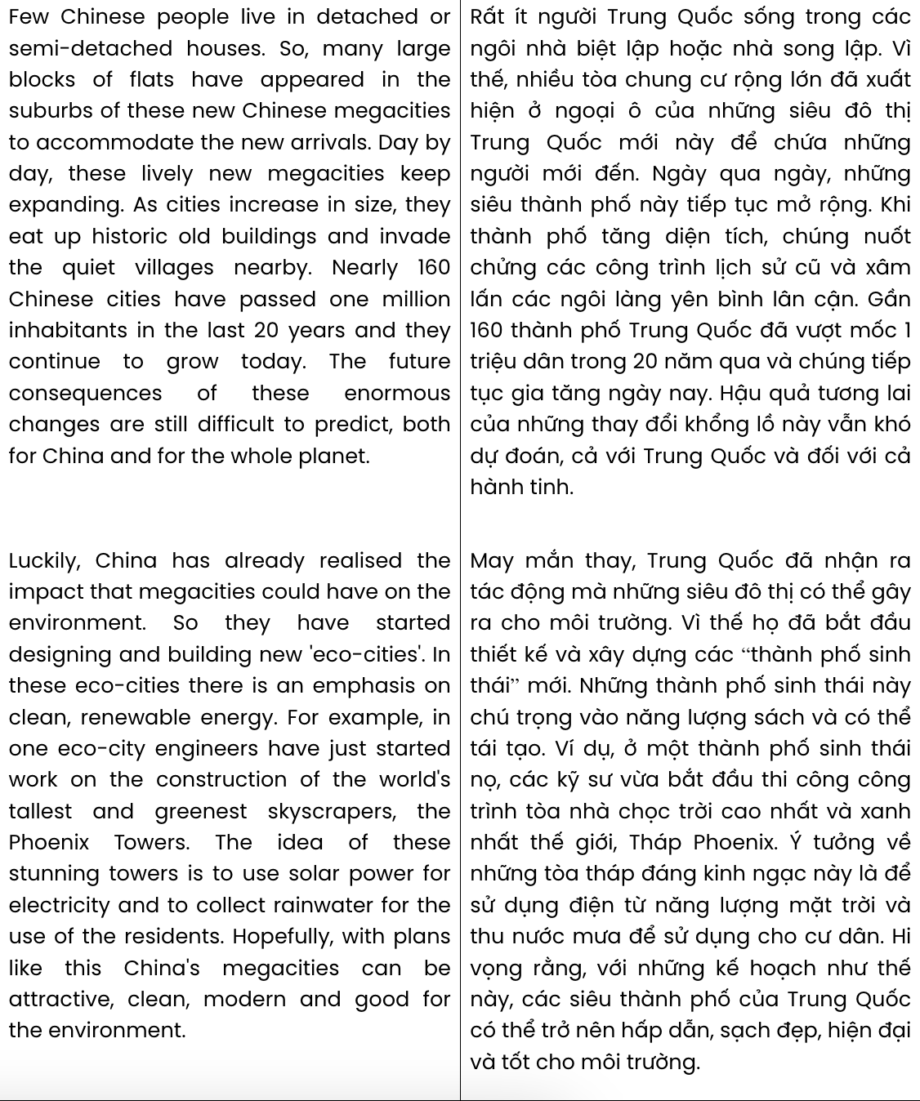
Question 31. Where in paragraph 1 does the following sentence best fit?
And they are all moving in the same direction – from the country to the city.

A. [I] B. [II] C. [III] D. [IV]

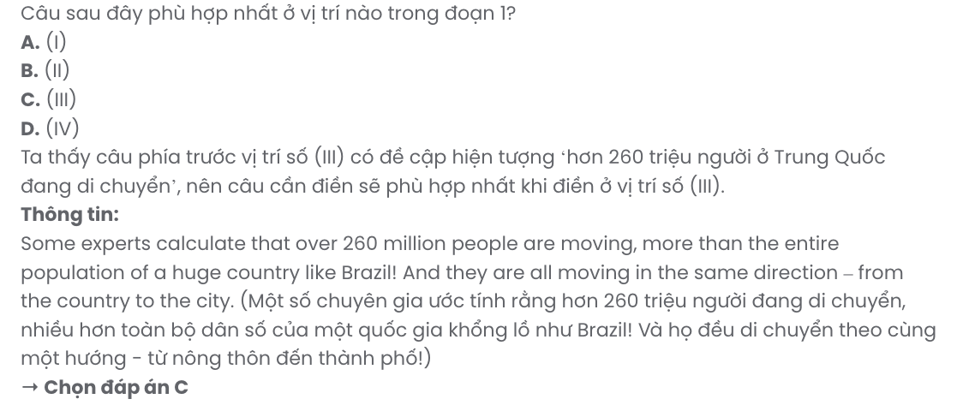
Question 32. The word it in paragraph 1 refers to .
A. transformation B. population C. China D. situation
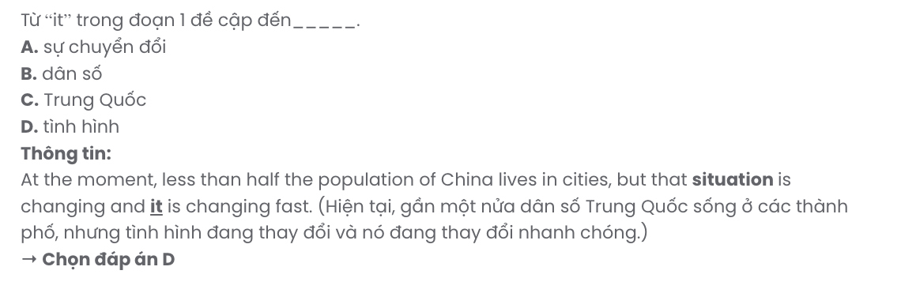
Question 33. According to the passage, more and more people move to live in cities in China because
.
- they are bored with the quiet pace of life in the country
- industry expansion has created demand for urban labour
- there has been a fall in living standards in the country
- people find it hard to make ends meet in the country
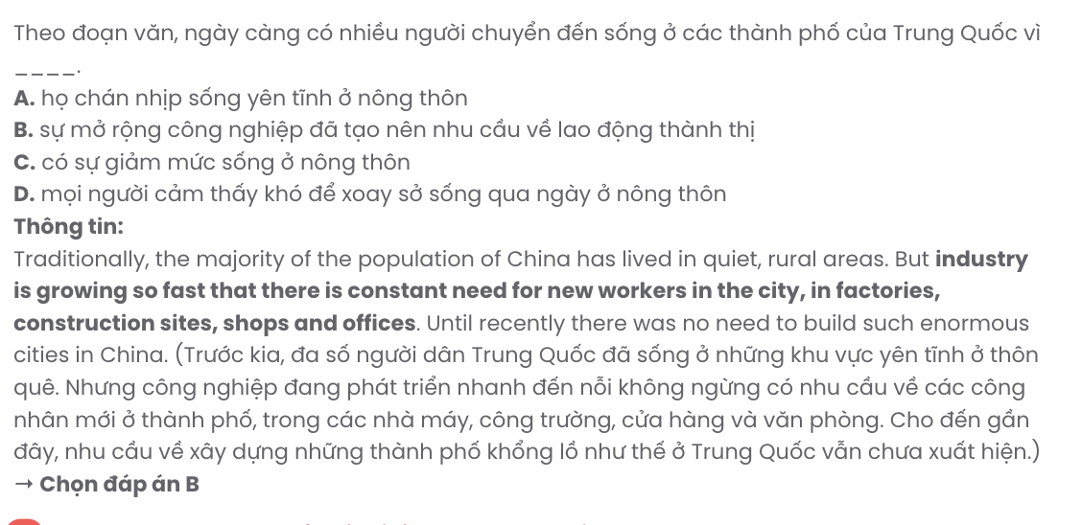
Question 34. The word urgent in paragraph 2 can be best replaced by .
A. pressing B. possible C. reduced D. common
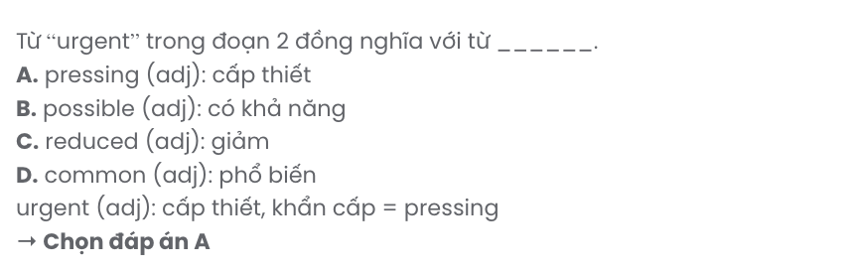
Question 35. The word invade in paragraph 3 is OPPOSITE in meaning to .
A. preserve B. suspend C. prevent D. spoil
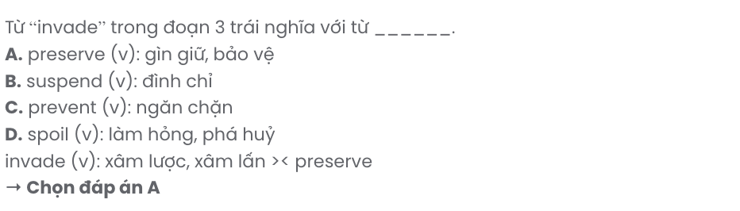
Question 36. Which of the following best paraphrases the underlined sentence in paragraph 3?

The future consequences of these enormous changes are still difficult to predict, both for China and for the whole planet.
- The impact of these major changes on both China and the rest of the world remains uncertain.
- The extent of these vast changes will only be completely comprehended in the future for China and beyond.
- Were these enormous changes comprehensible, it would be more straightforward for both China and the whole world to foresee the future results.
- Both China and the world have to deal with future consequences that become less predictable with the rise of some major changes.
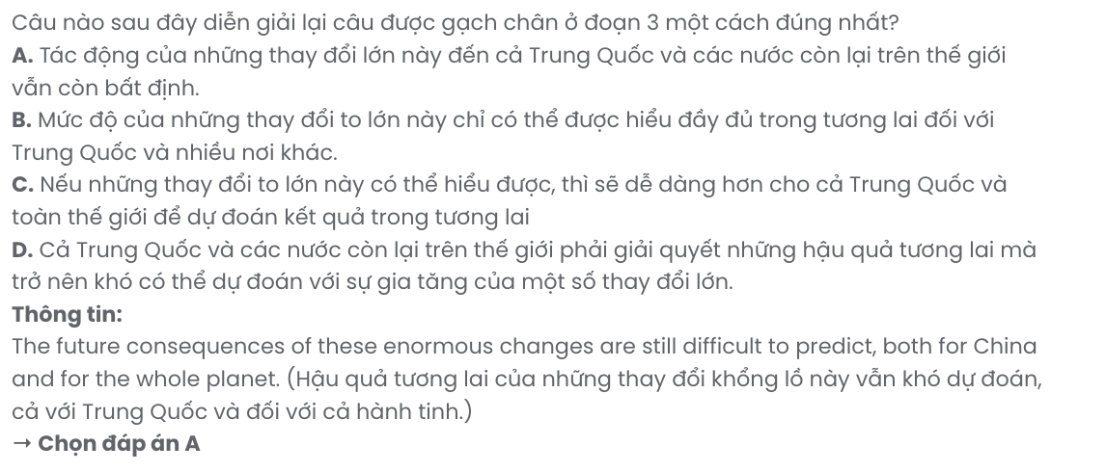
Question 37. Which of the following best summarises paragraph 4?
- Phoenix Towers are the greenest skyscrapers in China, focusing on clean energy and green urban spaces for environmental benefits.
- China's eco-cities, including Phoenix Towers, emphasise renewable energy to make megacities attractive and sustainable.
- Engineers in China are building Phoenix Towers, designed to use rainwater and solar power efficiently.
- China has developed several eco-cities, with Phoenix Towers being the most famous skyscrapers whose plans are to use solar energy.
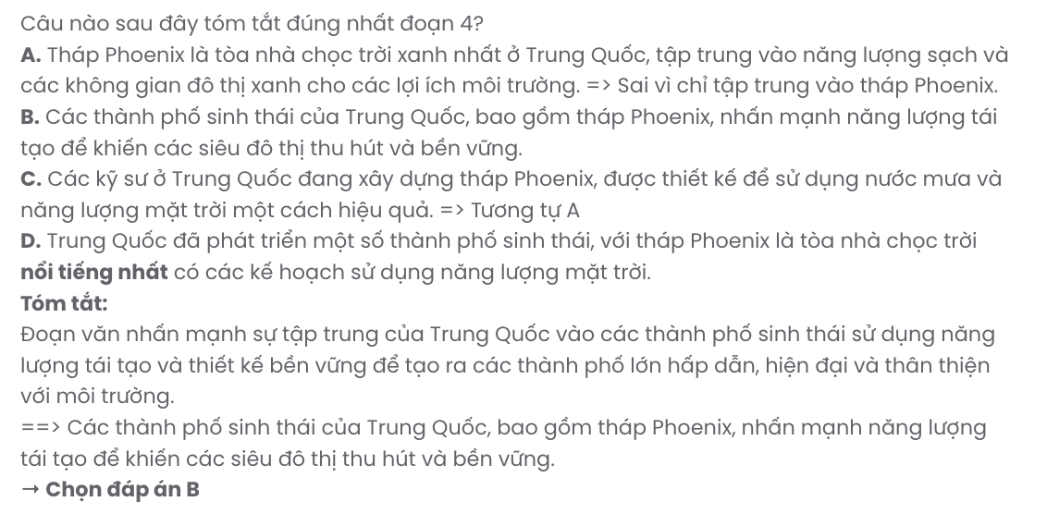
Question 38. Which of the following is TRUE according to the passage?
- Building enormous cities in China started to become popular a long time ago, supporting economic growth and modernisation.
- Chinese citizens no longer live and work in peaceful rural areas, leading to a decline in traditional lifestyles.
- Planners of eco-cities in China attach special importance to renewable energy, aiming to support sustainability.
- Chinese citizens often prefer living in detached houses over semi-detached ones, valuing privacy and personal space.

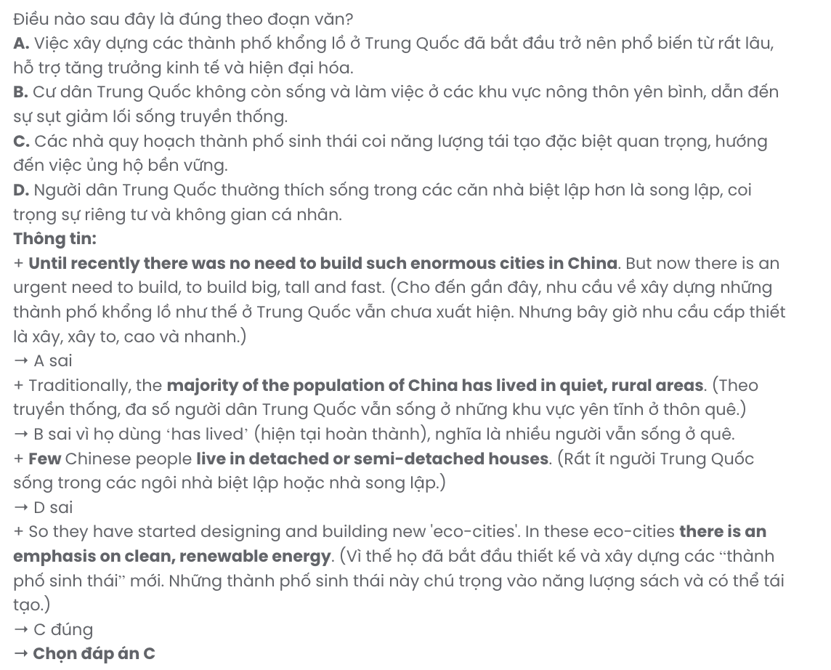
Question 39. Which of the following can be inferred from the passage?
- The Chinese government has failed to address the problems that are posed by megacities.
- China's megacities may not currently meet the standards of being environmentally friendly.
- The construction of eco-cities in China will come at the expense of economic development.
- Building the Phoenix Towers indicates China’s ambition to become the greenest country.
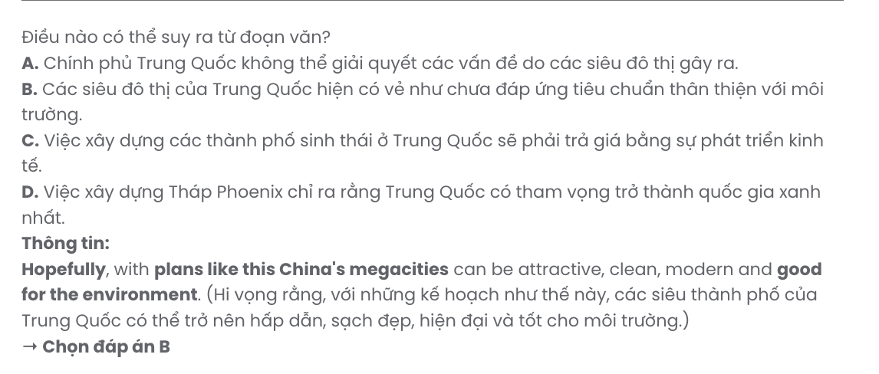
Question 40. Which of the following best summarises the passage?
- China's rural population is steadily declining as people migrate to megacities, causing a considerable strain on infrastructure and resources to keep up with the rising demand.
- China’s shift to urban living is always accompanied by the development of eco-cities that focus on sustainable energy solutions, such as the innovative Phoenix Towers project.
- Driven by urbanisation and the rising demand for workers, China’s megacities are expanding rapidly, with eco-cities being introduced to address environmental challenges.
- The demand for workers drives China’s rapid economic growth, with new eco-cities being developed to address environmental concerns and promote sustainability. GIA SƯ TẠI HUẾ (079.3833.272)

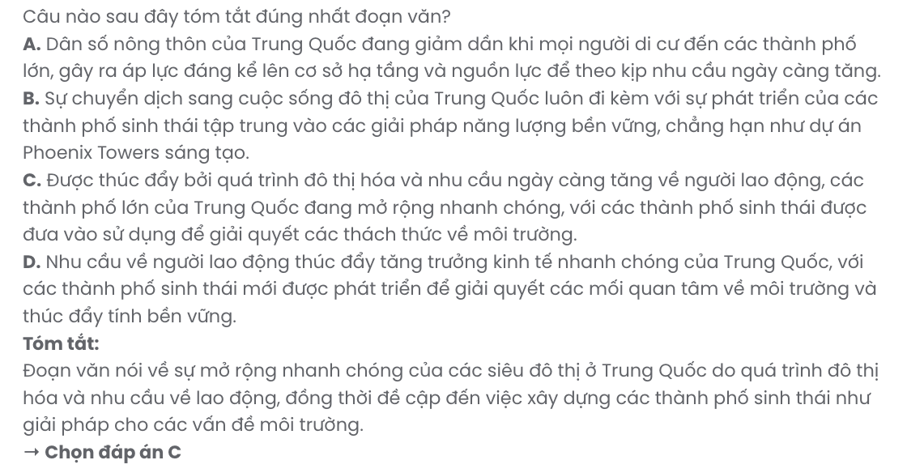
BẢNG TỪ VỰNG
STT | Từ vựng | Từ loại | Phiên âm | Nghĩa
1 | landscape | n | /ˈlænd.skeɪp/ | cảnh quan
2 | geographical | adj | /ˌdʒi.əˈɡræf.ɪ.kəl/ | thuộc địa lý
3 | extremely | adv | /ɪkˈstriːm.li/ | cực kỳ
4 | persistent | adj | /pəˈsɪs.tənt/ | bền
5 | organic | adj | /ɔːˈɡæn.ɪk/ | hữu cơ
6 | attack | v | /əˈtæk/ | tấn công
7 | spray | v | /spreɪ/ | xịt, phun
8 | pesticide | n | /ˈpes.tɪ.saɪd/ | thuốc trừ sâu
9 | cancer | n | /ˈkæn.sər/ | bệnh ung thư
10 | sustainability | n | /səˌsteɪ.nəˈbɪl.ə.ti/ | tính bền vững
11 | toxic | adj | /ˈtɒk.sɪk/ | độc hại
12 | vulnerable | adj | /ˈvʌl.nər.ə.bəl/  /ˈvʌn.rə.bəl/ | dễ bị tổn thương
13 | transformation | n | /ˌtræns.fəˈmeɪ.ʃən/ | sự chuyển đổi
14 | constant | adj | /kənˈtent/ | không ngừng
15 | urgent | adj | /ˈɜː.dʒənt/ | khẩn cấp
16 | megacity | n | /ˈmeɡ.ə.sɪt.i/ | siêu đô thị
17 | invade | v | /ɪnˈveɪd/ | xâm lấn
18 | skyscraper | n | /ˈskaɪˌskreɪ.pər/ | tòa nhà chọc trời
19 | passionate | adj | /ˈpæʃ.ən.ət | đam mê
20 | recruit | v | /rɪˈkruːt/ | tuyển
21 | project | n | /ˈprɒdʒ.ekt/ | dự án
22 | dedicated | adj | /ˈded.ɪ.keɪ.tɪd/ | tận tâm
23 | contribute | v | /kənˈtrɪb.juːt/  /ˈkɒn.trɪ.bjuːt/ | đóng góp
24 | enthusiasm | n | /ɪnˈθjuː.zi.æz.əm/ | sự nhiệt huyết
25 | effort | n | /ˈef.ət/ | nỗ lực
26 | vibrant | adj | /ˈvaɪ.brənt/ | sôi động
27 | satisfaction | n | /ˌsæt.ɪsˈfæk.ʃən/ | sự hài lòng
28 | satisfying | adj | /ˈsæt.ɪs.faɪ.ɪŋ/ | mang lại sự hài lòng
29 | satisfied | adj | /ˈsæt.ɪs.faɪd/ | hài lòng
30 | renovation | n | /ˌren.əˈveɪ.ʃən/ | sự cải tạo
31 | restoration | n | /ˌres.tərˈeɪ.ʃən/ | sự khôi phục
32 | preservative | n | /prɪˈzɜː.və.tɪv/ | chất bảo quản
33 | recent | adj | /ˈriː.sənt/ | gần đây
34 | charm | n | /tʃɑːm/ | sự quyến rũ
35 | original | adj | /əˈrɪdʒ.ən.əl/ | ban đầu
36 | intent | n | /ɪnˈtent/ | ý định
37 | resident | n | /ˈrez.ɪ.dənt/ | cư dân
38 | peaceful | adj | /ˈpiːs.fəl/ | yên bình
39 | complex | adj | /ˈkɒm.pleks/  /kəmˈpleks/ | phức tạp

40 | advancement | n | /ədˈvɑːns.mənt/ | sự cải tiến, sự tiến bộ
41 | dramatic | adj | /drəˈmæt.ɪk/ | đáng kể
42 | trend | n | /trend/ | xu hướng
43 | obsolete | adj | /ˌɒb.səlˈiːt/ | lỗi thời
44 | automation | n | /ˌɔː.təˈmeɪ.ʃən/ | sự tự động hóa
45 | repetitive | adj | /rɪˈpet.ə.tɪv/ | có tính lặp đi lặp lại
46 | workforce | n | /ˈwɜːk.fɔːs/ | lực lượng lao động
47 | requirement | n | /rɪˈkwaɪə.mənt/ | yêu cầu
48 | analysis | n | /əˈnæl.ə.sɪs/ | phân tích
49 | crime | n | /kraɪm/ | tội phạm
50 | harsh | adj | /hɑːʃ/ | gay gắt
51 | infrastructure | n | /ˈɪn.frəˌstrʌk.tʃər/ | cơ sở hạ tầng
52 | amenity | n | /əˈmiː.nə.ti/ | tiện ích
53 | insult | n | /ˈɪn.sʌlt/ | lời xúc phạm
54 | constantly | adv | /ˈkɒn.stənt.li/ | liên tục, không ngừng
55 | echo | v | /ˈek.əʊ/ | vang vọng
56 | escalate | v | /ˈes.kə.leɪt/ | leo thang
57 | painful | adj | /ˈpeɪn.fəl/ | đau khổ, đau đớn
58 | bullying | n | /ˈbʊl.i.ɪŋ/ | sự bắt nạt
59 | anticipate | v | /ænˈtɪs.ɪ.peɪt/ | dự đoán
60 | verbal | adj | /ˈvɜː.bəl/ | bằng lời nói
61 | exhibit | n | /ɪɡˈzɪb.ɪt/ | cuộc triển lãm
62 | digital | adj | /ˈdɪdʒ.ɪ.təl/ | thuộc kỹ thuật số
63 | format | n | /ˈfɔː.mæt/ | hình thức, định dạng
64 | portability | n | /ˌpɔː.təˈbɪl.ə.ti/ | tính di động
65 | tangible | adj | /ˈtæn.dʒə.bəl/ | hữu hình
66 | appreciate | v | /əˈpriː.ʃi.eɪt/ | đánh giá cao
67 | commitment | n | /kəˈmɪt.mənt/ | cam kết
68 | specific | adj | /spəˈsɪf.ɪk/ | cuụ thể
69 | comprehension | n | /ˌkɒm.prɪˈhen.ʃən/ | sự hiểu
70 | retention | n | /rɪˈten.ʃən/ | sự giữ lại
71 | immerse | v | /ɪˈmɜːs/ | hòa mình, chìm đắm
72 | vanish | v | /ˈvæn.ɪʃ/ | biến mất
73 | tactile | adj | /ˈtæk.taɪl/ | thuộc xúc giác
74 | sentimental | adj | /ˌsen.tɪˈmen.təl/ | thuộc tình cảm
75 | modify | v | /ˈmɒd.ɪ.faɪ/ | điều chỉnh
76 | authentic | adj | /ɔːˈθen.tɪk/ | chân thật

BẢNG CẤU TRÚC

STT | Cấu trúc | Nghĩa
1 | once and for all | một lần và mãi mãi
2 | take advantage of something | tận dụng cái gì
3 | take something into account/take account of  something | xem xét cái gì
4 | intend to do something | có ý định làm gì
5 | make up for something | bù cho cái gì
6 | get on with somebody | hòa hợp với ai
7 | face up to something | đối mặt với cái gì
8 | put up with somebody or something | chịu đựng ai/cái gì
9 | access to something | sự tiếp cận cái gì

