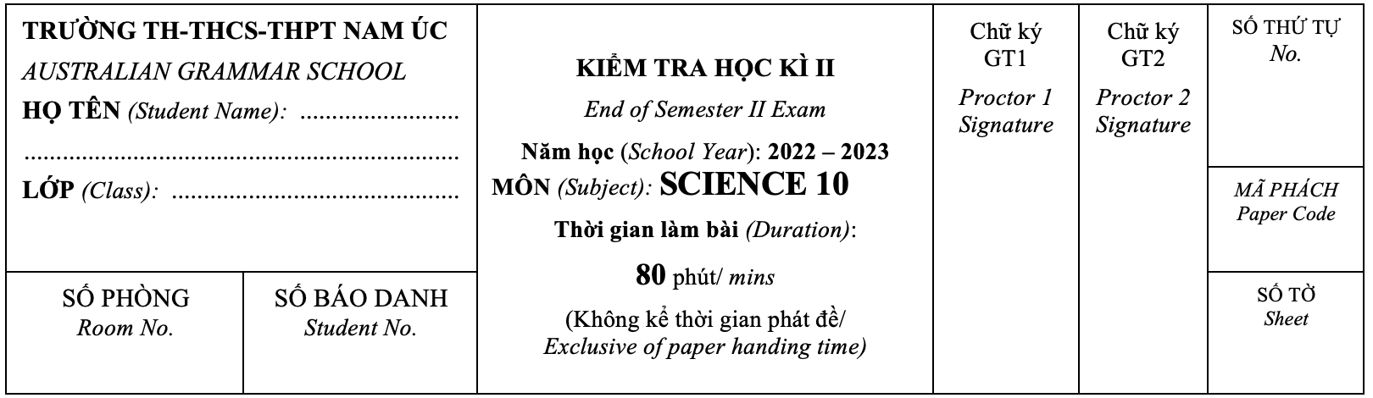

|  |
| --- |
| **INSTRUCTION**   ● Students were asked to **WRITE** ***all*** the answer on the **ANSWER PAPER.**  ● Use a ball-point pen (**blue** or **black** **ONLY**).  ● **Answer** all questions.  ● Section A: **30** questions - **WRITE** only ONE letter (A, B, C or D)  ● Section B: **10** questions - **WRITE** in **PEN** on the exam paper.  ● Without sufficient explanation or work, correct answers may **NOT** be awarded full marks.  ● **Answer** the questions **in the spaces provided** – there is more space than you need.  ***Scientific calculators can be used.*** |

1. Multiple choice questions [**60 pts**]

|  |
| --- |
| 1. Which of the following particles are used in determining the position of an element within the periodic table?    1. protons only b. neutrons only   c. electrons only d. protons and electrons |
| 1. Magnesium has 12 electrons. When in its ground state, its electron configuration is:    1. 11 b. 2,8,2 c. 2,9 d. 10,1 |
| 1. Which of the following statements about group 18 is incorrect?    1. All atoms in group 18 have 18 electrons.    2. Their valence shells are full.    3. Group 18 is known as the noble gases.    4. They are very stable, tend not to react or bond with other atoms. |
| 1. Which of the following is best explained by Newton’s third law?    1. Unbelted passengers will be thrown forward when a car stops suddenly.    2. A gun recoils when a shot is fired.    3. The acceleration of an object when a force is applied depends on the mass of the object.    4. The weight of an object varies from planet to planet. |
| 1. Sodium (Na) reacts violently when placed in water. Elements that could be expected to react with water in a similar violent way are:    1. Mg, Al, Si and P because they are in the same row    2. Li, K, Rb and Cs because they are in the same column    3. Ca, Y, Hf and Db because they are in the same diagonal    4. Ne, Ni, Nb and Np because they all have N in their symbol |
| 1. Which of the following best describes Newton's second law of motion?    1. An object at rest will remain at rest unless acted upon by an unbalanced force.    2. Force is equal to the product of mass and acceleration.    3. For every action, there is an equal and opposite reaction.    4. The velocity of an object remains constant unless acted upon by a force. |
| 1. Which of the following atoms belongs to the same element as Cl?    1. W b. X c. Y d.Z |
| 1. Nitrogen, N, is in period 2, group 15. Which of the following elements would have properties most similar to nitrogen?    1. a. phosphorus, P (period 3, group 15)    2. b. oxygen, O (period 2, group 16)    3. c. neon, Ne (period 2, group 18)    4. d. sodium, Na because its symbol also starts with N |
| 1. A red car and a yellow car are driven along a flat section of road from a standing start. The red car reaches a speed of 100 km/h in 10 seconds and the yellow car reaches the same speed in 12 seconds. The cars continue their journey at 100 km/h for another 5 minutes. Which of the following statements is correct?    1. After 12 seconds, the red car and the yellow car have the same acceleration.    2. After 10 seconds, the red car is travelling at a greater speed than the yellow car.    3. After 12 seconds, the red car is travelling faster than the yellow car.    4. After 20 seconds, both cars have travelled the same total distance. |
| 1. Identify the sections of the graph where the train has zero acceleration.    1. D only    2. A, B and C    3. B, D and F    4. A and G    5. E, F and G |
| 1. Select the option that best completes the following sentence. As a car exits a freeway, its speedometer shows 80 km/h. This is:    1. the distance the car travelled in the previous hour    2. the car's average speed    3. the car's instantaneous speed |
| 1. A skydiver glides to the ground at a steady speed of 10 m/s.   Which statement below best describes what is happening?   * 1. The upward force of air resistance acting on the skydiver is smaller than the downward weight force that is acting   2. The upward force of air resistance that is acting on the skydiver is larger than the size of the downwards weight force   3. The upward force of air resistance balances the downwards force of gravity acting on the skydiver   4. The weight force that acts on the skydiver is larger than the upwards force of air resistance |
| 1. Which of the following chemical reactions is a composition reaction?    1. 2H2O(l) → 2H2(g) + O2(g)    2. 2H2(g) + O2(g) → 2H2O(l)    3. 2H2O(l) + 2Na(s) → 2NaOH(aq) + H2(g)    4. 2HCl(aq) + 2Na(s) → 2NaCl(aq) + H2(g) |
| 1. Which is the best term to describe the following reaction?   CaCO3(s) → CaO(s) + CO2(g)   * 1. combination reaction b. acid–metal   c. precipitation reaction d. decomposition reaction |
| 1. A 110 N force is applied to a 65 kg mass. The mass will accelerate at:    1. 0.85 m/s2  b. 1.6 m/s2  c. 1.7 m/s2  d. 5.9 m/s2 |
| 1. Explain why crushin solid reactants helps to increase the rate of reaction.    1. It exposes more of the solid reactant to the other reactants so there can be more reactions occurring at any one time.    2. It weakens the chemical bonds in the solid so that it is easier for the reaction to occur.    3. It helps the solid to dissolve.    4. All answers are correct. |
| 1. Select the option that best completes the following sentence.   ***A speed-time graph for a train is shown below. The most appropriate description of the train's motion is that it:***   * 1. sped up, stopped for a while, sped up in the opposite direction   2. travelled at a constant speed, stopped for a while, returned to its starting position at a slower speed   3. sped up, stayed at a constant speed for a while, gradually slowed down |
| 1. Which of the following is a scalar quantity?   a. Velocity b. Speed c. Acceleration d. Force |
| 1. What is the difference between speed and velocity?    1. Speed is the rate of change of distance, while velocity is the rate of change of displacement.    2. Speed is the rate of change of displacement, while velocity is the rate of change of distance.    3. Speed and velocity are the same thing.    4. Speed and velocity have no relation to each other. |
| 1. Which of the following statements is true about acceleration?    1. Acceleration is always negative.    2. Acceleration is always positive.    3. Acceleration can be negative or positive, depending on the direction of the velocity.    4. Acceleration is always zero. |
| 1. Which one of the following statements about friction is ***INCORRECT***?    1. Friction operates in the same direction as a moving object.    2. Friction is a contact force.    3. Friction between two moving objects produces heat.    4. Without friction you could not grip an object or walk. |
| 1. A train travels at a speed of 18 m/s. This is equivalent to a speed of:    1. 5 km/h b. 64.8 km/h c. 64 800 km/h d. 0.005 km/h |
| **For question 23, 24, 25, 26**  *Match the following acceleration descriptions to the velocity-time graphs****.***    **A**  **B**  **C**  **D** |

1. Low positive acceleration then high positive acceleration. *Answer_______*
2. High negative acceleration then low positive acceleration. *Answer_______*
3. No acceleration. *Answer_______*
4. Steady positive acceleration. *Answer_______*

**For question 27, 28, 29, 30 Match the distance time-graph to speed time graph**

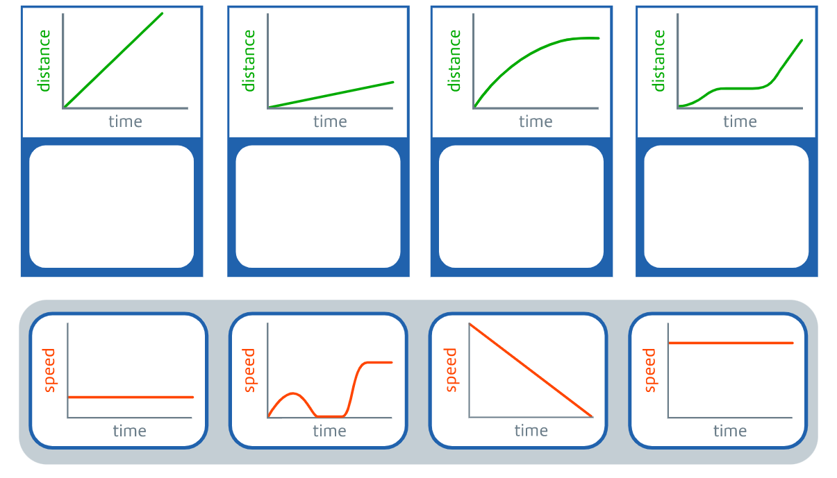

**27**

**28**

**29**

**30**



**A**

**B**

**C**

**D**

1. **SHORT ANSWER [40 pts]**
2. ***State the charge of: 5 marks***
3. a proton
4. a neutron
5. an electron
6. nucleus
7. atom
8. What is acceleration and the difference between positive and negative acceleration? ***4 marks***
9. What is the difference between instantaneous speed and average speed?

***3 marks***

1. If a car is travelling at a constant speed on a straight road, is it experiencing any net force? ***Explain your answer based on Newton's first law.*** ***4 marks***
2. What does Newton's third law of motion state? ***2 marks***

Give an example. ***2 marks***

1. A car travels 60 metres in 4 seconds, and then accelerates uniformly for 6 seconds to reach a final velocity of 30 m/s. What is the car's acceleration during the second part of the journey? ***Show your work 4 marks***
2. A car travels at a constant speed of 60 km/h for 1 hour, and then at a constant speed of 40 km/h for the next 2 hours. What is the car's average speed for the entire journey? ***4 marks***
3. The school bus slows from 60 km/h to 40 km/h when entering the school zone.

a. Calculate the conversion of these speeds from km/h to m/s.  ***2 marks***

b. Given that this change of speed occurred over 8 seconds, calculate the average deceleration of the bus. ***2 marks***

***Show your work***

1. Sketch a graph and describe the motion of an object in freefall.
2. Sketch a graph of an object in freefall ***2 marks***
3. What forces act on the object? ***2 marks***
4. Which of Newton's laws is the most relevant in this situation? ***2 marks***
5. A small object drops from the ceiling and hits the floor after 0.8 seconds. Due to the size of the object, air resistance can be ignored. What is the speed of the object when it reaches the floor? ***Show your work*** ***2 marks***

**---THE END OF THE TEST---**

Page 6 /6