Date of preparing: ………………………………….
Date of teaching: ………………………………….

Period …
UNIT 5: AROUND TOWN
Lesson 3 - Part 2 (Page 45) – Reading, Speaking and Writing

I. OBJECTIVES
By the end of the lesson, Ss will be able to…
1. Knowledge
- read an article about Vietnamese food.
- talk about food around the world.
- write a paragraph about two famous dishes.
2. Ability
- improve the reading, speaking and writing skills.
3. Quality
- have positive attitude in English language learning so that they actively participate in all classroom activities.
- eat healthy food.
II. TEACHING AIDS AND LEARNING MATERIALS
Lesson plan, PPT slides, student’s book, workbook, notebook, personal computer (if any), projector/TV, speakers, DCR & DHA on Eduhome, handouts…
III. PROCEDURES
A. Warm up: (5’)
a) Objective: Introduce the new lesson and set the scene for Ss to acquire new language; get students' attention at the beginning of the class by means of enjoyable and short activities as well as to engage them in the steps that follow.
b) Content: Introduction of food around the world / or introduction of “noodles”
c) Product: Ss have general idea about the dishes that are mentioned in the lesson
d) Competence: collaboration, communication
e) Organization of the activity:
Teacher’s Activities | Students’ Activities
- Give greetings  - Check attendance  - Option 1: Game: CROSSWORD  - Show game crossword, have Ss answer the questions (horizontal line) by looking at the pictures, give name of the pictures  - Encourage Ss to guess the key word (vertical line)  - Give a small present to Ss who can give the right keyword  Lead to the new lesson.  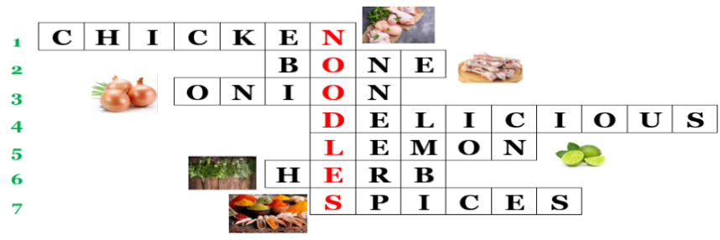  - Option 2: Pair Matching  - Have Ss close all books  - Show a picture (use handouts or show on the screen)  - Have Ss find 6 pairs (a word and a picture – name of the country and its dish)  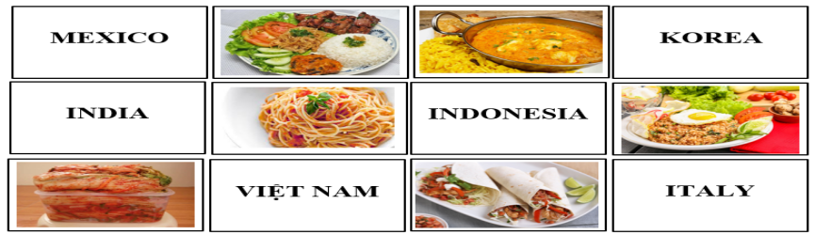  - Call Ss to give answers and give name of the dishes  - Give feedback  Lead to the new lesson | - Greet T  - Answer the questions  - Say key words  Answer keys  Keyword: Noodles  - Close books  - Work in pairs  Answer keys  1. Mexico - fajitas  2. India – curry  3. Korea – kimchi  4. Italy – spaghetti  5. Indonesia – nasi goreng  6. Việt Nam – cơm tấm

B. New lesson (36’)
- Activities 1: Reading (10’)
a) Objective: Ss improve their reading skill (scanning, skimming)
b) Content:
- Reading the article and circling the best headline
- Reading and answering the questions
c) Products: Ss know about cơm tấm and phở – famous dishes in Việt Nam. Ss can read for gist and read for details.
d) Competence: collaboration, communication, analytical and synthesizing skills.
e) Organization of the activity:
Teacher’s Activities | Students’ Activities
a. Read the article and circle the best headline  - Have Ss read the article individually  - Have some Ss read the article aloud  - Have Ss choose the best headline  - Call Ss to read answer  - Check answers as a whole class.  b. Read the article and answer the questions  - Option 1:  - Have Ss read the questions and guess the key word (the word that helps they find the answers quickly and correctly)  - Have Ss read the article again and answer the questions  - Haves Ss underline the sentences that help them find the answers  - Call Ss to give answers, explain  - Check answers as a whole class.  - Option 2: (for class with better student)  - Follow the same steps as option 1  - Give Ss an extra exercise: Fill in the blanks-using the words in the reading text  1. Phở and Cơm tấm are popular ______of Vietnam.  2. People make ______ with chicken or beef.  3. There are ______ and ______ in Phở.  4. The ingredients of Cơm tấm are rice, egg and ______ pork.  5. There is ______ on the top of Cơm tấm.  6. Phở and Cơm tấm are very ______.  - Call Ss to give answers  - Give feedback and evaluation  - Check answers as a whole class. | - Read in silence  - Read in front of the class  - Do the task  - Check  Answer key  2. A Taste of Vietnam  - Read, find key words  - Do the task  - Write answers, explain  Answer keys  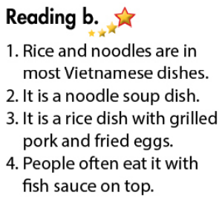  Answer key for extra exercise  1. Phở and Cơm tấm are popular dishes of Vietnam.  2. People make phở with chicken or beef.  3. There are onions and herbs in Phở.  4. The ingredients of Cơm tấm are rice, egg and grilled pork.  5. There is fish sauce on the top of Cơm tấm.  6. Phở and Cơm tấm are very delicious.
- Activity 2: Speaking: Food around the World (11’)
a) Objective: Ss can talk about some food in Vietnam and around the world
b) Content: Asking and answering about nasi goreng, spaghetti, cơm tấm and phở
c) Products: Ss can talk about the dishes they know.
d) Competence: collaboration, communication, creativity, presentation.
e) Organization of the activity:

Teacher’s Activities | Students’ Activities
a. You’re visiting an international food festival. Work in pairs. Student A asks Student B about four of the dishes below, and tick ()the ones you would like to try. Student B answers the questions.  - Demonstrate the activity by asking and answering with a student.  - Have Ss practice the conversation in pairs, then tick the dishes they would like to try  - Observe and give help if necessary  - Have some pairs act out the conversation in front of the class.  - Give feedback and evaluation.  b. Swap roles and repeat. How many dishes would you like to try? Which is your favorite?  - Option 1:  - Have Ss swap roles  - Go round and give help if necessary  - Call some pairs to demonstrate the activity, answer the questions  - Give feedback and evaluation  - Option 2:  - Follow the same steps as option 1  - Have Ss use their own ideas and other dishes they know  - Have Ss practice the conversation in pairs and present their conversation in front of the class.  - Give feedback and evaluation. | - Observe and listen  - Work in pairs: Student A asks Student B about four of the dishes. Student B answers the questions.  - Present  - Present  - Work in pairs  - Present
- Activity 3: Writing (15’)
a) Objective: Ss can write about their favorite dishes
b) Content: Asking and answering about two of the dishes from your country, then writing
c) Products: Ss can use what they have learnt to write a good paragraph about a dish in Vietnam.
d) Competence: collaboration, communication, writing
e) Organization of the activity:
Teacher’s Activities | Students’ Activities
a. With a partner, choose two of the dishes from your country and make notes.  - Demonstrate the activity by asking and answering with a student.  - Have pairs ask and answer about the dishes they choose and complete the notes  - Have some pairs demonstrate the conversation in front of the class  - Give feedback and evaluation  b. Write a paragraph about your choices.  - Have Ss use their notes and the information from the Reading and Speaking part to write a paragraph about the dishes they choose  - Have Ss write their paragraph on the board  - Check, correct Ss’ mistakes.  - Have Ss finish their writing part in their notebooks | - Observe  - Work in pairs  - Present  Expected answers  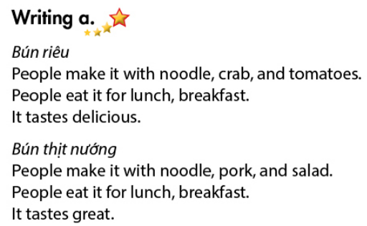  - Do the task  - Write / read  Suggested writing  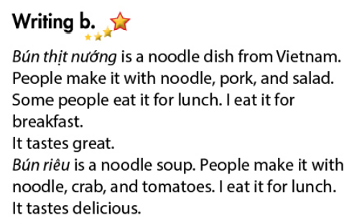

C. Consolidation (2’)
* Talk / write about your favorite dish follow the outline:
The name and the kind of dish
What people make it with
When people eat it
How it tastes

D. Homework (2’)
- Finish the writing part.
- Find more information about some famous dishes in Vietnam and around the world.
- Do exercises in Workbook: Reading and Writing (page 31).
- Prepare: Unit 5 - Review (page 94 – SB).

