Period
LESSON PLAN
TIẾNG ANH 10 FRIENDS GLOBAL
UNIT 1: FEELINGS
LESSON 1H: WRITING – A DESCRIPTION OF AN EVENT
I. OBJECTIVES:
By the end of the lesson, Ss will be able to:
1. Knowledge:
- know some new words
- describe people’s reactions to an event
2. Ability:
- main skills: listening and speaking skills
- sub skills: reading and writing skills
- Write a description of an event
3. Quality:
- have positive attitude in English language learning so that they can participate enthusiastically in all classroom activities, especially with the topic conducted by the teacher
- keen on writing English
II. TEACHER AIDS AND LEARNING MATERIALS:
Lesson plan, PPT slides, student’s book, workbook, notebook, personal computer (if any), projector/TV, speakers, IWB software.
III. PROCEDURES:
A. Warm-up (6’)
a) Objective: Introduce the new lesson and set the scene for Ss to acquire new language; get students' attention at the beginning of the class by means of enjoyable and short activities as well as to engage them in the steps that followed.
b) Content: Students work in pairs to describe the photos.
c) Outcomes: Students can gain more confidence and interest in the lesson.
d) Competence: communication, collaboration, guessing
e) Organisation of the activity:
TEACHER’S ACTIVITIES | STUDENT’S ACTIVITIES | CONTENTS
WARM-UP. T-Ss/ S-S  Activity 1 (2’): Task 1. Work in pairs and describe the photo with the words below.  - Ask students work in pairs to talk about the picture. Students need to use the words in the box to make sentences to describe the photo.  - Call out some pairs to share their ideas. Give bonus if the students can make complete sentences.  - Check the answer.  Activity 2 (4’): Work in pairs. Describe the photos with words in the box.  - Ask students continue working in pairs and describe the picture with given words.  - Invite some pairs to present their ideas. Give bonus  - Check the answers.  - Ask the students ‘Do you know any funny pranks?’. If yes, encourage students to share it. If no, the teacher can give one example.  - Lead in the lesson. | - Work in pairs to describe the photo with words in the box.  - Volunteer to share their ideas.  - Check the answer with the teacher.  - Describe the photos with words in the box.  - Volunteer to answer.  - Check the answers.  - Open book page 19. | 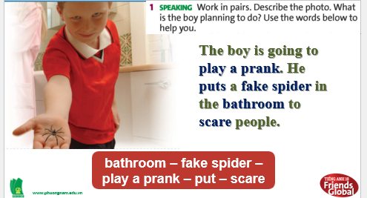  Suggested answer:  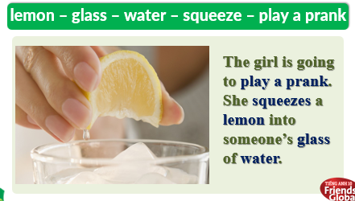  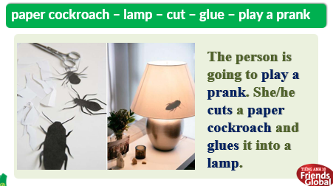

B. New lesson (34’)
- Activity 1: Presentation (8’)
a) Objective: Students get to know some new words.
b) Content:
Vocabulary study
Writing
c) Outcomes: Students review how to pronounce words correctly.
d) Competence: communication, presentation
e) Organisation of the activity:

TEACHER’S ACTIVITIES | STUDENT’S ACTIVITIES | CONTENTS
PRESENTATION. T-Ss/ S-S/ Indiv.  Teach new words:  - Use pictures and explanation to present new words.  - Ask students to practice their pronunciation drills.  Childish (a)  Clever (a)  Cruel (a)  Predictable (a)  Prank (v,n)  Enormous (a)  Disguise (v) | - Look, listen and repeat in chorus and individuals. | 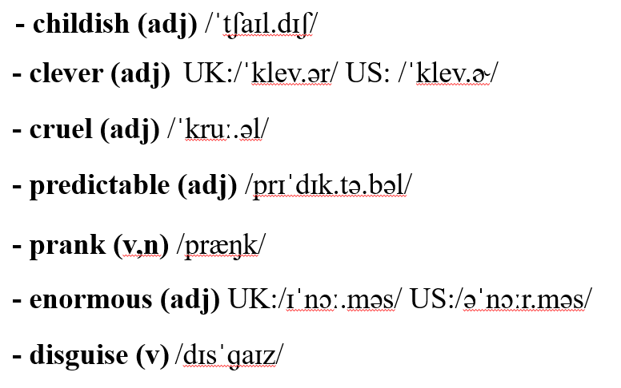
- Activity 2: Practice (16’)
a) Objective: Students can answer the questions to critical thinking, and they can finish the tasks in the textbook. Critical thing skills (guessing/ reasoning) and communication can also be practiced.
b) Content: Students match and circle. Then , find the phrases and practice.
c) Outcomes: Students read and write, and they can apply the useful language in everyday conversations.
d) Competence: communication, collaboration, presentation
e) Organisation of the activity:
TEACHER’S ACTIVITIES | STUDENT’S ACTIVITIES | CONTENTS
PRACTICE. T-Ss/ S-S/ Indiv  Activity 1 (5’): task 2 page 19. Read the descriptions of two events and check their ideas for exercise 1. What do you think of each prank? Use the adjectives below or your own ideas.  - Ask students to read the descriptions of two events and check their ideas for exercise 1. Use the adjectives below or their own ideas to talk about each prank.  - Encourage students to share their ideas.  Activity 2 (2’): Show Writing Strategy box.  - Present the ‘Writing Strategy’ box to the students. Focus on some main points about writing a description of an event.  Activity 3 (3’): Match the adjectives below with people in the stories (A-D). Say when and why they felt that way.  - Ask students to match suitable adjectives with people in the stories.  - Check the answers.  - Ask students to match the phrases on the left column with the correct expressions on the right.  - Check the answers.  Activity 4 (3’): Rearrange the texts into the correct time order.  - Ask students to put those sentences in order from 1 to 4 to make a complete event.  - Give the answers to the class.  - Have students read the text aloud.  Activity 5 (3’): Read the task above. Make notes using one of the idea below, real information or your own ideas.  - Ask students to make notes about a prank on a friend or family member. | - Read two events and check the ideas.  - Use the adjectives or own ideas to talk about each prank.  - Volunteer to share their opinions.  - Listen to the teacher and take note.  - Do what teacher said.  - Check the answers with the teacher.  - Complete the task.  - Check the answers with the teacher.  - Rearrange the text into the correct time order.  - Check the answer with the students.  - Volunteer to read.  - Make notes about a prank. | 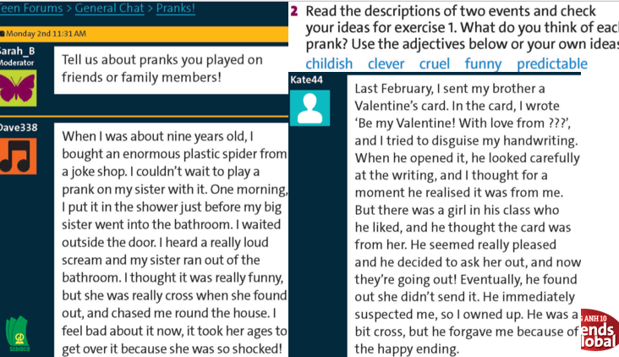  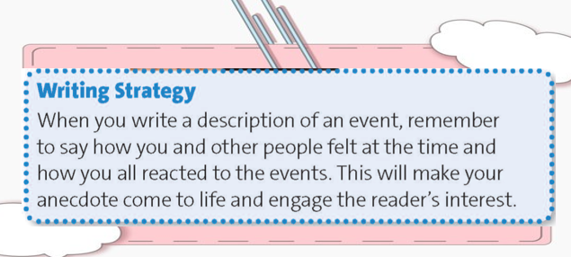  Answers:  A. Dave: amused, guilty  B. Dave’s big sister: angry, frightened  C. Kate: anxious, pleased  D. Kate’s brother: angry. Pleased  Answers:  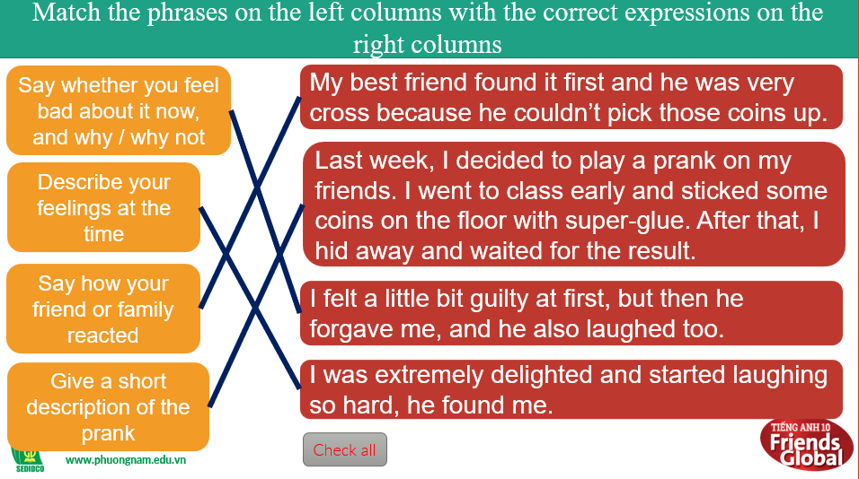  Answers:  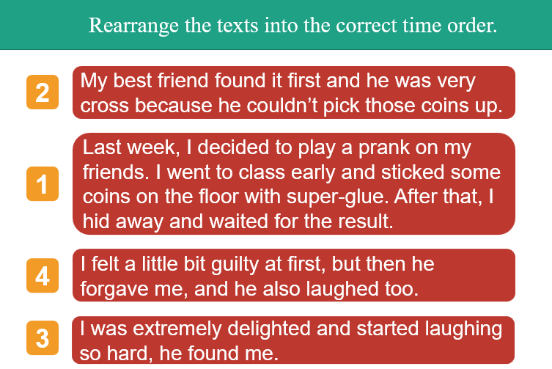  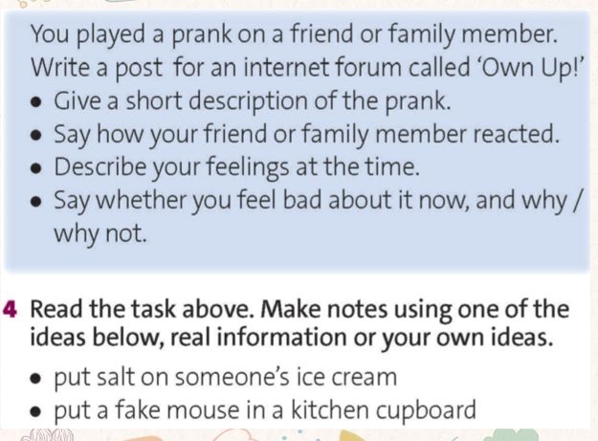

- Activity 3: Outcomes (10’)
a) Objective: Students write a post (100-120 words) about a prank and check their works.
b) Content: Task 5 page 19
c) Outcomes: Students write a description about an event in the past, and they can apply the adjectives to describe how people felt.
d) Competence: presentation, organization
e) Organisation of the activity:
TEACHER’S ACTIVITIES | STUDENT’S ACTIVITIES | CONTENTS
PRODUCT. T-Ss/ Indiv  - Ask students to write a forum post (100-120 words) about the prank they made notes in the previous activity.  - Go around to assist the students.  - If the students finish writing, ask them to check if they used adjectives to describe how people felt. Besides that, remind them to check spelling and grammar. | - Write a post to describe that prank using the clues.  - Raise hand if the students need help.  - Check their works.  - If the students haven’t finish, they can complete this post at home. | 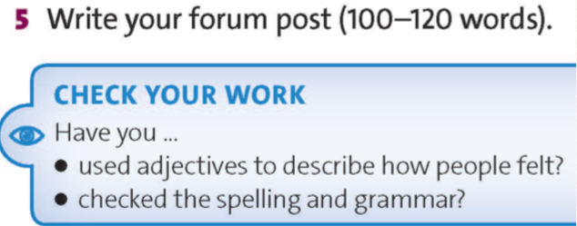
C. Consolidation (3’)
- Vocabulary: childish, clever, cruel, predictable, prank, enormous, disguise
- Ways to write a description of an event
D. Homework (2’)
- Learn by hear all the new words.
- Complete the writing task.
- Do exercise
- Prepare: Unit 1 – I- Culture (page 20– SB)

