SỞ GD – ĐT THÀNH PHỐ HỒ CHÍ MINH  ĐỀ THI THỬ SỐ 41 | KỲ THI TUYỂN SINH VÀO LỚP 10  Thời gian làm bài: 90 phút
Họ và tên học sinh:
- Choose the word that has the underlined part pronounced differently from the others (0.5 pts)
- A. slavery B. ancient C. celebrate D. parade
- A. carriage B. lift C. tidal D. shift
- Choose the word whose main stress pattern is not the same as that of the other (0.5 pts)
- A. collapse B. volcano C. temperature D. typhoon
- A. infrastructure B. receive C. ultimately D. separate
- Multiple choice: Read and choose appropriate word or phrase (1.5 pts)
- The government _______________ us about the upcoming storm.
A. warned B. said C. promised D. explained
- Tornadoes can suck _______________ anything that is in their path.
A. out B. about C. up D. with
- Tim should get his car _______________ soon. It’s dangerous to drive a broken down car.
A. to fix B. fixed C. fixing D. to be fixed
- Elephants _______________ are my favorite animals, have long noses.
A. ,which B. which C. who D. that
- This is one possible solution to the problem. _______________, there are others.
A. However B. And C. But D. So
- Rose: I got the highest score in English test today.
Rose’s mom: _______________.
A. Well done B. Thanks C. That’s terrible D. Word harder
- CAUTION SIGNS (0.5 pts)
- What does the sign say?
 | A. Wear your mask.  B. Hide your face.  C. Toxic area.  D. Food contamination.
- What does this sign mean?
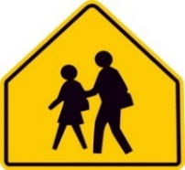 | A. School zone crossing.  B. Working zone.  C. Do not cross.  D. Pedestrian walkway.
- Complete the passage with the suitable words in the box (1.5 pts)
traditionally chimney celebration from actually only reindeer international
Christmas is a family (13)____________________ and many of the customs center on children. When they go to bed on Christmas Eve, children hang up a pillow case or sack for their presents. (14)___________________, it should be stocking, but a stocking wouldn’t hold enough to satisfy today’s kids.
While the children are sleeping, so the custom goes, Father Christmas or Santa Claus, comes but (15)____________________ to children who have been good. He travels (16)____________________ the North Pole in a sleigh which is pulled by (17)____________________. After landing on the roof, Santa Claus climbs down the (18)____________________ and puts presents in the sacks that the children have left out.
- Reading comprehension: TRUE or FALSE, answer the questions (1.5 pts)
I often hear or read about “natural disasters” – the eruption of Mount St. Helen, a volcano in the state of Washington, Hurricane Andrew in Florida, the floods in the American Midwest, terrible all over the world, huge fires, and so on.
But I’ll never forget my first personal experience with the strangeness of nature – “the London Killer Fog” of 1952. It began on Thursday, December 4th, when a high-pressure system (warm air) covered southern England. With the freezing – cold air below, heavy fog formed. Pollution from factories, cars, and coal stoves mixed with the fog. The humidity was high, there was no breeze at all. Traffic (cars, trains, and boats) stopped. People couldn’t see, and some walked onto the railroad tracks of into the river. It was hard to breathe, and many people got sick. Finally, on Tuesday, December 9th, the wind came and the fog went away. But after that, even more people got sick. Many of them died.
- A tornado is a natural disaster which isn’t mentioned in the text.
- His unforgettable personal experience is the heavy fog in London in 1925.
- The “London Killer Fog” lasted for five days.
- The traffic stopped because of the heavy fog.
Read the passage again and choose the best answer.
- What is the synonym with “terrible”?
A. horrific B. wonderful C. severe D. intense
- According to the passage, which of the following is true?
A. The London Killer Fog ended on Thursday, December 4th, 1952.
B. During the London Killer Fog, people travelled normally.
C. After the London Killer Fog, no one got sick.
D. The humidity in the London Killer Fog was extremely high.
- Use the correct form of the word given in each sentence (1.5 pts)
- The next stage in the development of television is _____________________________ TV. (active)
- The recording industry is driven by constant ____________________________________. (innovate)
- Scientists ______________________________ that the world would end on 12 November. (prediction)
- I don’t have very much to feel _______________________________ about at the moment. (joy)
- He stood up ____________________________________ and went outside. (abrupt)
- Hurricanes are one of the most powerful natural __________________________________. (disastrous)
- Rewrite each of the following sentences in another way so that it means almost the same as the sentence printed before it (2.0 pts)
- Although Nam wasn’t intelligent, he passed the exam easily.
- In spite of
- Avengers is a fantastic movie. I want to watch it again.
- Avengers
- Wendy is excited about her upcoming trip to Paris next week.
- Wendy is looking
- Today I’ve met a beautiful lady. Her dress looked so gorgeous.
- Today
- To their surprise, dinner was ready on the table.
- They were very
- The home team managed to win the match finally.
- The home team was
- It’s two months since we last saw a movie.
- We haven’t
- Minh doesn’t speak French as well as Lan.
- Minh wishes
- Put the words in their correct order (0.5 pts)
- that family member / a celebration / Tet is so important / try to come back home / living apart /. //
- Tet is
- and developing nations / the covid-19 / for preventing / Both developed / are responsible /. //
- Both

SỞ GD – ĐT THÀNH PHỐ HỒ CHÍ MINH  ĐỀ THI THỬ SỐ 42 | KỲ THI TUYỂN SINH VÀO LỚP 10  Thời gian làm bài: 90 phút
Họ và tên học sinh:
- Choose the word whose main stress pattern is not the same as that of the other (0.5 pts)
- A. acquaintance B. forecast C. freedom D. humor
- A. describe B. behave C. collapse D. nominate
- Choose the word that has the underlined part pronounced differently from the others (0.5 pts)
- A. destroy B. expect C. erupt D. decorate
- A. amount B. achieve C. dynamite D. deforestation
- Multiple choice: Read and choose appropriate word or phrase (1.5 pts)
- They _______________ wedding car with ribbons and flowers.
A. decorated B. fixed C. installed D. innovated
- Let me congratulate you on your successful project. – “_______________.”
A. You're welcome B. Yes, let's do that C. No problem D. It's nice of you to say so
- I will give you my phone number _______________ you want to ask me more information.
A. just in case B. just like that C. just a moment D. just now
- “Do you mind if I sit here?” – “_______________.”
A. Yes, I do B. No, I don 't C. Not at all D. Yes, of course
- Hue will _______________ the temperature ranging from 23°C to 30°C.
A. get B. take C. experience D. see
- You were standing there with tears while I was walking _______________ my groom.
A. to B. on C. in D. towards
- SIGNS (0.5 pts)
- What does the sign say?
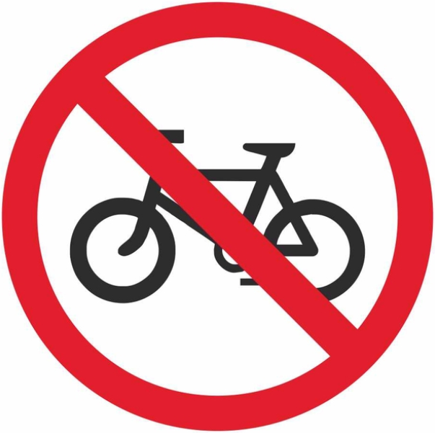 | A. Mustn’t ride a motorbike.  B. Mustn’t use a vehicle.  C. Mustn’t drive a car.  D. Mustn’t ride a bike.
- What does this sign mean?
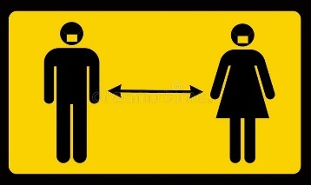 | A. Stand closer.  B. Keep social distance.  C. Stand on your right hand.  D. Stand on your left hand.
- Complete the passage with the suitable words in the box (1.5 pts)
protect of disappeared such as crops solve
Nowadays people are more aware that wildlife all over the world is in danger. Many species of animals are threatened, and could easily become extinct if we do not make an effort to (13)____________________ them. There are many reasons for this. In some cases, animals are hunted for their fur or for other valuable parts (14)____________________ their bodies. Some birds, (15)____________________ parrots, are caught alive, and sold as pets. For many animals and birds, the problem is that their habitat – the place where they live – is (16)____________________. More land is used for farms, for houses or industry, and there are fewer open spaces than there once were. Farmers us powerful chemicals to help them grow better (17)____________________, but these chemicals pollute the environment and harm the wildlife. The most successful animals on earth – human beings – will soon be the only ones left unless we can (18)____________________ this problem.
- Reading comprehension: TRUE or FALSE, answer the question (1.5 pts)
Air pollution is by far the most harmful form of pollution in our environment. It is caused by the injurious smoke emitted by cars, buses, trucks, trains, and factories. Even smoke from burning leaves and cigarettes is harmful to the environment causing a lot of damage to man and the atmosphere. Evidence of increasing air pollution is seen in lung cancer.
Water pollution caused by industrial waste products released into lakes, rivers, and other water bodies, has made marine life no longer hospitable. Humans pollute water with large scale disposal of garbage and other household waste. In many areas in the world, water in some rivers is too polluted to bath or drink.
Noise pollution, soil pollution and light pollution are also damaging the environment at an alarming rate. Noise pollution includes aircraft noise, noise of cars, buses, vehicle horns, loudspeakers, and industry noise which are extremely harmful to the environment.
- Air pollution isn’t the most harmful form of pollution.
- Burning forest doesn’t cause air pollution.
- Both waste products in industry and household make water polluted.
- Only the noise from the factories also does harm to the environment.
- What is the text about?
A. The air pollution B. The water pollution
C. The noise pollution D. Environmental pollution
- The word “vehicle” in the passage means _______________.
A. means of transport B. plane C. traffic jam D. traffic lights
- WORD FORMS (1.5 pts)
- One of the most famous tourists ______________________________ in Hue is the Citadel. (attract)
- What is your favorite type of _________________________________________________? (clothe)
- He is an _________________________________ worker. He often does something wrong. (experience)
- If we keep on polluting the sea, marine life will be ________________________________. (danger)
- They organized a ____________________________ party of their parents’ 50th anniversary. (celebrate)
- Our _________________________________________ situation is getting better and better. (economy)
- Sentence transformation (2 pts)
- “I’m working in a restaurant, and don’t care much for it.” she said
- She said
- Lan hasn’t written to Maryam for a month.
- It’s
- Most participants in the bull-fighting event enjoy it very much.
- Everyone who
- I think you should apply for that job.
- If
- Because of her carelessness, Lan broke the glass.
- Because Lan
- They stopped going out with each other two years ago.
- They have
- Despite not having enough money, we decided to hold a party.
- Though
- “I’m sorry I didn’t phone you earlier.” Daisy said to me.
- Daisy apologized
- Rearrange the words in the right order to make a meaningful sentence (0.5 pts)
- The London Eye, / which / one of the most famous / attracts / tourist hordes / is / a lot of travelers /. //
- The London Eye,

- garbage bins / to prevent / throwing trash / put / around the school yard / from / lazy students /. //
- Put

SỞ GD – ĐT THÀNH PHỐ HỒ CHÍ MINH  ĐỀ THI THỬ SỐ 43 | KỲ THI TUYỂN SINH VÀO LỚP 10  Thời gian làm bài: 90 phút
Họ và tên học sinh:
- Choose the word that has the underlined part pronounced differently from the others (0.5 pts)
- A. energy B. generous C. category D. suggest
- A. thunderstorm B. weather C. clothing D. therefore
- Choose the word whose main stress pattern is not the same as that of the other (0.5 pts)
- A. effective B. correspond C. compulsory D. religion
- A. inspiration B. intermediate C. communicative D. documentary
- MULTIPLE CHOICE: Read and choose the word or phrase (A, B, C or D) that best fits the space in each sentence (2.5 pts)
- Ha Long Bay is the place _______________ our family visits every year.
A. where B. which C. whom D. whose
- They have installed educational software to _______________ the needs of the school.
A. fight B. keep C. mash D. match
- - "In my opinion, detective films are interesting." - "_______________"
A. There's no doubt about it. B. Well done.
C. Yes, congratulations! D. It's very kind of you to say so.
- The English course will take _______________ at the end of this month.
A. part B. abroad C. place D. turn
- They _______________ you the job if you can use the computer.
A. will offer B. would offer C. have offered D. are offering
- That day was the sixteenth _______________ November.
A. in B. of C. on D. since
- We should develop such _______________ sources of energy as solar energy and nuclear energy.
A. alternative B. traditional C. surprised D. dangerous
- They didn't have a good crop this year _______________ the weather was good.
A. but B. because C. though D. despite
- Everyone is present here, _______________?
A. isn't he B. isn't it C. are they D. aren't they
- A funnel-shaped storm passing overland below a thunderstorm is called a _______________.
A. typhoon B. tsunami C. tornado D. hurricane
- CAUTION SIGNS – WARNINGS: Look at the signs. Choose the best answer (A, B, C, or D) for each sign (0.5 pts)
- The picture tells us:
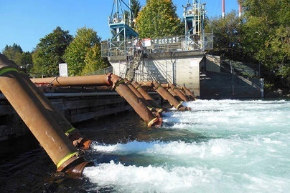 | A. The water source is being polluted.  B. There are many different supplies of water.  C. Factories inland are giving out clean water.  D. A water pumping station is nearby.
- What’s the disaster in the picture?
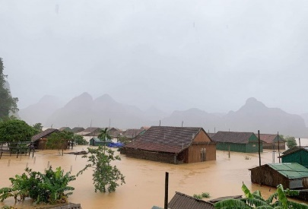 | A. Flood  B. Tidal waves  C. Earthquake  D. Hurricane
- GUIDED CLOZE: Choose the word (A, B, C, or D) that best fits the blank space in the following passage (1.5 pts)
I’m in (17)__________ of English speaking contests in schools. Such contests encourage students to practice (18)__________ English in their classes and help their speaking skills. Besides, while preparing (19)__________ for the contests, students have a chance to review their lessons thoroughly. Contests among classes provide students with opportunities to work with team spirit, thus enabling them to learn how to work and (20)__________ other people. Some students may think that their preparations for the speaking contests are time-consuming. However, (21)__________ such efforts are worth spending time on. My classes and I have found the contests useful and interesting always because it helps us to speak not only more (22)__________ but also more effectively in public communication. In conclusion, English speaking contests are more important and necessary for students in all schools now than written English contests.
- A. interest B. habit C. favor D. passion
- A. speak B. spoken C. to speak D. speaking
- A. their B. them C. theirs D. themselves
- A. cooperate with B. keep track will C. get rid of D. compete with
- A. in the end B. in my opinion C. in a word D. in total
- A. independently B. confidently C. considerately D. respectfully
- READING COMPREHENSION: Read the passage, then do the tasks that follow (1.5 pts)
A conservationist manages natural habitats including parks, forests, and lands. This job may also be called a conservation scientist. This green career involves finding ways to utilize land without harming the environment. A conservationist's average day depends on the needs of the environment they work in. Days in nature could be spent surveying nature. It all starts with a conservationist spending the day in the field counting signs of a species.
Conservationists also find themselves taking on the role of teachers. A conservationist could teach environment to people through leading guided tours, or sharing their knowledge through presentations.
Decide if these statements are TRUE or FALSE
- A conservationist can be considered as a scientist.
- Conservationists look for ways to use land and protecting the environment.
- Surveying nature is the only task conservationists have to do.
- They are not required to teach people about the environment.
Read the passage again and choose the best answer
- What can be inferred from the passage?
A. Conservationists are different from scientists.
B. Conservationists use presentations to protect lands.
C. The environment depends on the conservationists.
D. Conservationists’ workday is different from others.
- The word “average” could be best replaced by _______________.
A. strange B. normal C. careless D. indifferent
- WORD FORMS: Use the correct form of the word given in each sentence (1.5 pts)
- When there is a volcanic ________________________, hundreds of people may lose their lives. (erupt)
- The company must reduce costs to compete _________________________________________. (effect)
- We are all very ___________________________________ by our new neighbors’ enthusiasm. (impress)
- We believe the new program will be ____________________________________ to everyone. (benefit)
- Lots of __________________________________ activities have recently been held in our city. (culture)
- They saved the paintings from ___________________________________________________. (destroy)
- Sentence rearrangement (0.5 pts)
- that family members / a celebration / Tet is so important / try to come back home / living apart /. //
- Tet is so important
- can / their school’s name / take pride in / which bears / students / their uniform /. //
- Students
- Sentence transformation (1.0 pt)
- It is impossible to do this because we have no time.
- If
- There was too much traffic for us to go out.
- There was such
- They haven’t visited Hanoi for three years.
- The last time they paid
- Please don’t interrupt me when I’m talking.
- I’d rather you

SỞ GD – ĐT THÀNH PHỐ HỒ CHÍ MINH  ĐỀ THI THỬ SỐ 44 | KỲ THI TUYỂN SINH VÀO LỚP 10  Thời gian làm bài: 90 phút
Họ và tên học sinh:
- Choose the word that has the underlined part pronounced differently from the others (0.5 pts)
- A. predict B. consider C. priority D. sticky
- A. option B. question C. federation D. mention
- Choose the word whose main stress pattern is not the same as that of the other (0.5 pts)
- A. separate B. casual C. experience D. government
- A. disappointed B. pesticides C. garbage D. treasure
- MULTIPLE CHOICE: Read and choose the word or phrase (A, B, C or D) that best fits the space in each sentence (2.5 pts)
- Covid-19 is spreading. _______________, we should avoid crowds.
A. Therefore B. Moreover C. However D. So
- Never _______________ on others. Do it by yourself.
A. deny B. depend C. demand D. deliver
- – "Why don't you turn off the computer before leaving?” – “_______________”
A. Don’t ask me a silly question like that! B. OK. I'll do that.
C. You’re so noisy. D. There no doubt about it.
- Family members who live _______________ try to be together at Tet.
A. away B. distant C. along D. apart
- If people don't use fossil fuels too much, there _______________ less air pollution.
A. will be B. won't be C. is D. isn’t
- _______________ the night before Christmas, Santa Claus enters each house to give children gifts.
A. In B. On C. At D. Since
- Let's sweep all the litter here. We shouldn't turn our schoolyard into a _______________.
A. junkyard B. garbage place C. poisonous place D. dangerous place
- They continuously design new styles _______________ their products can attract more customers.
A. but B. because C. so that D. and
- Nobody understands what he says, _______________?
A. does it B. doesn't it C. do they D. don't they
- If you study at The Brighton Language Center-UK, you can live in a(n) _______________ on campus.
A. dormitory B. apartment C. mobile home D. shelter
- CAUTION SIGNS WARNINGS: Look at the signs. Choose the best answer (A, B, C, or D) for each sign (0.5 pts)
- What does this sign mean?
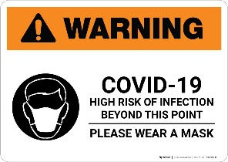 | A. We should wear the mask for nothing.  B. It is dangerous to wear mask nowadays.  C. Mask doesn’t help to prevent virus disease.  D. Wearing mask is helpful to prevent coronavirus.
- The sign tells us _______________.
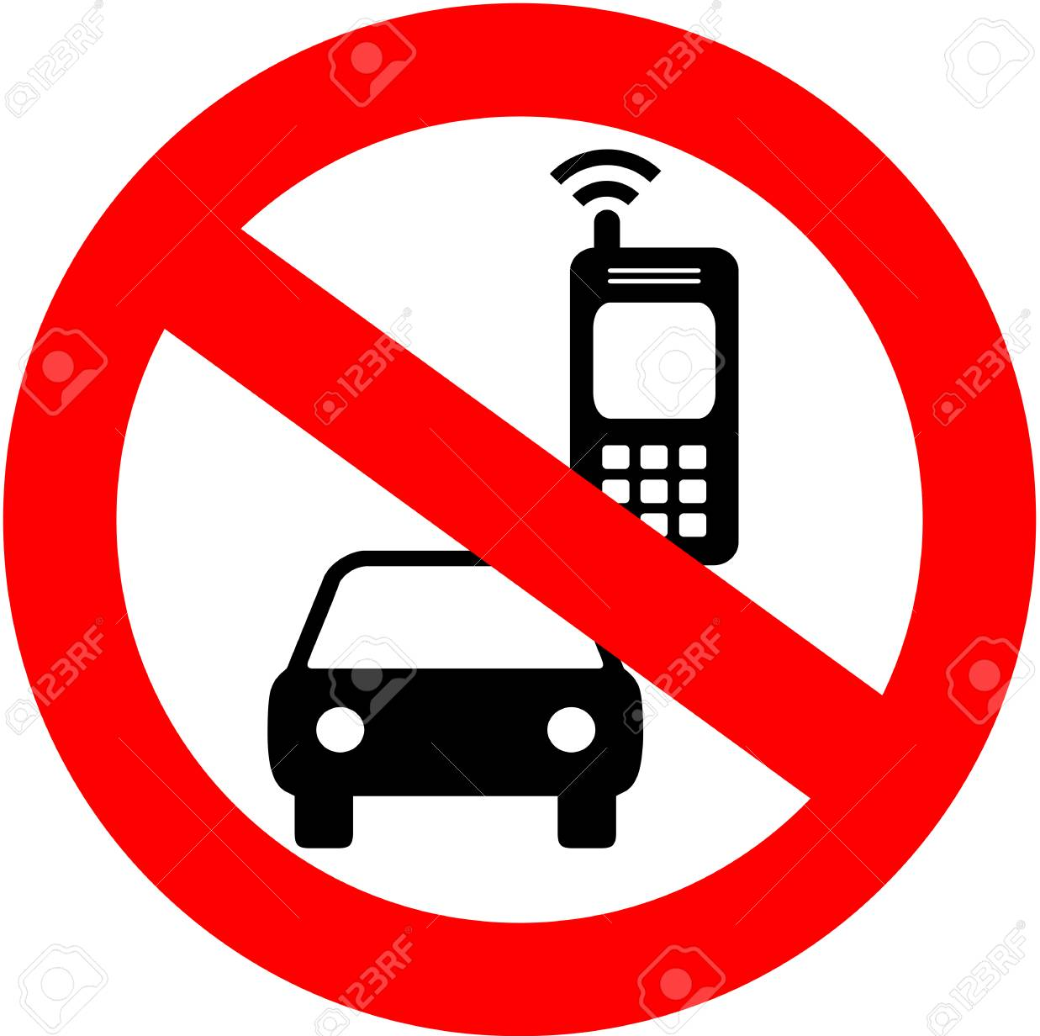 | A. to talk with friends when driving  B. not to use our phones when driving  C. not to play games when driving  D. to drive and keep our phones in hands
- GUIDED CLOZE: Choose the word (A, B, C, or D) that best fits the blank space in the following passage (1.5 pts)
We need to save energy because nobody can live without energy. So why don’t we start to (17)__________ it in our home right now. We have many ways to save energy in our home. One of those ways is using electricity, water and gas (18)__________. We should turn off the lights in our room when we go out or in (19)__________ situations, avoid wasting water, close the kitchen stove after cooking. Besides, we should use energy- (20)__________ equipment. These help us not only save money but also work effectively. We should use the solar energy-renewable one. It also has low carbon emissions so they are considered green and environment- friendly. (21)__________, using renewable energy can reduce your electricity bills. In (22)__________ we need to save energy so that energy can’t run out of and continues to serve human’s life.
- A. conserve B. pollute C. volunteer D. spoil
- A. naturally B. shortly C. politely D. economically
- A. necessary B. unnecessary C. need D. necessity
- A. situating B. saving C. turning D. deforesting
- A. Moreover B. However C. Therefore D. Whatever
- A. conclude B. sum up C. summary D. consequence
- READING COMPREHENSION: Read the passage, then do the tasks that follow (1.5 pts)
It was an unforgettable 3-day trip to the countryside to visit my grandparents last summer holiday. My family decided to go by bike on this trip because we all wanted to enjoy the atmosphere there. As expected, the air was so great and clear. We felt very excited about this place. After having lunch at my grandparents' house, we took a short nap and made all preparation to go fishing with grandparents in the afternoon. The lake beside the house has many fishes and we had a joyful fishing and a lot of dishes cooked in the evening. It was our first day.
On the second day, we got up early and drove bicycle around the village. The traffic was not heavy of course. We went along the small roads, had lunch under the shade of an old tree and saw the children play with kites in the afternoon. The wind made us feel relaxed and peaceful.
On the third day, dad and mom allowed my sister and me to help my grandparents with the work on the fields. The summer comes, either the harvest does. People are busier to collect all corns and rice. We had a hard- working day. We went to sleep early and the village at night was so silent.
It was such a memorable travel of mine, we felt very happy during the after time of that summer, and all sorrow was disappeared!
Decide if these statements are TRUE or FALSE
- The author visited his grandparents last summer.
- On the first day, they went to the restaurant for dinner.
- They felt comfortable because of the traffic was not heavy.
- The author and his parents helped with the work on the fields.
Read the passage again and choose the best answer
- They decided to go to the countryside by bike because _______________.
A. traveling by car cost a lot B. they wanted to enjoy fresh air
C. the road is too narrow D. the countryside is not far from their house
- The author and his family felt _______________ after the trip.
A. disappointed B. tired C. bored D. contented
- WORD FORMS: Use the correct form of the words given in each sentence (1.5 pts)
- The Internet is available only in cities; therefore, I can’t easily get __________________ to it. (accessible)
- This village has been ___________________________________________ since last year. (electric)
- The rising level of air pollution has caused concern among _________________________. (environment)
- Our neighbors are very __________________________. They never care about other folks. (consider)
- _______________________________________________! That student failed all the tests. (disappoint)
- Dreams can be a rich source of ____________________________________ for musicians. (inspire)
- SENTENCE REARRANGMENT (0.5 pts)
- takes place / of February / and lasts 10 days / at the beginning / each year / The festival /. //
- The festival
- are responsible / for / Some scientists / mobile phones / some health problems / believe that /. //
- Some
- SENTENCE TRANSFORMATION (1.0 pt)
- My son doesn’t have a chance to meet that famous singer.
- My son wishes
- When the boss is away from home, she is responsible for looking after his favorite dog.
- Taking
- My father said to the boys, “When will you come back here?”
- My father asked the boys
- We stayed at a very luxurious hotel during our trip to Ha Long Bay.
- The hotel

SỞ GD – ĐT THÀNH PHỐ HỒ CHÍ MINH  ĐỀ THI THỬ SỐ 45 | KỲ THI TUYỂN SINH VÀO LỚP 10  Thời gian làm bài: 90 phút
Họ và tên học sinh:
- Choose the word whose underlined part is pronounced differently from that of the others (0.5 pts)
- A. snowstorm B. knowledge C. show D. know
- A. shaped B. hired C. experienced D. laughed
- Choose the word whose main stress is placed differently from the others (0.5 pts)
- A. temperature B. thunderstorm C. Pacific D. celebrate
- A. typhoon B. nominate C. volcano D. considerate
- Choose the word or phrase (A, B, C, or D) that best fits the space in each sentence (2.5 pts)
- _______________ you use water economically, we won't have enough fresh water to use in the future.
A. If B. Unless C. Because D. Although
- You never go to school late, _______________?
A. are you B. don't you C. do you D. did you
- The volcanic eruption in the Philippines in 1991 was _______________ one.
A. the world largest C. the largest world
B. the largest of the world D. the world's largest
- People know clearly that cars cause pollution _______________ they still want to use them.
A. because B. but C. though D. therefore
- That boy had no difficulty _______________ on his own.
A. to get dressed B. getting dressed C. to get dressing D. getting dress
- The children were fascinated _______________ the toys in the shop window.
A. about B. in C. by D. for
- By learning English, people can have _______________ to the world's development.
A. touch B. success C. access D. acquaintance
- The men and the cattle _______________ work in the fields bring us food every day.
A. that B. which C. who D. whose
- Let's go to the pop concert! – “_______________.”
A. All right B. We go C. Yes, please D. Don't mention it.
- There will be thunderstorms _______________ the central highlands.
A. on B. above C. in D. over
- CAUTION SIGNS WARNINGS: Look at the signs. Choose the best answer (A, B, C, or D) for each sign (0.5 pts)
- What does this sign mean?
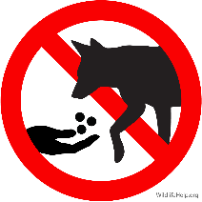 | A. You are not allowed to feed the animals.  B. You are permitted from playing with dogs.  C. Do not put your hands over the fence.  D. Do not take dogs in this area.
- What does this sing mean?
  Allow  at least  two hours  for your visit  to the castle | A. Each tour of the castle lasts less than two hours.  B. Two hours is the minimum time recommended for a visit to the castle.  C. Visitors are only allowed to spend two hours inside the castle.  D. Visitors are only allowed to visit the castle at 2 o’clock.
- Choose the word or phrase that best fits the blank space in the passage (1.5pts)
Energy is one of the problems that many people are interested in. It is not an unfamiliar word. It is heard, said, discussed day after day. It is close to everyone’s daily life. You turn on a lamp and it is energy that (17)__________ you light. You turn on a TV and it is energy that gives you pictures and sound. You ride a motorcycle and it is energy that gives you (18)__________. You cook your meals and it is energy that gives you heat to boil rice.
The problem is that the demand for energy is rising and that the price of energy is getting higher and higher. The supply of energy (19)__________ earth is limited. It cannot provide us all forever. The shortage of energy in the future is inevitable. (20)__________, saving energy is a must if we want to continue to live in a safe and sound world.
If we save energy, the environment will be less polluted and our health will be better and we will live a more meaningful life and more happily. Perhaps the best (21)__________ to the problem of energy is a source of clean energy coming from the sun: solar energy. This kind of energy is easily available, (22)__________ and inexhaustible. Furthermore, it does not cause pollution.
- A. give B. gives C. to give D. giving
- A. move B. moving C. movement D. moveable
- A. on B. in C. for D. at
- A. But B. As C. However D. Therefore
- A. conclusion B. advice C. solution D. reason
- A. expensive B. important C. fresh D. free
- Read the passage and decide whether the statements that follow are true or false (1.5 pts)
The struggle to have eight hours for work, eight hours for recreation, and eight hours for rest was the origin of International Workers’ Day, which is also referred to as May Day or Labor Day. The celebration commemorates the Haymarket Massacre in Chicago in 1886, when Chicago police shoot workers who were striking to establish the eight-hour day. Many workers died in the event. Historically, the first congress of the Second International, which was an organization of socialist and labor parties formed in Paris on July 14, 1889, called for international demonstrations on the 1890 anniversary of the Chicago protests. In 1891, the Second International recognized May Day as an annual event. In 1904, Social Democratic Party organizations and trade unions of all countries were called on to demonstrate actively on May First to establish eight hours of work a day and to get workers' rights. Unions of all countries were urged to go on strike on May 1, wherever it is possible without injury to the workers.
Most countries celebrate International Workers' Day on May 1st, except in the United States and Canada, where Labor Day is held in September. Millions of working people and their labor unions, all over the world, organize street demonstrations and street marches. Several countries celebrate the day with parades, shows and other patriotic and labor-oriented events.
Decide if these statements are TRUE or FALSE.
- International Workers' Day was first held to ask for the right to work.
- Many people lost their lives in the event in Chicago in 1886.
- May first was recognized as an annual event in 1891.
- International Workers' Day is celebrated everywhere in the world on the same day.
Read the passage again and choose the best answer.
- What does the word ''establish'' mean?
A. find B. found C. start out D. break out
- What is the main idea of the text?
A. The history of May Day B. The celebration of May Day
C. The activities on May Day D. The struggle of workers on May Day
- Use the correct form of the word given in each sentence (1.5 pts)
- The ___________________________________ of their house left them no place to live. (destroy)
- You should be ____________________________________________ of this good news. (information)
- We can't pass the exam without _____________________________________________. (prepare)
- The shoes are nice, but they were ____________________________________________. (comfort)
- The area is _____________________________________________ for its food and wine. (celebrate)
- Pompeii was ____________________ destroyed in A.D 79 by an eruption of Mount Vesuvius. (complete)
- Sentence arrangement (0.5 pts)
- The beauty / leaves a deep impression on / of women dressed in "Ao Dai" / foreign visitors / to / always / Vietnam /. //
- The beauty

- very popular today / very easy / because it / around the world / makes communication / Facebook has become/. //
- Facebook

- Rewrite the following sentences so that it has the similar meaning to the first (1.0 pt)
- I'm asking you this question for the third time.
- This

- Teenagers have used social network for many purposes these days.
- Social network

- "Why don't we use energy-saving appliances instead of ordinary ones to save energy?"
- I suggested that energy-saving

- They aren't strong enough to lift the heavy door.
- If

SỞ GD – ĐT THÀNH PHỐ HỒ CHÍ MINH  ĐỀ THI THỬ SỐ 46 | KỲ THI TUYỂN SINH VÀO LỚP 10  Thời gian làm bài: 90 phút
Họ và tên học sinh:
- Choose the word that has the underlined part pronounced differently from the others (0.5 pts)
- A. connect B. comfort C. computer D. contest
- A. pleased B. erased C. increased D. amused
- Choose the word whose main stress pattern is not the same as that of the other (0.5 pts)
- A. education B. development C. economic D. preparation
- A. different B. regular C. achieving D. property
- Choose the word/ phrase (A, B, C or D) that best fits the space in each sentence (2.5 pts)
- It's not _______________ to call anyone at night.
A. convenient B. equal C. difficult D. economic
- - A: Congratulations! You did great. - B: “_______________”
A. It's nice of you to say so. B. It's my pleasure.
C. You're welcome. D. That's okay.
- I'll look for another job _______________ my salary is increased.
A. if B. unless C. despite D. because
- Most robots are empowered by artificial _______________ or AI, and machine learning technology.
A. intelligence B. internet C. information D. interest
- Thousands of lives were saved because the scientists _______________ them about the tsunami.
A. have warned B. had warned C. warned D. would warn
- Remote controls are used to _______________ with television.
A. invent B. develop C. interact D. respond
- Wearing uniforms help poor students feel equal _______________ others.
A. about B. at C. on D. to
- Deforestation, garbage dump, and air pollution are main _______________ problems in Vietnam.
A. educational B. economic C. environmental D. social
- Hoai cannot remember the name of the restaurant _______________ she ate her favorite roasted duck.
A. which B. whose C. whom D. where
- I wish I could visit your village again someday, Ba. – “_______________.”
A. Too true B. What a day!
C. You are always welcome D. Yes let's
- CAUTION SIGNS WARNINGS: Look at the signs. Choose the best answer (A, B, C, or D) for each sign (0.5 pts)
- This sign means:
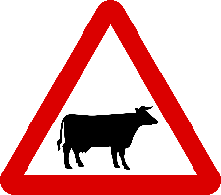 | A. You can buy cattle meat here.  B. There are wild animals ahead.  C. Cattle are not allowed.  D. There are cattle ahead.
- This sign means:
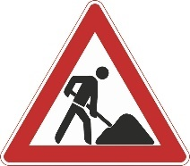 | A. Watch out! There are workers.  B. Be careful! Road works ahead.  C. Look out for working children.  D. There’s an accident ahead.
- Choose the word or phrase that best fits the blank space in the paragraph (1.5 pts)
CHANGING MINDS, LIVES AND KILLS
Studies have shown that television and its meteoric rise (17)__________ the 1950s has had more effect than any other technological development in this century on changing the way many of us live. Used (18)__________, television can be a wonderful medium to inform, expand and broaden one’s life. It can enlarge our understanding of the world. It can open up important knowledge about news, events, of different people, of history, the arts and sciences.
Tragically, the typical channels mainly ignore such development. (19)__________ programs are light and amusing. Many people have become hooked on certain forms of commercial entertainment. They no longer realize, or care, that they may be neglecting to develop important personal abilities. Let's so easy to let ready-made entertainment take over, to just sit back and let someone entertain us.
One study in the US found that more than half of ail elementary school children watched TV during their evening meal. An even larger percentage watched (20)__________ doing homework. Many adults spend more hours passively before TV than in any other activities except sleep.
Educators are also concerned with the steady decline in children's physical skills. Logic and putting ideas together are processes (21)__________ by regular reading and by having time to think about events. TV, by contrast, usually presents its messages in little, rapid clumps with little information as to how and why the events took shape.
Heavy television viewing kills the initiative to take an active part in outdoor games, which is essential (22)__________ a child’s development. And, at its worst, television entertainment is filled with false deals, morals, ethics, relationships, role-models and, or course violence.
(adapted from “The Plain Truth”, July 1990)
- A. in B. during C. since D. throughout
- A. fast B. wrongly C. moderate D. rightly
- A. Theirs B. Its C. That D. Which
- A. but B. while C. until D. as well as
- A. supported B. has supported C. are supported D. have been supported
- A. in B. to C. with D. for
- Reading comprehension: True – False + Answer the questions (1.5 pts)
During December, sometimes even earlier, the Christmas lights come on in the streets, and the big shops put on special "Christmas windows"', to bring in the shoppers. As Christmas gets closer, the shops become more and more crowded. Nowadays many shops start their "New Year Sales" before Christmas; some people therefore wait till the last days, in order to pay less for their presents.
When the shops finally close for the holiday, most people are happy that the shopping is over. For a day at least, everything is shut except pubs and restaurants, which do a lot of business on Christmas day (though not in 2020, on account of Covid 19).
In the past, most people used to go to church on Christmas morning; today some people go to church for a special Christmas service, but most stay at home to open presents and prepare the Christmas lunch. In the afternoon, it's time for more presents, or to watch a good film, or go out for a walk in the country, or in the park.
Then, after Christmas, the shopping season starts again, as people spend their Christmas money and look for bargains in the New Year sales. Most people have a week's holiday between Christmas and the New Year.
Some, of course, have to keep working; but for most, the last week of the year is a time to relax, enjoy more parties, and do a bit more shopping.
January sometimes seems very flat and empty!
(Extracted from: https://linguapress.com/intermediate/christmas22.htm)
True or False?
- The Christmas lights come on in the streets during Christmas time.
- In 2020, on account of Covid 19, all people stay at home to open presents and prepare the Christmas lunch.

- The shopping season starts for the New Year sales after Christmas.
- A week's holiday between Christmas and the New Year is a time to relax.
Questions
- Which of the following is the definition of "bargains"?
A. new arrivals B. new collections
C. special fashion seasons D. special offers
- Which of the following is NOT mentioned in the text?
A. As Christmas gets closer, the shops become much busier.
B. Christmas shopping ends before Christmas Day.
C. People keep spending their Christmas money on New Year Sales.
D. Shopping seems over in January.
- Supply the correct form of the words in bracket to complete each sentence (1.5 pts)
- Nam is one of the most effective __________________________ in the charity programs. (act)
- The bank performed very ________________________________ in the concert last night. (impress)
- I don't want to think of that __________________________________________ accident. (disaster)
- The two sides of the city are _______________________________________ by the river. (separation)
- We find advertising on television sometimes very ________________________________. (effect)
- Electricity, gas and water are ________________________________ in Western countries. (need)
- Sentence transformation (l.0 pt)
- The table was too old to keep.
- It was
- "Have lunch with me?", she said to me.
- She invited
- They were unable to finish their game of tennis because of a heavy shower.
- A heavy shower
- They wanted to climb the mountain even though it was dangerous.
- They wanted
- Rearrangement (0.5 pts)
- a child / My father/ go fishing / used to / was / he / when /. //
- My father
- storms / known as / Tropical / typhoons / in Asia / which are / occur / frequently /. //
- Tropical

SỞ GD – ĐT THÀNH PHỐ HỒ CHÍ MINH  ĐỀ THI THỬ SỐ 47 | KỲ THI TUYỂN SINH VÀO LỚP 10  Thời gian làm bài: 90 phút
Họ và tên học sinh:
- Choose the word that has the underlined part pronounced differently from the others (0.5 pts)
- A. garbage B. standard C. solar D. lunar
- A. ethnic B. whether C. those D. clothing
- Choose the word whose main stress pattern is not the same as that of the other (0.5 pts)
- A. exist B. avoid C. support D. notice
- A. medical B. restaurant C. remember D. government
- Choose the word/ phrase (A, B, C or D) that best fits the space in each sentence (2.5 pts)
- When she _______________ the top of the stairs, her heart was pounding.
A. went B. reached C. got D. arrived
- _______________ Easter, many children and adults enjoy painting eggs.
A. On B. In C. To D. At
- Designers have taken _______________ from Vietnam's ethnic minorities to modernize the Ao Dai.
A. tradition B. convenience C. inspiration D. fashion
- Bill Gates, _______________ is known as the king of computer programs, is famous for his charitable work.
A. who B. that C. whom D. A and B are correct
- He is very experienced _______________ looking after animals.
A. for B. with C. on D. in
- I wish I _______________ you but I can't.
A. can join B. could join C. will join D. join
- If _______________ continues, our planet will be destroyed.
A. deforestation B. conservation C. preservation D. disappointment
- Tom is only 17 and _______________ not eligible to vote.
A. because B. but C. therefore D. although
- Everyone will agree to our suggestion, _______________?
A. will they B. will he C. won't they D. won't he
- "How many languages can you speak?" - "_______________."
A. I have no difficulty in learning a foreign language B. I agree with you
C. Only English and Spanish D. I’m not sure about that
- CAUTION SIGNS WARNINGS: Look at the signs. Choose the best answer (A, B, C, or D) for each sign (0.5 pts)
- This sign means:
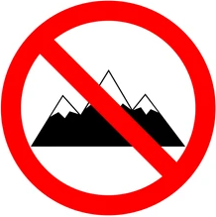 | A. You can climb the mountain.  B. You are allowed to climb the mountain.  C. You mustn’t climb the mountain.  D. Climbing the mountain is exciting.
- This sign means:
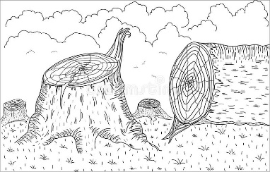 | A. People shouldn’t cut down trees.  B. We should save forests.  C. We should prevent deforestation.  D. All are correct.
- Choose the word or phrase that best fits the blank space in the paragraph (l.5 pts)
Cheap oil and cheap gasoline helped to make modern America. They shaped America's cities, and they were an essential part of the American lifestyle. They were also essential in the great empty states of the West, (17)__________ people often have to travel long distances.
Today, Americans consume about 25% of the world's energy far more than people in other countries; but the situation is (18)__________ changing. Americans are already buying smaller cars, and American cars consume much (19)__________ gas than they used to. But in the coming years, they will use less and less oil. They will have to.
There is still a lot of oil (20)__________ the ground, but oil and gas must become more expensive in the future. Over 50% of America's traditional oil reserves (21)__________-mostly since 1950. Nobody knows when America's oil will start running out, but the first problems could come in less than 20 years. And as soon as oil starts running out (22)__________ price will go up very quickly!
In conclusion, the "two-dollar gallon" was good for America. It has encouraged Americans to buy smaller cars, and to use less energy. That way, America's oil will last longer perhaps until the age of clean green energy arrives.
(From Internet)
- A. which B. that C. where D. when
- A. fast B. quickly C. slow D. slowly
- A. less B. fewer C. more D. least
- A. in B. on C. under D. over
- A. were used B. has already used C. already used D. have already been used
- A. that B. its C. their D. the
- Reading Comprehension: True – False + Answer the Questions (1.5 pts)
People often ask which is the most difficult language to learn, and it is not easy to answer because there are many factors to take into consideration.
Firstly, in a first language the differences are unimportant as people learn their mother tongue naturally, so the question of how hard a language is to learn is only relevant when learning a second language. A native speaker of Spanish, for example, will find Portuguese much easier to learn than a native speaker of Chinese because Portuguese is very similar to Spanish, while Chinese is very different, so first language can affect learning a second language. The greater the differences between the second language and our first, the harder it will be for most people to learn. Many people answer that Chinese is the hardest language to learn, possibly influenced by the thought of learning the Chinese writing system, and the pronunciation of Chinese does appear to be very difficult for many foreign learners. However, for Japanese speakers, who already use Chinese characters in their own language, learning writing will be less difficult than for speakers of languages using the Roman alphabet.
No language is easy to learn well, though languages which are related to our first language are easier. Learning a completely different writing system is a huge challenge, but that does not necessarily make a language more difficult than another. In the end, it is impossible to say that there is one language that is the most difficult language in the world.
(Extracted from https://www.usingenglish.com/comprehension/5.html)
True or False?
- The question of how hard a language is to learn is relevant to both first and second language acquisition.

- Portuguese is definitely easier than Chinese.
- Many language learners say that Chinese is the hardest language to learn because of the Chinese writing system, and the pronunciation of Chinese.
- The writer thinks that learning new writing systems is easy.
Questions
- Which of the following is the definition of "take into consideration"?
A. solve the problem B. discuss C. think carefully about C. take action
- Which of the following is the best heading for the passage?
A. Chinese is the most difficult language to learn in the world.
B. Which is the hardest language?
C. Both first and second languages are hard to learn.
D. Roman alphabet and Chinese characters.
- Supply the correct form of the words in brackets to complete each sentence. (1.5 pts)
- We enjoyed the _______________________________________________ atmosphere in Hue. (peace)
- ___________________________________________ of high quality always please customers. (produce)
- The next stage in the development of television is ________________________________ TV. (active)
- We can minimize _____________________________________ by recycling bottles and cans. (pollute)
- By the year 2025 many buildings will be _____________________________ by solar energy. (hot)
- She is old enough to live _______________________________________________________. (depend)
- Rearrange the sentences (1.0 pt)
- They say soccer is the best game to play.
- Soccer
- We can't survive when there is no air.
- Without
- She always turns on the lights when going to bed.
- I suggest
- Edison was a great scientist. He invented the electric light bulb.
- Edison,
- Rearrangement (0.5 pts)
- their uniform / take pride in / can / which bears / Students / their school's name /. //
- Students
- economically / and energy / spend / your money / should / as / You / as possible /. //
- You

SỞ GD – ĐT THÀNH PHỐ HỒ CHÍ MINH  ĐỀ THI THỬ SỐ 48 | KỲ THI TUYỂN SINH VÀO LỚP 10  Thời gian làm bài: 90 phút
Họ và tên học sinh:
- Choose the word that has the underlined part pronounced differently from the other (0.5 pts)
- A. physical B. seek C. specific D. west
- A. stream B. leather C. cream D. dream
- Choose the word whose main stress pattern is not the same as that of the other (0.5 pts)
- A. minority B. embroidery C. tradition D. scholarship
- A. experience B. reputation C. intermediate D. academic
- MULTIPLE CHOICE (1.5 pts)
- Jim: "What about collecting used paper, bottles and plastic bags every day?"
Ha and Mai: "_______________"
A. Because they can pollute the environment. B. How come? Who can do that?
C. That's a very good idea. Let's do that. D. What about this weekend?
- The food was so hot _______________.
A. that it burned my tongue B. for it to bum my tongue
C. and then it burned my tongue D. to have burned my tongue
- If I _______________ his advice, I would be a fool.
A. followed B. would follow C. will follow D. had followed
- Every possible test was carried _______________ decide the nature of her illness.
A. on B. of C. through D. out
- The ground is dry, and we haven't had any rain for months. It's a real _______________.
A. flood B. drought C. storm D. typhoon
- The panda's _______________ habitat is the bamboo forest.
A. nature B. natural C. naturalized D. naturally
- Listen to what I am saying, _______________?
A. don't you B. do you C. are you D. will you
- Scientists and engineers have invented devices to remove _______________from industrial wastes.
A. polluted B. pollute C. polluting D. pollutants
- _______________ this hand-embroidered picture was expensive, we bought it.
A. As B. Because C. Even though D. Despite
- This laptop is much more user-friendly, but it costs _______________ the other one.
A. as many as B. twice as much as C. twice as many D. so much as
- CAUTION SIGNS – WARNINGS (0.5 pts)
- What does this sign mean?
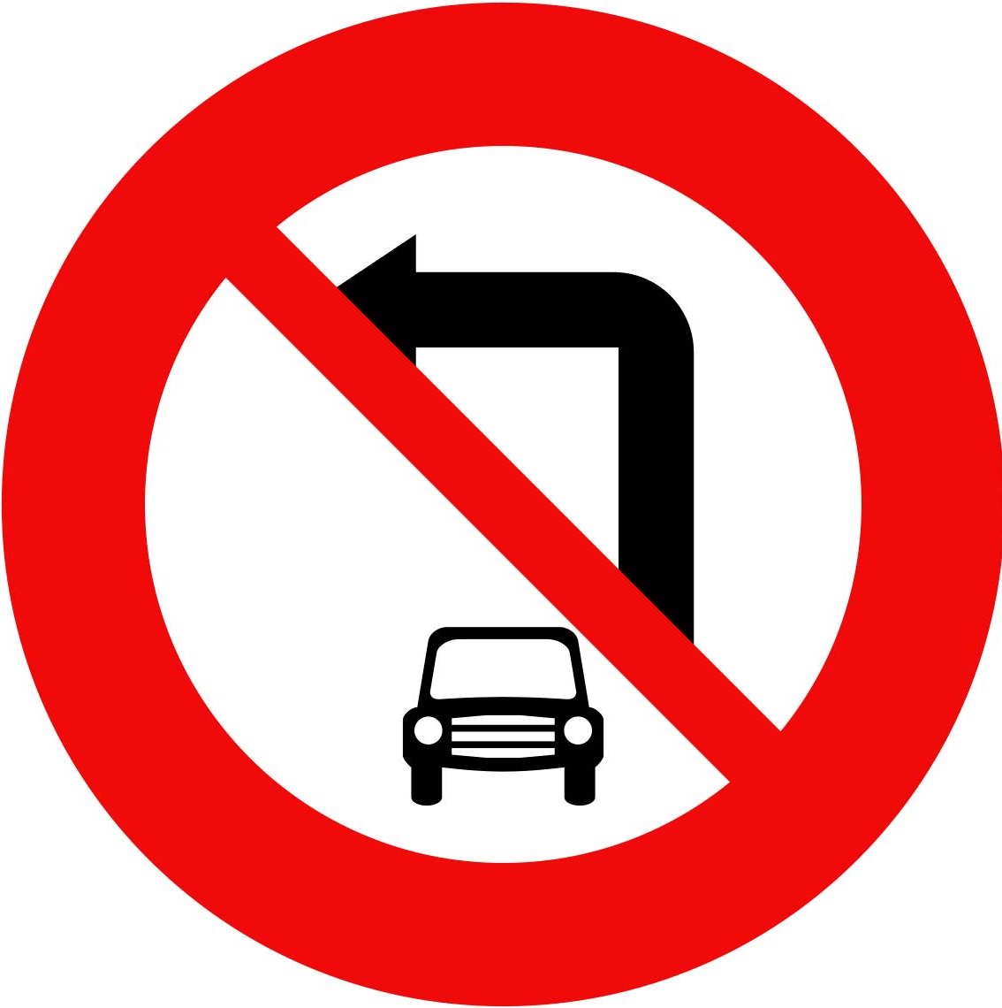 | A. We should stop driving cars.  B. Cars must not be turned left.  C. Cars must be turned right.  D. Cars must be parked here.
- What does the sign say?
 | A. Plastic cup prohibition.  B. Caution! It’s hot.  C. You cannot drink here.  D. Don’t litter plastic cup.
- GUIDED CLOZE (1.5 pts)
In a breakthrough, scientists have found an economically viable way to (17)__________ fuel from water by splitting it into oxygen and hydrogen. Just as solar light can generate electricity, the water splitting process could do the same via the generation of clean chemical fuel such as hydrogen. “It is already (18)__________ possible to split water in this way”, researchers said. The world is now (19)__________ five major issues for humanity – energy, environment, water, food, security and public health. Global warming is ranked first and it is all resulting (20)__________ burning fossil fuels because that is where carbon dioxide comes from. To reduce this, you have to find clean, renewable energy and hydrogen equals clean energy. It’s part of the solution – if we really can (21)__________ water into that will be one scientific solution for the future sustainable energy supplies, hydrogen would be a (22)__________ clean fuel over petrol in foreseeable future.
- A. do B. study C. create D. destroy
- A. scientifically B. scientific C. science D. scientist
- A. meeting B. looking C. facing D. having
- A. of B. to C. by D. from
- A. divert B. transfer C. require D. split
- A. synthetic B. promising C. obvious D. hopeful
- READING COMPREHENSION (1.5 pts)
Do you ever think about what schools will be like in the future? Many people think that students will study most regular classes such as maths, science and history online. Students will probably learn these subjects anywhere using a computer. What will happen if students have problems with a subject? They might connect with a teacher through live video conferencing. Expert teachers from learning centres will give students help wherever they live.
Students will still take classes in a school, too. Schools will become places for learning social skills. Teachers will guide students in learning how to work together in getting along with each other. They will help students with group projects both in and out of the classroom.
Volunteer work and working at local businesses will teach students important life skills about the world they live in. This will help students become an important part of their communities. Some experts say it will take five years for changes to begin in schools. Some say it will take longer. More people agree, though, that computers will change education the way TVs and telephones changed life for people all over the world years before.
TRUE or FALSE?
- Everyone just thinks that students will study school subjects online in the future.
- The expert IT staff from learning center will help students with their problems whenever they live.

- At school, students will have chances to learn how to work together with others and the important life skills.
- It will take more than five years for changes to start in most fields of education.
Read the passage again and choose the best answer.
- Students will learn important life skills through _______________.
A. going to school every day B. taking online classes
C. working in international businesses D. doing volunteer work
- What is the main idea of the passage?
A. Kids won’t have to go to school in the future.
B. Computers will change education in the future.
C. All classes will be taught online in the future.
D. Teachers will help students from home in the future.
- WORD FORMS (1.5 pts)
- The Internet has helped students study more _______________________________________. (effective)
- The school is performing well, but we recognized the need for further ___________________. (improve)
- He gives us some _____________________________ information about the increasing prices. (persuade)
- Don’t treat me as a ____________________________________________. (slavery)
- Tidal waves are the result of an abrupt shift in underwater ____________________ of the earth. (move)
- There may be a lot of _____________________________________________ stones in Mars. (preciosity)
- REARRANGEMENT
- A couple of / Panama’s climate / scientists noticed / growing drier / decades ago / was slowly /. //
- A couple of

- will receive / the most beautifully / The family / was decorated / for the holidays / a trophy / whose house /.
- The family

- SENTENCE TRANSFORMATION (1.0 pt)
- My boyfriend is very short-tempered.
- My boyfriend loses
- Nobody has paid for the tickets, have they?
- The tickets
- “Well done, I’m so glad you’ve passed your exam.”, I said to Melanie.
- I congratulated
- The water was so cold that the children could not swim in it.
- The water was not

SỞ GD – ĐT THÀNH PHỐ HỒ CHÍ MINH  ĐỀ THI THỬ SỐ 49 | KỲ THI TUYỂN SINH VÀO LỚP 10  Thời gian làm bài: 90 phút
Họ và tên học sinh:
- Choose the word that has the underlined part pronounced differently from the other (0.5 pts)
- A. wandered B. embroidered C. embarrassed D. preserved
- A. flood B. moon C. food D. soon
- Choose the word whose main stress pattern is not the same as that of the other (0.5 pts)
- A. selection B. interact C. recycle D. convenient
- A. entertain B. nominate C. documentary D. electronic
- MULTIPLE CHOICE (2.5 pts)
- We have to take our own rubbish to the _______________.
A. environment B. garbage dump C. refreshment D. pollution
- We are looking for a professionally _______________ home security system.
A. install B. installation C. installing D. installed
- Lucy likes fashion. She always wears _______________ clothes.
A. fashionable B. new C. typical D. modal
- Most of the movies we've reviewed this summer have had one thing in common - _______________ plot.
A. reliable B. predictable C. replaceable D. unsurprised
- We advised Virginia _______________ TV all the time.
A. don't watch B. not watching C. not to watch D. not watch
- I still can't believe. My bicycle _______________ last night.
A. stole B. was steal C. was stealed D. was stolen
- He's been nominated ______________ the Green Party ______________ their candidate in the next election.
A. by / as B. by / for C. with / as D. into / for
- People _______________ outlook on life is optimistic are usually happy people.
A. who B. that C. which D. whose
- "I'm too impatient, aren't I?" - "_______________."
A. Yes, never. B. Yes, you are sometimes.
C. No, I'm afraid. D. No, you are.
- - "I'm having an exam tomorrow." - "_______________."
A. Good luck! B. Congrats! C. It's not bad. D. Be careful!
- CAUTION SIGNS – WARNINGS (0.5 pts)
- What does this sign mean?
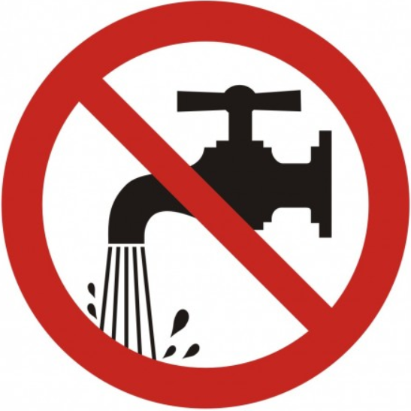 | A. Save water.  B. Waste water.  C. Use water economically.  D. A & C are correct.
- What does the sign say?
 | A. Touch the light.  B. No sunlight.  C. Please turn off lights when not in use.  D. Risk of electric shock.
- GUIDED CLOZE (1.5 pts)
One of the most important discoveries of the nineteenth century was a method (17)__________ using natural gas for cooking and heating. Large amounts of natural gas are (18)__________ in the United States, usually several thousand feet below the surface the earth. Natural gas is most often found in places where petroleum, the oil from (19)__________ gasoline is made, is found. Often the natural gas must be removed before the oil itself is reached.
For many years after natural gas was first discovered, it was thought to have no value. (20)__________, people began to understand its uses and to find ways of storing it and of moving it from place to place.
Today, natural gas is stored in large tanks and used for lighting, cooking and heating. In many ways natural gas is one of our finest fuels. It can be (21)__________ for cooking without making the room hot. It is cheap and can be moved (22)__________ from one place to another through long pipelines some of which are hundreds of miles in length.
- A. in B. of C. to D. from
- A. find B. finding C. to find D. found
- A. who B. whom C. which D. whose
- A. However B. Moreover C. Besides D. Therefore
- A. use B. using C. to use D. used
- A. easily B. easy C. easier D. easiest
- Read the passage and do the tasks below (1.5 pts)
The Carnival in Rio de Janeiro is the biggest carnival in the world, dating back to 1723. With more than 2 million people on the streets every single day, this carnival parade offers a real spectacle. Held just before Lent starts, the festival officially lasts form the Friday night until Wednesday morning, but many Brazilians continue celebrating for a few days more.
A typical parade includes happy revelers, colorful floats, as well as performances by samba schools – groups of local people dancing. The most famous dance is, of course, samba, a traditional Brazilian dance influenced by African traditions. Each year, the Queen of the Carnival and up to two princesses are pronounced publicly.
Read the passage and write True or False.
- The Carnival in Italy is the biggest carnival in the globe.
- The Carnival lasts from Friday to Wednesday unofficially.
- During the parade, there are performances by samba students.
- Annually, maybe one or two princesses are pronounced publicly.
Read the passage again and choose the best answer.
- When was The Carnival in Rio de Janeiro first celebrated?
A. 1724 B. before 1723 C. 1723 D. 1732
- What does “pronounced” mean?
A. to spell B. to state officially C. to call D. to perform
- WORD FORMS (1.5 pts)
- Even a short meditation session reduces stress _____________________________ and naturally. (effect)
- The Bill introduces the new offense of causing death by careless or __________________________ driving. (consider)
- Receipt is not _________________________________ and the company will not be responsible for the loss, tear, defacement or damage. (replace)
- We take part in many charity ________________________________ organized by our school. (act)
- Sulfur dioxide is one of several _____________________ that can be found in coal-fired power. (pollute)
- The company ____________________________________ because of its failure to innovations. (collapse)
- Sentence transformation (1.0 pt)
- It's been two years since we last visited our grandpa.
- The last time
- "Why don't you reduce your working hours and take more exercise?", her doctor said.
- Her doctor suggested that
- His wife usually brings him sandwiches at lunch time.
- Sandwiches
- The workers went on strike because the company didn't pay them enough.
- Because of
- REARRANGEMENTS (0.5 pts)
- such / wants / a wonderful / everyone / that / place / is / to visit / It /. //
- It
- have / Should / money / , he’ll / enough / he / the world / travel around /. //
- Should

SỞ GD – ĐT THÀNH PHỐ HỒ CHÍ MINH  ĐỀ THI THỬ SỐ 50 | KỲ THI TUYỂN SINH VÀO LỚP 10  Thời gian làm bài: 90 phút
Họ và tên học sinh:
- Choose the word whose main stress is placed differently from the others (0.5 pts)
- A. economic B. disappointed C. documentary D. compulsory
- A. journalism B. compulsory C. environment D. distinguish
- Choose the word whose underlined part is pronounced differently from others (0.5 pts)
- A. fashion B. crack C. advance D. congratulation
- A. exhaust B. explore C. minority D. communicate
- Read and choose the word or phrase (A, B, C or D) that best fits the space in each sentence. (2.5 pts)
- My mother usually listens to classical music for _______________.
A. impression B. inspiration C. suggestion D. relaxation
- My grandfather will _______________ me to Hoi An Town tomorrow.
A. reach B. pick up C. take D. get
- Ten percent of garbage is _______________, ten percent is burned, and the rests put in landfills.
A. conserved B. recycled C. wasted D. used
- I was very excited _______________ it was my first trip there.
A. because B. so C. but D. although
- Reading books, listening to radio or watching films are better ways to _______________ words.
A. mentioned B. improved C. memorize D. examine
- Tropical forests have provided us _______________ many kinds of food, medicine and industry.
A. into B. from C. for D. with
- Singapore is famous _______________ its shops and restaurants.
A. for B. with C. in D. from
- The teacher _______________ students to read all the questions carefully before doing them.
A. hoped B. advised C. let D. decided
- Her teacher was angry because her homework _______________.
A. doesn't finish B. didn't finished C. isn't finished D. wasn't finished
- The flowers _______________ in the yellow paper are five dollars.
A. wrap B. wrapping C. wrapped D. to wrap
- CAUTION SIGNS – WARNINGS (0.5 pts)
- The sign says:
 | A. Urban area  B. Rural area  C. Suburb  D. Construction
- What does the sign say?
 | A. Length limit  B. Speed limit  C. Height limit  D. Width limit
- Choose the word (A, B, C or D) that best fits the blank space in the following passage (1.5 pts)
In my opinion reading is the perfect hobby and I am sure that a lot of people would (17)__________. There are a lot of wonderful reasons (18)__________ reading is important.
Here are a few reasons why you should consider reading a book:
To expose yourself to new thing: Through reading, you expose yourself to new things, new information, new ideas, new ways (19)__________ a problem, and new ways achieve a goal. Reading might help you discover hobbies or exploring things you didn’t know you like. Exploration begins from reading and understanding.
To improve oneself: Reading helps you understand the world more. Through it, you begin to have a better understanding on a topic that interests you. Self-improvement starts from reading, through reading you have a better understanding and better decisions to take (20)__________ the future.
To reduce stress: Studies show that reading reduces stress. The (21)__________ in this study only needed to read silently for a few minutes to slow down the heart and ease tension in the muscles.
To entertain oneself: Reading has an entertainment value. Reading is not only fun, (22)__________ it has all the added benefits that we discussed so far. A good book can help you entertained while developing life skills.
- A. realize B. explain C. complain D. agree
- A. what B. why C. where D. how
- A. solve B. solving C. to solve D. solved
- A. in B. on C. at D. since
- A. activists B. participants C. scientists D. conservationists
- A. because B. although C. but D. so
- Read the passage and do the tasks below (1.5 pts)
More than two hundred years ago, the term "environment pollution" was quite strange to people. They lied healthily, drank pure water, and breathed fresh air. Nowadays, the situation is quite different. People all over the world are worried about things that are happening to the environment. Actually, it is man that is destroying the surroundings with many kinds of wastes. Everybody knows that motorbikes and cars emit dangerous gases that cause poisonous air and cancer, but no one wants to travel on foot or by bicycle. Manufactures know the wastes from factories make water and soil polluted, but they do not want to spend a lot of their money on treating the wastes safely. Scattering garbage is bad for our health, but no one wants to spend time burying it. It is worth talking a lot about pollution.
Answer: True or False?
- In former days, people knew nothing about environmental pollution.
- People nowadays still have no awareness of the danger of pollution.
- Nowadays most industrial waste is treated safely.
- Environmental pollution can have deadly effect on humans.
Choose the correct answers:
- Everybody knows that cars emit dangerous gases _______________.
A. but they still prefer traveling by car B. so they do not travel by car any longer
C. they no longer use cars D. so they prefer traveling by bicycles
- Factory owners _______________.
A. have no awareness of pollution
B. know nothing about pollution
C. do not want to spend their money on treating the wastes safely
D. treat wastes from their factories safely
- Word forms: Use the correct word forms (1.0 pt)
- This type of jeans is _________________________________ very fashionable these days. (consideration)
- Her family welcomed me very _______________________________________________. (warmth)
- The _________________________________________ of jeans seems unlikely to decline. (popular)
- Motorbikes and cars emit ____________________ gases that cause poisonous air and cancer. (danger)
- In my opinion, the Internet is a very fast and convenient way for us to get _________________. (inform)
- Many people still believe that ___________________________ resources will never be used up. (nature)
- Sentence transformation: Rewrite the following sentences without changing the meaning (0.5 pts)
- Tom said, “What can I do to help you with your assignment, Mary?”
- Tom asked
- He is accustomed to turning off the lights before leaving his room.
- He gets
- My brother told me that I could use his motorbike.
- My father allowed
- This boy cycled carelessly.
- This boy was
- Rearrange these sentences (0.5 pts)
- want us / unpolluted / What / about / do the conservationists / keeping the environment / to learn /? //

- tell / and their cultures / I like / different people / reading books / about / which /. //

SỞ GD – ĐT THÀNH PHỐ HỒ CHÍ MINH  ĐỀ THI THỬ SỐ 51 | KỲ THI TUYỂN SINH VÀO LỚP 10  Thời gian làm bài: 90 phút
Họ và tên học sinh:
- Choose the word whose main stress is placed differently from the others (0.5 pts)
- A. atmosphere B. candidate C. efficiency D. hurricane
- A. inspire B. disappear C. describe D. academy
- Choose the word whose underlined part is pronounced differently from others (0.5 pts)
- A. evidence B. violent C. hero D. compliment
- A. luxury B. institute C. reduce D. uniform
- Read and choose the word or phrase (A, B, C or D) that best fits the space in each sentence (2.5 pts)
- Tet is a(n) _______________ event in Vietnam because it is our traditional holiday.
A. optional B. major C. compulsory D. extensive
- Japan attracts millions of _______________ coming from all over the world every year.
A. aliens B. toads C. disasters D. tourists
- - I think the careless drivers should be _______________ heavily.
A. prohibited B. prevented C. fined D. denied
- Man is destroying the surroundings with many kinds of _______________.
A. deforestation B. natural disasters C. energy D. wastes
- Formal dinner parties seem to be _______________ fashion.
A. out of B. on C. into D. with
- The classroom is _______________ the ground floor.
A. in B. onto C. on D. under
- He said to me that he _______________ that car the following day.
A. sells B. was selling C. sold D. would sell
- I would rather you _______________ the test well.
A. do B. did C. doing D. done
- “Would you like some more chicken?” – “_______________. I’m full.”
A. No, thanks B. Yes, please C. No, I wouldn’t D. Yes, I would
- “Sam, I passed the exam.” – “Did you? _______________.”
A. Congratulations B. Good idea C. Best wishes D. With pleasure
- CAUTION SIGNS – WARNINGS (0.5 pts)
- The sign says: |  | - What does the sign say?
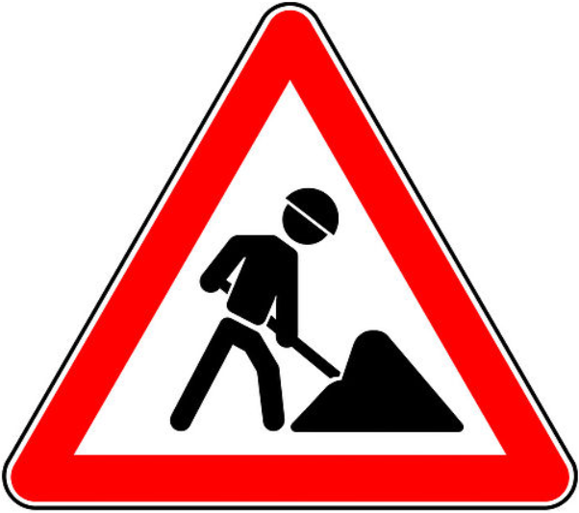 | A. Construction  B. Occupied  C. Caution  D. Quayside |  | A. Cross road  B. Highway begins  C. Roundabout  D. Two-way traffic
- Choose the word (A, B, C or D) that best fits the blank space in the following passage (1.5 pts)
Protecting yourself and others from the spread COVID-19
You can reduce your chances of being infected or spreading COVID-19 by taking some simple (17)__________:
- Regularly and thoroughly clean your hands with an alcohol-based hand rub or wash them with soap and water.
- Avoid going to crowded places. And maintain (18)__________ 1 metre (3 feet) distance between yourself and others.
- Avoid touching eyes, nose and mouth.
- Make sure you, and the people around you, follow good (19)__________ hygiene.
- Stay home and self-isolate even with minor (20)__________ such as cough, headache, mild fever, until you recover. If you need to leave your house, wear a mask to avoid infecting others.
- If you have a fever, cough and difficulty (21)__________, seek medical attention, but call by telephone in advance if possible and follow the directions of your local health authority.
- Keep up to date on the latest information from trusted sources, such as WHO or your local and national health authorities. Local and national authorities are best placed to advise (22)__________ what people in your area should be doing to protect themselves.
- A. evidences B. precautions C. imagination D. expectation
- A. at last B. at first C. at least D. at risk
- A. respire B. respiration C. respirative D. respiratory
- A. symptoms B. predictions C. warnings D. worries
- A. breath B. breathing C. to breath D. to breathing
- A. from B. to C. for D. on
- Read the passage and do the tasks below (1.5 pts)
Dear Mr. Lawrence
I have seen your advertisement for summer language courses and I am thinking of attending one for two or three weeks. Could you please send me some information and details of prices? I would particularly like to know how many students attend the schools, their ages and how many students there are in a class. Also, can you explain what is included in the sports program and what amenities there are near the school? For example, is there a cinema or swimming-pool in little Bonnington? Could you tell me something about your staff? Are they all qualified teachers? Lastly, as I am a music student, I wish they very much to stay with a family who have a piano that I can practice on. Do you think it would be possible to arrange this?
I look forward to receiving your reply.
Your sincerely,
Daniel Rovetta.
Answer: TRUE or FALSE?
- Daniel wants to attend the spring language courses.
- Daniel wants to know the number of students of that school.
- He wants to know the age of the teaching staff.
- He has a piano and wants to bring there.
Choose the correct answers:
- The word "amenities" in line 5 mostly means _______________.
A. humanities B. facilities C. universities D. capacities
- Which of the following is NOT true according to the passage?
A. Daniel would like to know the number of students in a class.
B. This is a formal letter.
C. Daniel doesn't care about the school fees.
D. Daniel is excited about the reply to her interests.
- Word forms: Use the correct word forms (1.5 pts)
- The tour around the country was __________________________________________ cheap. (surprise)
- In the 1980s jeans were high fashion ____________________________________________. (clothe)
- The __________________________ of the ancient city really impressed the foreign tourists. (beautiful)
- Most British farms are big because small farms are ________________________________. (economy)
- There was no evidence of _____________________________ in the death of John Wallace. (poisonous)
- Unless you understand, I will _____________________________________ it again to you. (explanation)
- Sentence transformation: Rewrite the following sentences without changing the meaning (1.0 pt)
- They used public buses instead of motorbikes four years ago.
- It has been
- He drove too fast for anyone to catch him up.
- He drove so
- He is asking one of the best experts in the city do his tattoo.
- He's having his
- Stop talking or you won't understand the lesson.
- If
- Rearrange these sentences (0.5 pts)
- these passages / What / a father / draw from / image of / can you /? //
- What
- this course, / If / to attend / pass / you want / the written examination / you must /. //
- If

SỞ GD – ĐT THÀNH PHỐ HỒ CHÍ MINH  ĐỀ THI THỬ SỐ 52 | KỲ THI TUYỂN SINH VÀO LỚP 10  Thời gian làm bài: 90 phút
Họ và tên học sinh:
- Choose the word whose underlined part is pronounced differently from others (0.5 pts)
- A. tired B. enjoyed C. reached D. arrived
- A. century B. convenient C. consist D. comfortable
- Choose the word whose main stress is placed differently from the others (0.5 pts)
- A. standard B. provide C. control D. amount
- A. language B. country C. religion D. interesting
- Read and choose the word or phrase (A, B, C or D) that best fits the space in each sentence. (2.5 pts)
- I won’t go to Yung Tau if it _______________ tomorrow.
A. rain B. will rain C. rains D. raining
- Nobody understands what he says, _______________?
A. does it B. doesn’t it C. do they D. don’t they
- Solar energy can help people _______________ the earth’s resources.
A. protect B. consume C. profit D. conserve
- She’s looked _______________ her glasses everywhere but she can't find them anywhere.
A. over B. after C. for D. into
- You should watch the news every day. It's really _______________.
A. informative B. boring C. time-consuming D. costly
- Mary’s eyes are weak. _______________, she has to wear glasses.
A. However B. But C. Therefore D. And
- There are many _______________ in this country but Buddhism is the strongest.
A. climates B. regions C. religions D. currencies
- Liz took a lot of photos to show the trip _______________ her parents.
A. for B. with C. to D. about
- – “_______________.” – “But grandma, the forecast says it'll be sunny.”
A. Remember the new words by heart B. Let's eat out
C. Let me go shopping D. Don't forget to bring along a raincoat
- “I promise I will study harder next term.” – “_______________.”
A. Good idea B. I hope so C. No, thanks D. I’m sorry I can’t.
- Choose the best opinion to match the sign (0.5 pts)
- What does the sign mean?
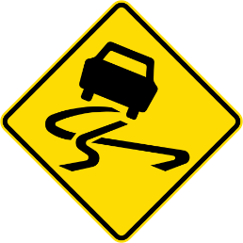 | A. Please swing when you drive on this road.  B. Please take care as the road is dark.  C. Please take care as the road is slippery.  D. Please swing if there is a care in front of you.
- What does the sign say?
 | A. Please put garbage into the basket.  B. Don’t put garbage into the basket.  C. Please put the basket conveniently.  D. Don’t put the basket conveniently.
- Choose the word/ phrase (A, B, C, or D) (1.5 pts)
One of the most urgent environmental problems in the world today (17)__________ the shortage of clean water. Having clean drinking water is a basic human right. But acid rain, industrial pollution and garbage have made many sources of water (18)__________. Lakes, reservoirs and even entire seas have become vast proofs of poison. Lake Baikal in Russia is one of the largest lakes in the world. It contains a rich (19)__________ of animals and plants, including 1,300 rare species that do not exist anywhere else in the world. But they are being destroyed by the massive volumes of industrial wastes (20)__________ pour into the lake every day. Even where law existed, the government did not have the power to enforce them. Most industries simply ignore the regulations. The Mediterranean Sea occupies 1% of the world’s water surface. But it is the dumping ground for 50% of all marine pollution. Almost 16 countries regularly industrial wastes a few miles offshore. Water is free (21)__________ everyone. A few years ago people thought that the supply of clean water in the world was limitless. Today, many water supplies have been ruined by pollution and sewage. Clean water is now scarce, and we are (22)__________ beginning to respect this precious source. We should do something now.
- A. is B. are C. have been D. was
- A. clean B. polluting C. undrinkable D. inedible
- A. amount B. variety C. lot D. plentiful
- A. which B. who C. what D. where
- A. with B. to C. for D. on
- A. at first B. at once C. at last D. at least
- READING COMPREHENSION: Read the passage and then decide whether the statements that follow are TRUE or FALSE (1.5 pts)
Nowadays our modern life is full of mass media. Normally, our day always begins with a newspaper, a print paper, delivered to us with our morning cup of tea or coffee. Some of us switch on the radio or TV while getting ready for the day. Many try to look for the daily news on their smart phones with some cigarettes. Others stop to buy some newspaper on the way to work because they want to read whenever they can. Some are at office work, using their computers to surf the internet and search the information they like. So, I wonder if there is no means of the media for our life, how will we become? And that's the reason why we need the latest daily news around the world. To me, as we are lucky to live in a modern hi-tech world, we easily contact anyone else through the internet. Actually, we can work at home after work or while going outside we're able to manage to check and reply our e-mails like we used to see our mail boxes.
- The media is necessary for our life.
- All people receive daily news from radio or TV.
- When going out, we have to bring a computer to check or reply to our e-mail.
- Traditionally, we begin our day life with news around the world by the media.
Read the passage again and choose the best answer A, B, C, or D.
- The passage mentioned _______________.
A. the usefulness of the means of internet B. the choice of news
C. the modernization of newspaper D. the importance of the media
- The passage refers to _______________.
A. using computers to choose daily news B. the convenience of smart phones
C. the way to get daily news D. the traditions for men and women
- WORD FORMS (1.5 pts)
- You are old enough to be _________________________________________ of your parents. (depend)
- It's important we must balance our work and ______________________________________. (relax)
- What can we do to reduce the electricity______________________________ of our factory? (consume)
- The building was _____________________________________ damaged by the earthquakes. (extend)
- You should pay attention to what the _____________________________________ is saying. (instruct)
- Mount Pinatubo, a volcano in the Philippines, _______________________________ in 1991. (eruption)
- Transformation: (l.0 pt)
- This problem is too complicated for him to solve.
- This problem is so
- Your father gave up smoking five years ago, didn't he?
- Your father has
- We were deeply impressed by his performance.
- His performance made
- The man cut the grass with a very modern machine.
- The machine
- Rearrangement (0.5 pts)
- stopped to talk to me / She saw me / and / while I / shopping / was going / this morning /. //
- She saw me
- funnel-shaped storms / below / a thunderstorm / are / Tornadoes / which pass overland /. //
- Tornadoes
SỞ GD – ĐT THÀNH PHỐ HỒ CHÍ MINH  ĐỀ THI THỬ SỐ 53 | KỲ THI TUYỂN SINH VÀO LỚP 10  Thời gian làm bài: 90 phút
Họ và tên học sinh:
- Choose the word whose underlined part is pronounced differently from others (0.5 pts)
- A. inspiration B. minority C. dynamite D. pesticide
- A. compose B. gemstone C. documentary D. volcano
- Choose the word whose main stress is placed differently from the others (0.5 pts)
- A. economic B. intermediate C. reputation D. dormitory
- A. appliance B. efficiency C. environment D. temperature
- MULTIPLE CHOICES: Read and choose the word or phrase (A, B, C or D) that best fits the space in each sentence (2.5 pts)
- _______________ you are interested in the film, don’t go to see it any cost.
A. If B. Unless C. Although D. Because
- I suggest _______________ the printer first.
A. you check B. you checking C. you must check D. you to check
- She’s always polite and considerate _______________ her friends.
A. with B. towards C. about D. for
- Those buckets must be filled _______________ water for future use.
A. by B. on C. into D. with
- Let me _______________ you and your success in the examination.
A. encourage B. distinguish C. celebrate D. congratulate
- My friends come to stay _______________ us _______________ Christmas.
A. to / at B. with / on C. with / at D. to / on
- Most rivers are polluted; _______________, we must use their water.
A. moreover B. therefore C. however D. so
- I have three sisters, _______________ are women doctors.
A. who they are B. that all of whom C. that all of them D. all of whom
- Though everything _______________ carefully, a small mistake happened in the end.
A. had been prepared B. had prepared C. has been prepared D. has prepared
- “Don’t put your bed next to the glass window.” – “_______________.”
A. OK. I’ll do it. B. I know. Flying glass can make bad cuts.
C. Great! Let’s do that D. OK. People will see my bed.
- Choose the best opinion to match the sign (0.5 pts)
- What does the sign mean?
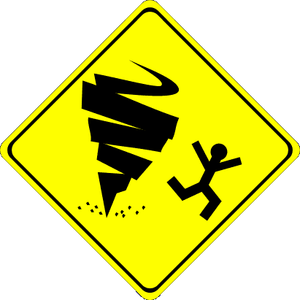 | A. Earthquake warning.  B. Hurricane warning.  C. Tornado warning.  D. Tsunami warning.
- What does the sign say?
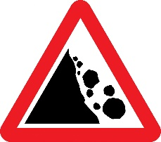 | A. Steep hill ahead: be prepared to use a lower gear if necessary.  B. Watch for fallen rock and be prepared to avoid a collision.  C. Construction zone ahead.  D. Road closed ahead due to fallen rocks.
- Choose the word/ phrase (A, B, C, or D) (1.5 pts)
The English word Easter comes (17)__________ the Old English word Eastre. Eastre is the name of the goddess of spring and light. In spring, flowers bloom and trees become green. The earth wears "new clothes". Many people wear new clothes on Easter Sunday, (18)__________. Two days before Easter is Good Friday. Christians (19)__________ Jesus Christ died on this day. Many schools and businesses close on Good Friday. Christians also believe Jesus rose from the dead on (20)__________. Easter is a very joyful holiday for Christians. On Easter Sunday, families often come together for a dinner of ham or lamp with fresh spring vegetables. Dessert is often cake in a (21)__________ of a lamp or rabbit. And there is (22)__________ candy from the Easter bunny!
- A. to B. from C. up with D. back
- A. so B. either C. too D. neither
- A. believe B. believed C. had believed D. will believe
- A. Easter Sunday B. Good Sunday C. Easter Friday D. Good Friday
- A. plate B. shape C. basket D. box
- A. lot of B. many C. a lots of D. plenty of
- READING COMPREHENSION: Read the passage and then decide whether the statements that follow are TRUE or FALSE (1.5 pts)
In the 19th century, fishermen in Peru noticed something unusual. They saw that the Pacific Ocean water was sometimes warm in December. The fishermen called this El Nino. The warm water caused problems. It kept fish away. The fishermen caught fewer fish, and their family were hungry. Today El Nino still caused problems. Every two or seven years, warm water off Australia’s coast moves east to South America. This changes the weather around the world. El Nino sometimes causes hot, dry weather in Southeast Asia, parts of South America, and Australia. It can also cause very heavy storms and high tides in eastern Africa and on the western coasts of North America, Central America, and South America.
- Fishermen in Australia gave El Nino its name.
- The fishermen caught fewer fish because of the cold water.
- El Nino doesn’t cause problems anymore.
- Many areas in the world experience natural disasters due to El Nino.
Read the passage again and choose the best answer.
- El Nino is a set of changes in the weather system that happens _______________.
A. every year B. every decade C. every few years D. every December
- According to the passage, which places in the world aren’t be affected by El Nino?
A. Southeast Asia B. Northeast Asia and Europe
C. Eastern Africa and Australia D. North, Central and South America
- WORD FORMS (1.5 pts)
- The rising level of air pollution has caused concern among ___________________________. (conserve)
- Many factories still allow ____________________, such as toxic waste, to flow into our river. (pollute)
- Governments encourage people to use the products which are _____________________________________ friendly. (environment)
- This pesticide can’t protect plants. It becomes ____________________________________. (effect)
- I don’t like _________________________________________________ fiction. It’s unreal. (science)
- My brother _______________________________ as the president of our company recently. (nominate)
- REARRANGEMENT (0.5 pts)
- had difficulty / The firefighters / the powerful fire / putting out / in /. //
- The
- helped her son / In spite of / being tired / Ms. Lien / , / with his homework /. //
- In
- TRANSFORMATION (1.0 pt)
- They often go swimming on Sundays. They have much free time then.
- They
- She is not free, so she cannot join in our trip.
- If she
- “Thank you very much for helping me with these assignments”, Tom said to me.
- Tom thanked
- How often does the mechanic service your car?
- How often do

SỞ GD – ĐT THÀNH PHỐ HỒ CHÍ MINH  ĐỀ THI THỬ SỐ 54 | KỲ THI TUYỂN SINH VÀO LỚP 10  Thời gian làm bài: 90 phút
Họ và tên học sinh:
- Choose the word whose underlined part is pronounced differently from others (0.5 pts)
- A. worked B. wanted C. stopped D. asked
- A. forces B. reduces C. divides D. impresses
- Choose the word whose main stress is placed differently from the others (0.5 pts)
- A. economic B. inspiration C. compulsory D. intermediate
- A. depend B. religious C. necessary D. deposit
- MULTIPLE CHOICES: Choose the word/ phrase (A, B, C, or D) that best fits the space in each sentence (2.5 pts)
- The United States has a _______________ of around 250 million.
A. population B. separation C. addition D. introduction
- Designers made different styles of jeans to _______________ the 1960s’ fashions: embroidered jeans, painted jeans and so on.
A. suit B. match C. fit D. wear
- Police are investigating the death of an _______________ man whose body was found yesterday.
A. evident B. imaginative C. unidentified D. infant
- Solar energy doesn’t cause _______________.
A. pollution B. polluted C. pollute D. pollutant
- Tet is festival _______________ occurs in late January or early February.
A. whom B. when C. where D. which
- It’s raining. _______________, Mr. Nam has to go to work.
A. However B. So C. Therefore D. But
- If I _______________ rich, I _______________ around the world.
A. will be – travel B. am – will travel C. were – would travel D. would be – traveled
- The girl wishes she _______________ in Hue for the festival next week.
A. had stayed B. was staying C. stay D. could stay
- You don’t like watching this film, _______________?
A. don’t you B. are you C. do you D. did you
- Minh Huy: “_______________.” – Thuy Linh: They plant rice and vegetables.
A. What do people do for a living in your village?
B. Where do people do for a living in your village?
C. What are people doing for a living in your village?
D. What did they do for a living in your village?
- CAUTION SIGNS – WARNINGS: Look at the signs. Choose the best answer (A, B, C, or D) for each sign (0.5 pts)
- What does the sign mean?
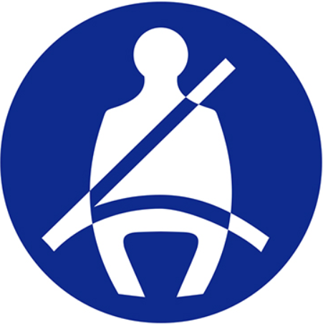 | A. No pedestrian crossing.  B. Wear your seat belt.  C. Remain seated on the bus.  D. No pedestrian allowed.
- What does the sign say?
 | A. Watch your hands.  B. Bare hands only.  C. No hands touch.  D. Wear protective gloves.
- GUIDED CLOZE: Choose the word/ phrase (A, B, C or D) that best fits the space in the following passage (1.5 pts)
Energy is one of the problems that many people are interested in. It is not an unfamiliar word. It is heard, said, discussed day after day. It is close to everyone's (17)__________ life. You turn on the lamp and it is energy (18)__________ gives you light. You turn on a TV and it is energy that gives you pictures and sound. You ride a motorcycle and it is energy that gives you movement. You cook your meals and it is energy that gives you (19)__________ to boil rice.
The problem is that the demand for energy is (20)__________ and that the price of energy is getting higher and higher. The supply of energy (21)__________ earth is limited. It cannot provide us all forever. The shortage of energy in the future is inevitable. (22)__________, saving energy is a must if we want to continue to live in a safe and sound world.
- A. wild B. daily C. marine D. social
- A. that B. this C. whose D. whom
- A. cool B. warm C. hot D. heat
- A. reducing B. decreasing C. rising D. raising
- A. on B. put C. move D. take
- A. So B. Therefore C. However D. Although
- READING COMPREHENSION: Read the passage, and then do the tasks that follow (1.5 pts)
Garbage is a serious problem in the United States. Every year, American produce 308 billion pounds of garbage (about 140 billion kilos)! A lot of garbage goes into landfills. However, many landfills do not have enough room for all the garbage.
One answer to the garbage problem is recycling. Half of all the garbage in the United States can be recycled and used again. Recycling helps the landfill problem and saves enough energy, too. When people recycle newspapers, they save trees. When they recycle glass, plastic, or cans, they save oil and electricity. Recycling is good for everyone.
Decide if these statements are TRUE or FALSE
- Garbage is a crucial problem in the United States.
- We save trees if we recycle glass.
- Fifty percent of garbage in the United States can be recycled and used again.
- Many landfills have enough room for all the garbage.
Choose the word/ phrase (A, B, C or D) that best fits the space.
- What is the main idea of this passage?
A. Energy B. Recycling C. Garbage D. Landfills
- It can be inferred from the passage that?
A. Reusing is the best way for the garbage problem.
B. Reducing is the best way for the garbage problem.
C. Saving is the best way for the garbage problem.
D. Recycling is the best way for the garbage problem.
- WORD FORMS: Use the correct form of the word given in each sentence (1.5 pts)
- The scores of those students are always ____________________________________ high. (impress)
- Poets take ___________________________________________ from many things in life. (inspire)
- I’m afraid that some medical facilities are _______________________ to people in remote areas. (access)
- I suggest ___________________________________ a show to raise money for the poor. (organization)
- The Internet has helped students study more _____________________________________. (effect)
- There was a very ____________________ noise in the old house; it sounded like a child crying. (mystery)
- SENTENCE REARRANGEMENT (0.5 pts)
- whom / The children / I am looking after / terribly naughty / are /. //
- The children
- natural resources / instead of / we can save / solar energy / coal, gas and oil / by using /. //
- We can save
- SENTENCE TRANSFORMATION (1.0 pt)
- Why don’t you install a burglar alarm in your house?
- I suggest
- I fell asleep because the film was boring.
- It was such
- “Do your parents still live in Nha Trang now?”, Nam said to me.
- Nam asked me
- The weather is bad, so we can’t go camping.
- If the weather

SỞ GD – ĐT THÀNH PHỐ HỒ CHÍ MINH  ĐỀ THI THỬ SỐ 55 | KỲ THI TUYỂN SINH VÀO LỚP 10  Thời gian làm bài: 90 phút
Họ và tên học sinh:
- Choose the word/ phrase (A, B, C or D) to indicate the word whose underlined part differs from the other three in pronunciation in each of the following questions (0.5 pts)
- A. wanted B. liked C. visited D. decided
- A. acquaintances B. replaces C. appliances D. persuades
- Choose the word/ phrase (A, B, C or D) to indicate the word that differs from the other three in the position of the primary stress in each of the following questions (0.5pts)
- A. nomination B. pollution C. innovation D. celebration
- A. volunteer B. considerate C. effective D. resource
- MULTIPLE CHOICES: Choose the word/ phrase (A, B, C or D) that best fits the space in each sentence (2.5 pts)
- After two hours walking, they _______________ a big old tree.
A. got B. reached C. arrived D. came
- If you study at The Brighton Language Center-UK, you can live in a _______________ on campus.
A. dormitory B. mobile room C. hotel D. private room
- Oil is one of our most important _______________.
A. natural disasters B. nuclear power C. solar energy D. natural resources
- Remember to turn _______________ the faucet after use.
A. off B. on C. up D. down
- It might _______________ tonight because of the cold climate.
A. rain B. to rain C. raining D. be rain
- It rains heavily, _______________ I can't go to the movie with you.
A. because B. and C. so D. therefore
- They _______________ you the job if you can use the computer.
A. would offer B. have offered C. will offer D. are offering
- I suggest you _______________ to the hospital with your parents.
A. to go B. going C. should go D. should going
- She is worried _______________ her water bill.
A. with B. about C. at D. that
- Hoang Nam: “Wow! What a beautiful dress!” - Yen Nhu: “_______________”
A. Good idea. B. Ok. Why not? C. Thanks D. You're welcome.
- CAUTION SIGNS- WARNINGS: Look at the signs. Choose the best answer (A, B, C or D) for each sign (0.5 pts)
- What does the sign mean?
 | A. Merging traffic coming from the left.  B. Right lane closed ahead.  C. Merging traffic coming from the right.  D. Yield to oncoming traffic.
- What does the sign say?
 | A. Traffic moving is both directions.  B. One-way road ahead.  C. Divided highway ahead.  D. Passing zone ahead.
- GUIDED CLOZE: Choose the word/ phrase (A, B, C, or D) that best fits the space in the following passage (1.5 pts)
Twitter is (17)__________ that allows users to send and receive short message, called tweets. Tweets can be up to 140 characters (18)__________. Like Facebook, Zalo or Instagram, Twitter is (19)__________ simple and convenient to use because you can send tweets (20)__________ your computer or even your mobile phone. However, you cannot post long status or photos or videos on Twitter as you can do with the other social networks. To send or get messages you just have (21)__________ an account on Twitter.
Twitter users cannot add friends to each other. They can only follow what other people post. In most cases Twitter is made up of many small groups of people. Sometimes only they can follow (22)__________ movements. You could post "Hey, I'm going to the pub, and all of your friends could read it at once."
- A. a film B. an online social network C. a software D. a TV program
- A. wide B. big C. tall D. long
- A. quite B. hardly C. fair D. most
- A. by B. on C. from D. in
- A. to unlock B. to post C. to create D. to lock
- A. them B. other's C. your D. each other's
- READING COMPREHENSION: Read the passage, and then do the tasks that follow. (1.5 pts)
The Future at our Fingertips
Technology has never developed as quickly as it has in the early 21st century. In recent years, we have seen a huge growth in access to personal communication with the introduction of the smartphone. Almost everyone has one these days, but what about changes to technology in the home? Welcome to the smart TV.
Televisions have been in our homes for many years now. From the first black and white TVs in the 1920s to flat screens today, they have become more advanced as modern living has progressed. We are all used to using a remote control instead of getting up to change the channel, but that is about to change with the latest developments in hardware design.
Imagine being able to control the TV with a wave of your hand or just by telling the TV what you want. This sounds like something out of a science fiction film, but it is actually real. New technologies allow you to operate your TV without pressing a button. Instead, you can use voice control to turn the volume up or down and the TV on or off. You can even use your body movements to surf the Internet.
The future of television is also very exciting. A team of Japanese scientists are even developing a TV where you can smell what you are watching. So the next time you are watching the cooking channel it could make you very hungry!
Decide if these statements are TRUE or FALSE.
- Most people own a smartphone.
- The first TVs appeared in color.
- You can operate the TV with your voice.
- You can use your body movements to control the volume on the TV.
Choose the word/ phrase (A, B, C or D) that best fits the space.
- What is the main idea of this passage?
A. The development of TV B. Communication on TV
C. The development of smartphones D. Communication on smartphones
- It can be inferred from the passage that in the future?
A. We will not need to watch TV. B. We will be able to turn on or off a TV by a remote control.
C. We will be able to smell what's on TV. D. We will be able to watch TV when we are hungry.
- WORD FORMS: Use the correct form of the word given in each sentence. (1.5 pts)
- The hurricane brought total _____________________________________________ to the city. (destroy)
- A Vietnamese firm makes ____________________ rice-flour straws to help protect environment. (eat)
- Son Doong is a beautiful place to which many _________________________________ go from all over the world. (sightsee)
- Her ideas were clear and ________________________________________________ presented. (logic)
- Facebook, Twitter, and Instagram are examples of _______________________________ media. (act)
- He's color-blind and can't ____________________________________________ the difference between red and green easily. (distinguishable)
- SENTENCE REARRANGEMENT (0.5 pt.)
- speak only / the course / advised to / English during / You are /. //
- You are
- last week / the book / which Lan / to me / I can't find / lent /. //
- I can't find
- SENTENCE TRANSFORMATION (2.0 pts)
- I don't have time to go around the city.
- I wish
- Stop using the computer after 9 pm.
- You must shut
- He last visited his home village when he was twenty.
- He has not visited
- Although his leg was broken, he managed to get out of the car.
- Despite his

SỞ GD – ĐT THÀNH PHỐ HỒ CHÍ MINH  ĐỀ THI THỬ SỐ 56 | KỲ THI TUYỂN SINH VÀO LỚP 10  Thời gian làm bài: 90 phút
Họ và tên học sinh:
- Choose the word with different pronunciation from the others (0.5 pts)
- A. installed B. composed C. impressed D. raised
- A. nation B. edition C. question D. description
- Choose the word whose stress pattern is different from that of the others (0.5 pts)
- A. ordinary B. appliance C. category D. profitable
- A. distinguish B. generous C. considerate D. acquaintance
- Choose the best option (a, b, c or d) of each sentence (1.5 pts)
- Birthday is one of the family _______________.
A. festivals B. parades C. members D. celebrations
- I think we should isolate the people _______________ have covid-19 to cure.
A. which B. whom C. who D. whose
- Mid Fall Festival is a _______________ festival for Vietnamese children.
A. effective B. different C. joyful D. important
- The 2nd exam is coming. _______________, Ba still plays games all day.
A. But B. Therefore C. However D. So
- _______________ the boy is sick, he tries to go to school.
A. Because B. Since C. As D. Although
- Boys account _______________ 60% of the students in our school.
A. for B. of C. about D. in
- Let's congratulate Thy _______________ her promotion.
A. with B. on C. in D. through
- Phong: "Your new hair style looks great, Chau!" - Chau: "_______________.”
A. OK B. I think so C. Good idea D. Thanks a lot
- Minh: "I've passed the exam to Grade 10, Mom!" - Mrs. Thoa: "_______________.”
A. So have I B. I have too
C. Congratulations! I'm proud of you D. I hope so
- Was the movie "Parasite" _______________ for an Oscar?
A. taken B. recognized C. nominated D. accepted
- CAUTION SIGNS- WARNINGS: Look at the signs. Choose the best answer (A, B, C or D) for each sign (0.5 pts)
- What should you do if you see these words on the garbage bin?
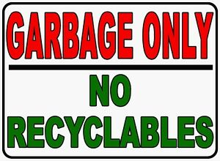 | A. Put recyclable things into it.  B. Not put recyclable things into it.  C. Not put garbage into it.  D. Put garbage and recyclable things into it.
- What does the sign say?
 | A. Departures.  B. Arrivals.  C. Delays.  D. There's a hotel ahead.
- Choose and circle the word (A, B, C or D) that best fits the blank space in the passage (1.5 pts)
In a breakthrough, scientists have found an economically viable way to (17)__________ fuel from water by splitting it into oxygen and hydrogen. Just as solar light can generate electricity, the water splitting process could do the same via the generation of clean chemical fuel such as hydrogen. "It is already (18)__________ possible to split water in this way", researchers said. The world is now (19)__________ five major issues for humanity - energy, environment, water, food security and public health. Global warming is ranked first and it is all resulting (20)__________ burning fossil fuels because that is where carbon dioxide comes from. To reduce this, you have to find clean, renewable energy and hydrogen equals clean energy. It's part of the solution - if we really can (21)__________ water into two that will be one scientific solution for the future of sustainable energy supplies, hydrogen would be a (22)__________ clean fuel over petrol in foreseeable future.
- A. do B. study C. create D. destroy
- A. scientifically B. scientific C. science D. scientist
- A. meeting B. looking C. facing D. having
- A. of B. to C. by D. from
- A. divert B. transfer C. require D. split
- A. synthetic B. promising C. obvious D. hopeful
- Read the passage then decide whether the statements that follow arc True or False (1.5 pts)
Tet, or the Lunar New year, is the largest and most important traditional celebration in Vietnam. The Vietnamese celebrate Tet sometimes between late January and early February, depending on the lunar calendar. It’s a national holiday and celebration can last from seven to ten days. All over the country, millions of people travel long distance to celebrate Tet with their families. In big cities like Ho Chi Minh City, Ha Noi, Hue, etc, … there are popular events including flowers festivals, light shows, dragon dances, puppet shows, book fairs, classical music performances and even cake making contests. There are also some amazing fireworks displays.
- No other celebration in Viet Nam is as important as Tet.
- People have to go to work during Tet.
- Family members who live apart try to be together at Tet.
- There are many activities at Tet.
Read the passage again and choose the best answer (A, B, C or D)
- The best topic for the passage is _______________.
A. Tet B. Lunar Year C. Tet in Viet Nam D. An important festival
- The word "amazing" is the nearest in meaning to _______________.
A. happy B. surprising C. joyful D. enormous
- Use the correct form of the word given in each sentence (1.5 pts)
- Tuan is one of the most effective ______________________________ in the charity programs. (act)
- His sense of humor ______________________________________________ him from others. (distinct)
- There is a ___________________________________ of food and shelter in the refugee camps. (short)
- Jogging is a very ________________________________________________ form of exercise. (energy)
- We shouldn't use natural resources _______________________________________________. (waste)
- Mrs. Smith has kindly __________________________________ a picnic lunch for volunteers. (provision)
- Rearrange the words in the correct order (0.5 pts)
- suggest / by bike / going to school / I / to save energy /. //
- I
- and generous man / by all his friends / My father is / a considerate / who is loved /. //
- My father is
- Rewrite the sentences so that they are nearest in meaning to the sentence (1.0 pt)
- Although Mr. Lam has worked for many years, he can’t buy himself a house.
- In spite
- This is the student. He helped me fix my bike yesterday.
- This is
- Ngoc can improve her English speaking skill by practicing with native speakers.
- If Ngoc
- I think we shouldn’t use electricity to catch fish.
- I suggested that electricity

SỞ GD – ĐT THÀNH PHỐ HỒ CHÍ MINH  ĐỀ THI THỬ SỐ 57 | KỲ THI TUYỂN SINH VÀO LỚP 10  Thời gian làm bài: 90 phút
Họ và tên học sinh:
- Choose the word with different pronunciation from the others (0.5 pts)
- A. corresponded B. congratulated C. impressed D. painted
- A. nation B. edition C. question D. description
- Choose the word whose stress pattern is different from that of the others (0.5 pts)
- A. minority B. majority C. traditional D. inspiration
- A. electricity B. population C. necessity D. innovation
- Choose the best option (a, b, cord) of each sentence. (1.5 pts)
- Auld Lang Syne is a song _______________ is sung on New Year's Eve.
A. whose B. who C. which D. whom
- Scientists are looking for an _______________ way to reduce energy consumption.
A. new B. effective C. cheap D. affect
- A(n) _______________ is a person whose job is to repair and fit things such as water pipes or toilets, etc.
A. electrician B. plumber C. carpenter D. bricklayer
- Plastic bags seem good for carrying things. _______________, people carelessly throw them away after use.
A. Because B. However C. Although D. Therefore
- It's an entertaining and _______________ documentary.
A. inform B. informed C. informative D. informal
- Hoa: Wow! You look terrific! - Nam: “_______________.”
A. You're welcome B. Thanks C. No problem D. Yes. I do
- If you want to save money, you should _______________ the amount of water your family uses.
A. increase B. reduce C. adapt D. repair
- They want us _______________ our classroom more attractively.
A. decorate B. to decorate C. decorating D. decorated
- Was the movie "Parasite" _______________ for an Oscar?
A. taken B. recognized C nominated D. accepted
- Computers account _______________ 5% of the country’s commercial electricity consumption.
A. to B. for C. in D. at
- CAUTION SIGNS- WARNINGS: Look at the signs. Choose the best answer (A, B, C or D) for each sign (0.5 pts)
- What does the sign mean?
 | A. We mustn’t park our vehicles here and continue walking.  B. We must park our vehicles here and continue walking.  C. We can park our vehicles but not start the engine.  D. We mustn’t stop or park any of our vehicles here.
- What does the sign say?
 | A. There is a roundabout ahead.  B. There is an intersection ahead.  C. There is a workshop ahead.  D. You must ride around.
- Choose and circle the word (A, B, C or D) that best fits the blank space in the passage (1.5 pts)
Recycling is beneficial in two ways: it reduces the inputs (energy and raw materials) to a production system and reduces the (17)__________ of waste produced for disposal. A study conducted (18)__________ the Technical University of Denmark found that in 80% of cases, recycling is the most efficient method to (19)__________ household waste. Some materials like aluminum can be recycled (20)__________ as there is no change to the materials. Recycling aluminum saves 95 % of the energy cost of processing new aluminum because the melting temperature is (21)__________ from 900°C to 600°C. It is by far the most efficient material to recycle. Recycling plastic saves 70% of the energy used in creating new plastic, and paper recycling saves 40% of the energy required to make a new (22)__________.
- A. number B. amount C. quality D. numbers
- A. via B. with C. in D. by
- A. add B. store C. get rid of D. maintain
- A. indefinite B. definite C. indefinitely D. indefinable
- A. reduced B. increased C. grew D. gone up
- A. producing B. product C. products D. produce
- Read the passage then decide whether the statements that follow arc True or False (1.5 pts)
The Carnival in Rio de Janeiro is the biggest carnival in the world, dating back to 1723. With more than 2 million people on the streets every single day, this carnival parade offers a real spectacle. Held just before Lent starts, the festival officially lasts from Friday night until Wednesday morning, but many Brazilians continue celebrating for a few days more. A typical parade includes happy revelers, colorful floats, as well as performances by samba schools - groups of local people dancing. The most famous dance is, of course, samba, a traditional Brazilian dance influenced by African traditions. Each year, the Queen of the Carnival and up to two princesses are pronounced publicly.
- The Carnival in Italy is the biggest carnival in the globe.
- The Carnival lasts from Friday to Wednesday unofficially.
- During the parade, there are performances by samba students.
- Annually, maybe one or two princesses are pronounced publicly.
Read the passage again and choose the best answer
- When was The Carnival in Rio de Janeiro first celebrated?
A. 1724 B. before 1723 C. 1723 D. 1732
- What does "pronounced" mean?
A. to spell B. to state officially C. to call D. to perform
- Use the correct form of the word given in each sentence (1.5 pts)
- She had such a sad ______________________ on her face that I wondered what was wrong. (expressive)
- I was surprised to find my name on the list of _____________________________________. (nominate)
- Her teachers seem _______________________________________________ with her result. (satisfactory)
- You can buy waste _______________________________________ made from this factory. (produce)
- A new air-conditioner will be _______________________________________ this morning. (install)
- We flew home ____________________________________________________ in first class. (luxury)
- Rearrange the words in the correct order (0.5 pts)
- there are / You should / to make sure / in the pipes / no cracks / get a plumber /. //
- You
- and generous man / by all his friends / My father is / a considerate / who is loved /. //
- My father is
- Rewrite the sentences so that they are the nearest in meaning to the sentence (1.0 pt)
- Although he loves her, she doesn't want to get married.
- In spite of
- Ride carefully or you'll cause an accident.
- If
- She is a famous singer. She has talked to me.
- She is a
- How about collecting these waste things for recycling?
- I suggest that

SỞ GD – ĐT THÀNH PHỐ HỒ CHÍ MINH  ĐỀ THI THỬ SỐ 58 | KỲ THI TUYỂN SINH VÀO LỚP 10  Thời gian làm bài: 90 phút
Họ và tên học sinh:
- Find the word which has a different sound in the underlined part (0.5 pts)
- A. congratulate B. consider C. ancient D. compose
- A. humor B. hug C. documentary D. nuclear
- Find the word which has different stress pattern from the others (0.5 pts)
- A. memory B. Christmas C. nationwide D. humorous
- A. cultural B. satisfy C. compliment D. nominee
- MULTIPLE CHOICE. Read and choose the appropriate word or phrase (2.5 pts)
- We have known each other _______________ we were in university.
A. since B. for C. when D. while
- Maryam's trip to Vietnam made a deep impression _______________ her.
A. for B. with C. on D. at
- The English 9 textbook _______________ ten units.
A. comprises B. consists C. divides D. separates
- It's _______________ to wear short skirt at the moment because the weather is very cold.
A. fashionable B. unfashionable C. fashionably D. unfashionably
- _______________ English _______________ all over the world?
A. Is / spoken B. Was / spoken C. Does / speak D. Did / speak
- She is worried _______________ the result of her final exam.
A. in B. on C. at D. about
- You should have the _______________ check the lights in your house.
A. doctor B. electrician C. mechanic D. plumber
- "I think we should turn off the TV and go for a walk." - "_______________."
A. No, thanks B. I'm sure C. I agree with you D. Not at all
- How about _______________ by bike instead of by car?
A. to travel B. traveling C. travel D. traveled
- Everyone must take part in _______________ deforestation.
A. permitting B. protecting C. persuading D. preventing
- CAUTION SIGNS (0.5 pts)
- What does the sign mean?
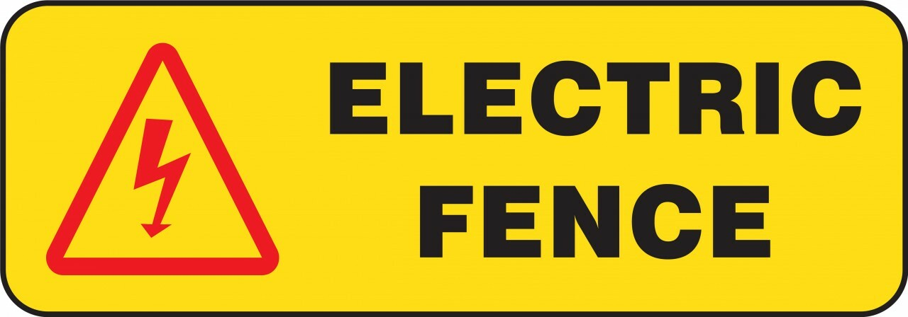 | A. The fence is safe.  B. Electricity on the fence can kill you.  C. You can put your hand on the fence.  D. Electricity on the fence is permitted.
- What does the sign say?
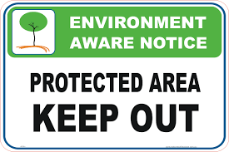 | A. Visitors aren't allowed to enter this area.  B. This area is open to everyone.  C. This area is only for authorized persons.  D. A & C are correct.
- CLOZE TEXT. Choose the word/ phrases (A, B, C or D) that best fits the space in the following passage (1.5 pts)
Pen pals are people who regularly write to each other, particularly via postal mail. A pen pal relationship is often used (17)__________ reading and writing in a foreign language, to improve literacy, to learn more about (18)__________ countries and lifestyles, and to make friendships. As with any friendships (19)__________ life, some people remain pen pals for only a short time, (20)__________ others continue to exchange letters and presents life-long. Some pen pals eventually arrange to meet face to face. Pen pals come in all ages, nationalities and cultures. You can get pen pals by visiting pen pal sites on the internet. Pen pal clubs can (21)__________ be found in magazine columns, newspapers and sometimes through clubs or special interest groups. Some clubs may be free while others may charge a partial (22)__________ full subscription fee.
- A. practicing B. to practice C. practiced D. to practicing
- A. other B. others C. another D. one another
- A. on B. at C. in D. with
- A. when B. what C. where D. while
- A. also B. too C. so D. only
- A. but B. and C. or D. as
- READING COMPREHENSION (1.5 pts.)
Are you looking for a cheap, clean, effective source of power that doesn't cause pollution or waste natural resources? Look no further than solar energy from our sun. Many countries are already using solar energy. Solar panels are placed on the roof of a house and the sun's energy is used to heat water. The energy can be stored for a number of days, so on cloudy days you can use solar energy, too. Sweden has an advanced solar energy program. There, all buildings will be heated by solar energy; cars and buses will use solar power instead of gas by the year two thousand fifteen.
Decide whether the following statements are TRUE or FALSE.
- Few countries in the world are ready to use solar energy.
- We can hardly use solar energy on cloudy days.
- Solar panels are used for water heating.
- Some types of vehicles in Sweden will use solar power by 2015.
Choose the best answer to each question
- Where can we install solar panels?
A. on houses' roofs B. on the sun C. on water heaters D. on cloudy days.
- When will buildings in Sweden be widely heated by solar energy?
A. before 2015 B. before 2050 C. in 2015 D. in 2050
- WORD FORMS: Use the correct word forms (1.5 pts)
- Most _______________________________ are about our poor protection of the environment. (complain)
- The ________________________________________ always want to receive the best service. (consume)
- The company must reduce costs to compete ________________________________________. (effect)
- ________________________________, I will have a piece of chocolate, but this is quite rare. (occasion)
- It was quite ____________________________ to order so much food, we were too tired to eat. (necessity)
- He was waiting for his friends at the ____________________________ to the amusement park. (enter)
- REARRANGEMENT (0.5 pts)
- luxuries / In Western countries / but / electricity, gas, and water / necessities / are not /. //
- In Western countries
- Van / a lot / has been learning / on a farm / since he arrived / about life /. //
- Van
- SENTENCE TRANSFORMATION: Rewrite the following sentences without changing the meaning (1.0 pt)
- We last saw our cousin Tom three months ago.
- The last time
- The dentist has just taken out one of my teeth.
- One of
- Follow these simple rules will help you save energy.
- If
- Our house is small, but we enjoy living there.
- Despite

SỞ GD – ĐT THÀNH PHỐ HỒ CHÍ MINH  ĐỀ THI THỬ SỐ 59 | KỲ THI TUYỂN SINH VÀO LỚP 10  Thời gian làm bài: 90 phút
Họ và tên học sinh:
- Find the word which has a different sound in the underlined part (0.5 pts)
- A. typhoon B. groom C. flood D. balloon
- A. guest B. generous C. celebrate D. describe
- Find the word which has different stress pattern from the others (0.5 pts)
- A. economic B. volcanic C. disappointed D. scientific
- A. activity B. appliance C. adventure D. average
- MULTIPLE CHOICES: Read and choose the appropriate word or phrase (2.5 pts)
- There are some cracks in the water pipes. Why don't you call a _______________ to replace?
A. mechanic B. electrician C. plumber D. carpenter
- "What a great bike you have, Nhat!" - "_______________."
A. Thanks. It was a present from my dad. B. Not at all.
C. The same to you. D. You are welcome.
- Let me _______________ you and your success in the examination.
A. encourage B. distinguish C. celebrate D. congratulate
- We _______________ until the whole area is clean.
A. won't eat B. haven't eaten C. don't eat D. aren't eating
- Most rivers are polluted; _____________, people living in the country use water from those rivers every day.
A. And B. But C. However D. So
- These clothes need _______________ immediately.
A. wash B. to wash C. to be wash D. washing
- "I suggest going to Vung Tau on the weekend." - "_______________."
A. That's a reason B. That's a good idea C. That's a fine day D. That's a trip
- She doesn't like to wear a _______________ blouse
A. short-sleeved B. short-sleeve C. shorter-sleeve D. short-sleeving
- Let's wait _______________ it stops raining.
A. when B. while C. during D. until
- Do you think jeans will be _______________?
A. out of fashion B. out of date C. out of work D. out of order
- CAUTION SIGNS (0.5 pts)
- What does the sign say?
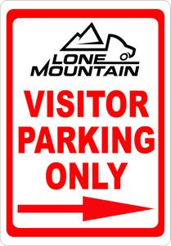 | A. Anybody can park here.  B. You can park here if you are not visitors.  C. Only the visitor living in this country can park here.  D. Parking in this space for visitor only.
- What does the sign say?
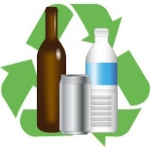 | A. Recycle plastic bottles.  B. Recycle cans.  C. Recycle bottles and cans.  D. Recycle all kinds of bottles.
- CLOZE TEXT: Choose the word/ phrases (A, B, C or D) that best fits the space in the following passage (1.5 pts)
(17)__________ pollution is a term that refers to all the ways by (18)__________ man pollutes his surroundings. Man dirties the air with harmful gases and smoke, contaminates water with chemicals and other substances, and damage the soil with too many fertilizers and pesticides. Man also pollutes his surroundings (19)__________ various other ways. For example, people not ruin natural beauty by scattering junk and litter not only on the land but (20)__________ onto the water. Pollution is one of the (21)__________ serious problems (22)__________ mankind today.
- A. Environment B. Environmental C. Environmentally D. Environmentalist
- A. who B. whom C. which D. that
- A. on B. at C. in D. with
- A. also B. as well C. Ø D. A and B are correct
- A. almost B. most C. most of D. best
- A. face B. faces C. facing D. faced
- READING COMPREHENSION (1.5 pts.)
As life was changing rapidly in the large cities of England, life in other areas remained much the same as it had been for centuries. Factories brought huge population increases to the cities, and city life boomed. City residents discovered a new way of life, but in country villages the traditional lifestyle remained nearly unchanged. There were a few changes, particularly the new steam-powered machinery, that made farm production more efficient. But for the people who remained in the countryside, daily life continued much as it had before the Industrial Revolution. Life in country villages continued to move at a slow pace. The daily schedule depended on the times that the sun rose and set and on the weather. In a typical village, the largest number of workers was still employed in agriculture or in domestic service. A smaller number of people worked in various trades. Even fewer worked in the professions.
Decide whether the following statements are TRUE or FALSE.
- Life in the country was changing as rapidly as in other areas of England.
- The new steam-powered machinery has also revolutionized the farm production.
- Life in country villages has slowly changed depending on the daily schedules.
- Most of people living in the traditional English countryside worked in public service.
Choose the best answer to each question
- What is the best tittle of the passage?
A. Life in the English Countryside B. Changes in the English Countryside
C. Traditional careers in a village D. the Industrial Revolution in the Countryside
- What detail is NOT mentioned in the passage?
A. Factories made the population increase in cities.
B. The traditional lifestyle seemed unchanged in country villages.
C. The weather determined the changes in the country life.
D. Not many people living in the countryside worked as lawyers or doctors.
- WORD FORMS: Use the correct word forms (1.5 pts)
- Long time ago, black men were sold into ________________________________________. (slave)
- Fuel ____________________________ can be cut down by having fewer cars on the roads. (consume)
- She decided not to use this machine anymore because it worked ______________________. (effect)
- She always spends her money _________________________________________________. (economy)
- We apologized for the delay and any ______________________________________ caused. (convenient)
- These shoes look nice but terribly ______________________________________________. (comfort)
- REARRANGEMENT (0.5 pts)
- the consumers / The label / tells / energy efficiency / each model has / how much /. //
- The label
- fashion designers / What / the Ao dai / have / to modernize / done /? //
- What
- SENTENCE TRANSFORMATION: Rewrite the following sentences without changing the meaning (1.0 pt)
- The dress no longer fits her well. Her boyfriend gave her the dress.
- The dress
- Leave the lights on all day will waste a lot of electricity.
- If
- It was such a long journey that they were all asleep by the time they arrived.
- The journey
- He found it not easy to finish the project alone.
- He had

SỞ GD – ĐT THÀNH PHỐ HỒ CHÍ MINH  ĐỀ THI THỬ SỐ 60 | KỲ THI TUYỂN SINH VÀO LỚP 10  Thời gian làm bài: 90 phút
Họ và tên học sinh:
- Choose the word whose stress pattern is different from that of the others (0.5 pts)
- A. luxury B. humorous C. activist D. volcano
- A. preparation B. innovative C. conservation D. disappointment
- Choose the word with different pronunciation from the others (0.5 pts)
- A. energetic B. wedding C. slavery D. expect
- A. polluted B. installed C. prepared D. destroyed
- MULTIPLE CHOICES: Read and choose the appropriate word or phrase (2.0 pts)
- You’ll be in trouble if you _______________ your passport.
A. lose B. will lose C. lost D. would lost
- The local authority should _______________ the fish catching by electricity.
A. permit B. allow C. prohibit D. protect
- Mrs. Mi gives Mrs. Ha advice _______________ how to save water.
A. about B. on C. in D. for
- That coat is designed without sleeves. It is _______________.
A. sleeved B. short-sleeved C. long-sleeved D. sleeveless
- He wishes he _______________ back to Viet Nam again in the future.
A. came B. would come C. will come D. come
- "Congratulation on your exam result!" - "_______________."
A. You're welcome B. Thanks a lot C. All right D. That's good
- We can't contact with each other _______________ we lost our phone number.
A. Because of B. if C. since D. although
- _______________ can suck up anything that is in their path.
A. Tsunami B. Tornadoes C. Deforestations D. Typhoons
- If I were in your shoes, _______________.
A. I will say sorry to them B. they would buy them for me
C. I would apologize to them D. they can have them
- “I’d like to book a flight to Melbourne, please.” – “_______________.”
A. No, of course not B. Do you mind if I say no?
C. Yes, sir, single or return? D. You can’t. We’re busy.
- WORD FORMS (1.5 pts)
- The show of the animals made us extremely ______________________________________. (impression)
- We find ______________________________________ on television sometimes ineffective. (advertise)
- The earthquake in Japan had caused ______________________________________ damage. (consider)
- The project has just been _________________________________________________ done. (innovation)
- She is very young so she is a little bit ___________________________________________. (experience)
- He was ______________________________ as the president of the football club last week. (nomination)
- CAUTION SIGNS (0.5 pts)
- What does the sign say?
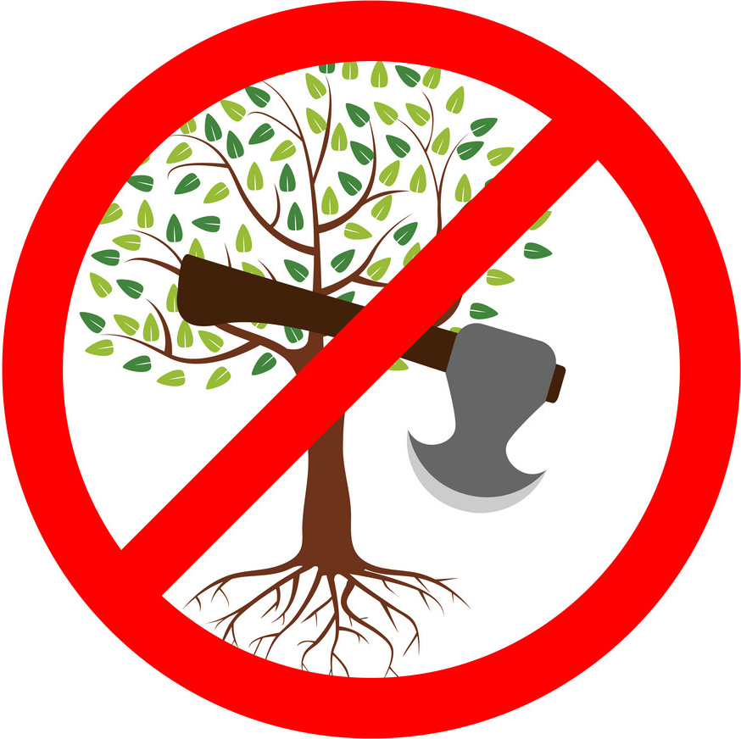 | A. Using hammer is harmful here.  B. Cutting down a tree is allowed.  C. Cutting down the woods is prohibited.  D. Having trees here is luxurious.
- The picture says:
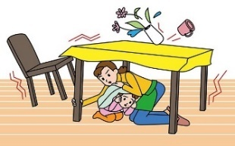 | A. If there is an earthquake, you must not stay inside.  B. If you live in an earthquake zone, you can put flower vase on the table.  C. If there is an earthquake, you should sit under a strong table.  D. If you live in an earthquake zone, you should check the furniture.
- Choose the word (A, B, C or D) that best fits the blank space in the following passage (1.5 pts)
For many years (23)__________ and quality of cloth were dependent (24)__________ social status and wealth. Before medieval times (25)__________ people in Britain wore plain woolen clothes. The main garment was a long (26)__________ fastened by a belt, and covered in cold weather by a cloak. In the 11th and 12th centuries differences in clothing between nobles and the common people became more noticeable. Women's dresses began to have more shape and style. They reached the ground and often had long hanging (27)__________. Rich people lined their cloaks with fur. When knights returned from the Crusades they brought new fashions and (28)__________ from the Middle East. Men began to wear colored tunics and stockings, and long pointed shoes.
- A. style B. stylish C. stylist D. stylistic
- A. in B. on C. at D. to
- A. most B. most of C. mostly D. almost
- A. tunic B. tunnel C. unique D. stockings
- A. sleeveless B. sleeve C. sleeved D. sleeves
- A. material B. materials C. materialism D. materially
- READING COMPREHENSION (1.5 pts)
THE NEWS MEDIA
News media are the means or methods by which people learn what is happening in the city, in the country and in the world. The news media can be classified into two general categories: the categories of print media and electronic media. Print media use the written material to communicate news to readers. Electronic media use air waves to send news into homes, offices, and public places. Print media are usually divided into magazines and newspapers. Most newspaper print news daily. The electronic media are generally divided into radio and television. Radio news is the one that you listen to. In the United States, many radio stations broadcast five minutes of news every hour. Television news is the one that you not only listen but also watch. In Canada and the United States, for example, many people watch an hour of news on TV at six o’clock in the evening. In the future, new categories of news media will develop. Even today computers are beginning to influence the transmission and reception of news.
Choose TRUE or FALSE
- The media can be arranged in the three major groups.
- Television and radio are broadcast media.
- In the United States, news is always broadcast every five minutes.
- Computers will soon be developed to transmit and receive news.
Read the passage again and choose the best answer
- What is the main idea of this text?
A. The influence of computers on media. B. The general introduction of news media.
C. The importance of news media in people’s lives. D. The types of news media.
- It can be inferred from the passage that _______________.
A. News media is actually a part of everyday life.
B. There are too many types of news media nowadays.
C. Print media is more convenient than electronic media.
D. Everybody watch an hour of news on TV at 6 in the US and in Canada.
- TRANSFORMATIONS (1.0 pts)
- It's a shame that I do nothing to help her.
- I wish
- English is a compulsory second language. Students have to study it in all secondary schools in Malaysia.
- English
- Though he is very young, he can earn a lot of money every month.
- Despite
- "Why don't you have a mechanic check your motorcycle once a year", my husband said to me.
- My husband advised me
- REARRANGEMENT (0.5 pts)
- to eat, drink / Sometimes celebrations / an opportunity for people / and have fun / are simply /. //
- Sometimes celebrations
- might just have / ecological disaster / the power to save / This new technology / the world from /. //
- This new technology

