Week: Date of planning:
Period: Date of teaching:
UNIT 8: SHOPPING
Lesson 3: A closer look 2

I. OBJECTIVES
By the end of this lesson, Ss will be able to:
1. Knowledge
- Revise and use some adverbs of frequency
- Identify how to use the present simple for future actions.
- Understand the difference in the use of present simple and future simple when talking about future activities.
2. Competences
- Develop competencies of communication, cooperation, and self-management.
- Be collaborative and supportive in pair work and teamwork
- Actively join in class activities
3. Personal qualities
- Be encouraged to know more about making plans, timetables, and schedules
- Develop self-study skills
II. MATERIALS
- Grade 8 textbook, Unit 8, A closer look 2.
- Computer connected to the Internet.
- Projector / TV
- hoclieu.vn
III. PROCEDURES
1. WARM-UP (5 mins)
a. Objectives:
- To create an active atmosphere in the class before the lesson;
b. Content:
- Brainstorming
c. Expected outcomes:
- Having a chance to speak English and focus on the topic of the lesson.
d. Organisation
TEACHER’S AND STUDENTS’ ACTIVITIES | CONTENTS
Brainstorming
- Ss work in two teams.  - Give Ss 2 minutes to write as many adverbs of frequency as possible.  - The team with the most correct sentences wins.  - T leads in the lesson A CLOSER LOOK 2 on page 85. | - always  - usually  - often  -sometimes  -rarely  -never
2. ACTIVITY 1: PRESENTATION (7 mins)
a. Objectives:
- To review ss’ knowledge of adverbs of frequency
- To revise ss’ knowledge of the simple sentences
b. Content:
- Review some adverbs of frequency and their use.
- Revise simple sentences
c. Expected outcomes:
- Recall the main adverbs of frequency and their use.
- Recall the form of the simple sentences
- Know the use of the present simple for future actions.
d. Organisation
TEACHER’S AND STUDENTS’ ACTIVITIES | CONTENTS
1. Adverbs of frequency
- T gets ss to list all the adverbs of frequency they can remember and the elicits the use of adverbs of adverbs of frequency from Ss.  - T confirms the answer and gets ss to take notes | 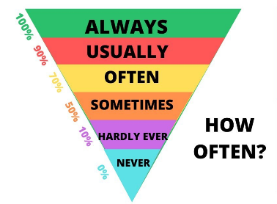
2. Present simple for future events
- T asks ss to recall the forms and uses of the present simple.  - T introduces the use of the present simple for future actions. | 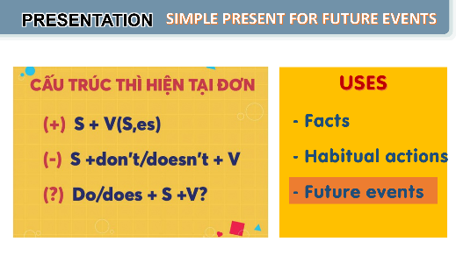
3. ACTIVITY 2: PRACTICE (24 mins)
a. Objectives:
- to revise and use some adverbs of frequency.
- to apply the use of present simple for future actions.
- to understand the difference in the use of present simple and future simple when talking about future activities.
b. Content:
- Task 1: Complete the sentences with the adverbs of frequency from the box.
- Task 2: Read the schedule of the field trip for the grade 8 students tomorrow and underline the verbs in the sentences. Then answer the questions.
- Task 3: Write A next to a sentence if it refers to a timetable, schedule, or plan, and B if it is an unplanned future action.
- Task 4: Choose the correct answer to complete each sentence.
c. Expected outcomes:
- Recall the main adverbs of frequency and their use.
- Recall the form and use of the simple sentences
- Can use the present simple for future actions.
d. Organisation
TEACHER’S AND STUDENTS’ ACTIVITIES | CONTENTS
Task 1: Complete the sentences with the adverbs of frequency from the box. (4 mins)
- Ask Ss to do the activity individually.  - Have Ss read the sentences and decide which adverb in the box best describes the frequency of the action.  - Call on some Ss to read aloud their answers.  - Check the answers as a class. Explain if needed. | Answer key:  1. always  2. rarely  3. never  4. often  5. sometimes
Task 2: Read the schedule of the field trip for the grade 8 students tomorrow and underline the verbs in the sentences. Then answer the questions. (5 mins)
- Have Ss do this activity individually or in pairs.  - Ask them to read the schedule and underline the verb in each sentence.  - Allow them some time to answer the questions.  - Call on some Ss to give their answers.  - Confirm the correct answers as a class.  - Have Ss read the Remember! box. Explain if needed. | Answer key:  Verbs: leaves, arrive, watch, starts, return  1. The present simple.  2. Future activities. (Refer to the word “tomorrow” in the task instructions.)
Task 3: Write A next to a sentence if it refers to a timetable, schedule, or plan, and B if it is an unplanned future action. (6 mins)
- Write scheduled future activity and unplanned future activity on the board. Say two sentences: The bus leaves at 11:00 and we have plenty of time. and Don’t move. I’ll answer the phone. Ask Ss which sentence is a scheduled future activity and which one is an unplanned future activity. Then write them underneath their correct categories.  - Ask Ss to work individually or in pairs.  - Call on 2 - 3 Ss to read aloud their answers.  - Confirm the correct answers as a class. Explain if needed. | Answer key:  1. B  2. A  3. A  4. A  5. B
Task 4: Choose the correct answer to complete each sentence. (5 mins)
- Have Ss do this activity individually.  - Ask Ss to read each sentence carefully and decide which option best completes the sentence.  - Call on some Ss to read out their answers.  - Confirm the correct answers as a class. | Answer key:  1. opens  2. will make  3. won’t buy  4. is  5. Does
4. ACTIVITY 3: PRODUCTION (5 mins)
a. Objectives:
- To provide Ss with a real-life practice to use the present simple to talk about events.
b. Content:
- Task 5: Work in pairs. Ask and answer to check planned events for the community fair next month.
c. Expected outcomes:
- Ss can us the present simple to talk about the future the events.
d. Organisation
TEACHER’S AND STUDENTS’ ACTIVITIES | CONTENTS
Task 5: Work in pairs. Ask and answer to check planned events for the community fair next month. (5 mins)
- Have Ss work in pairs.  - Ask Ss to read the example so that they know what they have to do.  - Allow Ss some time to read the schedule and ask and answer about the time of different events.  - Call on some pairs to say aloud their questions and answers. Ask the whole class to follow and correct if they make a mistake. | 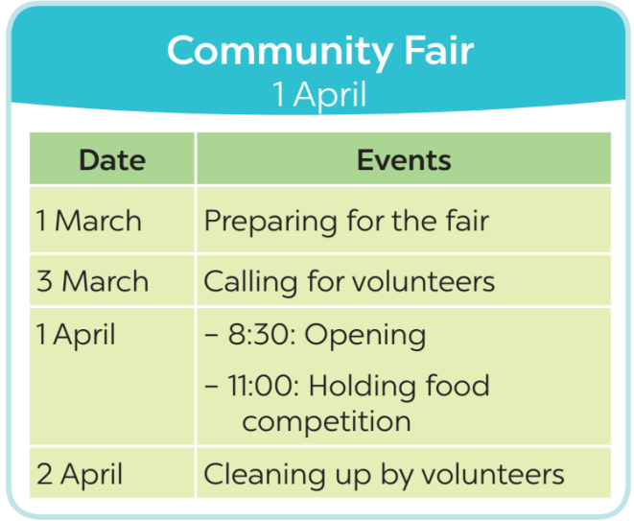
5. CONSOLIDATION (4 mins)
a. Wrap-up
- Ask Ss to summarise what they have learnt in the lesson.
- Have them say out loud the adverbs of frequency they learned in the lesson.
- Have them retell the form and uses of the present simple
b. Homework
- Learn the use of adverbs of frequency by heart.
- Make 5 sentences of the simple present for future meaning
- Do Exercise in the Workbook

