UBND HUYỆN …………..  Mã đề 6.1.4 | ĐỀ KIỂM TRA GIỮA HỌC KÌ I  NĂM HỌC 2022-2023  MÔN :Tiếng Anh LỚP 6- GLOBAL SUCCESS
I. LISTENING
Question 1. Listen then circle the right answers: A, B or C (1p)

1. What’s Tom playing? |  |  | 2. What’s Nick doing?
 |  |  | 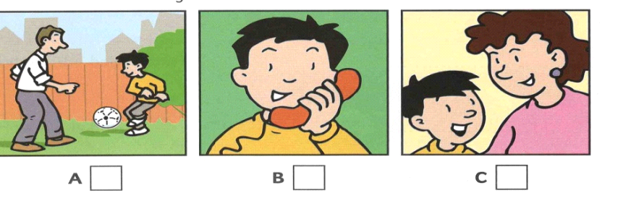
A | B | C | A | B | C
3. What’s Ben doing? |  |  | 4. What’s Kim doing?
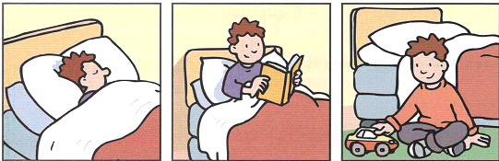 |  |  | 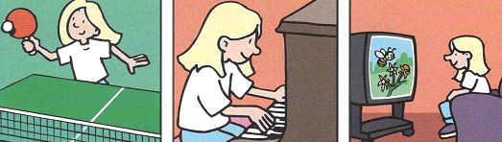
A | B | C | A | B | C
5. What’s Ann painting?
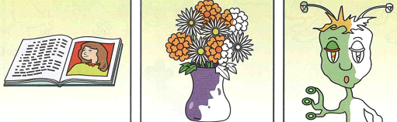
A |  | B |  | C
Question 2. You will hear a conversation between 2 people. Listen and complete questions 1-5.
There’s one example (1 p)
Name: Mary Smith
1.How old:………………………………………………………………………………………………...
2.Hair colour:………………………………………………………………………………………….….
3.Eye colour:…………………………………………………………………………………………...…
4.How many brothers:……………………………………………………………………….……………
5.How many sisters:……………………………………………………………………...……………….
II. VOCABULARY & GRAMMAR
Question 1. Choose the option (A, B, C or D that best completes each of the following sentences ( 3P ).
1. Tim: What's your new friend like? Bella:__________
A. She has blond hair B. She's very kind C. She's tall D. She’s black
2. Duong: Can you pass me the book, please? Phuc:“ ………………. ”
A. Yes, please B. Yes, sure C. Yes, I can D. No, I can’t
3. Nga: Would you like to have a picnic?Lan:“……………………….”
A. Oh, sorry, I can’t B. Yes, please C. No, I don’t D. Yes, I would
4. My mother__________ the gardening every Saturday.
A. does B. works C. makes D. plays
5.Tommy:__________ bedrooms does your apartment have? Jenny: It has two bedrooms.
A. How many B. How C. Where D. What
6.The national library is__________ the bank and the hospital.
A. on B. in C. among D. between
7. There are many dirty clothes on the floor. It is such a _______ room.
A. messy B. tidy C. clean D. clear
8.__________ the right of the room, you will see a big bookshelf.
A. on B. In C. At D. Of
9. Nam is very smart. He always answers the teacher’s questions well.
A. happy B. clever C. lazy D. hardworking
10. Hoa is a good friend. She always shares things with her classmate.
A. gives B. needs C. takes D. wants
11. This is Lan. ……..house is new.
A. My B. Your C. Her D. His
12.After school, we often__________ basketball together.
A. do B. play C. have D. study
13.Don't be __________! Share your food with your brother, Sam!
A. confident B. lazy C. selfish D. happy
14. My best friend __________ big brown eyes and a round face.
A. has B. does C. gets D. takes
15.We do_________ in the gym every afternoon.
A.table tennis B. football C. judo D. homework
III. READING
Question 1. Read the following passage and decide whether each of the statements is TRUE or FALSE( 1.5 P).
My family has just moved into a new house.It just has everything we wish for,especially a garden.It is not big and there are not a lot of trees my Dad plans to add more to make it beautiful. He thinks our family can have outdoor dinners at weekends. Mom cooks the best food in the world,so my sister and I can't wait to invite some friends over some time.
Statements | True/ False
1. The writer's family doesn't like the new house.
2. There are four members in the writer's family.
3. The writer's new house has a big garden.
4. The writer's father wants to make the garden beautiful.
5. The children enjoy their mom's cooking.
Question 2:Read the following passage and choose the best answer to each question (1,5 p )
Hello! My name is Chung. I’m twelve years old and I’m in grade 6. My school is in a suburb. It’s large and beautiful. My school has 3 floors and there are twenty-five classrooms. It also has a big yard and a stadium in front of my school. We often play football in the stadium after school. And at each break time the school – yard is full of students with various activities. There are over 600 students in my school. So the school is lively at the beginning of class break time. There are also function rooms: chemistry room, English room. Music room, Art room and a big library. The 26 teachers in my school are lovely and warm. They always spend time explaining the lesson to students if someone has misunderstanding problems. I love my school very much.
1. Where is Chung’s school?
A. in the city B. in the country C. in a town D. in a mountainous
2. What is Chung’s school like?
A. small and beautiful B. small C. big and beautiful D. No information
3. How many classrooms are there in the school?
A. 25 B. 24 C. 20 D. 26
4. What does the writer do after school?
A. go home B. play with friends C. play football D. go to the library
5. How are the teacher if someone doesn’tunderstand the lesson?
A. Ignore B. angry C. laugh D. helpful
IV. WRITING
Question 1. Complete the second sentence so that it has the same meaning as the first one. (1p)
1. There are three bedrooms in my house.
→ My house has_______________________________________________________________
2. The subject I like most is history.
→ My favorite subject ________________________________________________________
3. My mother teaches at this school.
→ My mother is_____________________________________________________________________
4. There is a stadium behind my house
→ My house is_____________________________________________________________________
5. I think you don't have to bring candles.
→ You don't need____________________________________________________________________
Question 2:Complete these sentences to finish the description of a person (1p)
1. This / my friend.=> This is my friend.
2. Her name/ Phuong
…………………………………………………………………………………………………………….
3. She/ black/ long/ hair
…………………………………………………………………………………………………………….
4. She/ oval face/ bright skin
…………………………………………………………………………………………………………….
5. She/ tall/ slim
…………………………………………………………………………………………………………….
6. She/ like/ read books and listen to music
…………………………………………………………………………………………………………….
7. She/ good at Math and English
…………………………………………………………………………………………………………….
8. She/ out-going and helpful
…………………………………………………………………………………………………………….
======= The end ========

Mã đề 6.1.4 | HƯỚNG DẪN CHẤM KIỂM TRA GIỮA HỌC KÌ I  NĂM HỌC 2022-2023  MÔN Tiếng Anh - LỚP 6  Hướng dẫn chấm gồm 01 trang
A.Listening
Q 1 (5 x 0.2 = 1pts)
1 A 2. B 3.A 4. A 5. C
Q 2 (5 x 0.2 = 1point)
1. 9 ( nine ) | 2. blonde | 3. blue | 4. 3- three | 5. 4- four
B.VOCABULARY - GRAMMAR – LANGUAGE FUNCTION (15 x 0.2 = 3 pts)
1. B | 2. B | 3. A | 4. A | 5. A
6. D | 7. A | 8. A | 9. B | 10. A
11. C | 12. B | 13. C | 14. A | 15. C
C.READING
Q 1.(5 x 0.3 = 1.5pt)
1.F | 2.T | 3.F | 4.T | 5.T
Q 2.(5 x 0.3 = 1.5pt)
1.B | 2.C | 3.B | 4.A | 5.A
D.WRITING
Q 1:Complete the sentences using the words given (5 x 0.3 = 1.5pt)
1. My house has three bedrooms
2. My favorite subject is history
3. My mother is a teacher
4. My house is in front of a stadium
5. You don't need to bring candles
Q 2. Complete these sentences to finish the description of a person
1. This is my friend.
2. Her name is Phuong
3. She has a black and long hair
4. She has an oval face and bright skin
5. She is tall and slim
6. She likes reading books and listening to music
7. She is good at Math and English
8. She is out-going and helpful
======= The end ========

