**ĐỀ KIỂM TRA CUỐI KỲ I NĂM HỌC: 2022-2023**

**MÔN: TIẾNG ANH LỚP 9**

**V. SPEAKING (2.0 POINTS)**

**1. Introduction(0.5 point)**

**Introduce yourself with basic information (***name, class, age, hobby, family, etc.***)**

**2. Each of you will now receive a card. On the card there are pictures and clues for five questions. You should use the words to make questions and ask your friend. Your friend will answer the questions based on the picture he/she has. (0.5 point)**

*Use the words given below to make questions. Ask your friend about his/her picture*

*and listen to the answers.*

1. Who / you /see/ the pictures?
2. Where/they?
3. How / students /the first picture/ study?
4. What / there / the second picture?
5. What / the benefits / modern equipment for study?

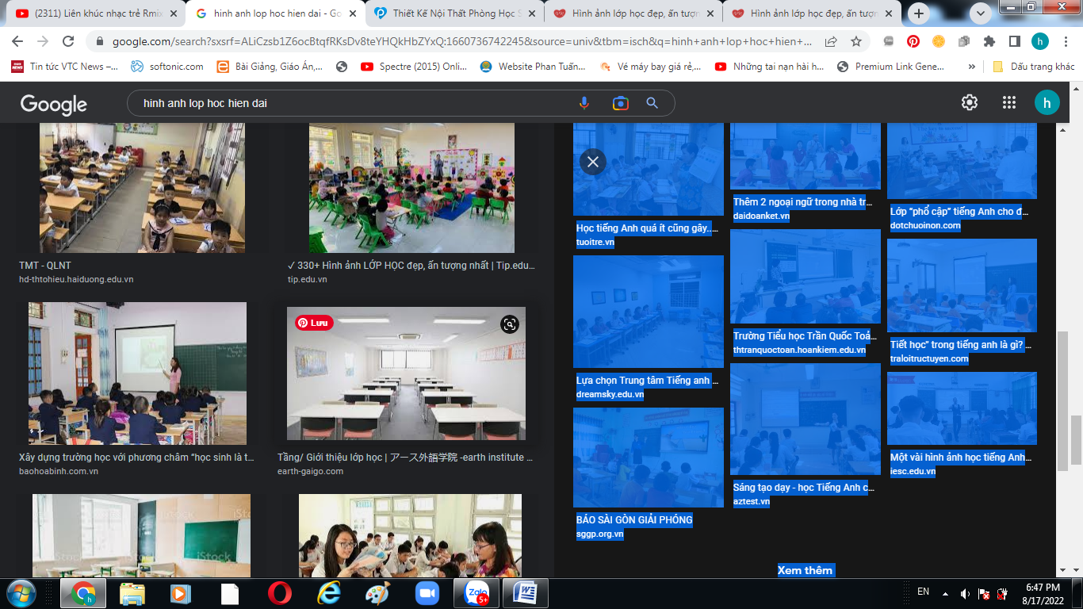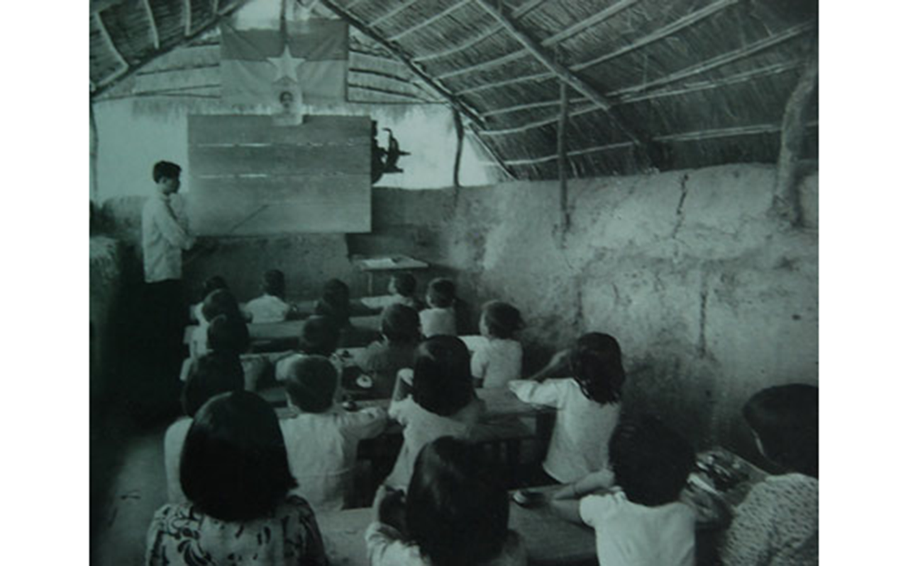  
**3. Answer further questions (1.0 point)**

- What equipment is there in your school?

- What equipment do you like most? Why?

- Do you want to have more modern equipment?

- What are they?

- What would you like to change about your school?

________________________

**ĐỀ KIỂM TRA CUỐI KỲ I NĂM HỌC: 2022-2023**

**MÔN: TIẾNG ANH LỚP 9**

**V. SPEAKING (2.0 POINTS)**

**1. Introduction(0.5 point)**

**Introduce yourself with basic information (***name, class, age, hobby, family, etc.***)**

**2. Each of you will now receive a card. On the card there are pictures and clues for five questions. You should use the words to make questions and ask your friend. Your friend will answer the questions based on the picture he/she has. (0.5 point)**

*Use the words given below to make questions. Ask your friend about his/her picture*

*and listen to the answers.*

1. Where/the people / pictures?
2. What problems/ you /see/ the pictures?
3. Have / you/suffer from/ traffic jam?
4. How/ you/ feel/ at that time?
5. What / the causes / air pollution/city?

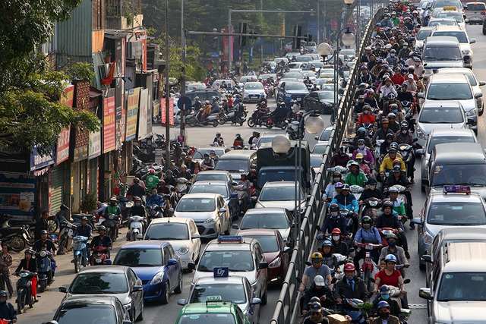 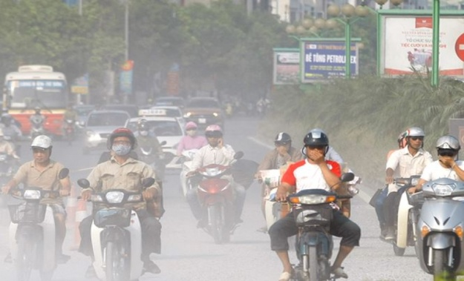

**3. Answer further questions (1.0 point)**

- Do you like living in the city or in the countryside?

- Which city in the world do you like most? Why?

- What are the positive sides in the cities?

- Beside the obove disadvantages,what are the other drawbacks in the cities?

- What should we do to solve these problems?

________________________